Scene Reproducer

A Serious Game where you reproduce 3D scene

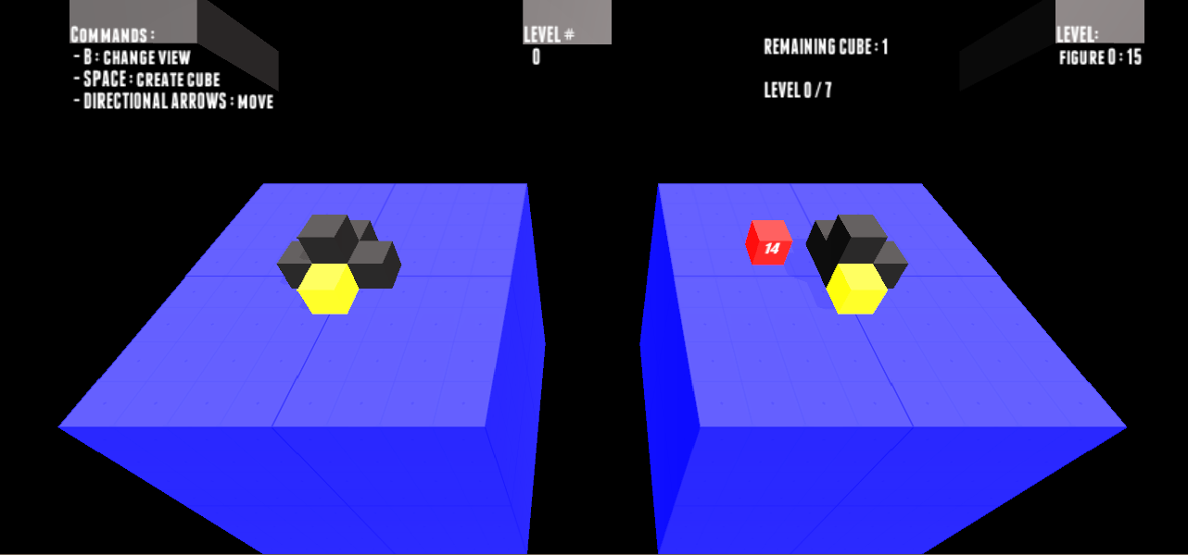

Document Purpose: | Describe the game concept
Document Version: | 1
Working Title: | Scene Reproducer
Game Concept:
Game Document Author: | Matthias Bonnivard, Florian Schmidt
Introduction :

- Genre : Serious Game
- Player Type: Control a cube that can create new ones
- Game Play: move the cube into the platform and generate new cube at your current position
- Technical Form: 3D game with refined look.
- History: No History for the moment
- Reference: None
- Theme: None
- Design Intentions: original

Game Description
Genre: | - Simple platform game (scene creation)
Game Elements: | - The player control a cube on the right platform and the left platform contain a scene to reproduce.

Theme: | - Sci-fi
Style: | - Quiet futuristic and maybe zen
Game Sequence: | - Simulation
Player: | - For the moment it is a single player game
Game Reference
Game Taxonomy: | - Fictional simulation game
Player Immersion: | - Mental game  - The player needs a good sense of analysis
Reference: | - References can come from any where.  - The game is thought to learn to a 6 to 9 year old child. The purpose is to improve his sense of spatial perception and his ability for perspective.  - The idea of the game as been created with Stephane Gobron.

Game Technical
Technical From: | - 3D graphics
View: | - The view is a camera that look 45 down to the platform and another camera vertically upon the scene (360 degree camera to develop)
Platform: | - Unity, C#
Device: | - PC (SmartPhone, Tablet to develop)
Game Sales
Consumer Group: | - 6 to 9 year old child
Payment: | - Serious Game not to sell for the moment
Estimated Price: | - 0
Device Support List

Game Atmosphere
For the moment the game is a little prototype. But with some futuristic sounds and music and a visual 3D with simple textures the game feel quiet futuristic and maybe make a little feeling to be in a factory.
The atmosphere need to evolve if the game is developed because the targeted player are young children.

Game Play

This outline will vary according to the type of game.
- Opening the game application
- For the moment when the application is open there is no menu. The game is directly launch and the player have to make the first level.
- As it is a prototype of a game project there is no story synopsis, modes.
- Game Elements: 2 platform, all the cube on the left make a scene to reproduce and the player control a cube on the right that can duplicate himself.
- Game Levels: For the moment there is only 8 levels of scene to reproduce.
- The player control a cube that he can move on a platform and that can duplicate himself in order to reproduce the actual level scene.
- Winning is for the moment a matter of time. The faster the assembly of a scene is done the better the final score is. But in the future this should depend on the number of error and other parameters.
- Losing is not possible for the moment. But it can be a good idea to define a game over after a certain amount of time.
- Why is all this fun? This game can be fun because it is really creative. Even if you have to reproduce a scene we can imagine that other game mode can be created to give more fun to the player.

Key Features

Key features are a list of game elements that are attractive to the player.

It is a good idea to talk about the key features with someone from marketing.
- Number of Levels: For the moment 8. But the game need a “Random” level generator.
- Replay ability: If the game had a multiplayer mode that permit each player to create level or game mode the ame might have an infinite life.
- Audio Specifications: For the moment there is a sound when the player controlled cube is moved and when a new cube is generated. There is also a zen ambient music to give the player a stress-less impression of the game.
- Graphic Specifications: For the moment the game is really simple. The texture and light are very basic but give an impression of a refined environment.
- Device Compatibility: For the moment the game is only playable on a PC. Thanks to unity a Android or a IOS version for tablet can be made very easily.
- Number of Players: For the moment one but a multiple player mode is obviously interesting for this game.

Design Version

Developed on unity for PC. But the reason unity has been chosen is that this Unity software gives possibility for multi platform compatibility.

Design Guidelines

For the design of the game everything is to made. A lots of possibility exists cause the game is based on creativity and is not supposed to happen in a defined world or environment.

System Requirements

The game is runnable on a computer with windows OS. Because a .exe file is launch.
For the running capacity of the computer, all nowadays computer are able to run it.

Visual Content
- Cube not controlled by the player
- The cube controlled by the player with color signification of a good or bad position
- Platform
- Source light
- Text content for the level, the number of remaining cube to complete a scene, the score for each level, the counter on the PlayerCube.Audio Content

Programming Content
Some C sharp scripts attached to GameObject are to the scene.

Scripts List:
- Cubecontroller → the directional arrows used to move.
- NewCube → generate a new cube on the right platform and control the grid to check and compare the scene reproduction. This script is the main logic of the game.
- NewCubeSound
- RotateCamera

