Imprint

Publisher
Deutsche Gesellschaft für Internationale Zusammenarbeit (GIZ) GmbH
Registered offices: Bonn and Eschborn, Germany
South African-German Energy Programme (SAGEN) – Capacities for the Energy Transition (CET)
GIZ South Africa
Hatfield Gardens, Block C
333 Grosvenor Street
Hatfield, Pretoria
South Africa

Contact
E-mail: sagen@giz.de
Website: www.sagen.org.za

Responsible for Content
Deutsche Gesellschaft für Internationale Zusammenarbeit (GIZ) GmbH

Technical Development
Fastbreak.One

Disclaimer
The Electricity Market Simulation Game is intended for educational and capacity-development purposes. Market outcomes, prices, scenarios and results generated within the simulation do not represent actual market forecasts, operational instructions or investment advice.
While every effort has been made to ensure the accuracy and relevance of the simulation, neither GIZ, National Transmission Company South Africa, Power Futures Lab nor Fastbreak.One assume liability for decisions taken on the basis of information generated through the game.

Data Protection
The processing of personal data on this platform is carried out in accordance with applicable data protection legislation. Further information can be found in the Data Privacy Notice.

External Links
This website may contain links to external websites. Responsibility for the content of external websites lies solely with their respective operators. GIZ assumes no responsibility for the content of external sites linked from this platform.

Funded by
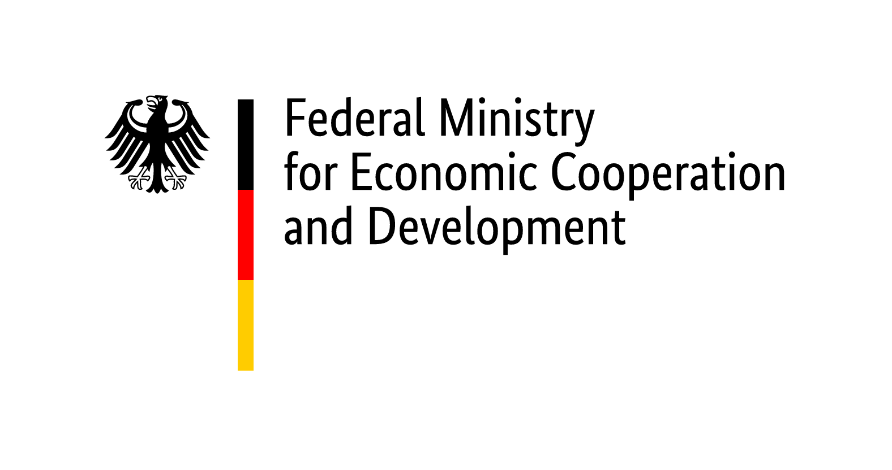

Implemented by  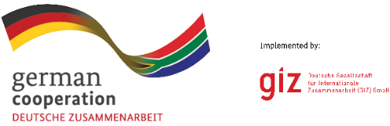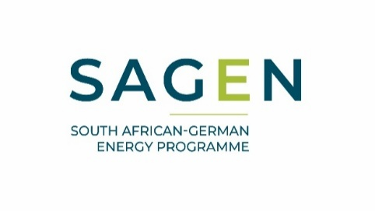 | In collaboration with  

Developed by



