Part 8 - API Testing (Postman) – SauceDemo

Summary

Endpoints | Positive negative Scenario | Response validations
https://dummyjson.com/auth/login | Login Fail | 400, json message
https://dummyjson.com/auth/login | Login Success | 200, json token
https://dummyjson.com/products | Product listing Fail | 400, json message
https://dummyjson.com/products | Product listing Success | 200, json
https://dummyjson.com/carts/add | Add to Cart Fail | 400, json message
https://dummyjson.com/carts/user/1 | View Cart Fail | 400, json message
https://dummyjson.com/carts/user/1 | View Cart Success | 200, json

Screenshots

Login Fail

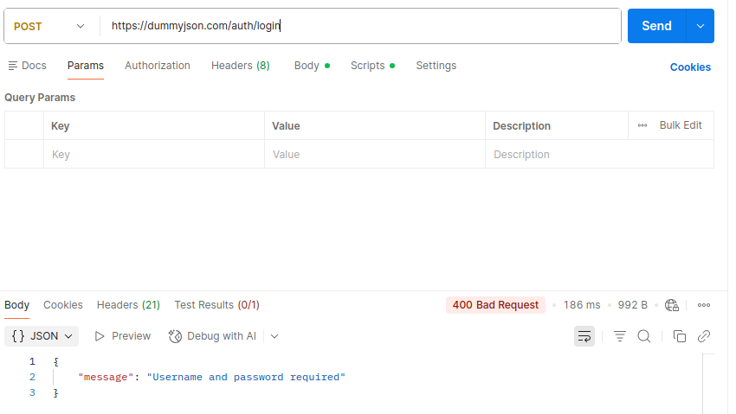

Login Success

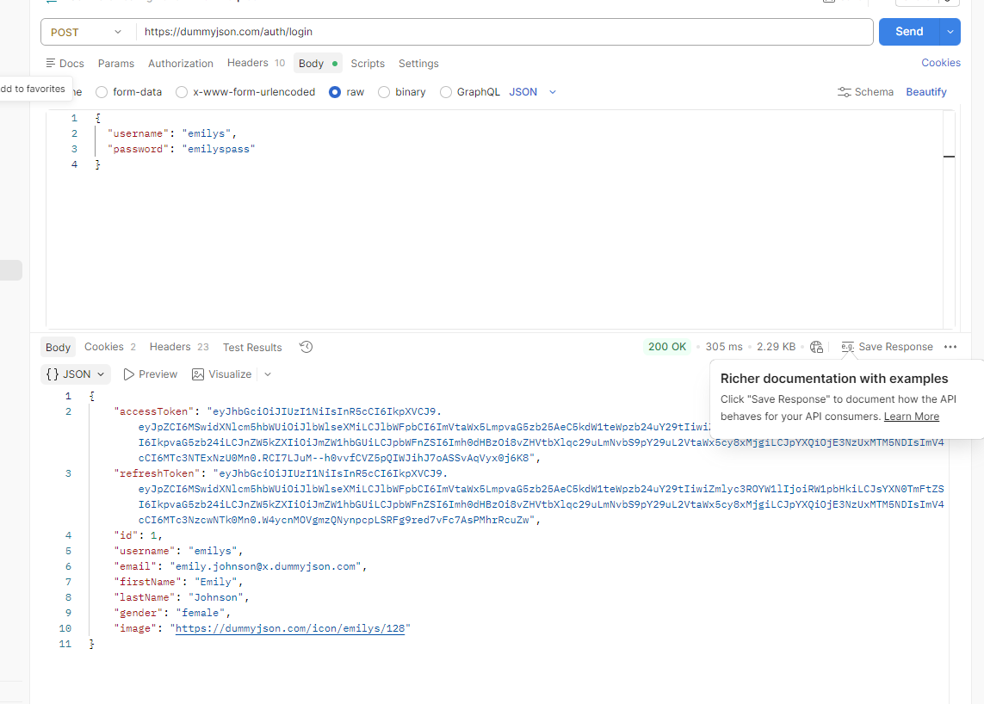

Product Listing Fail

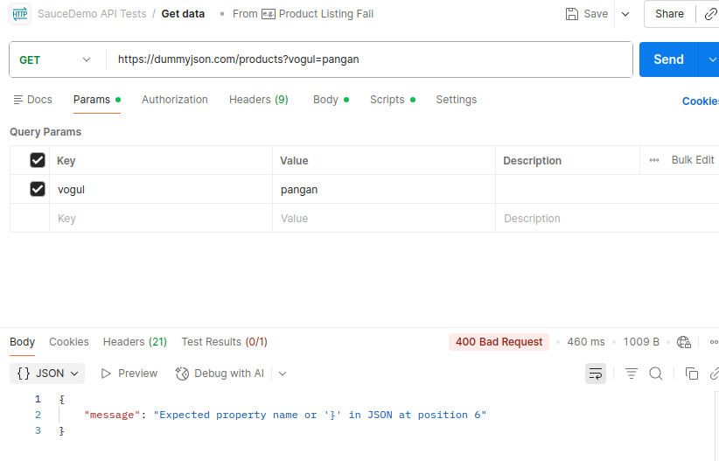

Product List Success

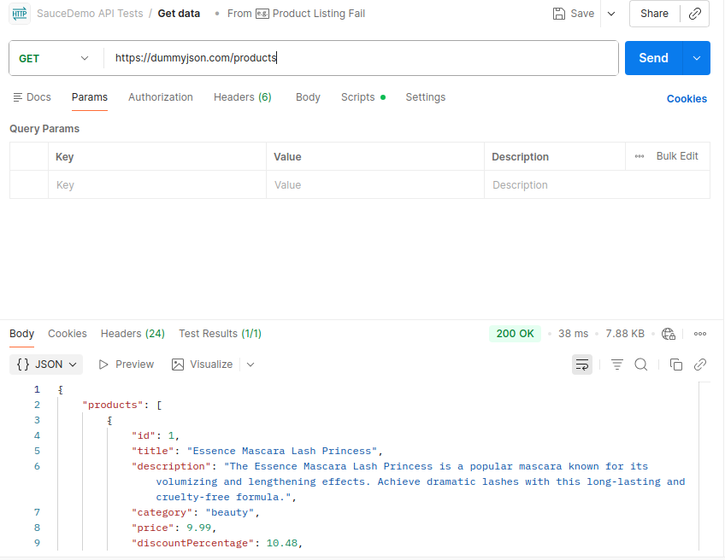

Add to Cart Fail

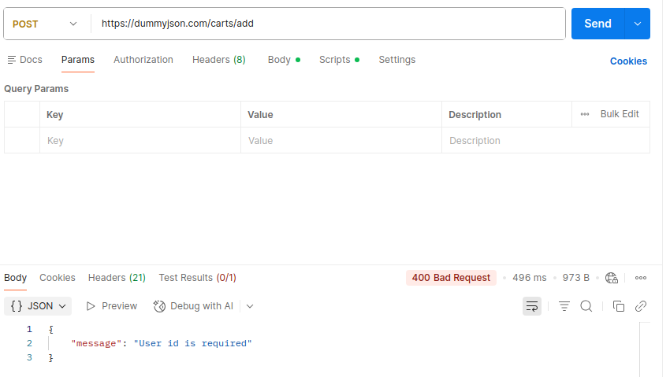

View Cart Fail

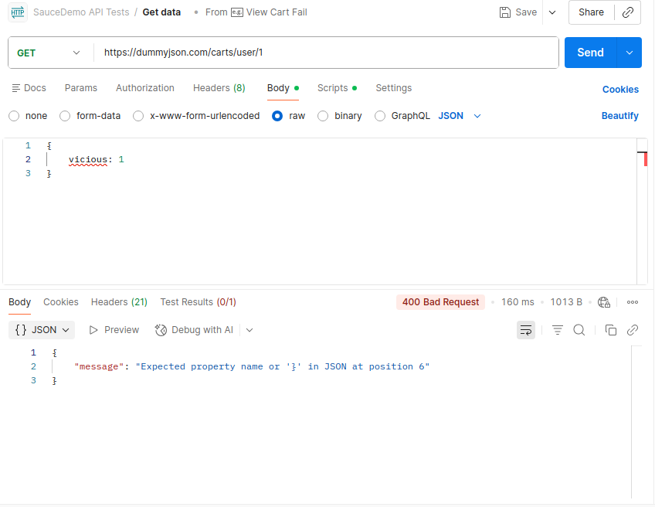

View Cart Success

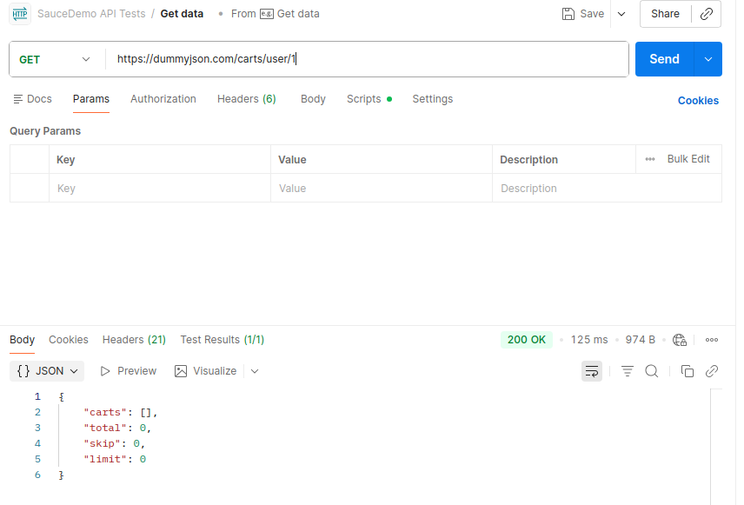
Product Listing Success

