Open-Source Tools for Relational Network Derivation, Visualization and Task Generation

Matthias Raemaekers¹, Martin Finn¹ and Jan De Houwer¹
¹ Department of Experimental-Clinical and Health Psychology, Ghent University, Belgium.

Author Note
Corresponding author MR can be reached at {matthias.raemaekers@ugent.be}, or Henri Dunantlaan 2, 9000, Ghent, Belgium. The work presented here was supported by fundamental research grant (11M0325N) of the Flemish Research Foundation to MR. All code presented in this manuscript and related materials are available at open science framework (https://osf.io/bjxqg/overview?view_only=5ab9e17676a3436d9d7878d0b7e1340e).

Abstract
Researchers across behavioral psychology, cognitive neuroscience, biology and computer science increasingly agree that relational abilities are a cornerstone of human cognition and intelligence. Human relational abilities are extremely generative, allowing individuals to flexibly adapt to novel environments, but this generativity also complicates research on complex relational cognition. Visualizing the network(s) of relations that govern(s) an individual’s behavior, or establishing such complex relational control in the lab is difficult and cumbersome. The current paper describes a set of open source resources that aim to facilitate relational reasoning research by allowing users to visualize and create complex relational procedures automatically. We provide a set of so-called relational derivation tables that can be used to automate relational derivation in computer programs. We derived three tools from them that illustrate their utility: (1) visualize a relational network; (2) generate matching-to-sample procedures with user-defined task parameters and (3) generate syllogistic reasoning problems with user-specified task characteristics. We illustrate there use in two tutorials that simulate relational reasoning research scenario’s. We hope these tools can help researchers overcome some of the difficulties associated with studying relational abilities in human or artificial systems and as such facilitate research on more complex relational behavior that underpins complex human cognition.
Keywords. Relational Reasoning, Syllogistic Reasoning, Relation Derivation, Open Source Software, Matching-to-sample, Relational Graph Networks

Introduction
Researchers from different fields in psychological research have emphasized the importance of relational abilities as a cornerstone of human cognition (e.g., Hayes et al., 2001; Penn et al., 2008; Halford et al., 2010; Gentner & Smith, 2013; Hughes & Barnes-Holmes, 2015; McLoughlin et al., 2020; De Houwer et al., 2023) and intelligence (e.g., Colbert et al., 2017; May et al., 2022). Researchers have developed many procedures to study the relational abilities of nonhuman animals (e.g., Harlow, 1949; Premack, 1983; Penn et al., 2008), humans (e.g., Alexander et al., 2016; Colbert et al., 2017) and artificial systems (e.g., Webb et al. 2023; Raemaekers et al., 2025), some of which have been proposed as proxy-measures of intelligence (e.g., Colbert et al., 2017; May et al., 2022) or are part of modern intelligence tests (i.e., tasks like matrix reasoning, verbal analogies, etc.; e.g., Raven & Raven, 2003; Kaufman & Lichtenberger, 2006; Wechsler, 2008). Human relational abilities are extremely generative, however, which allows for flexible adaptation to novel environments (humans only need to learn about a handful of relations to derive myriad new relations, Hayes et al., 2001), but also results in complex relational networks and behavioral repertoires. For researchers, these are often difficult to describe precisely, and it is difficult to devise sufficiently complex procedures to study them in a controlled laboratory setting, hampering the development of highly specified task procedures (e.g., Cortes et al., 2021) and detailed analytic and descriptive models (Smith & Hayes, 2022) required for good scientific understanding. Artificial intelligence researchers also increasingly study the relational abilities of artificial systems (e.g., Webb et al., 2023; Lewis & Mitchell, 2024; Eisape et al., 2024; Ozeki et al., 2024; Ando et al., 2024; Wu & Deng, 2024; Mitchell, 2026), draw upon insights from other research traditions to develop artificially intelligent systems (e.g., from behavior-analysis; Ninness & Ninness, 2020; Edwards et al., 2022; Johansson, 2024) and explore the implementation of relational networks in neural network models (e.g., Santoro et al., 2017; Webb et al., 2024; Duran et al., 2026). However, the relational information they learn is often obscured by the black box-nature of the architectures (Smith & Hayes, 2022), an important area of focus for future research to address.
This paper describes a set of open-source tools that aim to complement and facilitate research on relational abilities in different systems, be that nonhuman animals, humans or artificial systems. Inspired by the work of Allen (1983), who worked on the representation of temporal relations in computer systems, we constructed a set of so-called transitivity tables (also referred to as composition tables in logic and mathematics). As the name suggests, these tables describe the transitivity of various combinations of relations (i.e., if A is before B and B is before C, A is before C; and if A is opposite to B and B is opposite to C, A and C are the same). Where Allen’s tables contained only temporal relations (e.g., before, after, meets, starts), the tables described here contain other relationships also (e.g., equivalence, difference, opposition, comparison, hierarchy, temporal, …). Furthermore, we also included a table representing the bidirectionality of relations (e.g., if A is more than B, B is less than A; therefore, the tables are hereafter referred to as relational derivation tables). These tables can be used for constructing algorithms capable of automated reasoning about relations, which can in turn be implemented in different applications. Such tools for automated reasoning about relations are not readily available to researchers (Smith & Hayes, 2022), and where they are, they are often allow for only a limited number of relations. We share the derivation tables alongside software to create them and illustrate the utility of the automated relational derivation they support in three applications: (1) visualizing relational networks; (2) creating syllogistic reasoning problems; and (3) creating matching-to-sample (MTS) procedures. The tables, software and tools are available as a python module on the Open Science Framework. The tools are also shared as an online application. In what follows, we first describe the derivation tables in more detail. We then describe the software underlying the derivation tables and tools, before illustrating their use with two tutorials.

Relational Derivation Tables
We expanded on Allen’s idea and created relational derivation tables that include both the reversals [(as)symmetry, bidirectionality or mutual entailment] and transitivity of relations, and include many other relations beyond temporal relations. While more relations can be added, we chose to limit ourselves to this set of relations as it already provides prototypical versions of the most studied relations in psychological research (e.g., Hayes et al., 2001; Penn et al., 2008; Colbert et al., 2017).

Mutual Entailment
The mutual entailment table is illustrated in Table 1. It includes equivalence, difference and opposition, comparative relations (e.g., more than, less than), hierarchical relations (contains, is part of) and temporal relations. Equivalence relations are defined by symmetry (Sidman & Tailby, 1982; if A is equivalent to B, B is equivalent to A; any response to A in relation to B is functionally identical to response to B in relation to A). Some other relations, like difference and opposition are also symmetrical (e.g., if A is different from B, B is different from A, and if A is opposite to B, B is opposite to A). Most relations other than equivalence, however, are not symmetrical. Instead, they (often) form pairs of relations within which one relation is mutually entailed by the other, and vice versa, like for the comparative relations “A is more than B” and “B is less than A”. Other examples include the temporal relations ‘before’ and ‘after’ (as well as those described by Allen, 1983) and hierarchical relations (e.g., ‘contains’ and ‘is part of’). Table 1 only include a subset of all relations currently supported by the software to keep the illustrations legible. The included relations can be thought of as general categories of which many other relations are specific exemplars (i.e., they follow the exact same derivation patterns; e.g., more than/less than versus larger than/smaller than; we elaborate on the implications of this observation in the Discussion section). An overview of all relations that are currently supported can be found in Appendix A1.
Table 1
Derivation Table for Mutual Entailment or Bidirectionality of Relations
Source Relation (A – B) | Derived Relation (B – A)
Same as | Same as
Different from | Different from
Opposite to | Opposite to
More than | Less than
Less Than | More than
Contains | Is part of
Is part of | Contains
Before | After
After | Before

Combinatorial Entailment
A second set of tables describes the transitive property of relations (also referred to as combinatorial entailment; Hayes et al., 2001): two relations that share a common element afford the derivation of a novel relation between the non-shared elements (e.g., if A is related to B and B is related to C, then a relation between A and C can be derived). Importantly, the particular way in which two relations are combined determines what relation(s) can be derived. Two pairs of related stimuli (that share one common stimulus) can be combined in four ways, each resulting in slightly different derivations, as illustrated in Table 1.
Table 2
Different Configurations of Combinations of Relations
Configuration | Relation 1 | Relation 2 | Derived Relations
Linear | A – B | B – C | A – C and C – A
One-to-many | A – B | A – C | B – C and C – B
Many-to-one | A – B | C – B | A – C and C – A
Reversed Linear | A – B | C – A | B – C and C – B
Note. The labels used to designate the different configurations are inspired by research on stimulus equivalence, in which the effects of manipulating the configurations (referred to as training protocol or structure) of a relational training procedures are often investigated (e.g., Saunders & Green, 1999). Typically, only linear, one-to-many and many-to-one protocols are addressed. We have added what we here refer to as the ‘reversed linear’ (because the order of relations in the linear protocol can be said to be reversed) protocol for completion.
The derivation tables for combinatorial entailment contain the same relations as the mutual entailment table. When we study combinations of these different relations in the different configurations, particular patterns of relational derivations can be identified, as can be observed in Figure 1 below. For each configuration, the pattern can be summarized by a few simple rules, which we leveraged in the relational derivation algorithm described below. We have summarized the ‘rules’ governing those patterns of relational derivation in Table 2.
Figure 1
Relational Derivation Tables Illustrating Transitivity of Relations
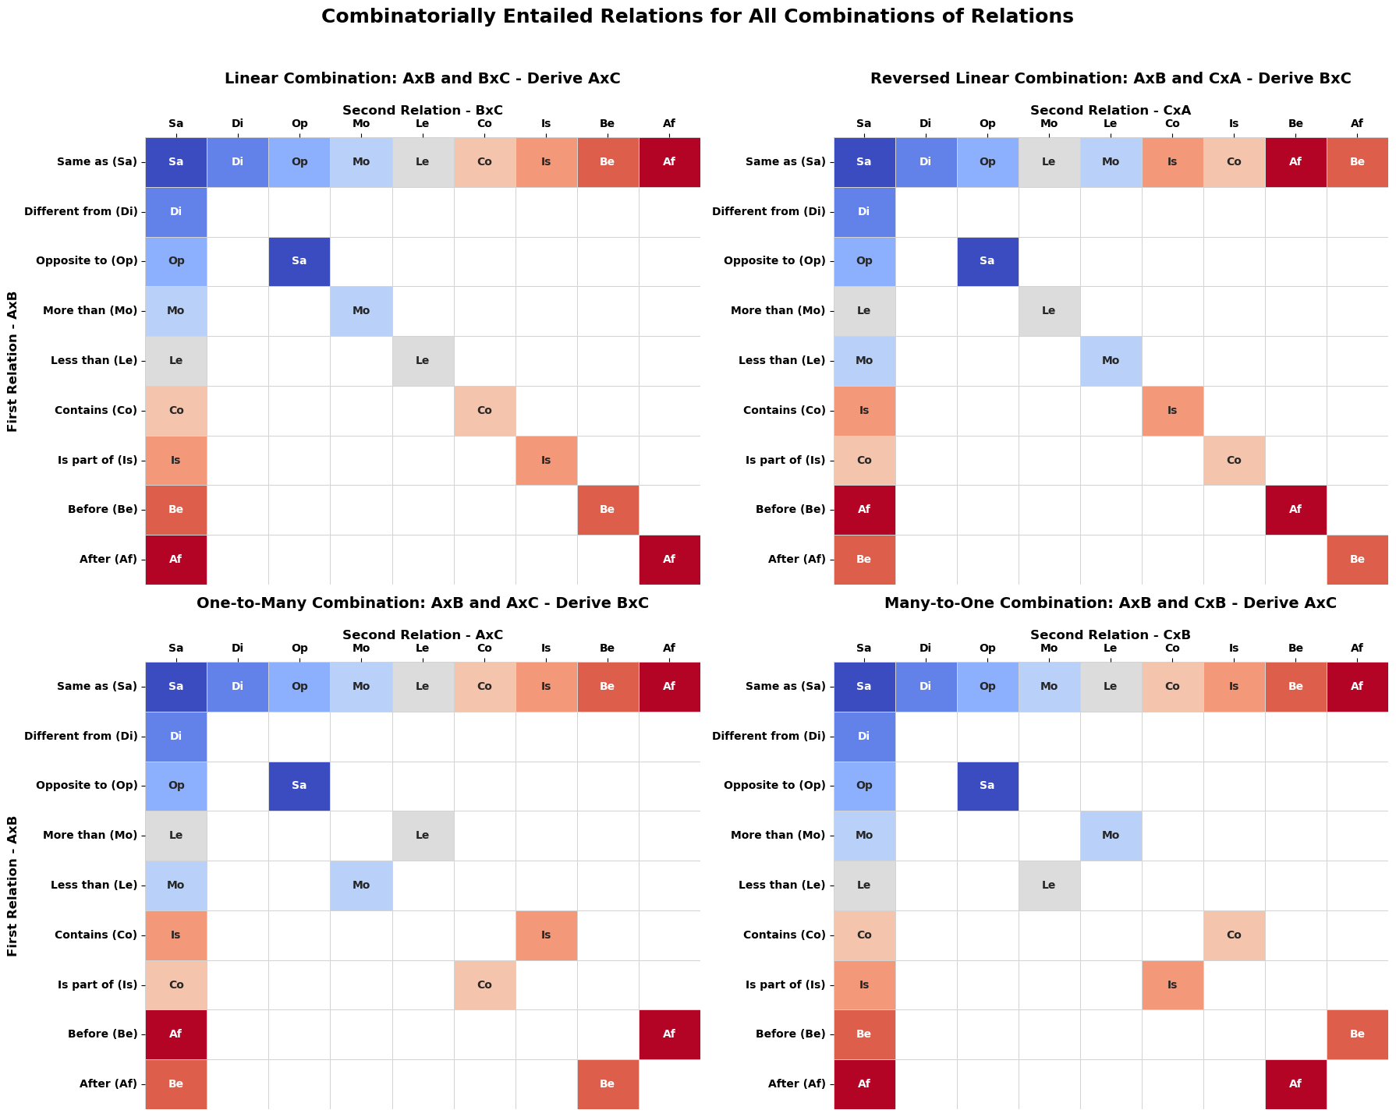
Note. Transitivity tables for four combinations of two relations. Rows and columns represent to-be-combined Relation 1 (A – B) and Relation 2 (B – C, C – A, A – C or C – B), respectively. All other cells represent the relations that can be derived from that combination. Empty (white) cells represent combinations for which no valid relation can be derived with certainty.
Table 3
Description of Relational Derivation Patterns in Four Combination Protocols
Linear Combination (A-B x B-C)
- Combination of two identical relations affords derivation of that same relation (e.g., if A is more than B and B is more than C, A is more than C), except for combinations of difference relations (no derivation) and combinations of two opposition relations (derived equivalence)
- If either relation is ‘equivalence’, the derived relation is the same as the second relation in the combination (e.g., if A is equivalent to B and B is opposite to C, A is opposite to C)
- All other combination of relations do not afford valid derivations
Reversed Linear Combination (A–B x C–A)
- Combinations of two identical, symmetrical relations lead to same derivations as in Linear combination
- For combinations of two identical, asymmetrical relations, derived relation is the reversed of that relation (e.g., if A is more than B and C is more than A, B is less than C)
- If either of the combined relations is equivalence, the derived relation is the reverse of the second relation (e.g., if A is before B and C is equivalent to A, B is after C)
- All other combination of relations do not afford valid derivations
One-to-many Combination (A-B x A-C)
- Combinations of identical relations do not afford valid derivation, except for two equivalence or two opposition relations
- If either relation is ‘equivalence’, the derived relation is the same as the second relation in the combination (e.g., if A is equivalent to B and B is opposite to C, A is opposite to C)
- If two relations are combined that are each other’s reversal, the derived relation is the second relation (if A is more than B and A is less than C, B is less than C)
Many-to-one Combination (A-B x C-B)
- Combinations of identical relations do not afford valid derivation, except for two opposition relations
- If either relation is ‘equivalence’, the derived relation is the same as the second relation in the combination (e.g., if A is equivalent to B and B is opposite to C, A is opposite to C)
- If two relations are combined that are each other’s reversal, the derived relation is the first relation (if A is more than B and C is less than B, A is more than C)

Creating Derivation Tables and Automating Relational Derivation
In this section, we describe the software that generates derivation tables and uses them for automated relational derivation. The createDerivationTables.py Python function generates the relational derivation tables (in Python) for a user-specified set of source relations. The function takes two optional input arguments. The first allows users to specify the relations for which they want to create the tables. This input argument (named relations) can be a Python list of relation labels (Python strings) or a Python dictionary in which the keys are the relation labels and the values are the indices those relations will take in the relational derivation tables (note that Python uses zero-based indexing, and therefore, the values in the list should also start from zero). As noted, this is an optional input argument: if no input is provided, the function will generate the tables for a default set of relations (i.e., those illustrated in Table 1 and Figure 1). The second optional input argument is a Boolean plotTables, allowing users to generate heatmap plots illustrating the derivation tables they created. The function outputs three variables. The first, named mutual, is a 1-by-n array (where n is the number of relations in the input dictionary, or in the default) that contains the mutually entailed relation (i.e., reversal) for each relation in the input dictionary. For example, say we input a dictionary relations = {‘same’: 0, ‘more than’: 1, ‘less than’: 2}, the resulting array mutual = [0, 2, 1]. That is because the sameness relation is symmetrical, whereas the comparative relations are not. The second output is a dictionary that contains four arrays, one for each order in which two relations can be combined (see Table 2). For symmetrical relations, the resulting table will be identical in each order, but for asymmetrical relations, different combinations will lead to different derivations. For each order (dictionary key), the value is an n-by-n array (where n is again the number of input relations), in which the row- and column-indices correspond to those provided in the input, and each cell in the array contains the index of the relation that can be derived from that particular combination of relations (in a given order). The final output is a copy of the input relation list with standardized labels for downstream use. Below, we provide pseudocode for the algorithm generating the derivation tables:
Input (optional): relations (list of relation labels) and plotTables (Boolean)
- Convert relations to standardized labels and define symmetrical and asymmetrical relations; add any missing relations from asymmetrical relation pairs.
- Create an empty list mutual for mutually entailed relations and loop relations list (or default list if no input) for relation r1
  - If r1 is symmetrical, mutually entailed relation is identical, add to mutual list
  - If r1 is asymmetrical, look up mutually entailed relation in list of asymmetrical relation pairs and add both to list
- Create a dictionary combi with four keys (different combinations of two relations) for the combinatioral entailment of input relations and loop relations again for r1 and again for r2 to find derived relation (r1, r2) for each of the four configurations
  - If r1 and r2 are identical:
    - If relation is equivalence or opposition, derived relation = equivalence, for all four configurations
    - If relation is difference, set derived relation is ill-defined for all four configurations
    - If the relation is asymmetrical set derived relation (r1, r2) for linear combination to r1, for reversed linear combination to the mutually entailed relation of r1, and for one-to-many and many-to-one configurations to ill-defined
  - If r1 and r2 are not identical:
    - For linear combination:
      - If r1 is equivalence: derived relation = r2
      - If r2 is equivalence: derived relation = r1
      - Else: derived relation is ill-defined
    - For reversed linear combination
      - If r1 is equivalence:
        - If r2 is symmetrical, derived relation = r2
        - Else: derived relation = mutually entailed relation of r2
      - If r2 is equivalence:
        - If r1 is symmetrical, derived relation = r1
        - Else: derived relation = mutually entailed relation of r1
      - Else: derived relation is ill-defined
    - For one-to-many combination
      - If r1 is equivalence:
        - If r2 is symmetrical, derived relation = r2
        - Else: derived relation = mutually entailed relation of r2
      - If r2 is equivalence: derived relation = r1
      - Else: derived relation is ill-defined
    - For many-to-one combination
      - If r1 is equivalence: derived relation = r2
      - If r2 is equivalence:
        - If r1 is symmetrical, derived relation = r1
        - Else: derived relation = mutually entailed relation of r1
      - Else: derived relation is ill-defined
- Optionally print tables and return mutual and combi
The second function for automated relational derivation is defined in the deriveRelationsFromBaseline.py script. The deriveRelationsFromBaseline function was developed to automatically derive relations from a user-specified set of input relations. The function takes as input a dictionary of relations, where each key is a relation label and each value is a list of ordered stimulus pairs instantiating that relation. The function first standardizes the supplied relation labels and constructs the derivation tables for the relation set contained in the baseline network (i.e., the keys of the dictionary are used as the input for the createDerivationTables function described above). To ensure all possible derivations are reached, the function works through a queue of relations until closure (or a user-defined maximum level of derivation) is reached. The baseline relations are added to the queue first, before it loops over the queue. For every baseline relation, the function first derives the corresponding mutually entailed relation by reversing the order of the stimulus pair and assigning the label of the mutually entailed relation (as per derivation tables), and then adds the mutually entailed relations to the queue. For instance, if the baseline network contains the relation ‘A more than B’, the function adds the derived relation ‘B less than A’. The function then loops the queue a second time and evaluates possible combinatorial entailments by comparing each relation instances. For each pair of relations, it identifies whether the two relations share a common stimulus. If no common stimulus is present, no combinatorial relation can be derived from that pair. If a common stimulus is present, the function determines the structural protocol defined by the two relations (i.e., linear, reversed linear, one-to-many or many-to-one), which determines which relation can be derived (between which stimuli). If the combinatorial entailment derivation table specifies a valid derived relation, the function adds this relation to the derived-relation dictionary and to the queue. It also adds the mutually entailed counterpart of that combinatorially entailed relation. Because derived relations are added to the queue, the algorithm can derive relations between stimuli multiple nodes apart. Finally, the function supports optional illustration modes via the ‘illustration’ argument; when set to ‘print’, the function will print out the reasoning steps to become the derived relations; when set to heatmap, function will generate stimulus-by-stimulus heatmaps of the baseline and derived relations; when ‘graph’ is selected, the baseline and derived relations in the network are illustrated as a directed graph network (described in more detail below). The function returns both a matrix-form relation table and a dictionary of derived relations. The latter uses the same relation-label-to-stimulus-pair structure as the baseline input. Below, we describe the relational derivation algorithm in pseudocode:
Input: baseline dictionary of relation labels and ordered stimulus pairs
- Create derivation tables for relations in input
- Add baseline relations to queue and loop relations r1(a,b)

- Find r_{mut} = mutual(r1) and add r_{mut}(b,a) to derived and queue
- Loop queue relations again for instances r2(c,d)
  - If r1(a,b) and r2(c,d) do not share a common stimulus, no derivation possible
  - Else: check configuration based on location of common stimulus and find r_{com} = combi(r1, r2), and add derived relation to derived and queue
    - Find mutually entailed relation of derived relation and add to derived and queue

Visualizing Relational Networks
The first tool we developed using the automated relational derivation algorithm was intended to help researchers visualize the relational complexity of the tasks and procedures they use. Due to the generativity of human relational responding, the combinatorial explosion that occurs when more and more relations are included in a procedure makes it difficult to visualize the relational structure of the task. In behavior-analytic research, for instance, researchers often use MTS procedures to first train participants to respond in accordance with particular relations (i.e., provide feedback for selecting a particular comparison stimulus in the presence of a sample stimulus), and then test whether participants also respond in accordance with relations that can be derived from the trained relations (i.e., through bidirectionality or transitivity of relations), in the absence of feedback. Because n ordered relations allow one to derive up to n² new relations, training even a small number of relations results in a large set of derived relations that researchers need to take into account. The tool we developed aims to facilitate this process by allowing users to visualize networks of trained and derived relations as graph networks. Smith and Hayes (2022) recently published software that generates and visualizes relational networks involving equivalence and comparative relations as directed graphs. Here, we introduce a python function (plotRelNetworkGraph) and an online tool that also allows users to visualize relational networks as directed graphs, but which also supports many other relations beyond equivalence and comparison and offers users more flexibility.
Python Function. The plotRelNetworkGraph function takes as its primary input a set of baseline relations as a python dictionary, in which relation labels serve as keys and each value is a tuple representing an ordered stimulus pair instantiating that relation. Stimuli are specified as numeric indices in this dict, which refer to a list of stimulus labels that users can choose, also supplied to the function. This allows users to display custom stimulus labels. Other optional arguments allow the user to specify derived relations (if the user does not need all derived relations to be computed and plotted), which relations to visualize (only baseline, mutually entailed or combinatorially entailed, or all combined), and other plot settings (title, network layout, colors, label size and styles). In the simplest use-case, users provide a set of baseline relations and a list of stimulus labels. If no derived relations are specified, the function automatically finds (using the createDerivationTables and deriveRelationsFromBaseline functions) all relations that can be derived from the (user-specified) baseline network and stores these. Stimuli are then represented as nodes and each relations as a directed arrow between two nodes. Users can determine the coordinates of stimuli by specifying the layout of the network: the ‘circular’ layout provides a simple and interpretable arrangement for small networks; a force-directed ‘spring’ layout places nodes according to the overall graph topology; a ‘degree’-based layout places highly connected stimuli near the center; and a hierarchical layout is suited to ordered or chain-like relations. Finally, the function includes several user-adjustable visual parameters, such as arrow color and curvature, relation-specific colors, label offset, font size, and stimulus marker size.
Online Application. We also created a Streamlit application to provide a user-friendly, interactive graphical interface for constructing, deriving and visualizing relational networks without requiring users to write Python code. The app interface presents some basic information and instructions centrally, and provides a sidebar where users can specify the relational network and plot settings. Users are first required to specify the number of stimuli that make up the network (with accompanying labels) and the relation types involved in the network (e.g., same, different, opposite to, more than, etc.). After selecting one or more relation types, users can specify how many stimulus pairs instantiate each relation and then select the source and target stimulus for each pair from dropdown menus with stimulus labels. Users have the option to apply this same logic can to manually define derived relations, allowing them to either rely on automatic derivation from the baseline network or to supply a custom derived network for visualization (e.g., if user wants to display only a subset of derived relations). Users can independently control which relations are displayed (i.e., baseline, mutually entailed, and combinatorially entailed relations separate or combined) and can choose among circular, spring, degree-based, hierarchical, and manual layouts. Finally, users can choose a title, select colors for baseline, mutually entailed, and combinatorially entailed relation arrows; adjust arrow curvature; modify the offset of relation labels; and set font and stimulus-marker sizes. Once the desired settings have been selected, users can click a button to generate the plot, which will be directly displayed in the app and provide users an option to download it as a png-file.

Matching-to-Sample Procedure Generator
The second tool we present in this manuscript allows users to generate matching-to-sample procedures. MTS procedures have long been used in behavior-analytic research (stimulus equivalence: e.g., Sidman, 1994; Perez et al., 2023; and relational responding: e.g., Steele & Hayes, 1991; Dougher et al., 2007; Delabie et al., 2021) and in cognitive psychology (e.g., Premack, 1983; Shivaram et al., 2026), and variants of it are frequently used in applied clinical settings (e.g., Dixon et al., 2017; Kirsten et al., 2021; Maes et al., 2026). Setting up such MTS procedures can be cumbersome, however, not only because is the abovementioned combinatorial explosion, but researchers also have to ensure that only one correct comparison stimulus is included on every trial and that participants cannot employ any unintended strategies to find the correct comparison stimulus (e.g., because it is always presented at the same location). Recently, researchers developed a Python package to create MTS procedures for stimulus equivalence (Carvalho et al., 2024). The tool we describe below leverages the derivation tables and software to allow user to create MTS procedures involving a large number of relations, while specifying task parameters.
Python Function. The generateMTStrials Python function was developed to create MTS procedures to train and test user-specified relational networks. The function takes as input a set of baseline relations, the number of baseline and test repetitions, the number of comparison stimuli per trial, an optional set of derived relations, and an optional list of stimulus labels. Baseline relations are represented as a dictionary in which relation labels serve as keys and ordered stimulus-index pairs serve as values. The function translates this relational network into a set of matching-to-sample trials in which each trial consists of a sample stimulus, a contextual cue corresponding to the relation, a set of comparison stimuli, and a correct comparison.
The function supports both manually specified relational networks and predefined network presets. In manual mode, the function uses the baseline dictionary supplied by the user. In preset modes, the function can construct predefined relational arrangements, such as the seminal Steele and Hayes (1991) MTS procedure, other procedures used in RFT and stimulus equivalence research, or a transitive-inference task. These presets define the relevant baseline relations, derived relations to be tested and stimulus labels. This allows the same generation routine to be used both for custom experimental designs and for standardized relational-learning procedures. In manual mode, the function first constructs trials to train the specified baseline relational network. The function loops through the baseline relation instances, assigns the source stimulus as the sample, the relation label tied to a particular cue label as the cue, and the target stimulus as the correct comparison. The function then identifies possible incorrect comparison stimuli by consulting the relation table and selecting stimuli that are not related to the sample by the cued relation (also excluding opposition relations if the cued relation is difference). If insufficient unrelated stimuli are available to serve as comparison stimuli, novel stimuli are added. For each repetition of a trial (as specified by the user), one valid comparison set is randomly selected and its order is randomized (to avoid correct comparison stimuli always being presented on the same location) before being stored.
The same logic is applied to create trials for testing derived relations. If derived relations are not specified by the user, the function first leverages the derivation tables and algorithm to find all relations that can be derived from the baseline relations, and thus can be tested. Each derived relation instance is converted into a test trial with a sample, relation cue, correct comparison, and randomly ordered comparison set, analogous to the baseline relations. Derived test trials are classified as either mutually entailed or combinatorially entailed. The output of the function is a dictionary containing trial-level arrays, including the trial index, trial type, relation cue, sample stimulus, comparison stimuli, correct comparison, relation label, and printable trial labels. An optional printing mode can display the generated trials in a human-readable form, which is useful for debugging and for verifying that the generated trials match the intended relational structure.
Online Application. We also developed a generateMTS Streamlit application that makes the functionality described above accessible through an interactive, code-free interface. The app allows users to specify the relational network, configure the procedure, preview the generated trials, and export the resulting task as a CSV file that users can then upload into their preferred experimental software. It therefore serves as a graphical front end to the underlying MTS trial-generation function. The first step is for users to choose whether to use a predefined relational-network preset (e.g., the Steele & Hayes, 1991, MTS procedure; a transitive inference procedure; etc.) or to define a network manually. When the user indicates to use a preset, a dropdown menu presents the available presets for the user to choose from, the app uses predefined structures to generate trials, and users only need to specify desired task characteristics (number of trial repetitions, number of comparison stimuli). When manual mode is selected, users specify the number of stimuli, provide stimulus labels, select the relations included in the network, and define the ordered stimulus pairs for each relation. This produces a baseline-relation dictionary in the same format expected by the Python generator. The app also allows users to specify derived relations (i.e., relations to test in the absence of feedback) manually in the same way as baseline relations, or to leave them unspecified, in which case they are computed automatically leveraging the derivation tables and algorithm. This design allows users to either test the full set of relations implied by the baseline network or restrict the test phase to a custom subset of derived relations. The app also offers the users the choice to visualize the specified relational network as graph networks.
In addition to relational-network specification, the app exposes procedural settings that determine the size and structure of the resulting procedure. Users can set the number of repetitions for baseline training trials and derived test trials, and the number of comparison stimuli presented on each trial. After the user has selected the desired settings and clicks the generation button, the app calls the MTS trial-generation function. The returned trial dictionary is converted into a tabular data frame containing the trial identifier, trial type, relation, sample stimulus, cue, comparison set, correct comparison, and trial label. The app also adds human-readable stimulus labels, making it easier to inspect the resulting task. A brief summary of the generated procedure is provided, including the total number of trials, counts by trial type, and counts by relation. It displays the complete trial table and presents an example trial showing the sample stimulus, relation cue, comparison stimuli, and correct comparison. Finally, the generated task can be downloaded as a CSV-file.

Creating Relational Syllogistic Reasoning Problems
The third tool we developed allows user to automatically generate large numbers of relational syllogistic reasoning problems. Syllogistic reasoning has long been considered a hallmark of human intelligence (e.g., by Aristotle) and is studied in various research areas such as behavioral psychology (e.g., McHugh et al., 2004; Colbert et al., 2017), cognitive psychology (e.g., Goodwin & Johnson-Laird, 2005; Todd et al., 2019), neurology (e.g., Goel & Dolan, 2001), and computer science (e.g., Hummel & Holyoak, 2001; Ando et al., 2023; Eisape et al., 2023; Ozeki et al., 2024). Traditionally, syllogistic reasoning tasks make use of meaningful stimuli (e.g., names of people, animals, etc.) and involve either comparative relations (e.g., “Ben is smaller than Tom, Tom is bigger than Lisa”, see Goel & Dolan, 2001, for an example) or (logical) reasoning about object categories and features (e.g., category-based induction problems, e.g., “All birds have wings; Penguin is a bird; Therefore penguins have wings”, see Eisape et al., 2023, for an example). In behavior-analytic research (e.g., Cassidy et al., 2011; Colbert et al., 2017; Cummins, 2023; Cummins & De Houwer, in press), procedures have been developed to train and test relational abilities using syllogistic-style problems involving nonwords (e.g., “WUG is the same as COG. COG is the same as BIK. Is WUG the same as BIK?”) and involving many different relations (sameness, difference, opposition, more or less than, hierarchical relations, temporal relations, deictic relations and analogies). The software we describe below supports many different relations and relata (nonwords, names, alphanumeric or custom labels), allowing the same task-generation procedure to be used for different experimental contexts), and allows users to vary many different task parameters. It is designed to generate relational reasoning tasks that are grounded in the same derivation-table framework used by the relational network tools. These tables determine which conclusions follow from a given set of premises. Thus, the generated syllogisms are not based on hand-coded conclusions for each individual problem, but on a general relational derivation system that specifies how relations combine across one or more premises.
Python Function. The generateSyllogism function takes as input a list of relation labels, a dictionary specifying the number and types of premise structures to generate, the number of repetitions per problem type, the type of relata to use, and the relational training protocol. The function returns a trial-level data frame in which each row represents a generated reasoning problem, including the premises, full prompt, correct response, relation set, derivation type, and problem type. The function supports several classes of stimuli, including nonwords, names, alphanumeric labels and custom labels. If custom stimulus labels are not supplied, the function selects from predefined stimulus pools. The function also includes a relation-vocabulary mapping that translates internal relation labels into natural-language phrases suitable for use in premise (e.g., converting “Same as” to “the same as”).
At the start of the generation process, the selected relation labels are passed to the derivation-table routine, which creates the mutual- and combinatorial-entailment lookup tables for the task-specific relation set (cf. supra). Problem generation proceeds by looping through the requested numbers of premises and the selected problem variants. For each premise level, the function identifies all compatible combinations of relation types and assigns unique stimuli to the premises. It then constructs the premise set according to the specified protocol (i.e., linear, one-to-many, many-to-one, or reverse-linear arrangements; linear is the default if no prototype is specified). The function derives the correct conclusion by applying the mutual-entailment table for one-premise problems and the combinatorial-entailment table for multi-premise problems. For problems with more than two premises, derivation is performed iteratively: the conclusion derived from the first two premises is combined with the next premise, and this process continues until a final relation between the relevant stimuli is obtained.
The function can generate several variants of each reasoning problem. Regular trials contain premises followed by a conclusion that is entailed by the relational structure. Incorrect trials use the same premises but replace the entailed relation with an alternative relation, producing a false conclusion. Irrelevant trials add an additional premise that is unrelated to the derivation required for the correct answer. The function can also generate trials testing the mutual counterpart of a combinatorially entailed relation, as well as analogy-style problems in which participants judge whether two stimulus-pair relations in two premises are the same or different. Optional transformation-of-function trials can also be generated when functional properties are attached to stimuli and queried through the derived relational structure.
The function supports both binary and multiple-choice response formats. When the number of response options is set to one, each trial consists of a set of premises followed by a single conclusion, and the correct response is either “Yes,” “No,” or “I cannot know.” When multiple response options are requested, the function constructs a conclusion set and records the correct option or options. It can also support a select-true/false format, in which the task instruction is adjusted and the correct-response representation is converted accordingly. Ill-defined problems, in which no certain conclusion can be derived from the premise structure, can optionally be included. These trials allow task designers to assess whether participants distinguish valid entailments from cases in which the relational information is insufficient.
The output is a pandas data frame containing all generated trials. Each row includes a trial identifier, the premise list, the relation combination used in the trial, the full participant-facing prompt, the correct answer, a printable version of the correct answer, the number of premises, the derivation type, and the problem type. This tabular output makes the generated tasks directly usable in experimental software and allows researchers to inspect, filter, or balance trials before deployment. Optional printing can be enabled to display each generated trial and its correct answer, providing a transparent check on the generated materials.
Online Application. The relational syllogism generator Streamlit app provides an interactive interface for generating relational reasoning tasks without requiring users to directly call the Python task-generation function. The app allows users to specify the relation set, premise structure, stimulus type, training protocol, number of repetitions, response format, and optional task variants, and then calls the underlying generateSyllogism function and displays the resulting syllogistic problem set as a downloadable table. Users first select the relations that will appear in the syllogistic premises from a list of supported relations (i.e., relations that serve as the cues premises such as “A is the same as B” or “C is more than D”). Users then specify which premise levels should be included, ranging from one-premise problems to five-premise problems. For each selected premise level, users can choose which problem variants they want to include, including incorrect conclusions, irrelevant premises, analogy problems, and tests of the mutual counterpart of combinatorially entailed relations. This interface makes the factorial structure of the task explicit and offers researchers tight control over different levels of relational complexity. The app also allows users to choose the type of stimuli used as relata (nonwords, names, or alphanumeric labels or custom labels) and the relational protocol (linear, one-to-many, many-to-one, or reverse-linear structures) and to specify the number of repetitions for each unique problem type. Finally, the app also allows users to choose the response format (open versus multiple choice), to randomize premise order and to include ill-defined problems.
After generation, the app provides a brief summary of the task. It reports the total number of generated trials, displays counts by trial type, and shows the distribution of premise levels. The app also displays an example trial, including the premises, full prompt, and correct answer, so that users can quickly verify that the generated task matches their intended design. A preview of the trial data frame is shown in the app, and the complete trial set can be downloaded as a CSV file that can then be imported into commonly used experimental software.

Tutorials
In this section, we illustrate the use of the tools by describing two research scenarios. The first is a use-case taken from behavior-analytic research, in which a researcher wants to use a MTS procedure to train relational responding to a set of specified relations and then test derived relational responding (e.g., Steele & Hayes, 1991). The second is a scenario more likely in cognitive psychology, where researchers want to study relational reasoning abilities using syllogistic reasoning problems (e.g., Goel & Dolan, 2001). Because we assume most users will prefer to use the apps rather than the underlying python module, we only demonstrate use of the apps.

Tutorial 1 – Visualizing a Relational Network and Training and Testing it in MTS
For this first tutorial, imagine we are researchers who wish to replicate the Steele and Hayes (1991) study, a seminal study in the field of relational frame theory (Hayes et al., 2001). We want to create MTS trials to train participants to respond in line with six arbitrarily applied relations by selectively reinforcing the selection of particular comparison stimuli in the presence of a sample stimulus and a contextual cue. We also want to create a second set of trials to test whether participants demonstrate derived relational responding in the absence of feedback. For simplicity, we will use the words ‘same’, ‘different’ and ‘opposite’ as contextual cues to train relations between randomly selected geometric figures (labeled A1, B1, B2, B3, C1, C2 and C3). We train the relations ‘A1 same as B1’ and ‘A1 same as C1’ by selectively reinforcing participants to select B1 or C1 in the presence of sample stimulus A1 and contextual cue SAME. Analogously, we train the relations ‘A1 different from B2’, ‘A1 different from C2’, ‘A1 opposite to B3’ and ‘A1 opposite to C3’ by selectively reinforcing the participants for selecting B2 or C2 in the presence of A1 and cue DIFFERENT, and B3 or C3 in the presence of cue OPPOSITE. Typically, this training would continue for a certain number of repetitions, or until participants reach a performance criterion. Afterwards, researchers typically test whether participants respond in line with derived relations (i.e., mutually and combinatorically entailed relations; e.g., do participants select A1 in the presence of sample B1 and cue SAME?) in the absence of feedback. For this example, let’s say we want to create trials that test responding to all relationships that can be derived from the six trained relations.
First, to get a sense of the complexity of the task for participants, let us visualize the relational network of trained relations and all relations that can be derived from them using the graph relational network visualizer app (note that the MTS app also has the functionality to visualize the network, but we describe the usage of the visualizer app for the sake of demonstration). First, we specify the number of stimuli in the network (i.e., seven) and accompanying labels (i.e., A1, B1, B2, B3, C1, C2, C3). Then, we select the relations involved in the network (i.e., same as, different from and opposite to) from the drop-down menu, which then allows us to specify the trained relations in the menu below. We specify two sameness relations, between A1 and B1 and between A1 and C1; two difference relations between A1 and B2 and between A1 and C2; and two opposition relations between A1 and B3 and between A1 and C3. We do not select the option to manually specify derived relations, so that all derived relations are plotted. Finally, we leave most of the plot parameters that can be specified in the app set to their default values, but we set the stimulus layout to ‘degree’ since this is a one-to-many protocol. Then, we generate two plots, one where we set ‘relations to display’ to only include the baseline (trained) relations and title ‘Trained Relational Network’ and the other with ‘relations to display’ including mutually entailed and combinatorially entailed relations, titled ‘Derived Relational Network’. The generated plots are presented in Figure 2 below.
Figure 2
Example Graph Relational Network Visualizer App Output
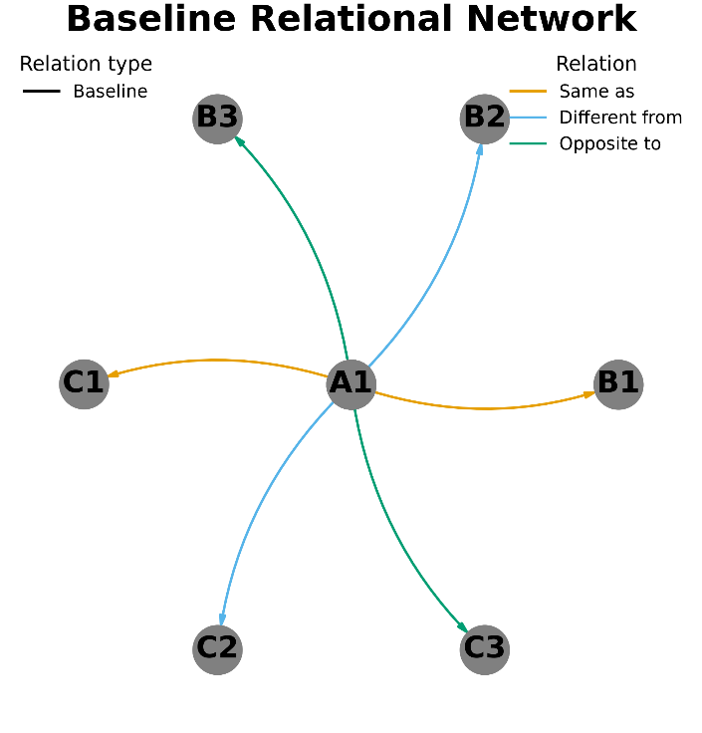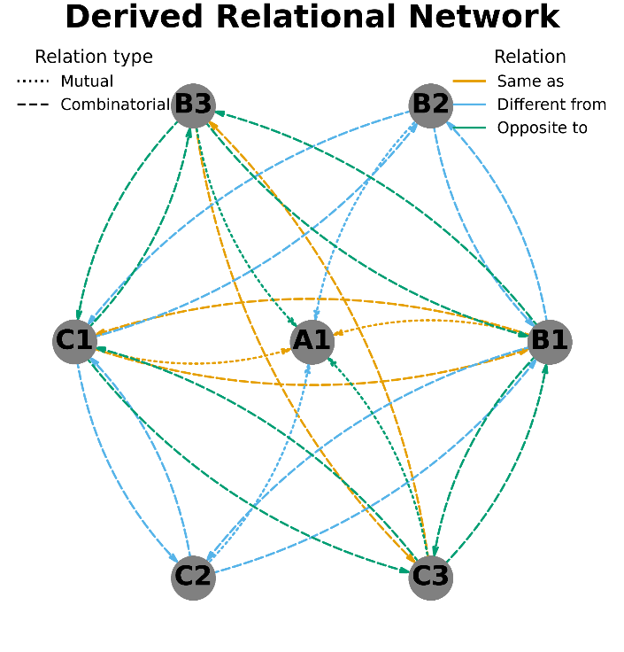
To generate a MTS procedure we turn to the MTS generator app. The app requires us to specify the baseline (trained) relations in exactly the same way as described above for the visualizer app. For the remaining settings, we set training trial repetitions to ten, test trial repetitions (for derived relations) to one and number of comparison stimuli to three. This should generate a trial set of sixty training trials (ten iterations of the six baseline relations) and twenty-six test trials (the number of novel relations that can be derived from the baseline relations). The app provides the following output: sixty baseline relations trials, six mutual entailment test trials, and twenty combinatorial entailment test trials. It also provides an overview of the generated trial data (with fields trial index, cue, sample stimulus, comparison stimulus, correct response, and labels), an example trial, and allows users to download the trial data as a csv-file. The csv output can then be used in experimental software like Psychopy, Labjs or JPsych to administer the procedure to participants.

Tutorial 2 – Syllogistic Reasoning Task
To illustrate the syllogistic reasoning problem generator, imagine a researcher who wants to create what is often referred to as an n-term (relational) reasoning task in cognitive and neuropsychology (e.g., Goel & Dolan, 2001). Such tasks typically involve syllogistic reasoning problems wherein the premises present relations between n relata or terms. Let’s say we are interested in studying the effect of relational complexity on social relational reasoning performance by increasing the number of terms (premises) in syllogistic reasoning problems. To create a set of syllogistic reasoning problems, we use the syllogistic reasoning problem generator app. First, we specify the relations we want to be involved in the problems by selecting ‘faster than’, ‘slower than’, ‘taller than’, and ‘smaller than’ from the drop down menu. Then, we leave the checkbox for one-premise problems empty but check the boxes for two-, three-, and four-premise problems. For each level of complexity, we get to select the problem variants we want to include, and we select ‘incorrect’ (to balance yes vs. no correct responses) and ‘mutualCE’ (to test transitive relations in both directions). We set the number of repetitions for each unique problem to four, the stimulus type to ‘names’ and number of response options to three to generate multiple choice problems. Finally, we do not include ill-defined problems and check the box to randomize premise order. When we generate the task, the app presents the following output:
The csv output can then be used in experimental software to administer the procedure to participants.

Discussion
This manuscript describes what we refer to as derivation tables that support a python module and algorithm for automated relational derivation. This algorithm, in turn, provides the foundation for a set of tools that are intended to facilitate research on relational reasoning. Specifically, we described functions to visualize relational networks as graph networks, generate MTS procedures and generate syllogistic reasoning problems, all contained in the python module. We also described online applications implementing the three tools in a more intuitive, code-free way, ready for researchers to use. The tutorials we provided illustrate their ease of use and utility.
While the derivation tables are limited to a set of (currently) about thirty relations, they do provide a survey of the most commonly studied relations in psychological research and go beyond currently available similar tools (e.g., Smith & Hayes, 2022; Carvalho et al., 2024). The open-source nature of the tools invites researchers to add more relations themselves or study the generality of the underlying derivation algorithm (i.e., what other relations fit the same patterns of derivation currently accounted for in the algorithm). In that sense, we provide the building blocks for researchers to continue this work. We only described three tools derived from the derivation tables and the relational derivation algorithm. While we believe that graph visualization, MTS procedures and syllogistics reasoning problems could be of use to a broad audience of relational reasoning researchers, we could have developed many other tools as well. Again, we hope that the derivation tables and algorithm can provide researchers with the building blocks they need to build and share their own tools tailored to their specific research contexts.
Beyond practical benefits, work like this may also inspire theoretical or conceptual insights. In our description of the derivation tables, we noted that some relations have distinct patterns of relational derivation, but that many relations also have identical patterns (e.g., the relations more than – less than and larger than – smaller than). Studying these patterns in more detail might offer insights into how humans acquire the ability for relational reasoning, and how it becomes so flexible. Researchers may also find that the patterns contradict certain theoretical predictions. For instance, in relational frame theory (Hayes et al., 2001), the ability to respond to different kinds of relations is described as separate so-called relational frames (i.e., coordination, distinction, opposition, comparison, hierarchy, temporal, and so on). Closer inspection of the patterns of derivation illustrated in Figure 1, however, reveals that some of these relations are very similar (i.e., the relational aspect is the same, but the psychological function that is related differs) and might rather be conceived of as different instances of the same relational frame. A lengthy discussion is beyond the scope of this manuscript, but the point illustrates that this work can also inspire conceptual developments.

Declarations

Funding
This research was supported by Flemish Research Fund fundamental research grant 11M0325N to the first author. The second author is supported Flemish Research Fund grant 12A2B26N. The third author was supported by grant BOF22/MET_V/002 - 01M00209 of Ghent University’s.

Conflicts of interest/Competing interests
None to declare.
Ethics approval and consent to participate
Not applicable. This manuscript does not report on any research involving participants.
Consent for publication
All authors have read and agree with the publication of this version of the manuscript.

Availability of data, materials and code
There is no data associated with this manuscript. All materials and code are openly accessible on the Open Science Framework: https://osf.io/bjxqg/overview?view_only=5ab9e17676a3436d9d7878d0b7e1340e
Authors' contributions
MR: Conceptualization, Funding Acquisition, Methodology, Project Administration, Resources, Software, Supervision, Visualization, Writing – Original Draft, Writing – Review and Editing; MF: Funding Acquisition, Supervision, Writing – Review and Editing; JDH: Funding Acquisition, Supervision, Writing – Review and Editing

References
Smith, P., & Hayes, S. (2022). An Open-Source Relational Network Derivation Script in R for Modeling and Visualizing Complex Behavior for Scientists and Practitioners. Frontiers in Psychology, 13. Article 914485. doi: 10.3389/fpsyg.2022.914485

https://osf.io/bjxqg/overview?view_only=5ab9e17676a3436d9d7878d0b7e1340e
The software is available on the OSF (https://osf.io/bjxqg/overview?view_only=5ab9e17676a3436d9d7878d0b7e1340e) as a Python module.
Available at https://relationalnetworkvisualizer.streamlit.app/
Available at https://mtsgenerator.streamlit.app/
https://relationalsyllogismgenerator.streamlit.app/

