Open-Source Tools for Relational Network Derivation, Visualization and Task Generation
Matthias Raemaekers, Martin Finn and Jan De Houwer
Department of Experimental-Clinical and Health Psychology, Ghent University, Belgium.

Author note. Author can be reached at {matthias.raemaekers@ugent.be}, or Henri Dunantlaan 2, 9000, Ghent, Belgium. The work presented here was supported by fundamental research grant (11M0325N) of the Flemish Research Foundation to MR. Preregistration documents, data and materials are available at open science framework repositories linked in the manuscript.

Abstract
Researchers across various fields of study in behavioral psychology, cognitive neuroscience, biology and computer science agree that relational abilities are a cornerstone of human cognition and intelligence. As a result, many different procedures have been developed to probe relational abilities, and relational tasks are often part of broader intelligence tests. Human relational abilities are extremely generative, allowing individuals to flexibly adapt to novel environments, but this generativity also complicates research on complex relational cognition. Visualizing the network(s) of relations that govern(s) an individual’s behavior, or establishing such complex relational control in the lab is difficult and cumbersome. The current paper describes a set of open source resources that aim to facilitate relational reasoning research. We provide a set of so-called relational derivation tables that can be used to automate relational derivation in computer programs. We derived three tools from them that illustrate their use: automatically (1) visualize a relational network of baseline and derived relations, (2) generate matching-to-sample procedures with user-defined task parameters and (3) generate a set of syllogistic reasoning problems with user-specified task characteristics. We hope these tools can help researchers overcome some of the difficulties associated with studying relational abilities in human or artificial systems and as such facilitate research on more complex relational behavior that underpins complex human cognition.
Keywords. Relational Reasoning, Relational Networks, Syllogistic Reasoning, Relation Derivation, Open Source Software

Introduction
Researchers from different fields in psychological research have emphasized the importance of relational abilities as a cornerstone of human cognition (e.g., Hayes et al., 2001; Hummel & Holyoak, 2001; Penn et al., 2008; Halford et al., 2010; Gentner & Smith, 2013; Hughes & Barnes-Holmes, 2015; McLoughlin et al., 2020) and intelligence more generally (e.g., Cassidy et al., 2011; Colbert et al., 2018; May et al., 2022). Many procedures have been developped to probe or train relational abilities in nonhuman animals (e.g., Harlow, 1949; Premack, 1983; Penn et al., 2008), humans (e.g., Alexander et al., 2016; Colbert et al., 2020; Dixon et al., 2021) and artificial systems (Hummel & Holyoak, 2001; Eisape et al., 2024). Some have been proposed to be a proxy-measure of intelligence (e.g., Cassidy et al., 2011; Colbert et al., 2017; May et al., 2022), while others are part of many modern intelligence tests (i.e., tasks like matrix reasoning, verbal analogies, etc.; e.g., Raven & Raven, 2003; Kaufman, A. S., & Lichtenberger, E. O., 2006; Wechsler, 2008; Cassidy et al., 2011; Colbert et al., 2017). In the current paper we describe a set of tools that aim to facilitate future research on relational abilities in different systems (nonhuman animals, humans, artificial systems).
Human relational abilities are extremely generative, allowing individuals to flexibly adapt to novel environments. Humans only need to learn about a handful of relations to derive a myriad of new relations (Hayes et al., 2001; Hayes, 2012; Smith & Hayes, 2022; e.g., if one knows A is related to B and B is related to C, one can derive a relation between B and A, between C and A, between A and C, and between C and B). This generativity quickly results in complex relational networks and behavioral repertoires, which are often difficult to describe, let alone study in a controlled laboratory setting. However, if we want to explore the full extent of relational abilities and their implications for intelligence in humans or other systems, it is necessary to have highly specified task procedures (e.g., Cortes et al., 2021) as well as detailed analytic and descriptive models (Smith & Hayes, 2022).
Another area where relational abilities have become increasingly relevant is artificial intelligence (AI) research. AI researchers have also assessed relational abilities of artificial systems as a cornerstone of general intelligence (e.g., Hummel & Holyoak, 2001; Eisape et al., 2024; Ozeki et al., 2024; Ando et al., 2024; Wu & Deng, 2024). AI researchers also increasingly draw upon insights about human relational abilities from other research traditions in developing artificially intelligent systems (e.g., Ninness & Ninness, 2020; Edwards et al., 2022; Johansson, 2024) and explore the implementation of relational networks in neural network models (e.g., Santoro et al., 2017; Webb et al., 2024; Duran et al., 2026). However, the relational information they learn is often hidden in the black box-nature of their many hidden layers (Smith & Hayes, 2022), an important area of focus for future research to address.
This paper describes a set of open-source tools that aim to complement and facilitate research on relational abilities in different systems, be that nonhuman animals, humans or artificial systems. Inspired by the work of Allen (1983), who worked on the representation of temporal relations in computer systems, we constructed a set of so-called transitivity tables (also referred to as composition tables in logic). As the name suggests, these tables describe the transitivity of various combinations of relations (i.e., if A is before B and B is before C, A is before C; and if A is opposite to B and B is opposite to C, A and C are the same). Where Allen’s tables contained only temporal relations (e.g., before, after, meets, starts), the tables described here contain other relationships also (e.g., equivalence, difference, opposition, comparison, hierarchy, temporal, …). Furthermore, we also included a table representing the bidirectionality of relations (e.g., if A is more than B, B is less than A; therefore, the tables are hereafter referred to as relational derivation tables). These tables can be used for constructing algorithms capable of automated reasoning about relations, which can in turn be implemented in different applications. We describe three such applications here, using automated relational derivation (1) for visualizing relational networks; (2) creating syllogistic reasoning problems; and (3) creating matching-to-sample procedures. We first describe the tables in more detail, before illustrating their use in these applications.

Relational Derivation Tables
Inspired by Allen’s (1983) work on the representation of temporal relations in computer systems, we developed a set of relational derivation tables that can be used to automate reasoning about relations. Such tools for automated reasoning about relations are not readily available to researchers (Smith & Hayes, 2022), and where they are, they are often allow for only a limited number of relations. We expanded on Allen’s idea and created relational derivation tables that include both the reversals [(as)symmetry] and transitivity of relations, and include many other relations beyond temporal relations. While other relations can be included, we chose to limit ourselves to this set of relations currently, as we believe it already provides prototypical versions of the most studied relations in psychological research (e.g., Hayes et al., 2001; Penn et al., 2008; Colbert et al., 2020). Below, we describe the different tables in more detail, before providing a walkthrough of the scripts that can be used to produce them in Python. The tables and software tools are available as a python module on the Open Science Framework.
Mutual Entailment. The mutual entailment table is illustrated in Figure 1. It includes equivalence, difference and opposition, comparative relations (e.g., more than, less than), hierarchical relations (contains, is part of) and temporal relations. Equivalence relations are defined by symmetry (Sidman & Tailby, 1982; if A is equivalent to B, B is equivalent to A; any response to A in relation to B is functionally identical to response to B in relation to A). Some other relations, like difference and opposition are also symmetrical (e.g., if A is different from B, B is different from A, and if A is opposite to B, B is opposite to A). Most relations other than equivalence, however, are not symmetrical. Instead, they (often) form pairs of relations within which the mutually entailed response to one relation is the other relation (e.g., comparative relations like A is more than B and B is less than C). Other examples include the temporal relations ‘before’ and ‘after’ (as well as those described by Allen, 1983) and hierarchical relations (e.g., ‘contains’ and ‘is part of’). The tables illustrated only include a subset of all relations currently supported by the software to keep the illustrations legible. These relations can be thought of as general categories of which many other relations are specific exemplars (i.e., they follow the exact same derivation patterns; we elaborate on the implications of this observation in the Discussion section). An overview of all relations that are currently supported can be found in Appendix A1.
Combinatorial Entailment.
Describe combinatorial entailment tables superficially.
A second set of tables describes the transitive property of relations (also referred to as combinatorial entailment): two relations that share a common element afford the derivation of a novel relation between the non-shared elements (e.g., if A is related to B and B is related to C, then a relation between A and C can be derived). Importantly, the particular way in which two relations are combined determines what relation(s) can be derived. Two pairs of related stimuli can be combined in four ways:
- linear combination - A x B and B x C relation afford derivation of relation A x C
- one-to-many combination – A x B and A x C relation afford derivation of B x C relation
- many-to-one combination – A x B and C x B relation afford derivation of A x C relation
- reversed linear combination – B x A and C x B relation afford derivation of A x C relation
As illustrated in Figure 1, each of these results in a distinct pattern of relational derivations. Broadly speaking, the patterns of relational derivation are summarized by the following rules:
- Linear combination:
- If two identical relations are combined, the derived relation is also identical, except for combinations of two difference relations (no derivation possible) and combinations of two opposition relations (derive sameness relation)
- If either relation is ‘equivalence’, the derived relation is the same as the second relation in the combination
- All other combination of relations do not afford valid derivations
- Reversed linear combination:
    - Pattern for symmetrical relations (same, different, opposite) is identical to that for linear combination.
    - If two identical asymmetrical relations are combined

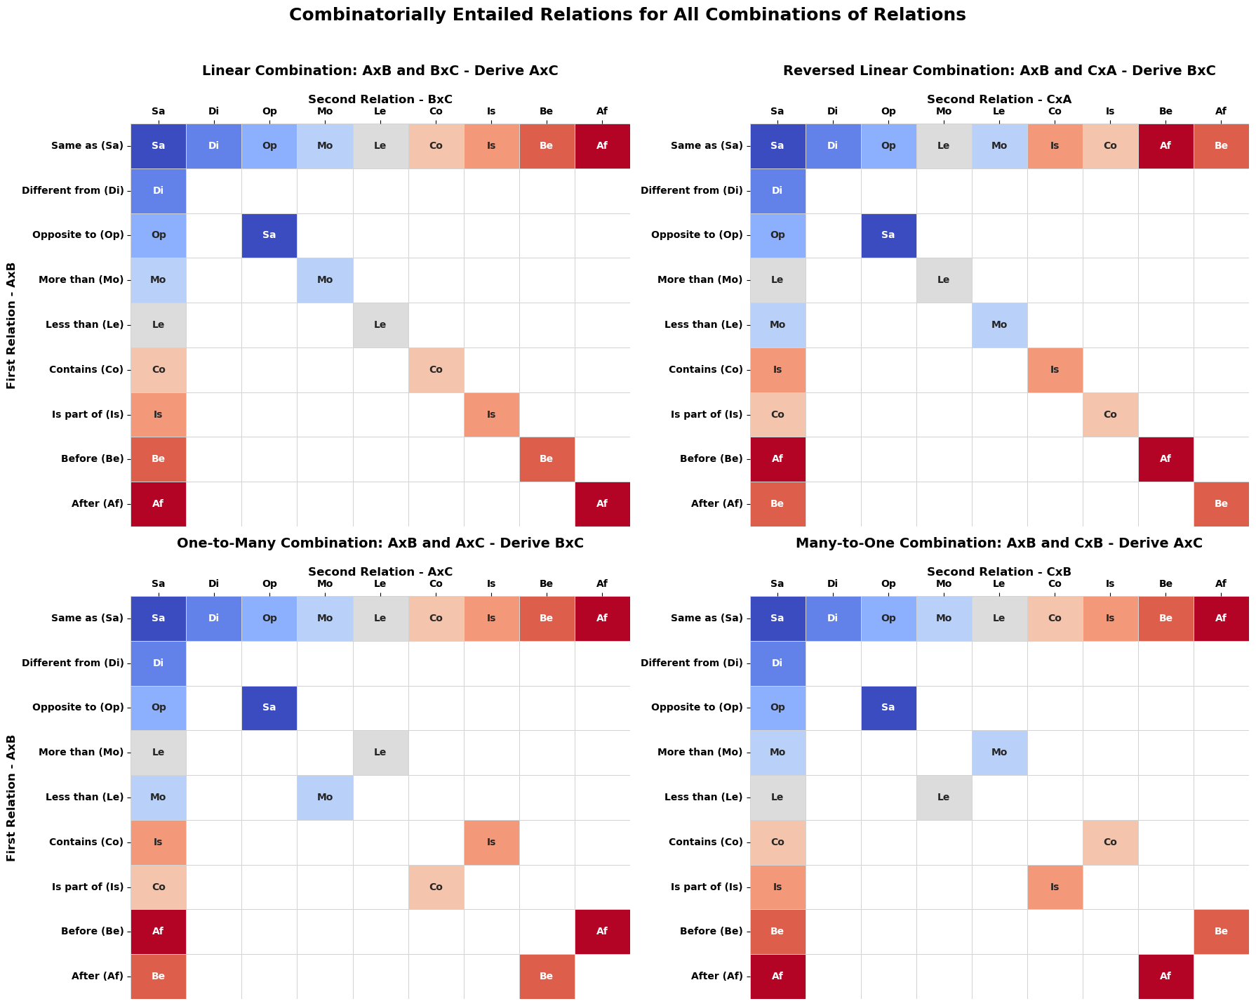

Linear combinations:
If one of the relations is equivalence, derived relation is the other relation
If two identical relations are combined, two special cases:
- Difference x difference -> ill-defined (always)
- Opposite x Opposite -> same
- Other relations combined allow derivation of the same relation.

** Insert cool Figure 1 here **

Step-by-step description of script for derivation.
The createDerivationTables.py Python function generates the relational derivation tables (in Python) for a given set of source relations. The function takes one optional input argument, which allows users to specify the relations for which they want to create the tables. This input argument (named relations) should be a Python dictionary in which the keys are the relation labels and the values are the indices those relations will take in the relational derivation tables (note that Python uses zero-based indexing, and therefore, the values in the list should also start from zero). As noted, this is an optional input argument: If no input is provided, the function will generate the tables for a default set of relations (i.e., same, different, opposite, more than, less than, contains, is part of, before and after). The function outputs two variables. The first, named mutual, is a 1-by-n array (where n is the number of relations in the input dictionary, or in the default) that contains the mutually entailed relation (i.e., reversal) for each relation in the input dictionary. For example, say we input a dictionary relations = {‘same’: 0, ‘more than’: 1, ‘less than’: 2}, the resulting array mutual = [0, 2, 1]. That is because the sameness relation is symmetrical, whereas the comparative relations are not. The second output is a dictionary that contains four arrays, one for each order in which two relations can be combined (i.e., linear: A-B and B-C; one-to-many: A-B and A-C; many-to-one: A-B and C-B; and reversed linear: B-C and A-B). For symmetrical relations, the resulting table will be identical in each order, but for asymmetrical relations, different combinations will lead to different derivations. For each order (dictionary key), the value is an n-by-n array (where n is again the number of input relations), in which the row- and column-indices correspond to those provided in the input, and each cell in the array contains the index of the relation that can be derived from that particular combination of relations (in a given order).
The second function for automated relational derivation is defined in the deriveRelationsFromBaseline.py script. The deriveRelationsFromBaseline function was developed to compute the relational entailments implied by a user-specified set of baseline relations. The function takes as input a dictionary of trained or otherwise specified baseline relations, where each key is a relation label and each value is a list of ordered stimulus pairs instantiating that relation. The function first standardizes the supplied relation labels and constructs the derivation tables for the relation set contained in the baseline network. The function loops through each baseline relation and each instance of that relation. For every baseline relation between two stimuli, the function first derives the corresponding mutually entailed relation by reversing the order of the stimulus pair and assigning the label of the mutually entailed relation (as per derivation tables). For instance, if the baseline network contains the relation ‘A more than B’, the function adds the derived relation ‘B less than A’. The function then evaluates possible combinatorial entailments by comparing each baseline relation instance with every other baseline relation instance. For each pair of baseline relations, it identifies whether the two relations share a common stimulus. If no common stimulus is present, no combinatorial relation can be derived from that pair. If a common stimulus is present, the function determines the structural protocol defined by the two relations (i.e., linear, reversed linear, one-to-many or many-to-one), which determines which relation can be derived (between which stimuli). If the combinatorial entailment derivation table specifies a valid derived relation, the function adds this relation to the derived-relation dictionary. It also adds the mutually entailed counterpart of that combinatorially entailed relation. Finally, the function supports optional illustration modes via the ‘illustration’ argument; when set to ‘print’, the function will print out the reasoning steps to become the derived relations; when set to heatmap, function will generate stimulus-by-stimulus heatmaps of the baseline and derived relations; when ‘graph’ is selected, the baseline and derived relations in the network are illustrated as a directed graph network (described in more detail below). The function returns both a matrix-form relation table and a dictionary of derived relations (same relation-label-to-stimulus-pair structure as the baseline input).

Tutorials
- Follow order of walkthrough notebook
- One or two examples of each functionality

Creating Custom Derivation Tables
- Describe function to create derivation tables
- Redundancy of relations here or above? Or both: reason for limiting tables to x relations for now; also helps explain flexibility of functino

Automated Relational Derivation
- Presets
- Custom, user-defined networks

Visualizing Relational Networks
A first hurdle that researchers encounter in the study of complex relational behavior is related to the combinatorial explosion that occurs when even a relatively small number of relations are combined. This generativity is a hallmark of human relational reasoning: from information about n relations, one can derive up to n² novel relations (Hayes et al., 2012). As experiments on relational behavior often involve large relational networks, it can be difficult to illustrate or map out the full extent of the relations that participants in such experiments ought to learn. Smith and Hayes (2022) recently published software that generates and visualizes relational networks involving equivalence and comparative relations as directed graphs. Here, we introduce a python function (plotRelNetworkGraph) and online tool developed to visualize relational networks as directed graphs, but which also supports many other relations beyond equivalence and comparison and offers users more flexibility.
The plotRelNetworkGraph function takes as its primary input a set of baseline relations as a python dictionary, in which relation labels serve as keys and each value is a tuple representing an ordered stimulus pair instantiating that relation. Stimuli are specified as numeric indices in this dict, which refer to a list of stimulus labels that users can choose, also supplied to the function. This allows users to display custom stimulus labels. Other optional arguments allow the user to specify derived relations (if user does not need all derived relations to be computed and plotted), which relations to visualize (only baseline, mutually entailed or combinatorially entailed, or all combined), and other plot settings (title, network layout, colors, label size and styles). In the simplest use-case, users provide a set of baseline relations and a list of stimulus labels. If no derived relations are specified, the function automatically finds (using the createDerivationTables and deriveRelationsFromBaseline functions) all relations that can be derived from the (user-specified) baseline network and stores these. Stimuli are then represented as nodes and each relations as a directed arrow between two nodes. Users can determine the coordinates of stimuli by specifying the layout of the network: the ‘circular’ layout provides a simple and interpretable arrangement for small networks; a force-directed ‘spring’ layout places nodes according to the overall graph topology; a ‘degree’-based layout places highly connected stimuli near the center; and a hierarchical layout is suited to ordered or chain-like relations. Finally, the function includes several user-adjustable visual parameters, such as arrow color and curvature, relation-specific colors, label offset, font size, and stimulus marker size.
We also created a Streamlit application to provide a user-friendly, interactive graphical interface for constructing, deriving and visualizing relational networks without requiring users to write Python code. The app interface presents some basic information and instructions centrally, and provides a sidebar where users can specify the relational network and plot settings. Users are first required to specify the number of stimuli that make up the network (with accompanying labels) and the relation types involved in the network (e.g., same, different, opposite to, more than, etc.). After selecting one or more relation types, users can specify how many stimulus pairs instantiate each relation and then select the source and target stimulus for each pair from dropdown menus with stimulus labels. Users have the option to apply this same logic can to manually define derived relations, allowing them to either rely on automatic derivation from the baseline network or to supply a custom derived network for visualization (e.g., if user wants to display only a subset of derived relations). Users can independently control which relations are displayed (i.e., baseline, mutually entailed, and combinatorially entailed relations separate or combined) and can choose among circular, spring, degree-based, hierarchical, and manual layouts. Finally, users can choose a title, select colors for baseline, mutually entailed, and combinatorially entailed relation arrows; adjust arrow curvature; modify the offset of relation labels; and set font and stimulus-marker sizes. Once the desired settings have been selected, users can click a button to generate the plot, which will be directly displayed in the app and provide users an option to download it as a png-file.

Matching-to-Sample Procedure Generator
The second tool we present in this manuscript allows users to generate matching-to-sample procedures. MTS procedures have long been used in behavior-analytic research to study stimulus equivalence (e.g., Sidman & Tailby, 1982; Sidman, 1994) and relational responding (e.g., Steele & Hayes, 1991; …), and is still used to study relational reasoning in mainstream cognitive psychology today (e.g., Premack, 1983; Shivaram et al., 2026).
Setting up such MTS procedures can be cumbersome, however. Researchers have to ensure that only one correct comparison stimulus is included on every trial and that participants cannot employ any .
- Dominant procedure in RFT/behavior-analytic literature
- Input parameters
- Examples – 3 member equivalence class with varying training protocol, steele & hayes?,

Generate a Syllogistic Reasoning task.
The final set of tools we introduce were developped to automatically construct relational syllogistic reasoning problems. Syllogistic reasoning has long been considered a hallmark of human intelligence (e.g. Aristotle) and syllogistic problems are still frequently used in behavior-analytic research (e.g., McHugh et al., 2004; Colbert et al., 2017), cognitive and neuroscience (Goel & Dolan, 2001; Goodwin & Johnson-Laird, 2005; Todd et al., 2019) as well as computer science (e.g., Hummel & Holyoak, 2001; Ando et al., 2023; Eisape et al., 2023; Ozeki et al., 2024). Therefore, we believe that researchers may find use in a tool that allows them to generate a virtually unlimited number of syllogistic reasoning problems with specified task characteristics. Again, we first describe the Python function and then the interactive Streamlit application.
The generateSyllogism function takes as its primary inputs a list of relations to be used in the syllogistic problems and a Python dictionary specifying the number premises (level of complexity) as keys and problem variants as values for each level. Users can vary problem difficulty from one to five premises and can specify the following problem variants: ‘incorrect’ (i.e., the prompted conclusion is invalid), ‘mutualCE’ (i.e., for problems with two or more premises, test the transitivity in both directions), ‘analogy’ (for two-premise problems only, prompt analogical comparison of the two premises), ‘ToF’ (add functions to premises and test transformation of function). Other required arguments for the function are the number of repetitions per problem type, the type of relata to use (i.e., nonwords, names or alphanumerics), and the relational training protocol. The function returns a trial-level data frame in which each row represents a generated reasoning problem. Because the function is also grounded in the derivation tables and algorithms described above, the first thing it does is compute derivation tables for the list of relations input by the user, which will be used to determine the conclusions for syllogistic problems.
Automatically and systematically vary parameters of task and generate virtually limitless trials.

Discussion
- Limitations: Limited to programmed relations or those that fit known patterns, until other patterns are discovered or generality of

- General patterns underlying multiple relations – possibility for scaling

Declarations
- Funding. This research was funded by Flemish Research Fund fundamental research grant … to MR. JDH is supported by …. MF is supported by Flemish Research Fund grant …
- Conflicts of interest/Competing interests. None.
- Ethics approval (include appropriate approvals or waivers). Not applicable.
- Consent to participate. Not applicable.
- Consent for publication. All authors have read and agree with the publication of this version of the manuscript.
- Availability of data and materials. Not applicable.
- Code availability. Software is available on the Open Science Framework (link).
- Authors' contributions (optional: please review the submission guidelines from the journal whether statements are mandatory
  - Also referred to as Open Practices Statement
  - All materials and code along with tutorials are made available at the OSF (link).

References
Smith, P., & Hayes, S. (2022). An Open-Source Relational Network Derivation Script in R for Modeling and Visualizing Complex Behavior for Scientists and Practitioners. Frontiers in Psychology, 13. Article 914485. doi: 10.3389/fpsyg.2022.914485

Link to OSF
https://relationalnetworkvisualizer.streamlit.app/

