- Je vais continuer à faire fonctionner le GPS, et essayer de l’intégrer et le faire fonctionner peut-être avec le LIDAR,
- Tp utiliser le GPS pour se dépacer en exterieur ? lidar permet de détecter objet et GPS à les coordonnées

- Pour activer le GPS sur le robot il faut aller dans teltonika et l’enable :
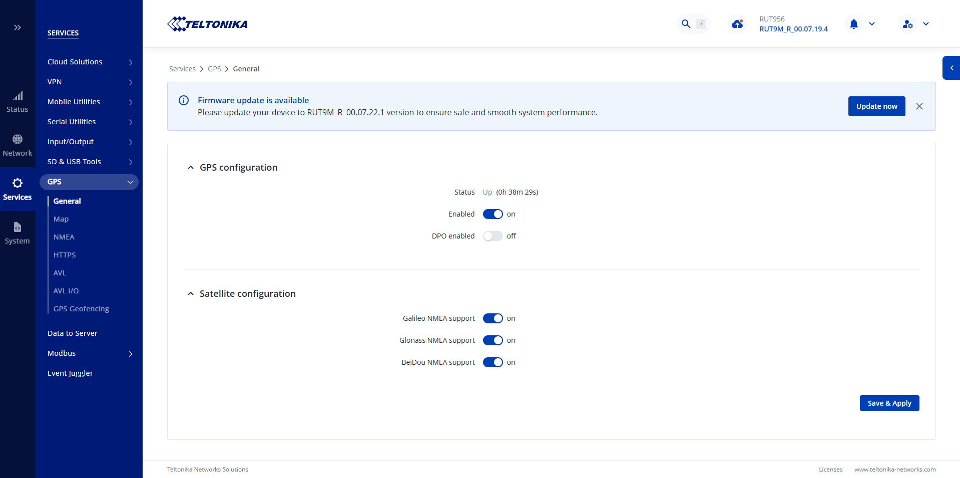

- Le GPS se calibre seul lorsqu’il est activé, cependant il marche uniquement en extérieur.
- Le temps je reprends l’entrainement de mon ia sur le dataset, je refinetunerai sur les panneaux adaptés quand j’aurai le bon dataset :

nohup python3 -c "
from ultralytics import YOLO

model = YOLO('/home/user/dataset_bdd100k/runs/bdd100k_yolo11n_v2/weights/last.pt')

model.train(
data='/home/user/dataset_bdd100k/bdd100k.yaml',
epochs=30,
imgsz=640,
batch=8,
device='CPU',
workers=4,
patience=10,
fraction=0.4,
resume=True,
project='/home/user/dataset_bdd100k/runs',
name='bdd100k_yolo11n_v2'
)" > ~/dataset_bdd100k/training_v2.log 2>&1 &

tail -f ~/dataset_bdd100k/training_v2.log

GPS :

- Le topic du GPS est /fix du package ros2-ublox-zedf9p

- Ros2 topic echo /fix :

- header:
- stamp:
- sec: 1777880169
- nanosec: 30292763
- frame_id: gps
- status:
- status: -1
- service: 1
- latitude: 0.0
- longitude: 0.0
- altitude: 0.0
- position_covariance:
- - 18446744065119.617
- - 0.0
- - 0.0
- - 0.0
- - 18446744065119.617
- - 0.0
- - 0.0
- - 0.0
- - 14064098445420.135
- position_covariance_type: 2

- Le GPS renvoie une position fiable (quelques m). Je vais essayer de faire un tp qui utilise l’IMU, le GPS et Nav2. Je donne une position au robot et il utilise les capteurs et le GPS pour y aller (les capteurs servent uniquement à détecter les obstacles, c’est le GPS qui aura la position)
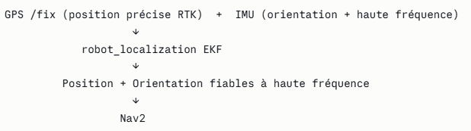

Voici l’architecture de l’algorithme. Le GPS à la position, l’IMU les orientations et roll,pitch et yaw.
Rtab ?

- L’odométrie de te dis de combien les roues ont tournées ! Si ca drift par exemple et que la position n’a pas changé le robot peut se perdre c’est pourquoi on la mets de paire avec l’IMU :
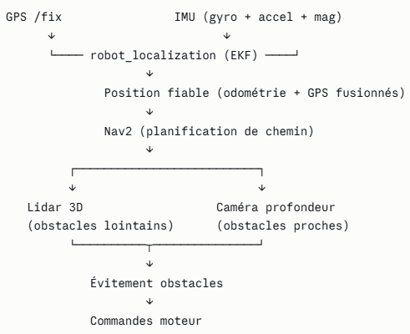

- Je vais créer un package pour utiliser le GPS de cette manière :
# Dans le conteneur
cd $ABSOLUTE_WORKSPACE/src

ros2 pkg create --build-type ament_python navigation_pkg \
--dependencies rclpy sensor_msgs nav_msgs geometry_msgs nav2_msgs action_msgs

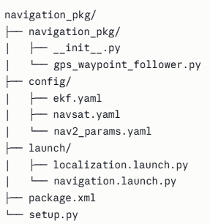

Il faut creer les dossiers config et launch

On créer ekf.yaml, Ce fichier configure la fusion GPS + IMU + odométrie :

ekf_filter_node:
ros__parameters:
frequency: 30.0
sensor_timeout: 0.1
two_d_mode: true
publish_tf: true
print_diagnostics: true

odom_frame: odom
base_link_frame: base_link
world_frame: odom

# Odométrie des roues
odom0: /odom
odom0_config: [true, true, false,
false, false, true,
false, false, false,
false, false, true,
false, false, false]
odom0_differential: false
odom0_relative: false

# IMU
imu0: /imu/data
imu0_config: [false, false, false,
false, false, false, # ← orientation désactivée
false, false, false,
true, true, true, # ← vitesses angulaires gardées
true, true, true] # ← accélérations gardées
imu0_differential: false
imu0_relative: true # ← ajoute cette ligne
imu0_remove_gravitational_acceleration: true
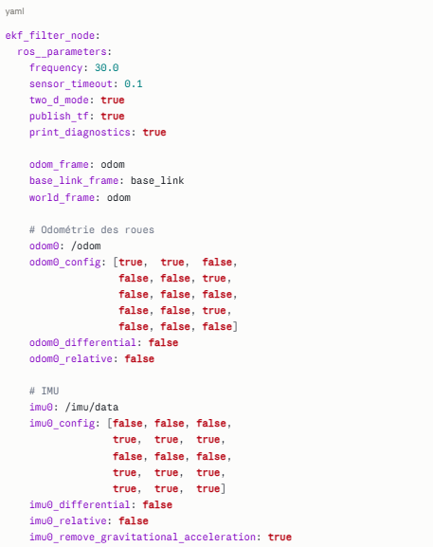

Mtn le navsat.yaml, Convertit les coordonnées GPS en coordonnées cartésiennes :

navsat_transform_node:
ros__parameters:
frequency: 30.0
delay: 3.0
magnetic_declination_radians: 0.0349 # ~2° pour la France
yaw_offset: 0.0
zero_altitude: true
broadcast_cartesian_transform: true
broadcast_utm_transform_as_parent_frame: false
publish_filtered_gps: true
use_odometry_yaw: false
wait_for_datum: false

Maintenant le nav2_params.yaml :

bt_navigator:
ros__parameters:
global_frame: odom
robot_base_frame: base_link
odom_topic: /odometry/filtered
bt_loop_duration: 10
default_server_timeout: 20
navigators: ['navigate_to_pose', 'navigate_through_poses']
navigate_to_pose:
plugin: "nav2_bt_navigator::NavigateToPoseNavigator"
navigate_through_poses:
plugin: "nav2_bt_navigator::NavigateThroughPosesNavigator"

controller_server:
ros__parameters:
controller_frequency: 5.0
min_x_velocity_threshold: 0.001
min_y_velocity_threshold: 0.5
min_theta_velocity_threshold: 0.001
failure_tolerance: 0.3
progress_checker_plugins: ["progress_checker"]
goal_checker_plugins: ["general_goal_checker"]
controller_plugins: ["FollowPath"]

progress_checker:
plugin: "nav2_controller::SimpleProgressChecker"
required_movement_radius: 0.5
movement_time_allowance: 10.0

general_goal_checker:
stateful: true
plugin: "nav2_controller::SimpleGoalChecker"
xy_goal_tolerance: 0.5
yaw_goal_tolerance: 0.25

FollowPath:
plugin: "nav2_regulated_pure_pursuit_controller::RegulatedPurePursuitController"
desired_linear_vel: 0.3
lookahead_dist: 1.0
min_lookahead_dist: 0.5
max_lookahead_dist: 2.0
lookahead_time: 1.5
rotate_to_heading_angular_vel: 0.5
transform_tolerance: 0.1
use_velocity_scaled_lookahead_dist: false
min_approach_linear_velocity: 0.05
approach_velocity_scaling_dist: 1.0
use_collision_detection: true
max_allowed_time_to_collision_up_to_lookahead: 1.0
use_regulated_linear_velocity_scaling: true
use_fixed_curvature_lookahead: false
curvature_lookahead_dist: 1.0
use_cost_regulated_linear_velocity_scaling: false
regulated_linear_scaling_min_radius: 0.9
regulated_linear_scaling_min_speed: 0.25
use_rotate_to_heading: true
allow_reversing: false
rotate_to_heading_min_angle: 0.785
max_angular_accel: 3.2
max_robot_pose_search_dist: 10.0

local_costmap:
local_costmap:
ros__parameters:
update_frequency: 5.0
publish_frequency: 2.0
global_frame: odom
robot_base_frame: base_link
rolling_window: true
width: 10
height: 10
resolution: 0.1
robot_radius: 0.5
plugins: ["obstacle_layer", "inflation_layer"]
obstacle_layer:
plugin: "nav2_costmap_2d::ObstacleLayer"
enabled: true
observation_sources: lidar
lidar:
topic: /rslidar_points
data_type: "PointCloud2"
marking: true
clearing: true
max_obstacle_height: 2.0
min_obstacle_height: 0.1
obstacle_max_range: 10.0
obstacle_min_range: 0.0
raytrace_max_range: 12.0
raytrace_min_range: 0.0
inflation_layer:
plugin: "nav2_costmap_2d::InflationLayer"
cost_scaling_factor: 3.0
inflation_radius: 1.0

global_costmap:
global_costmap:
ros__parameters:
update_frequency: 1.0
publish_frequency: 1.0
global_frame: odom
robot_base_frame: base_link
robot_radius: 0.5
resolution: 0.1
rolling_window: true # ← ajoute ça
width: 50 # ← 50m x 50m
height: 50 # ← au lieu de la taille par défaut
track_unknown_space: true
plugins: ["obstacle_layer", "inflation_layer"]
obstacle_layer:
plugin: "nav2_costmap_2d::ObstacleLayer"
enabled: true
observation_sources: lidar
lidar:
topic: /rslidar_points
data_type: "PointCloud2"
marking: true
clearing: true
inflation_layer:
plugin: "nav2_costmap_2d::InflationLayer"
cost_scaling_factor: 3.0
inflation_radius: 1.0

planner_server:
ros__parameters:
expected_planner_frequency: 1.0
planner_plugins: ["GridBased"]
GridBased:
plugin: "nav2_navfn_planner/NavfnPlanner"
tolerance: 0.5
use_astar: false
allow_unknown: true

smoother_server:
ros__parameters:
smoother_plugins: ["simple_smoother"]
simple_smoother:
plugin: "nav2_smoother::SimpleSmoother"
tolerance: 1.0e-10
max_its: 1000
do_refinement: true

behavior_server:
ros__parameters:
costmap_topic: local_costmap/costmap_raw
footprint_topic: local_costmap/published_footprint
cycle_frequency: 10.0
behavior_plugins: ["spin", "backup", "drive_on_heading", "wait"]
spin:
plugin: "nav2_behaviors/Spin"
backup:
plugin: "nav2_behaviors/BackUp"
drive_on_heading:
plugin: "nav2_behaviors/DriveOnHeading"
wait:
plugin: "nav2_behaviors/Wait"
global_frame: odom
robot_base_frame: base_link
transform_timeout: 0.1
use_sim_time: false
simulate_ahead_time: 2.0
max_rotational_vel: 0.5
min_rotational_vel: 0.2
rotational_acc_lim: 3.2

waypoint_follower:
ros__parameters:
loop_rate: 20
stop_on_failure: false
waypoint_task_executor_plugin: "wait_at_waypoint"
wait_at_waypoint:
plugin: "nav2_waypoint_follower::WaitAtWaypoint"
enabled: true
waypoint_pause_duration: 0

velocity_smoother:
ros__parameters:
smoothing_frequency: 20.0
scale_velocities: false
feedback: "OPEN_LOOP"
max_velocity: [0.3, 0.0, 0.5]
min_velocity: [-0.3, 0.0, -0.5]
max_accel: [2.5, 0.0, 3.2]
max_decel: [-2.5, 0.0, -3.2]
odom_topic: /odometry/filtered
odom_duration: 0.1
deadband_velocity: [0.0, 0.0, 0.0]
velocity_timeout: 1.0

map_server:
ros__parameters:
yaml_filename: ""

map_saver:
ros__parameters:
save_map_timeout: 5.0
free_thresh_default: 0.25
occupied_thresh_default: 0.65
Le localization.launch.py (qui lancera la localization) :

import os
from launch import LaunchDescription
from launch_ros.actions import Node
from ament_index_python.packages import get_package_share_directory

def generate_launch_description():
pkg = get_package_share_directory('navigation_pkg')

ekf_node = Node(
package='robot_localization',
executable='ekf_node',
name='ekf_filter_node',
output='screen',
parameters=[os.path.join(pkg, 'config', 'ekf.yaml')],
remappings=[('odometry/filtered', 'odometry/filtered')]
)

navsat_node = Node(
package='robot_localization',
executable='navsat_transform_node',
name='navsat_transform_node',
output='screen',
parameters=[os.path.join(pkg, 'config', 'navsat.yaml')],
remappings=[
('imu/data', '/imu/data'),
('gps/fix', '/fix'),
('odometry/filtered', '/odometry/filtered'),
]
)

return LaunchDescription([
ekf_node,
navsat_node,
])

Le deuxième fichier de lancement, navigation.launch.py :

import os
from launch import LaunchDescription
from launch.actions import IncludeLaunchDescription
from launch.launch_description_sources import PythonLaunchDescriptionSource
from ament_index_python.packages import get_package_share_directory

def generate_launch_description():
pkg_nav2 = get_package_share_directory('nav2_bringup')
pkg = get_package_share_directory('navigation_pkg')

nav2_launch = IncludeLaunchDescription(
PythonLaunchDescriptionSource(
os.path.join(pkg_nav2, 'launch', 'navigation_launch.py')
),
launch_arguments={
'params_file': os.path.join(pkg, 'config', 'nav2_params.yaml'),
'use_sim_time': 'false',
}.items()
)

return LaunchDescription([nav2_launch])le code qui va permettre au robot d’aller au point demandé, dans ce code on mets les waypoints auxquels ont veut que le robot aille :
import rclpy
from rclpy.node import Node
from rclpy.action import ActionClient
from nav2_msgs.action import FollowWaypoints
from geometry_msgs.msg import PoseStamped
from robot_localization.srv import FromLL
import math

class GPSWaypointFollower(Node):
def __init__(self):
super().__init__('gps_waypoint_follower')

# Client pour convertir GPS → coordonnées cartésiennes
self.ll_to_map = self.create_client(FromLL, '/fromLL')

# Client action Nav2
self.waypoint_client = ActionClient(
self, FollowWaypoints, 'follow_waypoints')

self.get_logger().info('GPSWaypointFollower prêt')

def lat_lon_to_pose(self, lat, lon, alt=0.0):
"""Convertit latitude/longitude en PoseStamped dans le repère map"""
while not self.ll_to_map.wait_for_service(timeout_sec=1.0):
self.get_logger().info('Attente service fromLL...')

from geographic_msgs.msg import GeoPoint
req = FromLL.Request()
req.ll_point = GeoPoint()
req.ll_point.latitude = lat
req.ll_point.longitude = lon
req.ll_point.altitude = alt

future = self.ll_to_map.call_async(req)
rclpy.spin_until_future_complete(self, future)

pose = PoseStamped()
pose.header.frame_id = 'map'
pose.header.stamp = self.get_clock().now().to_msg()
pose.pose.position.x = future.result().map_point.x
pose.pose.position.y = future.result().map_point.y
pose.pose.position.z = 0.0
pose.pose.orientation.w = 1.0

return pose

def follow_gps_waypoints(self, waypoints_gps):
"""
Envoie une liste de waypoints GPS au robot.
waypoints_gps : liste de tuples (latitude, longitude)
Exemple : [(48.8566, 2.3522), (48.8570, 2.3530)]
"""
self.get_logger().info(f'Conversion de {len(waypoints_gps)} waypoints GPS...')

poses = []
for lat, lon in waypoints_gps:
pose = self.lat_lon_to_pose(lat, lon)
poses.append(pose)
self.get_logger().info(f'Waypoint converti : lat={lat} lon={lon} '
f'→ x={pose.pose.position.x:.2f} '
f'y={pose.pose.position.y:.2f}')

self.get_logger().info('Envoi des waypoints à Nav2...')

while not self.waypoint_client.wait_for_server(timeout_sec=1.0):
self.get_logger().info('Attente Nav2...')

goal = FollowWaypoints.Goal()
goal.poses = poses

future = self.waypoint_client.send_goal_async(goal)
rclpy.spin_until_future_complete(self, future)

goal_handle = future.result()
if not goal_handle.accepted:
self.get_logger().error('Waypoints refusés par Nav2')
return

self.get_logger().info('Navigation démarrée !')

result_future = goal_handle.get_result_async()
rclpy.spin_until_future_complete(self, result_future)

self.get_logger().info('Navigation terminée !')

def main(args=None):
rclpy.init(args=args)
node = GPSWaypointFollower()

# ─── MODIFIE CES COORDONNÉES GPS ───────────────────────────────
# Mets ici les coordonnées GPS de tes waypoints
waypoints = [
(48.8566, 2.3522), # Waypoint 1
(48.8570, 2.3530), # Waypoint 2
(48.8575, 2.3515), # Waypoint 3
]
# ────────────────────────────────────────────────────────────────

node.follow_gps_waypoints(waypoints)
node.destroy_node()
rclpy.shutdown()

if __name__ == '__main__':
main()

Maintenant le setup.py :
from setuptools import setup
import os
from glob import glob

package_name = 'navigation_pkg'

setup(
name=package_name,
version='0.0.1',
packages=[package_name],
data_files=[
('share/ament_index/resource_index/packages',
['resource/' + package_name]),
('share/' + package_name, ['package.xml']),
(os.path.join('share', package_name, 'config'),
glob('config/*.yaml')),
(os.path.join('share', package_name, 'launch'),
glob('launch/*.py')),
],
install_requires=['setuptools'],
zip_safe=True,
entry_points={
'console_scripts': [
'gps_waypoint_follower = navigation_pkg.gps_waypoint_follower:main',
],
},
)

Et finalement de package.xml :
<?xml version="1.0"?>
<package format="3">
<name>navigation_pkg</name>
<version>0.0.1</version>
<description>GPS navigation package</description>
<maintainer email="user@robot.com">user</maintainer>
<license>MIT</license>

<depend>rclpy</depend>
<depend>sensor_msgs</depend>
<depend>nav_msgs</depend>
<depend>geometry_msgs</depend>
<depend>nav2_msgs</depend>
<depend>robot_localization</depend>
<depend>geographic_msgs</depend>

<export>
<build_type>ament_python</build_type>
</export>
</package>

Pour le fonctionnement du GPS il y a différent statuts quand on fait un topic echo :
Statut -1 : le robot ne capte pas et le gps n’est pas fonctionnel
Statut 0 c’est localisation basique à quelques metres pres
Statut 2 c’est que le gps est en mode rtk et donc qu’il se localise parfaitement a qlq cm pres

Javais un probleme d’orientation dans le ekf donc j’utlise que le gyro et l’acc et plus l’imu

A partir de la j’ai un gps qui se repere à quelques metres prêt et un robot qui arrive à peu prêt à s’orienter, mais c’est vraiment trop peu précis. J’ai 5 décimales de la positions qui sont stables (qlq metres) et j’aimerai avoir qlq cm de précision donc il faut que j’utilise de rtk du gps.
J’ai installer rtklib qui fait les correction ntrip :
# Installe RTKLIB
sudo apt-get update && sudo apt-get install -y rtklib
PARLER LE RTK, CORRECTION ET DE CETTE LIB
Je créer un nœud ntrip_client.py :
import rclpy
from rclpy.node import Node
from rtcm_msgs.msg import Message as RtcmMessage
import socket
import base64
import threading

class NtripClient(Node):
def __init__(self):
super().__init__('ntrip_client')

# Paramètres Centipède
self.declare_parameter('host', 'caster.centipede.fr')
self.declare_parameter('port', 2101)
self.declare_parameter('mountpoint', 'RTCM3')
self.declare_parameter('username', 'centipede')
self.declare_parameter('password', 'centipede')

self.host = self.get_parameter('host').value
self.port = self.get_parameter('port').value
self.mountpoint = self.get_parameter('mountpoint').value
self.username = self.get_parameter('username').value
self.password = self.get_parameter('password').value

# Publisher corrections RTCM vers le récepteur GPS
self.pub_rtcm = self.create_publisher(
RtcmMessage, '/rtcm', 10)

self.connected = False
self.socket = None

# Lance la connexion dans un thread séparé
self.thread = threading.Thread(target=self.connect_and_stream)
self.thread.daemon = True
self.thread.start()

self.get_logger().info(
f'NTRIP client démarré → {self.host}:{self.port}/{self.mountpoint}')

def connect_and_stream(self):
while rclpy.ok():
try:
self.get_logger().info('Connexion au caster Centipède...')
self.socket = socket.socket(socket.AF_INET, socket.SOCK_STREAM)
self.socket.settimeout(10.0)
self.socket.connect((self.host, self.port))

# Requête HTTP NTRIP
credentials = base64.b64encode(
f'{self.username}:{self.password}'.encode()).decode()
request = (
f'GET /{self.mountpoint} HTTP/1.0\r\n'
f'Host: {self.host}\r\n'
f'Ntrip-Version: Ntrip/2.0\r\n'
f'User-Agent: NTRIP ROS2Client/1.0\r\n'
f'Authorization: Basic {credentials}\r\n'
f'\r\n'
)
self.socket.sendall(request.encode())

# Vérifie la réponse
response = self.socket.recv(1024).decode('latin-1')
if 'ICY 200 OK' in response or '200 OK' in response:
self.get_logger().info('Connecté à Centipède ✅')
self.connected = True
self.stream_rtcm()
else:
self.get_logger().error(f'Connexion refusée : {response[:100]}')

except Exception as e:
self.get_logger().error(f'Erreur NTRIP : {e}')
self.connected = False

# Attends 5 secondes avant de réessayer
import time
time.sleep(5.0)

def stream_rtcm(self):
"""Lit les corrections RTCM et les publie sur /rtcm"""
buffer = b''
while rclpy.ok() and self.connected:
try:
data = self.socket.recv(4096)
if not data:
self.get_logger().warn('Connexion NTRIP perdue')
self.connected = False
break

buffer += data

# Parse les messages RTCM3 (commencent par 0xD3)
while len(buffer) >= 3:
if buffer[0] != 0xD3:
buffer = buffer[1:]
continue

# Longueur du message RTCM
msg_len = ((buffer[1] & 0x03) << 8) | buffer[2]
total_len = msg_len + 6 # header + data + CRC

if len(buffer) < total_len:
break # attend plus de données

rtcm_data = buffer[:total_len]
buffer = buffer[total_len:]

# Publie le message RTCM
msg = RtcmMessage()
msg.header.stamp = self.get_clock().now().to_msg()
msg.header.frame_id = 'gps'
msg.message = list(rtcm_data)
self.pub_rtcm.publish(msg)

except Exception as e:
self.get_logger().error(f'Erreur stream RTCM : {e}')
self.connected = False
break

def main(args=None):
rclpy.init(args=args)
node = NtripClient()
rclpy.spin(node)
node.destroy_node()
rclpy.shutdown()

if __name__ == '__main__':
main()

'ntrip_client = navigation_pkg.ntrip_client:main', # ← ajoute ça dans le setup.py

Changer le localization.launch.py du coup :
import os
from launch import LaunchDescription
from launch_ros.actions import Node
from ament_index_python.packages import get_package_share_directory

def generate_launch_description():
pkg = get_package_share_directory('navigation_pkg')

ekf_node = Node(
package='robot_localization',
executable='ekf_node',
name='ekf_filter_node',
output='screen',
parameters=[os.path.join(pkg, 'config', 'ekf.yaml')],
remappings=[('odometry/filtered', 'odometry/filtered')]
)

navsat_node = Node(
package='robot_localization',
executable='navsat_transform_node',
name='navsat_transform_node',
output='screen',
parameters=[os.path.join(pkg, 'config', 'navsat.yaml')],
remappings=[
('imu/data', '/imu/data'),
('gps/fix', '/fix'),
('odometry/filtered', '/odometry/filtered'),
]
)

ntrip_node = Node(
package='navigation_pkg',
executable='ntrip_client',
name='ntrip_client',
output='screen',
parameters=[{
'host': 'caster.centipede.fr',
'port': 2101,
'mountpoint': 'RTCM3', # ← change par ta station la plus proche
'username': 'centipede',
'password': 'centipede',
}]
)

return LaunchDescription([
ekf_node,
navsat_node,
ntrip_node,
])

J’avais des problèmes dans le .yaml, de plus le robot était considére comme base fixe et non base mobile donc j’ai change le zed_f9p.yaml (celui de ublox_gps) :
ublox_gps_node:
ros__parameters:
debug: 0
device: /dev/ttyACM0
frame_id: gps
uart1:
baudrate: 460800
tmode3: 0
rtcm:
ids: [0, 1, 2, 3, 4, 5]
rates: [1, 1, 1, 1, 1, 1]
publish:
all: false
rxm:
rtcm: true
nav:
all: true
relposned: true
posllh: true
posecef: true
inf:
all: true
config_on_startup: false # ← ne pas reconfigurer au démarrage

# Sur l'hôte
sudo ip link set can0 up type can bitrate 500000 sudo ip link set can0 txqueuelen 1000
permet de mettre CAN0 à l’état UP
EXPLIQUER CAN0

La correction rtk ne veut pas fonctionner j’ai essayer cette solution :
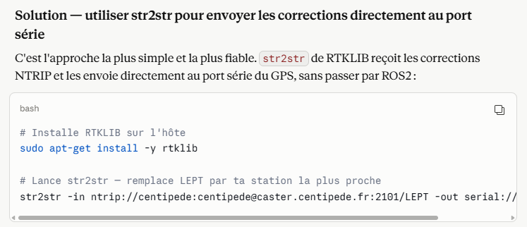
Mais ca ne marche toujours pas.
EXPLIQUER CENTIPEDE

Le rtk ne fonctionne vraiment pas
Je vais essayer de remettre comme c’était avant et remettre le rover en mode statique pour essayer. Le robot a de base un topic rtcm donc je vais l’étudier et voir s’il fonctionne de base.

