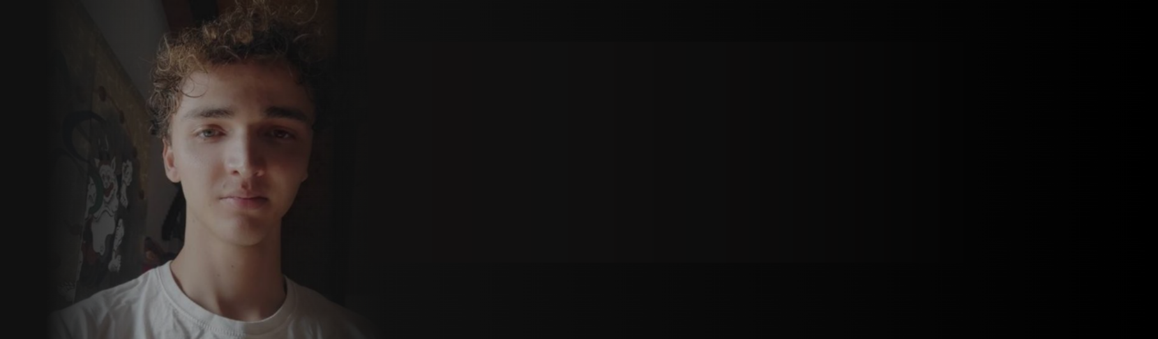

**MATTHIAS BRAT**

I follow change, autonomy, music and kindness.

**SION, VALAIS MATTHIAS.BRAT@GMAIL.COM**

**MATTHIASBRAT.DEV WWW.LINKEDIN.COM/IN/MATTHIAS-BRAT**

|  |  |
| --- | --- |
| **DevOps engineering program** **bruxelles formation** 2024-11 - 2025-05 | Agile, **Cloud,** Provisioning, CI/CD, Security Audits, Monitoring…  DevOps Engineer – Bruxelles Formation *https://www.bruxellesformation.brussels/catalogue-dorifor/devops-engineer-avec-certification-kubernetes/ |
| **Fullstack developer** **CANTONAL IT DEPARTMENT**  2024-08 - 2024-11 | Helping on the fishers and hunters web applications as well as **databases migrations**. |
| **INTEGRATOR INTERN** **CANTONAL IT DEPARTMENT OF VALAIS/WALLIS STATE,  SION, CH**  2022-11 - 2024-07 | Internship centered on learning and using deployment tools:   * **Gitlab CI/CD, ELK, Red Hat SSO, OC4, Quay** * **Angular (RxJS/NGXS), Svelte, PWA** * **Quarkus, Springboot, reactivity**   [Feeback](https://github.com/Matthiasbrat/certs/blob/main/feedback.pdf) |
| **SOFTWARE INTERN**  **COMPENSATION FUND OF VALAIS/WALLIS STATE,  SION, CH**  2022-11 - 2023-01 | Built an app that adds a QR-Code to existing bills using C# WPF.  Then migrating app in **PHP on a Tomcat server**. |
| **SOFTWARE INTERN**  **SPECIALIZED UNIVERSITY,  VALAIS/WALLIS, SIERRE, CH**  2022-03 - 2022-05 | Built an app tracing new renewable energies in Valais/Wallis, CH.  Using **Laravel 9**, Chart.js and making a python web scraper. |
| **STUDENT**  **CAMPUS EPTM, VALAIS/WALLIS, SION, CH**  2019-08 - 2024-06 | Followed ICTVS modules:  [Modulbaukasten](https://www.modulbaukasten.ch/?d=4f50e7f3-6b82-eb11-a812-0022486f6f83)  *https://www.modulbaukasten.ch/?d=4f50e7f3-6b82-eb11-a812-0022486f6f83  [**Final pdf**](https://raw.githubusercontent.com/Matthiasbrat/final/refs/heads/main/EN_Trimmed_Report_Brat_Matthias_v2.pdf) *https://raw.githubusercontent.com/Matthiasbrat/final/refs /heads/main/EN_Trimmed_Report_Brat_Matthias_v2.pdf |
| **IT INTERN**  **INSTITUTE OF RADIOLOGY OF SION**  2018-03 - 2018-04 | Discovering healthcare computer science and assistance. |



|  |  |
| --- | --- |
| **Maintainer**  **learn-fast**  Documentation | Documentation repository for people who want to get in-depth introductions to new technologies:  [**Matthiasbrat/learn-fast (github.com)**](https://github.com/Matthiasbrat/learn-fast)  *https://github.com/Matthiasbrat/learn-fast |
| **developer**  **dmsproxy**  Quarkus service | Migration of an API in java REST format from **Springboot to Quarkus** allowing to centralize invocations to the Valais/Wallis state's DMS OpenText system. |
| **developer**  **fidcom**  Angular migration | Fully rewrote an **AngularJS to Angular 17** application designed for Valais/Wallis state's fiduciaries, municipalities, and compensation funds. |
| **developer**  **csi-documentation**  Angular project | Wrote an Angular app to document the different reusable Angular components/libraries written by the cantonal IT department.  The documentation presented some challenging features that I independently chose to implement:   * Fully customizable article generator with: * Dynamic TS/HTML component loader based on components. * TS/HTML source code UI toggle. * Global efficient search bar. * Customizable UI behavior for compiled and uncompiled code. |



|  |  |
| --- | --- |
| **PROGRAMMING**: C#, C++ & .NET FRAMEWORK    3 years | **PROGRAMMING**: TS/JS  V8, reactive libraries and states |
| **PROGRAMMING**: PHP/LARAVEL  3 years | **Micro-services:** Springboot, Quarkus    3 years |
| **OPERATIONS**: ELK, CI/CD, OC4    2 years | **HARDWARE**: MICROCHIPS AND SERVERS  setting up servers and understanding protocols |
| **Auth**: IAM  2 years | **DATABASE**: MYSQL, POSTGRES, ACCESS    4 years |



|  |  |
| --- | --- |
| Documentation    Simple & Straightforward | communication    Explore -> Criticize -> Endorse |
| DUTCH    B2 | GERMAN    B2 |
| ENGLISH    C2 | FRENCH    native language |