**Earth Orbiter System**

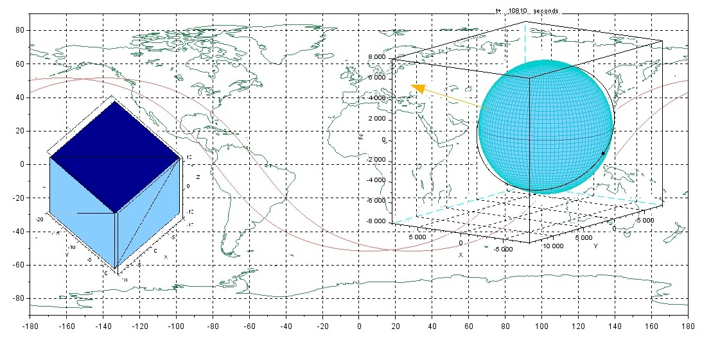

**User Manual**

**V. 0.4.0**

**Table of Contents**

|  |
| --- |
| Pg. # |
| //Introduction | 2 |
| //Installation | 3 |
| //Operation | 6 |
| //Simulation Output |  |
| //Error List |  |
| //References |  |

1. **Introduction**

This package offers the user a lightweight but comprehensive power system simulation. It allows the user to experiment with the placement of solar panels on a satellite, as well as with orbital parameters, spacecraft attitude, and other factors, to investigate the effect on power produced. Intended for educational use, this is also a demonstration of the simulation capabilities of the Scilab environment.

The user can load any STL model into the program, specify the solar panel geometry, and panel efficiency. The user will also set the attitude of the spacecraft, defining the axes for the QSW local orbital frame (see figure 1 below). The user can also choose to simulate missions around other master bodies (all other planetary bodies in our solar system, and the Moon).

QSW Frame:

* X axis – Unit vector from center of master to satellite, (zenith)
* Y axis – Unit vector in the same direction as the orbits angular momentum vector
* Z axis – Unit vector orthogonal to X and Y

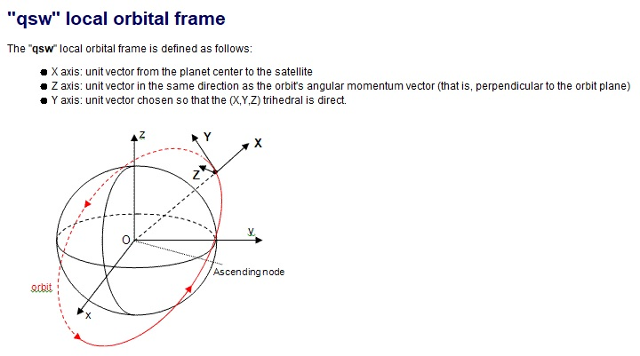

Figure 1: Graphic of QSW frame, as defined by Scilab[1]

Power

Power produced is given by equation 1 below. Note that the

$P=ηSAcos\left(θ\right)$

1. **Installation**

1: Install Scilab version 5.5.2

* Go to: <https://www.scilab.org/en/download/Previous-Scilab-Versions>
* scroll down the page towards the bottom, download version 5.5.2 (appropriate for your system)
* 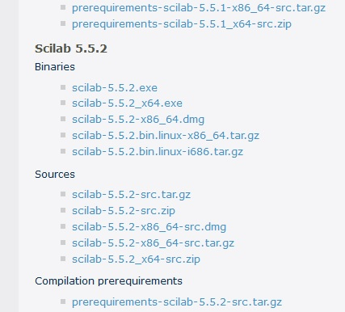Run the installer, follow steps to install Scilab

2: CelestLab toolbox

* Enter the following into Scilab Console: atomsInstall("celestlab")

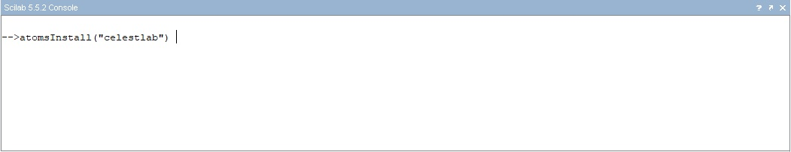

(Alternatively, download toolbox binary from: <https://atoms.scilab.org/toolboxes/celestlab> and install manually.)

3: STL toolbox

* Go to: <https://fileexchange.scilab.org/toolboxes/490000>
* Download “stlfiles.zip”, extract to Scilab work directory
* Using Scilab, run “builder.sce” script in the sources folder
* Run “loader.sce” script in the sources folder

4: EarthOrbiterSystem

* <https://github.com/Matthieu-71/PowerSubsystemSimulation>
* Unzip to Scilab work directory

1. **Operation**

Run “main.sce”

*Using an input file: this will remember the solar panel surfaces selected from a previous sim.* *(Useful for re-simulating complicated models)*

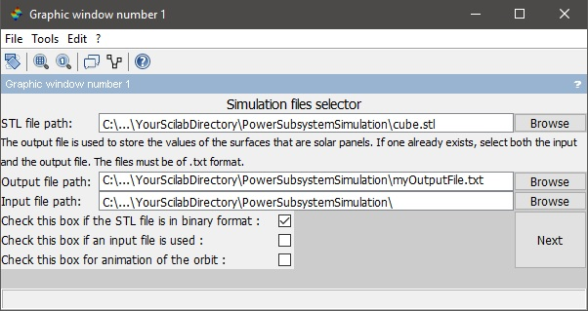

1: Select STL file

2: Select Output File (must be .txt extension

Optional: Select Input File (must be .txt extension)

4: Click “Next”

3. Check the binary box if applicable (cube.stl is a binary)

Optional: Animation of satellite orbit

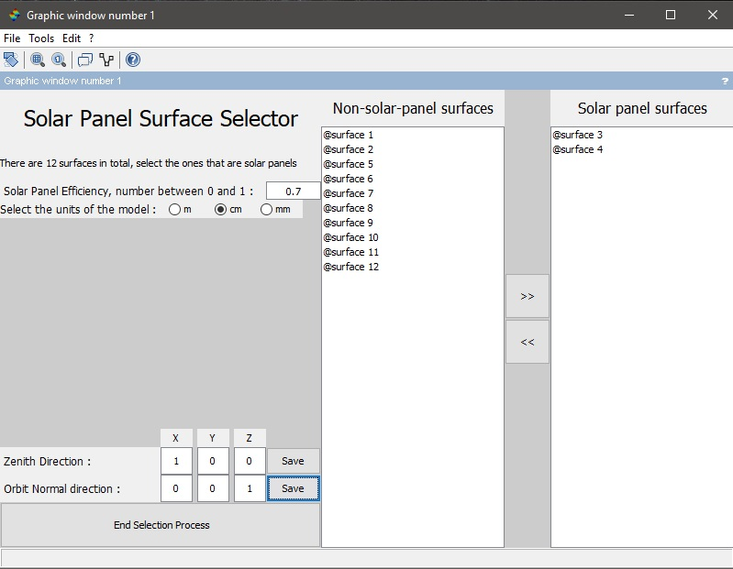

1: Input the Solar Panel efficiency, must be a number between 0 and 1

2: Select the dimensions of the stl model

4: Using the model axes for reference, input the zenith and orbit normal direction for the body frame.

3: Select desired surface and use the “>>” button to make them act as solar panels. Panel surfaces will appear as dark blue on the model.

5: Make sure you “save” these vectors before continuing.

6: Click “End Selection Process”

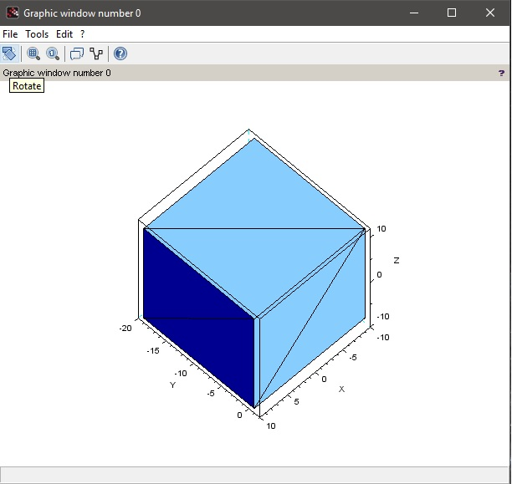

Model window displays the .stl file. Surfaces in dark blue indicate the user-designated solar panels.

Model can be rotated with right-click to view hidden surfaces.

3: Input desired Mission time and duration

1: Input desired Orbital Parameters

(default is set to ISS orbit)

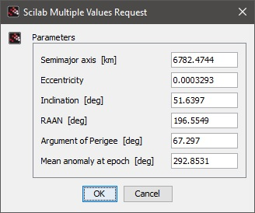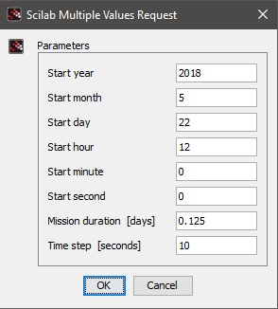

(Timestep is recommended to be between 10 and 30 seconds)

4: Click “OK”

2: Click “OK”

1. **Simulation Output**
2. Ground Track

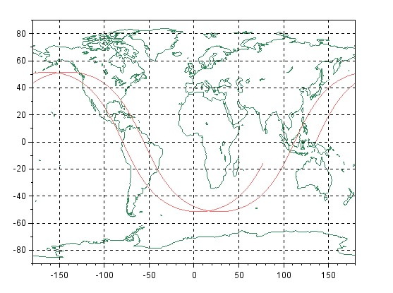

b) Solar Panel Power Produced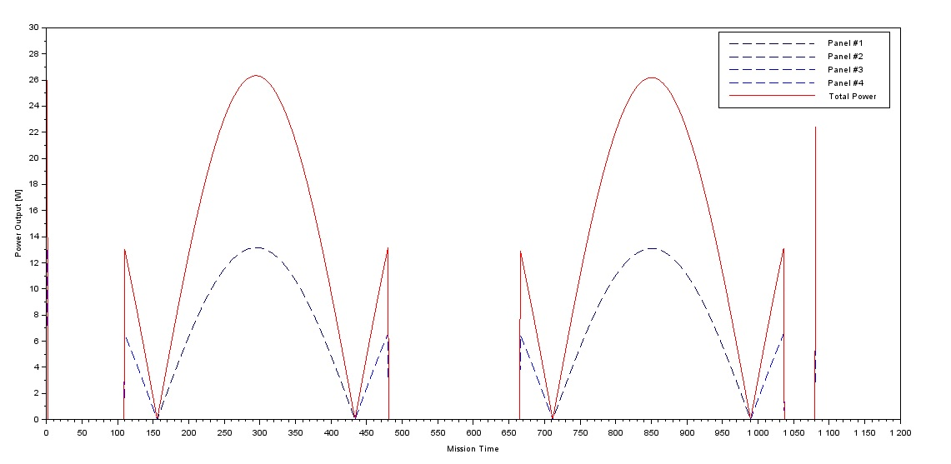

*The dashed blue lines indicate power produced at each time step by the solar panel faces. The panel numbers correspond to the order of selection in the surface-selector gui. Note that for faces with similar orientation, the plots may exactly overlap (e.g Panels 1-2 and 3-4 appear as only two plots in the above image).*

c) Orbit Animation (optional)

Mission Time

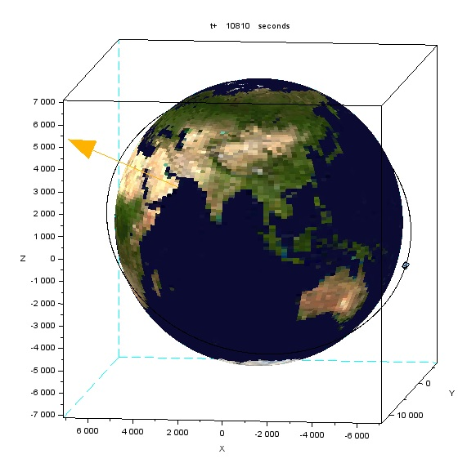

Earth-Sun Vector

Satellite model

Orbital Path

*This output is produced only if the user requests it in the primary GUI. A 3D animation of the satellite as it travels along its orbital path. The model accurately illustrates the satellite attitude. The large yellow vector shows the position of the Sun. Each frame represents one timestep in the simulation.*

1. **Error List**

n | Message | Reason

1 | Incorrect format selected! | Issue in the selection of the format of the STL file, in file selection GUI.

2 | File is not in an STL format! | The file selected as the model to be imported is not in an STL format, in file selection GUI.

3 | File is not in an txt format! | The input file selected is not in the required txt format, in file selection GUI.

4 | File is not in an txt format! | The output file selected is not in the required txt format, in file selection GUI.

5 | No units selected! | The user hasn't chosen units for the calculation of the area.

6 | Aligned vector is undefined | The user has not defined the radially outward direction

7 | Constraint vector is undefined! | The user has not defined the orbit normal direction

8 | No solar panels! | The user has not selected any solar panels

9 | Incorrect efficiency value! | The value for efficiency of the solar panels is greater than 1 or less than 0