Assignment 1

- This algorithm has been implemented using the code in “AUC.py: and “test.sh”. The AUC found was 0.792
- The performance appears to be maximal for r=3. For r=1 and r=9, performance is almost random. For r=1 this is due to the fact that single characters are used to match input and repertoire entries, so the only distinction between the languages would be the frequency of particular characters. For r=9 this poor performance is due to the T-cells being too specific in determining whether they fit the input, therefore only when almost the entire input matches a string in the repetoire, this is recorded as a match.
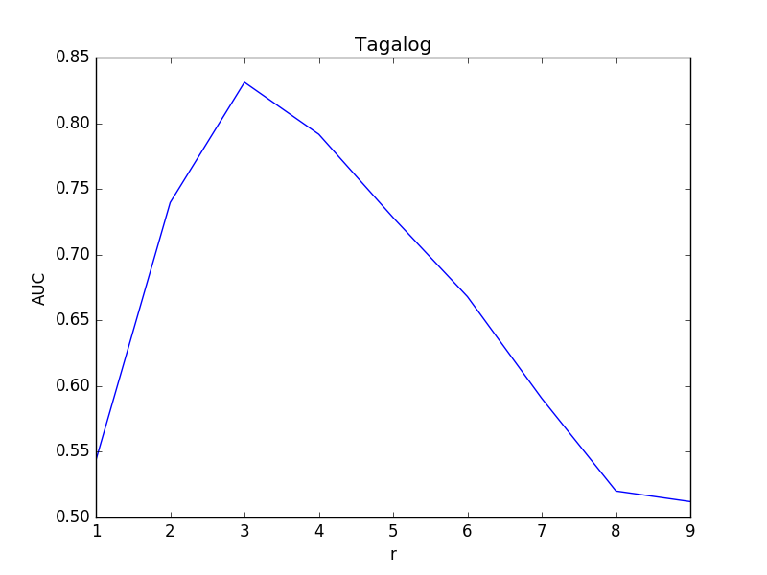

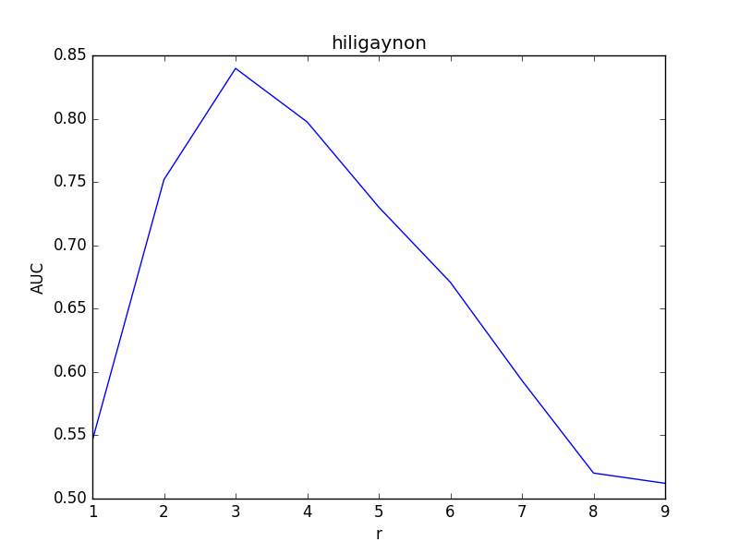 | 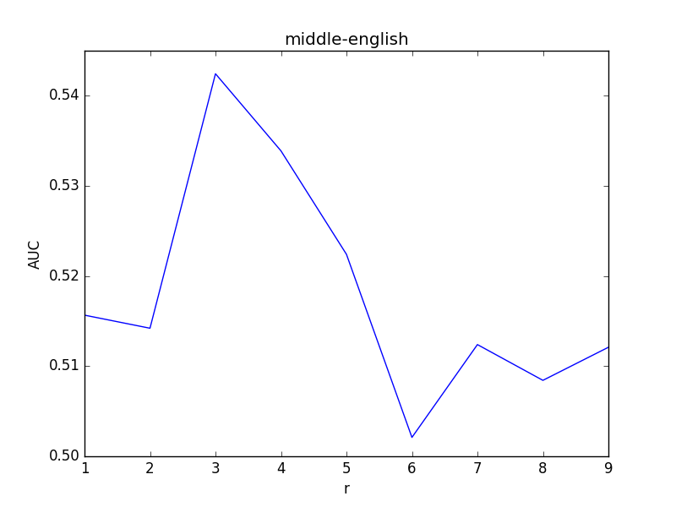
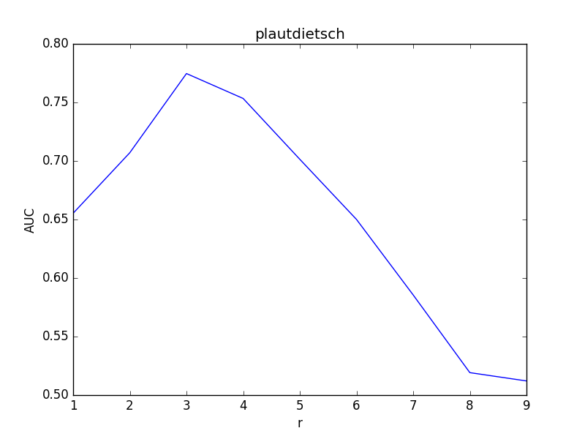 | 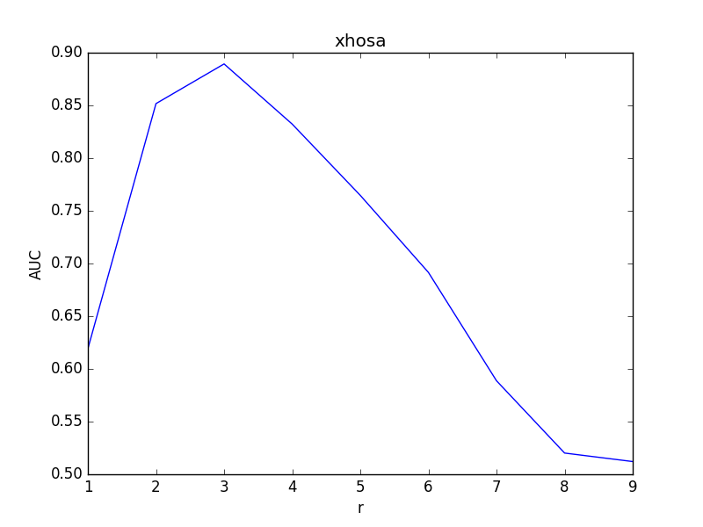
- The AUC scores have been computed for the four different languages in the lang folder for different values of r. For all languages, optimal performance occurs at r=3. Furthermore, Xhose can be best discriminated from English (r_max > 0.88) and Middle-English is most difficult to discriminate (r_max < 0.55). As expected, Middle-English is most similar in structure to modern English due to the fact that they are linguistically related. And apparently Xhosa is linguistically very dissimilar to modern English, containing very uncommon character combinations.

