Latchpoint
Game Design document
A puzzle platformer with combat elements

Table of Contents

Inhoud
1.Game Overview 3
1.1 Game Title 3
1.2 Genre 3
1.3 Platform 3
1.4 Summary 3
2. Game Mechanics 4
2.1 Core Gameplay 4
2.2 Player Mechanics 4
2.3 controls 4
2.4 Game Modes 4
2.5 Extra Mechanics 5
3. Story and Characters 5
3.1 story 5
3.2 characters 5
4. Game world 6
4.1 environment 6
4.2 regions 6
4.3 Levels 6
5. Art and style 7
5.1 visual style 7
5.2 Character design 7
5.3 UI/UX design 7
6. Sound And music 8
6.1 sound effects 8
6.2 music 8
7. secondary mechanics 9
7.1 Boss Mechanics 9
8. Production details 9
8.1 development team 9
8.2 development tools 9

1.Game Overview

1.1 Game Title
LatchPoint

1.2 Genre
Puzzle Platformer

1.3 Platform
Pc

1.4 Summary
A Game with Loading Screen separated levels
In LatchPoint you as the player have been send on a mission to destroy the ai chip from a underground stronghold while solving tasks and navigating the levels

2. Game Mechanics

2.1 Core Gameplay
you start of as a latchpoint operative in the stronghold almost complete the task of destroying the rogue ai chip and trying to solve puzzles and traversing to combat.

2.2 Player Mechanics
Like in portal the player has a gun but instead of a portal gun its a grapple gun the grapple gun will be upgraded overtime allowing new ways to solve puzzles and combat

2.3 controls
w to walk forward
s to walk backward
d to walk right
A to walk left
left mouse button to shoot
scroll to switch firing mode
default mode right click is pull
zipline mode use right click to shoot rope backward
combat mode use right click to zoom in to see target better
e to interact with items ammo or zipline

2.4 Game Modes
Single Player story mode

2.5 Extra Mechanics
latchpoint gun
pull mode pull object or yourself
zipline mode create ziplines
combat mode fire objects to enemies
bind mode bine enemies to walls or eachoter

3. Story and Characters

3.1 story
In "Latchpoint," players take on the role of "The Latchpoint Operative," a skilled agent tasked with dismantling a rogue AI. Armed with a versatile prototype tool known as the Latchpoint Gun, the mission goes wrong, forcing players to traverse a heavily guarded industrial facility from its depths to its highest levels. Players must master the Latchpoint Gun's capabilities to survive, adapt, and defeat the AI's defenses.

3.2 characters
The LatchPoint Operative
The player is an elite agent send to destroy a ai chip as the player you have to complete levels and find upgrades for the latchpoint gun
MAL-0 (Malevolent Artificial Lifeform Zero)
The evil ai controlling the facility that will test you on your combat skills

4. Game world

4.1 environment
Futuristic and industrial with a gritty, high-tech atmosphere, featuring metallic surfaces, neon lights, and intricate machinery.

4.2 regions
the compound highly protected base
cave beneath the compound a safer area where the player will have to infiltrate the compound

4.3 Levels
each level will be connected with an elevator or door to use a loading screen

5. Art and style

5.1 visual style
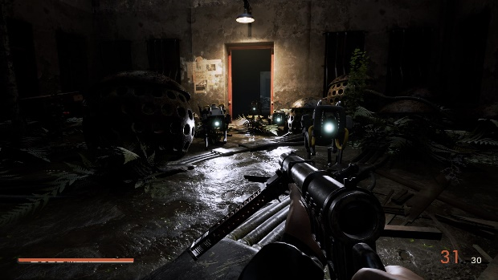
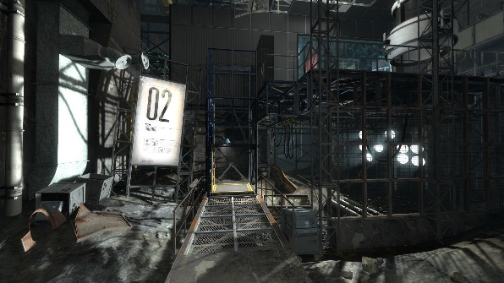
ark and intense, with a focus on high stakes and survival.
Futuristic and industrial with a gritty, high-tech atmosphere, featuring metallic surfaces, neon lights, and intricate machinery.
moodbord:
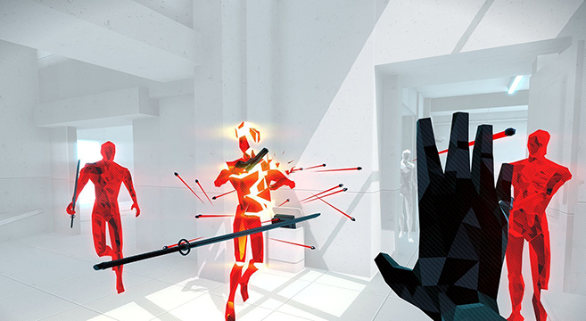
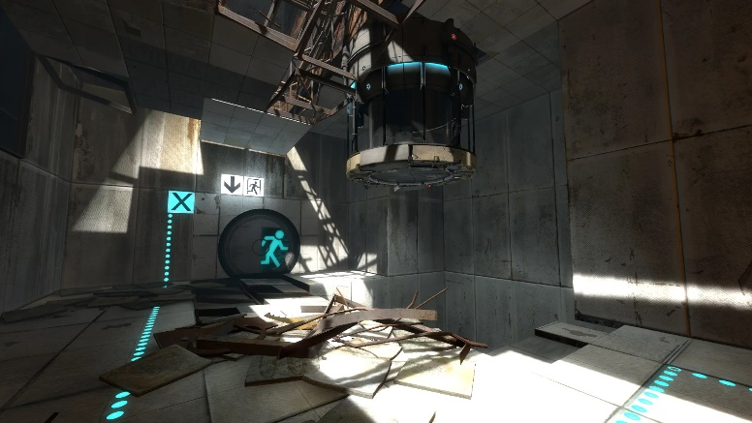

5.2 Character design
blocky but not square. Similar to superhot

5.3 UI/UX design
the UI will be very similar to that of portal 2

6. Sound And music

6.1 sound effects
Mechanical clinks, rope tension sounds, enemy alarms, and industrial ambiance.

6.2 music
Tense, industrial electronic music, intensifying during combat.

7. secondary mechanics

7.1 Boss Mechanics
The final boss fight tests the player’s mastery of all Latchpoint Gun abilities, combining platforming, combat, and strategy

8. Production details

8.1 development team
Matthijs schoonen (Lead developer)

8.2 development tools
Name | version | description
Unity | 22.3.45f1 | Long time support free game engine
Blender | x.x | Free opensource 3d editor
github | x.x | Version control and planning

