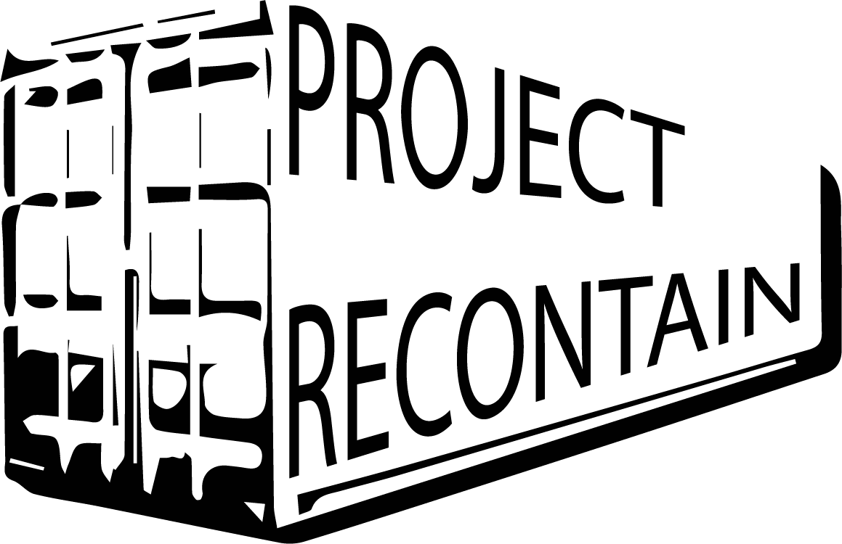

**Business Plan**

Group 6: The DirtBags

Case: Eco Baltia

**Hack The Waste**

**2020**

**I. Table of Contents**

I. Table of Contents ................................................................................................... 3

II. Executive Summary ............................................................................................... 4

III. General Company Description ............................................................................ 5

IV. Products and Services............................................................................................ 6

V. Marketing Plan ....................................................................................................... 7

VI. Operational Plan .................................................................................................. 16

VII. Risk assessment

VIII. Cash Flow Estimate ............................................................................................. 22

**II. Executive Summary**

Write this section last.

We suggest that you make it two pages or fewer.

Include everything that you would cover in a five‐minute interview.

Explain the fundamentals of the proposed business: What will your product be? Who will your customers be? Who are the owners? What do you think the future holds for your business and your industry?

Make it enthusiastic, professional, complete, and concise.

If applying for a loan, state clearly how much you want, precisely how you are going to use it, and how the money will make your business more profitable, thereby ensuring repayment.

**III. General Company Description**

The company aims to provide clients opportunities to transport their products cheaper, more efficiently and “greener”. This is aimed to be accomplished by using pallets of recycled polycarbonate (pc) to create the side and top panels as replacement for the traditional storage containers.

The clients of the company will mainly be focused on the shipping magnates around the globe focused on the land and air transport as there are still some concerns around the stacking of the containers as required in the case of sea transport.

The company will provide two main solutions, the first, the sale of the containers we produce and the second the lease of containers which will include the maintenance of these containers.

Main benefits of our product from a client's point of view would be the lighter weight of the container, thus less fuel consumption for transport and the responsibility we as company have to service and replace containers for the client.

From the side of the company or stakeholders the benefits of this company would be the effective use of recycled and recyclable materials. Entering the market of transport and serving as an alternate solution to container transport. This will also help to move the recycling of the world's plastic one step closer to realisation.  
As the focus would be for the products to be returned by the end of their life cycle, it will ensure the continuous flow of resources as the “broken” product will be able to be recycled into the new product.

**IV. Products and Services**

This product will be available in different shapes for different uses and different flooring depending on the weight of the content.

**Product Group 1:** Storage containers to buy.

This product will be focused on one time sales and possible scervicing of the product in the future of the products’ life cycle and then the money-back trade-in of the container by the end of the life-cycle.

**Product Group 2:** Storage containers for hire/subscription.

This product will offer the storage containers to be paid for on periodical installments that will also include the servicing and/or replacement of the product when it fails.

**V. Marketing**

**Economics**

The global shipping containers market was valued at $8.70 billion in 2019, and is projected to reach $12.08 billion by 2027, registering a CAGR of 4.3% for the forecast period 2020-2027.

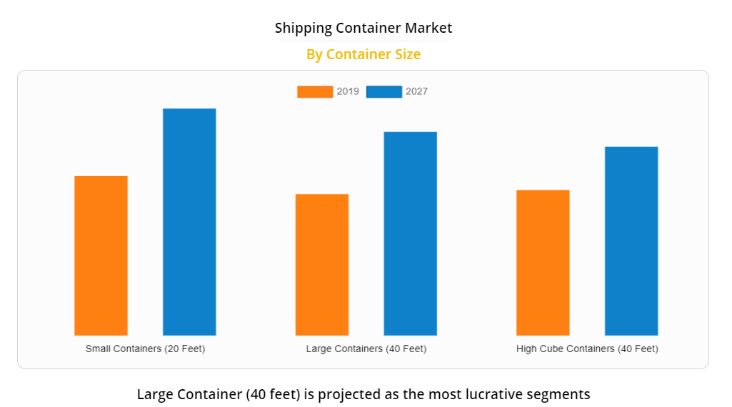

Source: <https://www.alliedmarketresearch.com/shipping-containers-market>

The small shipping container (20 feet) has a market share of approximately 36% in the global shipping container market which makes it the leading segment across different segments in the global shipping containers market.

Demand for larger (40 feet) shipping containers is lower, however as the production process and equipment of the machinery does not require additional features, as well as cost/price benefit is the same, company that is producing small shipping containers is easily also being able to produce larger ones to access broader customer base.

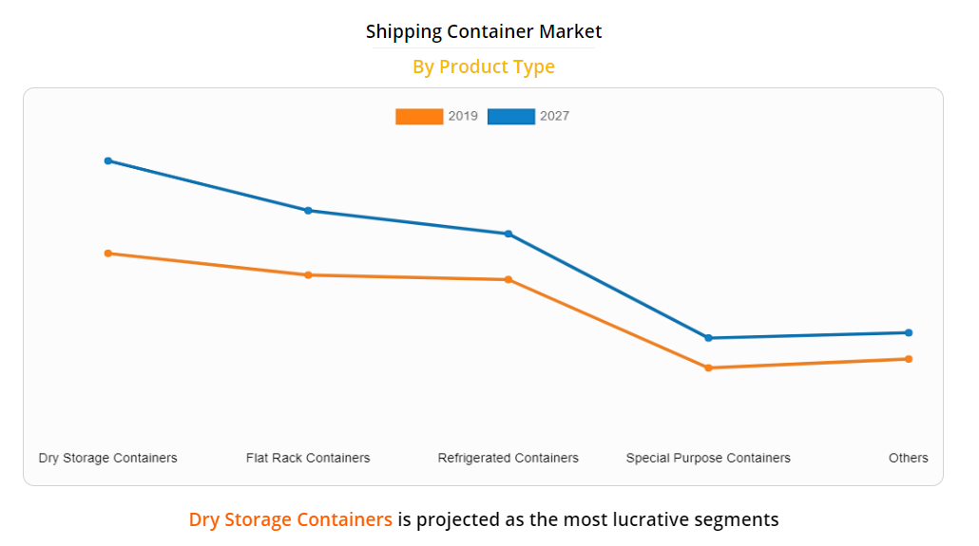

Source: <https://www.alliedmarketresearch.com/shipping-containers-market>

Dry storage containers– also known as standard containers – are the optimum transport solution for containerised cargo of every description. They are used for transportation of basically everything except moving food or chemicals that require refrigeration.

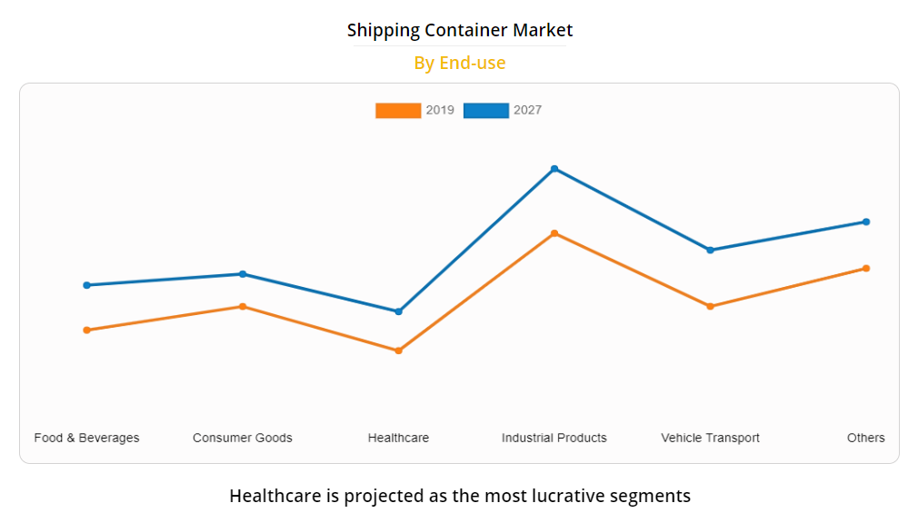

Source: <https://www.alliedmarketresearch.com/shipping-containers-market>

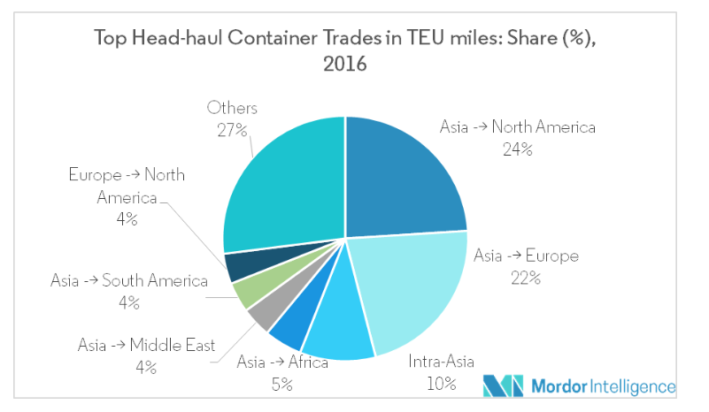

Source: <https://www.mordorintelligence.com/industry-reports/shipping-containers-market>

Based on the global Shipping Container market analysis, Asia-Pacific is the major revenue contributor in 2019 and is expected to provide more business opportunities during the forecast period as well as is expected to see a lucrative growth during the forecast period.

The containerized transport of goods, by sea, accounts for almost 60% of the total sea-borne trade in the world

**Barriers**

o High initial capital costs

o Comparably high production costs - China accounts for more than 90% of the world’s container manufacturing, with an advantage of low labor cost.

o High marketing costs - as business itself is very profitable, it is competitive

o Consumer acceptance and brand recognition - Transportation of goods with containers is very responsible activity that can lead to huge losses if not done properly, so gaining good reputation and brand recognition is essential.

o Location - most containers are being shipped from Asia to Europe or US, making it easy location wise for local Asian companies to gain access to customers.

o Training and skills - finding qualified and competent employees with the experience necessary to work with you in this type of business.

o The relative monopoly held in the business by a few large concerns.

**Positive side**

* Shipping is cyclical but when new boxes go into a leasing contract they usually go into a long-term lease of five years and then stay with the shipping line on lease.
* Rates do not vary much and these are usually a function of original purchase price.
* Rates are usually locked in by the long-term lease contract so there is not much variation in return.

***Investing in shipping containers is a very strong prospect with very little downside and a lot of upside if the investment is made properly with a reputable company***

**Product**

The product and service we provide is the buying, renting and returning of plastic shipping containers for bulk transport. Our product and service delivers lighter packaging containers to ship items with, resulting in a decrease in abundant plastic pellets and reduces the environmental damage resulting from transportation.

**Features and Benefits**

Mayor services:

* buying containers
* renting containers
* returning and recycling the container

For each product or service:

What is special about purchasing plastic containers is that you invest into recycled materials and giving those a second life in the transport industry. Additionally the money saved from transporting the product is rather high thanks to the use of recycled materials instead of new ones.

The benefits of this is that both the environment as the expenses of the buyer/shipment company are reduced thanks to the lightweight materials.

Added to this is with the renting of containers, that the containers can be returned at any time and result in a cashback, like with empty bottles. This same idea can be taken to the recycling service as well, this final one because the company that sells the containers get some or all of their resources back where the customer gets some of the spend money back.

**Customers**

With our project, we are aiming to sell the final product to the shipping companies. We are aiming at large shipping companies, who mostly use shipping containers, which are also called TEU (Twenty-Foot Equivalent Units).

Ten of the largest container shipping companies on the basis of cargo carrying capacity for the year 2019 are:

APM-Maersk: Maersk is a Danish shipping company, operating since 1904. Being the largest container shipping company in the world, Maersk has a capacity of 4 million shipping containers.

MSC : Mediterranean Shipping Company (MSC) is a Swiss cargo company, which has been in operation since 1970. Their container capacity is around 3.8 million containers.

COSCO: China Ocean Shipping Company (COSCO) is the third largest cargo shipping company. Its capacity is about 2.8 million containers.

CMA-CGM: CMA-CGM is a French shipping company. It was established in 1978. It has a capacity of about 2.6 million containers.

Hapag-Lloyd: German company Hapag-Lloyd was established in 1970. Its current capacity is about 1.6 million containers.

ONE: Ocean Network Express (ONE) is a newly established Japanese company, which started its' operations in 2017. Its current capacity is 1.5 million containers.

Evergreen Line: Another Chinese company Evergreen Line was established in 1968. Its' capacity is 1.2 million containers.

Yang Ming Marine Transport: Established in 1972, Yang Ming Marine Transport is a Taiwan-based shipping company. Its capacity is about 600.000 containers.

Hyundai Merchant Marine: Hyundai Merchant Marine is a South Korean shipping company, with a capacity of about 400.000 containers.

PIL: Pacific International Line (PIL) is a Singaporean shipping company with a capacity of about 400.000 containers.

**Competition**

Main competitors are traditional logistics companies in the Europe, as for example:

* C.H. Robinson
* CEVA Logistics
* DB Schenker
* Deutsche Post DHL
* Expeditors

However, none of the previously mentioned companies are providing recycled plastic containers. Potentially, other plastic recycling facilities could engage in the business and enjoy second mover advantages. Such companies could be:

* Brentwood Industries, Inc.
* [Granutech-Saturn Systems](https://www.environmental-expert.com/companies/granutech-saturn-systems-3238)
* Shred-Tech Corp.
* Premium
* [Presona AB](https://www.environmental-expert.com/companies/presona-ab-1756)
* [ATB WATER GmbH](https://www.environmental-expert.com/companies/atb-water-gmbh-7176)
* IRELAND.

**Budget**

**Pricing**

As such products do not exist yet in the marketplace, there is no similar product that could be used from competitors directly, however, as recycled plastic filling in the containers increase, also strength of the containers decrease substantially, meaning that the price should be lower than existing one in the marketplace for steel containers.

Creating our product affordable and “green” at the same time will be the main motivational factor for customers to switch from alternative shipping container options.

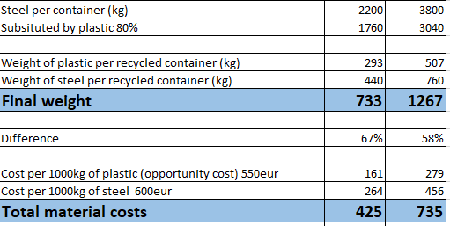

Cost reduction is going to be implemented through substituting steel with recycled plastic that company itself is producing. As recycled plastic is cheaper than steel and weight itself is going to be reduced, products will gain lower production costs and at the same time better physical properties.

**Proposed Location**

As the company operates and is based in Europe, also targeted customers are in-land logistics companies in this region, thus we have decided that production facilities of shipping containers will be in Latvia as it is in Europe good location in terms of companies knowledge of tax system, laws and regulations and economically it is also the cheapest option compared to neighbouring countries.

**Distribution Channels**

Product is being distributed through two channels:

* lease - 6month to 5 year;
* Sales

**Sales Forecast**

Sales forecast is made based on historical and predicted market development - 4,4% yearly. As the chosen product group of the containers is the one that is the fastest growing from all, the sales forecast is potentially accurate.

**VI. Operational Plan**

**Production**

The best place to produce our products would ideally be at or close to a plastic recycling plant, as this would grant the fastest access to the required resources and be situated in an environment where factory space is also available.

Method:

* The machine to produce the lexan panels from the polycarbonate pallets would be a computerised lexan smelter and press
* This machine would create the panels able to serve as the side panels for the transport crates/containers.
* The panels would then be mounted on a variety of base platforms to form the sides, doors and top of the container.
* The panels can also then be modified, eg. sealed or cut to extend its use to serving goods such as livestock and unprepared food.

**Location**

Location of the manufacturing plant needs to be close to various means of transportation (major roads, railroad, sea terminal). This is important since our end product is large and needs to be shipped out accordingly.

Physical requirements:

• There needs to be enough space to build a large manufacturing facility, together with the warehouse for short-term storage of finished products

• Building needs to be built according to all of the standards. It needs to have proper insulation to prevent energy losses.

• Building needs to be connected to the main water and drainage pipes, electricity and gas.

Access:

Location of the manufacturing unit needs to be convenient enough to ensure the good flow of incoming and outgoing material.

Access needs to be convenient to ensure a good flow of material throughout the facility. There needs to be adequate parking around the site to ensure the loading and unloading of the goods.

**Legal Environment**

* Certification for the structure and/or quality of the containers might need to be acquired before the business cycle can commence.
* Some other companies have approached the idea of plastic containers, and even though these aren't recycled plastic, the conflict of interest might coase legal action in certain countries where our product collides with existing patents.

**Risk assessment**

1. Shipping container industry is specific with the fact that logistic companies do not buy these containers. They rather lease them, moreover, they make lease agreements usually in between 5-10 years meaning that loyalty has a lot of value in the industry. Not gaining this loyalty is a risk that a company might face.

Probability of occurrence (1-5): 3

Impact on company (1-5): 4

Solutions:

* Offer better terms and pricing to bring unresistable financial advantage to the customer;
* Position strongly the fact that company is local and green, raising loyalty due to similarity, proximity and positive attitude towards companies that implement “green” practices in their process;

1. As in the shipping container industry quality is important, low pricing could unintentionally be seen as low quality, so our containers might not succeed to gain necessary demand.

Probability of occurrence (1-5): 2

Impact on company (1-5): 4

Solutions:

* Testing carefully product before starting to sell it, so company is sure about limitations of the product;
* Implementing continuous improvements based on feedback.

1. High production costs. Shipping container industry is very international due to the nature of the business and product. Using low cost labour countries in the production process of containers can substantially reduce labor costs. Compared to Asian countries, the choice of having production facilities will lead to higher production costs in terms of labor.

Probability of occurrence (1-5): 4

Impact on company (1-5): 3

Solution:

* However production costs are low in these locations, they are far from Europe, so they will have additional transport costs;
* Increasing loyalty by positioning company and product as local and green might help increase the customer base;

1. When the economy stabilizes and the prices of oil will go up, the opportunity cost of the recycled polymer will get so high that the project is not going to be profitable anymore.

Probability of occurrence (1-5): 4

Impact on company (1-5): 3

Solutions:

* Scale up recycling operations.
* Get enough 5 year subscriptions as insurance to have time to find a solution in case of economic development and raise in oil prices.

**Projected Cash Flow**

|  |  |  |  |  |  |  |
| --- | --- | --- | --- | --- | --- | --- |
| Cash Flow | CF0 | CF1 | CF2 | CF3 | CF4 | CF5 |
| Revenue |  | 327240 | 340330 | 353943 | 368100 | 382825 |
| COGS- |  | 60460 | 63479 | 66648 | 69976 | 73470 |
| Gross Margin= |  | 266780 | 276851 | 287295 | 298125 | 309355 |
| S&G&A |  | 32724 | 34033 | 35394 | 36810 | 38282 |
| EBITDA= |  | 234056 | 242818 | 251900 | 261315 | 271072 |
| DA- |  | 60000 | 60000 | 60000 | 60000 | 60000 |
| EBT= |  | 174056 | 182818 | 191900 | 201315 | 211072 |
| CIT- (20%) |  | 34811 | 36564 | 38380 | 40263 | 42214 |
| Net Profit |  | 139245 | 146254 | 153520 | 161052 | 168858 |
| Long term assets investments- | -300000 |  |  |  |  |  |
| DA+ |  | 60000 | 60000 | 60000 | 60000 | 60000 |
| FCF= | -€ 300,000 | € 199,245 | € 206,254 | € 213,520 | € 221,052 | € 228,858 |

Projected cash flow for the project is made based on following assumptions:

* Plants work 8h only on work days (251 in total per year);
* Yearly lease price per container is 120 EUR.
* Costs resulting from additional workforce are accordingly:

