### **Traditional recycling company**

Company recycles PET (polyethylene terephthalate), LDPE film and HDPE hard plastic

1. Plastic is brought to the recycling facility:

* Automated Plastic Sorting Machine by size
* Info-scanner sorts plastic by type
* Pressed in bails

1. It is washed, shredded and dried.

Made into 99% clean flakes

1. Ground in the powder
2. Melt
3. Turn into granules

**Containers**

Mostly, all **shipping containers are made from steel** and have closed-top with hinged doors. They have corrugated walls on the top and bottom sides and are welded to the rails and end frames.

**Shipping containers are typically made from corten steel** which is a self-healing/weathering steel. The strength of this material has revolutionized the way we transport cargo across large bodies of water

Steel shipping/cargo containers walls are made from 10m2. The top and bottom side rails and end frames are 5m2 tubular steel.

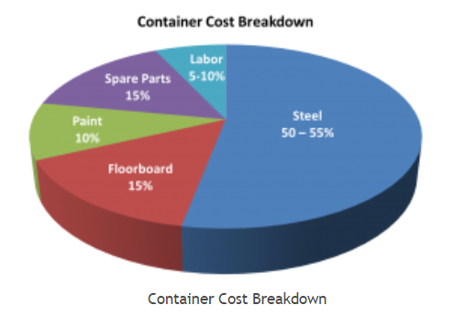

Today, most shipping containers are fitted with floors made out of tropical HARDWOOD plywood.

Corten steel price per ton = €600

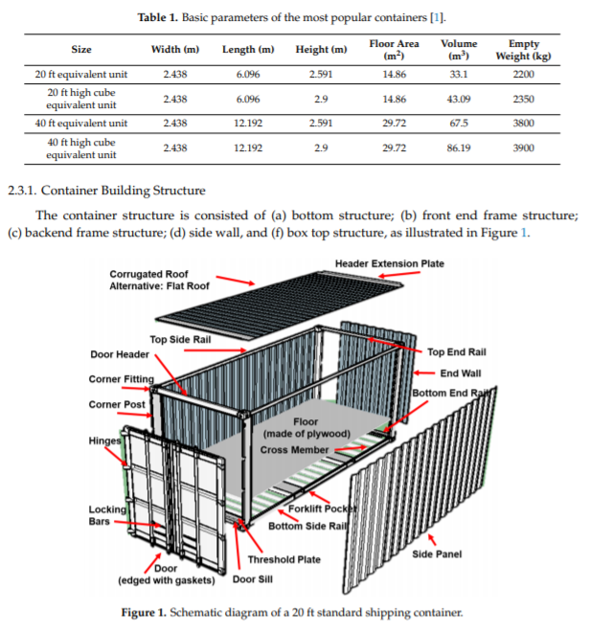

**There are three common materials used for plastic pallets in the market: high-density polyethylene (HDPE) reinforced plastic, polyethylene terephthalate (PET) reinforced plastic, and resin formulations**

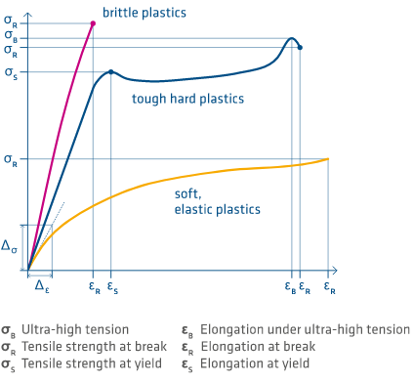

### **Polycarbonate refining process.**

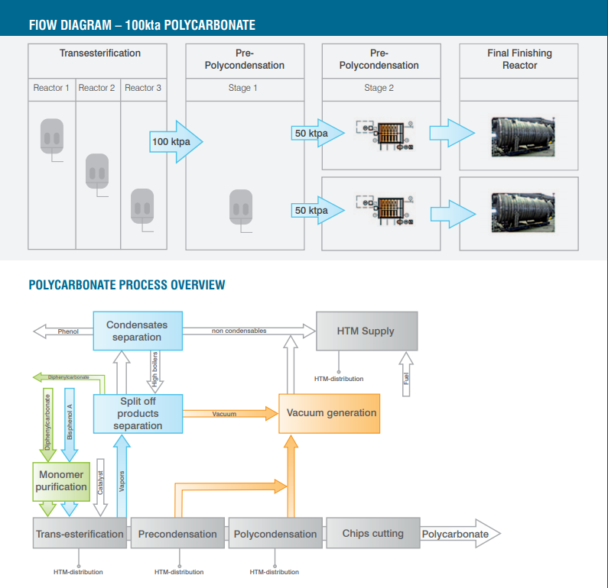

1. **Material processing** PC has high water absorption. So before injection molding, it must be preheated dried. The pure PC is dried at 120 Celsius degree, and the modified PC should generally be dried for more than 4 hours with a temperature of 110 Celsius degree. Drying time should not exceed 10 hours. Generally, you can use the method of air extrusion to determine whether it’s dry enough. The utilization of recycled materials can reach 20%. In some cases, the utilization of recycled materials can be100%, the actual quantity is subject to the quality requirements of the products. Recycled materials can’t mix different masterbatch simultaneously, or it will seriously damage the nature of the finished product.
2. **Selection of injection molding machine** Now, for the cost and other reasons, PC often uses modified materials, especially electrical products which should increase fireproof performance. When the flame-retardant PC and other plastic alloy products are molding, it should make sure the plasticizing system of the injection molding machine mix well and corrosion-resistant. It is unachievable for the conventional plasticizing screw. So when choosing, you should state in advance, usually, there are special PC screws for customers to choose from.
3. **Design of mold and gate for PC injection molding** The common mold temperature is 80-100 Celsius degree, the temperature of mold adding glass fiber is 100-130 Celsius degree. Small products can use the pinpoint gate, Gate depth should be 70% of the thickest part, and other gates are circular and rectangular. If the gate is bigger, it’s better, which can reduce the defects caused by excessive shear. The depth of the vent should be less than 0.03-0.06mm; the runner should be short and round. The ejection gradient is generally about 30′-1.
4. **Melt temperature for PC material** You can use a gas injection method to determine the processing temperature. Generally, the PC processing temperature is 270-320 Celsius degree. The temperature of the PC with some modification or low molecular weight is 230-270 Celsius degree.
5. **Injection speed** When molding, relatively fast injection speed is usually adopted, such as electrical switch parts. Commonly, it is from slow to rapid injection molding.
6. **Packing** Packing is 10bar around; it can be appropriately reduced without the gas lines and color mixing.
7. **Dwell time** If staying in the high temperature for a long time, the materials will degrade, emit CO2 and turn yellow. You should use PS to clean the cylinder, not LDPE, POM, ABS or PA.
8. **Special notes** Some modified PC, as being recycled many times (the molecular weight decreased) or an uneven of mixing ingredients, would easily produce the dark brown liquid bubble.

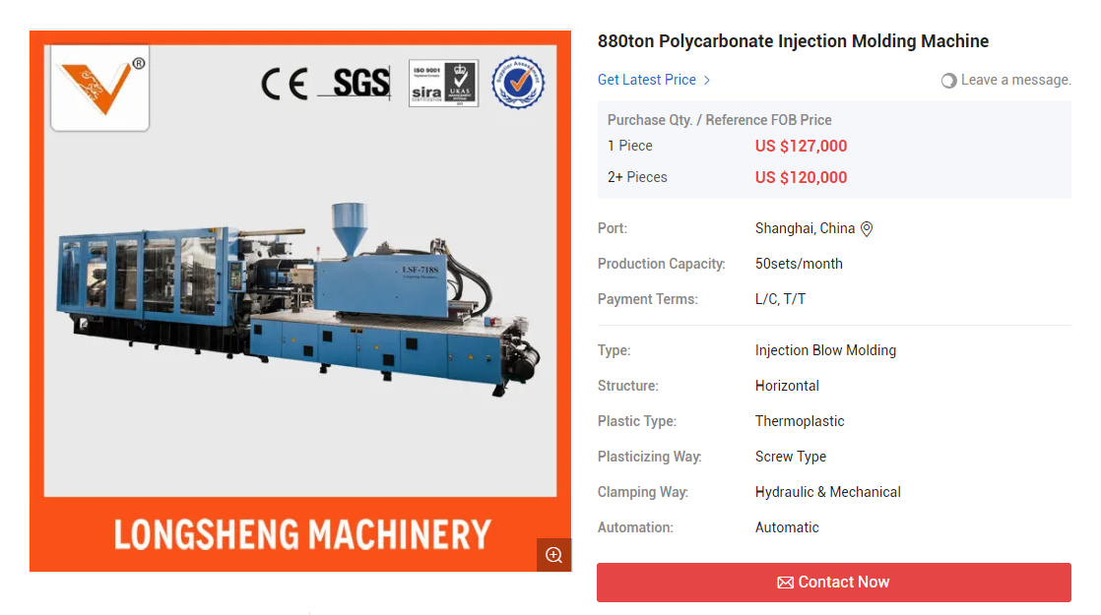

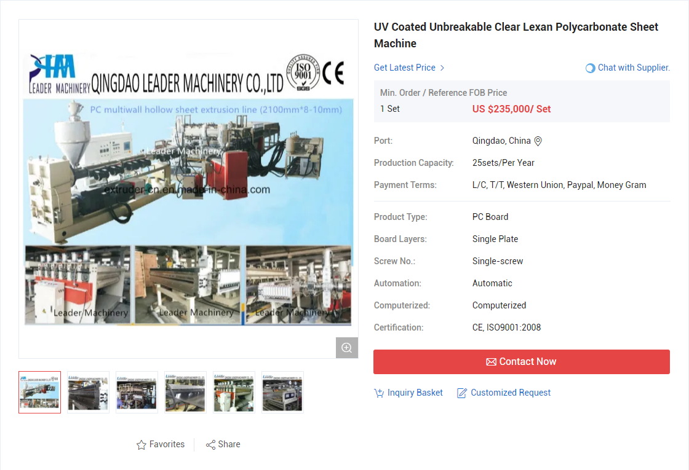

<https://extruder-cn.en.made-in-china.com/product/XvCmRTgcXeVL/China-UV-Coated-Unbreakable-Clear-Lexan-Polycarbonate-Sheet-Machine.html>

<https://sfs.sabic.eu/wp-content/uploads/resource_pdf/1482256914-51422789-SABIC-SFS-6212-EN-LEXAN-Sheet-Processing-Guide-FINAL-Nov-2015.pdf><<The Super long document on properties of polycarbonate- glassfiber compositions

### **Potential buyers**

With our project, we are aiming to sell the final product to the shipping companies. We are aiming at large shipping companies, who mostly use shipping containers, which are also called TEU (Twenty-Foot Equivalent Units).

Ten of the largest container shipping companies on the basis of cargo carrying capacity for the year 2019 are:

APM-Maersk: Maersk is a Danish shipping company, operating since 1904. Being the largest container shipping company in the world, Maersk has a capacity of 4 million shipping containers.

MSC : Mediterranean Shipping Company (MSC) is a Swiss cargo company, which has been in operation since 1970. Their container capacity is around 3.8 million containers.

COSCO: China Ocean Shipping Company (COSCO) is the third largest cargo shipping company. Its capacity is about 2.8 million containers.

CMA-CGM: CMA-CGM is a French shipping company. It was established in 1978. It has a capacity of about 2.6 million containers.

Hapag-Lloyd: German company Hapag-Lloyd was established in 1970. Its current capacity is about 1.6 million containers.

ONE: Ocean Network Express (ONE) is a newly established Japanese company, which started its' operations in 2017. Its current capacity is 1.5 million containers.

Evergreen Line: Another Chinese company Evergreen Line was established in 1968. Its' capacity is 1.2 million containers.

Yang Ming Marine Transport: Established in 1972, Yang Ming Marine Transport is a Taiwan-based shipping company. Its capacity is about 600.000 containers.

Hyundai Merchant Marine: Hyundai Merchant Marine is a South Korean shipping company, with a capacity of about 400.000 containers.

PIL: Pacific International Line (PIL) is a Singaporean shipping company with a capacity of about 400.000 containers.

### **HOW CONTAINER SHIPPING WORKS**

Containers travel all around the world, usually on fixed routes. Shipments are parts of pre-agreed supply chain routes. These chains need to be agreed in advance, since their main goal is to be as efficient as possible. Their aim is to transfer the goods from point A to a point B as fast as possible. This is not an easy job, since various, combined modes of transport are being used. Goods are normally loaded inside the container at the factory of origin and then being sealed. This ensures that the goods reach the final destination intact.

Shipping normally starts once finished goods are loaded inside a container at the manufacturing facility. Container is then placed on a truck and taken to the nearest seaport. Once the truck reaches the seaport, the container gets lifted and placed on a cargo ship. Container then travels on the cargo ship across the oceans, normally making a few stops on its way, where it can be further moved on another ship, according to the pre-planned route. Once the container reaches the final seaport, it is being transferred back to the truck and taken to the warehouse.

Containers can also be shipped on dedicated freight trains.

### ABOUT CONTAINERS

Main advantage of using containers is their standardization. The most standard container is the 20-foot container (6.09m). Containers can come in other sizes as well, for example 40-foot (12.18 m), 45-foot (13.7 m), 48-foot (14.6 m), and 53-foot (16.15 m). Due to their standardization, they can move freely between trucks, freight trains and cargo ships. Standardization applies for containers all around the world, and is being controlled through the ISO (International Organisation for Standardization). They are normally manufactured in steel or aluminium. They can be available in a variety of shapes, depending on their intended purpose. They can be closed, open, refrigerated, liquid tanks, etc. Each container has its unique number. The unique number serves to identify the owner of the container, the current user of the container and even where it is located.

**HISTORY OF CONTAINERIZATION**

Shipping containers started being used about 50 years ago. Before that, people were already using different types of transport boxes, namely in a combined horse and train transportation. Such methods of transportation were also used during World War II. The actual using of shipping containers started in 1955, when Malcolm P. McLean, an American entrepreneur came to an idea of lifting a whole vehicle onto a ship, without unloading it. His idea was based on intermodalism, which takes into account the simplifying and optimising the shipping process, thus shortening it.

**Calculations for steel and plastic comparison**

Steel density: 8.05 g/cm3

Polycarbonate density: 1.22 g/cm3

* Thus polycarbonate is 6.59 times less

steel psi: 60200

Polycarbonate psi:9000

Thus polycarbonate is 6.688 times less

**Marketing:**

“Containers shaped for the pleasure of the Earth and its citizens :) ”

* Lighter containers - Increased weight to be transported
* Sustainability - engagement in circular economy
* Easy maintenance - just recycle!
* Positive impact on your reputation
* Cheaper than alternatives
* Container strength can be customized for customer needs.