## Context

Comments below identify which sub-sections of the Directive on Privacy Practices, Tri-council Policy on Research, or Privacy Act are being addressed by the language in the notices. At this point potential participants have already reached out to CDS via email or phone to volunteer to participate.

We sent privacy and consent notices for the research activity at least two days in advance for participants to review. We then review the notice with participants before commencing the test and collect verbal or written consent.

This resource is meant to be a starting point for teams that want to conduct user research, to be worked on with their Access to Information and Privacy (ATIP) offices.

These phrases adapted to a department’s context can help address the directive on privacy practices and tri-council policy, but they’re not perfect. We are still working to improve our use of plain language and streamlining the content to ensure participants understand the information.

## Consent Notice

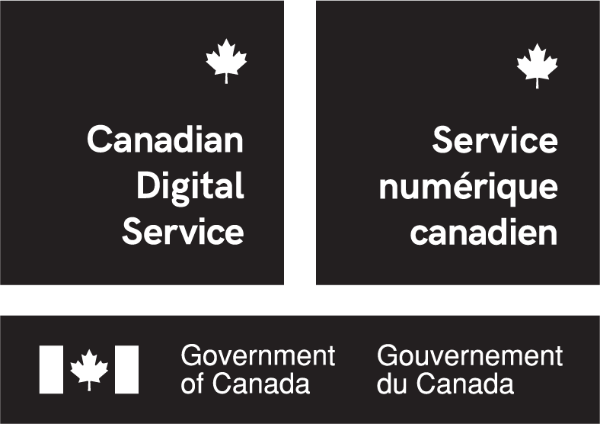

For any questions about this research, please contact:  
[researcher name]  
[researcher phone number]

[researcher email]

The Government of Canada is working to improve Veterans’ awareness and access to the benefits available to them. To meet this goal, the Canadian Digital Service (CDS) is conducting research with Veterans’ Affairs Canada (VAC) to:

1. Understand Veterans’ service needs; and,
2. Understand Veteran’ current use of online services.

This research will be conducted [*in-person or as a phone*] interview with two CDS researchers and yourself. Your participation is completely voluntary and will be confidential.

During your scheduled interview, the researcher will ask you a few questions regarding your awareness and use of Government of Canada services. It will take no longer than [*duration of interview*]

Before the interview starts the researchers will confirm that you understand and consent to the following:

* You are volunteering to participate, and may stop the interview any time for any reason;
* Your responses will be **anonymized**, which means they will not be linked back to you. Because your responses are anonymized, you will be unable to withdraw after you have provided them.
* During this interview CDS may collect your personal information***\**** such as, your:
  + biographic information;
  + experience with Government of Canada services; and,
  + medical history.

***\**** CDS handles your personal information in accordance with the *Privacy Act*, for more information please see our **Privacy Statement**.

* The personal information you provide to us will **not** be used for any administrative purposes (that is, any decision making process that directly affects your access to Government of Canada services).
* Your information will be used to achieve the two goals stated above, and may be shared with Veterans Affairs Canada to improve their service delivery or for training and learning purposes.
* You have the right to file a complaint with the Privacy Commissioner of Canada should you have an issue with the collection, handling, or use of your information. For more information, please see our **Privacy Statement**

# ☐ **I understand the points above and consent to participate in the research.**

Name: _______________________ Date: _________________________

Time: _________________________

## Privacy Statement

By attending your interview with CDS, you understand that your biographic information, experience with Government of Canada services, and medical history may be recorded to the extent that it is relevant to the research.

This personal information will not be used for any “administrative purposes”. This means that your information will **not** be used for any decision making process that directly affect your access to Government of Canada services.

Due to the anonymization of responses, CDS will have no reliable means of associating you with your responses, which means we may not be able to access the information you have provided to respond to your request for correction to inaccurate information or withdrawal.

CDS is a program within the Treasury Board Secretariat (TBS) of Canada. The collection and use of your personal information by TBS is authorized by the *Financial Administration Act*. Collection and use of your personal information for correspondence is in accordance with the federal *Privacy Act*.

Any personal information that may be collected is described in the Standard Personal Information Bank entitled [Outreach Activities, PSU 938](http://www.infosource.gc.ca/emp/emp03-eng.asp#psu938), which can be found in the TBS webpage [Information about programs and information holdings](https://www.canada.ca/en/treasury-board-secretariat/services/access-information-privacy/access-information/information-about-programs-information-holdings.html).

Any comments or concerns you may have regarding this Statement, your privacy rights and the Privacy Act may be directed to the TBS Access to Information and Privacy Coordinator by email at ATIP.AIPRP@tbs-sct.gc.ca or by telephone at 1-866-312-1511.

You may also wish to contact the Office of the Privacy Commissioner of Canada by email at info@priv.gc.ca or by telephone at 1-800-282-1376. You have the right to complain to the Office of the Privacy Commissioner of Canada about the handling of your personal information by TBS.