FUNCTIONAL DOCUMENTATION

Preface
The project involves the implementation of an interaction system through which a singer can use hand gestures to activate real-time effects on their voice during recording.
The goal is to allow even users without specific music production skills to express preferences regarding how their voice should be modulated at certain points in the track.
The innovative contribution of this project consists in using the PC's integrated camera as a visual input, without the need for external sensing devices, for landmark extraction and hand tracking.
We will then move on to the conversion phase of the detected gestures into MIDI signals, which are then sent to an audio engine responsible for modulating the sound effects.
Finally, as a type of feedback, we considered an auditory response more appropriate, since, in this context, the user's perception of change is closely linked to the variation in their voice.

What about related works in the literature?
- Technological Fundamentals: Hand Tracking & MediaPipe
The project is based on landmark extraction using the PC's built-in webcam, without the use of external sensors. The main scientific reference is the framework adopted for this process.
- MediaPipe Hands: On-device Real-time Hand Tracking (Fan Zhang et al.).
  - Relevance: Describes the 21-landmark hand tracking architecture that enables real-time hand tracking e gesture recognition on consumer devices, critical for accuracy and stability.
  - Results: Thanks to the combination of real and synthetic data is possible to significantly improve tracking accuracy and stability, reducing inter-frame jitter. Furthermore, the proposed 21-landmark tracking architecture achieves high real-time tracking performance on consumer devices and supports reliable static gesture recognition, making the system suitable for AR/VR and real-time gesture interaction applications.
  - https://arxiv.org/pdf/2006.10214

- Gesture-to-Audio and MIDI Mapping
The heart of the project is the conversion of gestures into MIDI signals to modulate parameters in a DAW (such as Logic Pro X).
- The Wekinator: A system for real-time, interactive machine learning in music (Rebecca Fiebrink & Perry R. Cook).
  - Relevance: A foundational work in the NIME literature, it explores how supervised machine learning can be used to map gestural and audio input to sound parameters in real time, supporting interactive training and refinement of musical systems.
  - Results: It is highlighted that Wekinator enables rapid prototyping of interactive musical applications based on gestures and audio analysis, supporting real-time qualitative evaluation, integration with external music software, and dynamic control of sound synthesis and visualization through machine learning.
  - https://archives.ismir.net/ismir2010/latebreaking/000012.pdf

- Augmenting Vocal Performance
The project aims to allow singers to manipulate their voices during recording.
- A Voice Interface for Sound Generators: adaptive and automatic mapping of gestures to sound (Stefano Fasciani & Lonce Wyse)
  - Relevance: Explores the use of vocal gestures to control sound synthesis parameters in real time through automatically generated many-to-many mappings, reducing the need for additional dedicated hardware beyond a microphone.
  - Results: The voice can be used as an effective and sufficiently stable control tool for real-time sound synthesis. The proposed system automatically generates consistent mappings between vocal gestures and synthesis parameters, enabling expressive timbre control without complex manual configurations. Furthermore, the many-to-many approach expands sonic exploration possibilities and supports more natural interaction during musical performance.
  - https://www.nime.org/proceedings/2012/nime2012_57.pdf

- Multimodal Feedback and Interaction in Digital Musical Devices
The project proposes a multidimensional interaction system that uses multimodal feedback (auditory and visual) to support the singer during the modulation of effects in real time.
- Assessing the Inﬂuence of Multimodal Feedback inMobile-Based Musical Task Performance (Alexandre Clément & Gilberto Bernardes)
  - Relevance: This study investigates how multimodal feedback influences user performance in digital musical tasks. Its findings support the design choice of using auditory feedback as the primary interaction response, while employing visual feedback as a secondary aid to reinforce system awareness and reduce user uncertainty during interaction.
  - Results: Additional multimodal feedback may improve certain aspects of interaction, particularly by helping users orient themselves toward target notes more quickly and with less hesitation. However, neither visual nor haptic feedback significantly improves final accuracy or overall task completion time compared to auditory feedback alone.
  - https://www.researchgate.net/publication/362546542_Assessing_the_Influence_of_Multimodal_Feedback_in_Mobile-Based_Musical_Task_Performance

Feature of this idea
We want to achieve a multi-dimensional interaction system, since we are involving both singer’s hands, so that we can subdivide actions into two dimensions, encouraging a more natural and consistent interaction too.

Architecture
Work pipeline
The implementation solution is based on the following workflow:
Python + MediaPipe + OpenCV + OSC/MIDI + DAW
Where:
- MediaPipe → for hand tracking / gesture recognition;
- OpenCV → for video management, preprocessing and camera feed visualization;
- A library for sending commands → MIDI (Musical Instrument Digital Interface);
- DAW (Digital Audio Workstation) → to manipulate the effects modulation parameters. In our case, we use Logic Pro X as audio environment.

Gesture design
The gesture design was defined to meet the following requirements:
- distinguishability;
- memorability;
- ease of execution during singing;
- reduced fatigue;
- low probability of accidental activation;
- semantic consistency with the controlled effect.
Furthermore, preliminary interviews were conducted with potential singers – or at least people familiar with this field – with the initial goal of presenting and discussing the design concept, then gathering feedback on the proposed gestures and evaluating any suggestions or alternatives.
The final gesture design was therefore derived from a combination of the requirements reported above and the observations that emerged during these preliminary interviews.

Types of gestures
- Left hand → effect selection
  - The user starts from the fist and the number of fingers he lifts determine the effect he wants to activate (e.g. lifting the first and second fingers => activating effect 2)
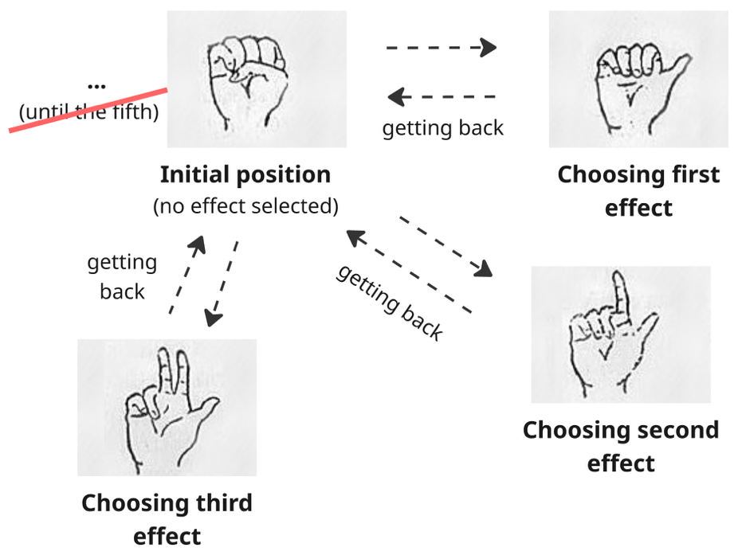
The constraint is that to switch from one effect to another one, the user must always pass from the initial position (becoming a transition point). Moreover, this position can be used to lock the amount of the selected effect once the desired point is reached.

- Right hand → modulation of the effect selected through two modalities (not handled simultaneously).

Modality 1 — pinch distance


To turn off all effects at once

Modality 2 — hand openness
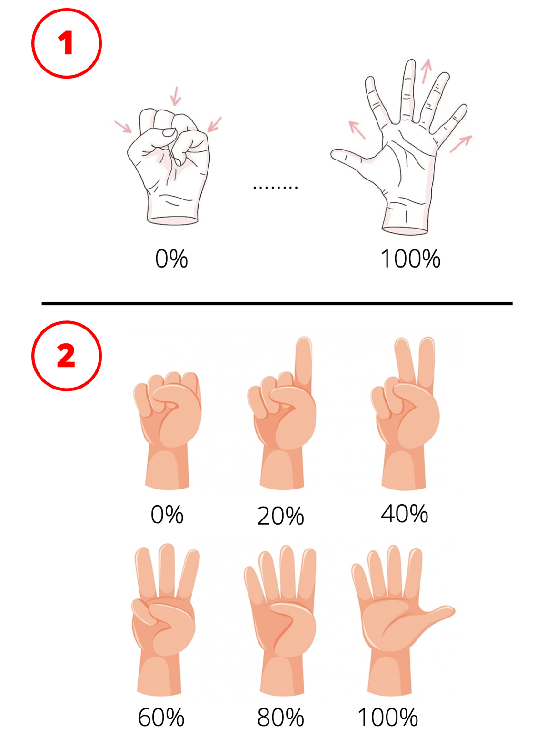

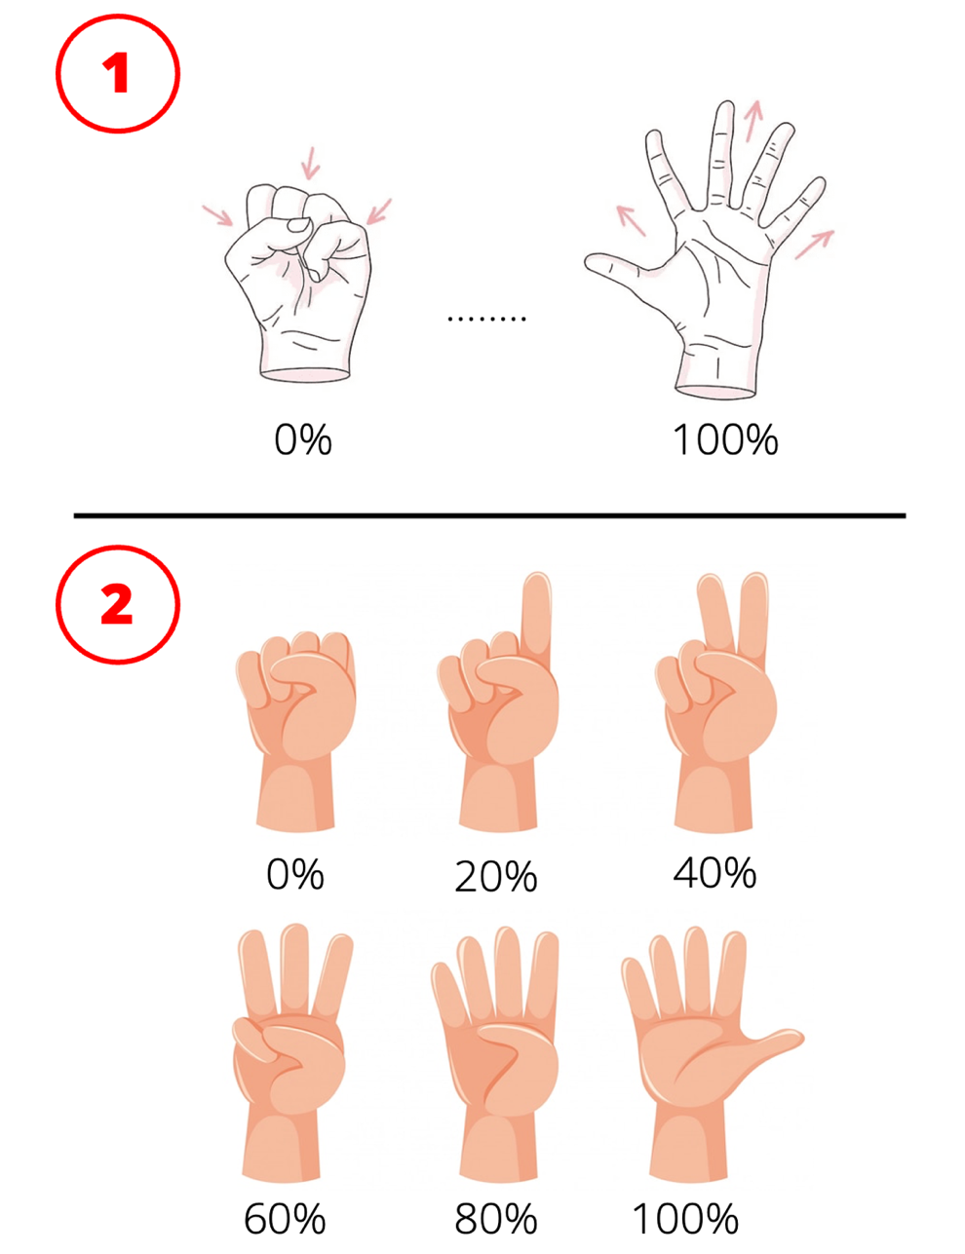
Hold this position to turn off all effects at once
We want to implement and compare these right-hand modulation strategies with the aim of evaluating which interaction style provides the best balance between accuracy, responsiveness, and perceived control in a vocal performance scenario.

Evaluation metrics of this idea
- Accuracy → how a user is able to reach a specific value, for example, 50% wet reverb;
- Stability → how much the value oscillates when the user tries to keep it still;
- Error rate → the number of undesired activations occurred;
- Learnability → how quickly the user understands how to use a gesture;

Feasibility
The overall gesture-based interaction is feasible using real-time hand tracking, but each modality differs in terms of stability, control precision, and sensitivity to noise, requiring specific design and filtering strategies.

Challenging points
What we need to take most care of is the precision of tracking and the stability of movements, especially for movements performed rapidly. So, we can consider to apply some “filters” to reduce jitter and unintended variations in continuous gesture input, improving control precision and perceived responsiveness.
The system reacts only when it receives a signal that is stable enough over time.

What about the audio engine (Logic Pro X)
We used MIDI Control Change (CC) messages, that are a type of MIDI data used to transmit continuous control information, allowing real-time modulation of parameters such as volume, effects intensity, or other audio processing settings. More specifically:
- CC number = which parameter we want to control
- CC value = the intensity of the parameter we want to control
In our solution, we have included a library called “mido” that is responsible to handle MIDI data and messages. Then we mapped up the right-hand pinch gesture into a continuous value (0–127) messages. These messages are sent in real time to Logic Pro via a virtual MIDI port (IAC Driver), where they are mapped to effect parameters (e.g., wet/dry), enabling dynamic and contactless modulation of audio processing during performance.

Evaluation metrics results
In order to verify the effectiveness and reliability of the implemented system, a testing procedure consisting of 10 operational tasks was designed, built around a usage scenario in which a singer, while recording a vocal track, must activate, deactivate and modulate audio effects in real time through one of the two interaction modes provided.
The evaluation is based on four binary-coded quantitative metrics:
METRICS | SUCCESS CRITERION
Accuracy | The user achieves the requested value or action within ±5% of the target
Stability | The user keeps the value stable for at least 3 seconds within the tolerance range
Error Rate | No unwanted activations occur
Learnability | L’utente comprende autonomamente il gesto al primo tentativo, senza assistenza

Overall, the following table compares the performance achieved by the two modes, highlighting a marked difference between the results.
METRICS | Modality 1 — pinch distance | Modality 2 — hand openness
Accuracy | 89/100 = 89% | 66/100 = 66%
Stability | 79/100 = 79% | 63/100 = 63%
Error Rate | 92/100 = 92% | 62/100 = 62%
Learnability | 87/100 = 87% | 66/100 = 66%
Overall total | 347/400 = 86,75% | 257/400 = 64,25%

In conclusion, the data show that Modality 1 is generally the most effective, reliable, and replicable. It achieves superior performance across all metrics: it is more accurate, more stable, less prone to unwanted activations, and easier to learn. On the other hand, Modality 2 shows weaker and less consistent performance. The main critical issue concerns error control: the overall Error Rate parameter is 62%, compared to 92% for the first mode. This aspect is particularly relevant in a real-time musical scenario, where an undesired activation can compromise the continuity of the performance or inadvertently alter the sound result.

