





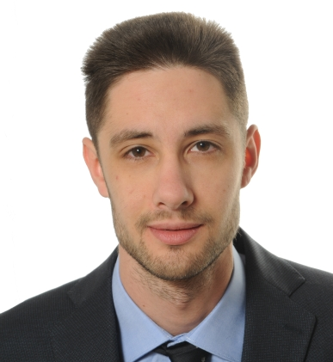

MATTIA
MARSETTI
Control Engineer
CONTACTS
(+39) 349 167 2584
marsigliomarsetti@gmail.com
Via Caggiati 2, Reggio Emilia (IT)
My name is Mattia Marsetti and I was born in the Alps in 1992. After playing with the famous bricks for almost a decade I dedicated my teens in mastering Latin and Greek, while self-teaching informatics. Then I found my way into Engineering, while spending my summers in volunteering.

I’m currently developing the SW that runs the Ferrari Endurance Race Cars, with a focus on innovation, tasks automation and process efficiency. I’m flexible, balanced, with a problem solving attitude.
ITALIAN - native
ENGLISH - fluent
ON THE WEB
Linkedin

EDUCATION
MASTER DEGREE - Automation and Control Engineering
Politecnico di Milano - Milano
HIGH SCHOOL – Diploma di maturità Classica
Liceo G. Piazzi - Sondrio
2011-2016
2006-2011
2020 - now
POWERTRAIN CONTROL ENGINEER – GT Cars
Set up of the SW Sharing environment with the Supplier and SW Development from Requirements to Tests. Debug in HIL/MIL/prototype car
Ferrari - Maranello
2017-2020
SW DEV. & DATA ANALYSIS: mainly Matlab/Simulink, often EXCEL, always GIT
PLAN & PROCESS DEV: Agile Development in JIRA and SW Life-Cyle Development with Polarion
CALIBRATION/DEBUG: proficient with CRETA – INCA – RACECON - MDA – ECU Diagnostics
OTHER EXPERIENCES
REFUGEE EMERGENCY OPERATOR
logistics, transportations for CARITAS – Palermo
Integration project for a refugee family – Sondrio
INTERESTS
Books & Comics
Board games
Film Photography
VOLUNTEER
Phone operator & visits to the hospital for CasAmica - Milano
2014-2017
LUG-AUG
2014 - 2017
LUG-AUG 2013
EDUCATOR
Kids education for Centro di Apojo Infanto Juvanil – Corumbà (Brazil)
PRIVACY
In compliance with the GDPR and the Italian Legislative Decree no. 196 dated 30/06/2003, I hereby authorize you to use and process my personal details contained in this document


