CORE DIRECTIVES
@for
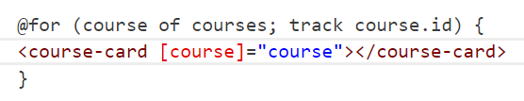
Angular needs a tracking function or you will get a compilation error.
The tracking function helps angular to update the list using an unique identifier, in ngFor directive the tracking function existed but it was’t mandatory.
We can use the @empty if we want to display something else in case the array is empty.
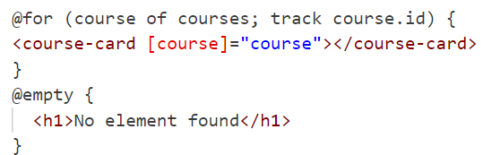
We also can have access to the element index using $index and the count using $count:
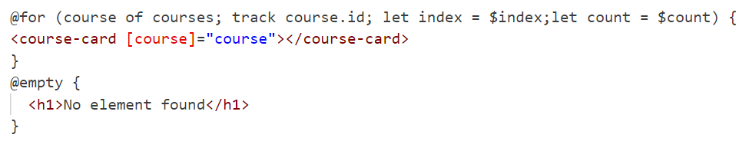
We have some more variables like $first and $last, they are booleans usefull to, for example, style the first and the last element of the array.
The same way we could use for similar pourposes $even and $odd.
Notice that all these variables could be used without renaming them for example:
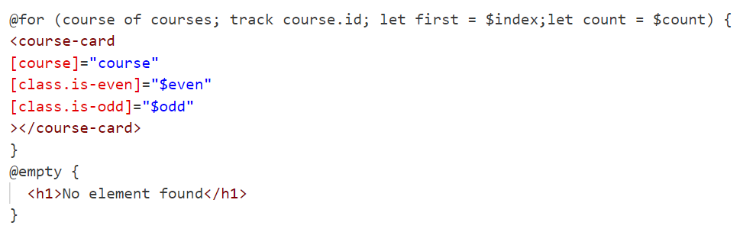
ngFor
the ngFor directive has the following syntax instead:
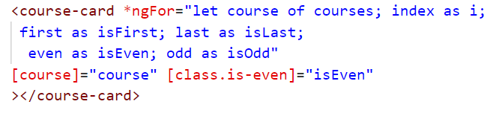
@If
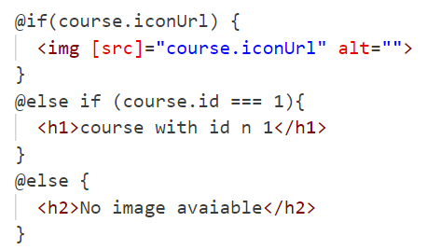
ngIf
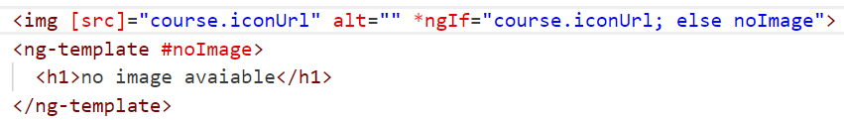
@switch
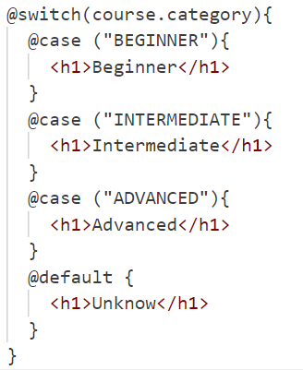
ngSwitch
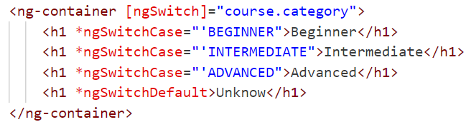
ng-container
It is usefull when you don’t need to create an extra DOM element to only apply one directive(it won’t create a DOM element ).

Local Template Querying
In angular you can have template variables and you can use them directly in the template like in the following example:

But sometimes you need a reference in the component class so you have to query that template variable.
The following example shows how you can have access to a child component directly in the parent component class:
So in the parent template I have:
Meanwhile in the parent class I can query the child class using the ViewChild decorator:
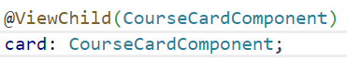
The card will be an instance of that CourseCardComponent. Notice that if I have multiple course-card component in the template the ViewChild decorator will query only the first one.
We can also query via template reference this way:
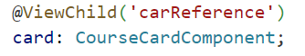
For now we have queryed components but we can also query plain DOM elements this way:
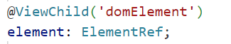
You can get these instance only in the ngAfterViewInit Lifecycle Hook!
We can have access also to multiple children using ViewChildren decorator:
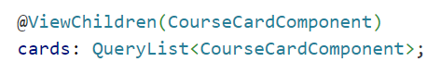
Querylist type is an iterable with a lot of interesting properties, for example the changes property is an observable that emit when something in the list change:
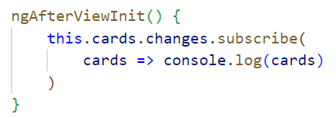
Content Projection
In angular you can put partial template inside a child component tag :
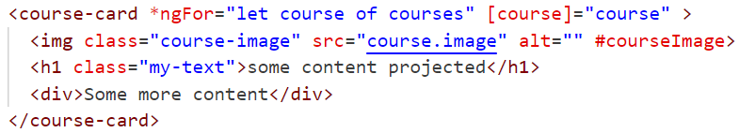
But you have to specify in the child component template where to display the projected content using the ng-content directive:
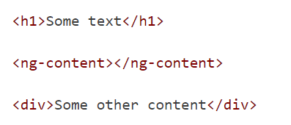
We can also use the select property to select partial template projection:
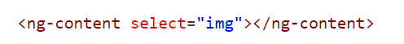
You can also use classes to select partial templates and also project the content in different places in the child template:
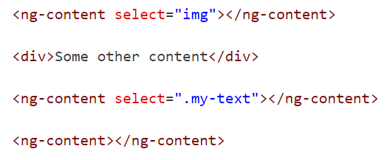
The remaining content will be displayed only if you add another ng-content tag without the select attribute.
There might be some cases in that you want to access the template reference in some projected content, in those cases you cannot use the ViewChild query intead you have tu use the ContentChild decorator:
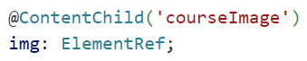
This is restricted only to the projected content in the child component and have the same logic of the ViewChild decorator (you can also use the ContentChildren decorator) but you can have access to that variables in a different Lifecycle Hook , the ngAfterContentInit:
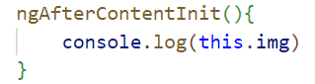

Templates
The ng-template directive allows us to define blocks of HTML that correspond to a single isolated template.
This code is not going to be displayed by default on the page but it's only going to be displayed if we use the template somewhere.
We have to instantiate the template somehow in order for the content of the template to be visible, the template can see the variables of the context on which it's embedded.

We can create local variables and instantiate the template in the following way using the ngTemplateOutlet:
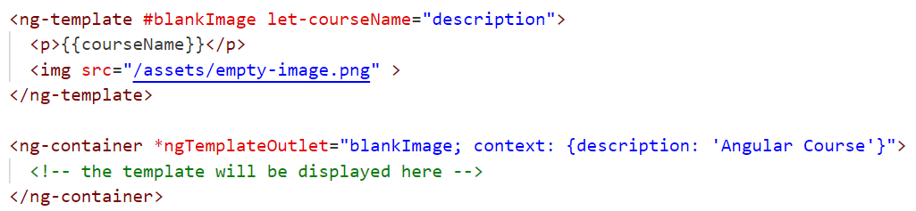
Is a good practice to use an ng-container in order to not create useless DOM elements.

Directives
A directive is a class that can modify the behavior or appearance of elements in the DOM.
For now we talk about structural directives but there are a lot more, for example :
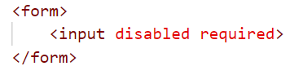
Disabled and required are attribute directive.
We also can generate our custom attribute directive using the angular cli command
And we generate:
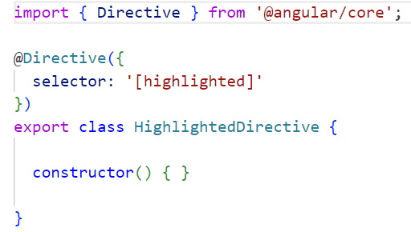
We can apply the directive using his selector:
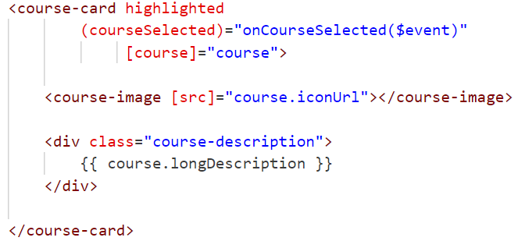
Now this particular instance of a course-card component is known as the host element of the highlighted directive.
So a directive is always applied to a host element.
Let say for example that we want to apply the highlighted css class to the host element of the directive.
We can interact with the host element using the HostBinding decorator:
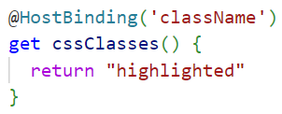
The decorator take as an argument the DOM property of the host that we want to change, and in order to change it we have to define a get function returning the value we want to assign.
For this particular example (adding a class to a host) we can also write:
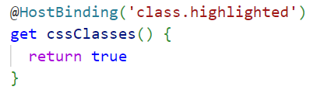
In a similar way we can also modify the style of the host:
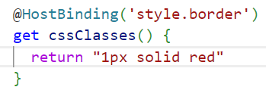
We can also have Input property in our directive, lets say we want to conditionally add our class to the host element:
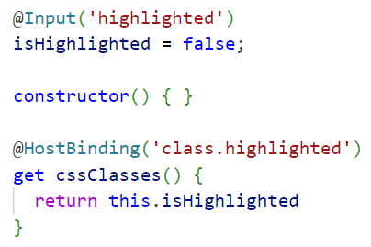
We can also modify DOM attributes:
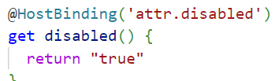
Let's say that whenever we hover over the card with our mouse, in that case we would like to apply the highlighted CSS syntax.
We can do so by using the HostListener decorator.
The host listener decorator is going to take as argument a string containing the DOM event that we want to detect.
So we are going to detect the mouseover native Dom event on the host element whenever we mouse over this element here is the logic that we are going to apply.
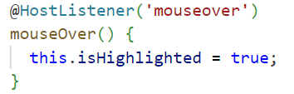

We can have access to the native event usign this syntax:
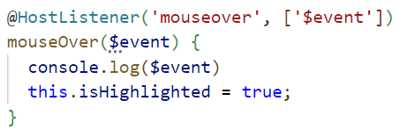
Directives also can emit events:
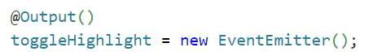
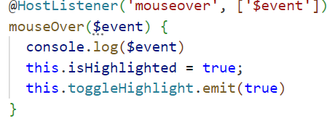
Lets see how we can implement a structural directive:
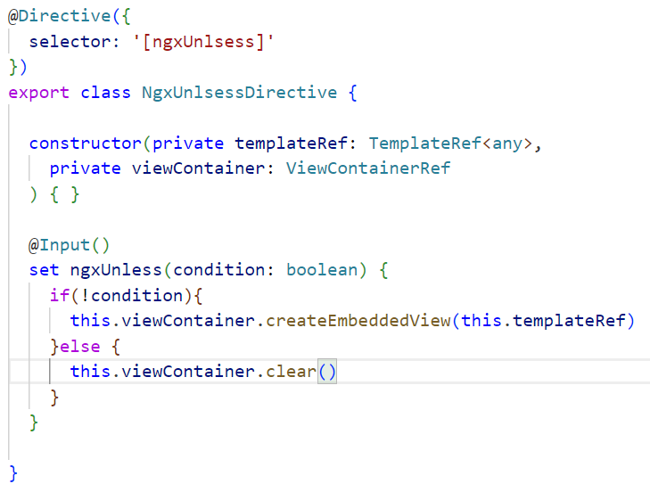
One of the key features of a structural directive when compared to a plain attribute directive is the ability to instantiate a template, so the first thing that this directive is going to need is to grab a reference to this template.
We can do so by directly injecting this template in our constructor.
So if we declare a variable that we are going to name templateRef, this is going to be a programmatic reference to our template.
With this variable, we are going to be able to instantiate the template somewhere on this directive.
Let's remember that the template by itself will not render the HTML.
We need a way to instantiate the template.
So in order to do that, we are going to inject another angular built in service which is called the view container.
The view container is of type ViewContainerRef.
Finally in order to apply our logic we need an input and a setter function.

Angular view encapsulation
Angular create an encapsulated styles for every component, you can add a global style or add some css classes to a particular component.
Angular will apply a particular attribute to every HTML tag that identify to which component it belongs to.
The encapsulated classes will be written with this kind of selector:
.my-class[_ngcontent-c1]
If we want to style the host element of the component inside the component itself we cannot do this:
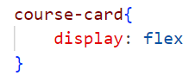
Instead we could use the angular host syntax:
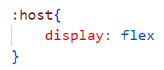
The style will be apply with a different attribute identifier like:
[_nghost-c1]
If we want to apply a certain style based on parent classes we could use the host-context pseudo class.
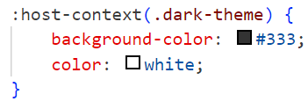
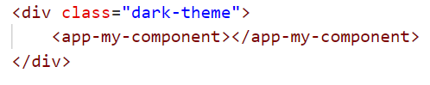
The style will be applied only if the component is inside a container with that particular class.

Dependency Injection
The provider is what creates the dependency on behalf of the angular dependency injection system.
So somehow the dependency injection system needs to create an instance of courses service.
The way to create that dependency is the provider.
The provider will give the angular dependency injection system a function known as a factory function that creates a dependency.
The angular dependency injection system will then call the factory function and generates the dependency.
Usually we specify this in our Injectable decorator:
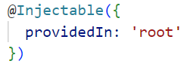
But we can try to manually write a provider, so in the component:
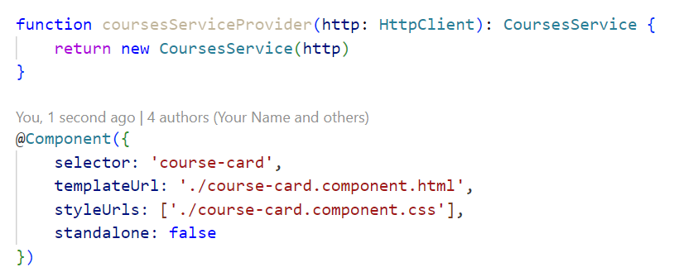
As you can see the provider is a simple function that gives a new instance of the service.
Now if we want to pass this function to the component we have to define the providers property of the component decorator, passing this configuration object:
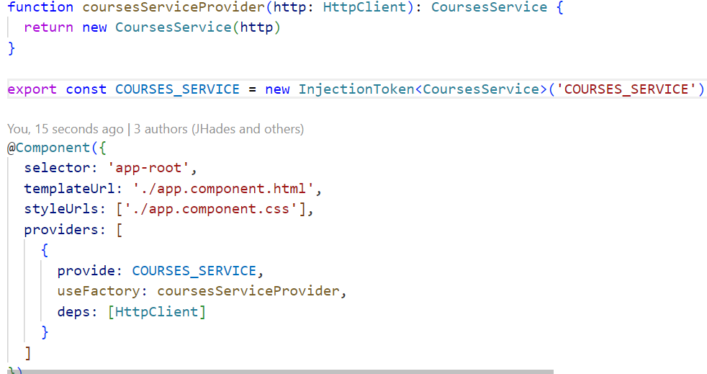
Each dependency in the dependency injection system needs to have a unique name.
So we have created the so called injection token. The injection token is like a unique identifier for a dependency.
And after having the factory function, we have then informed Angular how to create a course service by specifying these two things the unique token for the dependency and the factory function that Angular can call in order to get a course service.
Finally we have to specify in the deps property the dependencies of the service.
Now we are ready to inject the service in the constructor:
We hawe to specify the injection token in the Inject decorator.
This was for theory purposes, angular supports as injection token classnames and class constructor as factory function:
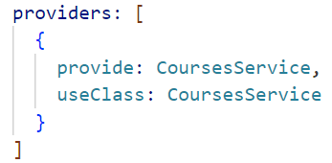
In more compact way we can only pass the class name to the providers array:
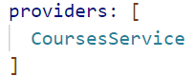
If we provide the services this way we will create an instance for the component and for all the children components, If we provide a courses service in a child component it will create another instance.
So when you inject a service in a constructor Angular will search a provider instance in the component, if it won’t find any provider, angular will search in the parents providers. This is called Hierarchical Dependency Injection.
We can also be sure to have a singleton instance of our service by using:
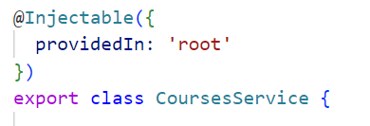
To do so we provide the service in the AppComponent from the service class itself, this is called the Tree-Shakeable Syntax.
We can also inject services in directives, if we want to be sure that the instance of the service comes from the host component of the directive we can use the Host decorator in the directive constructor:
Change detection
Change detection is the built in angular mechanism that Angular provides us out of the box in a transparent way that automatically rebuilds the view whenever the model gets changed.
What happens here is that after each event that is getting handled by Angular, Angular is going to go over all the expressions of the template that it has analyzed whenever the template was first compiled, and Angular is going to see if, something has changed.
Angular is trying to display data from mutable JavaScript objects on the screen if anything happens at the browser, such as, for example, a native Dom Click event, a timeout etc..
That asynchronous event can potentially modify the data. The only way that Angular has to be sure that the view always correctly reflects the data is to run all these checks again and update the components whenever necessary.
It might be expensive in terms of performance, this is why we have the opportunity to use OnPush change detection.
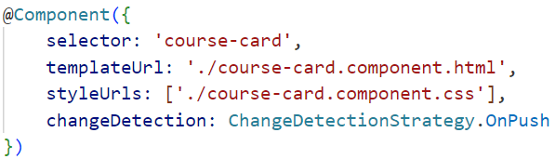
The two mechanism works the same way inside the component but if now if we try to modify somenthing from the parent component we have to do some tricky stuff.
Lets say for example that we have an input property that is an object.
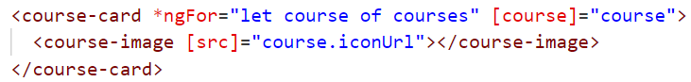
If we try to mutate the object property from the parent component when we click on a button and we fire a function:
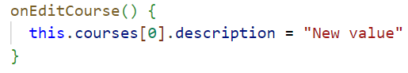
We can see that the view of the child component is not updated.
In order to do so we have to create a shallow copy modify the property of the copy and than modify the replace the entire object with the new copy:
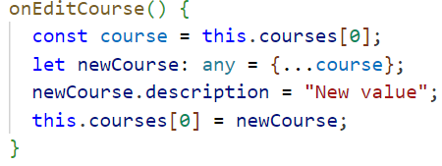
When using OnPush Angular is not going to try to detect changes on the input data by analyzing each of the expressions of the template.
Instead, Angular is going to try to detect changes in the input data of the component.
Notice that if an event handler gets triggered, then Onpush change detection is going to be triggered, just like the case of default change detection.
With Onpush, if we know that the inputs of a given branch of the component tree have not changed, then we can skip the whole branch entirely.
So if this course card component would have child components, those child components would not be checked for change detection if the course card component did not have itself, some changes passed to it so a whole branch of the component tree gets bypassed.
Also, in the case of input data such as, for example, JavaScript objects such as the course object, we are comparing the data that gets passed by object reference.
Onpush change detection will also look at any observable streams that are registered in the template using the async pipe and see if a new value got emitted by the registered observable.
This means that with onpush change detection, there are two ways to push data to a component, either via input properties of the component or via observable streams via the async pipe.
Both ways of pushing data to the component will trigger the rerendering of the component.
If we have an input property that remains constant during the whole application runtime for example:
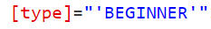
Instead of passing it as an input property we could use the attribute decorator, this will improve application performance:
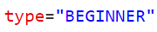
And in the child constructor:
This is called OneTime Binding

LifeCycle Hooks
OnInit and OnDestroy
ngOnInit is called once when the component is initialized, so after the constructor and when the original inputs are instantiated, is meant to put the initialization logic.
ngOnDestroy is called once just before the component get destroyed, is meant to releasing any resources that the component might be using, such as, for example, long running observables that are fetching data from a real time database.
OnChanges
ngOnChanges is called when input properties of the component change:
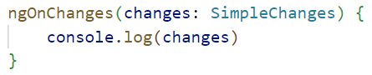
It takes as an argument a value of tipe SimpleChanges that is an object with inputs names as keys and those are also object of type SimpleChange and they have 3 properties: previousValue, currentValue, firstChange.
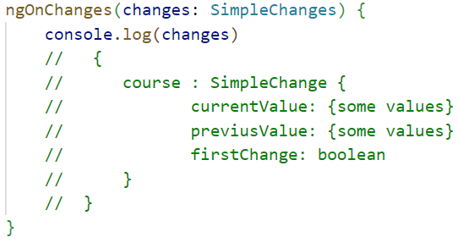
AfterContentInit and AfterContentChecked
ngAfterContentInit is called once after the content projected inside of a component is inserted, is meant to initialize things related to the projected content with @ContentChild variables.
ngAfterContentChecked is called every time the projected content is checked form the change detection mechanism. Notice that if we try to change something of the projected content in this lifeCycle hook we have a compilation error:
ExpressionChangedAfterItHasBeenCheckedError
That’s because we are trying to change some properties when firing change detections and this would cause an infinite loop.
AfterViewInit and AfterViewChecked
ngAfterViewInit is called once when Angular has created and initialized the DOM of the component is meant to have acces to the @ViewChild template variables.
ngAfterViewChecked is called every time the change detection mechanism occurs and is meant to have acces to the @ViewChild template variables updated. Similar to AfterContentChecked you cannot modify the view data in this lifecycle hook.
DoCheck
ngDoCheck runs every time the change detection occurs but before the view is updated and is meant to personalize the logic of change detection.

Pipes
Lets say that we would like to implement a custom pipe that filters our courses by category this way :
A pipe is a really simple class:
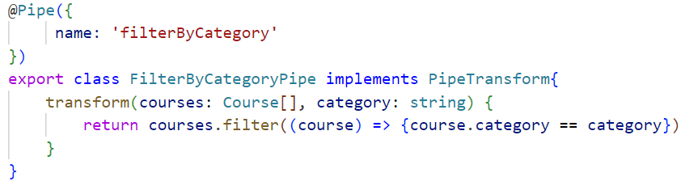
It has a Pipe decorator with the name of the pipe and it implements the PipeTransform interface, which has une method, transform(), who take as first argument the element whe are going to transform and as the second one the parameter we use for our logic.
The output of the transform method is the element modified.
Notice that the default behaviour of pipes is to not be updated with change detection if we want to modify this behaviour we need to specify that our pipe is an impure pipe:
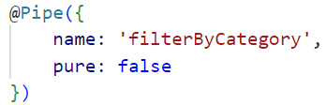

Angular Modules
An Angular module (often called an NgModule) is a fundamental building block in an Angular application. It's a container that groups together related components, directives, pipes, and services, so they can be organized and reused easily.
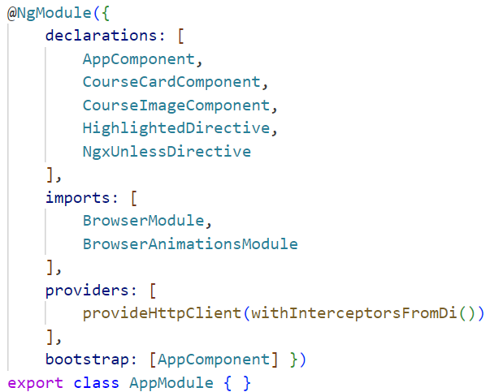
So first we have the declarations property, this is an array containing all the components and directives that are part of the module.
So as we can see, we have here the application root component, a couple of extra components, a directive, and we could even add here a pipe if we build a custom pipe.
So in summary, this is the list of components, directives and pipes that belong to this module.
Next we have here the imports property, this is where we are going to define the dependent modules of this module.
So this import statement means that the NG module application module, which is the root module of our application, also needs internally the browser module, the browser animations module and the Http client module.
Then in the providers we can declare our services instead of declaring them in the components.
The last property that our application root module is using is the bootstrap property, this property is used to identify the root components of our application component tree.
So in this case we only have here one component, which is our application component, but we could have several root components in an application.
Now lets try to build our module:
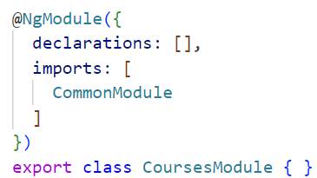
In the AppModule we have to import the new CoursesModule:
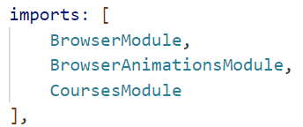
Now we want to move the course card component inside the new module:
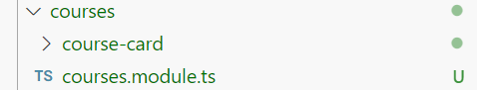
And we can add it to the declarations of our new module and then we can delete it from the AppModule:
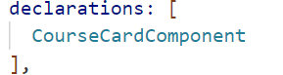
We can proceed this way with all the component and directives retated to the card in order to have a separate module.

Standalone Components
Standalone components sit outside of any module and can be used directly without being integrated into a particular module.
You can migrate automatically to standalone the entire application running the following command:
ng generate @angular/core:standalone
If you want manually migrate the application you have for each component set:
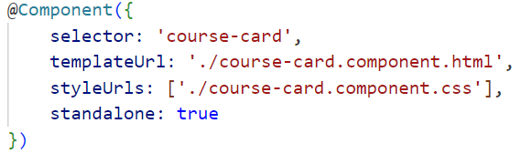
Then you have to import anything you need in your component:
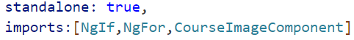
You can now remove every import on the module.
The last thing to do is to refactor the application Bootstrapping, in the main.ts file you usually have:
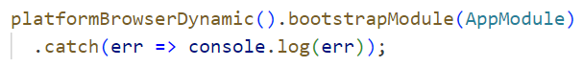
Instead we have to write:
