Stateless Observables Services
Understanding potential problems of a program written in Imperative Style
In our component we have a http request that calls a list of courses using the angular httpClient.
It returns an observable we can subscribe on, when it resolves we can have access to the courses list.
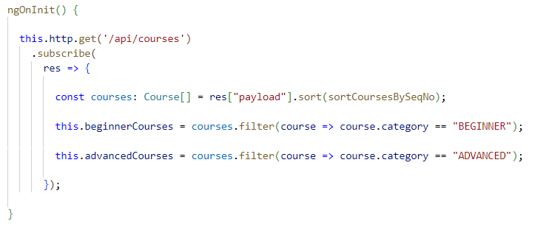
In a more complex code we can occurr in a “callback hell” and also the component know too mutch where the data came from and do too much work and those data might be usefull in other parts of the application.
Design Pattern: Stateless Observable-based Services
We create inside the app folder a new folder “services” and inside of it a new file “course.service.ts” we pass the “providedIn: root” option to make it a singleton instance of the application.
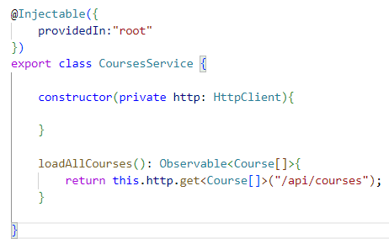
But now we ar not returning an observable of courses array but directrly the http response without modifying it.
So if we want to return a Course[] Observable we need the “map” operator.
Rxjs operators are chainable functions that allows us to quickly combine different observables in order to obtain different types of results.
In our case, we simply want to create an observable that is derived from the one that we already have, we could easilly see the operator behavior from the rxjs officcial website looking ad the marble diagram:
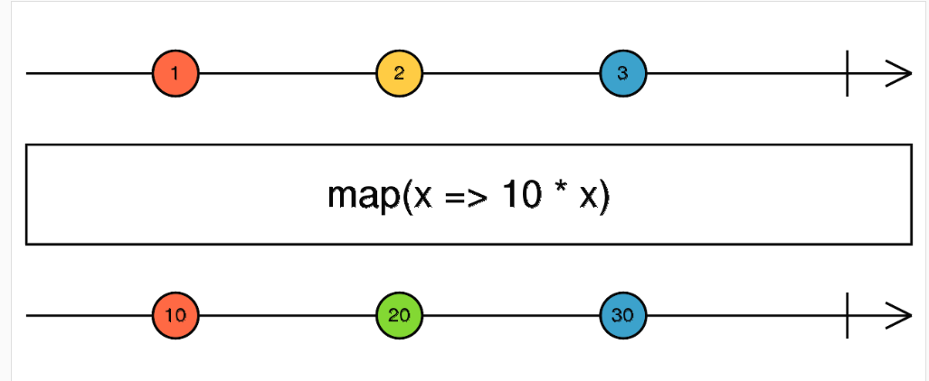
Now, how does the map operator work?
The map operator is going to take as an input, a mapping function. for example, this function here takes as an input, a value and multiplies it by ten.
What the map operator will do is taking the original source observable (1,2,3) and create a derived observable as you can see at the bottom of the diagram.
So we can access the payload property that countains the courses from our BE service and return our derived observable:
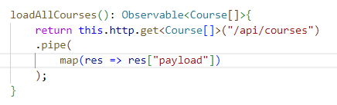
It’s important to understand that our service is only returning observables and the data emitted by the returned observables is not kept here in our service.
So our service is stateless, meaning that it does not hold any application data.
The only thing that the service holds in memory is a reference to the Http client in order to be able to do the Http calls.
Consuming Observable-based services using the angular async Pipe
Now we can refactor our component in reactive style:
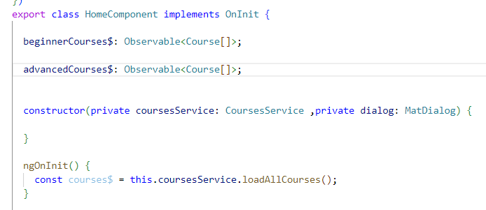
As we can se we have two observable variables that will derive from courses$ variable, but first lets see how to use them in our template:
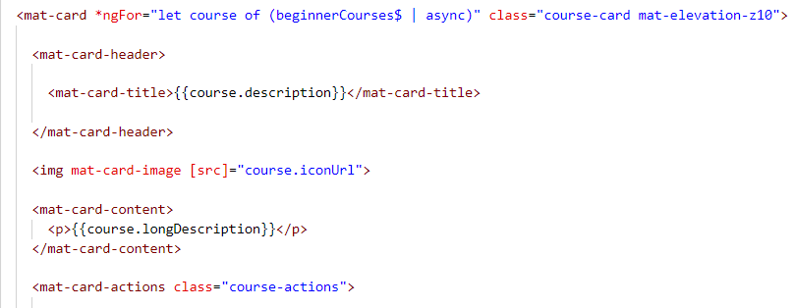
In Angular, the angular async pipe is going to subscribe to the beginner courses observable and is going to make the values emitted by the observable available to our template.
This pipe is essential to proper reactive programming. The async pipe will not only subscribe to the observable and get its values available to the template, but also when the component gets destroyed this async pipe will also unsubscribe from the observable if it's not yet completed or errored out.
And this way we will avoid any potential memory leaks in our component.
Now we can derive our variables from our courses$ variable using the rxjs map operator:
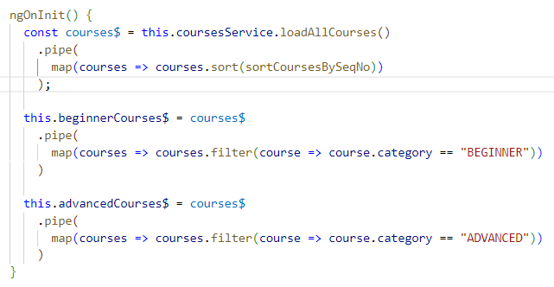
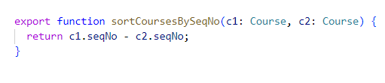

Avoiding Angular duplicate HTTP requests: The shareReplay operator
Using the previous code we can see that we are calling two times our API, that’s because we are using two times the async pipe so we are subscriving two times to our observables.
Now for every subscription we are going to get a separate Http request.
Let's remember that in the case of observables, if we don't subscribe to this observable returned here by loadAllCourses, then nothing will happen.
The observable by itself will not trigger an Http request.
This might be different for other types of observables, but in the particular case of angular Http observables, everything happens in a lazy way, meaning that the request to the backend is only going to get triggered if somebody is interested in receiving the value emitted by the backend.
So if somebody subscribes to the observable, if no subscriptions occur, nothing happens.
Using the shareReplay operator we solve the multiple subscription problem.
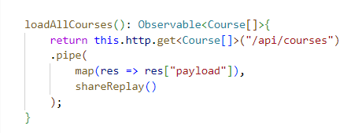
Notice that this is only applicable for this specific type of services.
So angular services that internally use the angular Http client, which are probably the most common type of angular services.
Data modification example in Reactive Style (Stateless Application)
We want now modify a course, we have a mat-dialog with a form and we wanto to implement a saveCourse method in our CoursesService:
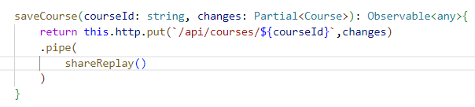
The changes variable is a Partial<course> so we don’t have to pass the entire course.
We do a put call passing the correct endpoint with the courseId and our changes object and also we will use the shareReplay operator to avoid multiple put http requests.
We can now using this new method in the mat-dialog component
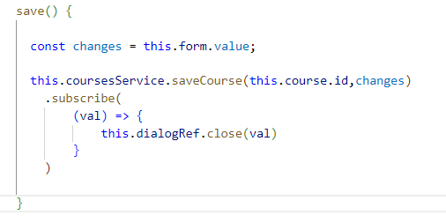
When we successful subscribe to the observable we close the dialog passing the value received from the subscription to distinguish from a simple closing.
Now we go back where we opened the mat-dialog:
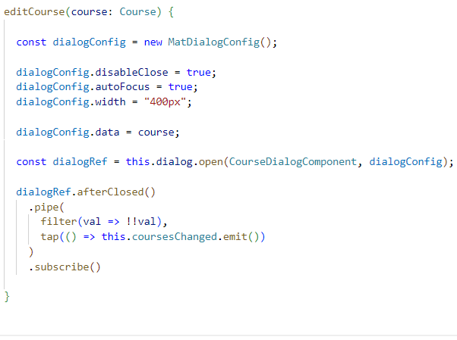
We can access to the afterClosed observable, the filter operator will filter if the dialog closure is from the change button and not from a simple closure, the tap operator is used when there are some side effects like in this case an eventEmitter emit().

Reactive Component Interaction
Decoupled component communication using a shared Service
In this lesson we are going to start implementation of our loading indicator solution.
As we will see by adopting a reactive design, we are going to make it very simple for different components at different levels of the angular component tree to easily interact with the loading component in a decoupled way.
First of all we set our loading component in the appComponent template:
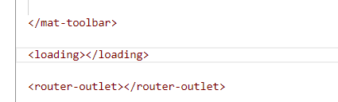
Now we ask ourselves: how the homeComponent could interact with the loadingComponent to show the loading indicator?
We use a shared service:
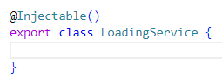
Notice that we are not using providedIn: ‘root’ because this service could have multiple instance in our application. For that we have to give it to the providers array of our application component so that istance is visible in the appComponent and in its children.
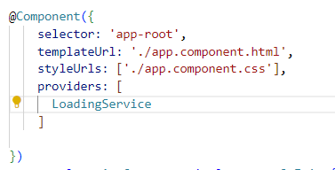
Now we inject the LoadingService in the LoadingComponent and in every component that could needs a loading indicator.
Our service will have just an Observable witch tell when to display the loader indicator and some methods to manage this Observable.

We can consume this Observable in the LoadingComponent template by using the async pipe:
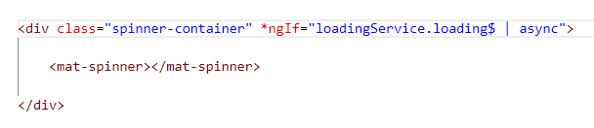
Lets see how our LoadingService look alike:
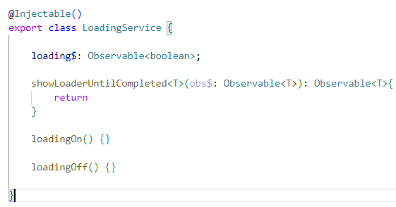
The showLoaderUntilCompleted is going to take as input argument an observable which is the observable that we want to track the life cycle in order to decide if the load indicator should be used or not.
And we are going to be returning as the output of this method, another observable of the same type.
And that observable that we are returning here is going to have a loading indicator capabilities.
So these new observable is going to be able to turn off and on the loading indicator at the appropriate moments.
Now these methods should be compatible for observables of any type.
So let's make this a generic type by adding here a generic type argument to our function so with this, we will be able to have type safe code with any type of observable.
Reactive Component Interaction using Custom Observables and behaviour subject
So the key component of our design is the loading observable, which emits observables of type boolean.
Now the question is how are we going to define this loading observable?
Well, the key ingredient for defining custom observables in any application in general is rxjs subjects.
A subject is very similar to an observable in the sense that we can subscribe to a subject just like we subscribe to an observable, but the subject has the extra capability of emitting values by himself.
So with an observable we only have a subscribe method, but we have no way to control the values emitted by the observable that is not the case with a subject.
With a subject we can define exactly when this observable here can emit the values.
Let's then define here a new rxjs subject.
We are going to be calling it the loading subject, and we could be tempted, for example, to use the Rxjs default subject class.
However, in general, I think it's better to use the BehaviorSubject class.
The BehaviorSubject class is a special type of subject that remembers the last value emitted by the subject.
So any new subscribers are going to receive the last value or the initial value in case that no value was emitted yet.
This is better in general for asynchronous applications because we don't know the exact timings of the life cycle of each component.
Like this we have defined a new subject with the initial value of “false”.
The idea is that anyone outside of the loading service should be able to subscribe to the loading observable and receive new values, knowing if the loading indicator should be displayed or not.
However, only the loading service should have control over the ability of emitting the values that’s why the loadingSubject is private.
So that's why instead of exposing the subject directly to the outside of the loading service.
We are going to instead take the loading subject and call here the asObservable method.
This is going to derive an observable from the subject that emits the exact same values as the subject, but it's simply an observable, so the loading observable will not allow us to control what values are emitted with the loading observable.
Now we can implement the two function that emits the values from the loadingSubject:
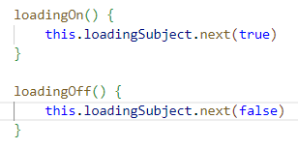
So the loading$ observable will receive the values true/false.
Finally we can implement the loading functionality in the HomeComponent:
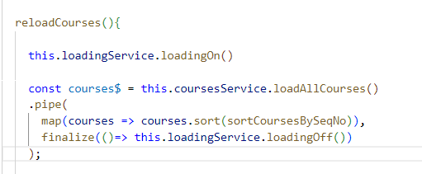
The Rxjs finalize operator is always going to be called when the observable that we are receiving here as input either completes or errors out.
We can improuve or code using the showLoaderUntilCompleted method:
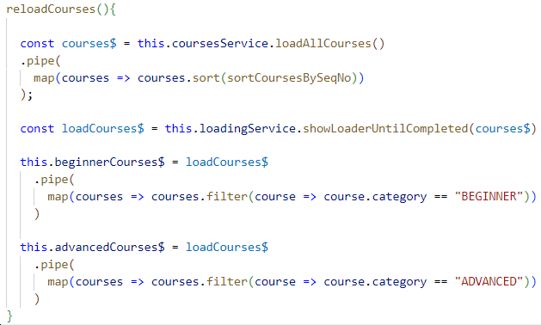
With this we don’t have to manually turn on/off the loader and we get rid of the finalize operator.
Let’s have a look at its implementation:
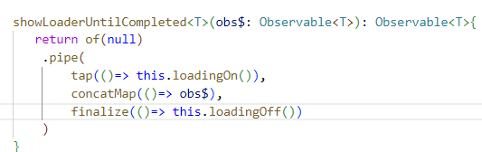
In order to create our initial observable we use the rxjs factory method of and we create an observable that initially emit only one value, the value null and then it will complete immediately.
Why is this initial value usefull?
When we receive this initial value we trigger a side effect with the tap operator in order to show the loading indicator.
We want this observable to now to start emit the values emitted by the input observable in order to switch from the values emitted by this initial observable and the values emitted by the input observable.
I'm going to be using a higher order mapping operator, the rxjs Concatmap operator.
Concatmap is going to take the values emitted by the source observable in this case, the initial observable (that one created with the of operator), which only emitted the value null and then it completed immediately.
And Concatmap is going to transform this value into a new observable, which is going to be our input observable.
This means that the values emitted by the result observable are going to be identical to the values emitted by the input observable, with the exception that the loading indicator has already been turned on.
When the input observable obs$ completes or errors out we turn off the loader using the finalize operator
Understanding the Angular Component Providers property
If we try to use the LoadingService in the matDialogComponent we get a nullInjector error, that’s because the component is not a direct child of the AppComponent.
So we have to provide the service instance in the providers array of the component.
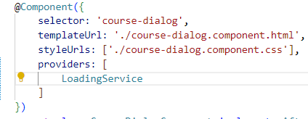
We don’t have to forget to add the selector tag in the template:
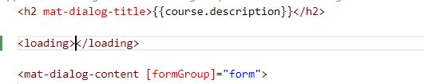
Error handling and the messages component
We now are going to create a component to give some error messages to the user.
This component is really simple and will display the messages we are giving to it in the top of our application.
So we put the selector tag in the appComponent template:
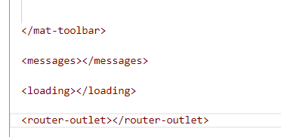
We already created a service MessagesService that we will implement later, but for now we provide the instance to the providers array in the AppComponent.
So for now we want to catch the errors and give them to the MessagesService and then it will take care of everithing else.
Let’s imagine that somethig went wrong while fetching all the courses from the backend:
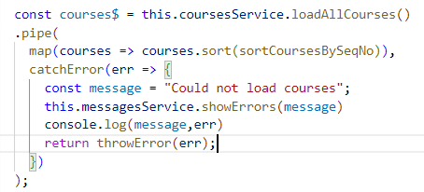
In that case, the first thing that we need to do is to somehow catch the error here in our observable chain, for that we are going to be using here the catchError Rxjs operator.
As the input argument of catch error, we are going to be receiving the error that the application has thrown and as the output of this function, we need to provide a new observable that is going to replace the failed observable.
We also want to call the messages service and inform the user that something went wrong.
Now here, as the output of this method, as we have mentioned before, we need to return a new observable that is meant to replace the observable that has errored out.
Now in our case, we don't really want to replace the source observable with a new observable but we want to instead terminate our observable chain.
So for that we are going to be returning here a new observable using the rxjs throwError factory method and we are going to pass the error that was received here on catch error.
So throwError is going to create a new observable that immediately emits the error and it ends its lifecycle.
So effectively we are terminating here our observable chain.
Yes, we are replacing this observable with another observable, but that new observable is going to immediately error out with the same error.
So it's not like load all courses was replaced with a new observable that continued to emit values over time.
Messages Service – implementation finished
After inject the service in the messages component we can consume the messagesService errors$ variable in the template:
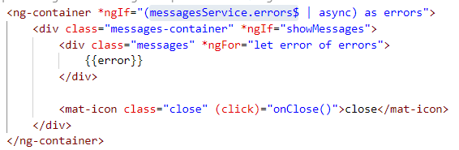
Let’s see how we can implement this observable:
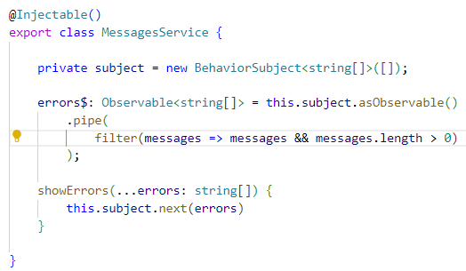
Like we did before we create a subject with the default value of an empty array.
Then we derive the public observable from the subject and finally we implement a method that make the subject emit the values.
We also filtered the default value emitted (the empty array);
As we can see below we have to set the showMessages flag to true in order to see the messages panel: 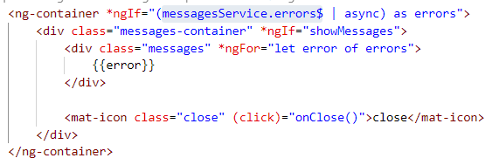
We can see this as a side effect of the emitted value, we can create a local observable derived from the messagesService errors$ observable and then use the tap operator.
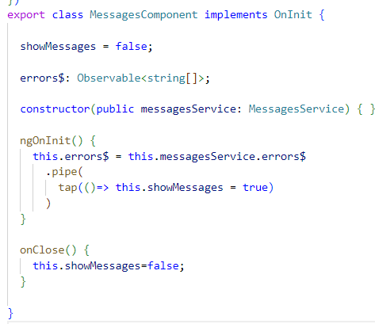

Angular State Management
When is it needed and why
Adopting a stateless solution it's very easy to maintain, to develop new features to reason about, but whenever the data changes in our application, the only way that we have to update the view is to bring again the data from the server.
And even if the data is not modified, if we navigate away from the screen that fetch the data that we want to display and we come back to that same screen, such as, for example, the home component, we are going to have to reload the data again.
Stateless solutions such as this one might be perfectly adapted to a large number of applications, and we should only add state management in our application if we really need to.
The general recommendation is to try to keep your application stateless and only add state management if you really need to improve the user experience.
If you have network requests that are very slow, that are really harming the user experience, if you are showing a lot of user indicators to the user, if there are long backend delays, then in those cases you can consider state management.
Initial implementation of a Store Service
In order to add state management to our application, we are going to be needing a different type of service, this new type of service, instead of being stateless is going to be stateful.
This means that the service is going to keep some state in memory, such as, for example, a list of courses in order to make it clear for anyone maintaining the application that this type of service is a stateful service, we are going to be calling this type of services a store.
We now create a CoursesStore:
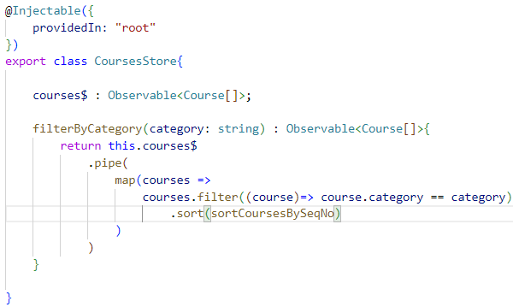
Besides data modification operations, the CoursesStore might also expose functionality that allows us to more easily consume the data that is stored in memory.
We can imagine, for example, here a new method called filter by category that would allow us to easily get back only the beginner or advanced courses.
If we use this store in our component it will look like this:
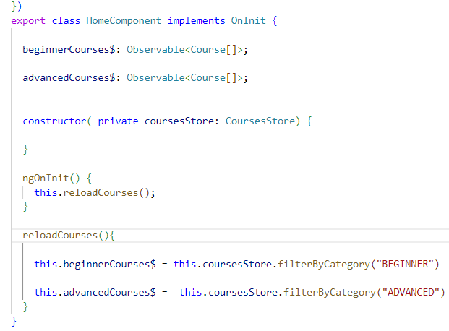
All the logic will be moved on the store, the component will appear more clean and simplified.
Step by step implementation of an angular store service
As we did before we use a new subject to define our custom observable, after some logic implementation we already seen the store will be like:
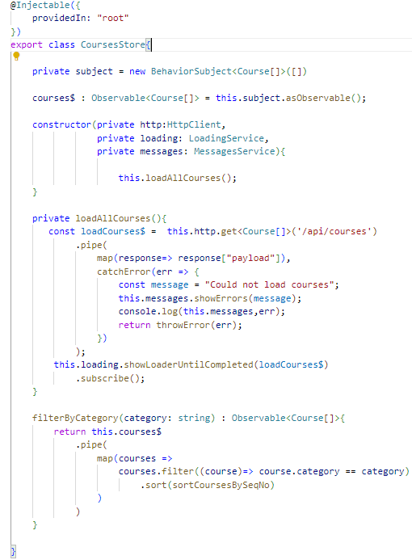
So now we are retrieving the courses from the backend, but we are not yet saving them somewhere in memory. In order to do that we are going to be using the subject.
So what we want to do is whenever we get the data from the backend, we want to call subject .next() and emit that data to any part of the application that might be interested in receiving it, such as, for example, our home component.
So we are going to be doing that as a side effect of our observable chain here after catch error.
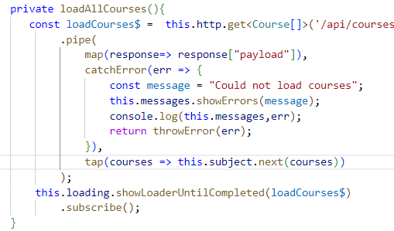
But if we try to run the application it will crush with a compiling error, that’s because we defined the LoadingService and the MessagesService in the AppComponent and for that we don’t have access to their instances here in our store.
To solve this problem we provide the two instances in the AppModule instead.
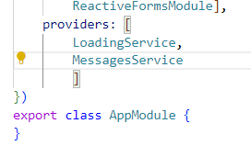
Now if we try to navigate on and away from the course component we will se that the data won’t be loaded multiple times and the loader will trigger only the firs time.
Store Optimistic Data Modification Operations -API Design
What we want to do now is to expose in the public API of our store a new method called saveCourse that is going to allow us to modify the data of a particular course.
Here is how this is going to work: We are going to do the data modification in an optimistic way, meaning that we are going to modify the data of the course directly in memory and we are going to emit the new value of the data via the courses observable immediately.
So we are not going to wait until the data gets saved on the backend before notifying the rest of the application.
This is going to give us a very responsive user interface where any data modification operation gets immediately reflected in the user interface without the need to show a loading indicator to the user.
I wont say more about this section, it’s not a common use to do such optimistic operations.

Authentication State Management
We want now create a store that manage the authentication data of our application.
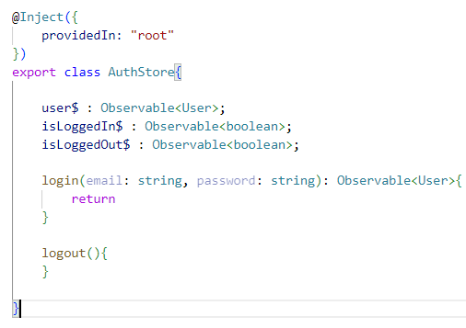
Firs of all we define the derived observables like we did in other sections:
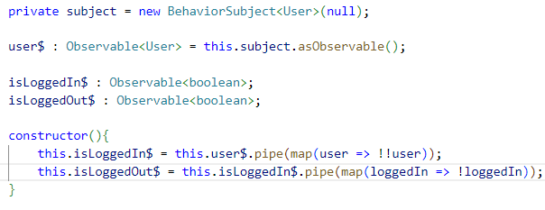
The login and logout function will look alike:
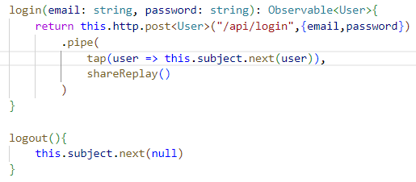
Basically we are emitting the User nor null.
Now we can use this service in the login component to authenticate the user:
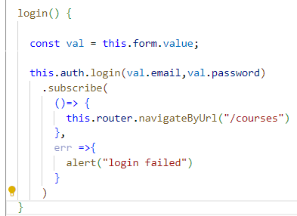
And the logout in the AppComponent:
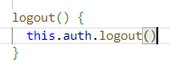
We could also show and hide the login and logout items in the sidebar:
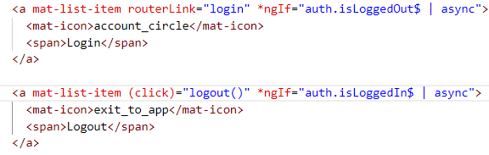
Authentication Store – Browser Refresh support with Local Storage
We want that our user authentication survive to the refresh button.
We start defing a localStorage key:
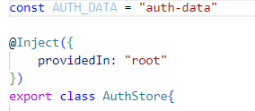
Ad saving the user into the localstorage:
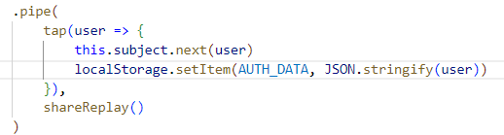
In the costructor we now verify if the user exists and then emit the value from the subject. We also remove the item in the localstorage in case of logout.
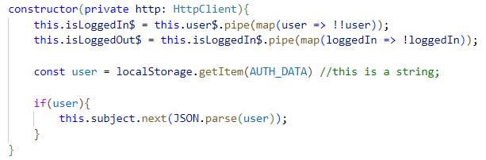
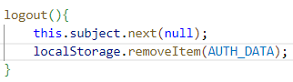

Master – Detail UI Pattern (with built-in State Management)
In this new section of the course, we are going to present another very common use case that benefits from some local state management.
A typical example of a master detail pattern happens whenever we want to do a search and we want to display a list of results and then we want to click separately in each of the search results and have a detailed view of the search result replacing the table view with the opportunity to go back.
So whenever we go back to the search results, we don't want to have to repeat the search again.
Instead, we want to take the search results from an in-memory store and we want to display them immediately to the user without having to contact the back end again.
This time we will store the data directly into the component.
In practice we have two components, one for searching and display results and another for display the lesson detail.
We can start with the SearchLessonsComponent:
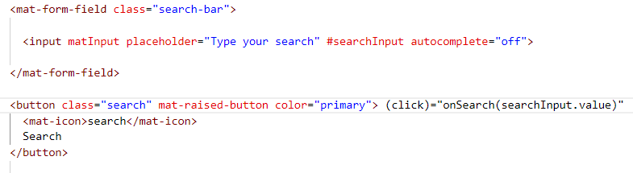
In its template we have an input tag with the #searchInput reference and a click emitter binded to the onSearch function, we pass to that function the searchInput value.
In the component we implement the onSearch method: 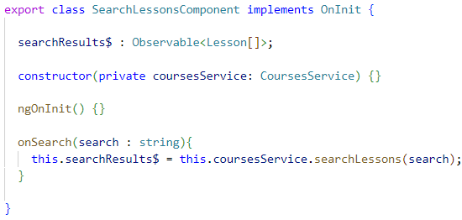
The searchLessons from the courses service will look like:
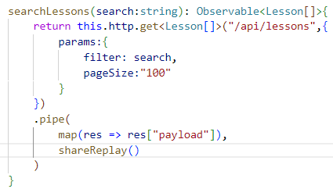
And in the template we consume the result with the async pipe:
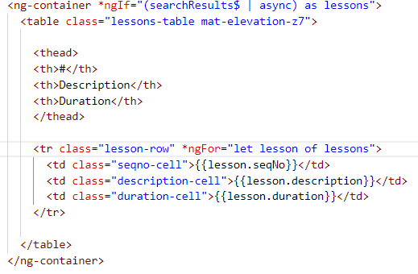

We continue the implementation this way:
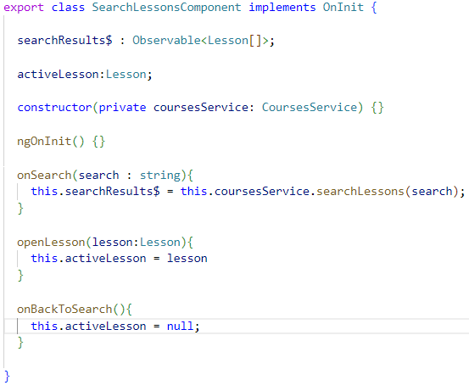
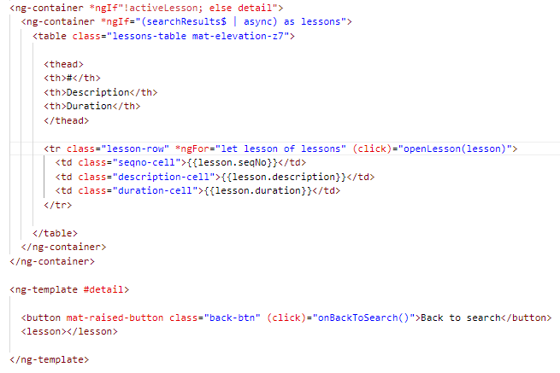
Then we only have to finish the lesson detail component but its implementation is not usefull for our purposes.
The importance of this lesson is the stored observable searchResults$ at the level of the component. This is acommon practice for search results like in this case.

The Single Data Observable Pattern
Imagine to have two or more observable fetching data from the backend. The template might look like:
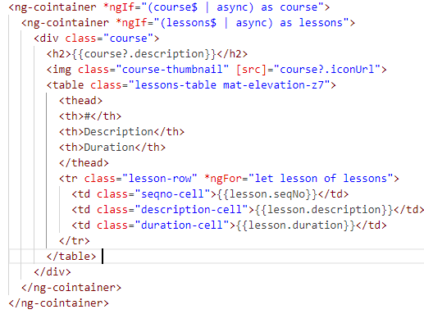
But the nested ng-containers are not a good solution, in particular when we have few of observables.
We can use a pattern to store all the observables in one variable.
We create an interface inside the component and a new observable:
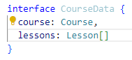
So we can refactor our template:
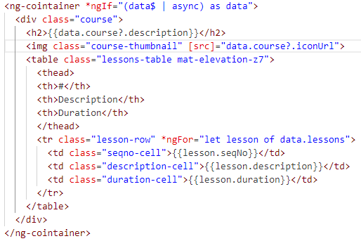
We now have to populate the new derived observable starting from the previouses ,but we are not going to wait for both observables to emit a value, instead, we want to emit a first value containing only the course.
And then when the lessons data is available, we will be emitting a second value, containing both the course and the lessons.
This way we are going to be able to feed the template with data as soon as the data is available from the backend.
So in order to create our derived data observable, we are going to be using the Rxjs CombineLatest factory function.
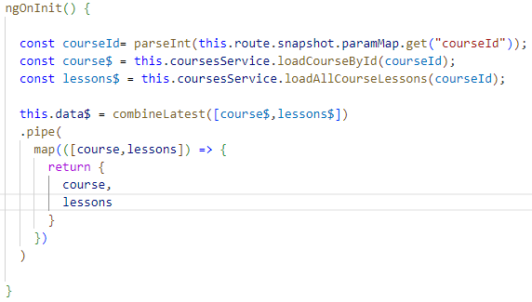

So in our case we want to combine the course observable with the lessons observable and notice that the returned value by combinelatest is going to be an observable whose values emitted are tuples.
So they are not objects containing these particular properties ,instead, Combinelatest is going to be emitting TypeScript tuples, which at runtime are arrays where in this case the position zero of the array would contain the values emitted by the course observable and position one would contain the values emitted by the lessons observable.
However, we can see that our implementation is not yet fully working as we want it to.
So if we refresh here the page, we can see that we get here an initial blank screen and only when the data observable emits its first value do we then display the data to the user.
So this is not the behavior that we would want.
The course data is available much sooner than the lessons data in our application, so we would like to be able to display to the user the course title and the thumbnail while the lessons are still loading.

This means that we would like our data observable to emit two values one initial value containing only the course once it's available and a second value containing both the course and the lessons.
Once the lessons are available from the backend, let's see how can we achieve that?
The problem is that combineLatest emits its first value only once all the first values are emitted, and then it will emits values each time one of his internal observables emits.
We can fix this problem with startWith:
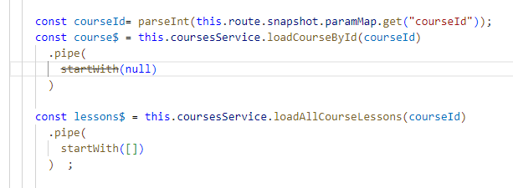
So the variables emits a default value once created, the data observable will emit:
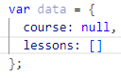
Then when the course$ emit:
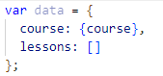
And when lessons$ emit;
