Characterizing Quartzite Points along Ume river valley, Västerbotten, Sweden

Mattias Sjölander1,✉

26 mars, 2021

Here is an abstract

1 Umeå University

✉ Correspondence: [Mattias Sjölander <[mattias.sjolander@umu.se](mailto:mattias.sjolander@umu.se)>](mailto:mattias.sjolander@umu.se)

Keywords: XRF; quartzite; pca

Highlights: These are the highlights.

# 1 Introduction

Here is a citation (Marwick, 2017)

# 2 Background

# 3 Methods

# 4 Results

#> Ag   
#> 51

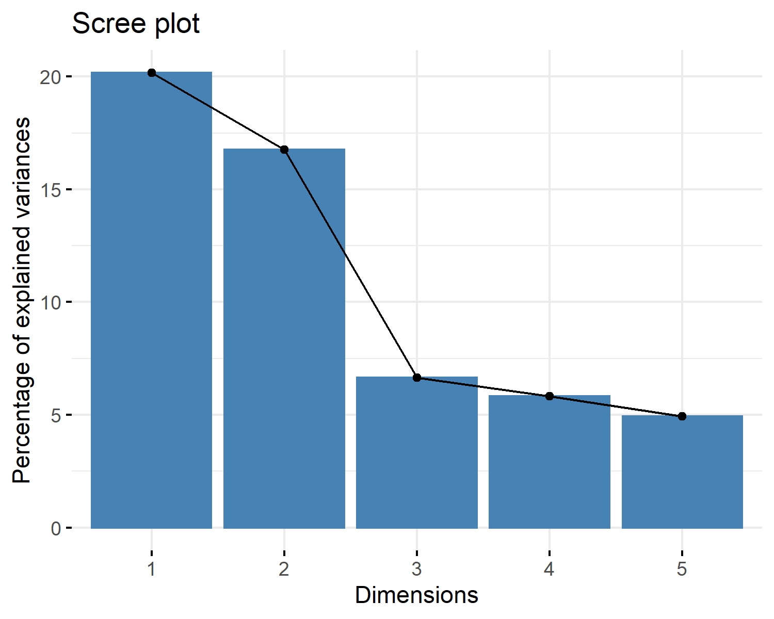

Figure 4.1: Screeplot for PCs

The above figure 4.1 visualises the explained variance of the 5 first principal components (PC). As can be seen most of the variance is explained in the first two PCs. Taking a closer look at which variables contribute to the PCs can be found in 4.2 and 4.3.

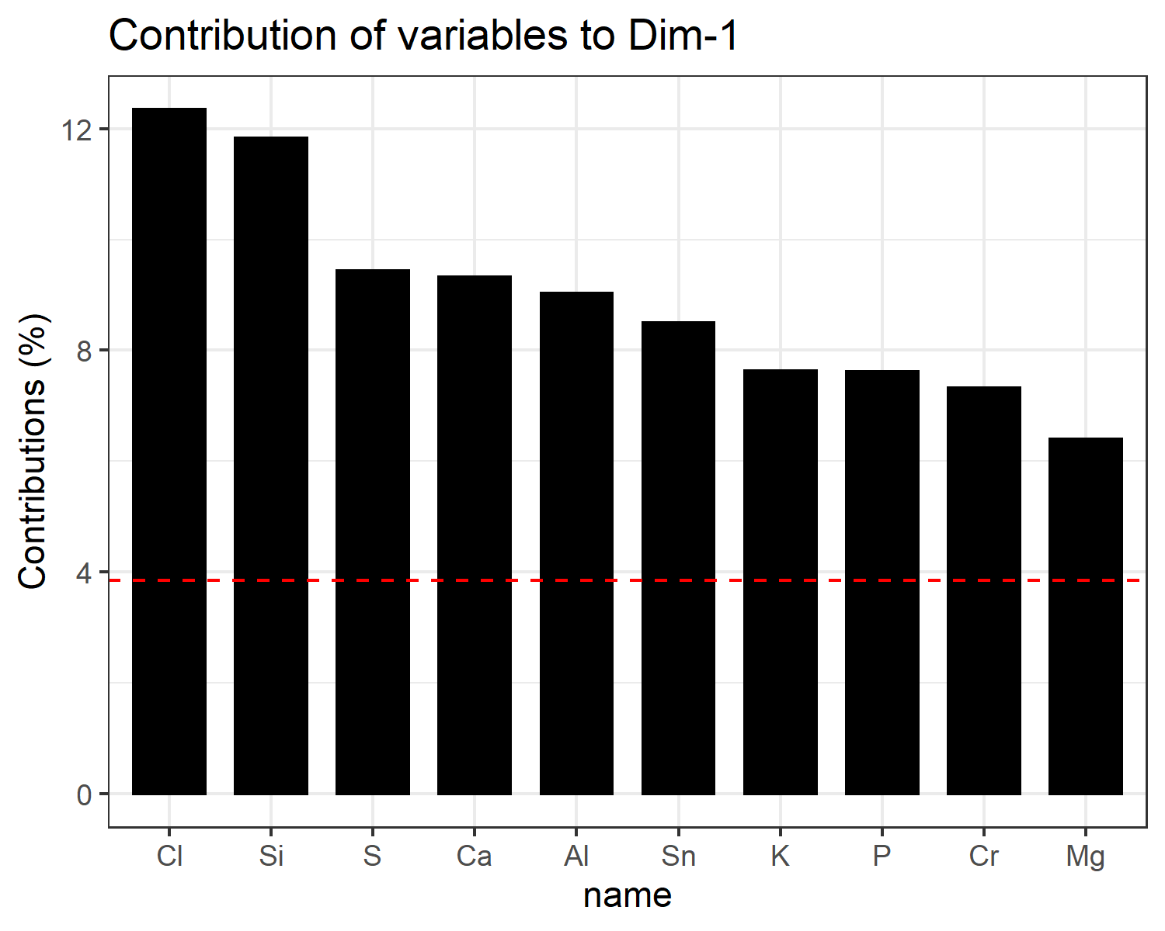

Figure 4.2: Contributions of variables to PC 1

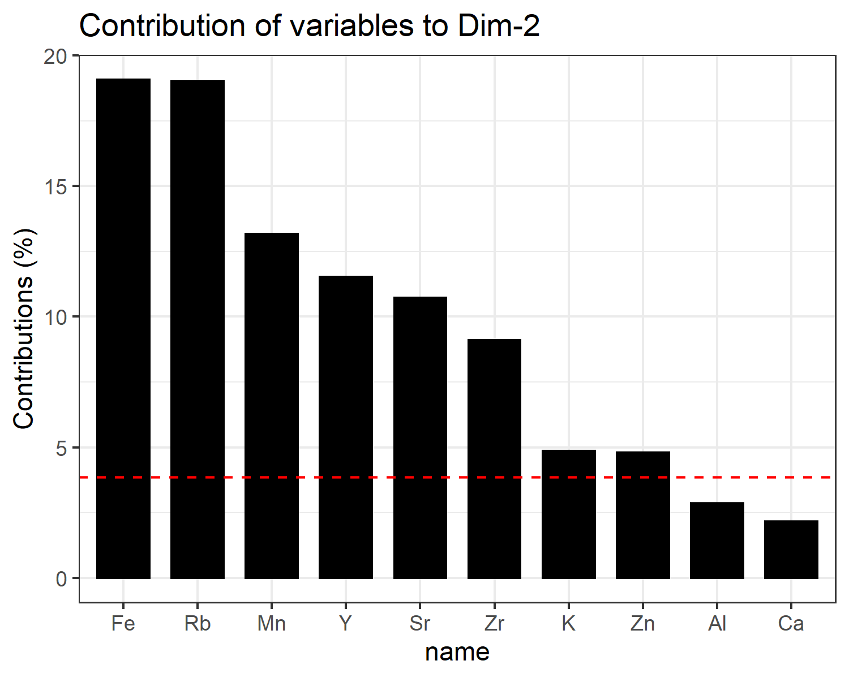

Figure 4.3: Contributions of variables to PC 2

The result of the PCA analysis can be seen in pca_biplot @ref(fig:pca_biplot).

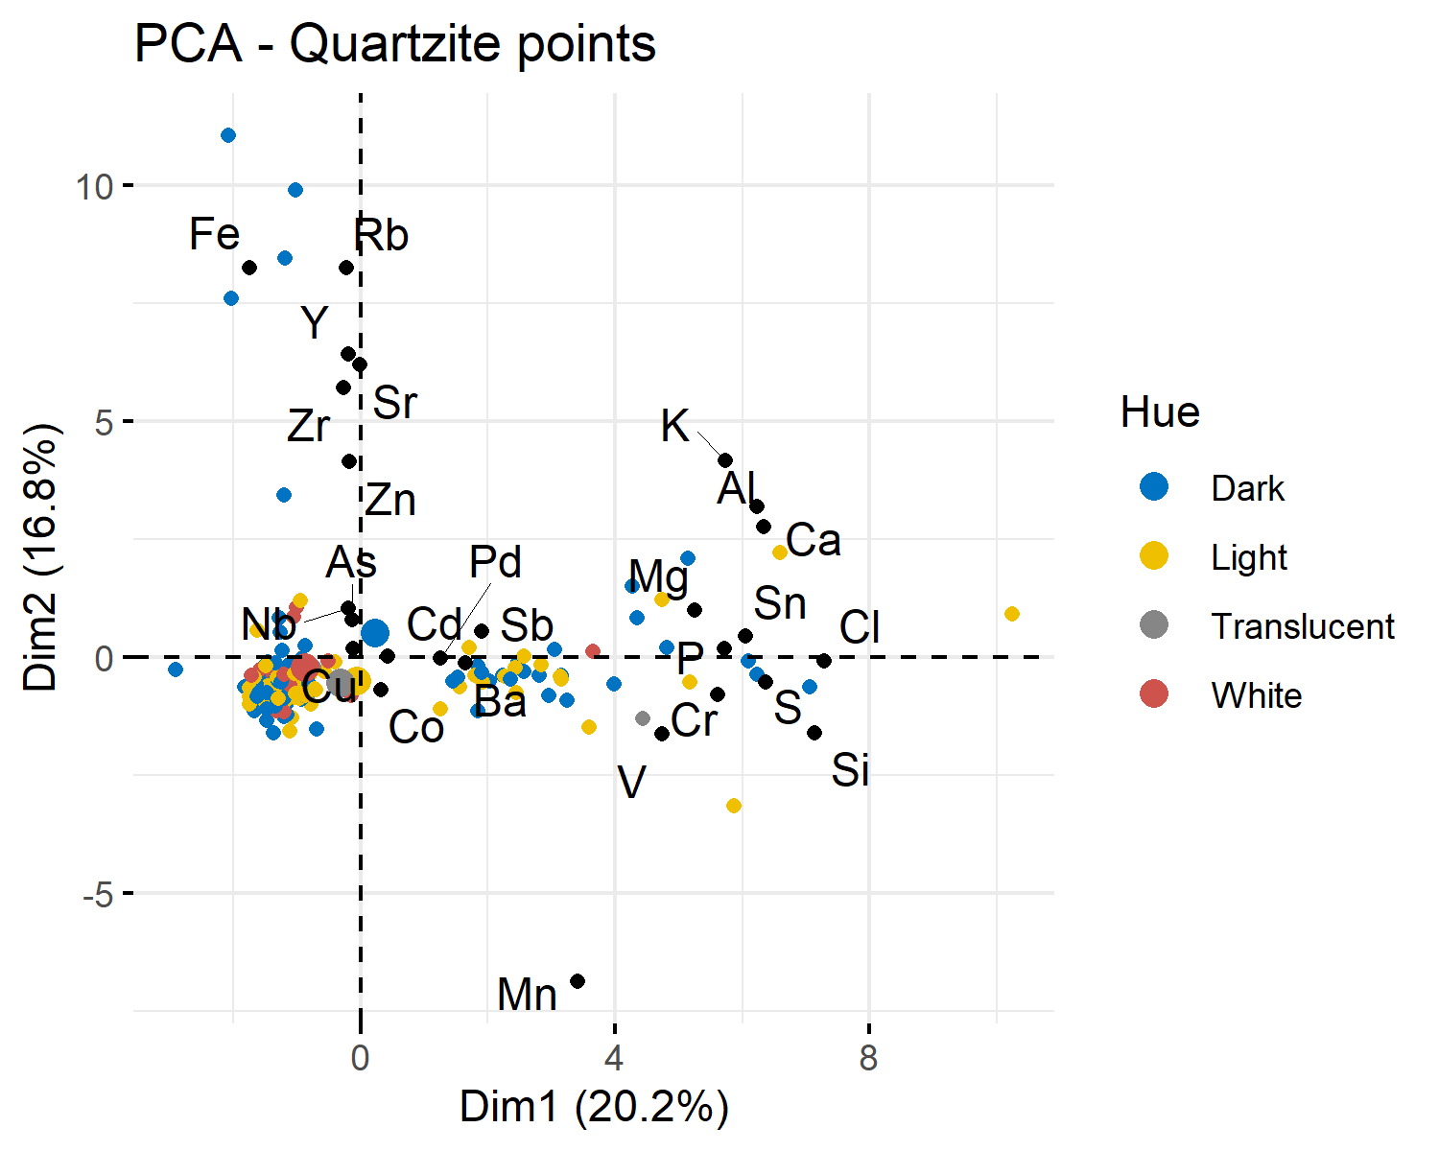

(#fig:pca_biplot)Biplot of PCA analysis with PC1 and PC2, no clear clustering can be seen related to the color of the material

Here is an example of inline code 3.14 in the middle of a sentence.

# 5 Discussion

# 6 Conclusion

# 7 Acknowledgements

# 8 References

Marwick, B., 2017. Computational reproducibility in archaeological research: Basic principles and a case study of their implementation. Journal of Archaeological Method and Theory 24, 424–450. <https://doi.org/10.1007/s10816-015-9272-9>

### 8.0.1 Colophon

This report was generated on 2021-03-26 14:30:45 using the following computational environment and dependencies:

#> - Session info ---------------------------------------------------------------  
#> setting value   
#> version R version 4.0.4 (2021-02-15)  
#> os Windows 10 x64   
#> system x86_64, mingw32   
#> ui RTerm   
#> language (EN)   
#> collate Swedish_Sweden.1252   
#> ctype Swedish_Sweden.1252   
#> tz Europe/Berlin   
#> date 2021-03-26   
#>   
#> - Packages -------------------------------------------------------------------  
#> package * version date lib source   
#> abind 1.4-5 2016-07-21 [1] CRAN (R 4.0.3)   
#> assertthat 0.2.1 2019-03-21 [1] CRAN (R 4.0.2)   
#> backports 1.2.1 2020-12-09 [1] CRAN (R 4.0.3)   
#> bookdown 0.21 2020-10-13 [1] CRAN (R 4.0.4)   
#> broom 0.7.5 2021-02-19 [1] CRAN (R 4.0.4)   
#> cachem 1.0.4 2021-02-13 [1] CRAN (R 4.0.4)   
#> callr 3.5.1 2020-10-13 [1] CRAN (R 4.0.4)   
#> car 3.0-10 2020-09-29 [1] CRAN (R 4.0.4)   
#> carData 3.0-4 2020-05-22 [1] CRAN (R 4.0.3)   
#> cellranger 1.1.0 2016-07-27 [1] CRAN (R 4.0.2)   
#> cli 2.3.1 2021-02-23 [1] CRAN (R 4.0.4)   
#> clisymbols 1.2.0 2017-05-21 [1] CRAN (R 4.0.4)   
#> cluster 2.1.1 2021-02-14 [1] CRAN (R 4.0.4)   
#> colorspace 2.0-0 2020-11-11 [1] CRAN (R 4.0.4)   
#> crayon 1.4.1 2021-02-08 [1] CRAN (R 4.0.4)   
#> curl 4.3 2019-12-02 [1] CRAN (R 4.0.2)   
#> data.table 1.14.0 2021-02-21 [1] CRAN (R 4.0.4)   
#> DBI 1.1.1 2021-01-15 [1] CRAN (R 4.0.4)   
#> dbplyr 2.1.0 2021-02-03 [1] CRAN (R 4.0.4)   
#> desc 1.3.0 2021-03-05 [1] CRAN (R 4.0.4)   
#> devtools 2.3.2 2020-09-18 [1] CRAN (R 4.0.4)   
#> digest 0.6.27 2020-10-24 [1] CRAN (R 4.0.4)   
#> dplyr * 1.0.5 2021-03-05 [1] CRAN (R 4.0.4)   
#> DT 0.17 2021-01-06 [1] CRAN (R 4.0.4)   
#> ellipsis 0.3.1 2020-05-15 [1] CRAN (R 4.0.2)   
#> evaluate 0.14 2019-05-28 [1] CRAN (R 4.0.2)   
#> factoextra * 1.0.7 2020-04-01 [1] CRAN (R 4.0.4)   
#> FactoMineR * 2.4 2020-12-11 [1] CRAN (R 4.0.4)   
#> fansi 0.4.2 2021-01-15 [1] CRAN (R 4.0.4)   
#> farver 2.1.0 2021-02-28 [1] CRAN (R 4.0.4)   
#> fastmap 1.1.0 2021-01-25 [1] CRAN (R 4.0.4)   
#> flashClust 1.01-2 2012-08-21 [1] CRAN (R 4.0.3)   
#> forcats * 0.5.1 2021-01-27 [1] CRAN (R 4.0.4)   
#> foreign 0.8-81 2020-12-22 [1] CRAN (R 4.0.4)   
#> fs 1.5.0 2020-07-31 [1] CRAN (R 4.0.2)   
#> generics 0.1.0 2020-10-31 [1] CRAN (R 4.0.4)   
#> ggplot2 * 3.3.3 2020-12-30 [1] CRAN (R 4.0.4)   
#> ggpubr 0.4.0 2020-06-27 [1] CRAN (R 4.0.4)   
#> ggrepel 0.9.1 2021-01-15 [1] CRAN (R 4.0.4)   
#> ggsci 2.9 2018-05-14 [1] CRAN (R 4.0.4)   
#> ggsignif 0.6.1 2021-02-23 [1] CRAN (R 4.0.4)   
#> git2r 0.28.0 2021-01-10 [1] CRAN (R 4.0.4)   
#> glue 1.4.2 2020-08-27 [1] CRAN (R 4.0.4)   
#> gtable 0.3.0 2019-03-25 [1] CRAN (R 4.0.2)   
#> haven 2.3.1 2020-06-01 [1] CRAN (R 4.0.2)   
#> here * 1.0.1 2020-12-13 [1] CRAN (R 4.0.4)   
#> highr 0.8 2019-03-20 [1] CRAN (R 4.0.2)   
#> hms 1.0.0 2021-01-13 [1] CRAN (R 4.0.4)   
#> htmltools 0.5.1.1 2021-01-22 [1] CRAN (R 4.0.4)   
#> htmlwidgets 1.5.3 2020-12-10 [1] CRAN (R 4.0.4)   
#> httr 1.4.2 2020-07-20 [1] CRAN (R 4.0.2)   
#> infer * 0.5.4 2021-01-13 [1] CRAN (R 4.0.4)   
#> jsonlite 1.7.2 2020-12-09 [1] CRAN (R 4.0.4)   
#> knitr 1.31 2021-01-27 [1] CRAN (R 4.0.4)   
#> labeling 0.4.2 2020-10-20 [1] CRAN (R 4.0.3)   
#> lattice 0.20-41 2020-04-02 [1] CRAN (R 4.0.4)   
#> leaps 3.1 2020-01-16 [1] CRAN (R 4.0.4)   
#> lifecycle 1.0.0 2021-02-15 [1] CRAN (R 4.0.4)   
#> lubridate 1.7.10 2021-02-26 [1] CRAN (R 4.0.4)   
#> magrittr 2.0.1 2020-11-17 [1] CRAN (R 4.0.4)   
#> MASS 7.3-53.1 2021-02-12 [1] CRAN (R 4.0.4)   
#> memoise 2.0.0 2021-01-26 [1] CRAN (R 4.0.4)   
#> modelr 0.1.8 2020-05-19 [1] CRAN (R 4.0.2)   
#> munsell 0.5.0 2018-06-12 [1] CRAN (R 4.0.2)   
#> openxlsx 4.2.3 2020-10-27 [1] CRAN (R 4.0.4)   
#> pillar 1.5.1 2021-03-05 [1] CRAN (R 4.0.4)   
#> pkgbuild 1.2.0 2020-12-15 [1] CRAN (R 4.0.4)   
#> pkgconfig 2.0.3 2019-09-22 [1] CRAN (R 4.0.2)   
#> pkgload 1.2.0 2021-02-23 [1] CRAN (R 4.0.4)   
#> prettyunits 1.1.1 2020-01-24 [1] CRAN (R 4.0.2)   
#> processx 3.4.5 2020-11-30 [1] CRAN (R 4.0.4)   
#> ps 1.6.0 2021-02-28 [1] CRAN (R 4.0.4)   
#> purrr * 0.3.4 2020-04-17 [1] CRAN (R 4.0.2)   
#> R6 2.5.0 2020-10-28 [1] CRAN (R 4.0.4)   
#> Rcpp 1.0.6 2021-01-15 [1] CRAN (R 4.0.4)   
#> readr * 1.4.0 2020-10-05 [1] CRAN (R 4.0.4)   
#> readxl 1.3.1 2019-03-13 [1] CRAN (R 4.0.2)   
#> remotes 2.2.0 2020-07-21 [1] CRAN (R 4.0.2)   
#> reprex 1.0.0 2021-01-27 [1] CRAN (R 4.0.4)   
#> rio 0.5.26 2021-03-01 [1] CRAN (R 4.0.4)   
#> rlang 0.4.10 2020-12-30 [1] CRAN (R 4.0.4)   
#> rmarkdown 2.7 2021-02-19 [1] CRAN (R 4.0.4)   
#> rprojroot 2.0.2 2020-11-15 [1] CRAN (R 4.0.4)   
#> rrtools * 0.1.5 2021-03-26 [1] Github (benmarwick/rrtools@668ee3d)  
#> rstatix 0.7.0 2021-02-13 [1] CRAN (R 4.0.4)   
#> rstudioapi 0.13 2020-11-12 [1] CRAN (R 4.0.4)   
#> rvest 1.0.0 2021-03-09 [1] CRAN (R 4.0.4)   
#> scales 1.1.1 2020-05-11 [1] CRAN (R 4.0.4)   
#> scatterplot3d 0.3-41 2018-03-14 [1] CRAN (R 4.0.3)   
#> sessioninfo 1.1.1 2018-11-05 [1] CRAN (R 4.0.2)   
#> stringi 1.5.3 2020-09-09 [1] CRAN (R 4.0.3)   
#> stringr * 1.4.0 2019-02-10 [1] CRAN (R 4.0.2)   
#> testthat 3.0.2 2021-02-14 [1] CRAN (R 4.0.4)   
#> tibble * 3.1.0 2021-02-25 [1] CRAN (R 4.0.4)   
#> tidyr * 1.1.3 2021-03-03 [1] CRAN (R 4.0.4)   
#> tidyselect 1.1.0 2020-05-11 [1] CRAN (R 4.0.2)   
#> tidyverse * 1.3.0 2019-11-21 [1] CRAN (R 4.0.4)   
#> usethis 2.0.1 2021-02-10 [1] CRAN (R 4.0.4)   
#> utf8 1.2.1 2021-03-12 [1] CRAN (R 4.0.4)   
#> vctrs 0.3.6 2020-12-17 [1] CRAN (R 4.0.4)   
#> withr 2.4.1 2021-01-26 [1] CRAN (R 4.0.4)   
#> xfun 0.22 2021-03-11 [1] CRAN (R 4.0.4)   
#> xml2 1.3.2 2020-04-23 [1] CRAN (R 4.0.2)   
#> yaml 2.2.1 2020-02-01 [1] CRAN (R 4.0.2)   
#> zip 2.1.1 2020-08-27 [1] CRAN (R 4.0.4)   
#>   
#> [1] C:/Users/masj0062/Documents/R/R-4.0.4/library

The current Git commit details are:

#> Local: C:/Users/masj0062/Documents/DOKTORANDSPROJEKT/VERSION CONTROL/phd-files/COURSES/DIALPAST/Quantitative_research/MyTestProject  
#> Head: nothing commited (yet)