Title Goes Here

Myfirstname Mylastname1,✉, and Yourfirstname Yourlastname2

12 april, 2021

Text of abstract

1 University of One Place  
2 University of Another Place

✉ Correspondence: [Myfirstname Mylastname <[fl@oneplace.edu](mailto:fl@oneplace.edu)>](mailto:fl@oneplace.edu)

Keywords: keyword 1; keyword 2; keyword 3

Highlights: These are the highlights.

# 1 Introduction

Here is a citation (Marwick, 2017)

# 2 Background

# 3 Methods

# 4 Results

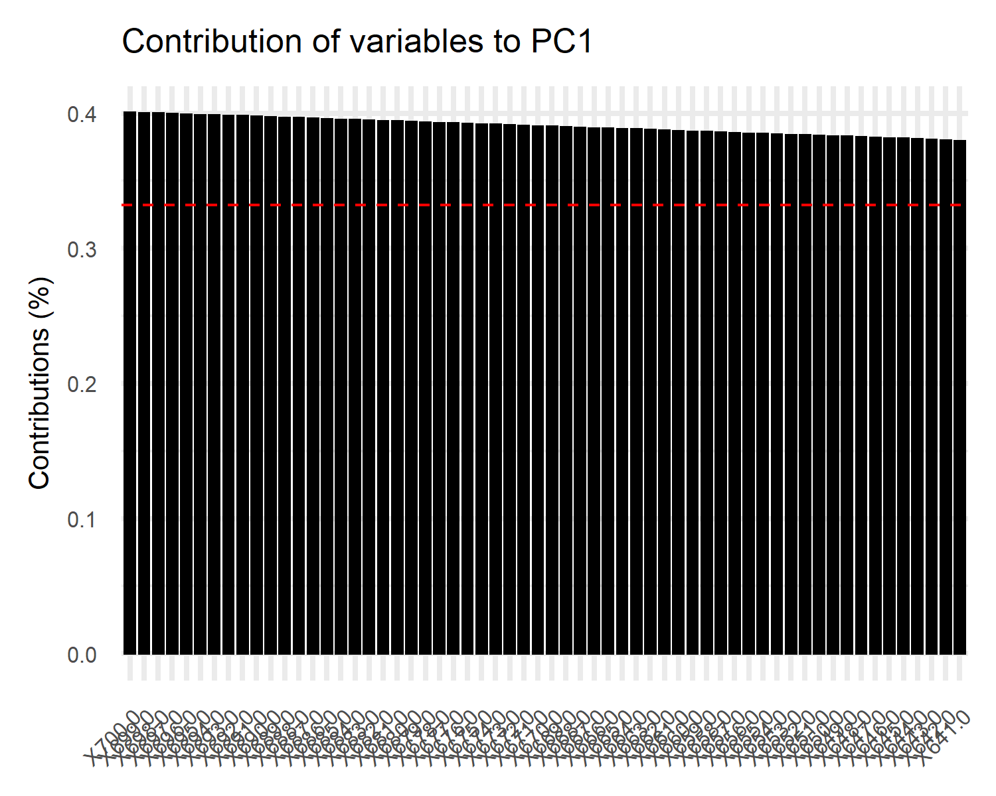

Figure 4.1: Contributing variables to PC1

Figure 4.1 shows that higher absorbance in the red part of the spectrum contributes more to PC1.

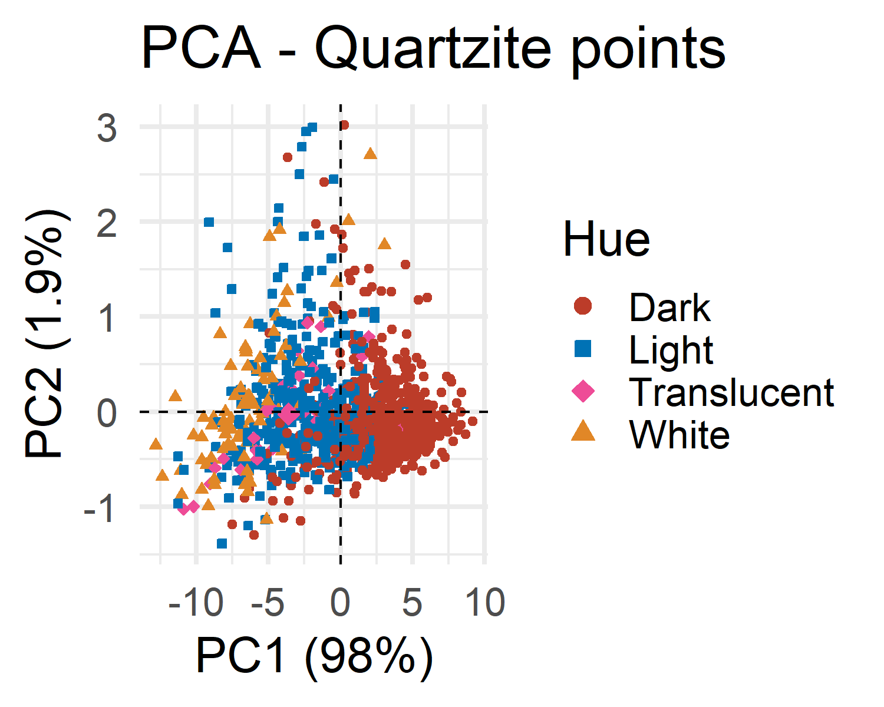

Figure 4.2: PCA of NIR measurements in the 400 - 700 nm part of the spectrum

Here is an example of inline code 3.14 in the middle of a sentence.

# 5 Discussion

# 6 Conclusion

# 7 Acknowledgements

# 8 References

Marwick, B., 2017. Computational reproducibility in archaeological research: Basic principles and a case study of their implementation. Journal of Archaeological Method and Theory 24, 424–450. <https://doi.org/10.1007/s10816-015-9272-9>

### 8.0.1 Colophon

This report was generated on 2021-04-12 11:26:45 using the following computational environment and dependencies:

#> - Session info ---------------------------------------------------------------  
#> setting value   
#> version R version 4.0.4 (2021-02-15)  
#> os Windows 10 x64   
#> system x86_64, mingw32   
#> ui RTerm   
#> language (EN)   
#> collate Swedish_Sweden.1252   
#> ctype Swedish_Sweden.1252   
#> tz Europe/Berlin   
#> date 2021-04-12   
#>   
#> - Packages -------------------------------------------------------------------  
#> package * version date lib source   
#> abind 1.4-5 2016-07-21 [1] CRAN (R 4.0.3)   
#> assertthat 0.2.1 2019-03-21 [1] CRAN (R 4.0.2)   
#> backports 1.2.1 2020-12-09 [1] CRAN (R 4.0.3)   
#> bookdown 0.21 2020-10-13 [1] CRAN (R 4.0.4)   
#> broom 0.7.5 2021-02-19 [1] CRAN (R 4.0.4)   
#> cachem 1.0.4 2021-02-13 [1] CRAN (R 4.0.4)   
#> callr 3.5.1 2020-10-13 [1] CRAN (R 4.0.4)   
#> car 3.0-10 2020-09-29 [1] CRAN (R 4.0.4)   
#> carData 3.0-4 2020-05-22 [1] CRAN (R 4.0.3)   
#> cellranger 1.1.0 2016-07-27 [1] CRAN (R 4.0.2)   
#> cli 2.3.1 2021-02-23 [1] CRAN (R 4.0.4)   
#> clisymbols 1.2.0 2017-05-21 [1] CRAN (R 4.0.4)   
#> cluster 2.1.1 2021-02-14 [1] CRAN (R 4.0.4)   
#> codetools 0.2-18 2020-11-04 [1] CRAN (R 4.0.4)   
#> colorspace 2.0-0 2020-11-11 [1] CRAN (R 4.0.4)   
#> crayon 1.4.1 2021-02-08 [1] CRAN (R 4.0.4)   
#> curl 4.3 2019-12-02 [1] CRAN (R 4.0.2)   
#> data.table 1.14.0 2021-02-21 [1] CRAN (R 4.0.4)   
#> DBI 1.1.1 2021-01-15 [1] CRAN (R 4.0.4)   
#> dbplyr 2.1.0 2021-02-03 [1] CRAN (R 4.0.4)   
#> desc 1.3.0 2021-03-05 [1] CRAN (R 4.0.4)   
#> devtools 2.3.2 2020-09-18 [1] CRAN (R 4.0.4)   
#> digest 0.6.27 2020-10-24 [1] CRAN (R 4.0.4)   
#> dplyr * 1.0.5 2021-03-05 [1] CRAN (R 4.0.4)   
#> DT 0.17 2021-01-06 [1] CRAN (R 4.0.4)   
#> ellipsis 0.3.1 2020-05-15 [1] CRAN (R 4.0.2)   
#> evaluate 0.14 2019-05-28 [1] CRAN (R 4.0.2)   
#> factoextra * 1.0.7 2020-04-01 [1] CRAN (R 4.0.4)   
#> FactoMineR * 2.4 2020-12-11 [1] CRAN (R 4.0.4)   
#> fansi 0.4.2 2021-01-15 [1] CRAN (R 4.0.4)   
#> farver 2.1.0 2021-02-28 [1] CRAN (R 4.0.4)   
#> fastmap 1.1.0 2021-01-25 [1] CRAN (R 4.0.4)   
#> flashClust 1.01-2 2012-08-21 [1] CRAN (R 4.0.3)   
#> forcats * 0.5.1 2021-01-27 [1] CRAN (R 4.0.4)   
#> foreach 1.5.1 2020-10-15 [1] CRAN (R 4.0.4)   
#> foreign 0.8-81 2020-12-22 [1] CRAN (R 4.0.4)   
#> fs 1.5.0 2020-07-31 [1] CRAN (R 4.0.2)   
#> generics 0.1.0 2020-10-31 [1] CRAN (R 4.0.4)   
#> ggplot2 * 3.3.3 2020-12-30 [1] CRAN (R 4.0.4)   
#> ggpubr 0.4.0 2020-06-27 [1] CRAN (R 4.0.4)   
#> ggrepel 0.9.1 2021-01-15 [1] CRAN (R 4.0.4)   
#> ggsignif 0.6.1 2021-02-23 [1] CRAN (R 4.0.4)   
#> git2r 0.28.0 2021-01-10 [1] CRAN (R 4.0.4)   
#> glue 1.4.2 2020-08-27 [1] CRAN (R 4.0.4)   
#> gtable 0.3.0 2019-03-25 [1] CRAN (R 4.0.2)   
#> haven 2.3.1 2020-06-01 [1] CRAN (R 4.0.2)   
#> here * 1.0.1 2020-12-13 [1] CRAN (R 4.0.4)   
#> highr 0.8 2019-03-20 [1] CRAN (R 4.0.2)   
#> hms 1.0.0 2021-01-13 [1] CRAN (R 4.0.4)   
#> htmltools 0.5.1.1 2021-01-22 [1] CRAN (R 4.0.4)   
#> htmlwidgets 1.5.3 2020-12-10 [1] CRAN (R 4.0.4)   
#> httr 1.4.2 2020-07-20 [1] CRAN (R 4.0.2)   
#> infer * 0.5.4 2021-01-13 [1] CRAN (R 4.0.4)   
#> iterators 1.0.13 2020-10-15 [1] CRAN (R 4.0.4)   
#> jsonlite 1.7.2 2020-12-09 [1] CRAN (R 4.0.4)   
#> knitr 1.31 2021-01-27 [1] CRAN (R 4.0.4)   
#> labeling 0.4.2 2020-10-20 [1] CRAN (R 4.0.3)   
#> lattice 0.20-41 2020-04-02 [1] CRAN (R 4.0.4)   
#> leaps 3.1 2020-01-16 [1] CRAN (R 4.0.4)   
#> lifecycle 1.0.0 2021-02-15 [1] CRAN (R 4.0.4)   
#> lubridate 1.7.10 2021-02-26 [1] CRAN (R 4.0.4)   
#> magrittr 2.0.1 2020-11-17 [1] CRAN (R 4.0.4)   
#> MASS 7.3-53.1 2021-02-12 [1] CRAN (R 4.0.4)   
#> mathjaxr 1.4-0 2021-03-01 [1] CRAN (R 4.0.4)   
#> memoise 2.0.0 2021-01-26 [1] CRAN (R 4.0.4)   
#> modelr 0.1.8 2020-05-19 [1] CRAN (R 4.0.2)   
#> munsell 0.5.0 2018-06-12 [1] CRAN (R 4.0.2)   
#> openxlsx 4.2.3 2020-10-27 [1] CRAN (R 4.0.4)   
#> pillar 1.5.1 2021-03-05 [1] CRAN (R 4.0.4)   
#> pkgbuild 1.2.0 2020-12-15 [1] CRAN (R 4.0.4)   
#> pkgconfig 2.0.3 2019-09-22 [1] CRAN (R 4.0.2)   
#> pkgload 1.2.0 2021-02-23 [1] CRAN (R 4.0.4)   
#> prettyunits 1.1.1 2020-01-24 [1] CRAN (R 4.0.2)   
#> processx 3.4.5 2020-11-30 [1] CRAN (R 4.0.4)   
#> prospectr * 0.2.1 2020-10-23 [1] CRAN (R 4.0.4)   
#> ps 1.6.0 2021-02-28 [1] CRAN (R 4.0.4)   
#> purrr * 0.3.4 2020-04-17 [1] CRAN (R 4.0.2)   
#> R6 2.5.0 2020-10-28 [1] CRAN (R 4.0.4)   
#> Rcpp 1.0.6 2021-01-15 [1] CRAN (R 4.0.4)   
#> readr * 1.4.0 2020-10-05 [1] CRAN (R 4.0.4)   
#> readxl 1.3.1 2019-03-13 [1] CRAN (R 4.0.2)   
#> remotes 2.2.0 2020-07-21 [1] CRAN (R 4.0.2)   
#> reprex 1.0.0 2021-01-27 [1] CRAN (R 4.0.4)   
#> rio 0.5.26 2021-03-01 [1] CRAN (R 4.0.4)   
#> rlang 0.4.10 2020-12-30 [1] CRAN (R 4.0.4)   
#> rmarkdown 2.7 2021-02-19 [1] CRAN (R 4.0.4)   
#> rprojroot 2.0.2 2020-11-15 [1] CRAN (R 4.0.4)   
#> rrtools * 0.1.5 2021-03-26 [1] Github (benmarwick/rrtools@668ee3d)  
#> rstatix 0.7.0 2021-02-13 [1] CRAN (R 4.0.4)   
#> rstudioapi 0.13 2020-11-12 [1] CRAN (R 4.0.4)   
#> rvest 1.0.0 2021-03-09 [1] CRAN (R 4.0.4)   
#> scales 1.1.1 2020-05-11 [1] CRAN (R 4.0.4)   
#> scatterplot3d 0.3-41 2018-03-14 [1] CRAN (R 4.0.3)   
#> sessioninfo 1.1.1 2018-11-05 [1] CRAN (R 4.0.2)   
#> stringi 1.5.3 2020-09-09 [1] CRAN (R 4.0.3)   
#> stringr * 1.4.0 2019-02-10 [1] CRAN (R 4.0.2)   
#> testthat 3.0.2 2021-02-14 [1] CRAN (R 4.0.4)   
#> tibble * 3.1.0 2021-02-25 [1] CRAN (R 4.0.4)   
#> tidyr * 1.1.3 2021-03-03 [1] CRAN (R 4.0.4)   
#> tidyselect 1.1.0 2020-05-11 [1] CRAN (R 4.0.2)   
#> tidyverse * 1.3.0 2019-11-21 [1] CRAN (R 4.0.4)   
#> usethis 2.0.1 2021-02-10 [1] CRAN (R 4.0.4)   
#> utf8 1.2.1 2021-03-12 [1] CRAN (R 4.0.4)   
#> vctrs 0.3.6 2020-12-17 [1] CRAN (R 4.0.4)   
#> withr 2.4.1 2021-01-26 [1] CRAN (R 4.0.4)   
#> xfun 0.22 2021-03-11 [1] CRAN (R 4.0.4)   
#> xml2 1.3.2 2020-04-23 [1] CRAN (R 4.0.2)   
#> yaml 2.2.1 2020-02-01 [1] CRAN (R 4.0.2)   
#> zip 2.1.1 2020-08-27 [1] CRAN (R 4.0.4)   
#>   
#> [1] C:/Users/masj0062/Documents/R/R-4.0.4/library

The current Git commit details are:

#> Local: main C:/Users/masj0062/Documents/DOKTORANDSPROJEKT/VERSION CONTROL/MethodPaper  
#> Remote: main @ origin (https://github.com/MattiasSealander/Quantifying-Quartzite)  
#> Head: [3eba2cb] 2021-04-12: visNIR PCA visualization script