Civilisation Wars: Advanced

Software Requirements Specification

30 January 2014

B4

Alex Bor

Mattie432

Luke Richardson

Dhruvil Tank

Robbie Zlatarski

# 

# Prepared for

Team Project

# Introduction

This is the Software Requirements Specification (SRS) document for creating and developing a turn based strategy game, providing a cooperative and competitive experience, being able to play against the AI or another player over a network.

## Acronyms and Abbreviations

**1v1** One-Versus-One

**2v2** Two-Versus-Two

**AI** Artificial Intelligence

**AOE** Area Of Effect

**ATK** Attack

**FFA** Free For All

**GUI** Graphical User Interface

**HP** Health Points

**JVM** Java Virtual Machine

**UI** User Interface

**SVN** Subversion

**VOIP** Voice Over Internet Protocol

# Overview

The game involves players taking turns in order. Players must think strategically, thinking ahead and anticipating the move of the opponent. Players are able to construct and train squads of units from the appropriate structures. Squads can move a specific number of tiles, depending on the type of unit.

## Map

a where every tile has a type of terrain, which will influence the stats on the unit placed on the tile.

## Size

The size of the tiles are 20x20 pixels, and the size of the grid is 600x600 pixels, or 30x30 tiles.

## Terrain

There are different types of terrain which will have different properties and will influence the stats on the unit placed on the tile.

## Flat

The default tile, all units can travel on it, no special effects.

## Mountain

Only infantry can travel on it, less damage is dealt to the unit on the tile, gives -2 Move.

## Forest

Only infantry can travel on it, -2 Move.

## River

Only tanks can travel on it, extra damage is dealt to the unit on the tile.

## Bridge

Only infantry can travel on.

## Mechanics

Each player takes turns on the day, taking turns in order. During the day (turn), the player is able to build structures and from these structures, train squads of units. The player can also move their squad a specific amount and once in range of an enemy squad or building, it is able to attack. The player cannot move or attack using the same unit more than once a day. Once a player has finished their turn, the next player can begin their turn.

Squads consist of a number of the same unit. The health of the squad influences the number of units in the squad, which will then influence its attack. Squads are only able to attack an enemy squad or structure once it is in range. Each squad is treated as a group of 10 units, where a 10% deduction in health, will be treated as -1 units, therefore, having 10% less ATK, dealing less damage.

Training squads of units and building structures requires money, this is obtained by destroying structures or units along with a passive income at the start of each day. As well as money, it also takes time, where the building or training of a structure or unit takes a specific amount of days.

Unit stats can be increased by purchasing research from the main building, which also requires money and takes a specific number of days to become active.

## Units

There are different types of units available to the player, each trained as a squad from a different type of structure.

## Infantry

Infantry units consists of cheap mobile units.

## Marines

The Marines are a squad of cheap mobile units that deal moderate single target damage.

## Health (per squad)

100 HP

## Attack (per squad)

50 ATK

## Move (per squad)

5 Tiles

## Cost (per squad)

£100

## Reward (per squad)

£50

## Heavy

Heavy units consists of more expensive more-mobile units.

## Tanks

The Tanks are a squad of expensive more-mobile units that deal high AOE target damage.

## Health (per squad)

200 HP

## Attack (per squad)

100 ATK

## Move (per squad)

10 Tiles

## Cost (per squad)

£200

## Reward (per squad)

£100

## Structures

There are different types of structures available to player, each building with a specific purpose.

## Capital

The main building that represents the player, if this building is destroyed, that player loses. Research is available from this building to improve unit stats.

## Health

500 HP

## Reward

None

## Barracks

The player is able to train Infantry units from the Barracks. The Barracks is able to train squads of Marines.

## Health

300 HP

## Cost

£200

## Reward

£100

## Factory

The player is able to train Heavy units from the Factory. The Factory is able to train squads of Tanks.

## Health

300 HP

## Cost

£400

## Reward

£200

# Specific Requirements

## User Interface Requirements

There are a number of user interfaces in the game, giving the user various options depending on their current state. The user is able to make the selection using the mouse left click.

## Design

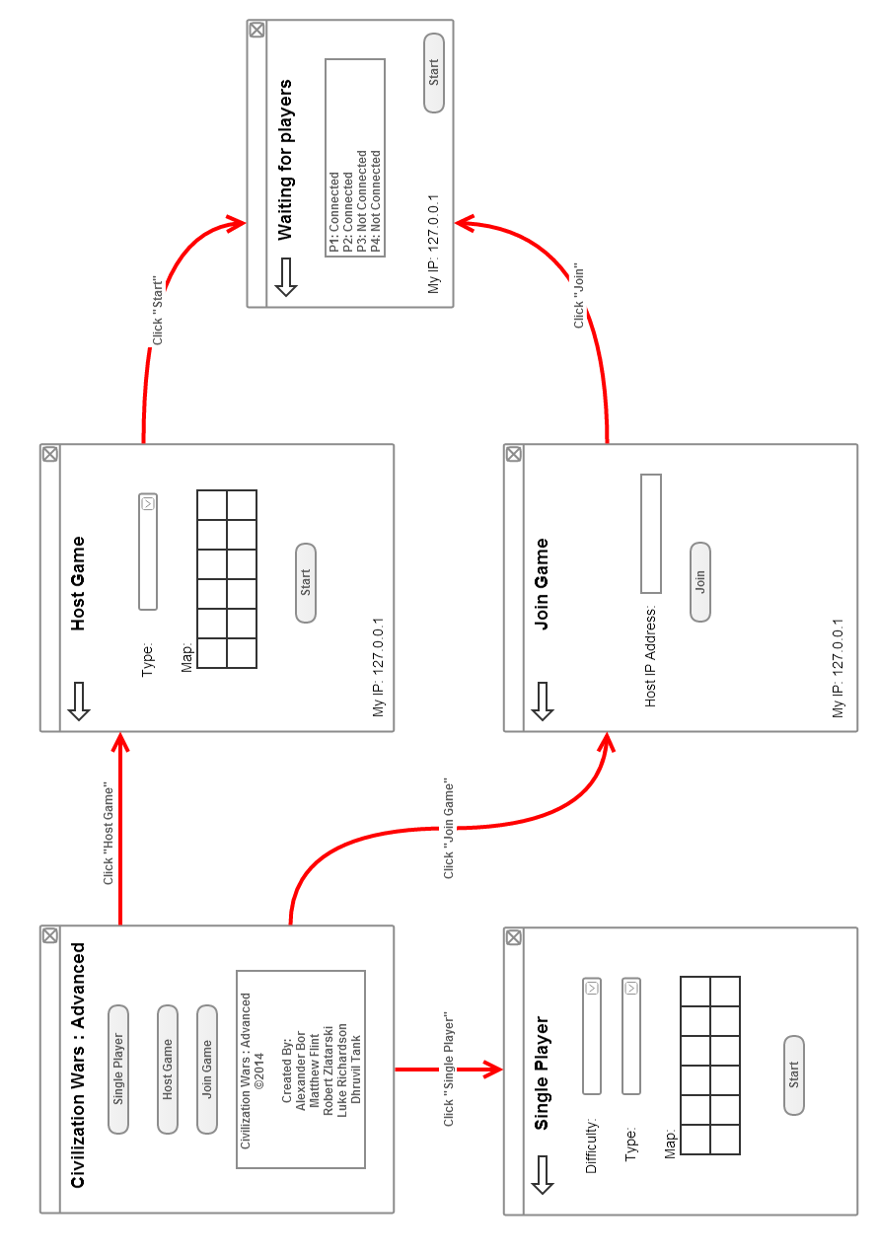

## Main Menu

The user is taken to the Main Menu upon running the game. The Main Menu consists of options for the user to choose their choice of game mode.

## Single Player

The user has clicked on the Single Player button. The user has chosen to play versus AI.

## Back

The user has clicked the Back button. The user has chosen to go back to the previous menu.

## Difficulty

The user has clicked the drop-down menu for the difficulty setting.

## Easy

The user has clicked the Easy option from the Difficulty drop-down menu. The user has chosen to play versus Easy AI.

## Medium

The user has clicked the Medium option from the Difficulty drop-down menu. The user has chosen to play versus Medium AI.

## Hard

The user has clicked the Hard option from the Difficulty drop-down menu. The user has chosen to play versus Hard AI.

## Game Type

The user has clicked the drop-down menu for the game type setting.

## 1v1

The user has clicked the 1v1 option from the Game Type drop-down menu. The user has chosen to play a 1v1 with the selected difficulty of AI.

## 2v2

The user has clicked the 2v2 option from the Game Type drop-down menu. The user has chosen to play a 2v2 with the selected difficulty of AI.

## 4 Player FFA

The user has clicked the 4 Player FFA option from the Game Type drop-down menu. The user has chosen to play a 4 Player FFA with the selected difficulty of AI.

## Map

The user has clicked on a predefined map from the map selection grid on which there game will be played.

## Start

This option is initially disabled. The user has chosen the difficulty of AI, the user has chosen the game type and the user has chosen a predefined map to play on, only then is this option enabled.

## Multiplayer

The user has clicked on the Multiplayer button.The user has chosen to play a multiplayer game against other human players.

## Back

The user has clicked the Back button. The user has chosen to go back to the previous menu.

## Create Game

The user has clicked on the Create Game button. The user has chosen to host multiplayer game.

## Back

The user has clicked the Back button. The user has chosen to go back to the previous menu.

## 1v1

The user has clicked on the 1v1 button. The user has chosen to create a 1v1 multiplayer game. The map will be generated and started upon player joining the game.

## 2v2

The user has clicked on the 2v2 button. The user has chosen to create a 2v2 multiplayer game. The map will be generated and started upon 3 players joining the game.

## 4 Player FFA

The user has clicked on the 4 Player FFA button. The user has chosen to create a 4 Player FFA game. The map will be generated and started upon 3 players joining the game.

## Join Game

The user has clicked on the Join Game button. The user has chosen to join an already hosted multiplayer game.

## Quit

The user has clicked on the quit button. The user has chosen to quit the game. The game client will close and shutdown.

## In-Game Interface

The In-Game Interface is available once you enter a game. It adapts its options depending on the selection. The user is able to make the selection using the mouse left click. The game has a top-down view of the map.

## Design

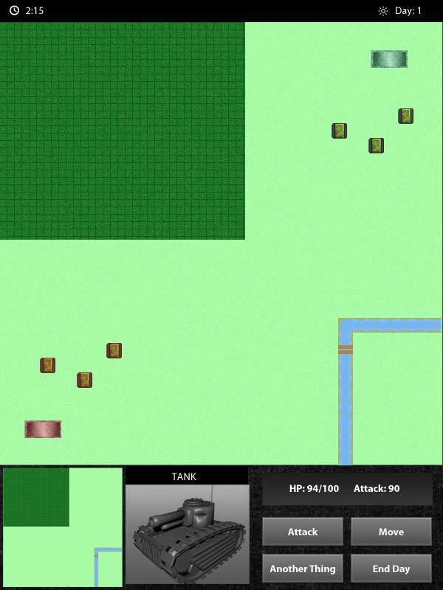

This is a draft image of the ingame GUI design. The GUI will adapt depending on the selection. For example, the picture of the Tank will change to a Marine if a squad of Marines is selected. When having a tile selected, the GUI will, instead of having options to attack and move, it will instead have options to build structures.

## No Selection

The player is able to select structures to build. Structures will be disabled if the player does not have enough money. The player is able to go back to the no selection state if a tile is clicked.

## Unit Selection

The stats of the unit will be displayed. The player is able to select to move or attack a unit. Movable tiles and attackable units will be highlighted.

## Structure Selection

The stats of the structure will be displayed. The player is able to train units. Trainable units will be disabled if the player does not have enough money.

## Tile Selection

The type of tile will and it’s properties will be displayed. The player is able to build structures. Structures will be disabled if the player does not have enough money or if the tile has the non-buildable property set (e.g. River).

## Capital Selection

The stats of the Capital will be displayed. The player is able to start research. Research will be disabled if the player does not have enough money.

## Exit Game (All Selections)

The user has choose to exit the game by clicking on the power symbol. The user will leave the current game and be taken back to the Main Menu.

## Player & Game Stats (All Selections)

The stats of the player and the game will be shown at the top of the in-game interface. This will include the money available to the player, the timeleft for the turn, and the current game-day.

## Software Requirements The user will require JVM installed on the computer in order to play the game, as the game will be developed using Java.

## Hardware Requirements The user will require a computer (desktop/laptop) with a keyboard and mouse to operate the game. If the user will like to play with another player, the user must be connected to the other player via a network.

## Game Functions

## Begin Game

The map is generated with the selected predefined map. Each player is placed in a corner of the map, with their Capital structure and a single squad of marines to start them off.

## End Game

Display victorious player once opposing Capital structures are destroyed.

## Turn

Each day (turn) the first player in the queue is given £50 and is able to take their turn. After the first player, it is the next player in the queue. The player ends the turn by clicking on the End Turn button. The turn for each player is timed for 2 minutes. If the time runs out, the player’s turn will end and it will begin the turn of the next player in the queue.

## Move

The user must click on a unit and click the Move button. A unit is able to move once a day. If a unit has been moved, it cannot attack in the same day. If the user clicked on an unhighlighted tile, the move will not take place. If the selection was valid, the selected unit will move to the selected tile.

## Attack

The user must click on a unit and click the Attack button. The unit must be next to the tile of another opposing unit in order to attack. The unit is able to attack once a day. If a unit has attacked, it cannot move in the same day. If the user clicked on an unhighlighted unit, the attack will not take place. If the selection was valid, health points will be taken from the target. If the target unit or structure is eliminated (HP reaches 0), the reward for eliminating that type of unit will be added to the player’s bank.

## Train

Units take a specific amount of days to be trained and money will be deducted. The unit will appear next to the structure from which the unit was trained from.

## Build

A tile must be selected in order to build a structure. The tile will be highlighted to show that a structure is being built. Structures take a specific amount of days to be built and money will be deducted.

## Research

Research is available from the Capital. Research will increase the stats of the unit. Research takes a specific amount of days to become active and money will be deducted.

## Class Diagram

# Networking

Networking will be used to create cooperative aspects of the game. This involves playing with another human player, as a team, to defeat another team of human players. This will be done by using sockets, opening a socket to enable the transfer of the Map object, which holds the state of the game, to each player. This will occur every time when a move has been made. This way, both players see the other players’ moves in real time. They don’t have to wait until the end of the a player’s turn to see what they are doing.

# Project Life Cycle

The most appropriate project life cycle for this particular project is the incremental agile development life cycle. The functionality of the game will be implemented gradually. It it likely that initially unknown requirement will emerge and may have to be implemented before other requirements. This may set back other requirements. Some intended requirements and functionality may not be implemented due to time constraints on the project.

# Team Management

At the beginning of every week, work to be done will be decided as a team. Instead of a single team member that delegates tasks, tasks will be assigned to team members depending on their strengths and weaknesses. For example, a team member will have a better grasp of UI design compared to the other team members.

Since it’s likely that more than one person will be working on the code for the game, we will be using SVN to help program concurrently and do control the versions of the code. This allows us to track the changes made to the code so if committed code breaks the game, the code can easily be reverted back to the previous, working, version.

# Risk Analysis

Due to a time constraint of the project of developing a cooperative and competitive game, it can be that the product is delivered incomplete. The number of features and functions in the game is ambitious, which is why we will prioritise the features and functions implemented into the game. Features and functions that the game will work without will be developed after the more vital and important features and functions. For example, the development of AI will be developed after the implementation of playing over a network, as the ability to play against an AI does provide a more cooperative and competitive compared to being able to play against another player over a network.

A team member may be unable to carry out work due to health reasons. In order to overcome this risk, the task initially for the team member will be delegated to or among other team members to make sure the project does not get behind schedule and we are able to deliver the finished product.

To make sure that we do not get behind in terms of the implementation of features and functions of the game, we will hold weekly meetings where team members will discuss the progress of their work and any emerging problems and matters and find an alternative in order to solve these. Agendas are produced for every meeting and minutes are taken for when a team member is unable to make a meeting, they can refer back to the agenda and minutes to catch up upon what was discussed. Meeting will take place as a face-to-face meeting or using VoIP software: Skype.

# Gantt Chart

Resources have not been allocated to team members as this will be done at the start of every week, taking account of team member strengths and weaknesses.

See attached document.