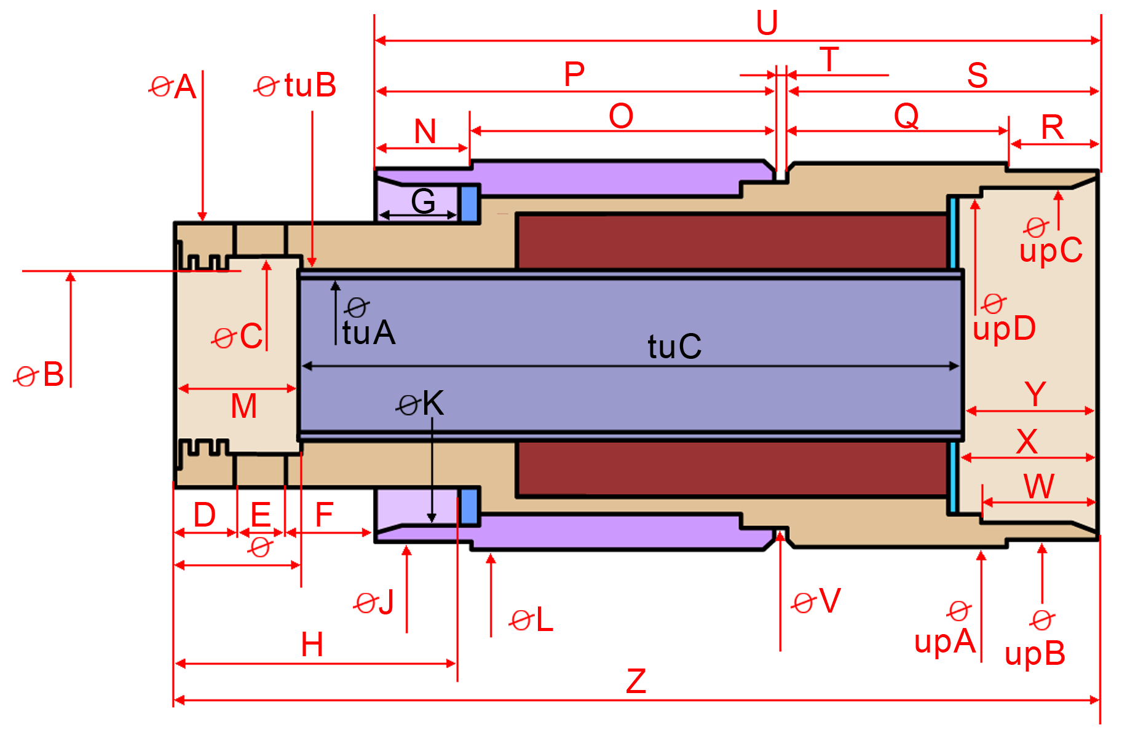
Figure 1-1 Solenoid * Ø marks Diameter, all values in inches
Bottom
Ø A = [0.620] ………….
Ø AB = [0.544] ………….
Ø B = [0.435] ………….
Ø C = ………….
D = ………….
Ø E = [0.115 to 0.130] ………….
D + E = [0.270] = …………
F + G = ……………..
G = ………….
H = D + E + F + G = …………………
D + E + F = [0.470] ………….
Middle
Ø J (out) = [0.875] ………….
Ø K (in) = ………….
Threads/inch [27?] …………..
Ø L (ribbed) = [0.912] ………….
Ribs [72] ………
M = ………………..
N = [0.225] …………
O = [0.710] …………..
P = N + O = ……………..

Middle
Q = [0.515] ………….
R = [0.213] ………….
S = Q + R = ……………..
T = ………………..
U = ………………..
Ø V = ………….
Ø tuA = [0.364] ………………..
Ø tuB = ………………..
tuC = Z – M – Y = ………………..

Top
W = ………….
X = [0.353] ………….
Y = [0.315] ………….
Z = ……………..
Ø upA (ribbed) = ………………..
Ribs [72] ………
Ø upB (out) = [0.865?] ………………..
Ø upC (in) = [0.779] ………………..
Threads/inch [40?] …………..
Ø upD = ………………..

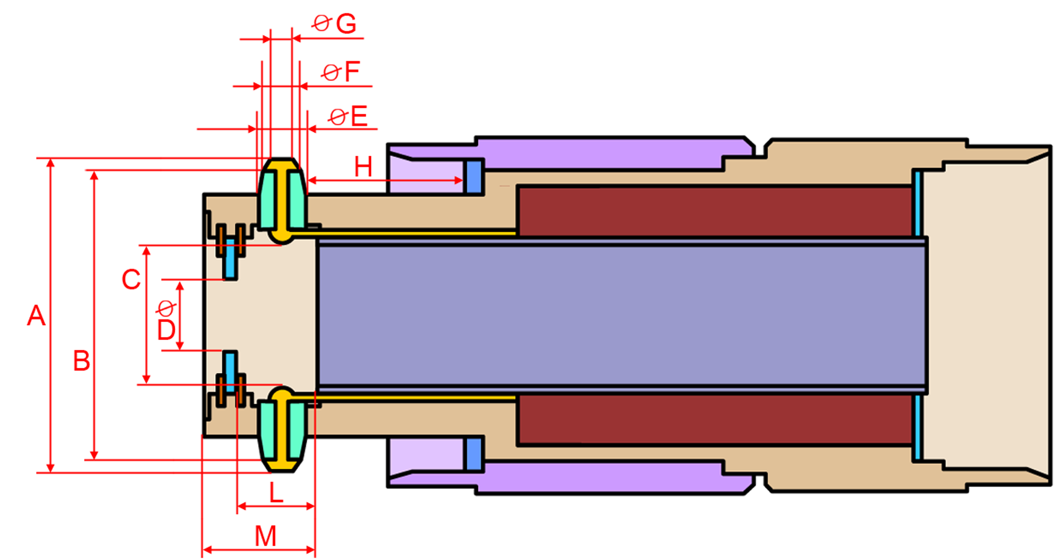
Figure 1-2 Solenoid contacts * Ø marks Diameter, all values in inches

Electrical contacts
A = [0.800] ………….
B = ………….
C = ………….
Ø D = [0.171] ………….
Ø E = [0.130] ………….
Ø F = ……………..
Ø G = [0.115] ………….
H = …………………

L = …………………
M = …………………

CREDITS
Drawings in this document are made by Tom Mikulic:
http://tomislavmikulic.com/proj-565.html

They are based on dimensions provided by Herb Johnson on his web site:
http://www.retrotechnology.com/restore/cal_sketch1.jpg

Invaluable support and information provided by David Gesswein:
http://www.pdp8online.com/563/563.shtml

and Jeffrey Jonas:
http://ferretronix.com/1627/

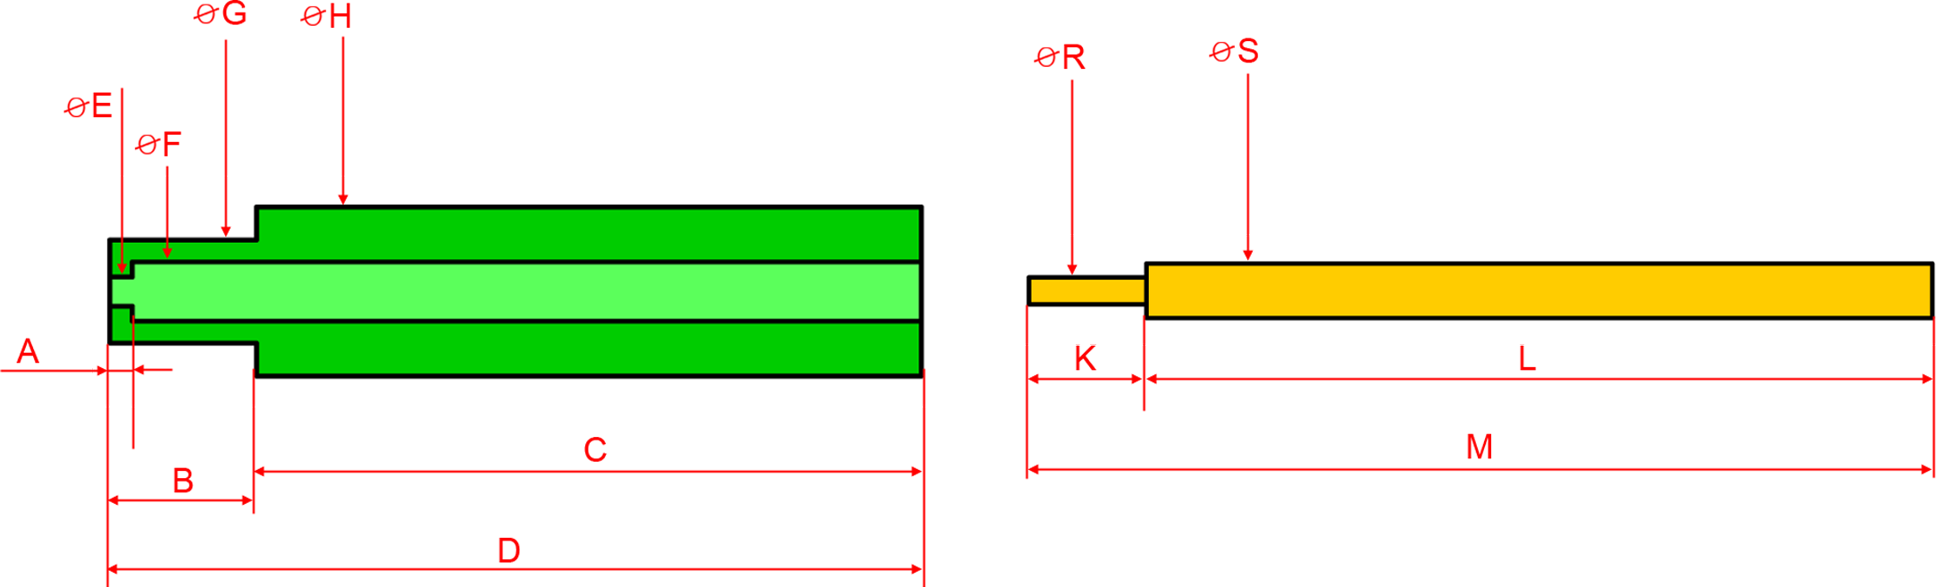
Figure 2-1 Ballpoint pen and plunger * Ø marks Diameter, all values in inches

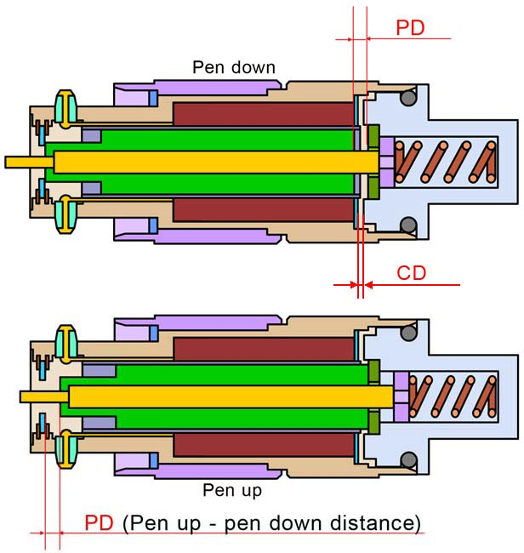
Ballpoint pen and plunger
A = ………….
B = [0.315] ………….
C = [1.427] ………….
D = ………….
Ø E = [0.070] ………….
Ø F = [0.134] ……………..
Ø G = [0.220] ………….
Ø H = [0.360] …………………

K = …………………
L = [1.79] …………………
M = [2.062] …………………
Ø R = [0.0625] ………….
Ø S = [0.125] …………………

PD = …………………

CD = …………………
(Critical distance between coil and the top)

Figure 2-2 Distance between pen-up and pen-down stops

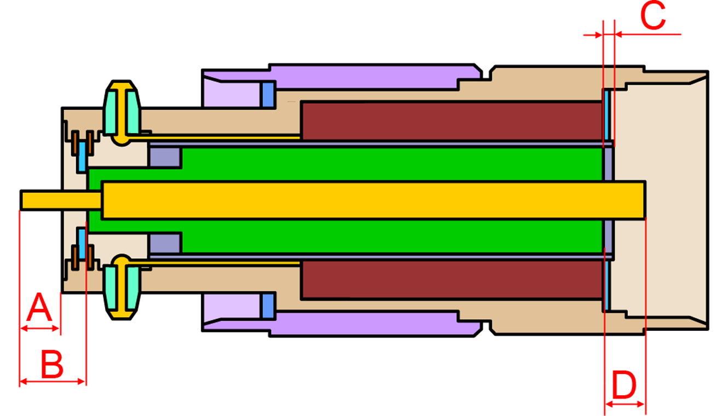
Figure 2-3 Ballpoint pen and plunger * Ø marks Diameter, all values in inches
Ballpoint pen and plunger
A = ………….
B = ………….
C = ………….
D = ………….

Ballpoint pen top

Ø E = [0.690] ………….
Ø F = [0.865?] ……………..
Ø G = ………….
Ø H = [0.858?] …………………
Ø J (ribbed)= [0.467] …………………
Ribs [48] ……………..
Ø K = [0.415] ………….
Ø L = ……………..
Ø M = ………….
Ø N = [0.125] …………………
Ø O = Ø K = [0.415] …………………

P = [0.067] …………………
Q = [0.140] …………………
R = [0.089] …………………
S = [0.067] ………….
T = [0.500] …………………
U = …………………

V = …………………
W = ………….
X = …………………

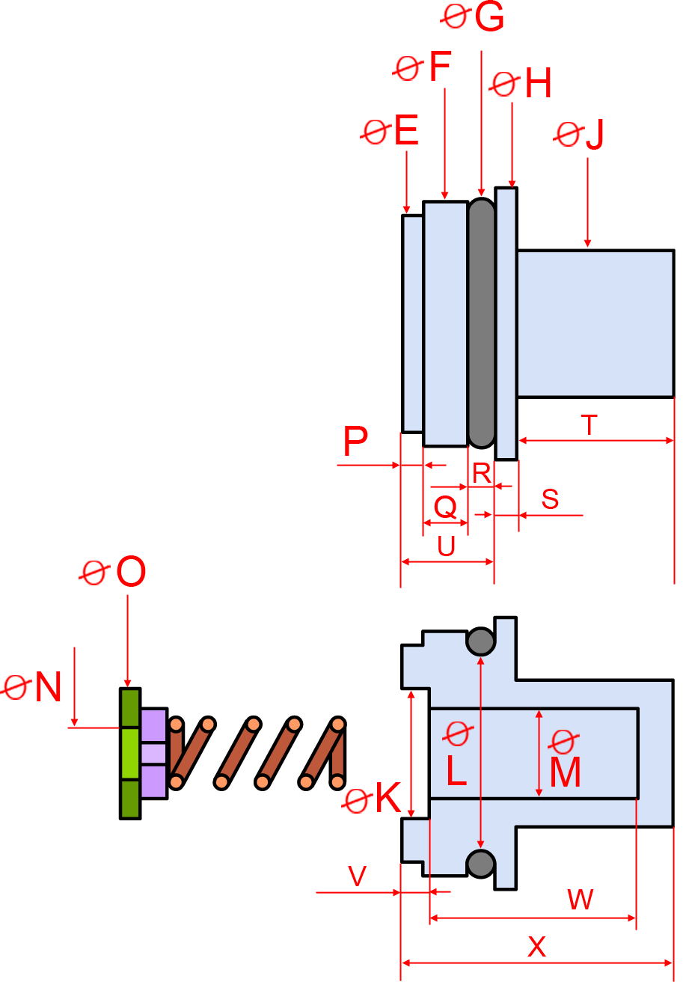
Figure 2-4 Ballpoint pen top

