MS-WSP Test Deployment Guide
Microsoft Corporation.
Published: September 2008.
This deployment guide helps you to setup and configure the MS-WSP test suite environment.

Abstract
This document provides an overview and a standard process to help you deploy MS-WSP test environment.
Table of Contents
1. Test Environment Requirement 3
1.1 Test Machines and Devices List 3
1.2 Network Setting 5
2. Test Environment Configuration 6
2.1 Installing and Configuring DC 6
2.2 Installing and Configuring SUT 6
2.3 Installing and Configuring CLIENT 12
3. Test Suite Deployment 15
3.1 How to install test suite 15
3.2 How to configure ptfconfig 15
3.3 How to run the test suite 15
4. Troubleshooting 16
4.1 Test Setup/Environment 16
4.2 Test Suite 16
4.3 Operating System Specific 17
4.4 Tool Specific 17
4.5 Known Issues 17
5. Appendix 19
5.1 How to install Domain Controller on Windows 2003 19
5.2 How to install Domain Controller on Windows 2008 20
5.3 How to install Visual Studio 2008 21
5.4 How to install Microsoft Network Monitor 3.2 24
5.5 How to observe network trace 27
5.6 How to install Protocol Test Framework 28
5.7 How to install Spec Explorer 31

Test Environment Requirement

Test Machines and Devices List

Generic Requirements
The MS-WSP requires the test environment including:
- 2 machines for servers and clients.
- Generic software list.
- Ethernet network.
Please refer to table 3-1-1 for the details.
Device Type | Role | Description
Hardware | SUT | System Under Test.
Hardware | KDC | Key Distribution Center.
Hardware | Client | Client computer to run the test suite.
Service | SUT | A licensee implementation of MS-WSP. or  A licensee implementation of MS-WSP which support the features of Windows Search Service.
Service | KDC | A licensee implementation of Key Distribution Center.
Service | Client | None.
Software | SUT | Run software to make the SUT act as Client.
Software | KDC | Run software to make the DC act as the role of a Domain Controller.
Software | Client | Required software installed to enable the running of test suite.
Network | The network is an isolated hub/switch connected Ethernet network, which the test suite and network topology are attached.
Table 3-1-1 Test Environment Requirements

Requirements on Windows Platform
The MS-WSP requires the specific test environment when running on Windows platform as shown in table 3-1-2-1.
Machine Name | Operating System | CPU Architecture | Domain Workgroup | IP Version | Role
SUT01 | Windows Server 2008 enterprise SP1 | x64 | Domain | IPv6 | SUT
SUT02 | Windows Server 2003 R2 Enterprise. | x86 | Workgroup | IPv4 | SUT
DC01 | Windows Server 2008 Enterprise. | X64 | Domain | IPv4  IPv6 | KDC
ENDPOINT01 | Windows Vista Ultimate ServicePack1. | X86 | Domain | IPv6 | Client
ENDPOINT02 | Windows XP Professional ServicePack3. | x86 | Workgroup | IPv4 | Client
Table 3-1-2-1 Windows Test Environment Requirements
The following table is the list of software that should be installed on machines for running MS-WSP test suite on the platform of Windows:
Machine Name | OS | Software
SUT01 | W2K8 | Server role.
SUT02 | W2K3 | Server role.
DC01 | W2K8 | Domain Controller Role with domain name “WSPDC.Net”.
ENDPOINT01 | Vista | Visual Studio 2008 Team System.  Protocol Test Framework version 2.1.866.0.  Network Monitor version 03.02.1106.0001.  Spec Explorer version 2.1.861.
ENDPOINT02 | WinXP | Visual Studio 2008 Team System.  Protocol Test Framework version 2.1.866.0.  Network Monitor version 03.02.1106.0001.  SE PTF PAC June 2008.
Table 3-1-2-2 Software Requirements

Network Setting
MS-WSP requires 2 groups of test environments. These test LANs are isolated from all other networks and also isolated from each other.
Figure 3-2-1 Network Topology
Notes:
- Test suites should be run on the ENDPOINT01, ENDPOINT02 and CLIENT.
- Domain name: WSPDC.Net
Machine Name | IPv4 / Subnet Mask | IPv6 /  Prefix Length | Default Gateway | DNS Server
SUT01 | N/A | fec0::1a49:2aa:ff:fe34:ca1a/64 | 2001::5 | 2001::5
SUT02 | 192.168.0.2/255.255.255.0 | N/A | 192.168.0.5 | 192.168.0.5
DC01 | 192.168.0.5/255.255.255.0 | fec0::1a49:2aa:ff:fe34:ca1a5/64 | N/A | local host
ENDPOINT01 | N/A | fec0::1a49:2aa:ff:fe34:ca11/64 | 2001::5 | 2001::5
ENDPOINT02 | 192.168.0.4/255.255.255.0 | N/A | 192.168.0.5 | 192.168.0.5
Table 3-2-1 Computer Network Configurations
//NOTE:
//Server IP from 10.50.210.89
//Client IP from 10.50.212.61
//DC IP: fec0::1a49:2aa:ff:fe34:ca1a
//Domain name: WSPDC.Net

Test Environment Configuration
This section provides a step-by-step instruction to setup and configure the test environment when MS-WSP test suite is running on Windows platforms.

Installing and Configuring DC
For steps and screenshots Ref to Appendix.

Installing and Configuring SUT

SUT01
Installing Windows Search Service
In Windows Server 2008 (Longhorn):

- Go to Start and select Server Manager.
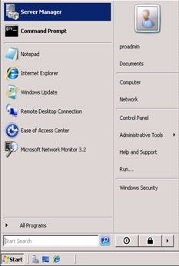

- Select Roles from the Server Manger and click Add Roles in Roles Summary.

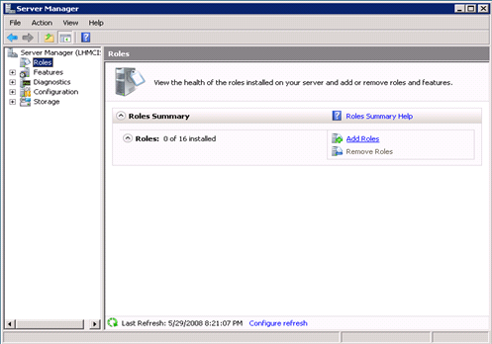

- Select Server Roles in Add Roles Wizard.

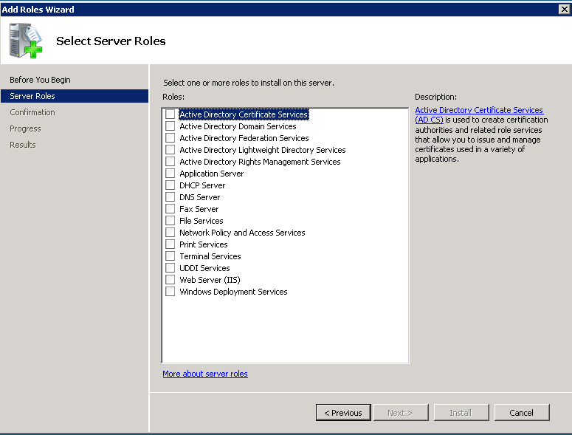

- Select File Services role to install on the server and click Next.

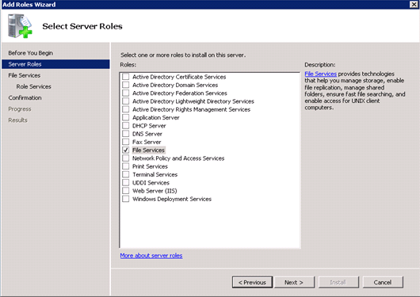

- Click Next.
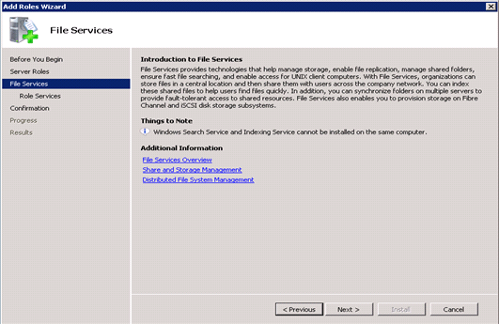

- Select Windows Search Service from the list of Role Services to install for Distributed File System and click Next.
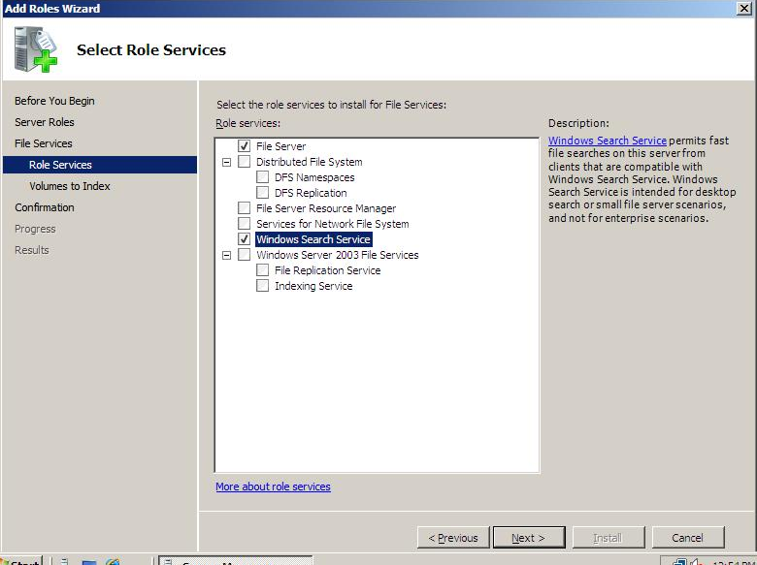

- Select the appropriate volume to index for Windows Search service.

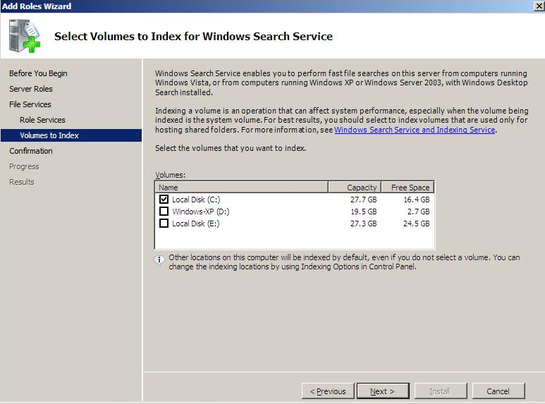

- Click Install.
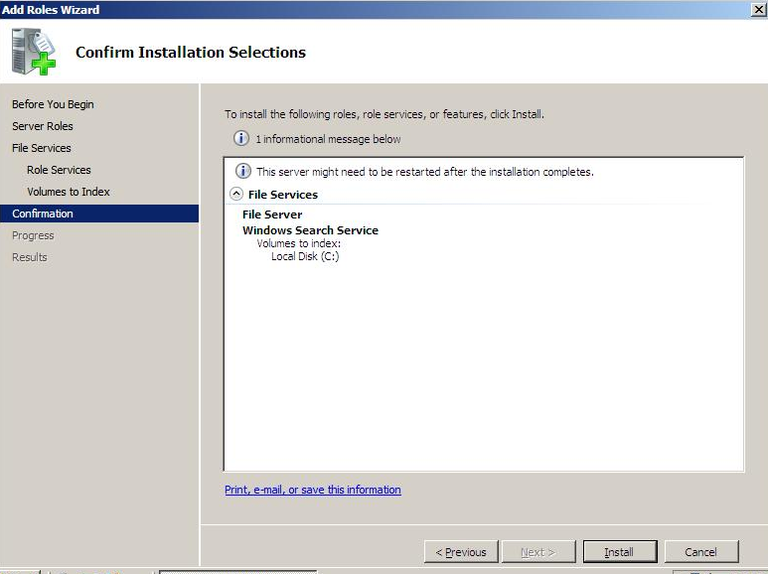
- The Windows Search Service will be installed. Click Close.

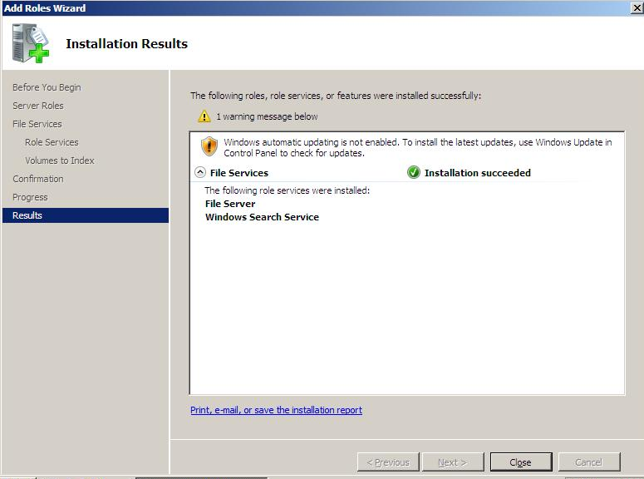

SUT02
Installing Windows Search Service
In Windows 2003 Server:

- Double Click the Windows Desktop Search 4.0 setup file.

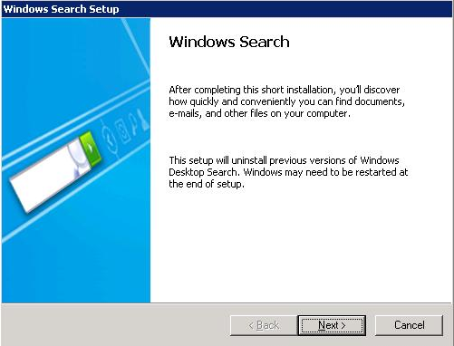

- Select Accept and click Next.

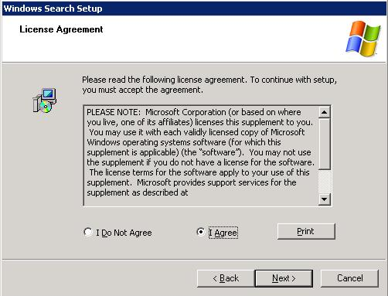

- Click Finish to complete the Windows Search setup.

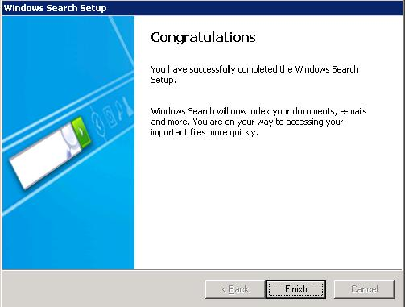

Installing and Configuring CLIENT

Installing and Configuring ENDPOINT01

Installing Windows Search Service
In Windows Vista Ultimate:

- Windows Search service is available in vista by default. To start the windows search service from the services open services.msc from the command prompt.
- Right click Windows Search Service and select Properties.
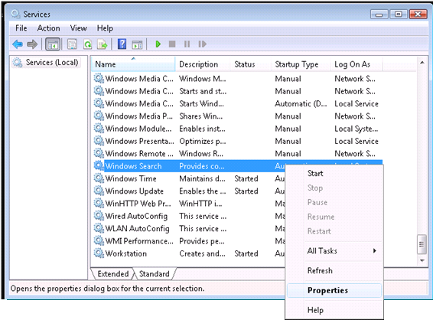

- Click Start from the popup menu.

Install Network Monitor 3.2 on ENDPOINT01
Please refer to Appendix to install Microsoft Network Monitor 3.2.

Installing and Configuring ENDPOINT02

Installing Windows Search Service

- Double click Windows Desktop Search 4.0 setup file.

- Select Accept and click Next.

- Click Finish.

Install Network Monitor 3.2 on ENDPOINT01
Please refer to Appendix to install Microsoft Network Monitor 3.2.

Test Suite Deployment

How to install test suite
Copy TestSuite folder from DVD to a local folder of CLIENT.
For an example in this document, it is C:\.

How to configure ptfconfig
Open MS-WSPTestSuite.deployment.ptfconfig:
- Find <Property name="ServerComputerName" value="wsp2k3" />, make sure the value is either the Name or the ip address of the Server Computer;
- Find <Property name="SERVER_MACHINE_NAME" value="wsp2k3" />, make sure the value is the Name of the Server Computer;
- Find <Property name=" CLIENT_USERNAME" value="administrator" />, make sure the value is the Client’s User Name;
- Find <Property name="CLIENT_MACHINE_NAME" value="wspxp" />, make sure the field value is the name of the client machine.
- Find <Property name=" CATALOG_NAME " value=" Windows\SYSTEMINDEX " />, make sure the value is the Name of the catalog;
- Find <Property name=" LANGUAGE_LOCALE " value=" EN " />, make sure the value is the Name of the language locale;
- Find <Property name=" LCID_VALUE " value=" 1033" />, make sure the value is the value of the language locale;
- Find <Property name=" ServerOffset " value=" 32" />, make sure the field specifies the Machine Architecture of the WSP server under test whether it is 64 bit or 32 bit.
- Find <Property name=" ClientOffset" value=" 32" />, make sure the field specifies the Machine Architecture of the WSP client whether it is 64 bit or 32 bit.
- Find <Property name="IsServerWindows " value=" true" />, make sure the field value indicates whether the server is windows.
- Find <Property name="IsWDSInstalled" value="false" />, make sure the field value indicates whether Windows Desktop Search is installed on Windows Server under test. It is only applicable when 'IsServerWindows' is set to true.
- Find <Property name="ServerVersion " value="265" />, make sure the field value indicates whether the version number (uint) of 32 bit server.
For Windows Server:
Windows 2003 32 it must be 265 (with Windows Desktop Search Installed)
Windows 2008 32 it must be 258 (without Windows Desktop Search)
Windows 2003 64 it must be 65801 (with Windows Desktop Search Installed)
Windows 2008 64 it must be 65794 (without Windows Desktop Search)
For Non-Windows Server:
The value should be less than 0x00010000 for 32 bit server.
The value should be greater than or equal to 0x00010000 for 64 bit server. the server is windows.
- Find <Property name="ClientVersion" value="258" />, make sure the field value is the value specifies the version number (uint) of 32 bit client
For Windows XP 32 it must be 265 (with Windows Desktop Search Installed).
Vista 32 it must be 258 (without Windows Desktop Search)
Please specify the version number (uint) of 64 bit client
For Windows XP 64 it must be 65801 (with Windows Desktop Search Installed)
Vista 64 it must be 65794 (without Windows Desktop Search)
- Find <Property name="TDI-19919 " value="Not Applicable" />, make sure the field value is the value defines whether the TDI is applicable to the SUT or not.
- Find <Property name="QueryPath" value=”file://wsp2k3/SharedFolderForTest “/>,make sure the value is the path of the search location on server;
- Find <Property name="QueryText" value="a" />, make sure the value is the Query string to be searched on the server;

How to run the test suite
- Double click RunTest.cmd in the C:\TestSuite\bin to execute the test suite.
- Press any key to close the console, when Pass appears on the screen.
- Check the test logs in the C:\TestSuite\bin\TestResults.

Troubleshooting

Test Setup/Environment
Problem | Unable to install the Active Directory Services.
Cause | DNS Server is not installed or configured.
Resolution | Ensure that the DNS Server is installed and configured on the Server.

Problem | Unable to add Client to the domain.
Cause | The DNS server IP address is incorrect.
Resolution | Ensure that the appropriate IP for DNS Server is provided.

Problem | Access denied error from Server when client requests for a query.
Cause | Administrative rights not given to the Client by the Server.
Resolution | Provide Administrative rights to the client.

Problem | Service not running error from Server when client requests for a query.
Cause | Windows Search service is not installed or not running in the server.
Resolution | Install and Start Windows Search service.

Test Suite
Problem | MS-WSPHelper.dll could not be found.
Cause | dll is not added in the testrunconfig file.
Resolution | Add the path of the dll in the deployment section of testrunconfig file under solution items.

Problem | ptfconfig could not be found.
Cause | ptfconfig file is not added in the testconfig file.
Resolution | Add the path of the ptfconfig file in the deployment section of testrunconfig file under solution items.

Problem | None of the test cases get executed and are aborted.
Cause | PtfConfig file is missing.
Resolution | Deploy the PtfConfig File to the solution.

Problem | None of the test cases get passed and are getting error as “Could not create handle”.
Cause | WSS is not running on server.
Resolution | Start the WSS on server.

Problem | Report is not generated.
Cause | The Requirement Specification is not added to testrunconfig file.
Resolution | Add the path of the Requirement Specification file in the deployment section of testrunconfig file under solution items and verify test log and report section in MS-WSPTestSuite.ptfconfig file.

Operating System Specific
None.

Tool Specific
PROBLEM | Reference of “IAdapter” and “NetworkMonitor” are not found in the Test Suite.
CAUSE | SpecExplorer is not installed.
RESOLUTION | Install the Spec Explorer.

PROBLEM | Null node Exception.
CAUSE | SpecExplorer is not installed.
RESOLUTION | Install the Spec Explorer.

PROBLEM | Netmon frames not being captured.
CAUSE | Netmon API has not been installed properly.
RESOLUTION | Re-install Netmon.

Known Issues
When using netmon 03.02.1106.0001, getting errors

“Netmon managed API failure: loading NPL parser: failed with error NOT_FOUND”.
Or
“Netmon managed API failure: Netmon not installed”.

Follow the below work around to run test suite:

- Install NetmonPT3.msi and Microsoft_PT3_Parser.msi.
- Run netmon.exe and wait for parsers compile successfully.
- Copy parsers folders:
xcopy /s "%ALLUSERSPROFILE%\Application Data\Microsoft\Network Monitor 3\NPL" "%ALLUSERSPROFILE%\Application Data\Microsoft Network Monitor 3\NPL"
- Copy sparser.npl:
At Client (XP):
copy "%USERPROFILE%\Local Settings\Application Data\Microsoft\Network Monitor 3\sparser.npl" "%ALLUSERSPROFILE%\Application Data\Microsoft Network Monitor 3\NPL"
At Client (Vista):
copy "%USERPROFILE%\AppData\Local\Microsoft\Network Monitor 3\sparser.npl" "%ALLUSERSPROFILE%\Application Data\Microsoft Network Monitor 3\NPL"
- Start running the project.

Appendix

How to install Domain Controller on Windows 2003

Installing Active Directory Domain Services on DC
  - Create and save a file named domain.txt in C:\ with following content.
[DCINSTALL]
ReplicaOrNewDomain=Domain
TreeOrChild=Tree
CreateOrJoin=Create
NewDomainDNSName=contoso.com
DNSOnNetwork=yes
DomainNetbiosName=contoso
AutoConfigDNS=yes
SiteName=Defaule-First-Site-Name
AllowAnonymousAccess=yes
DatabasePath=%systemroot%\ntds
LogPath=%systemroot%\ntds
SYSVOLPath=%systemroot%\sysvol
SafeModeAdminPassword=Password01!
CriticalReplicationOnly=No
RebootOnSuccess=yes
  - Go to Start and click Run.
  - Type dcpromo /answer:c:\domain.txt
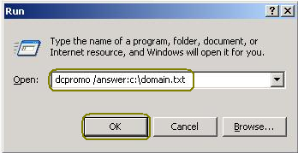
Figure 7-1-1 Promote a Domain Controller
  - Click OK.

How to install Domain Controller on Windows 2008

Installing Active Directory Domain Services on DC
- Run cmd.exe.
- Type the following command:
dcpromo /unattend /InstallDns:yes /dnsOnNetwork:yes /replicaOrNewDomain:domain /newDomain:forest /newDomainDnsName:contoso.com /DomainNetbiosName:contoso /databasePath:"c:\ntds" /logPath:"c:\ntdslogs" /sysvolpath:"c:\sysvol" /safeModeAdminPassword:Password01!/forestLevel:2 /domainLevel:2 /rebootOnCompletion:yes
- Press ENTER.
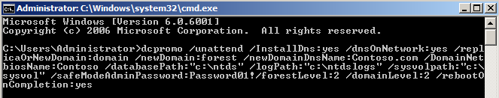
Figure 7-2-1 Promote domain controller by console

How to install Visual Studio 2008
- Open VSTS\VS directory.
- Double click setup.exe.
- Click Install Visual Studio 2008.
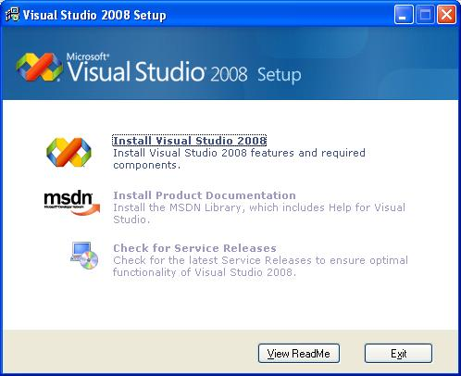
Figure 7-3-1 Install Visual Studio 2008
- Click Next.
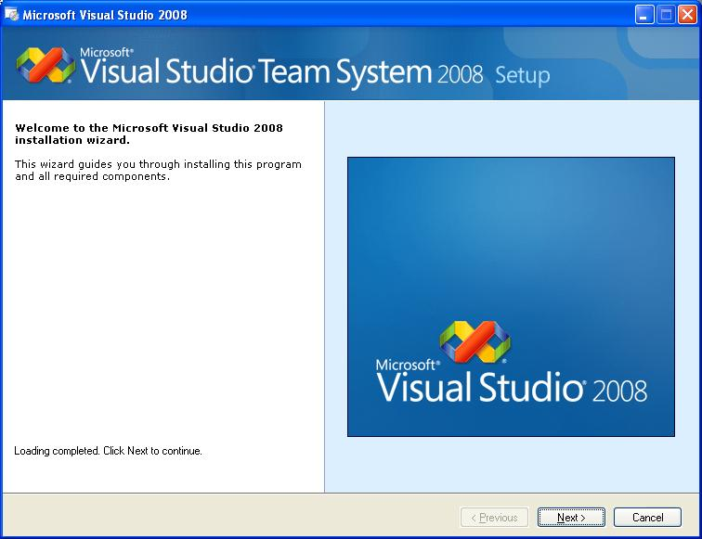
Figure 7-3-2 Install Visual Studio 2008
- Select I have read and accept the license terms and click Next.
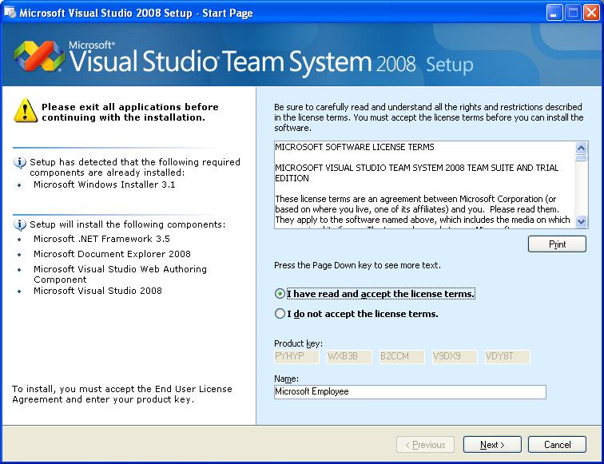
Figure 7-3-3 Install Visual Studio 2008
- Select Custom and click Next.
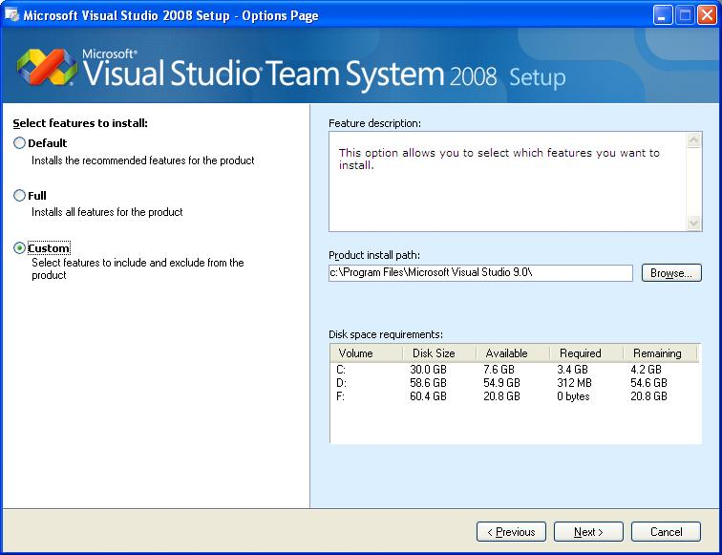
Figure 7-3-4 Install Visual Studio 2008
- Select the necessary components as shown and click Install.
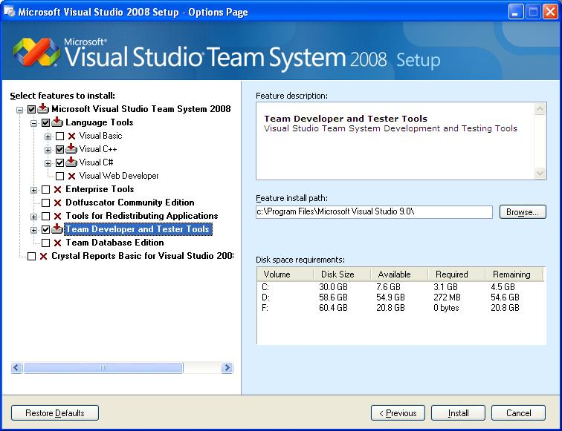
Figure 7-3-5 Install Visual Studio 2008
- Click Finish.
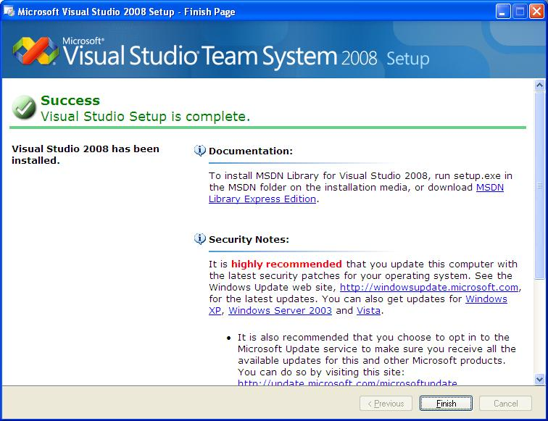
Figure 7-3-5 Install Visual Studio 2008

How to install Microsoft Network Monitor 3.2
- Double-click the netmonpt3.exe.
- Click Next.
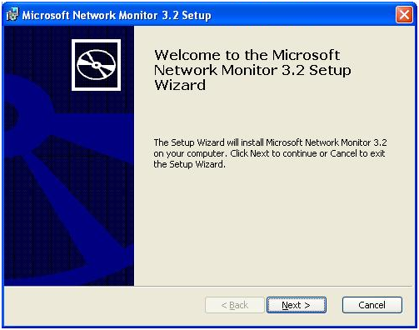
Figure 7-4-1 Install Network Monitor 3.2
- Select I accept the terms in the License Agreement and click Next.
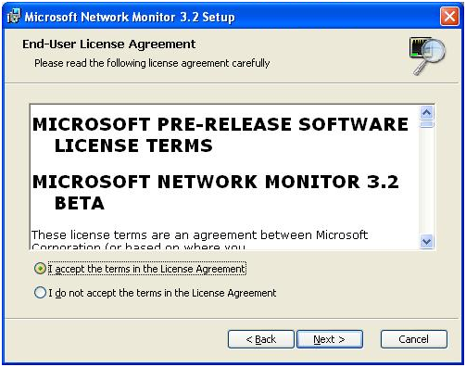
Figure 7-4-2 Install Network Monitor 3.2
- Select Participate in the Microsoft Network Monitor 3.2 Customer Experience Improvement Program. (Recommended) and click Next.
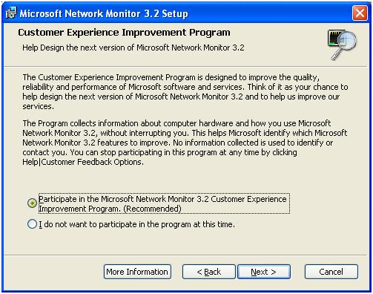
Figure 7-4-3 Install Network Monitor 3.2
- Click Complete.
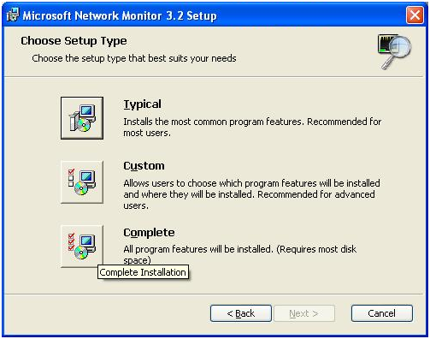
Figure 7-4-4 Install Network Monitor 3.2
- Click Install.
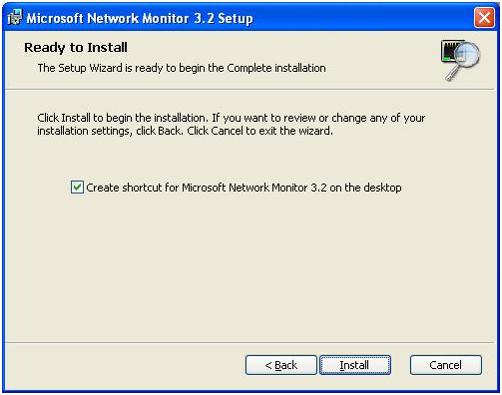
Figure 7-4-5 Install Network Monitor 3.2
- Click Finish.
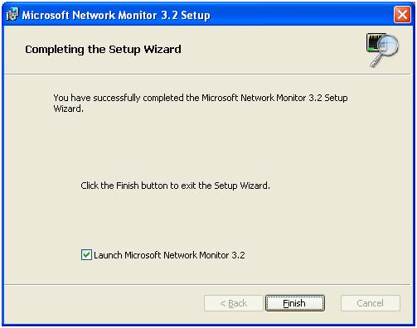
Figure 7-4-6 Install Network Monitor 3.2

How to observe network trace
- Open Network Monitor 3.2.
- Click New capture tab …
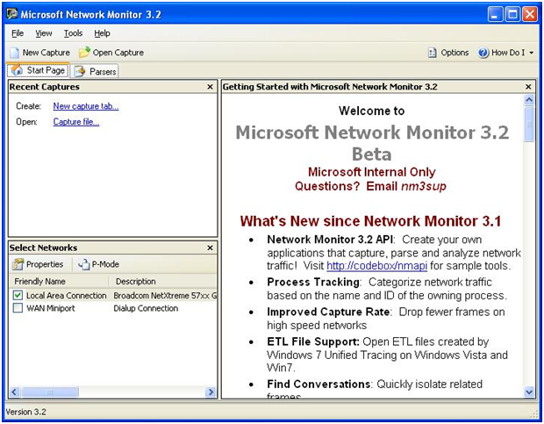
Figure 7-5-1 Observe Network Trace
- Type “MSWSP” in the Display Filter panel, and click Apply.
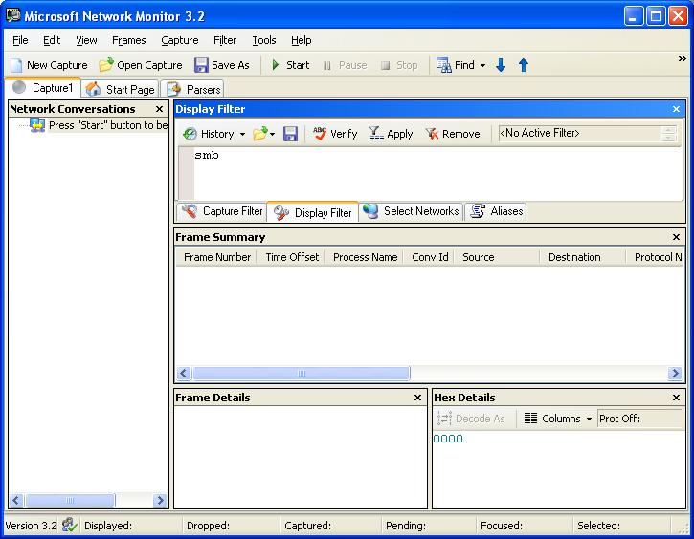
Figure 7-5-2 Observe Network Trace
- Click Start to start capturing and run the test suite to capture the network trace.

How to install Protocol Test Framework
- Double-click the ProtocolTestFramework.msi.
- Click Next.
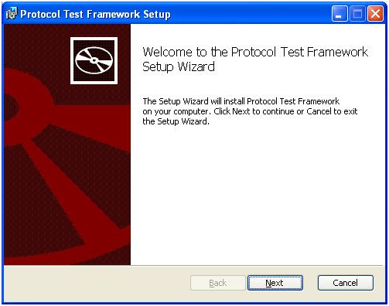
Figure 7-6-1 Install Protocol Test Framework
- Select I accept the terms in the License Agreement and click Next.
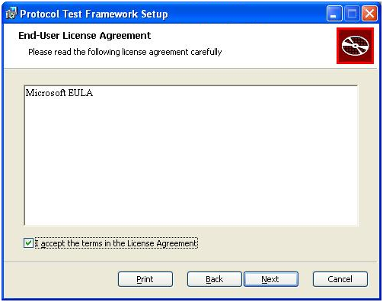
Figure 7-6-2 Install Protocol Test Framework
- Click Next.
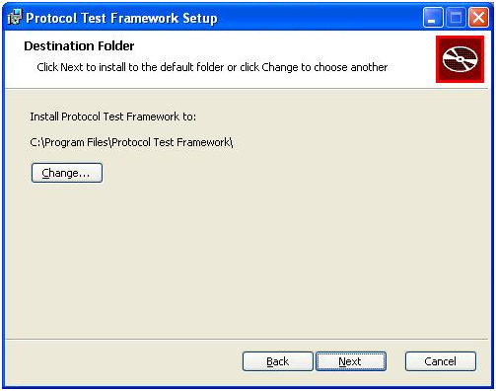
Figure 7-6-3 Install Protocol Test Framework
- Click Install.
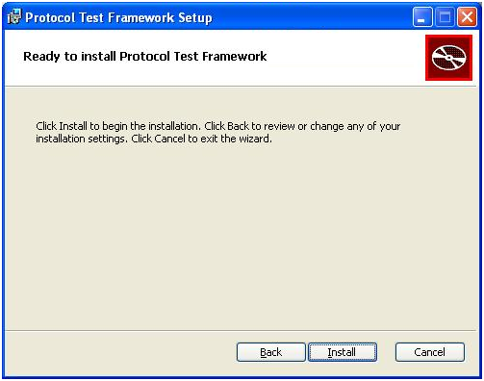
Figure 7-6-4 Install Protocol Test Framework
- Click Finish.
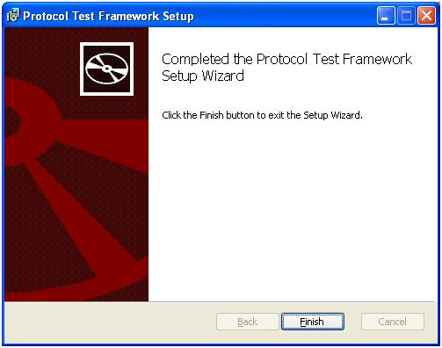
Figure 7-6-5 Install Protocol Test Framework

How to install Spec Explorer
- Double-click the SpecExplorer.msi.
- Click Next.
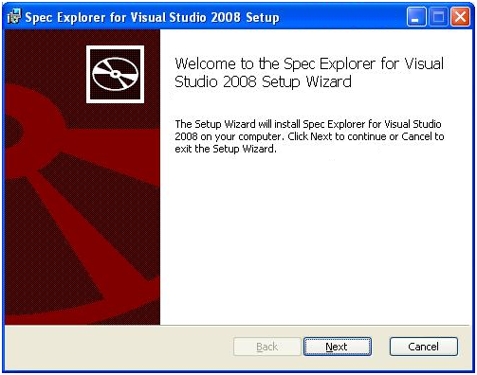
Figure 7-7-1 Install Spec Explorer
- Choose I accept the terms in the License Agreement and click Next.
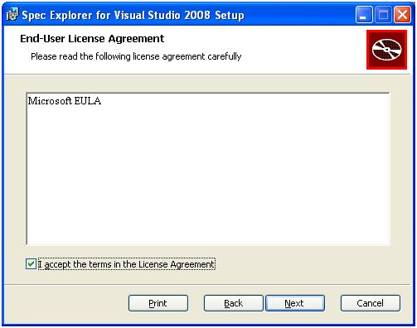
Figure 7-7-2 Install Spec Explorer
- Click Next.
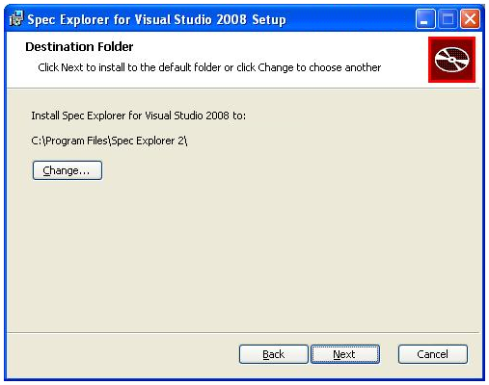
Figure 7-7-3 Install Spec Explorer
- Click Install.
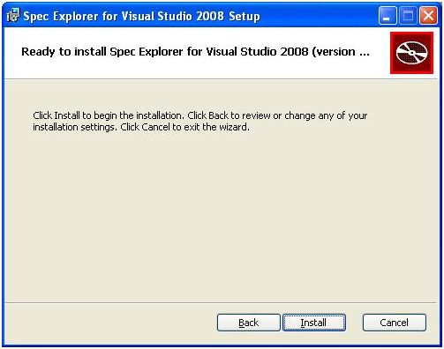
Figure 7-7-4 Install Spec Explorer
- Click Finish.
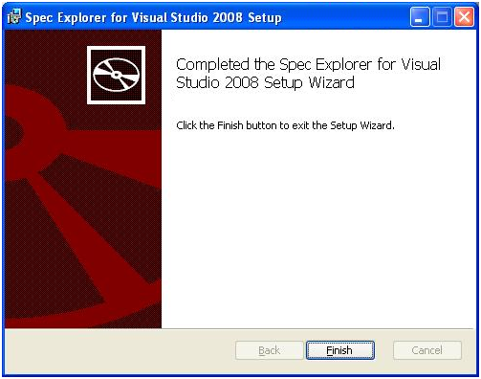
Figure 7-7-5 Install Spec Explorer

