Threat Analysis and OSINT Report

Introduction
This report examines the cyber threat landscape of the UK Higher Education (HE) sector and assesses the security of a specific institution using Open-Source Intelligence (OSINT). The University of Cambridge has been selected for this investigation because of its importance as a major research university. With a group income of over £2.66 billion and a population of more than 25,000 students [1], the University holds large amounts of valuable Intellectual Property (IP) and Personally Identifiable Information (PII). This scale makes it a huge target for both financially motivated cybercriminals and Advanced Persistent Threats (APTs) looking to steal research.
The primary aim of this report is to assess the current sector-wide threats (such as the 91% attack prevalence reported in the 2025 UK Government Cyber Security Breaches Survey [2]) and apply these risks to the University of Cambridge. A passive OSINT investigation will then map out the University’s online presence and identify key security risks without using any active scanning methods.

Cyber Threat Intelligence
The HE sector manages high-value IP and PII, attracting both state-sponsored espionage and financial extortion. The 2025 Cyber Security Breaches Survey confirms this severity: 91% of HE institutions identified attacks in the last year. Despite a marginal decline from 97% in 2024 [5], the intensity remains critical, with 30% of institutions facing weekly incursions and 40% suffering negative outcomes, such as data loss or service disruption. [2]
This high frequency is driven by Advanced Persistent Threats (APTs) like Silent Librarian (Cobalt Dickens). Affiliated with the Iranian-based Mabna Institute, this actor has systematically targeted university research since 2013 [4]. Their reliance on credential theft via spoofed login pages correlates with survey findings identifying phishing as the dominant vector, affecting 97% of institutions [2].
Beyond phishing, the attack surface is diversifying. Supply chain attacks have risen significantly to 69%, forcing institutions to audit third-party software rigorously. Other critical vectors include impersonation (68%) and Denial of Service (36%). While ransomware remains lower volume (15%), its impact is often catastrophic. However, defences are hardening; 94% of institutions now conduct phishing simulations, compared to just 18% of businesses [2]. These threats are global, with similar campaigns compromising US Ivy League institutions like Princeton and Harvard [3]. These precedents underscore the specific risk to UK equivalents like Cambridge, confirming that research-intensive universities are prime targets for data exfiltration.
Furthermore, universities are harder to defend than standard businesses because they are designed to be open and accessible. Unlike an organisation that owns and monitors each device, universities must allow students and staff to bring in and use their own devices, making it more difficult to secure [7]. Additionally, institutions like Cambridge produce technology that can be used for both civilian and military purposes, making the university a target for foreign governments [8]. Instead of developing this technology themselves, these actors try to steal data directly from university servers to bypass international trade laws [9].

OSINT Analysis
This investigation strictly employed passive reconnaissance techniques to map the University of Cambridge’s digital footprint. The goal was to identify public exposures that a Threat Actor (such as the groups identified in the sector analysis) could exploit, without engaging the University's infrastructure directly. The analysis followed the "Cyber Kill Chain" reconnaissance phase: gathering intelligence, mapping the network, and identifying potential entry points.
Initial intelligence gathering utilized Google Advanced Search operators to uncover sensitive directories (site:cam.ac.uk). While standard filetype queries returned vast amounts of benign academic data, refining the search to administrative keywords (filetype:pdf "admin" "guide") successfully exposed the internal "Equipment Sharing Database User Guide" [A].
While the document itself is not classified, it provides a "blueprint" for an attacker. It explicitly details user roles, internal terminology, and confirms the University’s reliance on "Raven" for Single Sign-On (SSO). For a cybercriminal, this is valuable context; knowing exactly how the internal systems are named and structured makes phishing emails look significantly more authentic and convincing to staff. [6].
To understand the technology running the University's website, Shodan.io was used to profile the servers. The analysis revealed a significant migration to third-party cloud providers, with many services hosted on Google Cloud Platform (GCP) and Amazon Web Services (AWS).
Crucially, the query identified multiple subdomains labelled webapp.devel. These potential non-production environments are a frequent source of risk, as they often lack the rigorous security patching applied to live sites. Furthermore, passive header analysis detected Apache HTTP servers (v2.4.52/2.4.58) issuing mod_auth_openidc cookies [B, C]. This technical detail confirms the University uses the OpenID Connect protocol for its central login system. This creates a high-stakes security model: because one "Identity Provider" handles logins for many different university services, a compromise of this single system would have a catastrophic, university-wide effect.
Censys query returned over 58,000 results, indicating a massive digital footprint [D]. Automated tools (theHarvester and DNSdumpster) were used to map out the "subdomains" that sit beneath the main university website. Two specific areas of risk were identified:
- Administrative Interfaces: The tool identified the subdomain hive.em.admin.cam.ac.uk [E]. The terms "Admin" and "EM" suggest this is a backend interface used by staff, not students. If this login page is exposed to the open internet, it presents a high-value target for credential theft attacks.
- Development Environments: The network map highlighted subdomains containing "dev" and "api," such as api-dev-amicus.admin.cam.ac.uk [H, I]. This is a critical finding. "Dev" (development) environments are test sites often used by IT staff before a system goes live. If an attacker can find a vulnerability here, they may be able to use it as a "backdoor" into the wider network.
A "Whois" query was conducted to identify domain ownership. The contact details were redacted, meaning the University successfully uses a privacy service to hide administrator names from the public [F]. This is a positive security control, as it prevents attackers from easily finding specific IT staff to target with social engineering. The records confirmed the University’s connection to the JANET network, linking it to the wider UK academic infrastructure.
Finally, nslookup was used to analyse the network addressing. The results confirmed a "dual-stack" configuration, meaning the University is accessible via both standard (IPv4) and modern (IPv6) addresses [G]. While necessary for connectivity, this effectively doubles the attack surface. Security controls are often less mature on IPv6 infrastructure; if the University has configured strong firewalls for IPv4 but overlooked the IPv6 ranges, these newer addresses could serve as an obscured entry point for the attacks described in the sector analysis.

Discussion
The correlation between the sector-wide threat intelligence and the specific OSINT findings reveals a critical vulnerability in the University’s security posture. The University relies on the "Raven" Single Sign-On (SSO) system. While SSO improves user experience, it creates a single point of failure; if a threat actor successfully spear-phishes a single administrator credential, they bypass the perimeter entirely. The presence of mod_auth_openidc cookies confirms that this one key unlocks multiple doors, potentially granting access to sensitive internal data without further authentication.
While this technical analysis focused on infrastructure, a comprehensive threat actor would likely pivot to social media reconnaissance (LinkedIn) to identify specific Raven users. Targeting these individuals with phishing emails remains the most probable path for credential theft.
However, the Whois analysis demonstrates a robust defence against specific types of social engineering. By utilising privacy redaction services to mask administrator contact details, the University successfully breaks the "Reconnaissance" phase of the Cyber Kill Chain. This obfuscation forces attackers to rely on broader, less effective phishing campaigns rather than attacks targeting specific high-privilege IT staff. This suggests the University has prioritised protecting its personnel, even if the technical documentation remains exposed.
Furthermore, the infrastructure analysis highlights the risk of development subdomains. This gives an attacker two choices: brute-force the hardened Raven login or try to slip through the development API. The CTI data suggests that financially motivated groups would likely exploit the API to deploy payloads, whereas state-sponsored actors would target the administrative system via Raven for persistent access.
Finally, the IPv4/IPv6 configuration identified via nslookup creates a dangerous opening. When legacy security tools fail to monitor IPv6, they provide "blind spots" for command-and-control (C2) traffic to operate undetected. This lack of visibility is precisely why 30% of institutions now report successful weekly attacks; by providing a hidden path for exfiltration, these unmonitored edges allow automated scans to transition into persistent, high-frequency security breaches.

Conclusion
This report confirms that the UK Higher Education sector faces a severe and evolving threat landscape, dominated by credential theft (97%) and ransomware. The OSINT investigation of the University of Cambridge reveals a security posture that is strong in administrative privacy but fragile in its expanding technical attack surface.
The University’s reliance on the "Raven" Single Sign-On system creates a critical dependency: a single compromised credential could grant wide-ranging access to sensitive internal data. Furthermore, the discovery of unmonitored development subdomains and API endpoints exposes a "Shadow IT" risk that bypasses traditional perimeter defences. To mitigate these risks, the University must prioritize securing its cloud environments and ensuring that non-production assets are subject to the same rigorous monitoring as live systems.

References
[1] University of Cambridge, "Reports and Financial Statements for the Year Ended 31 July 2025," cam.ac.uk, 2025. [Online]. Available: https://www.cam.ac.uk/system/files/university_of_cambridge_group_annual_reports_financial_statements_2024-25.pdf. [Accessed: Feb. 2026].
[2] Department for Science, Innovation and Technology, "Cyber security breaches survey 2025: education institutions findings," GOV.UK, 2025. [Online]. Available: https://www.gov.uk/government/statistics/cyber-security-breaches-survey-2025/cyber-security-breaches-survey-2025-education-institutions-findings. [Accessed: Feb. 2026].
[3] Nature, "Cyberattacks on US universities are on the rise," Nature, vol. 638, 2025. [Online]. Available: https://www.nature.com/articles/d41586-025-03484-9. [Accessed: Feb. 2026].
[4] MITRE ATT&CK, "Group G0122: Cobalt Dickens," MITRE, 2024. [Online]. Available: https://attack.mitre.org/groups/G0122/. [Accessed: Feb. 2026].
[5] Department for Science, Innovation and Technology, "Cyber security breaches survey 2024: education institutions annex," GOV.UK, 2024. [Online]. Available: https://www.gov.uk/government/statistics/cyber-security-breaches-survey-2024/cyber-security-breaches-survey-2024-education-institutions-annex. [Accessed: Feb. 2026].
[6] University of Cambridge, "Equipment Sharing Database User Guide," admin.cam.ac.uk, n.d. [Online]. Available: https://www.equipment.admin.cam.ac.uk/esd-admin/raven/Equipment%20Sharing%20Database%20User%20Guide.pdf. [Accessed: Feb. 2026].
[7] Jisc, "Security Conference 2025: Why it's time to act on tackling cyber threats," Jisc, 2025. [Online]. Available: https://www.jisc.ac.uk/blog/security-conference-2025-why-its-time-to-act-on-tackling-cyber-threats. [Accessed: Feb. 2026].
[8] National Protective Security Authority (NPSA), "State Threats in Academia: Secure your success," NPSA, 2025. [Online]. Available: https://www.npsa.gov.uk/national-security-act/state-threats/state-threats-academia. [Accessed: Feb. 2026].
[9] Royal United Services Institute (RUSI), "The Government Needs to Send a Wake-Up Call on Research Security," RUSI, 2025. [Online]. Available: https://my.rusi.org/resource/the-government-needs-to-send-a-wake-up-call-on-research-security.html. [Accessed: Feb. 2026].

Appendix
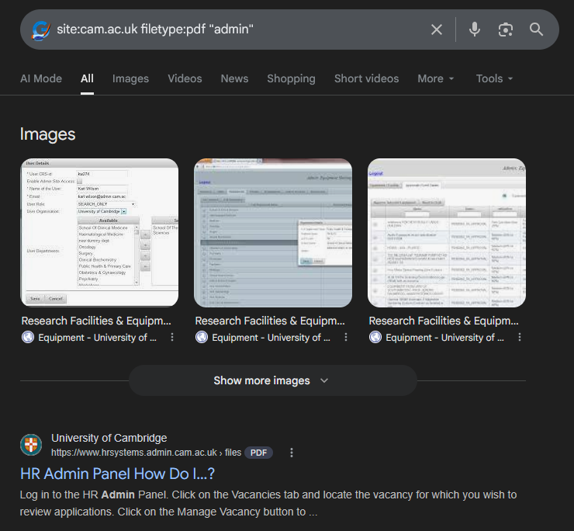
[Appendix A]
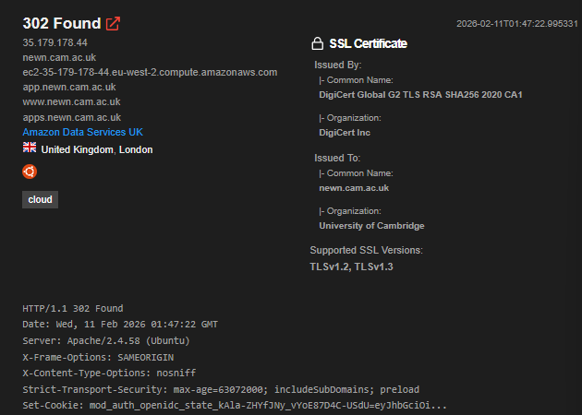
[Appendix B]
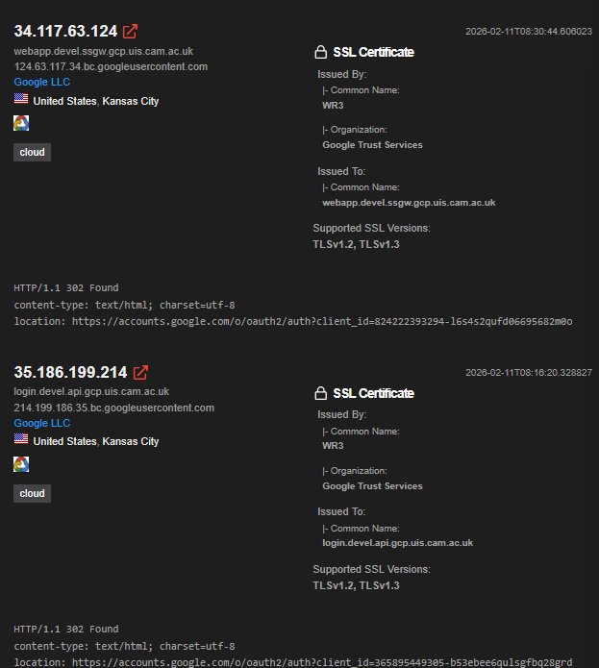
[Appendix C]
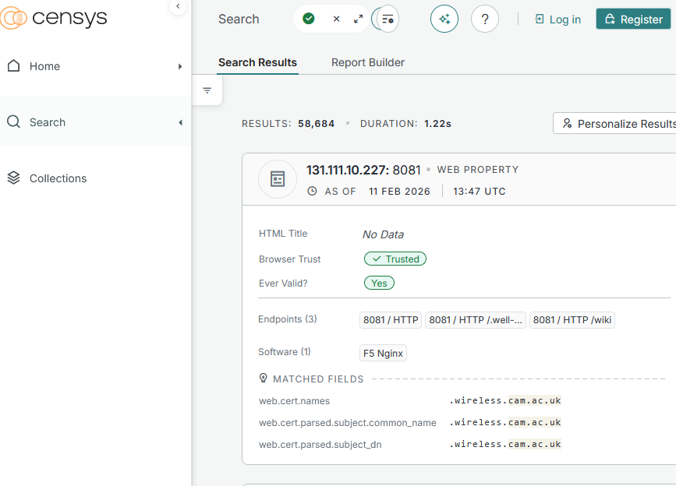
[Appendix D]
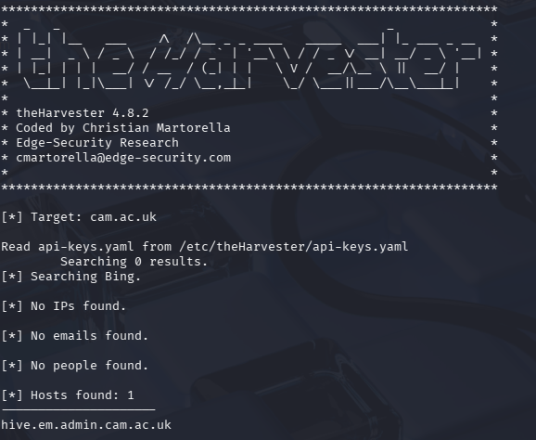
[Appendix E]
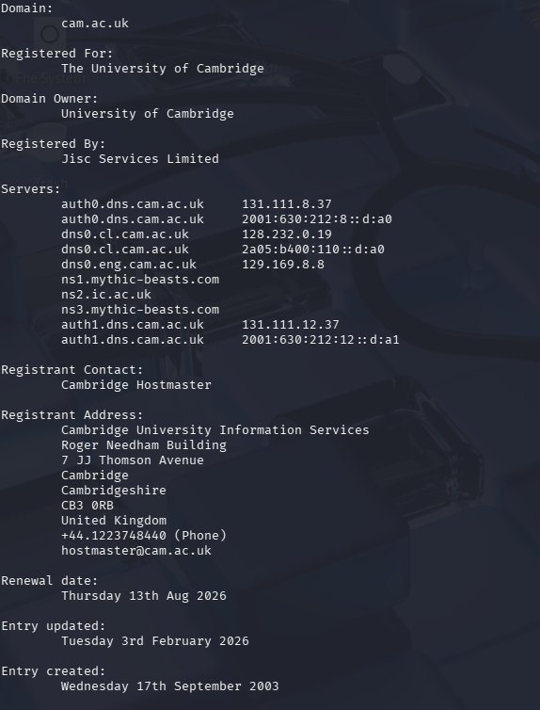
[Appendix F]
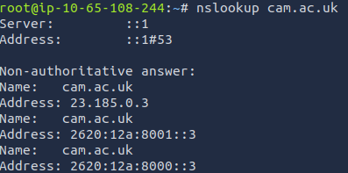
[Appendix G]
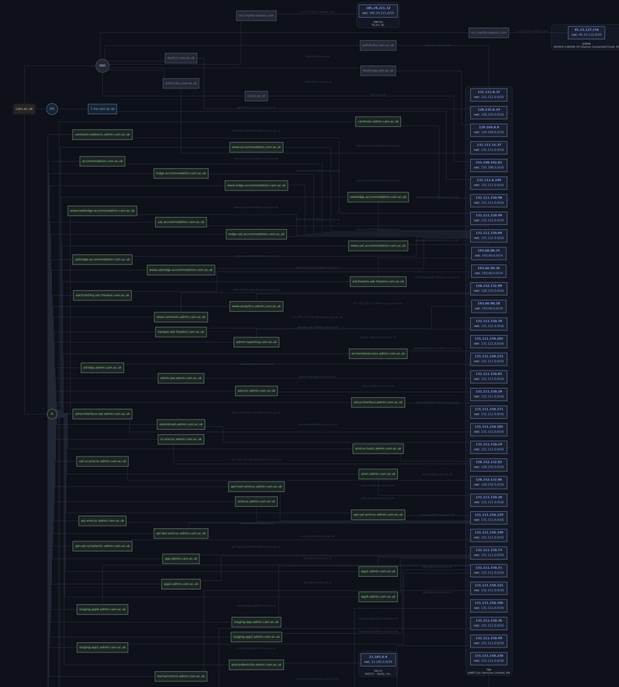
[Appendix H]
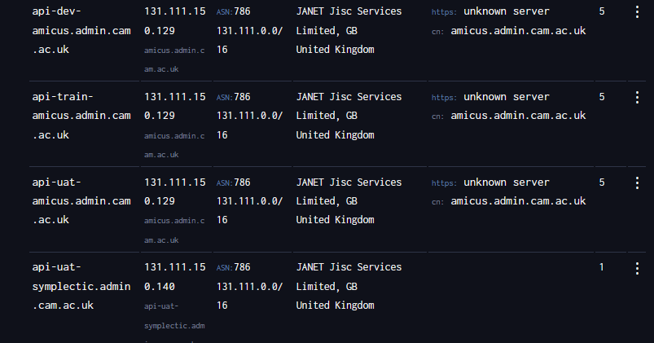
[Appendix I]

Student Declaration of AI Tool use in this Assessment
Please indicate your level of usage of generative AI for this assessment - please tick the appropriate category(s).
If the “Assisted Work” or “Partnered Work” category is selected, please expand on the usage and in which elements of the assignment the usage refers to.

Solo Work | S1 - Generative AI tools have not been used for this assessment. | ☐
Assisted Work | A1 – Idea Generation and Problem Exploration  Used to generate project ideas, explore different approaches to solving a problem, or suggest features for software or systems. Students must critically assess AI-generated suggestions and ensure their own intellectual contributions are central. | ☐
 | A2 - Planning & Structuring Projects  AI may help outline the structure of reports, documentation and projects. The final structure and implementation must be the student’s own work. | ☐
 | A3 – Code Architecture  AI tools maybe used to help outline code architecture (e.g. suggesting class hierarchies or module breakdowns). The final code structure must be the student’s own work. | ☐
 | A4 – Research Assistance  Used to locate and summarise relevant articles, academic papers, technical documentation, or online resources (e.g. Stack Overflow, GitHub discussions. The interpretation and integration of research into the assignment remain the student’s responsibility. | ☐
 | A5 - Language Refinement  Used to check grammar, refine language, improve sentence structure in documentation not code. AI should be used only to provide suggestions for improvement. Students must ensure that the documentation accurately reflects the code and is technically correct. | ☒
 | A6 – Code Review  AI tools can be used to check comments within the code and to suggest improvements to code readability, structure or syntax. AI should be used only to provide suggestions for improvement. Students must ensure that the code accurately reflects their knowledge and is technically correct. | ☐
 | A7 - Code Generation for Learning Purposes  Used to generate example code snippets to understand syntax, explore alternative implementations, or learn new programming paradigms. Students must not submit AI-generated code as their own and must be able to explain how it works. | ☐
 | A8 - Technical Guidance & Debugging Support  AI tools can be used to explain algorithms, programming concepts, or debugging strategies. Students may also help interpret error messages or suggest possible fixes. However, students must write, test, and debug their own code independently and understand all solutions submitted. | ☒
 | A9 - Testing and Validation Support  AI may assist in generating test cases, validating outputs, or suggesting edge cases for software testing. Students are responsible for designing comprehensive test plans and interpreting test results. | ☐
 | A10 - Data Analysis and Visualization Guidance  AI tools can help suggest ways to analyse datasets or visualize results (e.g. recommending chart types or statistical methods). Students must perform the analysis themselves and understand the implications of the results. | ☐
 | A11 - Other uses not listed above  Please specify: | ☐
Partnered Work | P1 - Generative AI tool usage has been used integrally for this assessment  Students can adopt approaches that are compliant with instructions in the assessment brief.  Please Specify: | ☐

Please provide details of AI usage and which elements of the coursework this relates to:
A5: Used for spelling and grammar checks across the report. A8: Used to clarify technical concepts after use of tools.

I understand that the ownership and responsibility for the academic integrity of this submitted assessment falls with me, the student. | ☒
I confirm that all details provide above are an accurate description of how AI was used for this assessment. | ☒

