Target:
University Of Cambridge
Reason: A large university that has a lot of research, meaning more valuable information could be gathered. Due to the sixze of the uni, there will be more data for me to gather during OSINT. As this uni is one of the bestin the UK it will also bne a prime target for APTs.
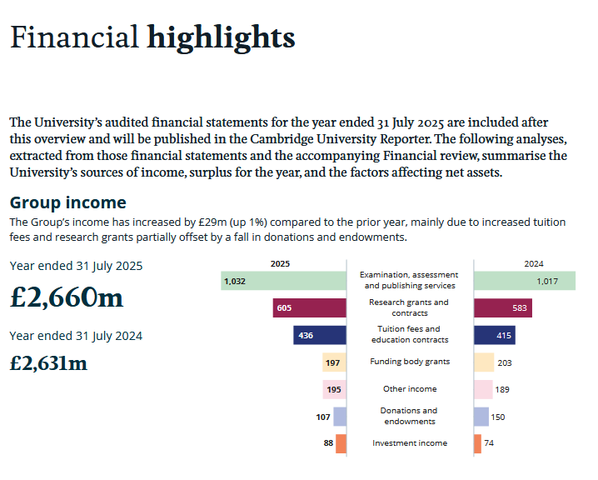
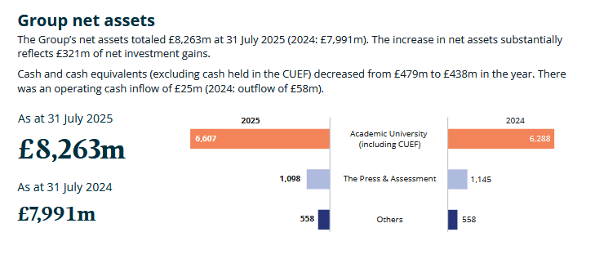




Cyber Security breaches survey 2024: education institutions annex

- “Further education and higher education institutions are more likely to experience breaches and attacks than schools, and to experience a wider range of attack types, such as impersonation, viruses or other malware, and unauthorised access of files or networks by outsiders.”
- “Higher education institutions are more likely to be affected by cyber-attacks - 97% identified a breach or attack in the past year. Just under six in ten of the higher education institutions identified that they had been negatively impacted by a breach.”
- “Education institutions typically report a higher level of board engagement with cyber security than the average UK business. In this sense, they are more like large businesses.”
Quantitative survey
The survey of educational institutions comprised a random probability telephone survey, carried out from September 2023 to January 2024. It included:
- 185 primary schools
- 171 secondary schools
- 43 further education colleges
- 31 higher education institutions
The school samples include a random selection of free schools, academies, Local Authority-maintained schools and special schools.
The samples were selected from the following sources:
- All institutions in England: Get Information About Schools
- Schools in Scotland: Scottish Government School Contact details
- FE Colleges in Scotland: Colleges Scotland directory
- Schools in Wales: Welsh Government Address list of schools
- FE Colleges in Wales: Colleges Wales directory
- Schools in Northern Ireland: NI Department of Education database
- FE Colleges in Northern Ireland: NI Direct FE College directory
- Higher education institutions in Scotland, Wales and Northern Ireland: Universities UK website, cross-referenced against the comprehensive list of Recognised Bodies on GOV.UK
Qualitative interviews
In addition, we carried out 15 qualitative interviews with institutions that took part in the survey. Including:
- 2 primary schools
- 6 secondary schools
- 7 higher education institutions
In this annex, we include the key findings from these education institutions, as well as a selection of quotes from these interviews to illustrate the themes raised. We do not provide job title descriptions when attributing the quotes as these may be disclosive. Participants in these interviews were all cyber or IT specialists.

Figure 2.2: Percentage that identified the following types of breaches or attacks in the last 12 months, among the educational institutions that have identified any breaches or attacks
Higher education institutions stood out in particular in terms of phishing attacks (100%), impersonation attacks (90%), viruses, spyware or malware (77%), unauthorised access of files or networks by staff (27%), unauthorised access of files or networks by outsiders (20%) and any other breaches or attacks (47%).
Among those that have experienced breaches or attacks in the last 12 months, higher education institutions were more likely to be affected than further education colleges and schools: Over two in five (43%) higher education institutions reported experiencing a breach or attack at least weekly.
Table 2.1: Percentage of educational institutions undertaking action in each of the 10 Steps areas
Step description and how derived from the survey | Primary | Secondary | Further | Higher
1 Risk management - Organisations who update boards at least annually and have at least 2 of the following: a cyber security policy or strategy, adherence to Cyber Essentials or Cyber Essentials Plus, undertake risk assessments, have cyber insurance (either a specific or non-specific policy), undertake cyber security vulnerability audits, have an incident response plan, managing suppliers or supply chain cyber risks. | 58% | 71% | 88% | 90%
2 Engagement and training - Organisations that train staff or do mock phishing exercises | 62% | 75% | 88% | 90%
3 Asset management - Organisations that list of critical assets | 65% | 71% | 95% | 77%
4 Architecture and configuration - Organisations that configure firewalls and either: secure configurations, i.e., security controls on company devices or have a policy around what staff are permitted to do on company devices | 98% | 100% | 100% | 100%
5 Vulnerability management - Organisations that have a patching policy and at least one of the following: undertake vulnerability audits, penetration testing, update anti-malware, or have a policy covering SaaS | 49% | 68% | 88% | 87%
6 Identity and access management - Organisations that restrict admin rights or password policy or two factor authentication | 72% | 71% | 100% | 97%
7 Data security - Organisations with cloud or other backups and at least one of the following: secure personal data transfers, have policy covering removable storage or on how to store data | 97% | 98% | 100% | 100%
8 Logging and monitoring - Organisations with monitoring tools or if log breaches and had a breach | 90% | 95% | 88% | 94%
9 Incident management - Organisation with incident response plans or formal debriefs | 70% | 81% | 86% | 94%
10 Supply chain security - Organisations that monitor risks from suppliers or wider supply chain | 39% | 43% | 67% | 58%

