University of Plymouth

School of engineering,

computing, and mathematics

Final Stage Computing Project

2025/2026

S.I.R.A: Simplifying Cybersecurity

for SMEs

Matthew Fish
10855826
BSc (Hons) Computer Science (Cyber Security)

Acknowledgements
I would like to express my gratitude to my supervisor, Nathan Clarke, for his continuous guidance and support throughout this project. His constant availability and willingness to help whenever in need ultimately led to a stronger end product. I would also like to extend my thanks to my family and friends who have supported and encouraged me along the way.

Abstract
Small and medium-sized enterprises (SMEs) face a growing volume of targeted cyberattacks but frequently lack the capital for dedicated Security Operations Centres (SOCs) or enterprise-grade SIEMs. While many implement open-source intrusion detection systems, they often struggle to interpret the complex, raw technical logs generated. The purpose of this project was to develop S.I.R.A. (Security Incident Response Assistant), an affordable, LLM-powered incident response dashboard designed to bridge this cybersecurity expertise gap.
The system integrates a log watcher with a large language model (Google Gemini) and a real-time cloud database. To guarantee data privacy and address cloud security concerns, a rigorous two-tier security pipeline was implemented. Raw logs undergo local regex sanitisation to strip Personally Identifiable Information (PII) prior to AI analysis, and all incident records are subsequently secured via AES encryption before transmission. A React-based frontend then displays this data, utilising dynamic AI personas to tailor the technical depth of mitigation playbooks based on specific user roles.
Rigorous security assessments and User Acceptance Testing (UAT) demonstrated that the localised pre-processing pipeline successfully prevented sensitive data exposure to the LLM. Furthermore, the dynamic AI personas successfully translated complex security alerts into plain-English summaries, accurate risk scores, and actionable mitigation steps. The system allowed non-technical users, such as business owners, to confidently understand and address threats, while still providing sufficient technical depth for IT and SOC analysts.
The S.I.R.A. dashboard successfully simplifies incident management for SMEs. The project proves the viability and effectiveness of combining localised data sanitisation with cloud-based Large Language Models to deliver a secure, accessible, and cost-effective cybersecurity solution.
Contents
Acknowledgements 1
Abstract 1
List of Tables 4
List of Figures 5
Word Count 5
Github Repo 5
1. Introduction 5
1.1 Background and Problem Statement 6
1.2 Aims and Objectives 6
1.2.1 Project Rationale 6
1.2.2 Aim 7
1.2.3 Objectives 7
1.3 Scope and Constraints 7
1.3.1 In-Scope 7
1.3.2 Out-of-Scope (Exclusions) 8
1.3.3 Technical Constraints 8
2. Literature Analysis 8
2.1 The Cybersecurity Landscape for SMEs 8
2.2 Existing Security Solutions and Resource Constraints 9
2.3 The Role of Large Language Models in Cybersecurity 10
2.3.1 Overcoming AI Adoption Barriers 10
3. Legal, Social, Ethical, and Professional Issues (LSEP) 11
3.1 Legal 11
3.2 Social 11
3.3 Ethical 11
3.4 Professional 11
4. Requirements & Specification 12
4.1 Target Audience 12
4.2 Functional Requirements 13
4.3 Non-Functional Requirements 14
4.4 Use Case and User Stories 15
4.4.1 System Use Cases 15
4.4.2 User Stories 17
5. Project Management & Methodology 17
5.1 Development Methodology 17
5.2 Project Management Technologies 18
5.2.1 The Gantt Chart 18
5.2.2 Trello Workspace 18
5.3 Project and System Risk Assessment 19
5.3.1 System and Flows 19
5.3.2 Risk Categories and Impact 19
5.3.3 Existing Mitigation Control 19
5.3.4 Risk Register 20
6. System Design & Architecture 20
6.1 Technology Stack Justification 20
6.1.1 Frontend Architecture (React, TypeScript & Tailwind CSS) 20
6.1.2 Backend Processing & API (Python & FastAPI) 20
6.1.3 Database & Authentication (Google Firebase/Firestore) 21
6.1.4 AI & Logic Engine 21
6.1.5 Ingestion Strategy 21
6.2 High-Level Architecture 21
6.3 Database Design 22
6.4 System Logic & Processing Models 24
6.4.1 Functional Decomposition (HIPO) 24
6.4.2 System Sequence & Interaction 25
6.5 System Resilience & Error Handling 26
6.6 User Interface Design 27
6.6.1 Initial Low-Fidelity Prototyping 27
6.6.2 Agile Feedback & Design Iteration 28
7. Development & Implementation 30
7.1 Data Origin & Local Ingestion 30
7.1.1 Continuous Monitoring 30
7.1.2 Initial Triage and Noise Reduction 31
7.2 Privacy & Data Sanitisation 31
7.2.1 Deep Text Sanitisation (Regex) 32
7.2.2 Intelligent IP Masking 32
7.3 AI Integration 33
7.3.1 Asynchronous Batching 33
7.3.2 Dynamic AI Personas 33
7.3.3 Cryptographic Storage 33
7.4 Frontend Dashboard 34
7.4.1 Real-Time Data Synchronisation 35
7.4.2 Analytics and Data Visualisation 35
7.4.3 Rendering the Mitigation Playbooks 36
7.5 The Secure API Gateway 36
7.5.1 The Cryptographic Gateway 36
7.6 Overcoming Challenges 37
7.6.1 Intelligent Caching and Quota Management 37
7.6.2 AI Rate Limiting and Prompt Evolution 37
7.6.3 Frontend Graph and CSS 37
7.6.4 System Integration 37
7.6.5 Modular Architecture and API Key Management 38
8. Testing & Evaluation 38
8.1 Testing Strategy 38
8.1.1 Unit testing 38
8.1.2 Integration Testing 41
8.1.3 Performance / Stress Testing 41
8.2 User Acceptance Testing (UAT) 42
9. Conclusion & Future Work 44
9.1 Project Summary 44
9.2 Critical Evaluation & Limitations 44
9.3 Future Enhancements 45
9.4 Final Thoughts 45
References 46
Appendices 47
Appendix A: Literature Evidence 47
Appendix B: Project Management 48
Appendix C: Initial Project Risk Assessment 51
Appendix D: Initial Wireframes 55
Appendix E: Final Wireframes 58
Appendix F: Unit Tests 61
Appendix G: Integration Tests 67
Appendix H: Performance / Stress Tests 68
Appendix I: Blank UAT Questionnaire and Results. 72
Appendix J: Code Snippets 93
Appendix K: AI Declaration 100

List of Tables
Table 1: Comparison of existing security solutions against SME resource constraints. 9
Table 2: S.I.R.A. user persona profiles, associated challenges, and dynamic AI system integration. 12
Table 3: Functional Requirements. 13
Table 4: Non-Functional Requirements. 14
Table 5: User Stories 16
Table 6: Initial Firestore database schema design illustrating the conceptualised processing queue and plaintext data fields. 22
Table 7: Final implemented Firestore database schema illustrating the three core collections. 23
Table 8: Error-Handling matrix detailing system failure domains. 25
Table 9: Backend Unit Test Results 38
Table 10: Frontend API Unit Test Results 39
Table 11: Frontend Analytics Unit Test Results 39
Table 12: Frontend Incidents Unit Test Results 39
Table 13: Frontend Login Unit Test Results 39
Table 14: Frontend Settings Unit Test Results 40
Table 15: Integration Test Results 40
Table 16: Performance Test Results 41

List of Figures
Figure 1: UML Use Case Diagram illustrating User and System interactions within S.I.R.A. 16
Figure 2: High-Level System Architecture diagram illustrating the data flow across the Presentation, Processing, Database, and Local layers. 22
Figure 3: HIPO Diagram detailing the functional decomposition of system modules. 25
Figure 4: Sequence Diagram illustrating the chronological message passing between system components. 26
Figure 5: Initial low-fidelity paper prototype for the system dashboard. 27
Figure 6: Initial wireframe for the proposed Admin Management page. 28
Figure 7: Final high-fidelity design for the dedicated 'View Incident' page, featuring the persistent top navigation bar. 29
Figure 8: Code snippet showing the "digital bookmarking" mechanism used to prevent duplicate processing of log files. 31
Figure 9: Code snippet demonstrating the regex sanitisation used to strip PII. 32
Figure 10: Implementation of the IP pseudonymisation logic. 32
Figure 11: Implementation of the crypto.py module, utilizing Fernet for AES-128 payload encryption and decryption. 34
Figure 12: Screenshot of the S.I.R.A. main analytics dashboard. 35
Figure 13: Screenshot of the unencrypted metadata in firestore. 36

Word Count
10,830

Github Repo
https://github.com/Mattrfish/Matt-Fish-COMP3000-Computing-Project

1. Introduction
Small and medium-sized enterprises (SMEs) represent the backbone of the global economy. According to recent UK Government business population estimates (GOV.UK, 2025), SMEs account for 99.9% of the total private sector business population, representing roughly 5.7 million businesses in the UK alone. Despite making up the vast majority of the economy, they are increasingly targeted in a rapidly evolving cyber threat landscape. This project details the design, development, and evaluation of S.I.R.A. (Security Incident Response Assistant), an AI-driven dashboard designed to empower SMEs to remediate cyber threats without the need for an expensive in-house security team.

1.1 Background and Problem Statement
Cyber threats are escalating globally at an unprecedented rate, with over 2,000 major data breaches reported annually, incurring an average organisational cost exceeding $3.9 million per incident (Fadziso et al., 2023). As digital technology expands the attack surface, the continuous maturation of enterprise-level security has forced threat actors to strategically pivot towards softer, more vulnerable targets—most notably, small and medium-sized enterprises (SMEs) (Saleem et al., 2017). According to the latest industry data, 59% of SMEs experienced a cyberattack within a single twelve-month period, often leading to severe operational downtime, financial loss, and in many cases, complete business failure (Hiscox Group, 2025).
Despite this escalating threat environment, SME management often suffers from a pervasive cognitive bias, identified in cyberpsychology research as the "illusion of invulnerability"—the flawed belief that their limited financial turnover renders them "too small" to be targeted (Troublefield, 2025). Threat actors, however, increasingly target smaller businesses specifically because they are perceived as soft targets with weaker defences (Tetteh, 2024; Junior et al., 2025).
This dangerous false sense of security is compounded by severe operational constraints. Unlike enterprise-level organisations, SMEs typically lack the capital required to fund dedicated Security Operations Centres (SOCs) or employ experienced, full-time cybersecurity analysts to monitor their networks (Saleem et al., 2017). Without professional monitoring or robust incident response plans, malicious network intrusions frequently go entirely unnoticed until the point of critical impact (Tetteh, 2024).
To mitigate these risks on a restricted budget, some SMEs attempt to implement free, consumer-grade commercial tools or open-source Security Information and Event Management (SIEM) software. However, the overarching lack of internal technical expertise renders these efforts largely ineffective. Non-technical staff often fail to understand how to properly configure these systems or interpret the complex security alerts they generate, creating a dangerous illusion of security (Manzoor et al., 2024). Ultimately, this combination of outdated technology, inadequate training, and overwhelming "technical noise" leads to severe alert fatigue, leaving SMEs highly vulnerable to attack (Lake, 2022). There is, therefore, a critical need for an automated, affordable, and accessible incident response solution capable of translating complex threat data into actionable intelligence for non-technical users.

1.2 Aims and Objectives

1.2.1 Project Rationale
Recent academic literature emphasises that Artificial Intelligence (AI) offers transformative capabilities for cyber defence, enabling automated detection and response without the need for intensive manual oversight (Femi et al., 2025). However, despite this potential, AI adoption among SMEs remains critically low. Femi et al. (2025) highlight that SMEs are frequently deterred by the high costs, technical complexity, and the opaque, "black box" nature of enterprise-grade AI tools. To successfully bridge the cybersecurity expertise gap, resource-constrained organisations urgently require frameworks that are not only affordable and automated but also highly transparent. Systems must provide clear, explainable reasoning so that non-technical users can confidently trust and execute the suggested mitigation strategies.
This project directly addresses this identified academic and industry gap through the development of S.I.R.A. (Security Incident Response Assistant). By leveraging a Large Language Model (LLM) to translate complex security events into plain-English summaries and dynamic, role-specific playbooks, S.I.R.A. aims to deliver a resilient, user-friendly, and cost-effective cybersecurity solution tailored specifically to the operational realities of SMEs.

1.2.2 Aim
The primary aim of this project is to design, develop, and evaluate an affordable, LLM-powered incident response dashboard that bridges the cybersecurity expertise gap for SMEs by automatically translating complex technical logs into actionable, easy-to-understand mitigation strategies.

1.2.3 Objectives
To successfully achieve this aim, the following technical objectives have been established:
- Log Ingestion and Parsing: Develop a robust backend system capable of continuously monitoring and parsing raw log files from standard open-source detection tools (e.g., Snort, Winlogbeat).
- Data Privacy and Sanitisation: Implement a strict, localised pre-processing pipeline to strip Personally Identifiable Information (PII) from logs, ensuring no sensitive company data is exposed to the external LLM.
- AI Integration and Analysis: Integrate the Google Gemini 1.5 Flash API to analyse the sanitised logs, accurately calculate risk scores, and formulate step-by-step mitigation strategies.
- Dynamic AI Personas: Engineer the system to adjust the technical depth of its AI-generated summaries based on the user's specific role (e.g., providing high-level business impact summaries for Business Owners, and explicit CLI commands for SOC Analysts).
- Secure Cloud Synchronisation: Utilise Google Firestore for real-time data storage, ensuring all AI insights and incident records are secured via Fernet AES encryption prior to cloud transmission.
- User Interface Development: Design and build an intuitive, low latency React frontend dashboard tailored for non-technical users, complete with automated email notifications for critical threat alerts.

1.3 Scope and Constraints
To ensure the project remains achievable and aligned with SME operational realities, clear system boundaries have been established.

1.3.1 In-Scope
The S.I.R.A. dashboard is designed strictly as an intelligent incident management and advisory platform. The core scope encompasses the passive ingestion and parsing of raw logs from existing detection tools (e.g., Snort or Windows Event Viewer). It features a localised pre-processing pipeline utilising regular expressions (regex) to strip Personally Identifiable Information (PII) prior to cloud transmission. The system leverages the Google Gemini 1.5 Flash API to translate these sanitised alerts into plain-English summaries and mitigation playbooks, displayed via a role-based React frontend.

1.3.2 Out-of-Scope (Exclusions)
To distinguish S.I.R.A. from enterprise-grade SIEM tools, active threat mitigation is explicitly excluded. The application functions purely in an advisory capacity; it is not an Intrusion Prevention System (IPS) or active firewall. It will not automatically block IP addresses, terminate malicious processes, or alter network configurations. Furthermore, the installation of underlying host detection engines and deep forensic analysis (such as malware sandboxing) fall completely outside the project scope.

1.3.3 Technical Constraints
As an academic endeavour, the development of S.I.R.A. was shaped by several high-level logistical and structural constraints:
- Financial and Resource Limitations: The project was entirely self-funded and operated with a zero-budget constraint. Consequently, the architecture was explicitly designed around open-source software and free-tier cloud services (such as the Google Gemini API and Firebase). While this perfectly aligns with the project's goal of delivering a low-cost solution for SMEs, it inherently limited access to enterprise-grade development tools, premium threat-intelligence feeds, and large-scale, paid testing environments. Furthermore, as a solo-developer project, there was a strict limitation on available human resources for quality assurance and peer review.

- Temporal Constraints: The project lifecycle was strictly bounded by the academic calendar. The initial requirements engineering and system design phases were compressed into a two-month window (September to October), followed by a primary development and testing phase from November to April. This rigorous timeframe necessitated the strict prioritisation of core functionalities. Because of these time constraints, certain advanced features and exhaustive edge-case testing had to be scoped out to ensure a minimum viable product (MVP) was delivered on schedule. Consequently, there is an acknowledged possibility that some secondary SME operational requirements may have been deferred to future iterations.

2. Literature Analysis

2.1 The Cybersecurity Landscape for SMEs
Recent systematic literature reviews evaluating the state of SME cybersecurity research highlight a critical imbalance in defensive strategies (Chidukwani et al., 2022). When mapped against the National Institute of Standards and Technology (NIST) Cybersecurity Framework, research indicates a disproportionate academic and industry focus on the 'Identify' and 'Protect' functions. Conversely, there is a severe lack of literature and tooling addressing the 'Detect', 'Respond', and 'Recover' phases (see Appendix A, Figure 1).
The evidence suggests that this disparity exists because the later stages of the NIST lifecycle require a level of real-time technical interpretation that most SMEs cannot provide. While tools for protection, such as firewalls or antivirus, are relatively straightforward to deploy, the response and recovery phases depend on the ability to understand complex network telemetry. This means that even when a small business is aware of an intrusion, they often lack the specific technical guidance needed to contain the threat. This indicates that the primary challenge for SMEs is not just the presence of a threat, but the difficulty of translating raw security data into a practical recovery plan without expert assistance.
This technical deficit is further compounded by a dangerous false sense of security. Research by Lake (2022) highlights a significant 'confidence gap' among small businesses; while 62% of SME owners feel confident in their ability to quickly respond to a cyberattack, only 34% have a formal incident response plan in place. This indicates that many SMEs are relying on assumptions rather than actionable strategies, leaving them entirely unprepared for a real-world breach.
Lake (2022) further notes that when these businesses do attempt to improve their posture by implementing network monitoring, they frequently succumb to "alert fatigue." Because standard open-source detection tools generate thousands of highly technical alerts, small IT teams or solo administrators quickly become overwhelmed by the constant stream of technical noise. Under this cognitive load, genuine indicators of compromise are often missed or ignored. Ultimately, this proves that the primary challenge for SMEs is not a lack of network data, but the absence of automated filtering and translation. Without a tool to distil raw alerts into clear, manageable recovery steps, small businesses remain highly vulnerable, even with detection software running.

2.2 Existing Security Solutions and Resource Constraints
To combat the escalating threat landscape, the cybersecurity industry heavily promotes the adoption of Security Information and Event Management (SIEM) systems. These platforms aggregate and correlate network telemetry to provide a unified view of an organisation's security posture. However, a recent comprehensive evaluation by Manzoor et al. (2024) highlights that the SIEM market is fundamentally bifurcated into two categories (commercial and open source) neither of which adequately serves the operational realities of an SME.
Proprietary, enterprise-grade SIEM solutions, such as Splunk Enterprise, IBM QRadar, and LogRhythm, historically dominate the market and provide exceptional threat visibility. However, Manzoor et al. (2024) note that these products are accompanied by "huge licensing costs," making them entirely unaffordable for most small businesses. Furthermore, they operate under the assumption that the purchasing organisation employs a dedicated Security Operations Centre (SOC) staffed by analysts who can actively monitor dashboards and triage alerts.
Consequently, budget-constrained SMEs frequently attempt to deploy open-source or free-tier alternatives, such as Wazuh, AlienVault OSSIM, or Elastic Security. While these solutions successfully circumvent initial licensing costs, Manzoor et al. (2024) explicitly warn that selecting and maintaining them is a highly challenging task. Effective deployment demands an "in-depth understanding of security features, performance parameters, and a specialised knowledge base." The technical overhead required to operate these open-source systems is immense; administrators must manually configure Syslog forwarding, deploy host-based agents for File Integrity Monitoring (FIM), and continuously tune custom correlation rules to manage high volumes of Events Per Second (EPS) without dropping data.
For an SME relying on a small IT team or a single generalist administrator, this level of manual configuration, performance tuning, and alert triage is fundamentally unsustainable. To contextualise S.I.R.A. within this landscape, Table 1 evaluates prominent existing solutions against the core SME constraints identified in the literature.
To contextualise S.I.R.A. within this landscape, Table 1 evaluates prominent existing solutions against core SME constraints identified in the literature.
Table 1: Comparison of existing security solutions against SME resource constraints.
Security Solution | Target Market | Licensing Cost | Hardware / Resource Overhead | Technical Expertise Required
Splunk / IBM QRadar | Enterprise | High | High (requires dedicated servers) | High (Dedicated SOC)
Wazuh / Elastic | Enterprise | Free | High (Heavy Local Processing) | High (complex config)
S.I.R.A | SMEs | Free / Low-Cost | Low (Cloud-based Processing) | Low (Non-technical)

As demonstrated in Table 1, this visual dichotomy exposes a stark operational gap: enterprise solutions are financially unviable, while open-source alternatives are technically overwhelming. This synthesis of literature and market reality provides a strong academic basis for the development of S.I.R.A. By functioning as a lightweight translation layer, it delivers SIEM-like insights without the associated financial burden or complex technical overhead.

2.3 The Role of Large Language Models in Cybersecurity
Research suggests that Artificial Intelligence (AI) has become a significant asset for cyber defence, yet its implementation within the SME sector remains limited. This low adoption is primarily driven by significant barriers such as high implementation costs, technical complexity, and difficulties with system integration (Femi et al., 2025). While the literature highlights that AI could greatly improve the cybersecurity posture of smaller organisations, most businesses still lack the necessary funding and technical resources to adopt these tools effectively. This resource gap appears to be the most substantial challenge identified across current research.
Femi et al. (2025) further note that even when cloud-based or AI-enhanced solutions are available, they are often overlooked by SMEs due to their inherent complexity. This suggests that for AI to be a viable solution for this demographic, it must be delivered through a framework that is both affordable and technically accessible to non-specialist users.
However, recent industry data suggests that this complexity gap is compounded by an emerging trust gap. A survey by Hiscox (2025) reveals a notable dichotomy: while 65% of SMEs recognise AI as a defensive asset rather than a vulnerability, over 57% of these organisations have already fallen victim to an attack involving an AI-driven vulnerability. This indicates that while the theoretical value of AI is understood, the practical reality of AI-powered threats has created a climate of apprehension. For many SMEs, the decision to avoid AI adoption may be less about a lack of interest and more about a fear of the unknown; without a clear understanding of the risks or the internal expertise to manage them, the perceived danger of the technology currently outweighs its defensive benefits.

2.3.1 Overcoming AI Adoption Barriers
To overcome these barriers, AI deployment must align with SME resource constraints. Localised LLMs require expensive infrastructure and maintenance, reintroducing enterprise-level barriers. Alternatively, leveraging a managed, cloud-based LLM via an API (such as Google Gemini 1.5 Flash) entirely abstracts hardware requirements and costs.
Therefore, the literature dictates a clear architectural requirement. This project proposes integrating a cloud-hosted LLM to translate complex technical alerts into step-by-step mitigation playbooks. By acting strictly as an accessible advisory tool, this framework eliminates prohibitive barriers, empowers rapid incident response, and educates users on their cyber environment.

3. Legal, Social, Ethical, and Professional Issues (LSEP)

3.1 Legal
From a legal perspective, the main concern for any security monitoring tool is complying with the UK General Data Protection Regulation (UK GDPR) and the Data Protection Act 2018 (gov.uk, 2011). Because S.I.R.A. reads network logs, it handles potentially identifiable information (PII) such as user IP addresses and internal usernames. For example, if an external actor probes the SME's network using a scanning tool like Nmap, the resulting security logs will capture those specific IP addresses. To stay legally compliant when sending this data to a cloud-hosted Large Language Model (the Gemini API), S.I.R.A. utilises a strict data sanitisation pipeline. Personal and sensitive data, such as IP addresses, are automatically redacted and removed before the telemetry leaves the SME’s internal network.
Additionally, the system must adhere to the Computer Misuse Act 1990 (Legislation.gov.uk, 1990), specifically concerning network scanning. Under the Act, unauthorised active scanning or probing of third-party networks constitutes a criminal offence. To ensure strict legal compliance, S.I.R.A. is designed as a purely passive, read-only tool. It does not actively execute network scans; rather, it only monitors pre-existing local logs. Finally, strong access controls are implemented to ensure the tool cannot be used by unauthorised people to view this sensitive network data.

3.2 Social
Socially, this project helps solve a major problem: the cybersecurity skills gap. As cyber threats increase, small businesses are frequently targeted because they cannot afford to hire full-time, expensive security experts. S.I.R.A. provides a clear social benefit by giving these smaller businesses an affordable, accessible way to defend themselves. Furthermore, by translating confusing technical alerts into plain English, the system helps non-technical staff understand their security posture. This empowers business owners to take control of their own networks and builds better cyber awareness across the wider business community.

3.3 Ethical
Ethically, using Artificial Intelligence for security raises concerns about "hallucinations" (where the AI generates incorrect information) and who is ultimately responsible if things go wrong. If the AI gives bad advice and a business gets hacked because they followed it, the ethical and financial blame can be complicated. To prevent this, S.I.R.A. is designed using a "Human-in-the-Loop" approach. It acts purely as an advisor, not an automated system. By ensuring the AI cannot automatically change network settings or firewall rules, the human user always keeps final control and responsibility. The tool will also clearly warn users that its advice is AI-generated, ensuring they do not blindly rely on it without human judgement.

3.4 Professional
Professionally, building this system requires a strong duty of care. The project strictly follows the British Computer Society (BCS) Code of Conduct, specifically the rules regarding working in the public interest and maintaining professional competence (BCS, 2022). By basing the AI's incident response playbooks on standard industry frameworks, such as the NIST lifecycle, the project ensures that the guidance provided is professional and trustworthy. Finally, the software will be thoroughly tested against modern threats to ensure it meets the high standards expected of a professional software engineering project.

4. Requirements & Specification
Having established the theoretical and ethical foundations of the project in previous chapters, this chapter defines the specific requirements for the S.I.R.A. system. It outlines the target users through defined personas, details the methods used to gather system requirements, and establishes the strict functional and non-functional specifications necessary to deliver an accessible, AI-driven incident response tool for SMEs.

4.1 Target Audience
S.I.R.A. is primarily targeted towards SME business owners who lack formal technical expertise but are committed to protecting their organisations and fostering a proactive cybersecurity culture. However, the system recognises that the target audience encompasses individuals with varying degrees of technical proficiency. For instance, a small business may be run by someone with previous IT experience, or they may employ a solo generalist IT administrator, yet still lack the financial resources to maintain a dedicated Security Operations Centre (SOC).
To accommodate this broad spectrum of expertise, S.I.R.A. incorporates tailored user personas. This architectural feature dynamically adjusts the AI's response generation to match the specific skill level of the active user. By categorising users into distinct profiles, the system ensures that incident data is neither too complex for a beginner nor too simplistic for an expert. The system is designed around three core target personas:
Table 2: S.I.R.A. user persona profiles, associated challenges, and dynamic AI system integration.
Personas | Profile | Challenge | System Integration
Business Owner | The CEO or founder of the SME with minimal to no formal IT knowledge. | They hold the financial and legal risk of a breach but cannot understand raw security alerts to gauge the severity of an incident. | The AI provides a brief, plain-English executive summary of the threat, explains the potential business impact (e.g., data loss or downtime), and offers highly simplified, high-level mitigation advice.
IT Admin | A generalist IT staff member responsible for day-to-day technology operations (e.g., managing networks, printers, and basic software). | They understand basic networking but suffer from "alert fatigue" when faced with thousands of complex Intrusion Detection System (IDS) logs. | The AI explains the nature of the alert and provides specific, intermediate-level instructions, such as how to isolate an infected machine or block a malicious IP address on the firewall.
SOC Analyst | A highly technical security professional, potentially working for an external Managed Service Provider (MSP) overseeing the SME's network. | They need to rapidly verify threats across multiple clients and require deep technical data to ensure the AI is not hallucinating. | The AI delivers advanced threat intelligence, specific command-line execution scripts for rapid containment, and preserves access to the raw network telemetry (e.g., JSON logs) for manual verification and forensic analysis

4.2 Functional Requirements
The functional requirements define the specific behaviours, interactions, and data processing capabilities of the S.I.R.A. system. To ensure a structured development lifecycle and prioritise core features within the project’s time constraints, these requirements have been categorised using the MoSCoW prioritisation methodology.
Must Have (Critical Core Functionality): These requirements form the minimum viable product (MVP) necessary to prove the project's core concept. FR 1, 2, 3, 4, 6, 7, 12, 16.
Should Have (Important Enhancements): These features add significant value to the user experience and operational security but are not strictly required for the core AI translation to function. FR 8, 9, 10, 13, 14
Could Have (Desirable Additions): FR 15.
Won't Have (Out of Scope): As defined in the project constraints (Section 1.4), the system will not feature active Intrusion Prevention System (IPS) capabilities, such as automatically modifying firewall rules or blocking IP addresses.
Table 3: Functional Requirements.
FR1 | The system shall ingest log files from an IDS or a controlled test log source.
FR2 | The system shall parse each log line to extract: timestamp, source IP, destination IP, ports, protocol, event type, severity, and message text.
FR3 | The system shall convert all parsed log data into JSON format for further processing.
FR4 | The system shall allow users to securely provide their own API key for an external LLM provider.
FR5 | The system shall allow users to select an LLM model from supported online providers.
FR6 | The system shall send parsed JSON log data to the chosen LLM for summarisation, risk scoring, and recommended mitigation steps.
FR7 | The system shall store all generated summaries, risk scores, and related metadata in Firebase.
FR8 | The system shall use Firebase Authentication to control access to the dashboard.
FR9 | The system shall display an analytics dashboard as the default landing page after login.
FR10 | The analytics dashboard shall show metrics such as:  - number of incidents over time  - distribution of severity levels  - most common attack types  - trends or spikes in activity
FR11 | The system shall allow users to navigate from the analytics dashboard to a detailed incident log page.
FR12 | The incident log page shall list all processed incidents with risk score, attack type, summary, and mitigation steps.
FR13 | The system shall allow users to filter and search incidents by severity, timestamp, and attack type.
FR14 | The system shall generate notifications for high-risk incidents.
FR15 | The system shall allow users to acknowledge, comment on, or mark incidents as resolved.
FR16 | The system shall allow the user to enter their technical experience level, and the generate incident summaries tailored to that level.

4.3 Non-Functional Requirements
While functional requirements dictate what the system does, the non-functional requirements (NFRs) dictate how well the system performs these tasks, with a strict emphasis on security, privacy, and performance.
Table 4: Non-Functional Requirements.
NFR1 | Incident summaries shall be available within 5–10 seconds of log ingestion, depending on LLM API latency.
NFR2 | Only authenticated users shall access the dashboard via Firebase Authentication.
NFR3 | API keys shall be stored securely and never logged, transmitted, or exposed.
NFR4 | Data shall only be sent to the selected LLM provider and Firebase services.
NFR5 | The Firebase database shall use encryption at rest and least-privilege access controls.
NFR6 | All log inputs shall be validated and sanitised before processing.
NFR7 | The analytics dashboard shall present information that’s suitable to the type of user.
NFR8 | The user interface shall use colour-coded risk indicators (red = critical, amber = medium, green = low).
NFR9 | Navigation between pages shall be simple and intuitive.
NFR10 | The system shall use a modular architecture to allow future enhancements to be added without changing core logic.
NFR11 | The system shall include documentation for setup, API key configuration, and troubleshooting.
NFR12 | The system shall use encryption in transit for all data transmitted between the client, Firebase services, and external LLM APIs.

4.4 Use Case and User Stories
To bridge the gap between high-level system requirements and the technical system design, Use Case modelling and User Stories were utilised. These tools translate the strict MoSCoW specifications into practical, user-centric interactions, ensuring the final architecture aligns with the operational realities of the target personas.

4.4.1 System Use Cases
A comprehensive Use Case diagram was developed to map the boundaries of the S.I.R.A. system and define how external entities interact with it. The system architecture is driven by two primary actors: the User (representing the SME personas defined in Section 4.1) and the System (representing the automated backend infrastructure).
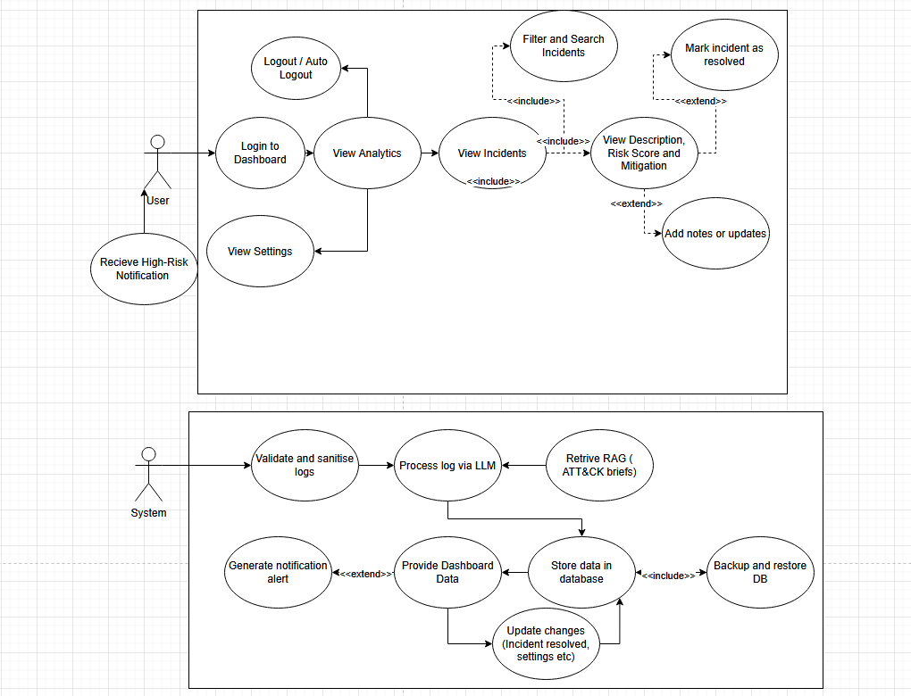
Figure 1: UML Use Case Diagram illustrating User and System interactions within S.I.R.A.
As illustrated in the diagram, the interactions are separated into two distinct workflows:
- Frontend User Workflow: The User actor interacts primarily with the React dashboard. After securely logging in, they can view top-level analytics or navigate to specific incidents. The core interaction involves viewing incident descriptions, risk scores, and mitigation steps, which can optionally be extended (<<extend>>) by marking incidents as resolved or adding manual notes.
- Backend System Workflow: The System actor operates autonomously to manage the data pipeline. It is responsible for validating and sanitising raw logs before processing them via the LLM. The diagram highlights several advanced architectural features, including an initial design concept to retrieve MITRE ATT&CK briefs via Retrieval-Augmented Generation (RAG) to enrich the LLM prompt. However, during the development and testing phases, it was determined that the selected LLMs possessed sufficient inherent training data to generate highly accurate and contextualised summaries out-of-the-box. Consequently, the RAG component was deemed unnecessary and excluded from the final build to streamline system processing and reduce latency. The remaining autonomous features, such as securely storing the parsed data and dynamically triggering high-risk notification alerts to the User, operate exactly as mapped.

4.4.2 User Stories
To further refine the user experience and ensure strict traceability against the defined Functional (FR) and Non-Functional Requirements (NFR), a structured set of User Stories was established. These stories dictate the necessary capabilities of the dashboard from the perspective of the end-user.
Table 5: User Stories
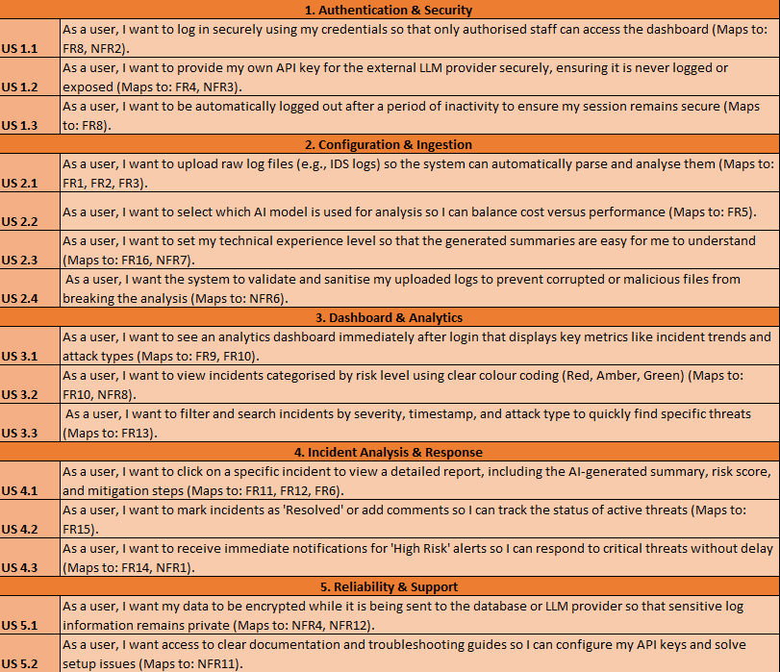
5. Project Management & Methodology
This chapter outlines the development methodology, the tools used to facilitate it, and the proactive risk assessment undertaken to mitigate potential points of failure.

5.1 Development Methodology
The development lifecycle of this project was governed by an Agile project management methodology. For a solo developer, Agile was identified as the optimal framework over traditional, rigid methodologies, as it allows for continuous iteration, rapid prototyping, and the flexibility to pivot based on testing outcomes. To accelerate this process, Generative AI was used assistively to outline report structures and generate high-level pseudocode to help conceptualise system architecture.
The project was structured into two-week development 'sprints'. At the conclusion of each sprint, fortnightly review meetings were held with the project supervisor, who acted as a proxy stakeholder. These meetings provided a structured environment to review the progress of the previous sprint, highlight technical challenges or blockers, and strategically plan the deliverables for the subsequent weeks.
Crucially, this Agile approach allowed for significant architectural refinements during development. For example, as noted in Section 4.5.1, the initial system design included a Retrieval-Augmented Generation (RAG) module. By employing an iterative, Agile testing approach, it was quickly identified that the LLM performed adequately without this module. Agile allowed the project scope to be rapidly adapted, cutting the redundant feature to save development time without derailing the overall project schedule.

5.2 Project Management Technologies
To facilitate the Agile framework and ensure strict adherence to academic deadlines, a dual-tiered approach to project management was employed, utilising both high-level scheduling and granular sprint tracking.

5.2.1 The Gantt Chart
While the initial baseline (Appendix B, Figures 1 & 2) provided a roadmap, it was formulated before the full literature review and prototyping were complete. Using Agile methodology, the schedule was dynamically updated to reflect two major shifts in strategy:
Research revealed that SMEs face significant hardware constraints. To avoid unnecessary technical complexity, the planned local stack (Llama 3 and PostgreSQL) was substituted for lightweight, cloud-based solutions (Google Gemini API and Firebase).
Iterative testing proved that the Gemini model could contextualize security logs without a custom RAG module. This task was scoped out to reduce system latency and streamline the architecture.
By treating the Gantt chart as a flexible baseline rather than a rigid contract, the project ensured the final system remained practical and aligned with the end-user’s operational reality.

5.2.2 Trello Workspace
While the Gantt chart dictated the overarching timeline, Trello was utilised to manage the day-to-day micro-execution of the Agile sprints. The Trello workspace was explicitly structured to support weekly sprint planning and issue tracking across several dedicated boards:
- The Sprint Plan: Rather than a traditional state-based Kanban board, this board was structured chronologically, featuring dedicated columns for each week of development. Tasks were proactively assigned to specific weeks based on the MoSCoW priorities, and were systematically ticked off upon completion. This provided clear, immediate visibility into weekly progress.
- Deadlines: A chronological tracker dedicated solely to upcoming academic and project deliverables, ensuring critical submission windows were never missed.
- Queries and Questions: A dedicated board used to log technical blockers, bugs, or unresolved questions as they arose during coding, preventing them from halting active development.
- Meetings: A repository for documenting the outcomes, feedback, and specific action items discussed during the fortnightly supervisor sprint meetings.
(See Appendix B, Figures 4–7 for screenshots of the active Trello workspace)

5.3 Project and System Risk Assessment

5.3.1 System and Flows
The first stage of the assessment involved defining the strict boundaries and data flows of the system. The initial scope mapped the journey of the data from ingestion to display, identifying the privacy risks at each node:
- Source to LLM: Ingestion of structured JSON network logs containing potentially identifiable IP addresses (Assessed Risk: Low–Medium).
- LLM Processing: The AI model receiving JSON input and returning text-based summaries (Assessed Risk: Low).
- Database Storage: The structured storage of processed insights (Assessed Risk: Medium, requiring encryption).
- Web Dashboard: The frontend display of the processed data (Assessed Risk: Low, reliant on authentication).
- Test Environment (Scoped Out): Initially, local Virtual Machines (VMs) were planned to generate test logs. To streamline development and reduce security overhead, this flow was scoped out in favour of pre-existing, open-source log datasets (e.g., alert.ids).
(See Appendix C, Figure 1)

5.3.2 Risk Categories and Impact
To quantify the threats to these data flows, risks were grouped into specific technical and ethical categories, including Privacy Violations, Bias & Fairness, Security, and Operational Reliability.
The overall risk severity was calculated using a quantitative matrix. The Likelihood of a vulnerability being exploited and the potential Impact on the SME was scored on a scale of 1 to 10. These combined metrics generated an overall priority rating of Low, Medium, High or Significant.
(See Appendix C, Figure 2)

5.3.3 Existing Mitigation Control
Before finalizing the risk register, existing mitigation controls inherent to the proposed architecture were evaluated. The primary controls established to protect the system included:
- Input Sanitisation & Pseudonymisation: Truncating or hashing IP addresses before they are stored or processed by the LLM.
- Access Control & Basic Authentication: Enforcing Role-Based Access Control (RBAC) and the principle of least privilege on the API and web dashboard.
- Database Security: Utilizing least-privilege service accounts and ensuring encryption at rest.
- System Isolation: Initially planned via Docker container isolation, though ultimately mitigated by the Agile pivot to isolated cloud environments (Google Gemini and Firebase).
(See Appendix C, Figure 3)

5.3.4 Risk Register
The final stage of the assessment involved compiling the identified threats, their calculated impact scores, and the proposed mitigation strategies into a formal Risk Register. Rather than serving purely as a theoretical exercise, this register acted as a critical project management tool throughout the development lifecycle.
It systematically ensured that all 'High' and 'Significant' priority threats were addressed before core development began. By explicitly mapping specific engineering controls to each vulnerability, the register formally demonstrates how the project's initial security risks were successfully reduced to an acceptable, operational 'Low' residual score.
(See Appendix C, Figure 4 for the complete Risk Register)

6. System Design & Architecture

6.1 Technology Stack Justification
To ensure the system remained lightweight, secure, and highly responsive, a modern, decoupled technology stack was selected.

6.1.1 Frontend Architecture (React, TypeScript & Tailwind CSS)
To deliver an accessible user experience for non-technical SME owners, a web-based dashboard was selected over a standalone desktop application.
- React & TypeScript: React was chosen as the core frontend framework, as its component-based structure allows for a highly modular dashboard design (e.g., separating charts, incident logs, and settings) that can be easily updated independently. Furthermore, the frontend was developed using TypeScript. Selecting TypeScript over standard JavaScript enforces strict type safety, significantly reducing runtime errors and making the codebase far easier to maintain and debug as complexity increases.
- Tailwind CSS & Recharts: Tailwind CSS was utilised to guarantee a modern, highly responsive user interface. Additionally, the Recharts library was integrated to handle dynamic data visualisations without the overhead of building custom graphical components from scratch.

6.1.2 Backend Processing & API (Python & FastAPI)
To efficiently manage the computational load of parsing network telemetry alongside serving web requests, a decoupled backend architecture was implemented.
Python was selected as the core language for the backend. Its extensive native libraries make it exceptionally efficient at handling continuous file I/O operations and complex Regular Expression (Regex) matching for data sanitisation. Furthermore, Python seamlessly integrates with Google's Generative AI SDK, allowing the script to independently batch sanitised logs, query the Gemini API, and encrypt the resulting insights using the cryptography.fernet library before pushing them to the database.
FastAPI was implemented as a secure, high-performance intermediary between the React frontend and the database. It was selected over Flask for its superior speed and native Pydantic integration, which automatically validates JSON payloads to prevent injection attacks.

6.1.3 Database & Authentication (Google Firebase/Firestore)
A critical architectural decision was the selection of the data persistence layer. Initially, a traditional relational database (PostgreSQL) was considered for its JSON support. However, it was ultimately rejected to reduce infrastructure complexity. Firestore was selected as the optimal alternative:
- Real-Time Synchronisation: Firestore operates as a NoSQL document database with built-in WebSocket capabilities via onSnapshot listeners. This allowed the React dashboard to subscribe to the database and automatically update the UI the exact moment the Python backend pushes a new AI analysis. This perfectly satisfied the critical Non-Functional Requirement (NFR1) for real-time alerting without the immense engineering overhead of building a custom WebSocket server.
- Schema-less Flexibility: Because network logs (such as Snort or Winlogbeat alerts) vary wildly in their JSON structure, Firestore's schema-less NoSQL collections inherently suit the storage of unstructured threat data far better than rigid SQL tables.
- Delegated Security & Authentication: Rather than manually engineering a custom login system (which introduces severe risks regarding password hashing and salt storage) Firebase Authentication was implemented. This abstracts the immense security overhead of identity management, enabling secure, token-based user sessions that strictly control access to the dashboard (NFR2).

6.1.4 AI & Logic Engine
The system's core analytical engine is powered by the Google Gemini (Flash-Lite) API. As previously discussed, locally hosted models were ruled out due to hardware limitations. By offloading the heavy analytical processing to the cloud, the application remains exceptionally lightweight and accessible on standard business hardware. Furthermore, enterprise cloud models provide vastly superior reasoning capabilities for analysing and correlating complex security threats compared to hardware-constrained local alternatives.

6.1.5 Ingestion Strategy
Rather than building a tight, rigid integration with a single Intrusion Detection System (such as Snort or Suricata), the backend Python script (log-forwarder.py) was designed to autonomously poll and monitor a designated local directory for file system changes. This architectural choice ensures the system is entirely IDS-agnostic. Any security tool, firewall, or custom script capable of outputting log files to a specific local folder is automatically supported. This guarantees maximum flexibility and ease of integration across diverse SME IT environments.

6.2 High-Level Architecture
To visualise the end-to-end data pipeline and establish the boundaries between local processing and cloud infrastructure, a high-level system architecture diagram was developed. The architecture is explicitly designed to isolate sensitive local network telemetry from the external cloud environment using a strict, unidirectional data flow.
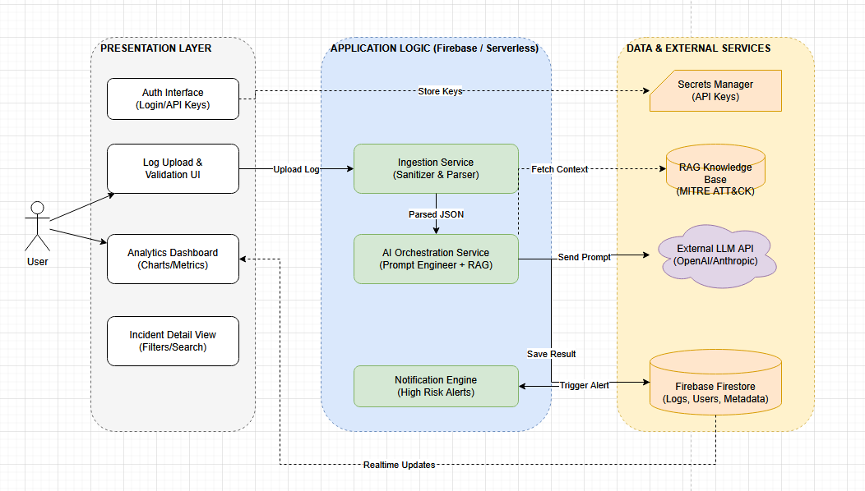
Figure 2: High-Level System Architecture diagram illustrating the data flow across the Presentation, Processing, Database, and Local layers.
As illustrated in the diagram, the S.I.R.A. data flow operates through four chronological stages:
1. Local Ingestion & Pre-Processing: A local IDS (e.g., Snort) writes raw alerts to alert.ids. The Python log-forwarder.py detects these entries and applies a Regex sanitisation pipeline to strip all Personally Identifiable Information (PII), such as IP and MAC addresses, ensuring complete data anonymisation prior to transmission.
2. Cloud AI Processing: Sanitised logs are batched and transmitted via HTTPS to the Google Gemini API, injected alongside a dynamic, role-based persona prompt (Business Owner, IT Support, or SOC Analyst). The LLM processes this context and returns a structured JSON payload containing a plain-English summary, a risk score (1–10), and mitigation steps.
3. Cryptographic Storage: Upon receiving the LLM JSON response, the Python backend encrypts the AI insights via AES (using the cryptography.fernet library). The ciphertext payload is then pushed to Firestore, ensuring all cloud incident data is securely encrypted at rest.
4. Real-Time Presentation: The React dashboard utilises Firestore onSnapshot listeners to establish a persistent WebSocket connection, eliminating manual API polling. When new ciphertext enters the database, Firestore actively pushes it to the client. The data is instantly decrypted and rendered on the UI, simultaneously triggering any configured email notifications.

6.3 Database Design
S.I.R.A. utilises Google Firestore, a NoSQL document-based database. Data is structured into discrete 'Collections' containing individual JSON-like 'Documents'.

Table 6: Initial Firestore database schema design illustrating the conceptualised processing queue and plaintext data fields.
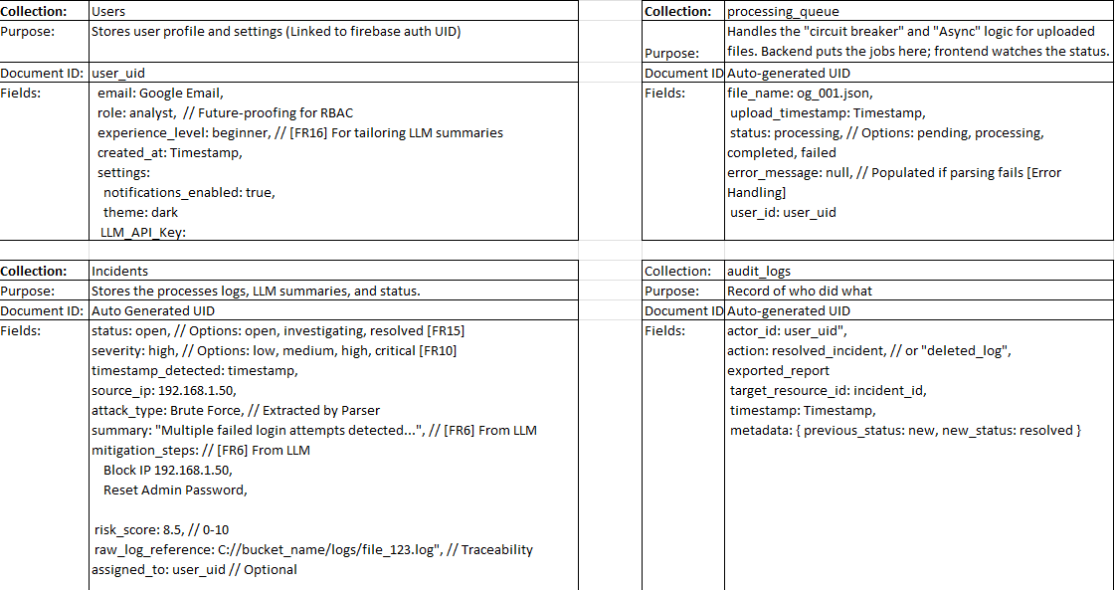
The database schema underwent significant refactoring between the initial design phase and final implementation. The original design proposed a processing_queue collection to manage asynchronous parsing jobs. However, to optimise Firestore read/write quotas and reduce cloud costs, this was refactored; batching and queuing are now handled entirely in-memory by the Python orchestrator. Additionally, an integrity_hash field was initially conceptualised to cryptographically verify log authenticity. During development, this was evaluated as computationally redundant for the MVP's scope) given Firestore's inherent TLS transmission and internal security rules (and was subsequently scoped out to streamline database writes.

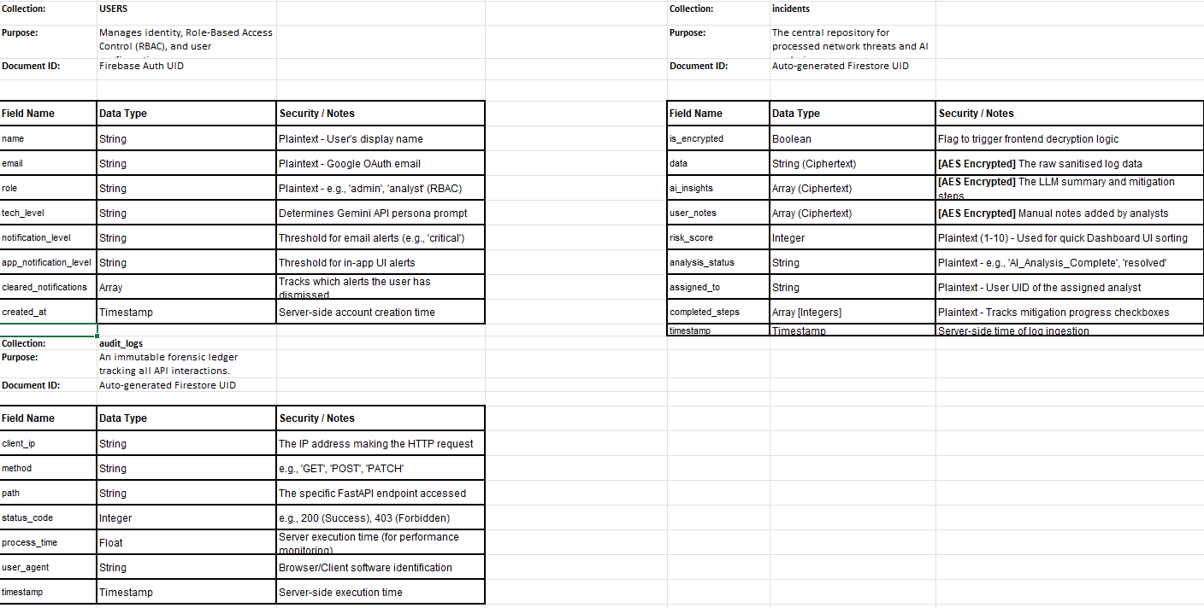
Table 7: Final implemented Firestore database schema illustrating the three core collections.
As visualised in Table 7, the final data model consists of:
- incidents: This is the primary collection for storing processed alerts. To enforce strict data-at-rest encryption, sensitive fields (such as data, ai_insights, and user_notes) are stored purely as AES-encrypted ciphertext blobs. Only non-sensitive metadata required for database querying and dashboard analytics (e.g., risk_score, timestamp, analysis_status, assigned_to) is stored in plaintext. This hybrid schema ensures the React frontend can quickly generate charts without decrypting the entire database.
- users: This collection manages Role-Based Access Control (RBAC) and user preferences. Crucially, it stores the user's tech_level (which dictates the specific persona prompt injected into the Gemini API) alongside their notification_level (which dictates the threshold for triggering automated email alerts).
- audit_logs: To ensure strict system accountability, this collection operates as an immutable ledger. Populated autonomously by the FastAPI backend middleware, it records the client_ip, HTTP method, path, status_code, and process_time for every single request made to the API, establishing a comprehensive forensic trail against unauthorised dashboard access.

6.4 System Logic & Processing Models
To accurately map the behavioural logic and chronological data flow of the S.I.R.A. system, two distinct processing models were developed during the design phase.

6.4.1 Functional Decomposition (HIPO)
A Hierarchy plus Input-Process-Output (HIPO) diagram was constructed to break down the system into modular functional units. This established strict boundaries between core processes, such as Log Ingestion (reading and validating .ids files), LLM Processing (batching and API interaction), and Analytics (aggregating metrics for the dashboard). Defining these distinct input-process-output boundaries ensured the system adhered to the principle of separation of concerns during development.
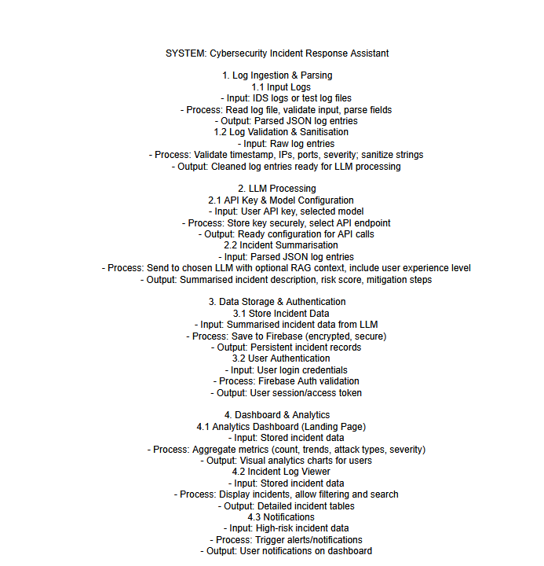
Figure 3: HIPO Diagram detailing the functional decomposition of system modules.

6.4.2 System Sequence & Interaction
While the HIPO diagram established what the system does, a Sequence Diagram was developed to map when it happens. The diagram illustrates the chronological lifecycle of a threat event, specifically highlighting the asynchronous interactions between the local Python orchestrator, the external Gemini API, and the React frontend. Crucially, it visualizes the non-blocking nature of the architecture: while the backend awaits the 10–30 second LLM response, the React dashboard remains fully interactive, only updating once the Firestore onSnapshot listener receives the final ciphertext payload.
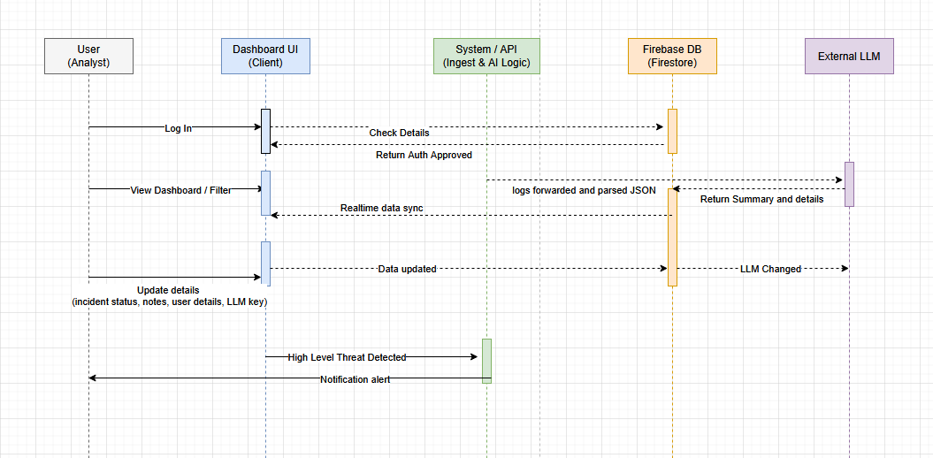
Figure 4: Sequence Diagram illustrating the chronological message passing between system components.

6.5 System Resilience & Error Handling
A critical component of the system design involved mapping potential failure domains. Rather than allowing the application to crash upon encountering edge cases, a comprehensive error-handling matrix was developed to ensure system resilience and graceful degradation.
Table 8: Error-Handling matrix detailing system failure domains.
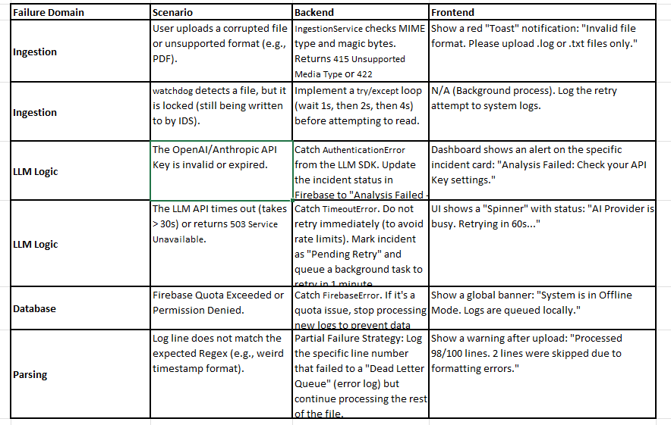
As detailed in Table 8, the system architecture was designed to anticipate failure across both local and cloud environments. The matrix maps how backend faults (such as network timeouts or API authentication errors) should safely queue data locally rather than causing permanent data loss. However, while these robust failure domains were thoroughly mapped during the design phase, applying Agile MoSCoW prioritisation dictated that the complex frontend UI feedback mechanisms (such as global offline banners and specific toast notifications) be scoped out of the Minimum Viable Product (MVP). Documenting these strategies ensures the architecture is prepared for future enterprise iterations, while allowing core development to remain strictly focused on the primary analytical pipeline.

6.6 User Interface Design
To make the S.I.R.A. system accessible for non-technical users (FR8), the UI and UX were designed to be highly intuitive. The interface was built iteratively using Agile methods, relying on continuous feedback rather than rigid upfront planning.

6.6.1 Initial Low-Fidelity Prototyping
The initial design phase involved sketching paper wireframes and low-fidelity mockups to establish the core layout. (Initial designs can be found in Appendix D).
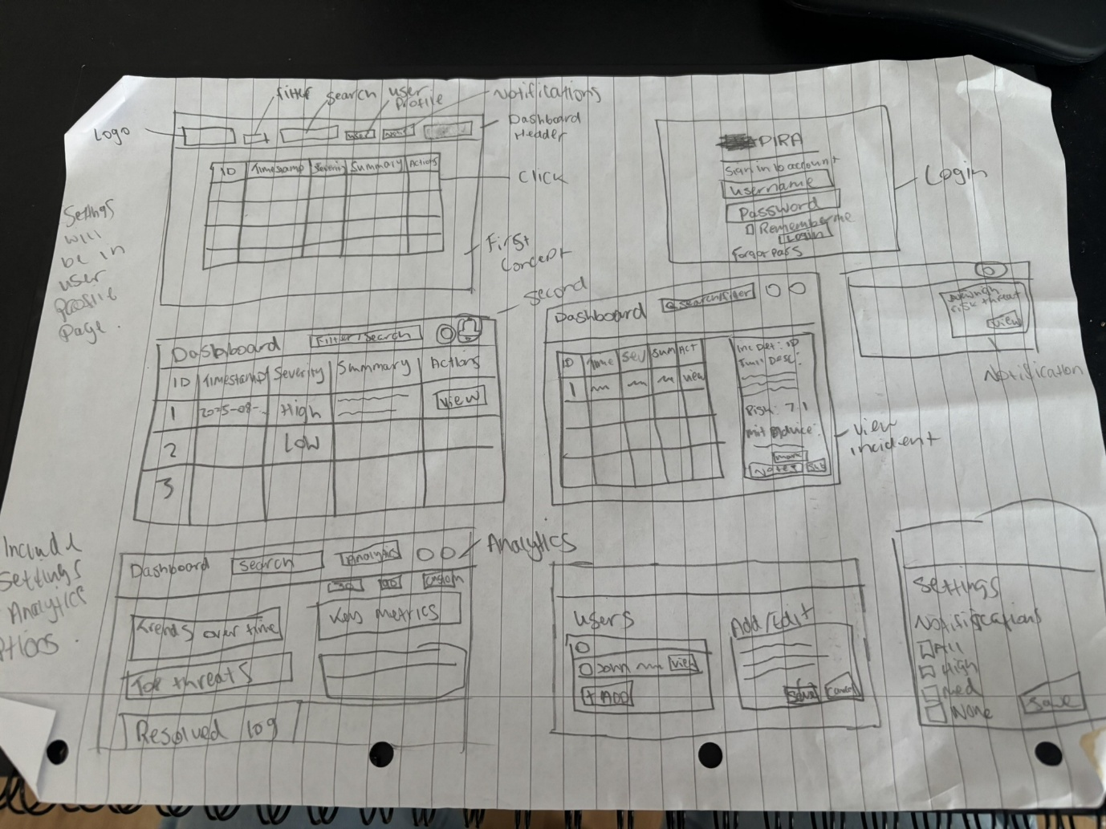
Figure 5: Initial low-fidelity paper prototype for the system dashboard.
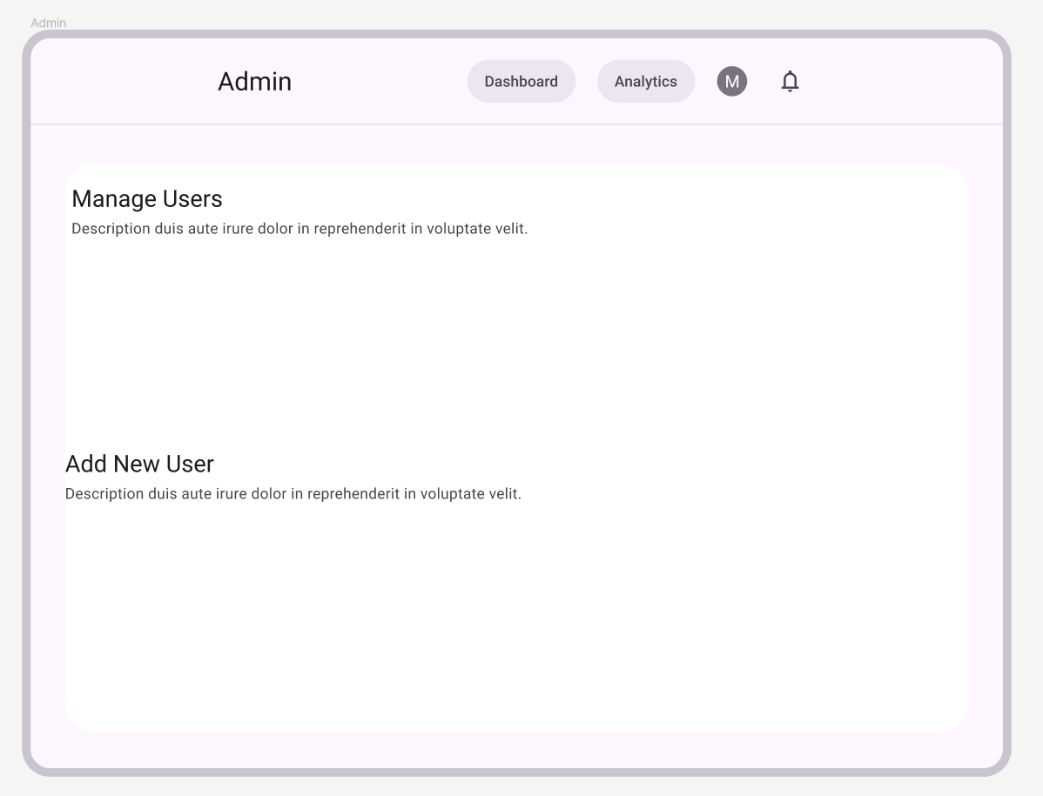
Figure 6: Initial wireframe for the proposed Admin Management page.
As seen in the initial designs, the core structure included an Analytics page for key metrics, an Incidents log, and a Settings page. The original design also included a dedicated 'Admin Page', which was intended to allow business owners to manually create and manage employee accounts. Furthermore, viewing an incident was initially designed to open as a small pop-up window over the main dashboard.

6.6.2 Agile Feedback & Design Iteration
Following supervisor feedback and Agile self-evaluation, several critical changes were made to the UI to reduce cognitive load and improve system usability. The wireframes were subsequently upgraded to high-fidelity designs.
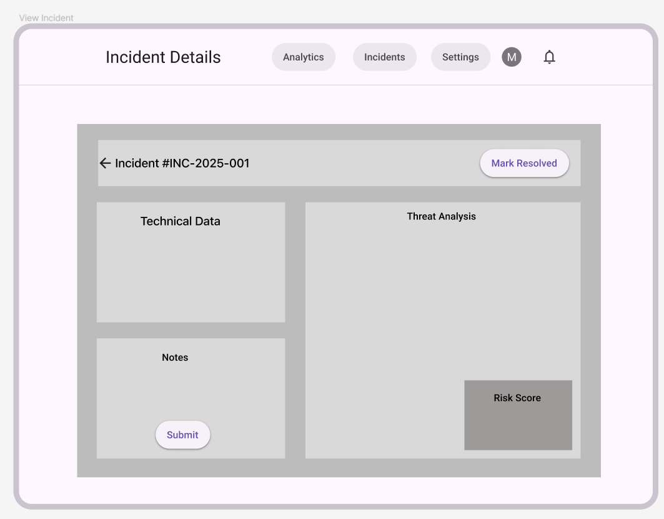
Figure 7: Final high-fidelity design for the dedicated 'View Incident' page, featuring the persistent top navigation bar.
(See Appendix E for the full suite of final high-fidelity UI screenshots).
The key justifications for the design evolution are as follows:
- Removal of the Admin Page: The dedicated user management page was completely scoped out of the final UI. Since the backend utilises Google Firebase, user accounts and role management are handled entirely via the secure Firebase Console. Removing this feature from the React frontend eliminated unnecessary complexity and saved significant development time.
- Consolidation of Resolved Logs: Originally, 'Resolved Logs' were going to have their own separate page. To reduce UI clutter, this was replaced with a simple status filter on the main Incidents page, creating a single, centralized repository for all threat data.
- Redesigning 'View Incident': The initial idea of using a pop-up modal to view incident details was abandoned. Because the Gemini LLM generates highly detailed summaries and step-by-step mitigation advice, a small pop-up felt too restrictive. Instead, it was moved to a dedicated, full-screen page to provide maximum screen real estate for reading technical advice comfortably.
- Expanded Settings & Navigation: A permanent top navigation bar was implemented to allow users to switch pages seamlessly. Furthermore, the Settings page was heavily expanded based on early feedback. Rather than hardcoding API keys, the UI was updated to allow users to securely input their own Gemini API keys and dynamically select their 'Technical Persona' (e.g., Business Owner vs. IT Support), ensuring the system remains highly customisable.

7. Development & Implementation
This chapter outlines the translation of core system requirements into functional code, highlighting the key technical mechanisms driving the localised log-parsing pipeline, the AI integration, and the React frontend, while detailing how critical technical challenges were overcome.

7.1 Data Origin & Local Ingestion
The operational lifecycle of the S.I.R.A. system begins at the local network level. The architecture relies on external detection engines, such as Snort (for network intrusion) or Winlogbeat (for Windows system events), to generate raw logs. The primary engineering challenge for this stage was capturing this continuous stream of data efficiently without overwhelming the host machine.

7.1.1 Continuous Monitoring
To ingest these logs, a custom Python backend service was developed. Rather than reading entire log files from start to finish every time the script executes, the log_watcher function was engineered to be "stateful". By utilising os.path.getsize(), the system acts as a digital bookmark. It records the exact byte position where it last finished reading in a local log_progress.json file. Consequently, when Snort or Winlogbeat appends a new alert to a file, the Python script jumps directly to that new line, ensuring rapid, deduplicated data ingestion.
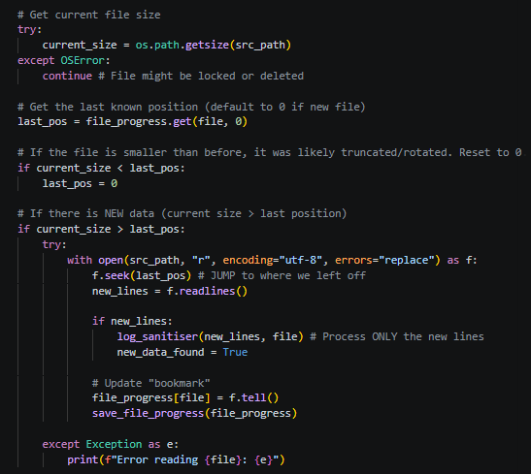
Figure 8: Code snippet showing the "digital bookmarking" mechanism used to prevent duplicate processing of log files.

7.1.2 Initial Triage and Noise Reduction
Once a new log line is ingested, it undergoes immediate local triage. Because the architecture relies on a free-tier external LLM, it is financially and computationally unviable to process every piece of benign background traffic. To solve this, the script implements a two-tier filtering mechanism:
- Noise Reduction: The logs are first checked against a KNOWN_SAFE_PATTERNS array. This aggressively discards safe, high-volume events (such as standard DHCP requests or successful Windows Event 4624 logons) locally, preventing them from consuming further system resources.
- Threat Identification: If the log bypasses the noise filter, it is evaluated against a custom ThreatDictionary. This dictionary contains known indicators of compromise categorised by attack type (e.g., SQL injection strings like ' OR '1'='1).
By implementing this, the system guarantees that only genuinely suspicious lines advance to the next stage of the pipeline, significantly optimising performance. (See Appendix J, Figures 1 and 2).

7.2 Privacy & Data Sanitisation
Once a log entry is flagged as suspicious by the local triage phase, it enters the pre-processing pipeline. Because the S.I.R.A. system relies on sending data to a third-party cloud API (Google Gemini), transmitting raw logs directly would pose a severe security risk. Raw network logs frequently contain Personally Identifiable Information (PII) and sensitive internal network layouts, which would violate data protection laws like the UK GDPR if leaked or stored externally.

7.2.1 Deep Text Sanitisation (Regex)
To guarantee data privacy, the Python script executes a rigorous local sanitisation process before any internet connection is made. Using complex Regular Expressions (Regex), the system actively scans the text to find and scrub sensitive data points. This includes stripping plain-text passwords, email addresses, MAC addresses, and specific Windows user directory paths, replacing them with safe, generic tags (such as [EMAIL_REDACTED] or [PASSWORD_REDACTED]).
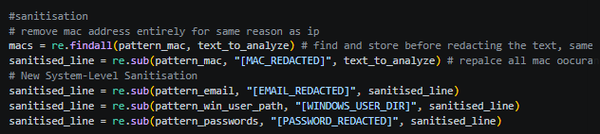
Figure 9: Code snippet demonstrating the regex sanitisation used to strip PII.

7.2.2 Intelligent IP Masking
A major engineering challenge during this phase was dealing with IP addresses. If the system simply deleted all IP addresses, the AI would lose critical context—it would not be able to tell if one attacker was scanning ten machines, or if ten attackers were scanning one machine.
To solve this, an intelligent anonymisation function was built. The script extracts all unique IPv4 and IPv6 addresses from the log and checks their prefixes to categorise them as internal (e.g., starting with 192.168. or 10.) or external. It then replaces them in the text with sequential placeholders, such as [EXTERNAL_IP_0] and [INTERNAL_IP_1]. It ensures the external LLM never learns the SME's actual network layout, whilst accurately track an attacker's movements across the network.
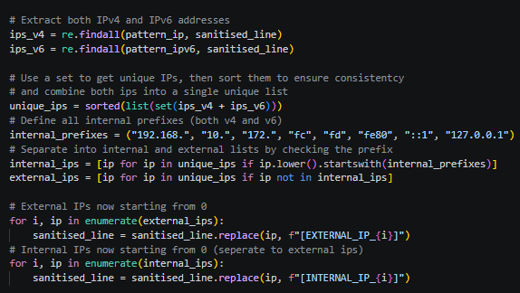
Figure 10: Implementation of the IP pseudonymisation logic.

7.3 AI Integration
With the log data completely sanitised, it is ready to be analysed by the Gemini LLM. However, interacting with cloud APIs and databases introduces new challenges regarding network efficiency and data security.

7.3.1 Asynchronous Batching
During early development, the script sent a new API request for every single suspicious log. Testing quickly revealed that this approach instantly triggered the Gemini API's rate limits (HTTP 429 errors), causing the system to crash. To resolve this, an in-memory queueing system was developed. The script now collects up to 50 logs into a single 'batch' before making a single, consolidated call to the LLM. A timeout mechanism was also added to ensure that if only a few logs are generated, they do not get stuck waiting in the buffer indefinitely. (See Appendix J, Figures 3–5).

7.3.2 Dynamic AI Personas
Before the batch is sent to the LLM, the backend queries the user's settings to determine their technical level. It then injects a specific prompt—either 'Business Owner', 'IT Support', or 'SOC Analyst'—alongside the log data. Furthermore, the prompt strictly commands the LLM to return its analysis in a highly structured JSON format. Enforcing JSON output ensures the React frontend can reliably map the AI's response to the dashboard UI without errors. (See Appendix J, Figures 6–7).

7.3.3 Cryptographic Storage
Once the LLM returns the mitigation playbook, the data must be stored in Firestore so the web dashboard can read it. To protect this data at rest and during transit, the Python backend uses the cryptography.fernet library to encrypt the AI's insights via AES before uploading them to the database. Initially, this stage also included a cryptographic hashing feature designed to verify the integrity of logs on the frontend. However, it was concluded that it was out of scope and was not necessary.
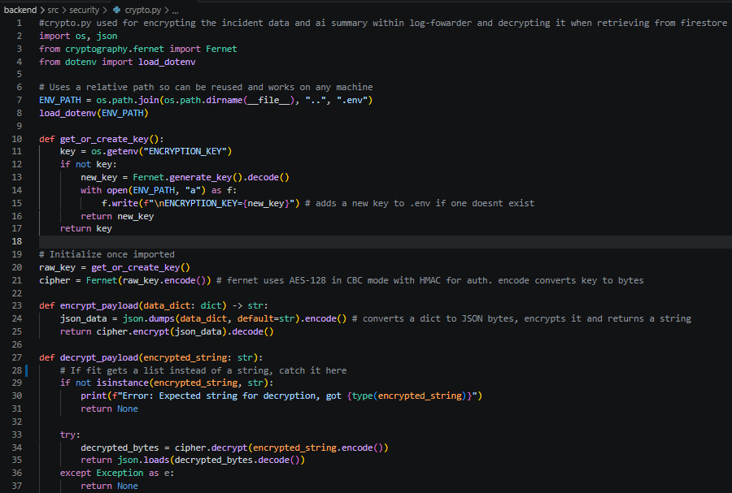
Figure 11: Implementation of the crypto.py module, utilizing Fernet for AES-128 payload encryption and decryption.

7.4 Frontend Dashboard
The final stage of the S.I.R.A. architecture involves retrieving the processed, encrypted data from the cloud and presenting it to the user in an accessible format. The frontend dashboard was developed using React and Tailwind CSS, ensuring a responsive and modern user interface that caters specifically to non-technical SME owners.
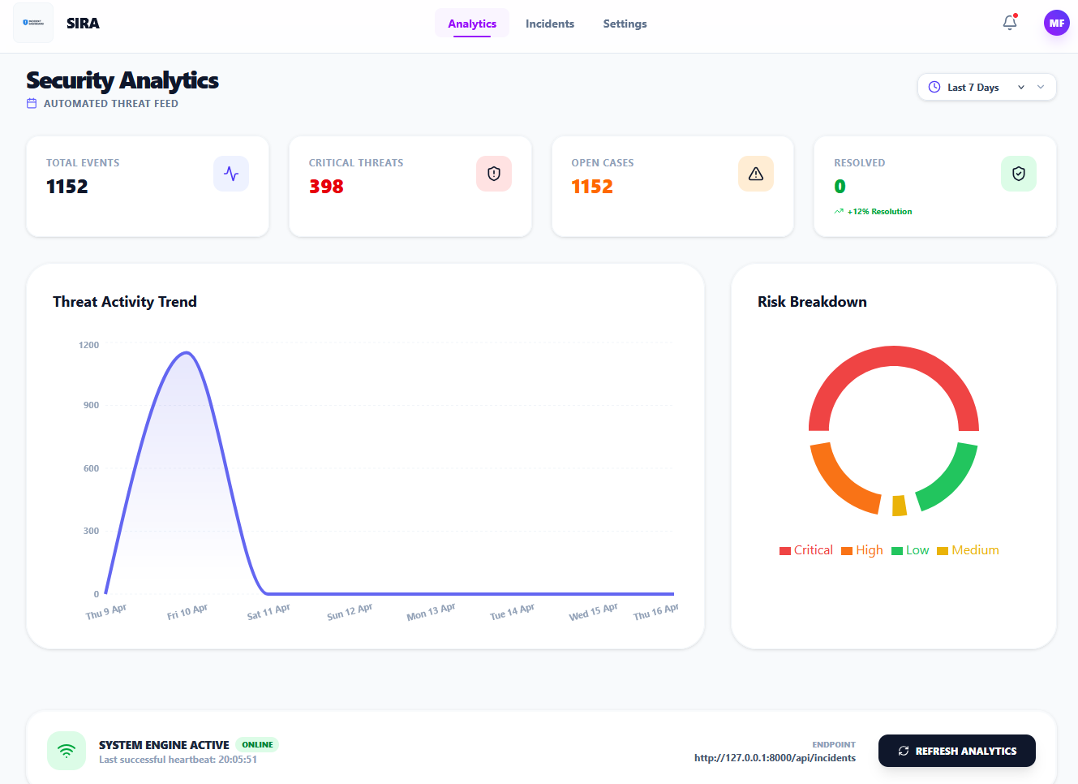
Figure 12: Screenshot of the S.I.R.A. main analytics dashboard.

7.4.1 Real-Time Data Synchronisation
A traditional web application often requires the user to manually refresh the page or relies on inefficient 'polling' (constantly asking the server if new data exists). To provide a seamless experience, the dashboard utilises Firebase onSnapshot listeners. This establishes a persistent WebSocket connection between the React frontend and the Firestore database. When the Python backend uploads a newly analysed threat, Firestore actively pushes this update to the React client. This guarantees that the dashboard UI updates instantly and automated email notifications are triggered without any manual input from the user, ensuring critical threats are surfaced in real-time. (See Appendix J, Figures 8–10).

7.4.2 Analytics and Data Visualisation
To help business owners quickly understand their security posture, the dashboard features a dedicated analytics page generating visuals like the 'Threat Activity Trend' and 'Risk Breakdown' charts. A critical architectural decision here was the implementation of a hybrid database schema. While the sensitive AI threat summaries are stored securely as encrypted ciphertext, basic metadata is deliberately stored in plaintext. By allowing the Recharts library to read this directly, the system avoids the massive computational overhead of downloading and decrypting everything just to count incidents. This ensures the analytics dashboard loads instantly, even when processing thousands of logged events.
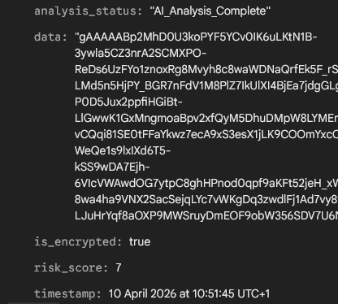
Figure 13: Screenshot of the unencrypted metadata in firestore.

7.4.3 Rendering the Mitigation Playbooks
When a user clicks on a specific incident, the React frontend retrieves the heavily encrypted ai_insights payload. Once securely decrypted, the structured JSON generated by the Gemini LLM is mapped directly into the UI components. The system dynamically renders the 'Incident Overview', a colour-coded 'Risk Score', and the step-by-step 'Mitigation Plan'. This final mapping process is the core realization of the project's primary aim. It successfully translates complex, raw technical telemetry into a highly readable, actionable interface, empowering users of any technical background to confidently understand and remediate cyber threats. (See Appendix J, Figures 11 – 12).

7.5 The Secure API Gateway
While the React dashboard relies on Firestore’s onSnapshot listeners for real-time update notifications, retrieving and rendering the actual content required a more robust handling mechanism. To manage this secure data flow, a custom REST API was developed using FastAPI.

7.5.1 The Cryptographic Gateway
Because the Python ingestion script encrypts all sensitive AI insights before uploading them to Firestore, passing this ciphertext directly to the browser would require exposing the AES decryption keys in the frontend code. To mitigate this, FastAPI was deployed as a strict cryptographic middleman to handle two-way data translation:
- Secure Decryption: When the dashboard fetches an incident, the API retrieves the encrypted data from Firestore, decrypts the AI insights using its secure server-side keys, and passes the readable plaintext to the React UI for rendering.
- Secure Encryption: Conversely, if the frontend were permitted to write data directly to the database, sensitive user notes could be intercepted. When a user submits an investigation note, the frontend sends the raw text to the API. FastAPI validates the JSON payload using Pydantic, encrypts the text, and pushes the resulting ciphertext to the database.

7.6 Overcoming Challenges

7.6.1 Intelligent Caching and Quota Management
A critical challenge was the rapid exhaustion of cloud database read quotas, caused by the frontend requesting full data reads on every page load. To overcome this, AI was utilised similarly to Stack Overflow, to explore syntax and debug state management strategies. Using these insights, a local caching mechanism was engineered into the API layer. When the frontend requests data, the FastAPI server now checks if any new incidents have been ingested. If the database state remains unchanged, the API serves the data directly from its cache. This significantly reduces latency, eliminates unnecessary database reads, and successfully protects the free-tier quotas. (See Appendix J, Figures 13 – 15).

7.6.2 AI Rate Limiting and Prompt Evolution
While the batching mechanism (detailed in Section 7.3.1) successfully resolved the API rate-limiting issues, the next major challenge was ensuring the AI's output was useful for the target audience.
A major challenge was ensuring the AI's output was actionable for non-technical users. Initially, generic prompts produced highly technical, jargon-heavy responses, rendering the mitigation steps unusable for business owners without IT teams.
For the 'Business Owner' persona, the LLM is explicitly commanded to "provide absolute clarity without technical jargon." Crucially, to accommodate micro-SMEs, the prompt was further updated to warn the AI that "not all businesses will have an IT team." This ensures the model generates practical mitigation steps the owners can execute independently, rather than unhelpfully advising them to escalate the issue. This iterative engineering guarantees that complex threat intelligence is consistently translated into accessible, operational steps. [See Appendix J, Figures 16 - 18]

7.6.3 Frontend Graph and CSS
Initially, the 'Threat Activity Trend' graph rendered completely empty. Debugging revealed this was caused by timezone offsets between the backend server and the client's browser, which recorded the day of an event differently. This was resolved by standardising a strict YYYY-MM-DD date format across both the backend and frontend, ensuring the data grouped correctly.
Additionally, Tailwind CSS initially failed to load on the frontend. While the packages were correctly installed, the global stylesheet had not been imported into the application's root file (main.tsx). Adding this missing import successfully applied the styling across the dashboard.

7.6.4 System Integration
Attempting to run the open-source Snort IDS natively on Windows failed repeatedly, as the default configuration files were strictly formatted for Linux directory structures. The .conf files required massive manual modification, and a custom .bat script was written to forcefully generate the alert.ids files required by the Python watcher.
Also, Hardcoded file paths for log directories and environment variables (.env) broke instantly when moving the project between development machines. This was resolved by implementing os.path.dirname(__file__) in Python, ensuring the backend dynamically resolves relative paths regardless of the host machine's specific file structure.

7.6.5 Modular Architecture and API Key Management
During the later stages of development, an attempt was made to refactor the AI integration into a highly modular architecture. The objective was to isolate the LLM logic into a dedicated file, which would enable future support for multiple AI providers (e.g., OpenAI and Gemini) and allow users to securely input their own personal API keys via the React settings dashboard.
While the frontend interface was successfully built and the key could be transmitted to the backend, a critical architectural limitation arose regarding backend state management. I could only retrieve and apply the custom API key globally across the entire application, rather than securely isolating it on a strict per-user basis. The key would also be exposed in the frontend which I would need more time to secure and prevent.

8. Testing & Evaluation
A comprehensive testing strategy was implemented to verify the system's functionality, security, and overall resilience. This focussed on unit testing of individual components, end-to-end integration testing of the complete data pipeline, and User Acceptance Testing (UAT) to assess the dashboard's efficacy from the perspective of the target end-users.

8.1 Testing Strategy

8.1.1 Unit testing
To ensure the Security Incident Response Assistant (S.I.R.A.) operates securely and reliably, a comprehensive full-stack testing strategy was implemented. During this phase, AI tools were used assistively to review code readability and suggest complex edge cases for validation. Backend stability was verified through automated Python unit tests for core logical functions, alongside manual API endpoint testing via Swagger UI to confirm data validation and security rules. Frontend integrity was validated using automated component testing via Vitest and React Testing Library. By mocking the live database connection, the frontend tests deterministically proved that all user interfaces, mathematical aggregations, and error boundaries function flawlessly without risking the production environment. (See Appendix F for the Actual Unit Test)

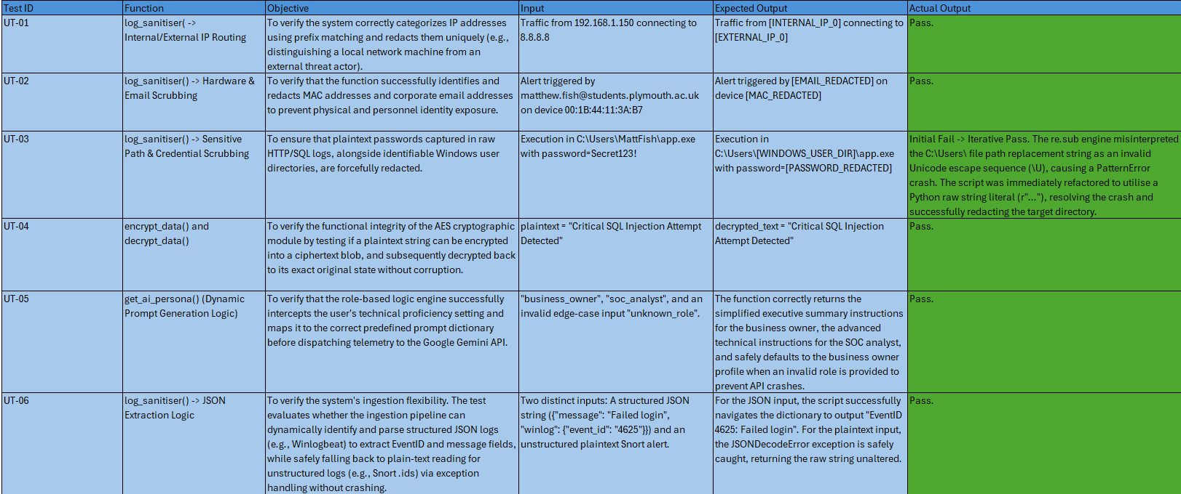
Table 9: Backend Unit Test Results
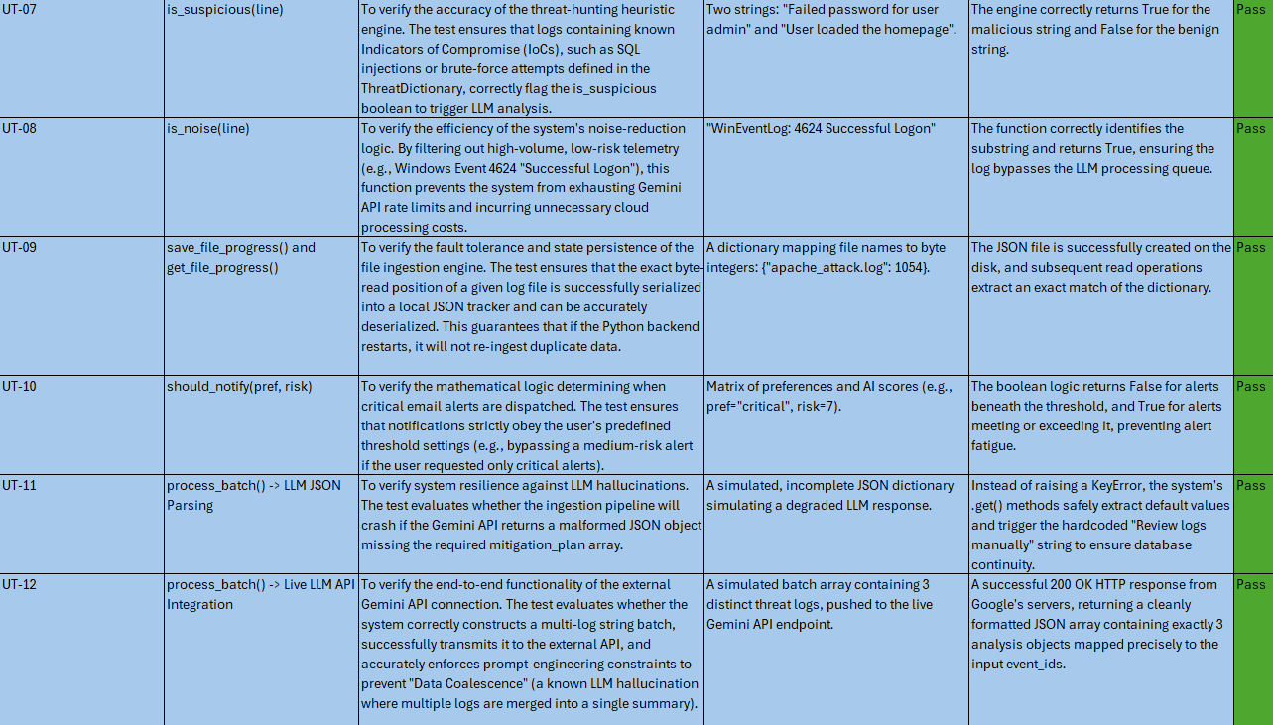

Table 10: Frontend API Unit Test Results
Table 11: Frontend Analytics Unit Test Results
Table 12: Frontend Incidents Unit Test Results
Table 13: Frontend Login Unit Test Results
Table 14: Frontend Settings Unit Test Results

8.1.2 Integration Testing
While component testing isolated individual features, integration testing verifies that S.I.R.A.’s independent modules communicate securely. These manual tests validate the complete end-to-end data lifecycle: from AI generation via the Gemini API, through the Python API's encryption and decryption middleware, to final rendering on the React frontend.
Table 15: Integration Test Results
During the INT-01 test, the data ingestion test temporarily failed because the Python log forwarder's tracking file remembered read-positions from older, deleted logs. Clearing this hidden progress file forced a fresh read and instantly resolved the issue. Furthermore, network inspection for INT-04 revealed a critical security vulnerability: the Firebase API key was inadvertently exposed in the headers of the authentication POST request. [See Appendix G for the Actual Test Examples]

8.1.3 Performance / Stress Testing
To ensure S.I.R.A. remains resilient in a live enterprise environment, a rigorous suite of performance and stress tests was conducted. This phase evaluated the system's capacity to handle high-volume data ingestion, simultaneous API requests, and complex frontend rendering without performance degradation. By simulating real-world traffic bursts and prolonged usage, these tests validate the application's scalability, ensuring that both the React frontend and Python backend remain stable and responsive under extreme operational loads.
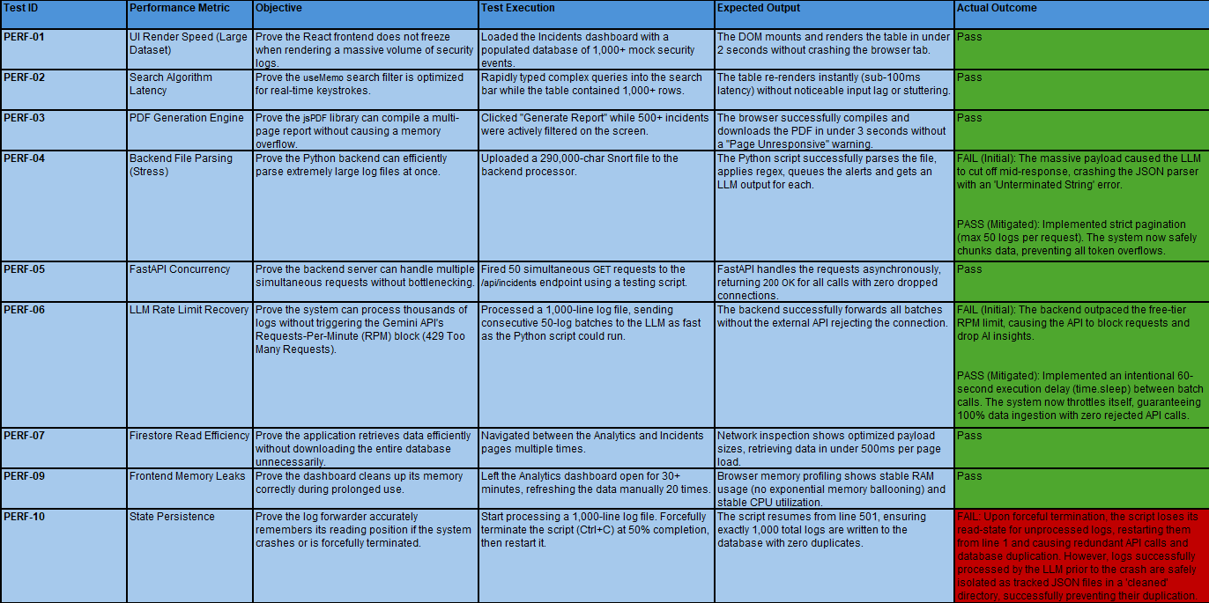
Table 16: Performance Test Results

During stress testing, three key limitations were identified. First, processing massive data batches caused the LLM to exceed its token output limits, resulting in unparseable JSON crashes; this was successfully mitigated by implementing strict pagination (capped at 50 log lines per request) to prevent token overflow. Second, the backend ingestion rate outpaced the API's free-tier Requests-Per-Minute (RPM) limits, which was resolved by engineering a 60-second execution delay between batch calls, guaranteeing 100% data retention with zero rejected requests. Finally, testing revealed a partial state persistence issue upon forceful system termination: while logs processed prior to a crash are safely isolated in a 'cleaned' directory to prevent duplication, unprocessed logs lose their read-state and restart from line one, highlighting an area for future database deduplication enhancements. (See Appendix H for the Actual Test Examples)

8.2 User Acceptance Testing (UAT)
To rigorously evaluate the real-world usability and effectiveness of the S.I.R.A. dashboard, User Acceptance Testing (UAT) was conducted. The methodology involved a cohort of seven participants, specifically selected to represent the system's diverse target personas. This group included a mix of individuals with varying levels of technical expertise, ranging from non-technical individuals simulating the 'Business Owner' persona to computer science students acting as proxy 'IT Administrators'.
The evaluation followed a structured, task-based approach. Participants were provided with access to the S.I.R.A. dashboard, populated with pre-ingested threat data, and asked to independently complete core operational workflows (e.g., authenticating, navigating the analytics dashboard, and triaging a critical AI-generated incident).
To provide strong academic support for the approach taken, the evaluation quantified user feedback using a structured post-test questionnaire based on a 5-point Likert scale (1 = Poor/Strongly Disagree, 5 = Excellent/Strongly Agree). (See Appendix I for the blank questionnaire and full results).
Overall, the UAT results strongly validate the core hypothesis of the S.I.R.A. project: that an AI-driven dashboard can effectively simplify cybersecurity incident response for SMEs. Across all seven participants the quantitative scores consistently averaged between 4 and 5 out of 5 across most functional areas.
Key Strengths
- UI/UX and Accessibility: The system achieved unanimous maximum scores (5/5) for account creation, authentication, and top-level analytics navigation (e.g., Total Events, Trend Charts, and Pie Charts). Multiple participants explicitly praised the modern, intuitive layout, noting its superiority over traditionally complex SIEM interfaces.
- The Core AI Engine: The integration of the LLM was highly successful in filtering out technical noise. Notably, one participant identified an emergent use-case: the system serves as an effective educational tool for junior SOC analysts, enabling them to learn from the AI-generated mitigation steps rather than blindly escalating tickets.
- Incident Management Workflow: Core operational features, such as assigning team members, adding investigation notes, resolving incidents, and adjusting configurations, received unanimous 5/5 ratings, demonstrating that the system is robust and frictionless for daily operational use.
Areas for Improvement and Limitations
- AI Persona Prompting: While generally effective, the "Business Owner" persona requires further prompt tuning. One non-technical user rated the jargon reduction at 3/5, observing that some summaries were too brief and occasionally recommended "escalating to an IT team"—a directive that contradicts the operational reality of micro-SMEs without dedicated IT staff.
- Data Redaction Context: A critical limitation was identified regarding the PII sanitisation pipeline. While stripping IP and MAC addresses is essential for privacy prior to LLM processing, displaying this redacted data separately from the main technical alert created a fragmented experience for technical users. Furthermore, inconsistencies were noted where certain redacted elements (such as usernames) were omitted from the final UI display.
- UI/UX Refinements: Minor usability improvements were identified. The notification bell currently requires users to dismiss active alerts to view older ones; implementing a scrollable history was suggested as a scalable solution. Additionally, the formatting of the generated PDF incident reports received slightly lower scores (averaging 3.5/5), indicating a need for a more professional styling template. Finally, the absence of a "Forgot Password" workflow was flagged as a missing standard feature.
Primary Feature Requests
The most consistent feedback across the testing cohort was the desire for advanced, granular analytics. Specific recommendations included:
- Implementing keyword-based threat tracking (e.g., visually isolating SQL injection attempts versus NMAP scans).
- A highly innovative proposal to feed aggregated, long-term analytics back into the LLM. This would allow the system to generate macro-level security posture reports over weeks or months, moving beyond the analysis of isolated, single incidents.

9. Conclusion & Future Work

9.1 Project Summary
The primary aim of this project was to design, develop, and evaluate an affordable, LLM-powered incident response dashboard to bridge the cybersecurity expertise gap for SMEs. Reflecting upon the initial objectives, this aim has been successfully achieved. The S.I.R.A. platform demonstrates a highly efficient, end-to-end data pipeline capable of translating raw network telemetry into accessible, actionable intelligence.
The core technical objectives were met through the development of a stateful Python backend that actively monitors and parses IDS logs. To guarantee data privacy, a rigorous local pre-processing pipeline was implemented, successfully stripping Personally Identifiable Information (PII) and pseudonymising network IPs via regex before cloud interaction.
Crucially, the integration of the Gemini LLM proved highly effective. By engineering an asynchronous batching system and a FastAPI RAM cache, the architecture successfully circumvented cloud rate limits and protected free-tier database quotas. Furthermore, as validated by User Acceptance Testing (UAT), iteratively refining the dynamic AI personas successfully eliminated technical jargon, allowing the system to tailor mitigation playbooks specifically for non-technical business owners. Ultimately, the real-time React dashboard, coupled with AES payload encryption, successfully delivered a secure, intuitive interface that fundamentally reduces the cognitive load associated with traditional SIEM management.

9.2 Critical Evaluation & Limitations
While S.I.R.A. successfully functions as a prototype, testing revealed several key operational and security limitations.
From a security standpoint (INT-04), the Firebase VITE_API_KEY is inadvertently exposed within the frontend headers. Additionally, an attempt to let users securely input their own Gemini API keys was abandoned; the backend architecture could only apply the key globally across the application, rather than securely isolating it per user.
Operationally, the Python ingestion script requires manual execution. It does not yet run as a background service, meaning if the terminal is closed, log ingestion stops entirely. Furthermore, stress testing showed that if the system crashes, unprocessed logs lose their read-state and restart from line one, creating a risk of duplicate data ingestion.
Finally, User Acceptance Testing (UAT) highlighted issues with the AI context and UI. The "Business Owner" persona occasionally provided unhelpful advice by suggesting users "escalate to an IT team"—ignoring the reality of micro-SMEs. Additionally, while the PII sanitisation pipeline is essential for privacy, it fragmented the dashboard for technical users by separating redacted data from the main alerts, occasionally omitting elements like usernames entirely.

9.3 Future Enhancements
To evolve S.I.R.A. from an academic prototype into a highly resilient, enterprise-ready application, several key enhancements have been identified for future iterations:
- Service Automation: Convert the Python ingestion script into a dedicated Windows/Linux background service to ensure continuous, autonomous monitoring without manual user execution.
- Frontend API Security: Secure the exposed Firebase VITE_API_KEY by routing authentication requests through a secure backend proxy, and implement Firebase JWT Authentication for true zero-trust security.
- Database Multi-Tenancy: Refactor the database schema and user account logic to support multi-tenancy. Currently, the database provides a global view; this must be isolated so individual organisations or users only see their specific incident data.
- Custom API Key Integration: Develop the frontend settings UI to allow users to securely input and store their own personal LLM API keys, transferring the usage costs and quota management directly to the user.
- System Resilience: Enhance the Python script's state management to ensure that if the script is interrupted, any logs that were parsed but not yet processed by the LLM are automatically re-uploaded upon restart.
- Active Mitigation Integration: Expand the system's scope by adding automated API integrations with local firewalls, allowing S.I.R.A. to dynamically block malicious IPs based on the AI's recommendations.
- Advanced Analytics: Implement broader, macro-level analytics that track long-term threat trends, and feed this aggregated data back into the LLM to generate weekly or monthly security posture reports.
- Enhanced PII Redaction: Expand the local regex sanitisation dictionaries to capture a wider array of sensitive data points, ensuring maximum compliance with UK GDPR standards.
- Alternative Infrastructure: Explore migrating the backend logic to AWS or supporting free-tier, localised LLMs to prevent cloud API credit exhaustion during periods of high network traffic.
- UI Quality of Life Features: Implement standard application features requested during UAT, like a secure "Forgot Password" workflow for account recovery.

9.4 Final Thoughts
Small and medium-sized enterprises remain the backbone of the global economy, yet they are systematically under-resourced and disproportionately targeted in the modern cyber threat landscape. Traditional enterprise security tools are often financially prohibitive and operationally overwhelming, leaving small business owners to rely on a dangerous false sense of security. S.I.R.A. fundamentally bridges this gap. By leveraging the analytical power of Large Language Models within a highly secure, privacy-first pipeline, the system removes the overwhelming technical noise of standard detection engines. It translates complex, daunting network telemetry into clear, educational, and actionable steps. Ultimately, S.I.R.A. empowers non-technical users to take confident ownership of their digital environments, proving that proactive cybersecurity can be both highly accessible and cost-effective.

References
Fadziso, T. et al. (2023) Evolution of the cyber security threat: An overview of the scale of Cyber Threat, researchgate. Available at: https://www.researchgate.net/publication/374156044_Evolution_of_the_Cyber_Security_Threat_An_Overview_of_the_Scale_of_Cyber_Threat (Accessed: 23 March 2026).
Hiscox Group (2025) Cyber-attacks leave smes with hefty fines and uncertain futures, Cyber-attacks leave SMEs with hefty fines and uncertain futures | Hiscox Group. Available at: https://www.hiscoxgroup.com/news/press-releases/2025/29-09-25 (Accessed: 23 March 2026).
Saleem, J. et al. (2017) A state of the art survey - impact of cyber attacks on SME’s | proceedings of the International Conference on Future Networks and Distributed Systems, ACM Digital Library. Available at: https://dl.acm.org/doi/abs/10.1145/3102304.3109812 (Accessed: 23 March 2026).
Tetteh, A.K. (2024) Issues in information systems volume 25, issue 1, pp. 235-246, 2024 235, International Association for Computer Information Systems. Available at: https://iacis.org/iis/2024/1_iis_2024_235-246.pdf (Accessed: 23 March 2026).
Lake, K. (2022) Top SME cybersecurity challenges and how to overcome them, JumpCloud. Available at: https://jumpcloud.com/blog/overcome-top-sme-cybersecurity-challenges (Accessed: 23 March 2026).
Manzoor, J. et al. (2024) Cybersecurity on a budget: Evaluating security and performance of open-source Siem solutions for smes, PLOS ONE. Available at: https://journals.plos.org/plosone/article?id=10.1371%2Fjournal.pone.0301183 (Accessed: 23 March 2026).
Femi, A. et al. (2025) Designing Resilient AI-Based Cybersecurity Frameworks for Small and Medium Enterprises (SMEs), British Journal of Cyber Criminology. Available at: https://www.pubtexto.com/journals/british-journal-of-cyber-criminology/fulltext/designing-resilient-aibased-cybersecurity-frameworks-for-small-and-medium-enterprises-smes (Accessed: 23 March 2026).
Junior, C.R., Becker, I. and Johnson, S. (2025) Unaware, unfunded and uneducated: A systematic review of SME Cybersecurity, arXiv.org. Available at: https://arxiv.org/abs/2309.17186 (Accessed: 23 March 2026).
Troublefield, T. C. (2025) The Cyberpsychology of Small and Medium-Sized Enterprises Cybersecurity: A Human-Centric Approach to Policy Development. Journal of Information Security, 16, 158-183. Available at: 10.4236/jis.2025.161009. (Accessed: 23 March 2026).
Chidukwani, A., Zander, S. and Koutsakis, P. (2022) A survey on the cyber security of small-to-medium businesses: Challenges, research focus and recommendations | IEEE Journals & Magazine | IEEE Xplore, IEEE.org. Available at: https://ieeexplore.ieee.org/abstract/document/9853515/ (Accessed: 23 March 2026).
BCS, The Chartered Institute for IT (2022) Code of Conduct for BCS Members. Available at: https://www.bcs.org/membership-and-registrations/become-a-member/bcs-code-of-conduct/ (Accessed: 24 March 2026).
gov.uk (2011) The UK's data protection legislation. Available at: https://www.gov.uk/data-protection (Accessed: 24 March 2026).
Legislation.gov.uk (1990) Computer Misuse Act 1990. Available at: https://www.legislation.gov.uk/ukpga/1990/18/contents (Accessed: 24 March 2026).
gov.uk (2025) Cyber security breaches survey 2025. Available at: https://www.gov.uk/government/statistics/cyber-security-breaches-survey-2025/cyber-security-breaches-survey-2025 (Accessed: 24 March 2026).
Business population estimates for the UK and regions 2025: Statistical release (2025) GOV.UK. Available at: https://www.gov.uk/government/statistics/business-population-estimates-2025/business-population-estimates-for-the-uk-and-regions-2025-statistical-release (Accessed: 29 April 2026).

Appendices

Appendix A: Literature Evidence
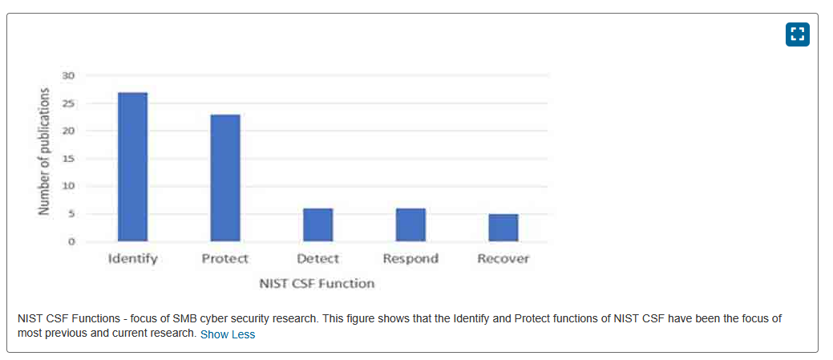
[Figure 1: A graph from a recent study showing the number of publications per each phase of the NIST CSF.]

Appendix B: Project Management
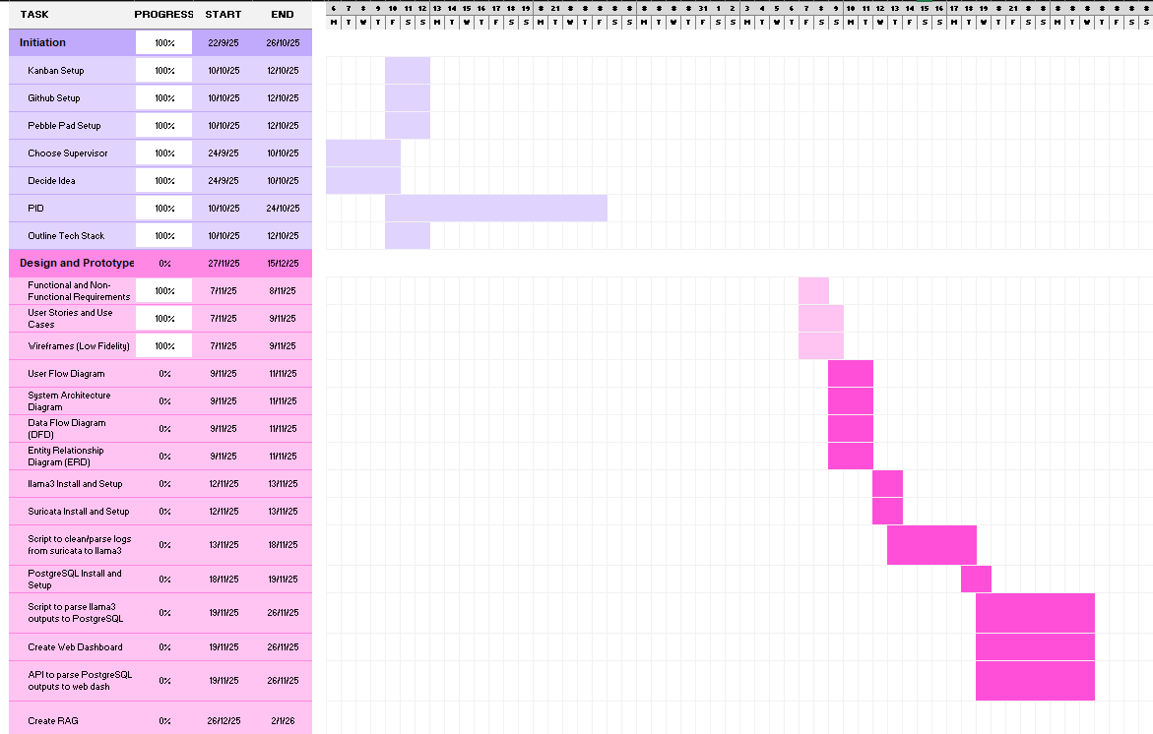
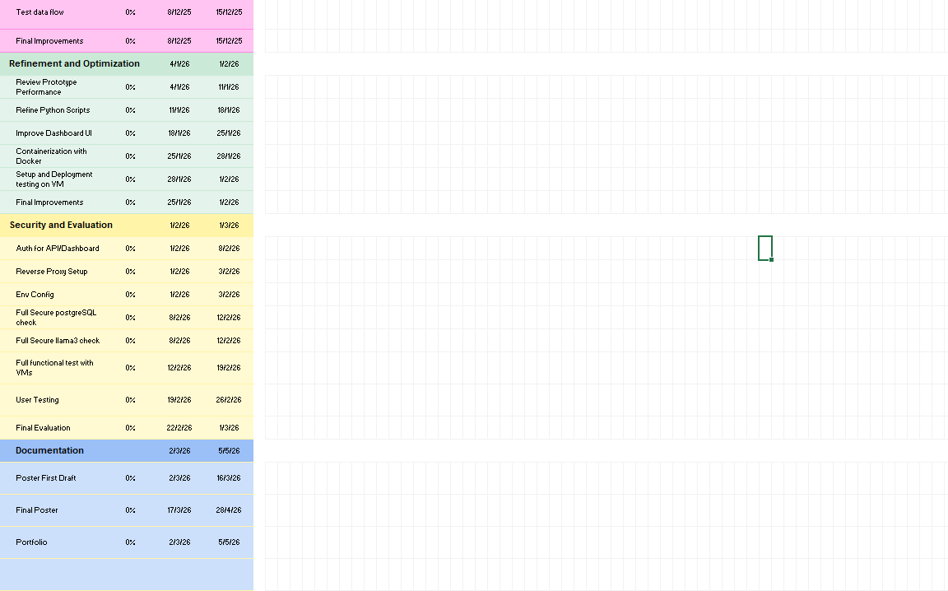
[Figures 1 & 2: Screenshots of the initial Project Gannt Chart.]
Final goes here
[Figure 3: Screenshot of the final Project Gannt Chart.]
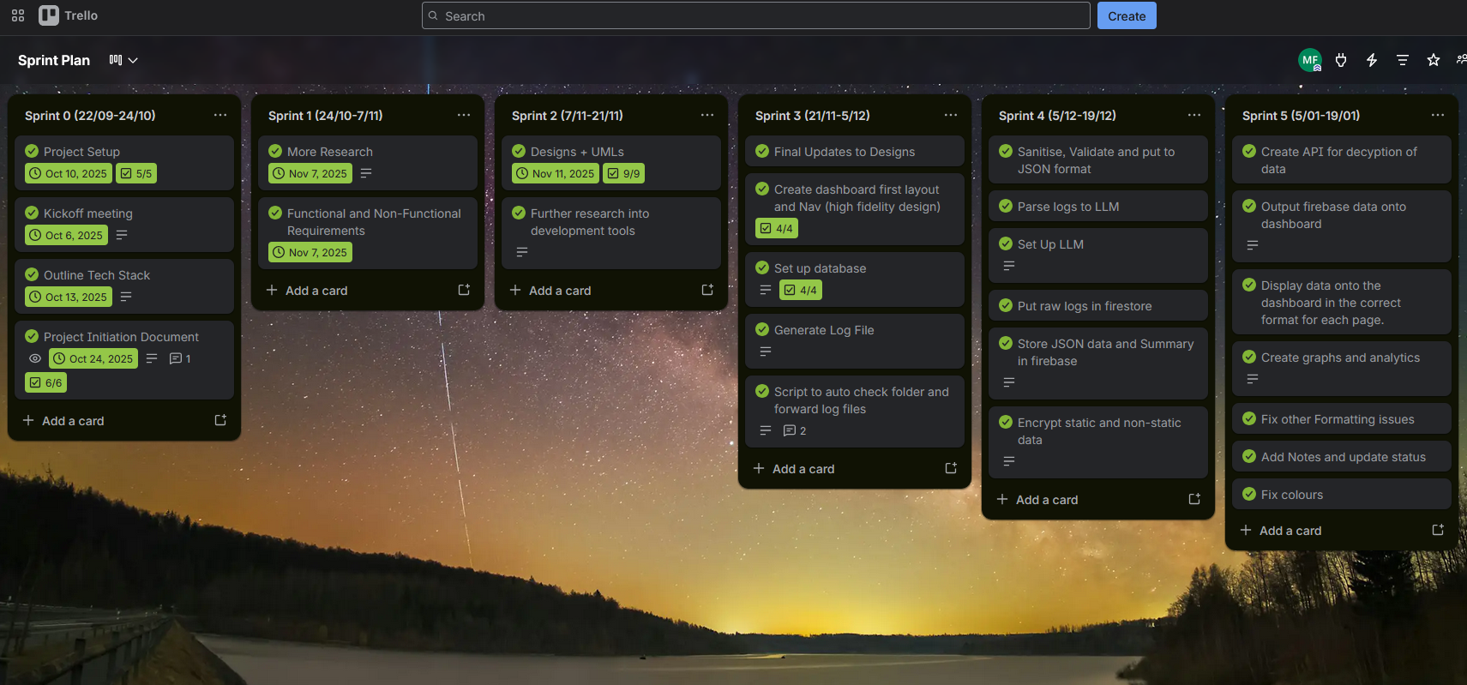
[Figure 4: A Screenshot of the Trello Sprint Plan board weeks 1 – 5.] note: add the final weeks too
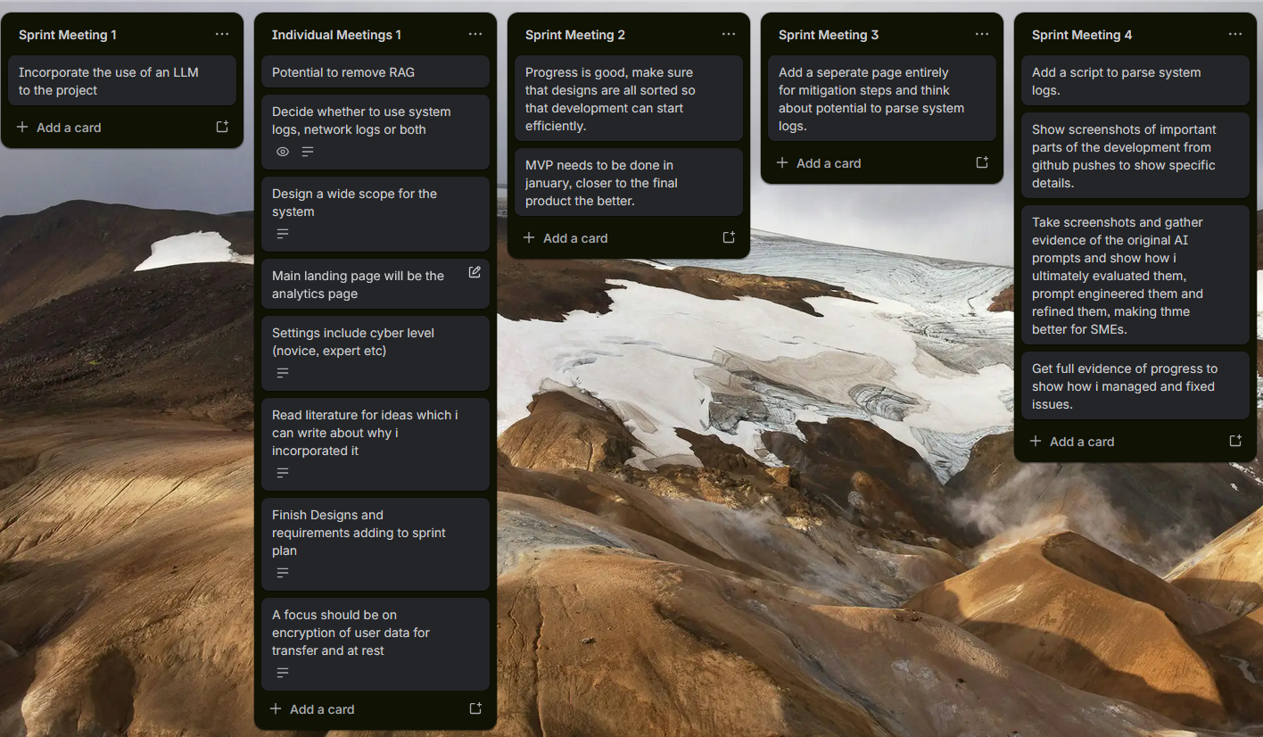
[Figure 5: A Screenshot of the Trello Meeting notes board weeks 1-4.]
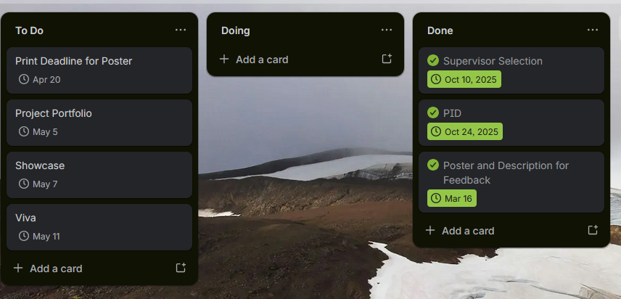
[Figure 6: A Screenshot of the Trello Deadlines board.]
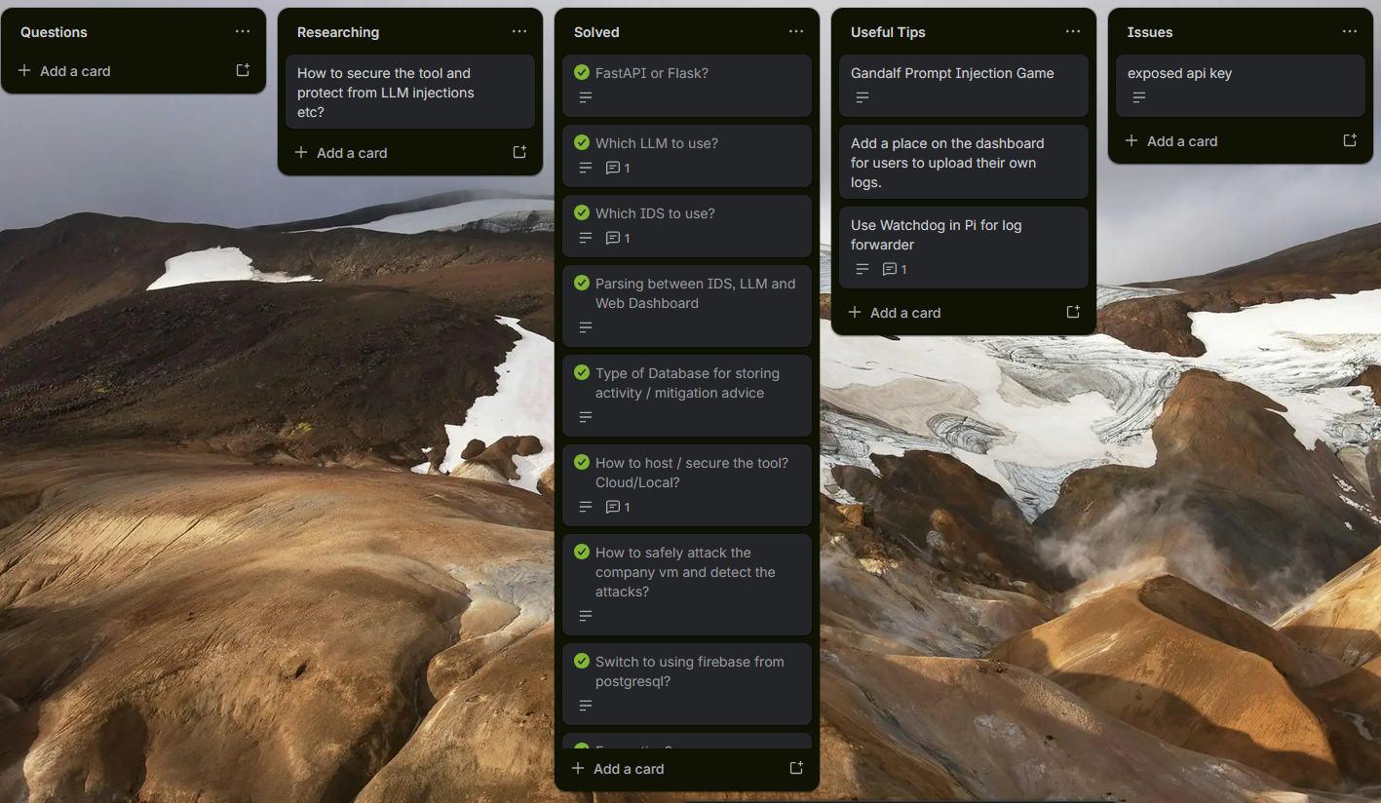
[Figure 7: A Screenshot of the Trello Queries & Questions Board.]

Appendix C: Initial Project Risk Assessment
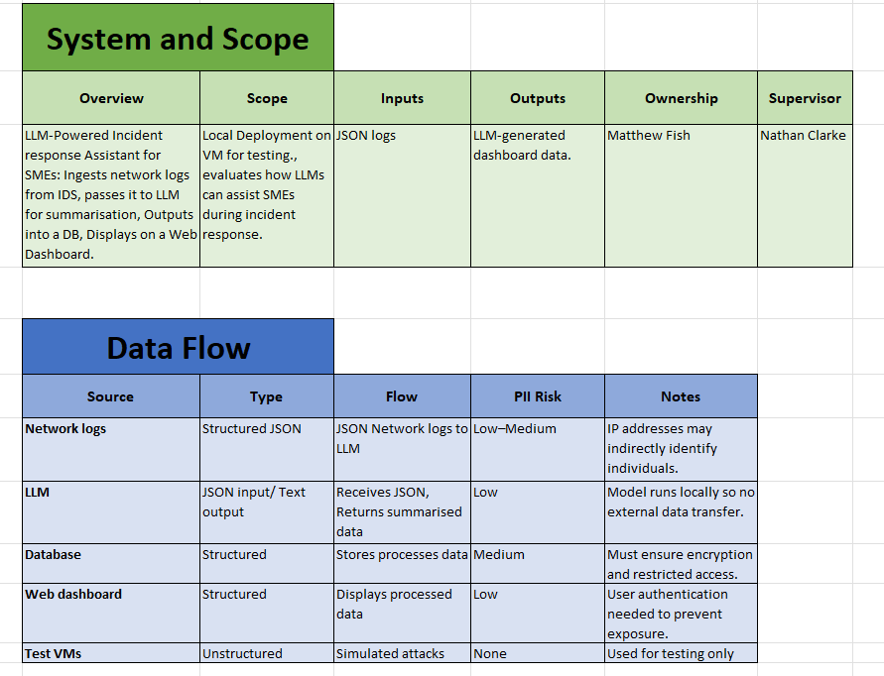
[Figure 1: A Screenshot of the System Scope and Data Flow PII Risk]
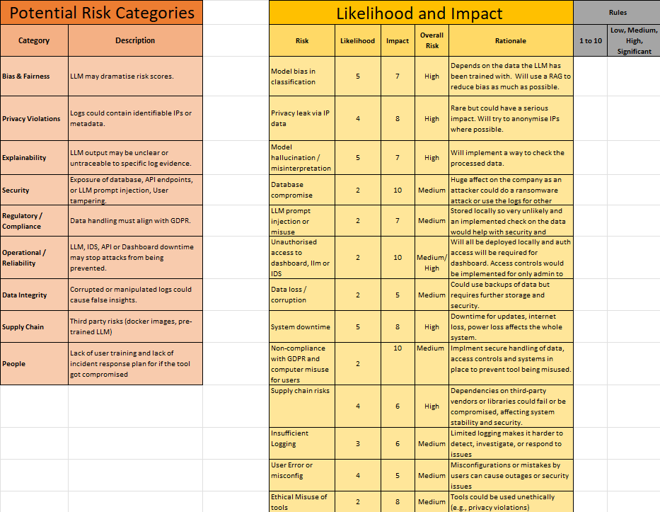
[Figure 2: A Screenshot of the potential risk categories with their likelihood and impact]
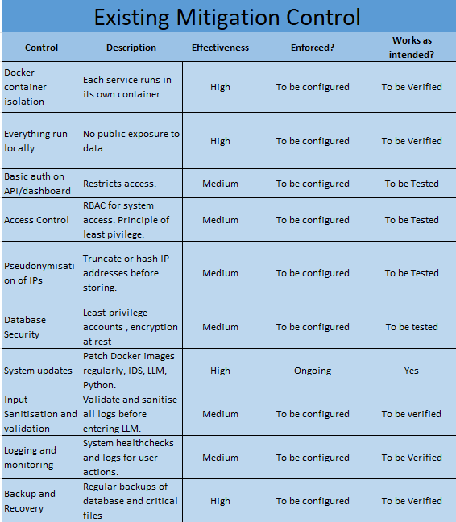
[Figure 3: A Screenshot of the pre design and development existing mitigation controls]
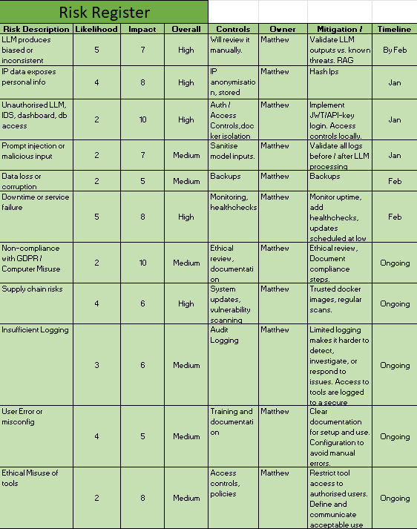
[Figure 4: A Screenshot of the final detailed Risk Register]

Appendix D: Initial Wireframes
[Figure 1: Admin Page Wireframe]
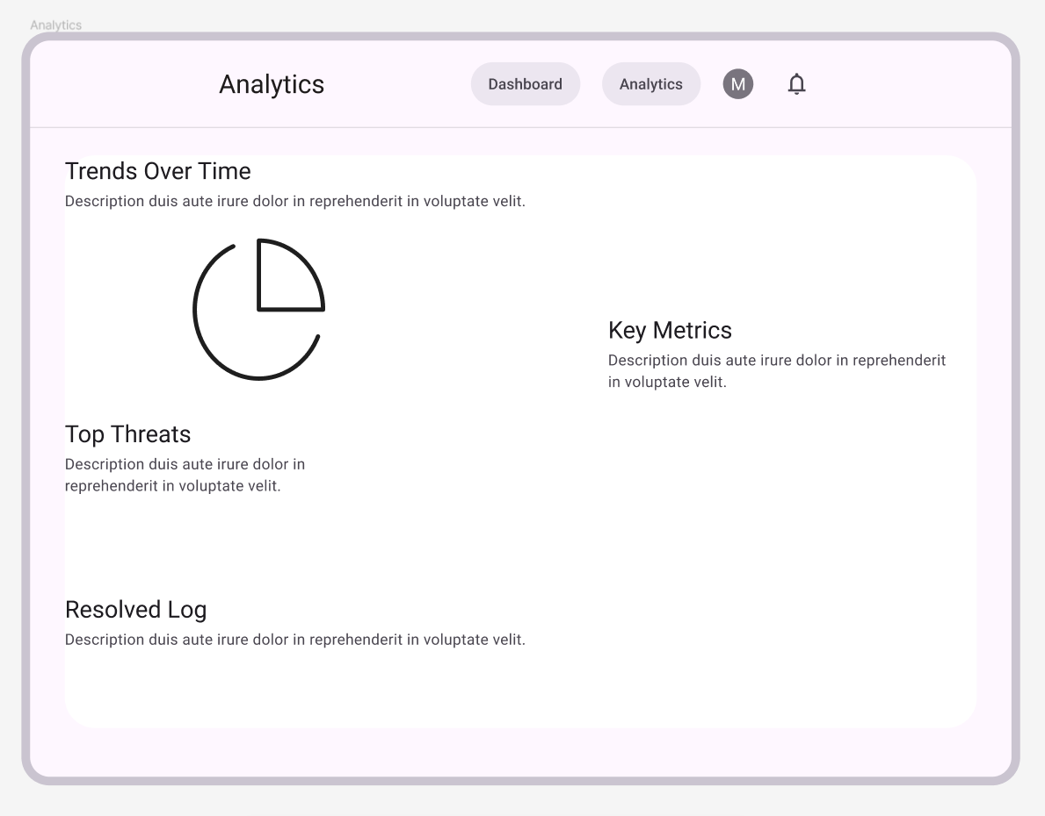
[Figure 2: Analytics Page Wireframe]

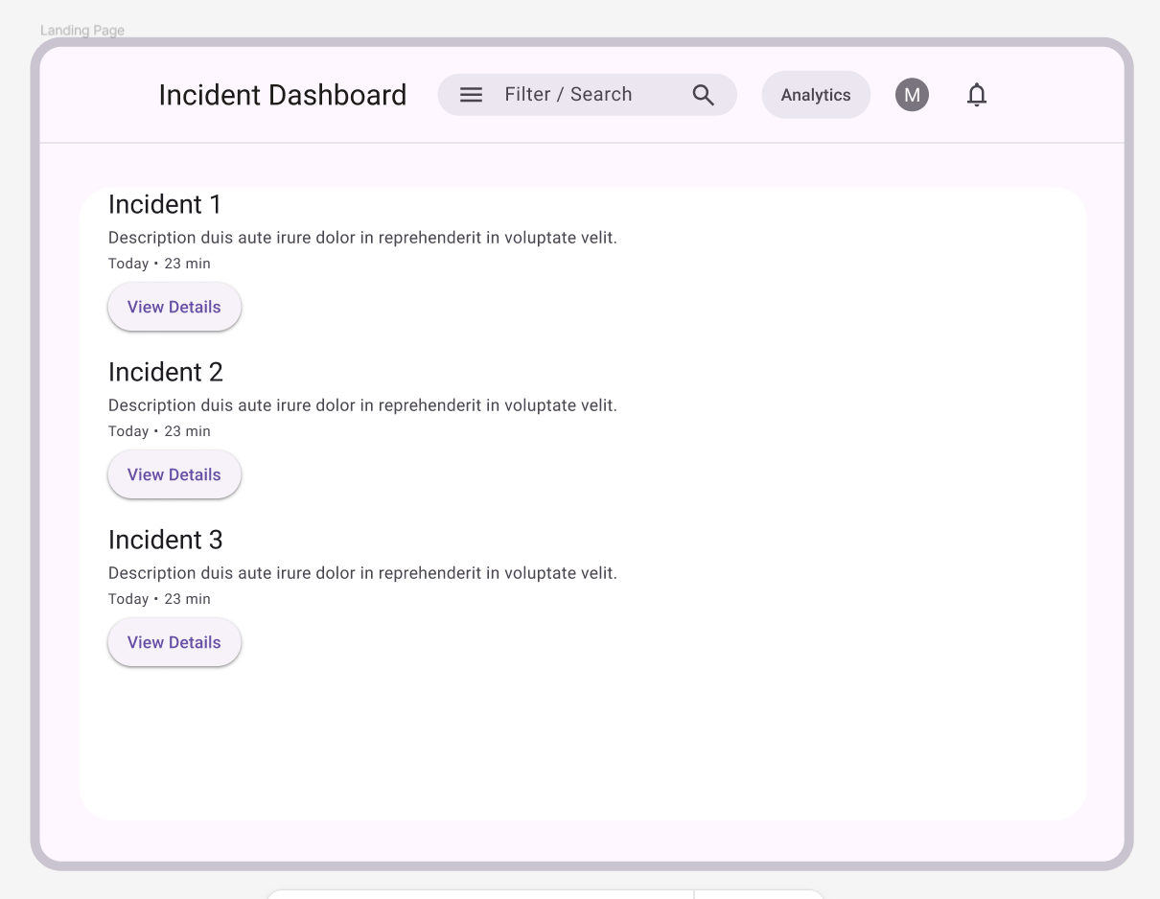
[Figure 3: Incidents Page Wireframe]

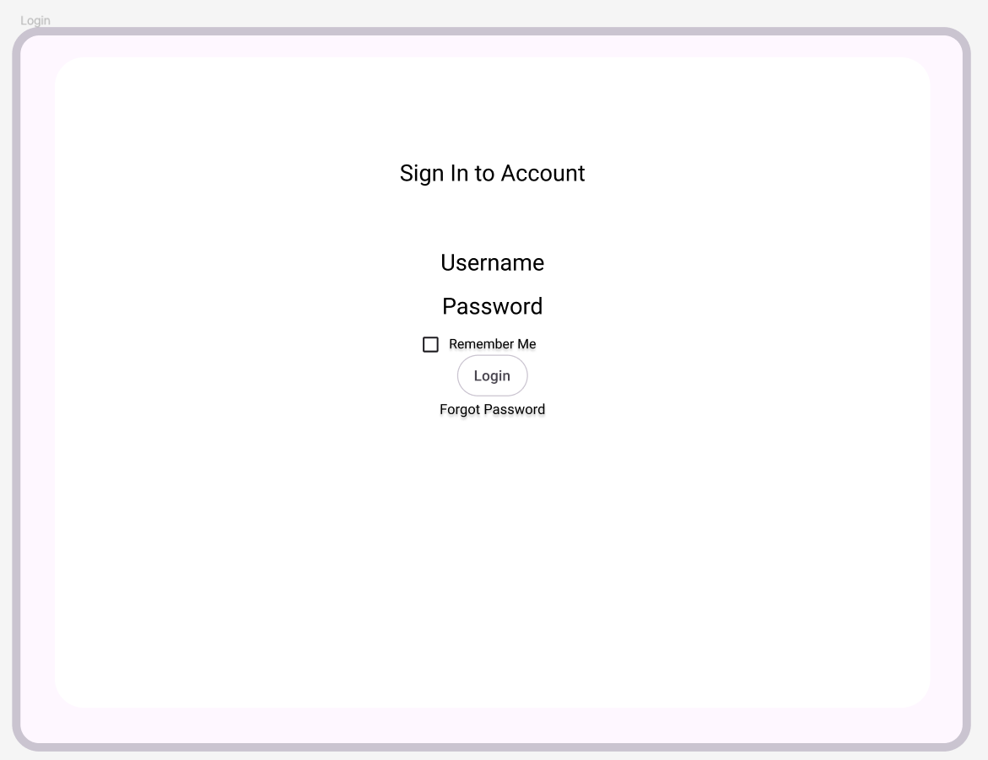
[Figure 4: Login Page Wireframe]

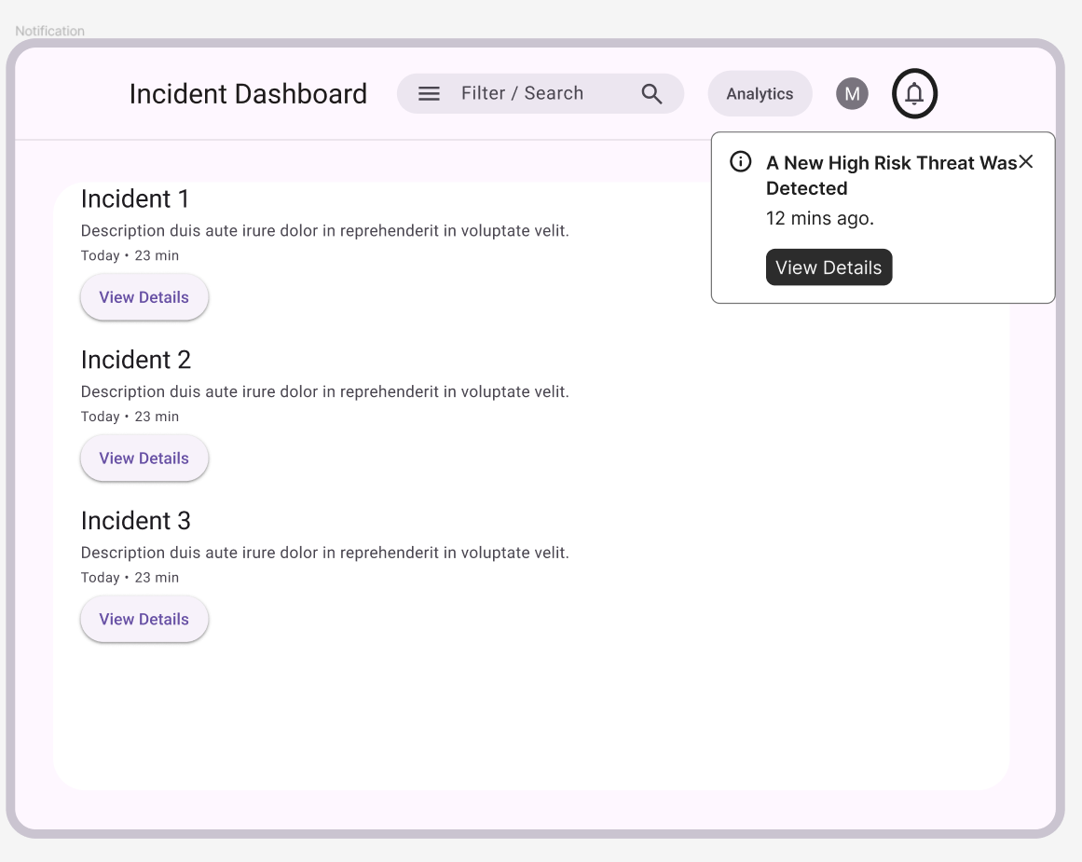
[Figure 5: Notification Popup Wireframe]

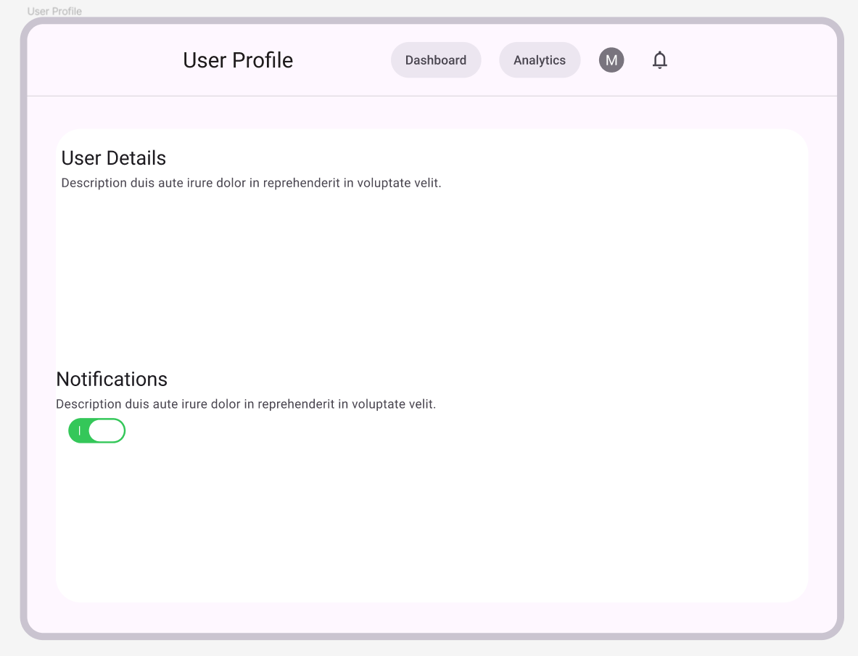
[Figure 6: User Profile Page (Settings) Wireframe]

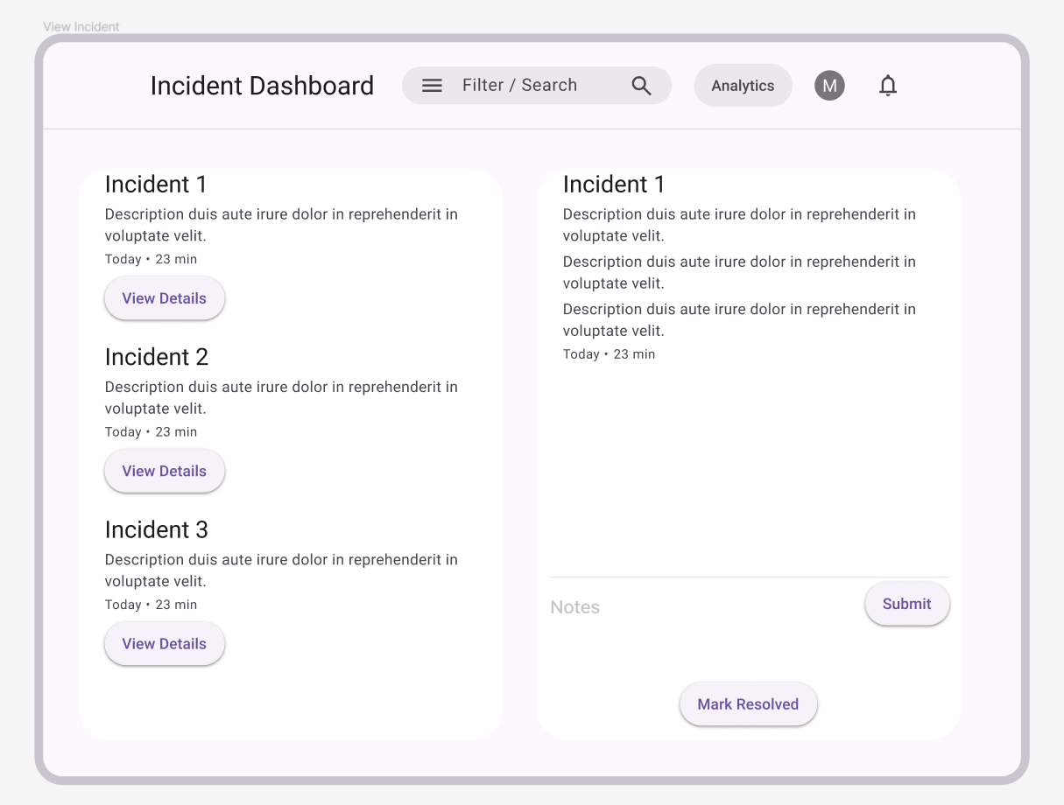
[Figure 7: View Incidents Page Wireframe]

Appendix E: Final Wireframes
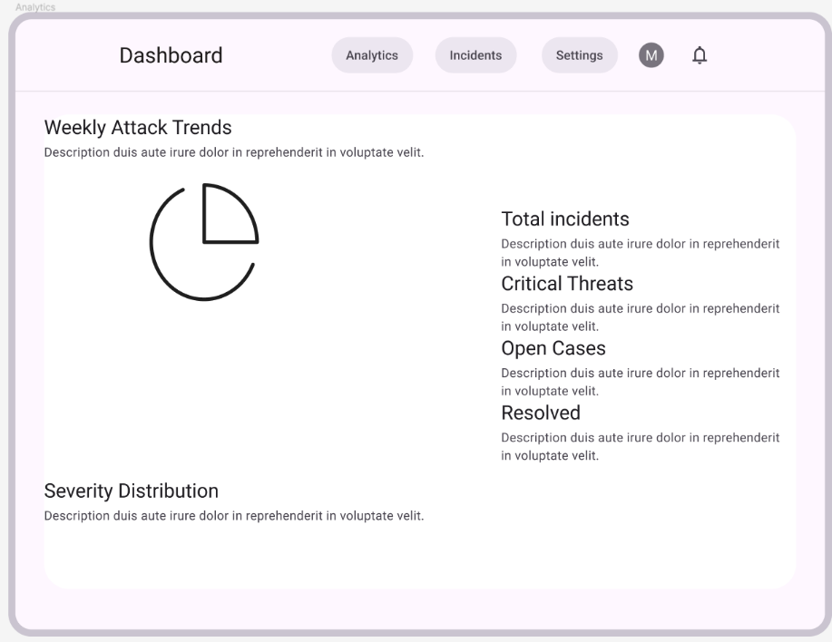
[Figure 1: Analytics Page Wireframe]
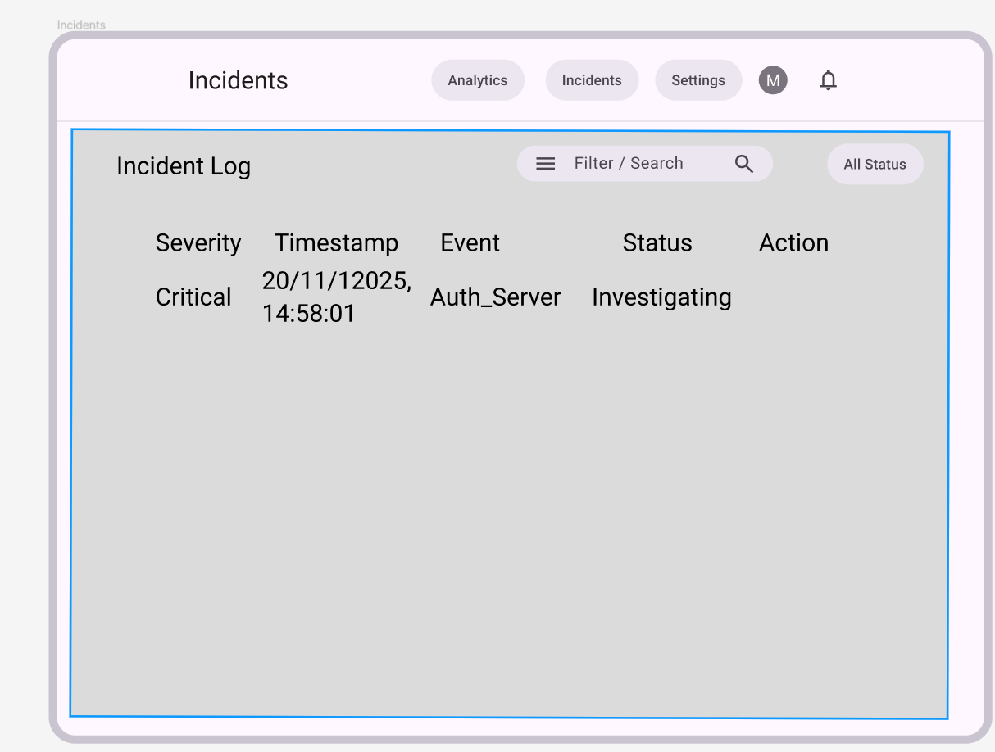
[Figure 2: Incidents Page Wireframe]

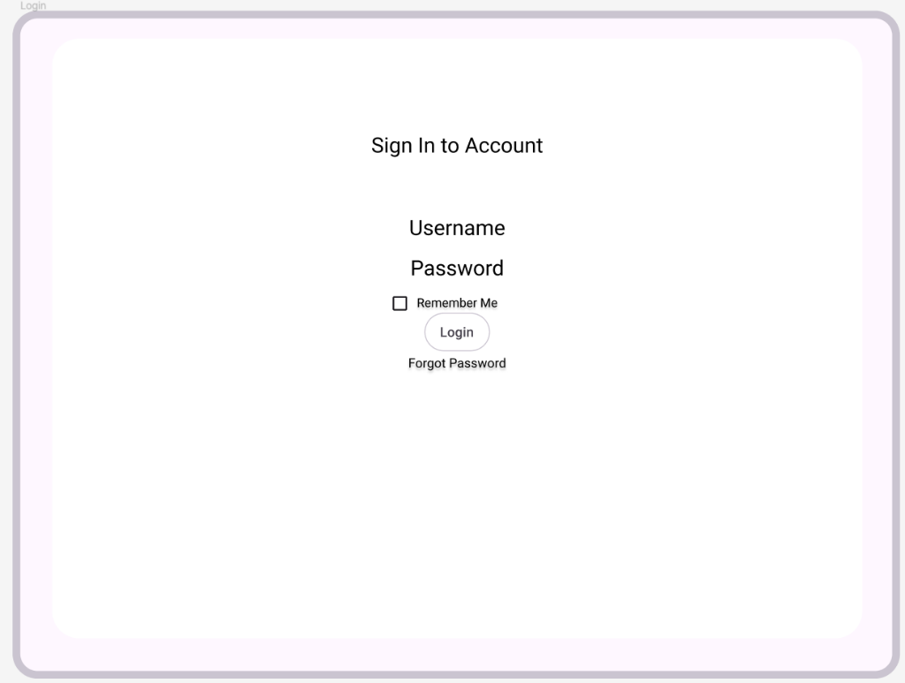
[Figure 3: Login Page Wireframe]

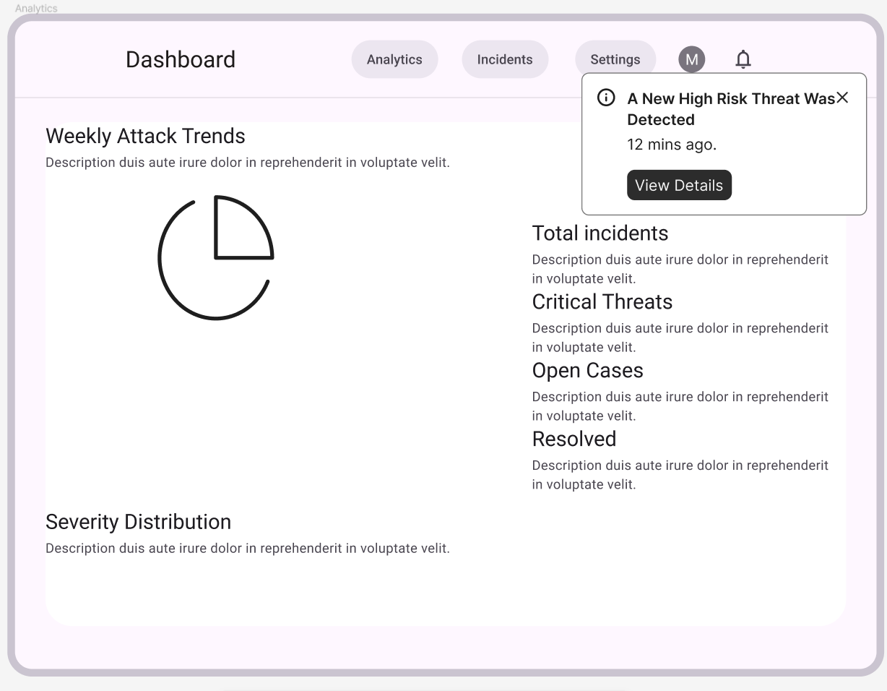
[Figure 4: Notification Popup Wireframe]

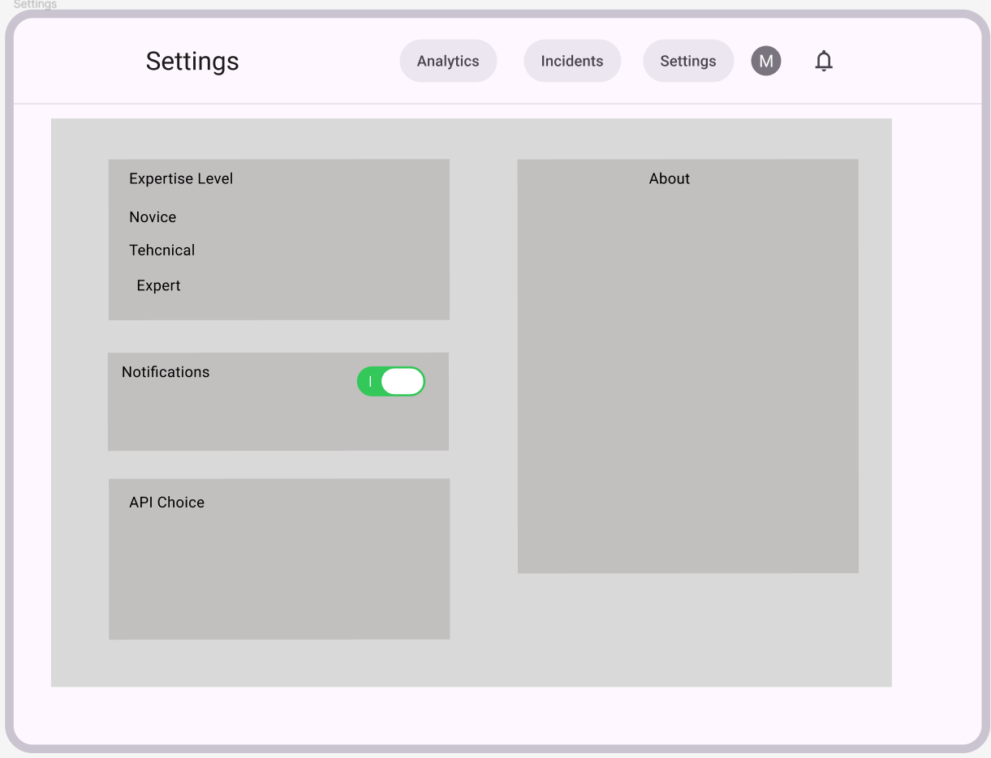
[Figure 5: Settings Page Wireframe]

[Figure 6: Incident Details Page Wireframe]

Appendix F: Unit Tests
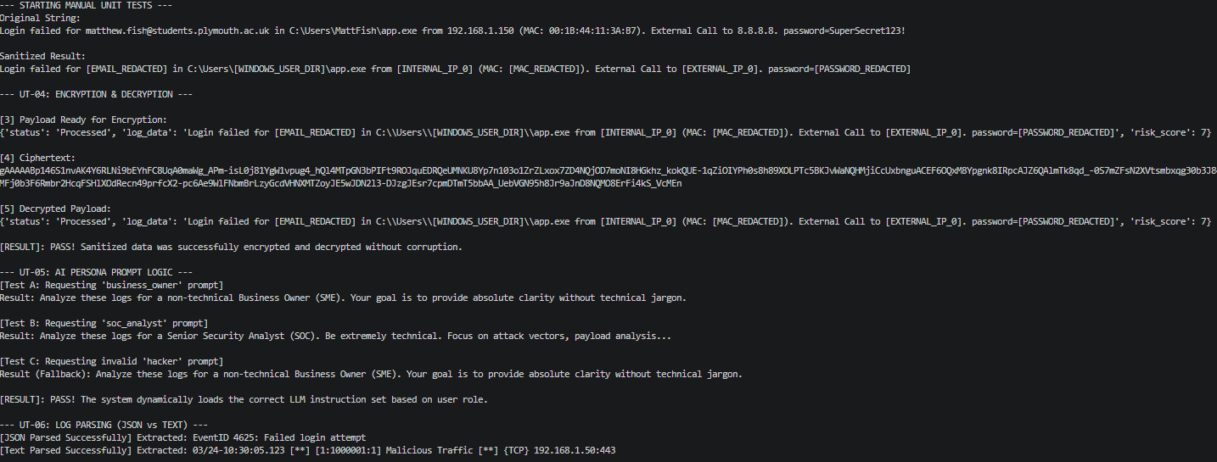
[Figure 1: Unit Test Part 1]
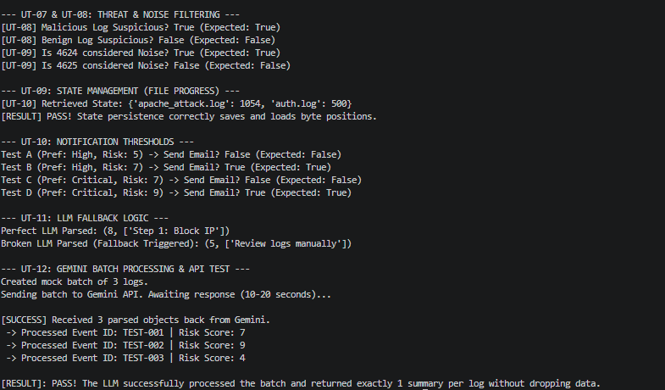
[Figure 2: Unit Test Part 2]
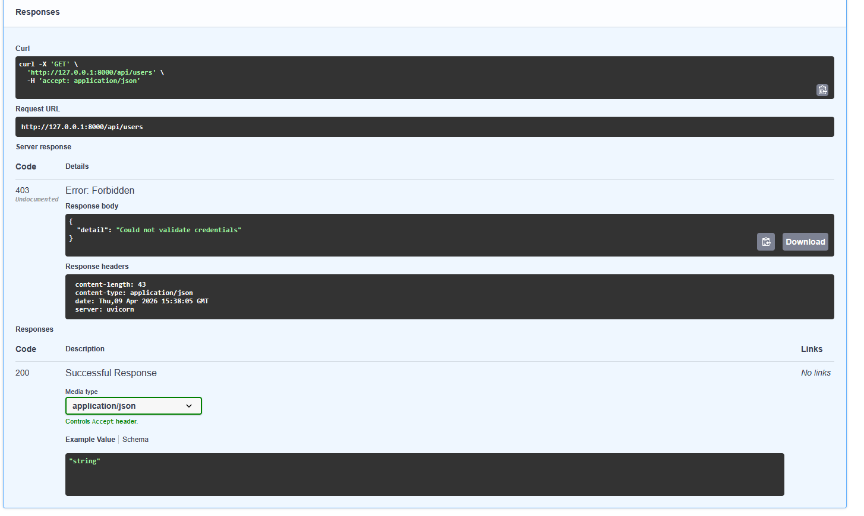
[Figure 3: Api Unit Test 01 Result]
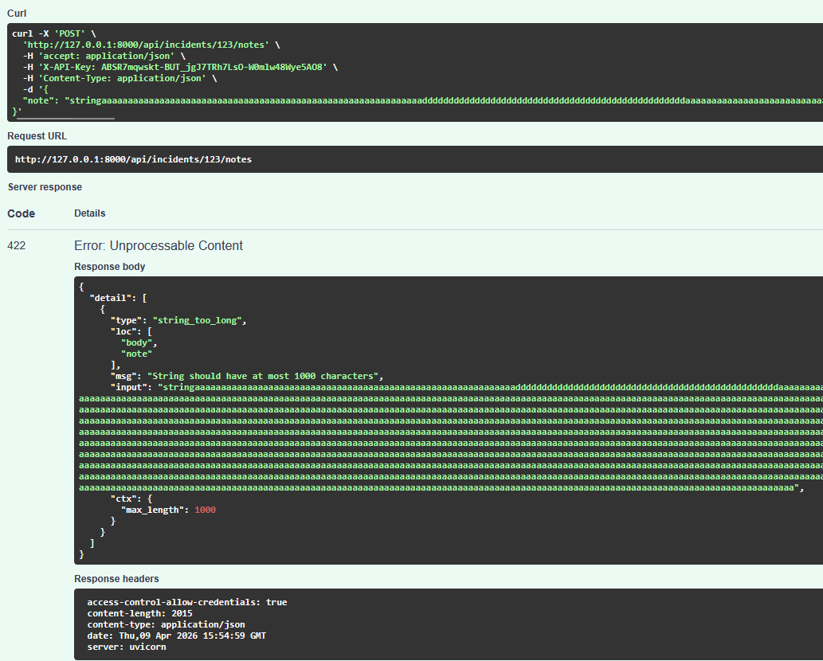
[Figure 4: Api Unit Test 02 Result]
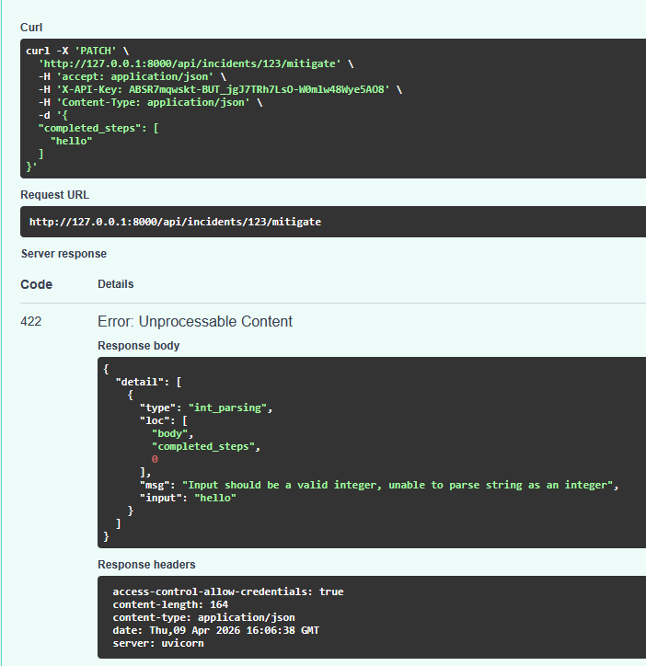
[Figure 5: Api Unit Test 03 Result]
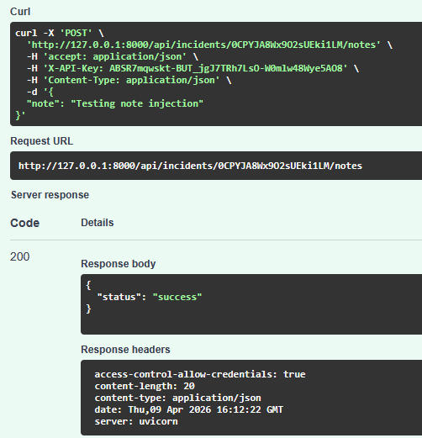
[Figure 6: Api Unit Test 04 Result]
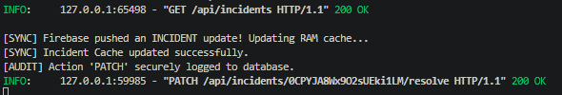
[Figure 7: Api Unit Test 05 Result]

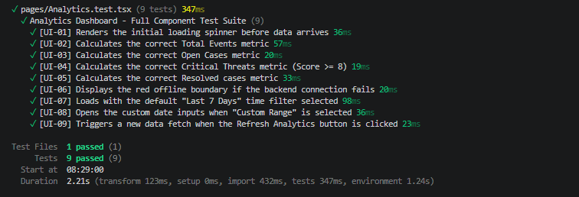
[Figure 8: Analytics Page Unit Test Result]
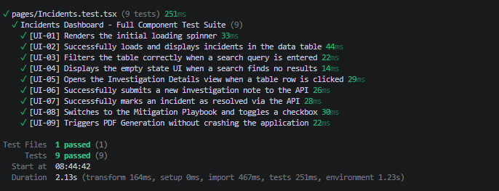
[Figure 9: Incidents Page Unit Test Result]
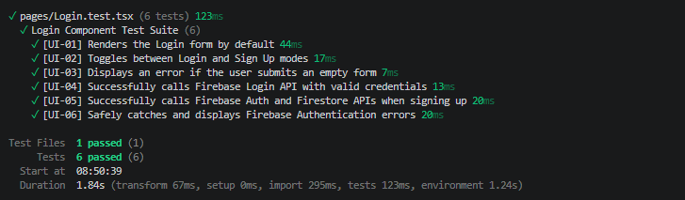
[Figure 10: Login Page Unit Test Result]
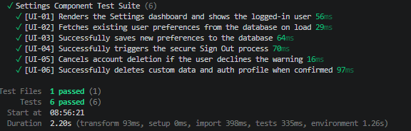
[Figure 11: Settings Page Unit Test Result]

Appendix G: Integration Tests
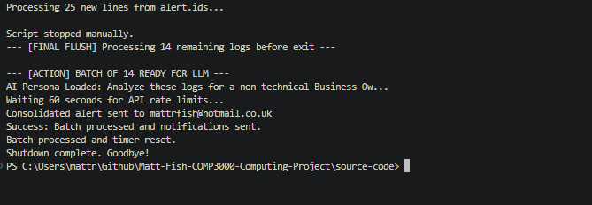
[Figure 1: INT 01 Test – Sending data to api, encrypting it, and adding to firestore.]
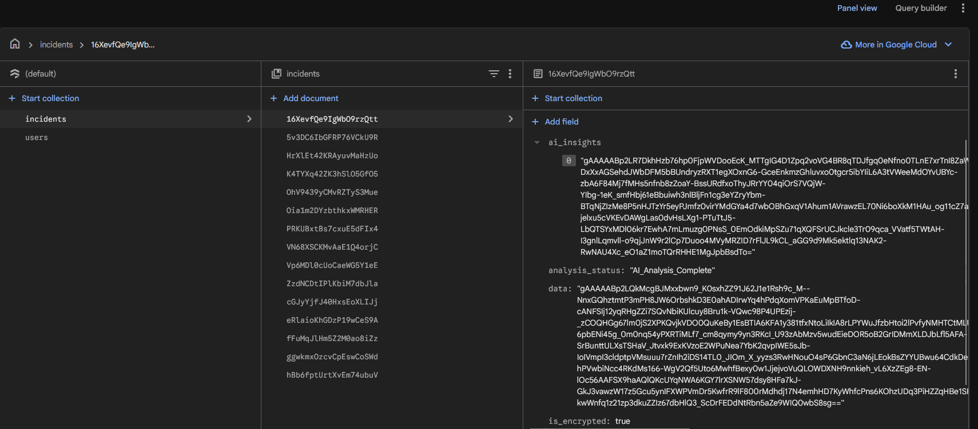
[Figure 2: INT 01 Test – Firestore Encrypted Data Received]
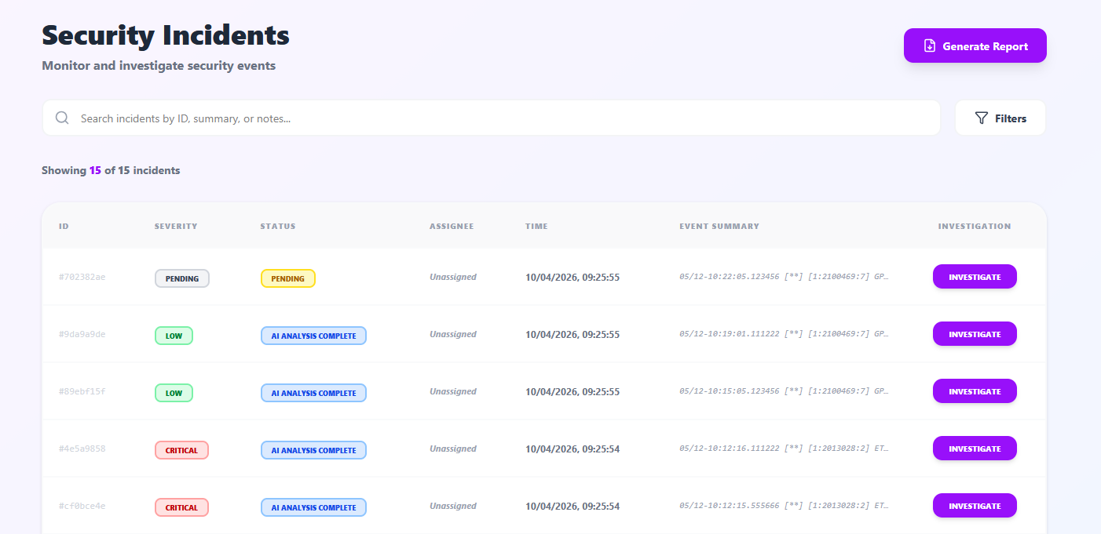
[Figure 3: INT 02 Test – Frontend successfully rendering data on the screen, with a known issue from INT 01 being displayed.]
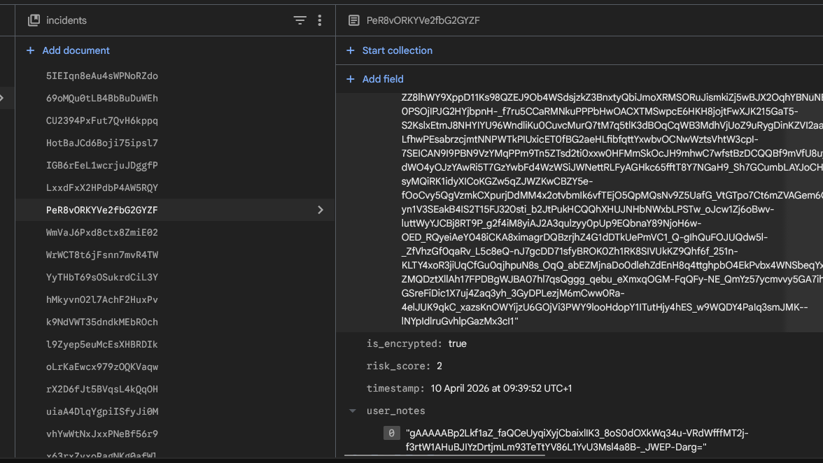
[Figure 4: INT 03 Test – Frontend successfully encrypted a note and added it to the database.]
[Figure 5: INT 04 Test – User successfully logs in, however the firebase api key is exposed.]

Appendix H: Performance / Stress Tests
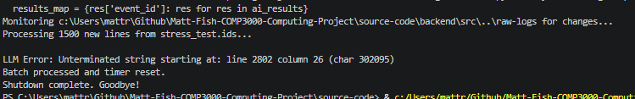
[Figure 1: PERF-04 Test Fail.]
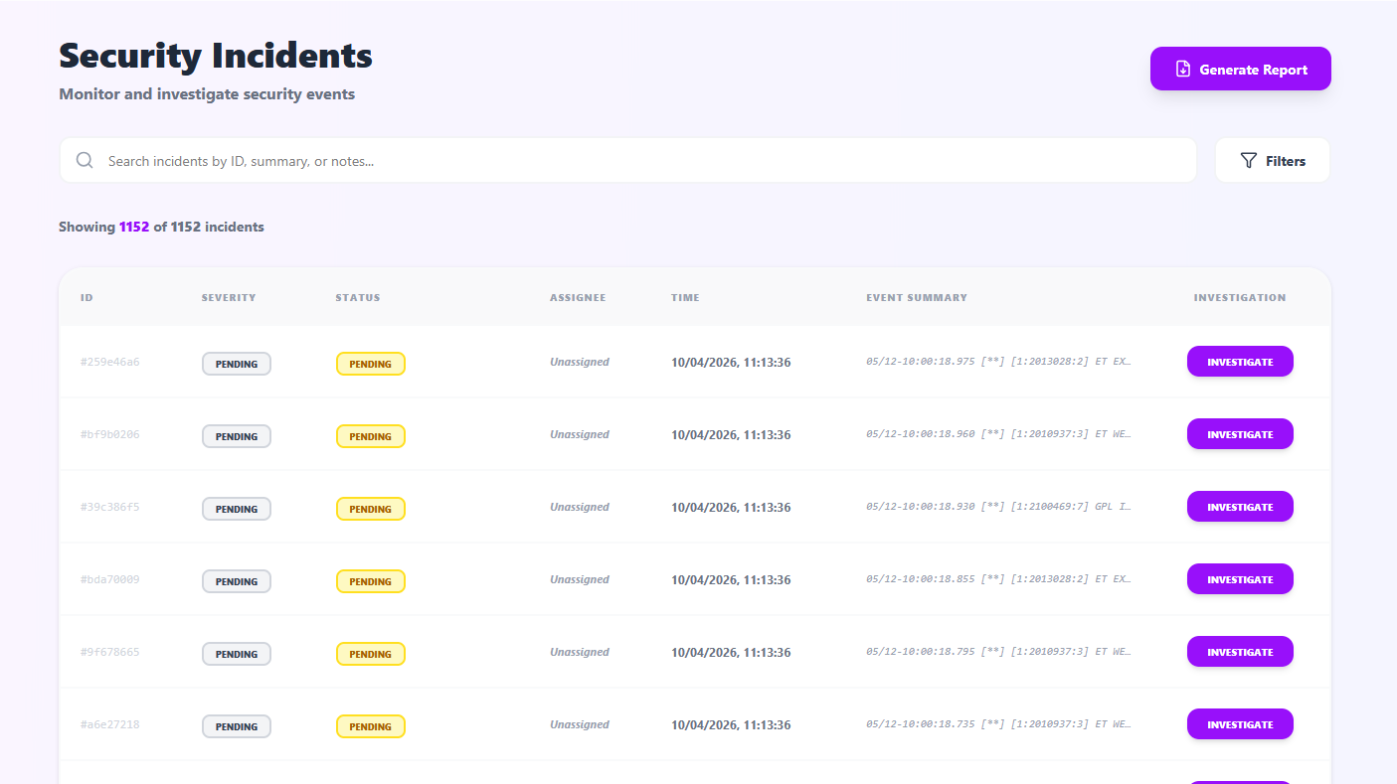
[Figure 2: PERF-01 and PERF-07 Test Pass.]

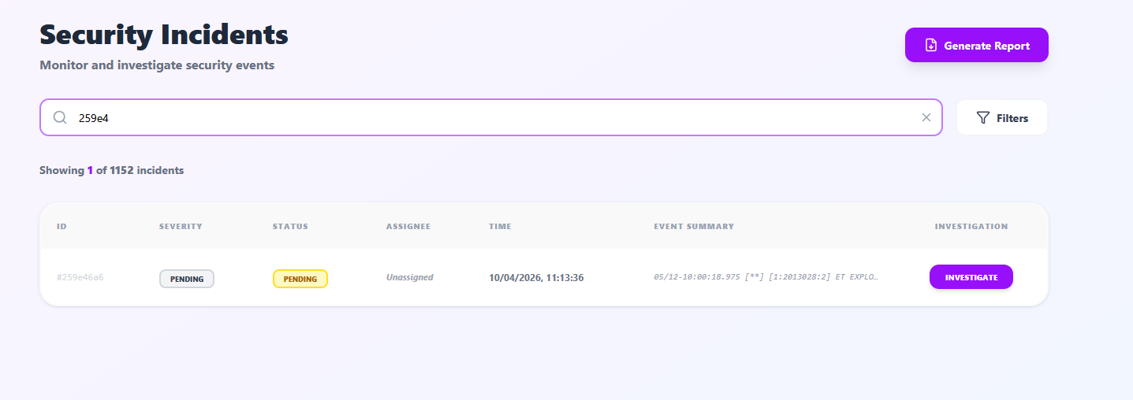
[Figure 3: PERF-02 Test Pass.]
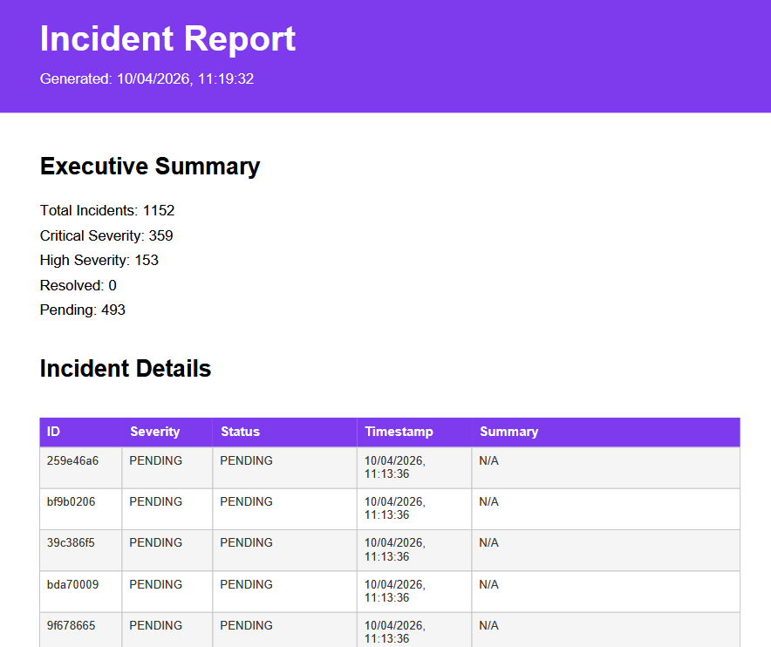
[Figure 4: PERF-03 Test Pass.]
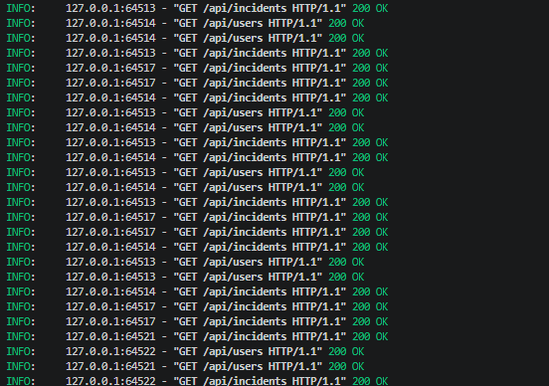
[Figure 5: PERF-05 Test Pass.]
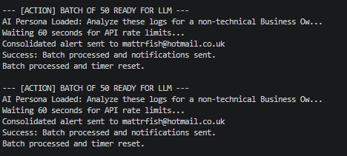
[Figure 5: PERF-06 Test Pass.]

Appendix I: Blank UAT Questionnaire and Results.
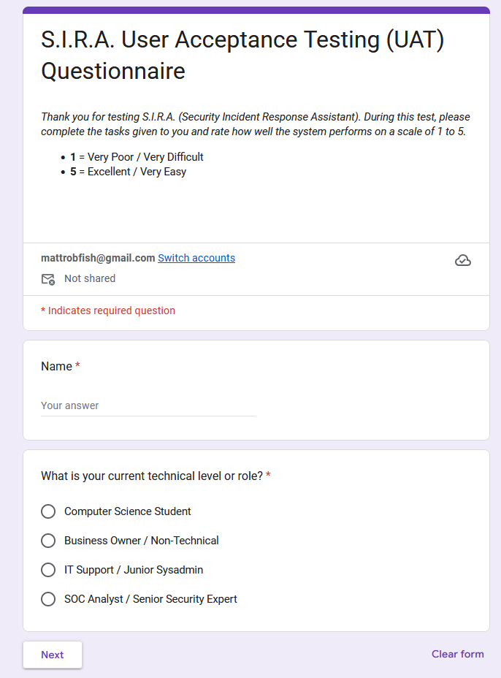
[Figure 1: Blank UAT Page 1.]
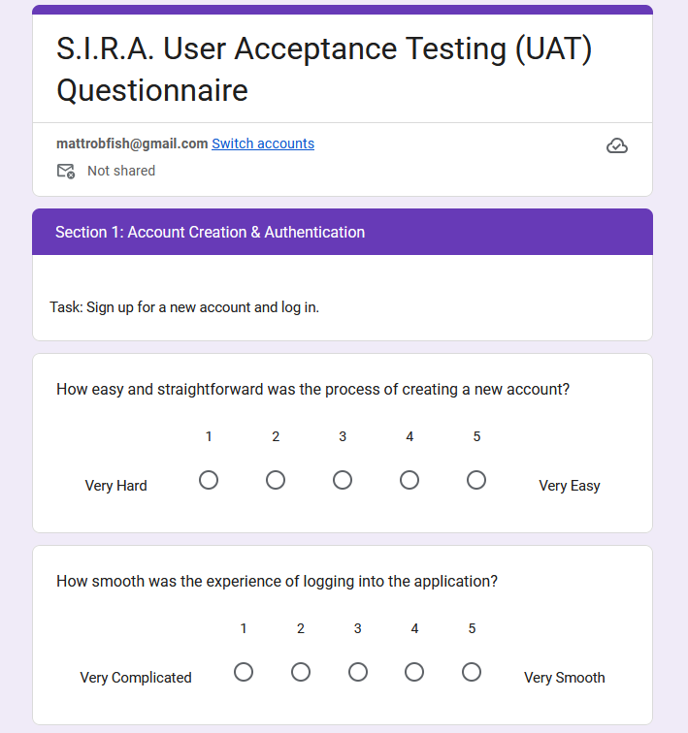
[Figure 2: Blank UAT Section 1, Page 2.]
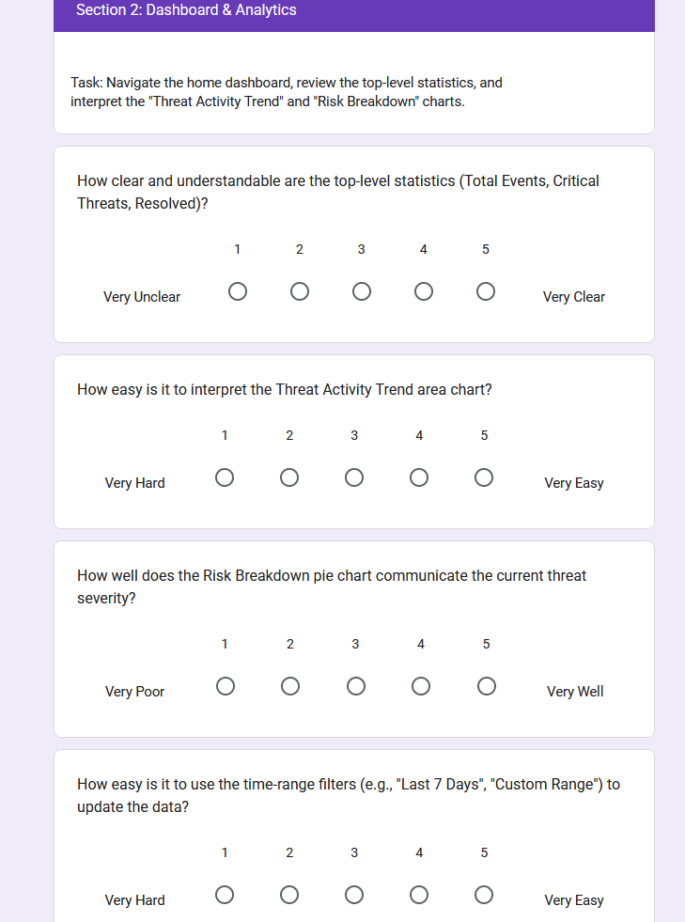
[Figure 3: Blank UAT Section 2, Page 3.]
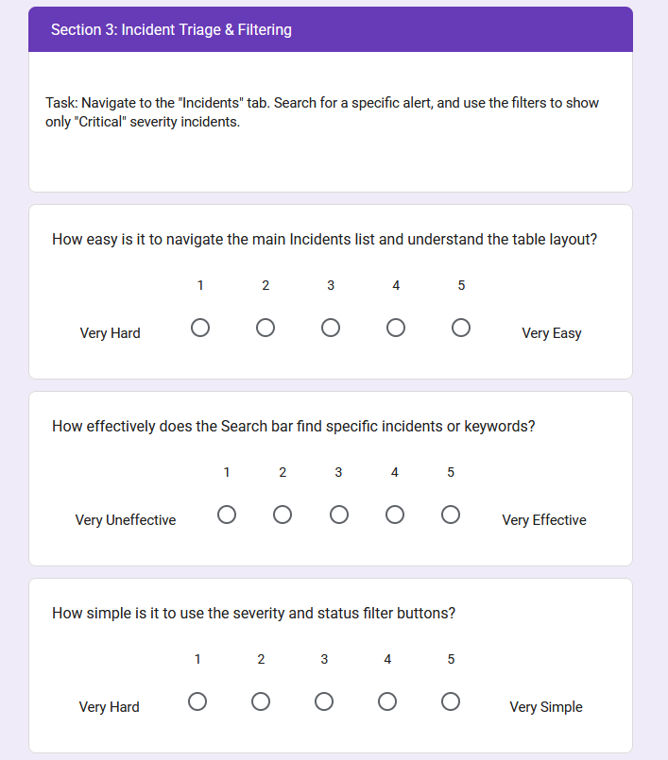
[Figure 4: Blank UAT Section 3, Page 4.]
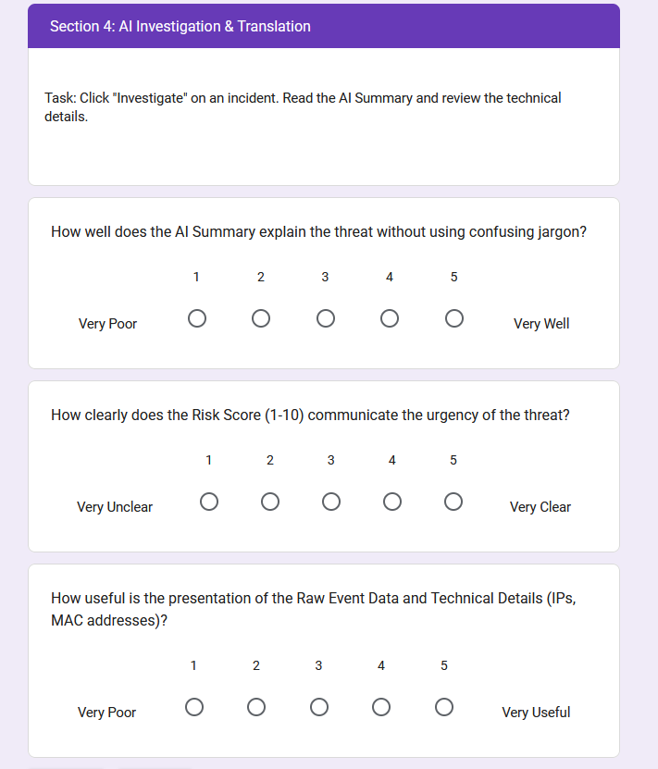
[Figure 5: Blank UAT Section 4, Page 5.]
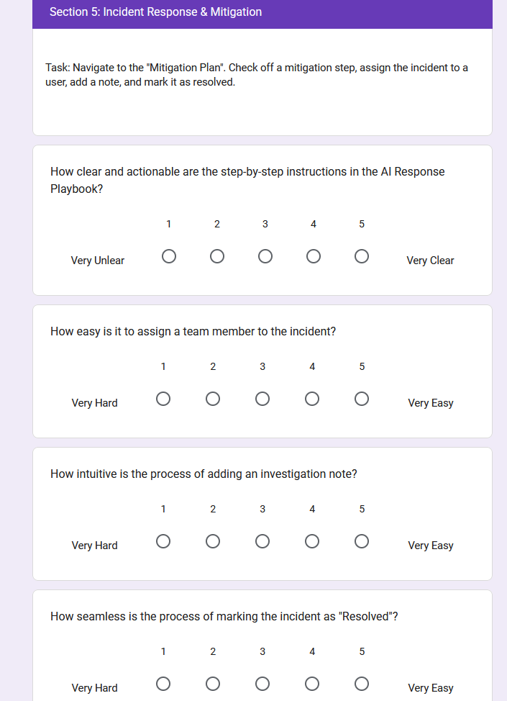
[Figure 6: Blank UAT Section 5, Page 6.]
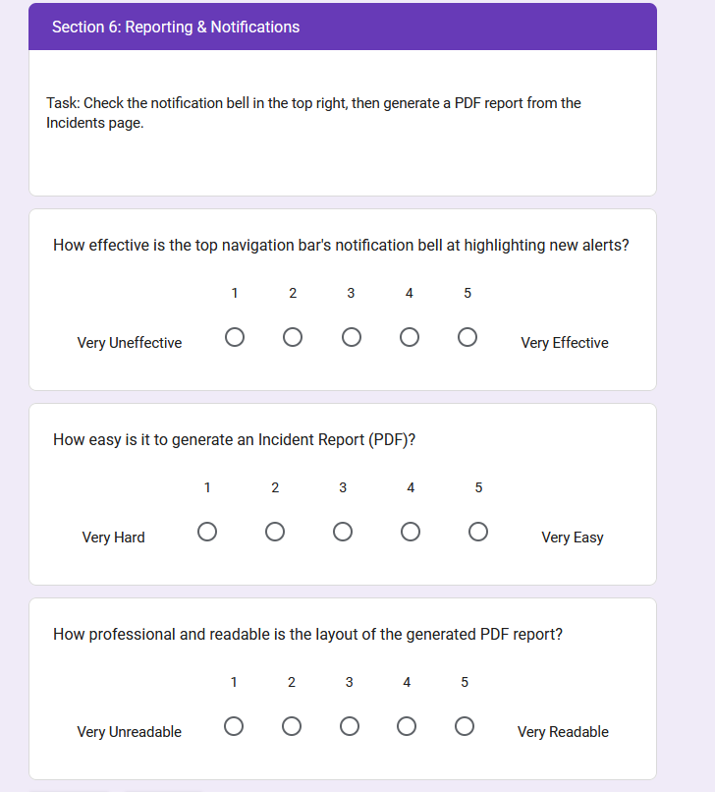
[Figure 7: Blank UAT Section 6, Page 7.]
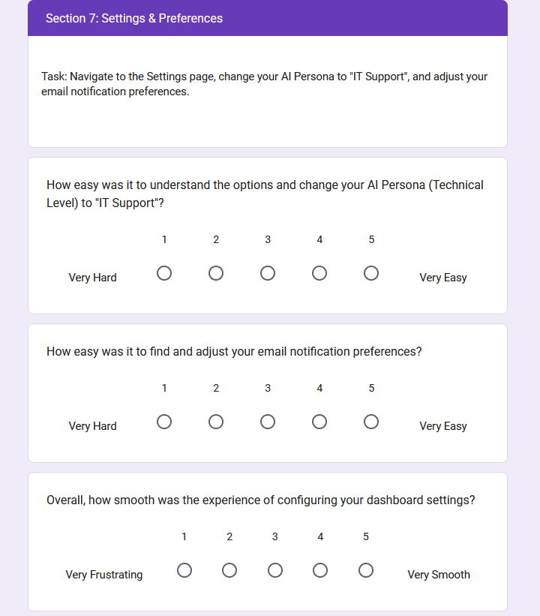
[Figure 8: Blank UAT Section 7, Page 8.]
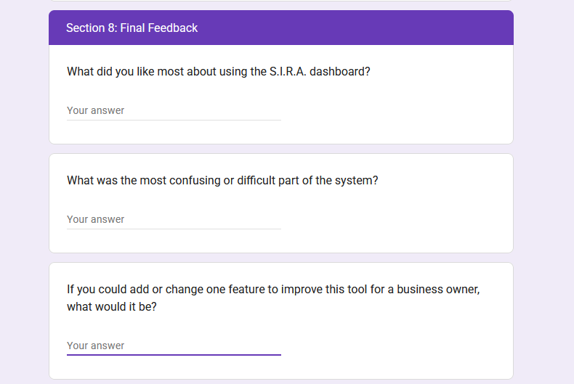
[Figure 9: Blank UAT Section 8, Page 9.]
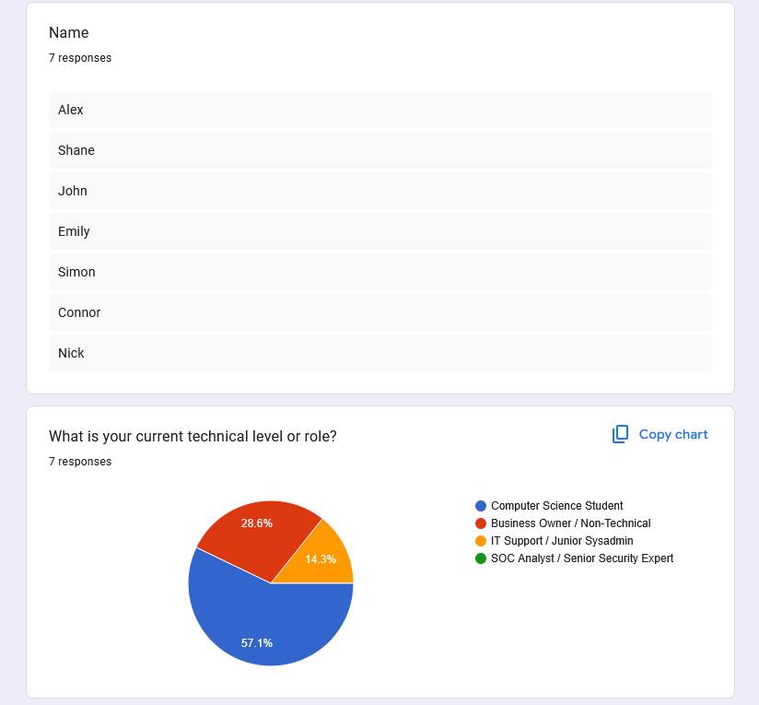
[Figure 10: Completed UAT.]
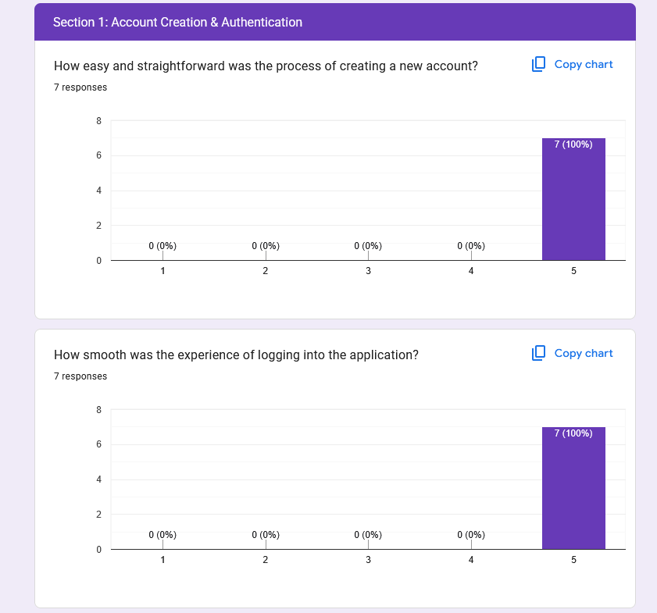
[Figure 11: Completed UAT Section 1, Q1+2.]
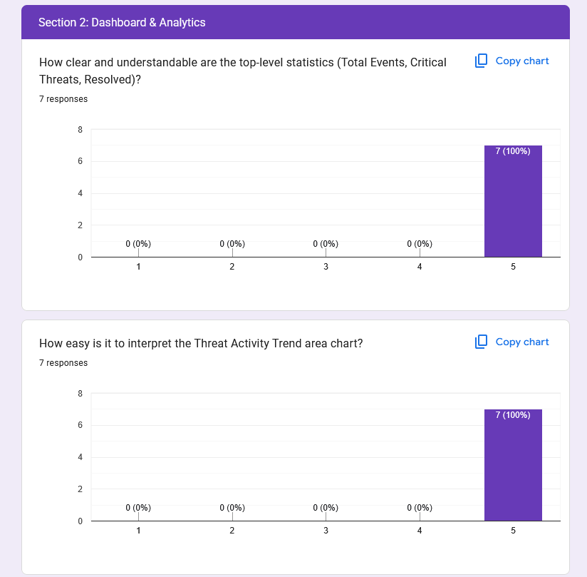
[Figure 12: Completed UAT Section 2, Q1+2.]
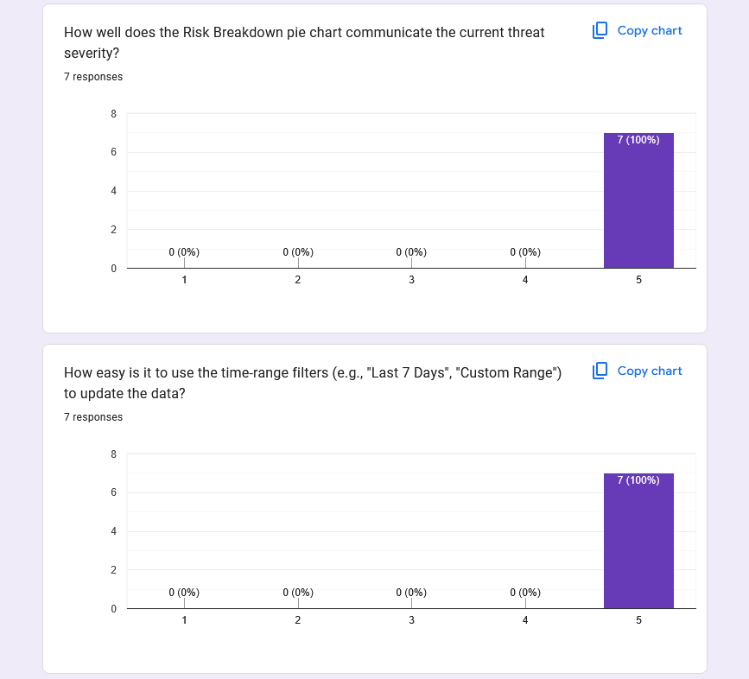
[Figure 13: Completed UAT Section 2, Q3+4.]
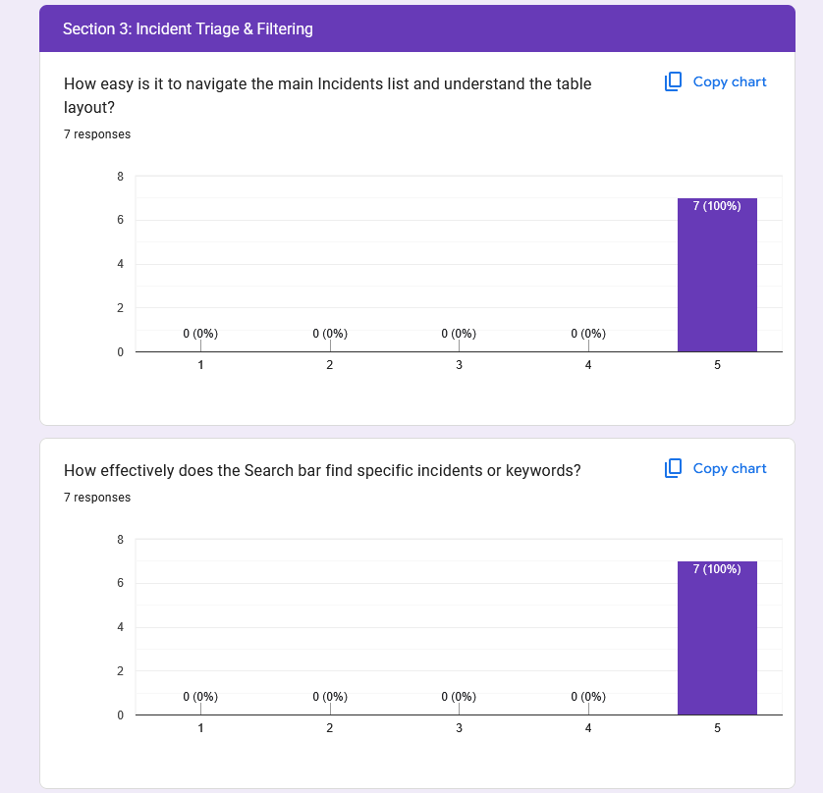
[Figure 14: Completed UAT Section 3, Q 1+2.]
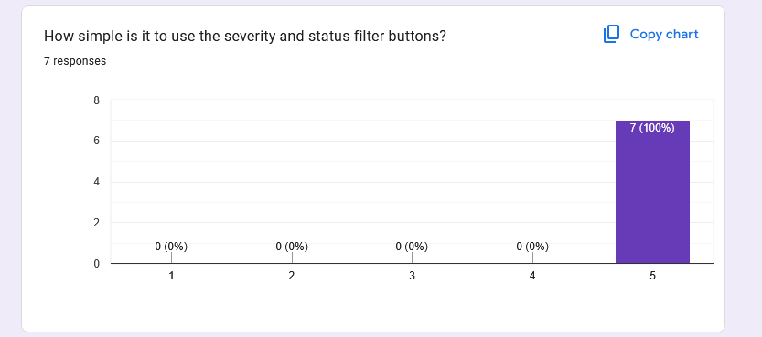
[Figure 15: Completed UAT Section 3, Q3.]
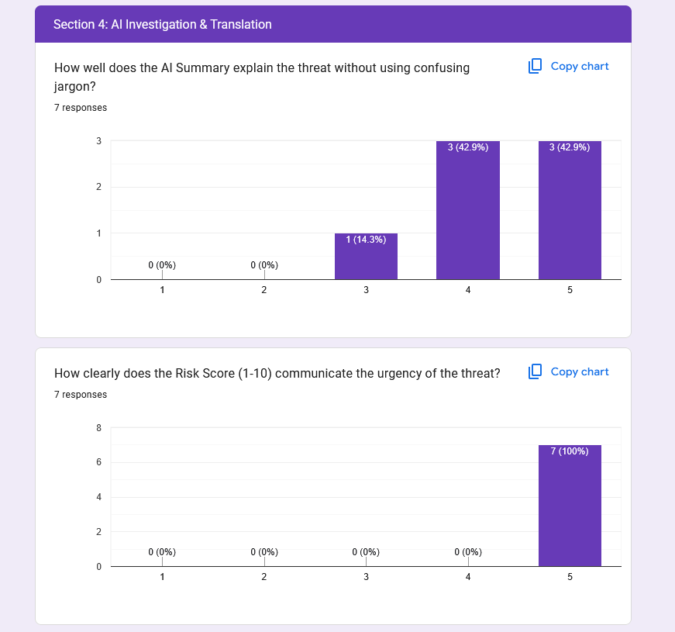
[Figure 16: Completed UAT Section 4, Q1+2.]
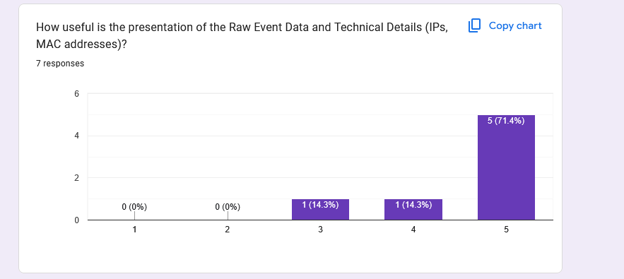
[Figure 17: Completed UAT Section 4, Q3.]
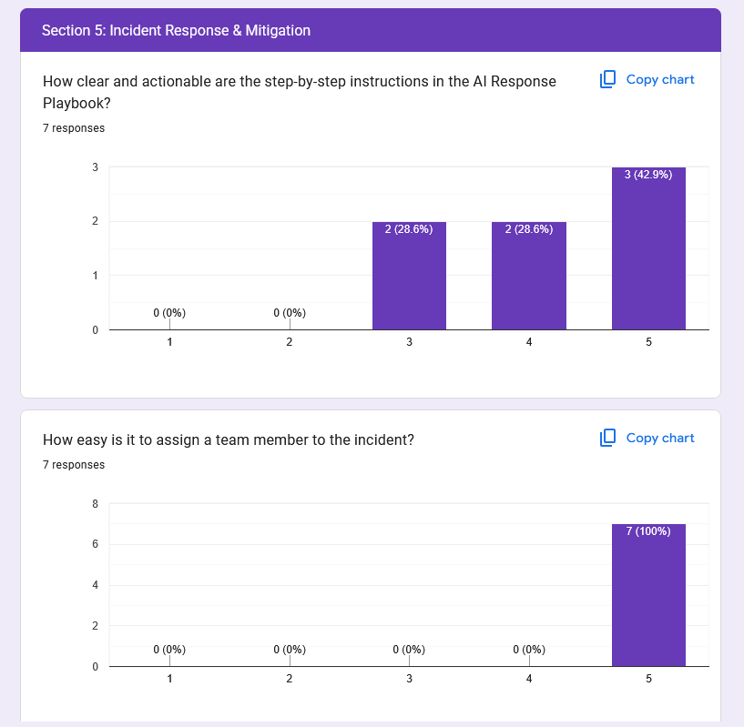
[Figure 18: Completed UAT Section 5, Q1+2.]
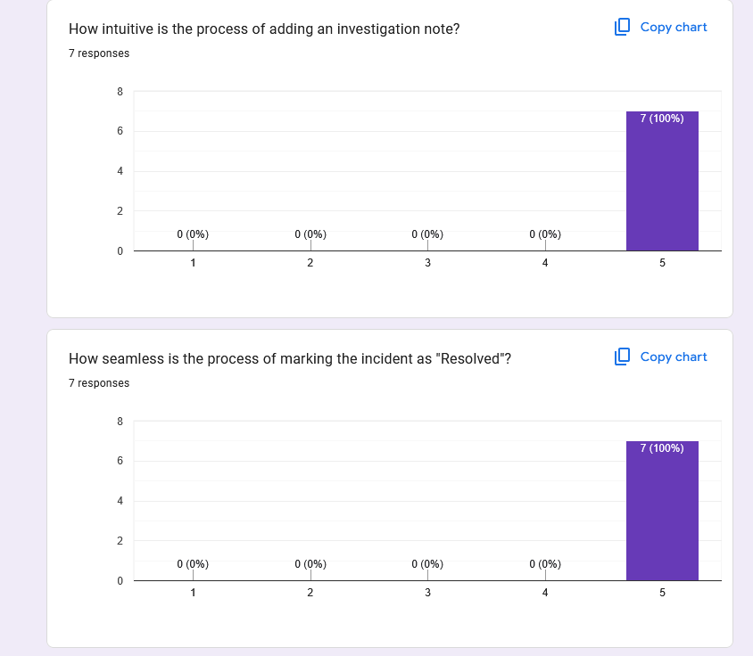
[Figure 19: Completed UAT Section 5, Q3+4.]
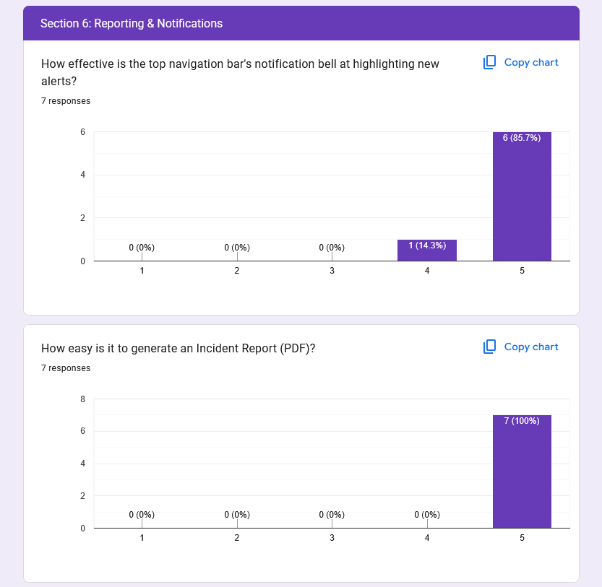
[Figure 20: Completed UAT Section 6, Q1+2.]
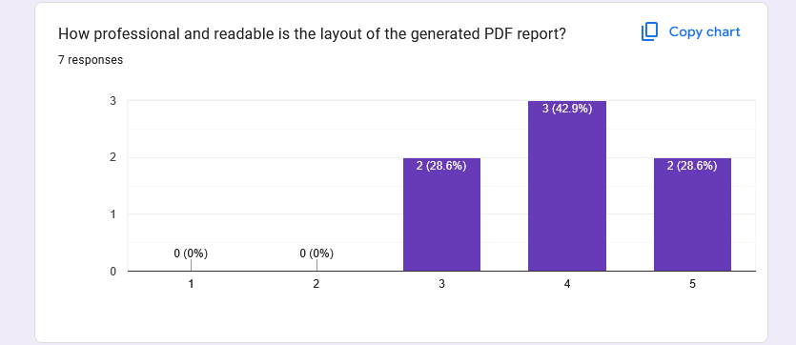
[Figure 21: Completed UAT Section 6, Q3.]
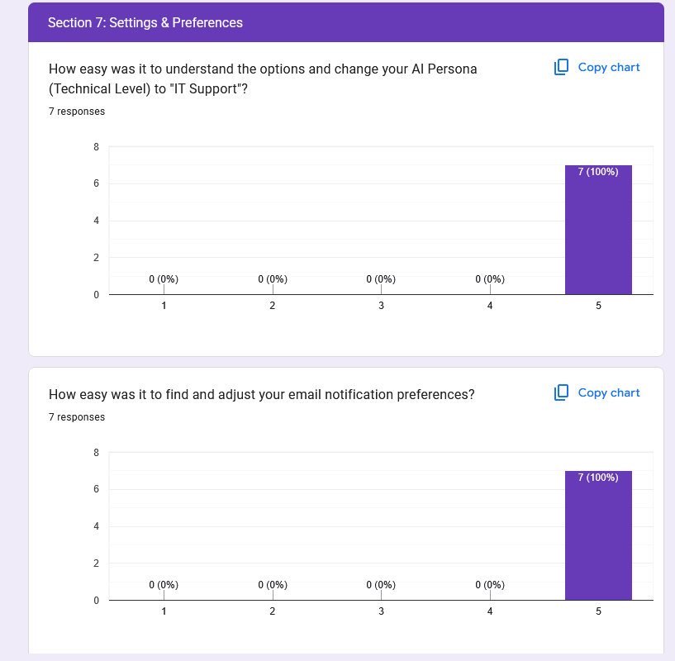
[Figure 22: Completed UAT Section 7, Q1+2.]
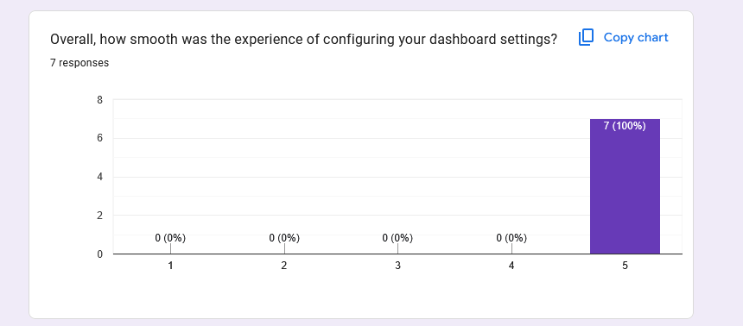
[Figure 23: Completed UAT Section 7, Q3.]
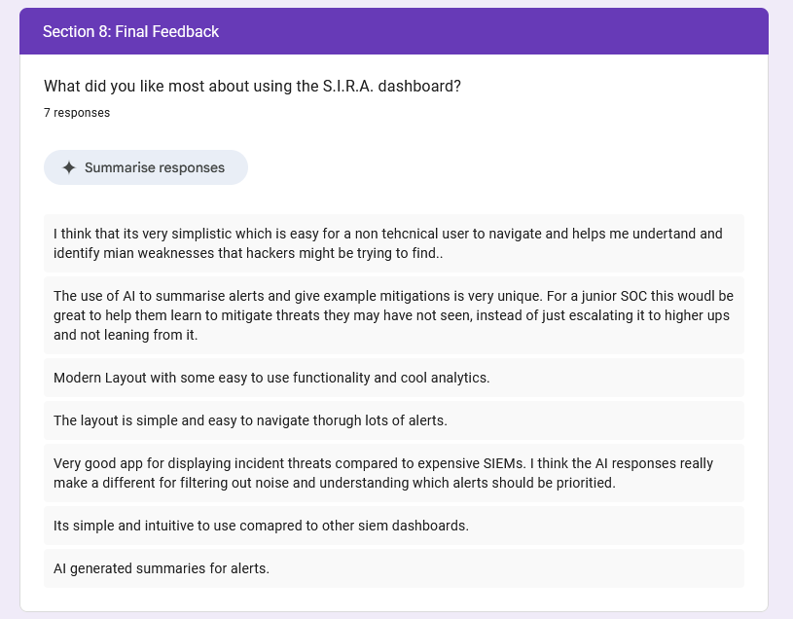
[Figure 24: Completed UAT Section 8, Q1.]
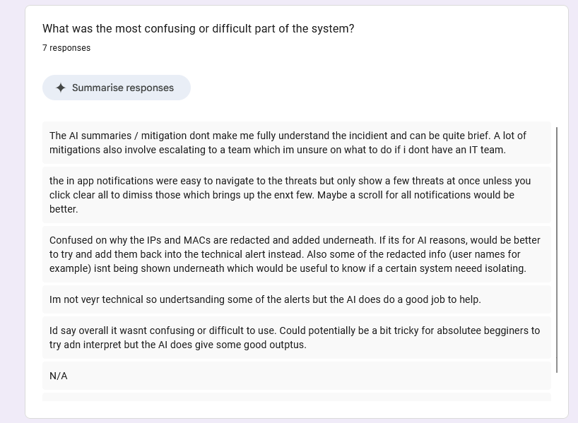
[Figure 25: Completed UAT Section 8, Q2.]
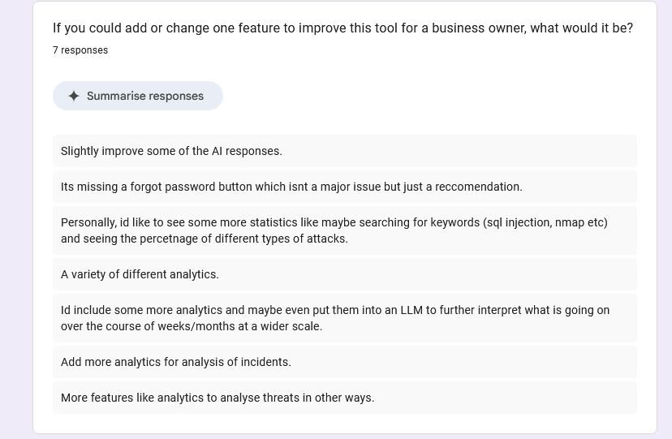
[Figure 25: Completed UAT Section 8, Q3.]

Appendix J: Code Snippets
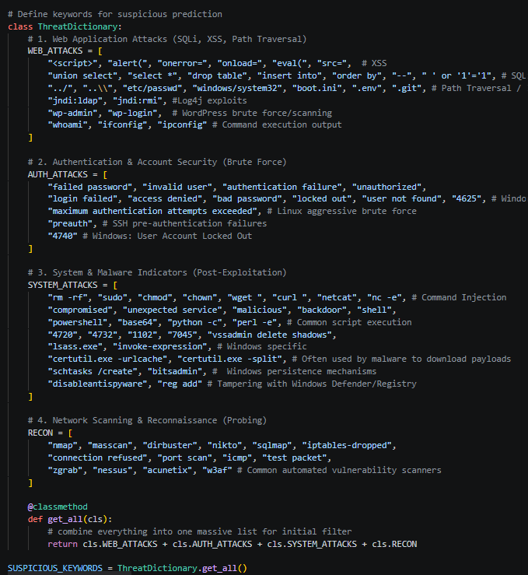
[Figure 1: Code snippet defining the ThreatDictionary, used to categorise and aggregate suspicious keywords for initial log triage.]
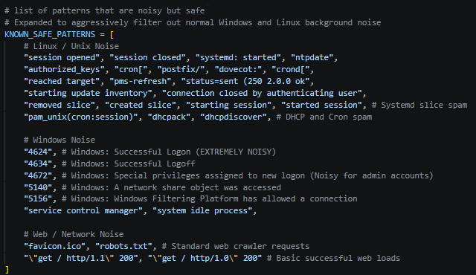
[Figure 2: Code snippet of the KNOWN_SAFE_PATTERNS array, used to filter benign background noise during initial log triage.]
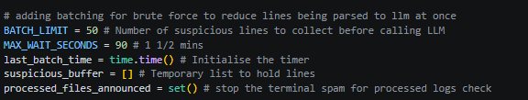
[Figure 3: Code snippet defining the core global variables used to control the LLM batching parameters.]
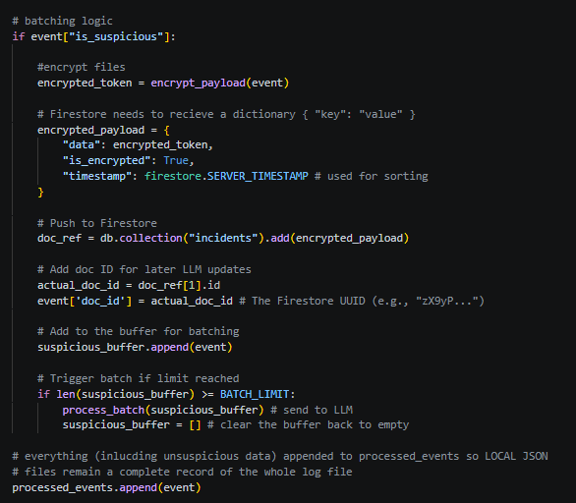
[Figure 4: Implementation of the batching pipeline, detailing how encrypted alerts are buffered locally and batched to optimize external API usage.]
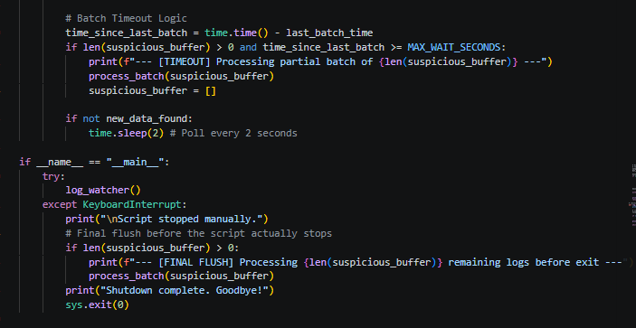
[Figure 5: Code snippet illustrating the batch timeout logic and shutdown sequence.]
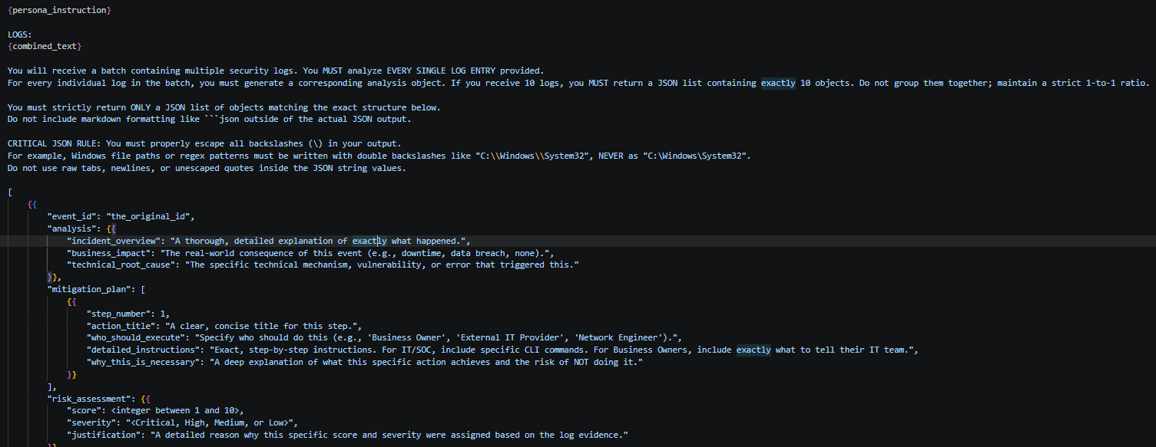
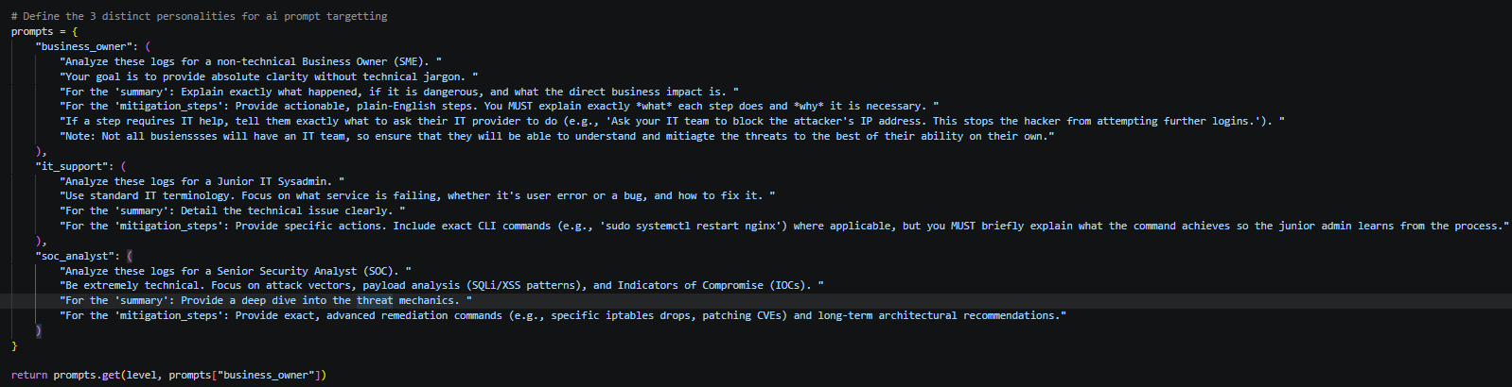
[Figure 6: Code snippet defining the dynamic, role-based AI persona prompts used to tailor LLM responses.]
[Figure 7: Code snippet of the strict system prompt used to enforce structured JSON output from the LLM.]
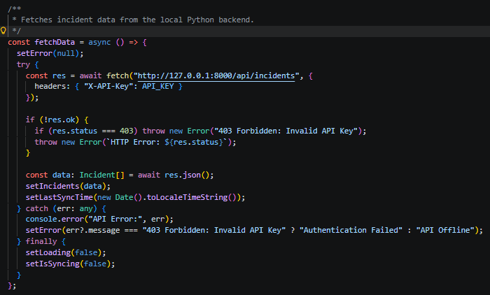
[Figure 8: Implementation of the asynchronous data fetching logic, illustrating the dashboard's integration with the Python backend API.]
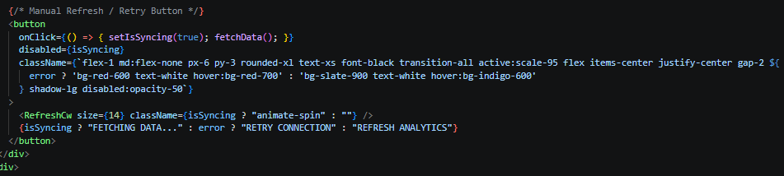
[Figure 9: The manual refresh and synchronization interface, allowing users to forcefully trigger a state update from the backend.]
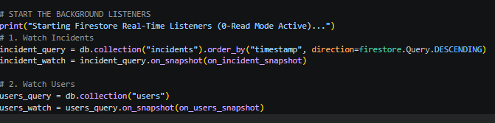
[Figure 10: Code snippet demonstrating the initialization of Firestore on_snapshot listeners to establish a real-time data connection.]
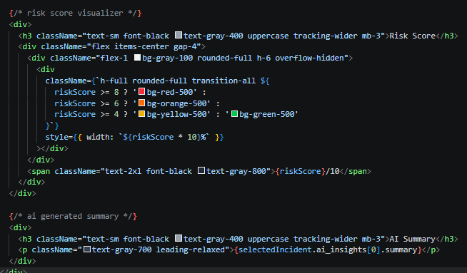
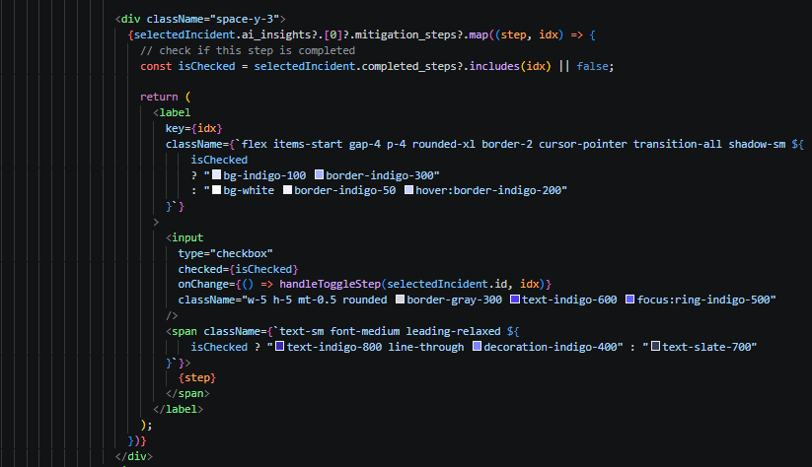
[Figures 11 + 12: React frontend snippets demonstrating the dynamic rendering of the JSON AI insights into the Risk Score and Mitigation Playbook UI components.]
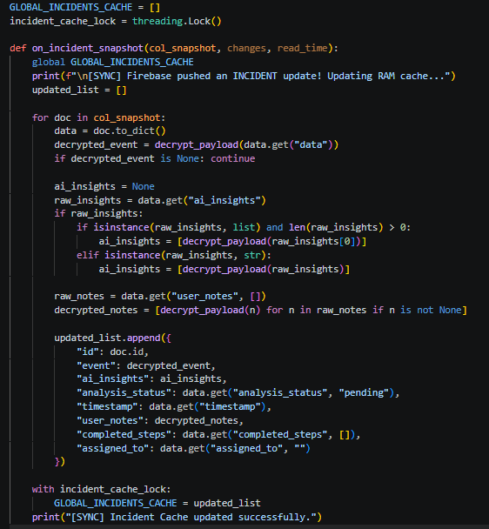
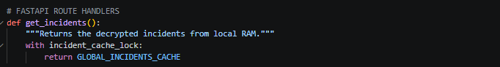
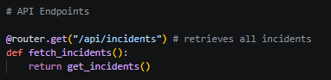
[Figures 13 - 15: Implementation of the API caching layer, demonstrating how the FastAPI backend serves decrypted incident data directly from local memory to eliminate redundant database queries.]


[Figures 16 + 17: Screenshot of multiple prompt refinement evidence via github commits.]
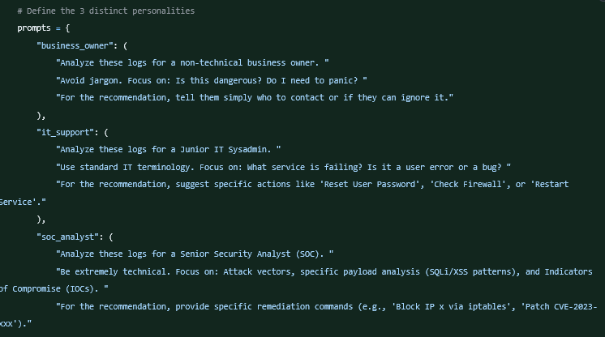
[Figure 18: Screenshot of the original persona prompts before iterative refinement.]

Appendix K: AI Declaration

Solo Work | S1 - Generative AI tools have not been used for this assessment. | ☐
Assisted Work | A1 – Idea Generation and Problem Exploration  Used to generate project ideas, explore different approaches to solving a problem, or suggest features for software or systems. Students must critically assess AI-generated suggestions and ensure their own intellectual contributions are central. | ☐
Assisted Work | A2 - Planning & Structuring Projects  AI may help outline the structure of reports, documentation and projects. The final structure and implementation must be the student’s own work. | ☒
Assisted Work | A3 – Code Architecture  AI tools maybe used to help outline code architecture (e.g. suggesting class hierarchies or module breakdowns). The final code structure must be the student’s own work. | ☒
Assisted Work | A4 – Research Assistance  Used to locate and summarise relevant articles, academic papers, technical documentation, or online resources (e.g. Stack Overflow, GitHub discussions. The interpretation and integration of research into the assignment remain the student’s responsibility. | ☐
Assisted Work | A5 - Language Refinement  Used to check grammar, refine language, improve sentence structure in documentation not code. AI should be used only to provide suggestions for improvement. Students must ensure that the documentation accurately reflects the code and is technically correct. | ☒
Assisted Work | A6 – Code Review  AI tools can be used to check comments within the code and to suggest improvements to code readability, structure or syntax. AI should be used only to provide suggestions for improvement. Students must ensure that the code accurately reflects their knowledge and is technically correct. | ☒
Assisted Work | A7 - Code Generation for Learning Purposes  Used to generate example code snippets to understand syntax, explore alternative implementations, or learn new programming paradigms. Students must not submit AI-generated code as their own and must be able to explain how it works. | ☒
Assisted Work | A8 - Technical Guidance & Debugging Support  AI tools can be used to explain algorithms, programming concepts, or debugging strategies. Students may also help interpret error messages or suggest possible fixes. However, students must write, test, and debug their own code independently and understand all solutions submitted. | ☒
Assisted Work | A9 - Testing and Validation Support  AI may assist in generating test cases, validating outputs, or suggesting edge cases for software testing. Students are responsible for designing comprehensive test plans and interpreting test results. | ☒
Assisted Work | A10 - Data Analysis and Visualization Guidance  AI tools can help suggest ways to analyse datasets or visualize results (e.g. recommending chart types or statistical methods). Students must perform the analysis themselves and understand the implications of the results. | ☐
Assisted Work | A11 - Other uses not listed above  Please specify: | ☐
Partnered Work | P1 - Generative AI tool usage has been used integrally for this assessment  Students can adopt approaches that are compliant with instructions in the assessment brief.  Please Specify: | ☐

Please provide details of AI usage and which elements of the coursework this relates to:
Generative AI was used in an assistive capacity for technical guidance and learning, functioning similarly to a resource like Stack Overflow (A7, A8). I prompted the AI to generate isolated example snippets and high-level pseudocode to help conceptualise my overall code architecture before writing my own implementation (A3). During development, I utilised AI to review my written code for syntax and readability improvements (A6), and to suggest edge cases and validation strategies for my testing phase (A9). Finally, AI assisted in planning and outlining the overall structure of my project report (A2), and was used to refine the grammar and sentence structure of the written documentation (A5). All AI outputs were critically assessed to ensure the final integrated codebase and report remain entirely my own independent work.

I understand that the ownership and responsibility for the academic integrity of this submitted assessment falls with me, the student. | ☒
I confirm that all details provide above are an accurate description of how AI was used for this assessment. | ☒

