moveHMM output from BTGO_moveHMM_v2.R on <https://github.com/mtduggan/bltg-movement>

Output generated on Friday 12.17.20

Authors: Luke Wilde and Matt Duggan

Mbest – following parallel comparison of 25 candidate models with different starting values

Value of the maximum log-likelihood: -33678.91

Step length parameters:

----------------------

|  |  |  |  |
| --- | --- | --- | --- |
|  | **State 1** | **State 2** | **State 3** |
| **Mean (km)** | 0.04054045 | 1.329929 | 57.79852 |
| **sd** | 0.04386793 | 1.973509 | 25.06863 |
| (95% CI)  Lower, mean | 0.039632 | 1.282725 | 55.43059 |
| Lower, sd | 0.042673 | 1.90493 | 23.12876 |
| Upper, mean | 0.041469 | 1.378869 | 60.2676 |
| Upper, sd | 0.045097 | 2.044557 | 27.1712 |

Turning angle parameters:

------------------------

|  |  |  |  |
| --- | --- | --- | --- |
|  | **State 1** | **State 2** | **State 3** |
| **Mean (|radians|)** | 3.0870695 | 2.90637730 | 0.01462354 |
| **sd** | 0.3143937 | 0.07002256 | 4.51946890 |
| Lower, mean | 3.025783 | 2.443763 | -0.03351 |
| Lower, sd | 0.29452 | 0.040376 | 3.840835 |
| Upper, mean | 3.148313 | 3.362236 | 0.063096 |
| Upper, sd | 0.334607 | 0.103518 | 5.200307 |

Regression coeffs for the transition probabilities:

--------------------------------------------------

|  |  |  |  |
| --- | --- | --- | --- |
| State change | Regression coeffs for the transition prob | Beta$lower | Beta$upper |
| 1 – 2 | -1.534995 | -1.5804 | -1.48959 |
| 1 – 3 | -8.282193 | -9.8869 | -6.67748 |
| 2 – 1 | -0.4210039 | -0.48764 | -0.35437 |
| 2 – 3 | -4.97759 | -5.31087 | -4.64431 |
| 3 – 1 | -4.037115 | -5.37046 | -2.70377 |
| 3 – 2 | -2.16808 | -2.5237 | -1.81246 |

Transition probability matrix:

-----------------------------

|  |  |  |  |
| --- | --- | --- | --- |
| Transition probabilities | 1 | 2 | 3 |
| 1 | 0.82256 | 0.177227 | 0.000208 |
| 2 | 0.394635 | 0.601222 | 0.004143 |
| 3 | 0.01559 | 0.101053 | 0.883357 |

Initial distribution:

--------------------

|  |  |  |  |
| --- | --- | --- | --- |
| Initial distribution | 0.2162216 | 0.7428759 | 0.0409025 |

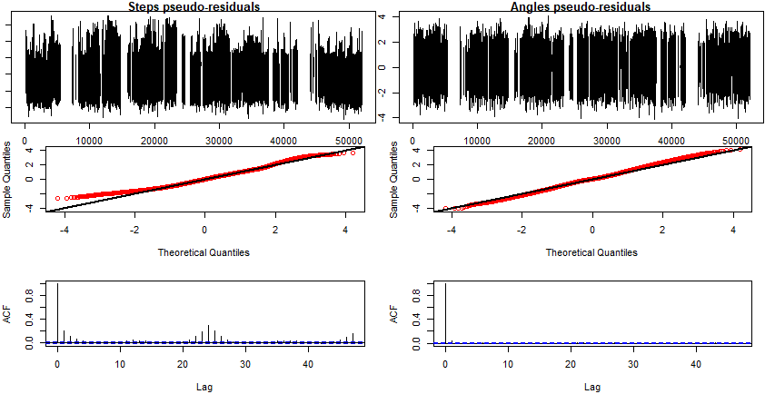Residuals and autocorrelation factor

Step Lengths are in km. This graph is hard to interpret at the current X axis scale so **use the summary above to inform.**

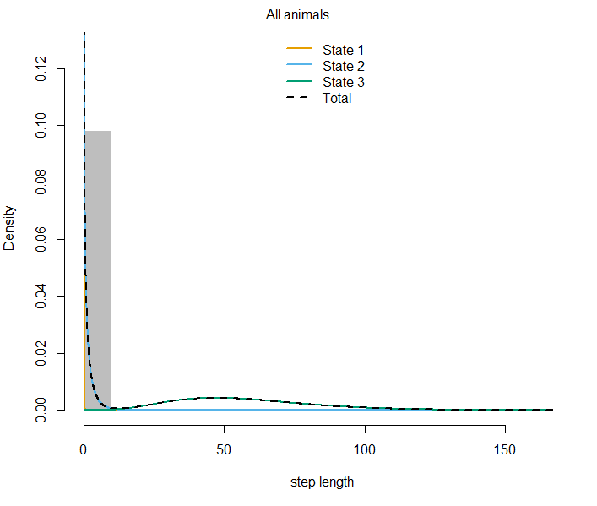

Recall, peak at zero indicates long directed movements, whereas peaks at π or -π indicate circuitous behavior characteristic of foraging or (in our case) chick tending.

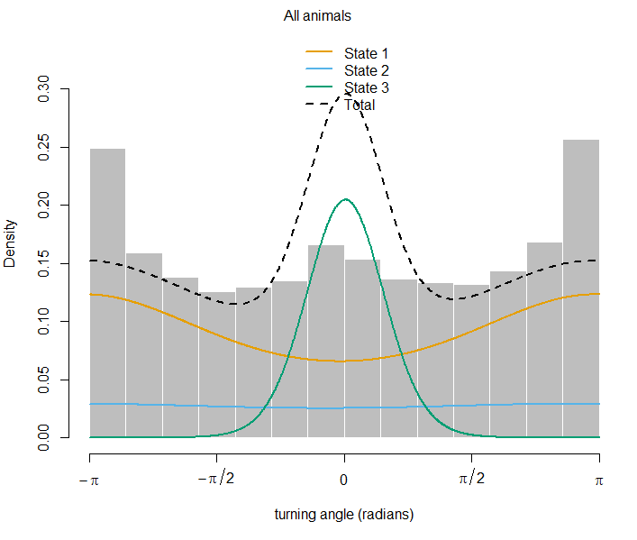

Orange – brood tending or foraging behavior

Blue – local flight behavior

Green – migratory flight behavior

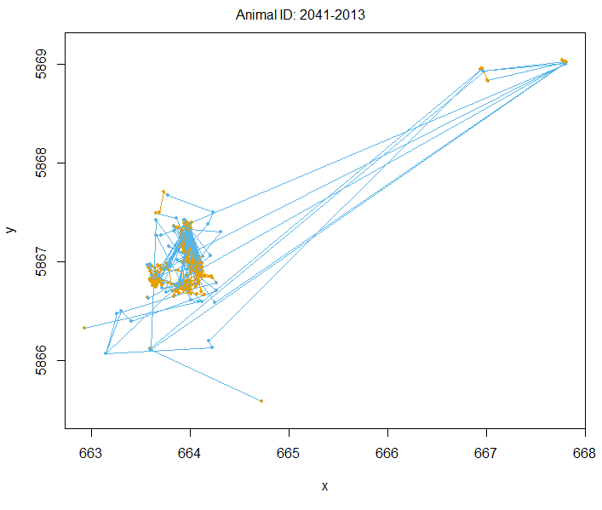

Foraging?

Brooding?

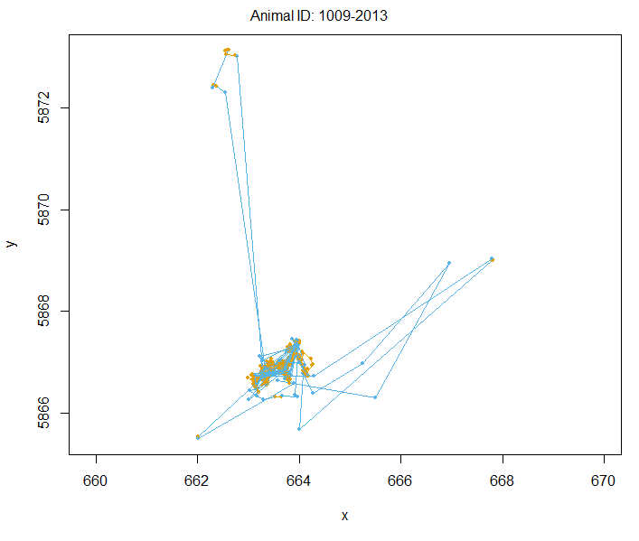

Foraging

Foraging

Brooding