NAME

# Problem 1

Discuss how you determined the reference frequency and all scale / chord frequencies for this project.

To determine the reference frequency, I attempted to use the circle of fifths. I used A, 220 Hz as the first reference. A fifth up from this is E. I multiplied 440 Hz by 3/2 to get the frequency for E. I followed the circle of fifths all the way with this method until I filled out every reference frequency except for Db and Gb. For these two, I started at A and divided by 2/3 until I got to that part of the circle. Db and C# are the same for equal temperament, but for just they are different. That is why I started at A and went in both directions on the circle. Once I had the reference, I used the intervals for the complete scale of just intonation to fill in the rest of the values. I also treated Cb and B to be the same note.

# Problem 4

Insert plots and describe.

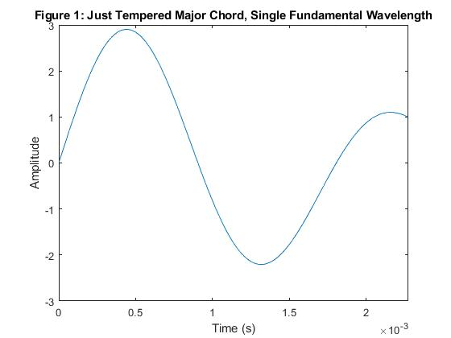

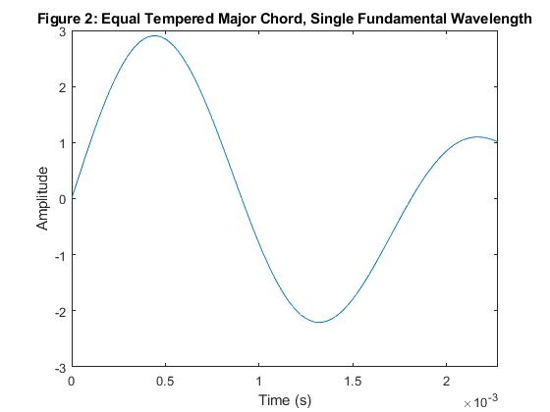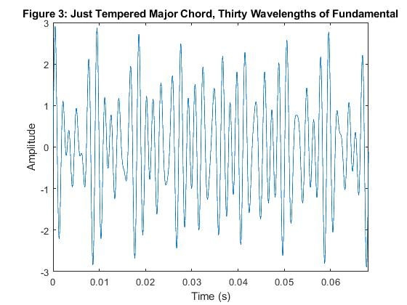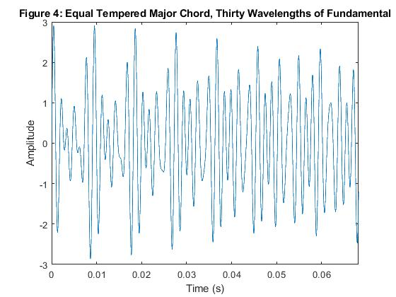

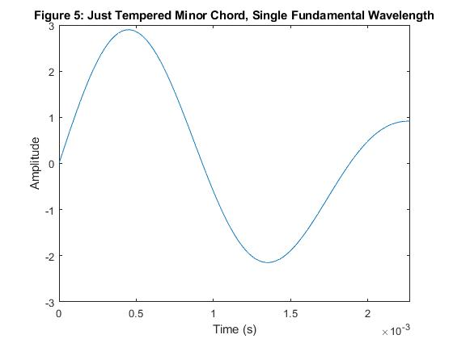

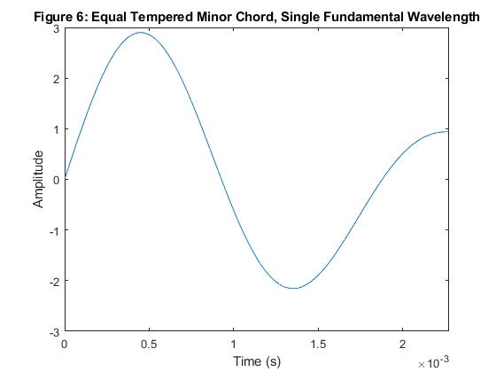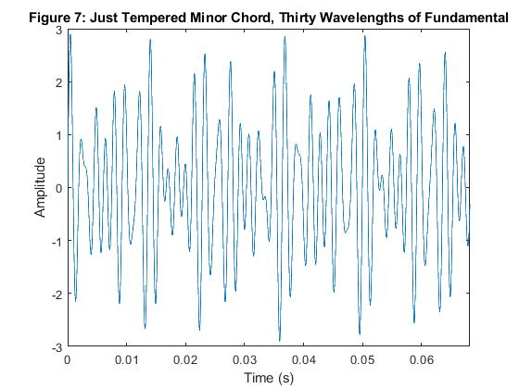

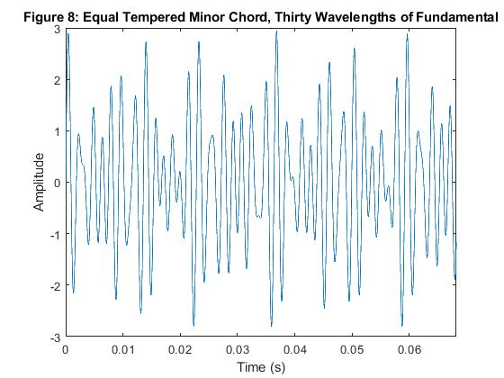

You can see the difference between just and equal tempered over tens of wavelengths of the fundamental, but not over a single wavelength.

# Problem 5

1. Can you hear the difference between the just tempered Major scale and the equal tempered Major scale?

It is very difficult to hear the difference between the two. When just a single note is being played, the difference in frequencies between the two scales is too slight to be able to guess which one I am listening to.

1. Which one sounds better? - Why (explain)

It is hard to say which one sounds better since they are so similar.

1. Can you hear the difference between the just tempered Minor scale and the equal tempered Minor scale?

It is very difficult to hear the difference between the two. When just a single note is being played, the difference in frequencies between the two scale is too slight to say guess for certain which one I am listening to.

1. Which one sounds better? - Why (explain)

It is hard to say which one sounds better since they are so similar.

1. Can you hear the difference between the just tempered Major chord and the equal tempered Major chord?

If you listen carefully, you can hear a beat frequency in the envelope of the equal tempered chord. This is not present for the just tempered chord.

1. Which one sounds better? - Why (explain)

Just tempered sounds more pure without the beat frequency.

1. Can you hear the difference between the just tempered Minor chord and the equal tempered Minor chord?

I was not able to tell the difference in the minor chord. Perhaps the beat frequency is not audible for equal temperament here because the minor chord uses minor third instead of major third interval. You can also see less of an envelope in the equal tempered minor plot.

1. Which one sounds better? - Why (explain)

Neither

# Other Comments