**Töö nr 1**

**Mathias Siimon**

**Ülesanne 1**

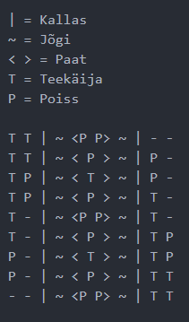

**Ülesanne 2**

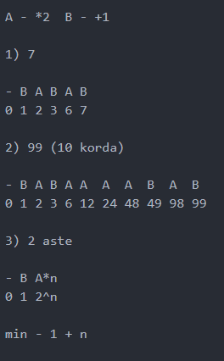

**Ülesanne 3**

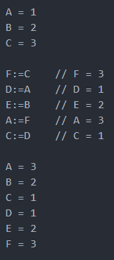

**Ülesanne 4**

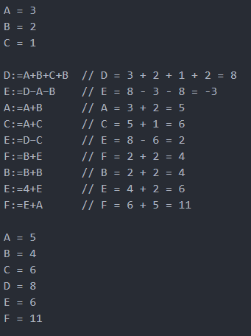

**Ülesanne 5**

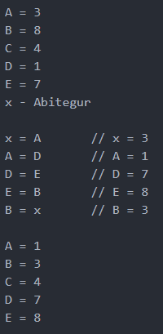

**Ülesanne 6**

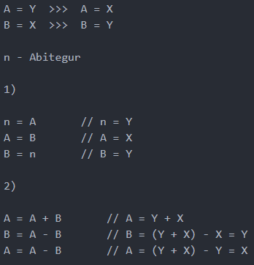

**Ülesanne 7**

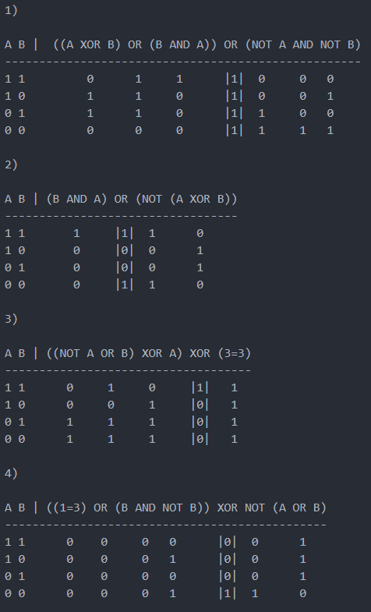

**Ülesanne 8**

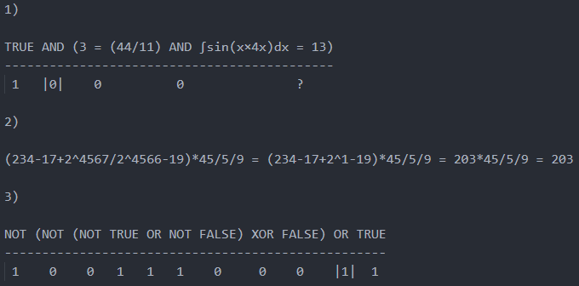

**Toores tekst**

Ülesanne 1:

| = Kallas

~ = Jõgi

< > = Paat

T = Teekäija

P = Poiss

T T | ~ <P P> ~ | - -

T T | ~ < P > ~ | P -

T P | ~ < T > ~ | P -

T P | ~ < P > ~ | T -

T - | ~ <P P> ~ | T -

T - | ~ < P > ~ | T P

P - | ~ < T > ~ | T P

P - | ~ < P > ~ | T T

- - | ~ <P P> ~ | T T

Ülesanne 2:

A - *2 B - +1

1) 7

- B A B A B

0 1 2 3 6 7

2) 99 (10 korda)

- B A B A A A A B A B

0 1 2 3 6 12 24 48 49 98 99

3) 2 aste

- B A*n

0 1 2^n

min - 1 + n

Ülesanne 3:

A = 1

B = 2

C = 3

F:=C // F = 3

D:=A // D = 1

E:=B // E = 2

A:=F // A = 3

C:=D // C = 1

A = 3

B = 2

C = 1

D = 1

E = 2

F = 3

Ülesanne 4:

A = 3

B = 2

C = 1

D:=A+B+C+B // D = 3 + 2 + 1 + 2 = 8

E:=D−A−B // E = 8 - 3 - 8 = -3

A:=A+B // A = 3 + 2 = 5

C:=A+C // C = 5 + 1 = 6

E:=D−C // E = 8 - 6 = 2

F:=B+E // F = 2 + 2 = 4

B:=B+B // B = 2 + 2 = 4

E:=4+E // E = 4 + 2 = 6

F:=E+A // F = 6 + 5 = 11

A = 5

B = 4

C = 6

D = 8

E = 6

F = 11

Ülesanne 5:

A = 3

B = 8

C = 4

D = 1

E = 7

x - Abitegur

x = A // x = 3

A = D // A = 1

D = E // D = 7

E = B // E = 8

B = x // B = 3

A = 1

B = 3

C = 4

D = 7

E = 8

Ülesanne 6:

A = Y >>> A = X

B = X >>> B = Y

n - Abitegur

1)

n = A // n = Y

A = B // A = X

B = n // B = Y

2)

A = A + B // A = Y + X

B = A - B // B = (Y + X) - X = Y

A = A - B // A = (Y + X) - Y = X

Ülesanne 7:

1)

A B | ((A XOR B) OR (B AND A)) OR (NOT A AND NOT B)

----------------------------------------------------

1 1 0 1 1 |1| 0 0 0

1 0 1 1 0 |1| 0 0 1

0 1 1 1 0 |1| 1 0 0

0 0 0 0 0 |1| 1 1 1

2)

A B | (B AND A) OR (NOT (A XOR B))

----------------------------------

1 1 1 |1| 1 0

1 0 0 |0| 0 1

0 1 0 |0| 0 1

0 0 0 |1| 1 0

3)

A B | ((NOT A OR B) XOR A) XOR (3=3)

------------------------------------

1 1 0 1 0 |1| 1

1 0 0 0 1 |0| 1

0 1 1 1 1 |0| 1

0 0 1 1 1 |0| 1

4)

A B | ((1=3) OR (B AND NOT B)) XOR NOT (A OR B)

-----------------------------------------------

1 1 0 0 0 0 |0| 0 1

1 0 0 0 0 1 |0| 0 1

0 1 0 0 0 0 |0| 0 1

0 0 0 0 0 1 |1| 1 0

Ülesanne 8:

1)

TRUE AND (3 = (44/11) AND ∫sin(x×4x)dx = 13)

--------------------------------------------

1 |0| 0 0 ?

2)

(234-17+2^4567/2^4566-19)*45/5/9 = (234-17+2^1-19)*45/5/9 = 203*45/5/9 = 203

3)

NOT (NOT (NOT TRUE OR NOT FALSE) XOR FALSE) OR TRUE

---------------------------------------------------

1 0 0 1 1 1 0 0 0 |1| 1