Wireless magnetic field sensor
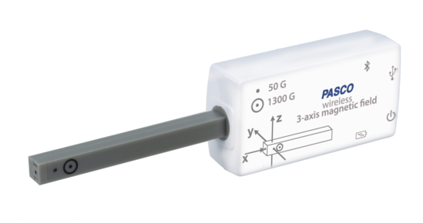
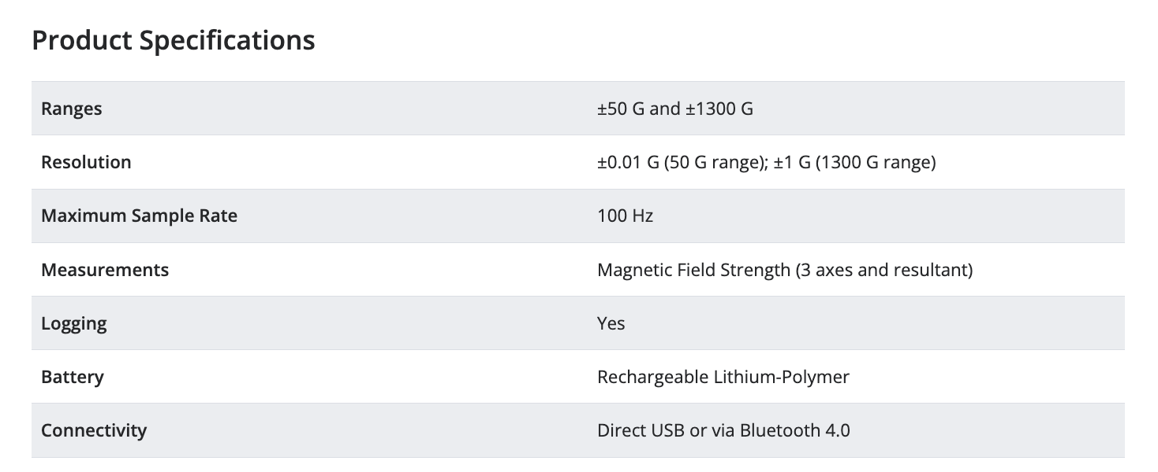

Additional notes
- There are two sensors within the wand, each with a specific range. The locations are identified by markings on the sensor itself.

PASPORT Motion Sensor
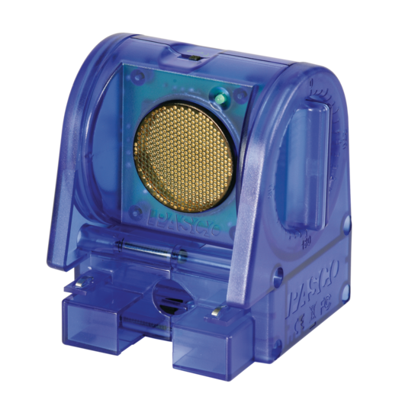
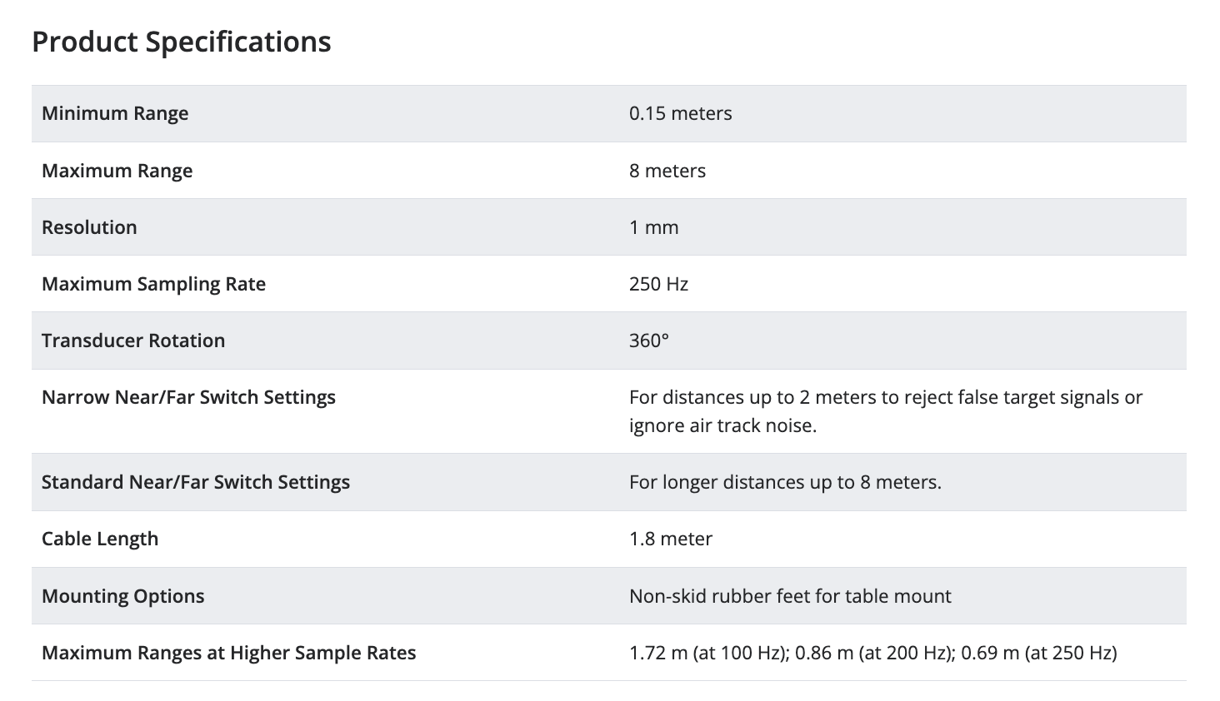
(cart)
(person)

Additional notes
- How this sensor works: “The sensor produces a series of ultrasonic pulses and detects the sound reflected back from the object. The interface then measures the times between outgoing pulses and returning echoes. From these measurements, the sensor determines the object’s position…” (Motion Sensor Manual). Then Capstone calculates the velocity and acceleration from those position measurements.
- Tip: The ultrasonic pulses are emitted from the gold circle, so be sure the sensor is aligned with the motion of the object being tracked.
- Troubleshooting tip: If you think the sensor is acting up, set up a position vs. time display, start data collection, and move your hand back and forth along the sightline of the sensor. The information you get from this graph can help you isolate the problem with the data.

Digital multimeter (DMM) – EXTECH MT310
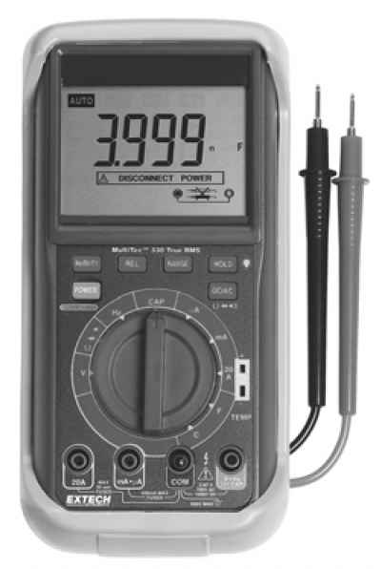

Product specifications
Type of measurement | Range | Accuracy
DC current | 20.00 A | +/- (2% reading + 0.1 A)
Capacitance | 40.00 nF | +/- (2% reading + 0.1 nF)
Capacitance | 400.00 nF | +/- (2% reading + 1 nF)
Resistance | 400.0 Ω | +/- (0.5% reading + 1 Ω)
Resistance | 4.000 kΩ | +/- (0.5% reading + 0.01 kΩ)

Example of uncertainty calculation
You measured the DC current as 0.643 A on the 20.00 A range. The accuracy of this measurement is +/- (2% reading + 0.1 A). Two percent of the reading is 0.01286 A, so the accuracy is +/- (0.01286 A + 0.1 A) = +/- 0.11286 A. When rounded to a single significant figure, this becomes 0.1 A.

Wireless current sensor module
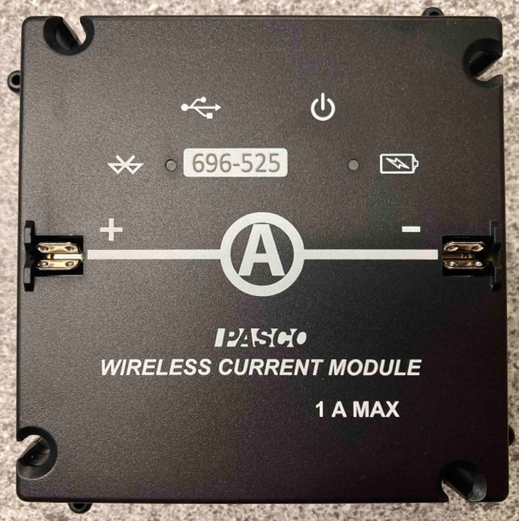
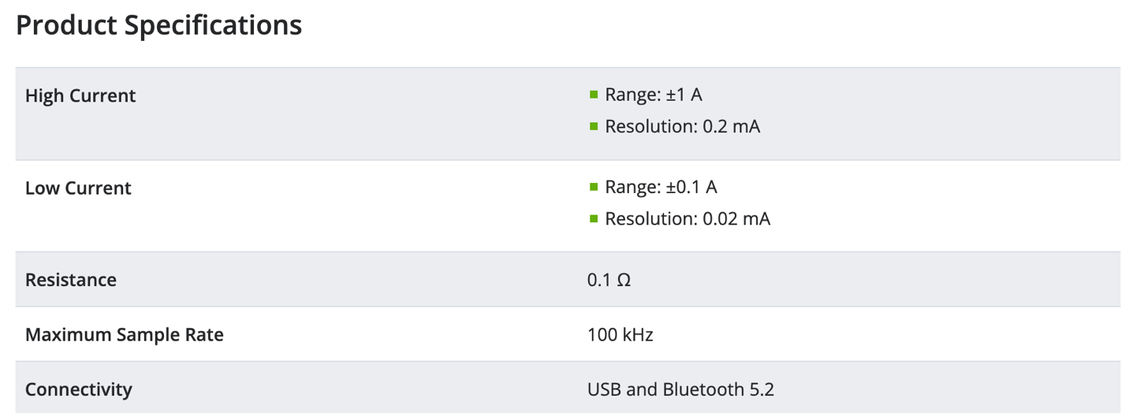

Notes
- We will use the high current range in this course.
- The sensor is in the high current range by default.

Wireless voltage sensor
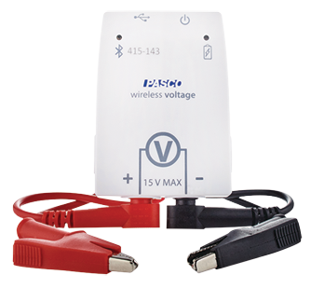
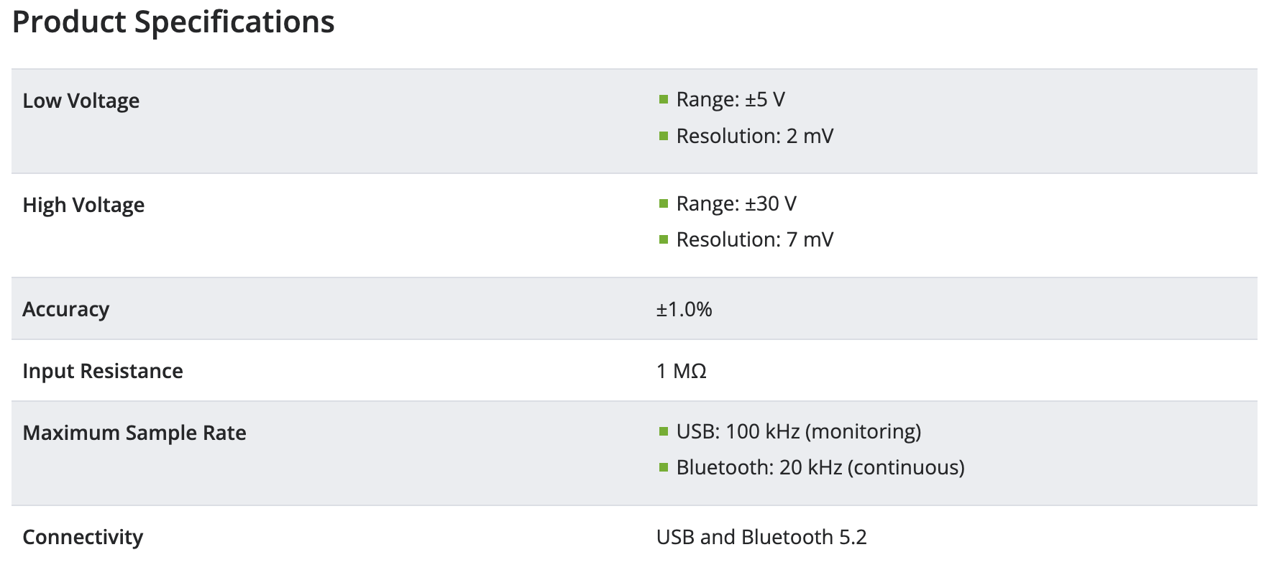

Notes
- We will use the low voltage range in this course.
- The sensor is in the high voltage range by default, so you’ll need to change that as directed in your pre-lab video and lab manual.

