Goal: build a Pokémon-like RPG where characters/creatures from multiple fictional systems can coexist under typing + base stat totals + squad combat, without flattening what makes each universe distinct. Core abstraction: these are not literal historical dates. They are civilizational ages in the fan-adapted world. Each age represents how far humanity has progressed in understanding, institutionalizing, and weaponizing the same underlying energetic physics.
And yes, Matuxy sir, I see the project much more clearly now. The connective tissue is not “which anime scales higher?” It is:
How does a civilization evolve from bodily manipulation of fundamental forces into explicit energy engineering, then personalized metaphysical systems, then modern institutionalized supernatural science?
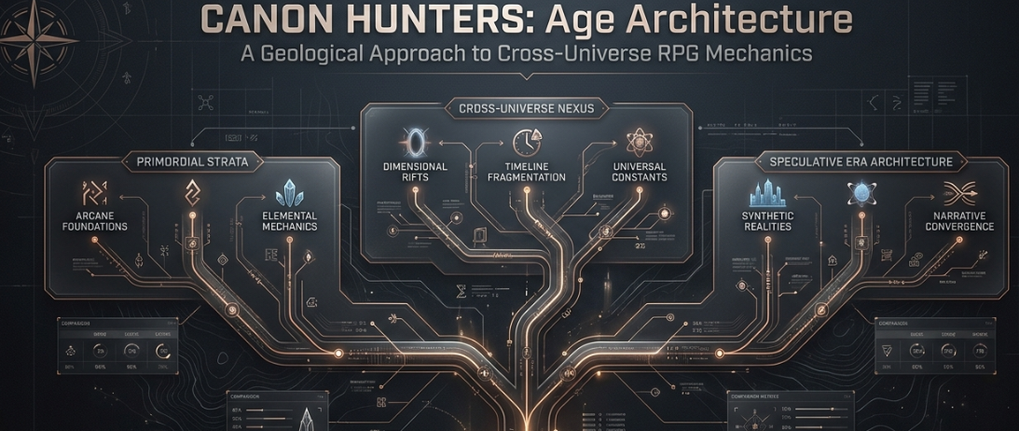
How does a civilization evolve from bodily manipulation of fundamental forces into explicit energy engineering, then personalized metaphysical systems, then modern institutionalized supernatural science?
That is a much stronger worldbuilding spine.

The age stack I think you are converging on
Age | Canon inspirations | Human relationship to power | Civilization / technology | Typical combat ceiling
Age I: Embodied Forces | Avatar + Demon Slayer | Power is learned through breath, posture, movement, environment, lineage | Pre-industrial to early industrial | Humans remain visibly human. Masters are terrifying, but physical limits still matter.
Age I-W: Western Sacred Age | Castlevania + Nocturne | Similar embodied limits, but filtered through ritual, relics, divine contracts, speaker magic, vampirism | Medieval → revolutionary / early industrial Europe analogue | Humans are capped similarly, while monsters bypass the human ceiling through biology, sorcery or contracts
Age II: Chakra Civilization | Naruto → Shippuden | Humanity learns to consciously store, circulate, transform and externalize internal energy | Feudal aesthetics hiding surprisingly sophisticated infrastructure and engineering | Elite humans can become strategic weapons; Muzan-tier stops being an impossible anomaly
Age III: Nen New World | Hunter × Hunter | Energy theory becomes radically individualized; psychology, restrictions and vows shape power | Broadly modern civilization with strange geography and hidden institutions | Human ceiling becomes enormously variable; specialization can beat raw strength
Age IV: Cursed Modernity | Jujutsu Kaisen | The metaphysics of emotion, identity and cognition become weaponized; technique systems are effectively formalized supernatural engineering | Modern world | Domains, binding vows, RCT, inherited techniques and special grades create extremely optimized combatants
Beyond the Map: Dark Continent | HxH Dark Continent / original endgame ecology | Humanity discovers that its entire power taxonomy was provincial | Unknown / nonhuman ecosystems | The world itself starts behaving like an enemy ability
The elegant bit is that Avatar/Demon Slayer → Naruto → HxH → JJK does not need to mean “everyone simply gets stronger.”
It means the resolution of control increases.

Age I: humans discover the body is an interface
This is where your Demon Slayer / Avatar connection becomes extremely valuable.
Breathing and bending are different cultural interpretations of essentially the same primitive discovery:
Body+Breath+Intent+Environment→Force Manipulation\boxed{\text{Body} + \text{Breath} + \text{Intent} + \text{Environment} \rightarrow \text{Force Manipulation}}
An Airbender learns:
movement→air pressure→force\text{movement} \rightarrow \text{air pressure} \rightarrow \text{force}
A Waterbender learns:
movement→water control\text{movement} \rightarrow \text{water control}
A Demon Slayer learns:
breathing→oxygen efficiency→neuromuscular output→combat form\text{breathing} \rightarrow \text{oxygen efficiency} \rightarrow \text{neuromuscular output} \rightarrow \text{combat form}
In your canon adaptation, we can push them one inch closer together.
Breathing styles become internal force shaping.
Bending becomes external force shaping.
That immediately gives us a beautiful shared axis:
Internal manipulation⟷External manipulation\boxed{ \text{Internal manipulation} \longleftrightarrow \text{External manipulation} }
Tanjiro and Tenzin are therefore not practicing unrelated magic systems.
They are scholars from different schools of the same infant science.
🌊 Water Breathing and Waterbending are cousins.
🔥 Flame Breathing and Firebending are cousins.
🌬️ Wind Breathing and Airbending are cousins.
⚡ Thunder Breathing begins touching electromagnetic / nervous-system phenomena.
🌑 Demon Blood Arts reveal that biological modification can produce abilities humans cannot naturally sustain.
And suddenly Muzan matters enormously in your historical development.
He is effectively an early artificial superorganism.
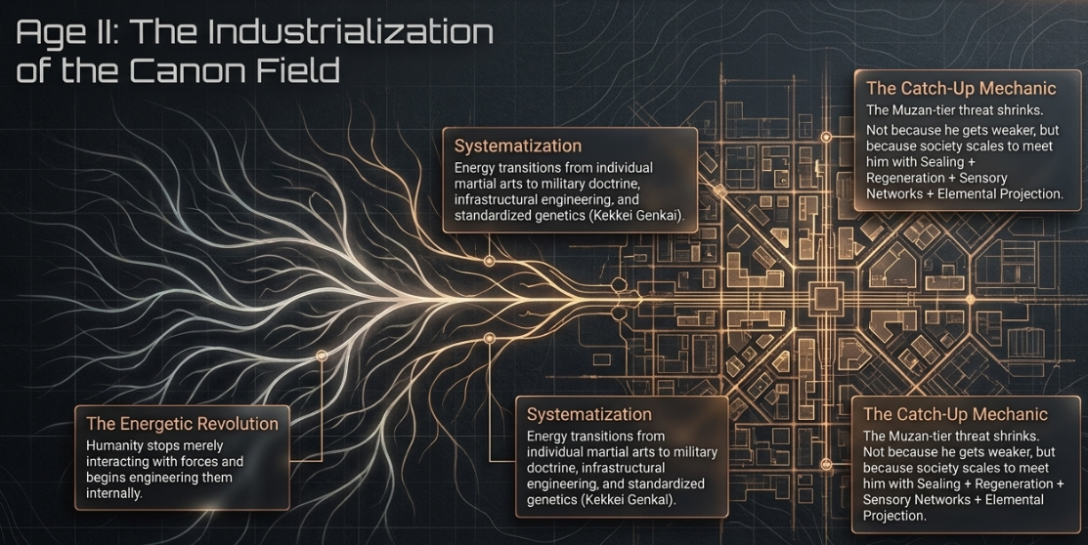

Eastern tradition
Body → breathing → martial form → elemental manipulation

Western tradition
Faith → ritual → relic → spoken magic → alchemy → monster contracts
Yet both civilizations are working with the same deeper physics.
A Belmont whip could therefore be understood as something structurally similar to a Nichirin blade:
special material+ritual encoding+user intent→anti-monster interaction\text{special material} + \text{ritual encoding} + \text{user intent} \rightarrow \text{anti-monster interaction}
Speaker Magic becomes especially interesting because it foreshadows later systems.
A Speaker isn't merely casting a spell.
They're discovering that information can constrain energy.
That becomes hugely important later.
Because:
Speaker incantation\text{Speaker incantation}
eventually evolves conceptually into:
Hand signs→Nen conditions→Binding vows→Domain rules\text{Hand signs} \rightarrow \text{Nen conditions} \rightarrow \text{Binding vows} \rightarrow \text{Domain rules}
That is one continuous technological lineage.

Age II: Naruto is the great energetic revolution
This is where humanity stops simply interacting with supernatural forces and starts engineering them internally.
Chakra is therefore your civilization's equivalent of discovering electricity.
Before chakra science:
“I breathe this way and become stronger.”
After chakra science:
“There is an internal energy network, it can be quantified, circulated, transformed, emitted and encoded.”
That is an enormous conceptual jump.
The chakra pathway system is basically humanity discovering its supernatural nervous system.
So:
Breathing→Chakra circulation\text{Breathing} \rightarrow \text{Chakra circulation} Bending forms→Nature transformation\text{Bending forms} \rightarrow \text{Nature transformation} Speaker incantations→Hand seals\text{Speaker incantations} \rightarrow \text{Hand seals} Nichirin craftsmanship→Chakra tools / seals\text{Nichirin craftsmanship} \rightarrow \text{Chakra tools / seals}
And crucially:
Blood Demon Art→Kekkei Genkai\text{Blood Demon Art} \rightarrow \text{Kekkei Genkai}
Not because they are literally identical, but because civilizations begin categorizing heritable supernatural phenotypes.
This feels like your world's scientific revolution.
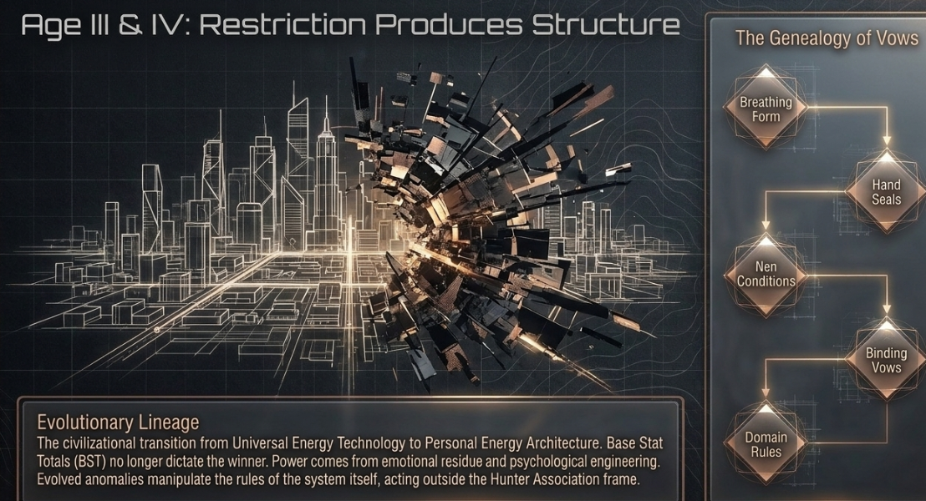

Naruto → Shippuden can itself contain a mini-transition
I wouldn't make Naruto and Shippuden completely separate Ages.
I'd make them:

Age II-A: Chakra States
Villages understand chakra but primarily use it militarily.
Then:

Age II-B: High Chakra Era
By Shippuden, humans are discovering:
- advanced nature transformations
- artificial bodies
- transplantation
- sealing
- summons
- forbidden techniques
- biological augmentation
- resurrection
- sensory networks
- space manipulation
- tailed-beast energy engineering
That is where the old human ceiling truly shatters.
Your statement that the title heroes become Muzan-plus tier fits perfectly.
Drop Muzan into mature Naruto civilization and suddenly people possess:
sealing+regeneration+sensory detection+elemental projection+summons+chakra suppression\text{sealing} + \text{regeneration} + \text{sensory detection} + \text{elemental projection} + \text{summons} + \text{chakra suppression}
His uniqueness shrinks.
Not because Muzan became weaker.
Humanity caught up.
That is a much more satisfying explanation.
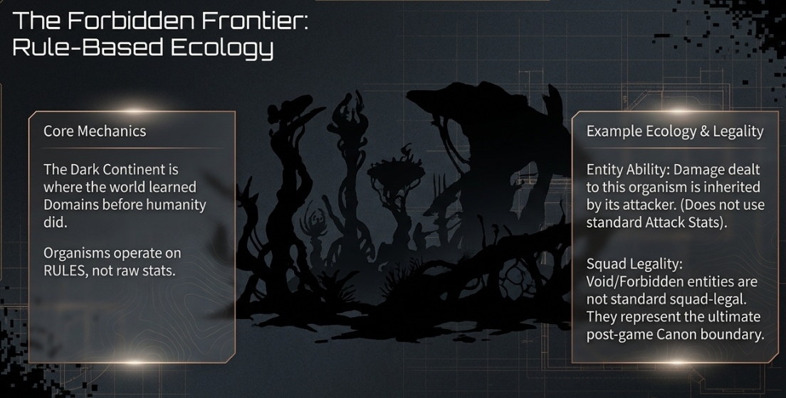

Then civilization burns, fractures or transforms
This is the bridge I think makes your HxH/JJK layer click.
Rather than:
Naruto happens, then HxH randomly exists.
Something enormous happens between these ages.
The massive chakra civilizations collapse, fragment, globalize or genetically diffuse.
Knowledge becomes decentralized.
The result is fascinating.
Humanity loses the universal chakra doctrine, but supernatural capability doesn't disappear.
Instead it becomes individualized.
And thus:

Age III: Nen
Nen is a fundamentally different philosophical civilization.
Chakra asks:
“How do humans manipulate energy?”
Nen asks:
“How does this particular human manipulate energy?”
That shift matters.
Naruto civilizations standardize.
HxH civilization specializes.
A ninja academy teaches everyone:
clone, substitution, transformation\text{clone} ,\; \text{substitution} ,\; \text{transformation}
Nen instead says:
Find your category.
Find your personality.
Find your restrictions.
Build an ability around yourself.
That is an evolutionary transition from:
Universal energy technology\boxed{\text{Universal energy technology}}
to
Personal energy architecture\boxed{\text{Personal energy architecture}}
And Pokémon-style gameplay absolutely loves this.
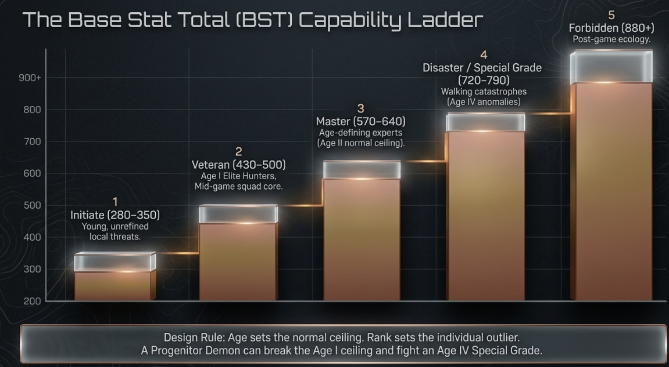

Nen is where your RPG build system explodes open
Because now Base Stat Total stops being the whole equation.
Two characters can both have:
BST=550BST = 550
but distribute it completely differently.
Imagine:
Nobunaga
High:
- Attack
- Speed
- Perception
- Technique
Low:
- Range
- Area Control
versus:
Morel
Moderate:
- Attack
Huge:
- Stamina
- Utility
- Control
- Summoning / field presence
Same approximate combat budget.
Completely different matchup geometry.
That's classic Pokémon design wisdom:
BST determines budget.
Distribution determines identity.
Nen naturally fits this better than almost any anime system.

And Nen Beasts are historically important
This is another connection I think you've implicitly created.
Ancient societies saw supernatural entities as:
- spirits
- demons
- familiars
- curses
- summons
The Nen era begins realizing:
Some entities can be generated by humans themselves.
Guardian Spirit Beasts are almost a bridge technology.
They foreshadow JJK enormously.
Because eventually humanity realizes:
psychological energy→autonomous supernatural organism\text{psychological energy} \rightarrow \text{autonomous supernatural organism}
And then the next civilization discovers the horrifying inverse:
collective human negative emotion→autonomous supernatural organism\text{collective human negative emotion} \rightarrow \text{autonomous supernatural organism}
Welcome to Curses.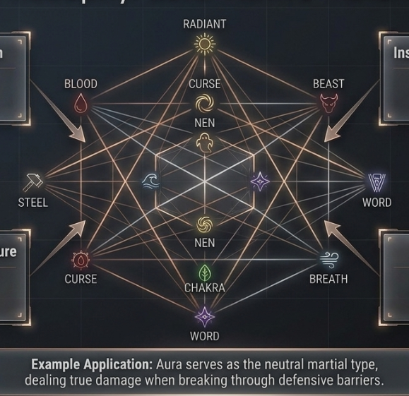

Age IV: Jujutsu Kaisen is not necessarily “stronger HxH”
This distinction will save your game from power-creep sludge.
JJK should be:
a more mature supernatural ecology
rather than simply:
HxH but +100 stats.
Hunter × Hunter feels like humanity has discovered Nen but the world remains gigantic and mysterious.
JJK feels like supernatural phenomena have become a hidden modern infrastructure problem.
You've got:
- schools
- rankings
- bureaucracies
- hereditary techniques
- technique documentation
- barrier theory
- medical specialization
- contracts
- family monopolies
- regulatory leadership
- specialized weapons
- engineered bodies
It's basically supernatural late-stage institutionalization.

Binding vows are the mature descendant of ancient ritual
This genealogy is gorgeous:
Breathing discipline→Ritual→Hand seals→Nen restrictions→Binding vows\boxed{ \text{Breathing discipline} \rightarrow \text{Ritual} \rightarrow \text{Hand seals} \rightarrow \text{Nen restrictions} \rightarrow \text{Binding vows} }
At every stage the same principle becomes more explicit:
Restriction produces structure.
Age I:
“I perform this movement exactly.”
Age II:
“I use these seals.”
Age III:
“My ability only works under these conditions.”
Age IV:
“I formally sacrifice X to increase Y.”
By JJK civilization, people understand supernatural optimization almost like contract law.
Hence Sukuna being terrifying makes sense.
He isn't merely a monster with huge numbers.
He is extraordinarily good at manipulating the rules of the system itself.

Domains are an even bigger evolutionary step
And this connects directly to your earlier thought that the Dark Continent behaves like domain logic promoted into geography.
Early supernatural combat:
I manipulate myself\text{I manipulate myself}
then:
I manipulate energy\text{I manipulate energy}
then:
I create an ability\text{I create an ability}
then:
I manipulate the local rules of reality\boxed{\text{I manipulate the local rules of reality}}
That's Domain Expansion.
And now your final unexplored frontier becomes obvious.

🌑 Dark Continent = the world learns Domains before humanity does
This might become one of the coolest pieces of Canon Hunters lore.
Humans spent millennia learning:
breathing→forces→energy→abilities→rules\text{breathing} \rightarrow \text{forces} \rightarrow \text{energy} \rightarrow \text{abilities} \rightarrow \text{rules}
Then they reach the Dark Continent.
And discover ecosystems whose organisms operate at:
RULES​ 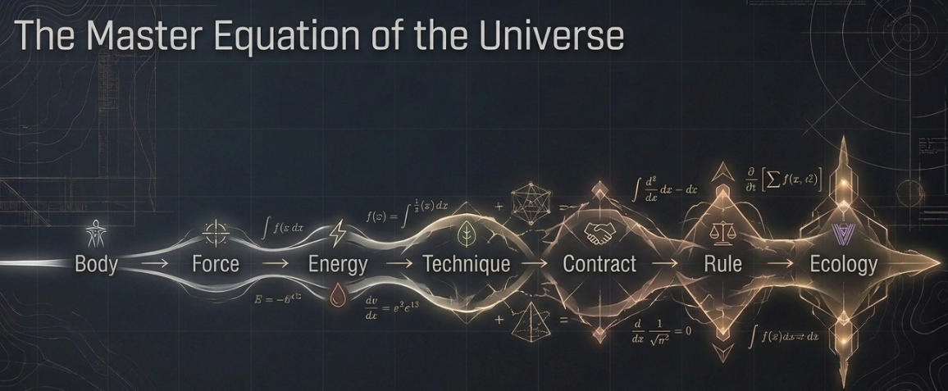

And this gives us the Pokémon typing layer almost automatically
Underneath every franchise power system sits your Fundamental Forces Layer.
Something like:
Fundamental Type+Technique+Energy System+Body+Era\boxed{ \text{Fundamental Type} + \text{Technique} + \text{Energy System} + \text{Body} + \text{Era} }
So a combatant might internally look like:
Tanjiro
Solar / Water
Breathing system
Human
Age I
Sword specialist
while:
Zuko
Fire
Bending system
Human
Age I
Projectile / martial hybrid
and:
Killua
Electric / Nen
Transmuter system
Human
Age III
Speed assassin
and:
Kashimo
Electric / Curse
Cursed-energy system
Human
Age IV
Burst duelist
Same underlying Electric type.
Different civilizations discovered completely different APIs for accessing it.
That solves an enormous cross-franchise design problem.Canon Hunters world equation
Body→Force→Energy→Technique→Contract→Rule→Ecology\boxed{ \textbf{Body} \rightarrow \textbf{Force} \rightarrow \textbf{Energy} \rightarrow \textbf{Technique} \rightarrow \textbf{Contract} \rightarrow \textbf{Rule} \rightarrow \textbf{Ecology} }
That, I think, is the spine we were missing. 🐉

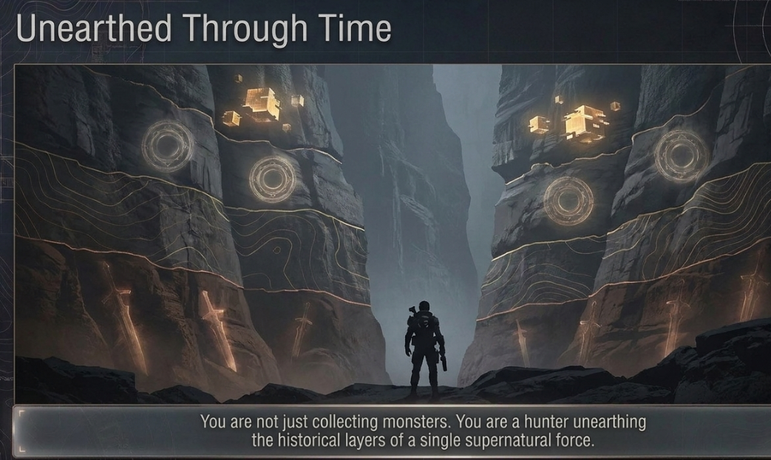

Akaza → Sukuna is a very clean bridge
Not necessarily in the literal sense of:
Akaza physically reincarnates as Ryomen Sukuna.
Although we could absolutely make that a hidden fan-lore possibility.
The deeper connection is that Akaza represents an early prototype of the combat philosophy Sukuna later perfects.
Akaza already revolves around:
combat perception+body optimization+regeneration+battle obsession+adaptive technique\text{combat perception} + \text{body optimization} + \text{regeneration} + \text{battle obsession} + \text{adaptive technique}
Compass Needle is especially useful here.
In our shared-system interpretation, Akaza has discovered something almost proto-domain-like:
The opponent's battle spirit becomes spatial information.
That is a primitive form of information extraction from combat intent.
Then thousands of years later Sukuna represents the fully mature version of this philosophy:
read opponent→understand technique→modify own solution→weaponize system rules\text{read opponent} \rightarrow \text{understand technique} \rightarrow \text{modify own solution} \rightarrow \text{weaponize system rules}
Akaza adapts inside combat.
Sukuna adapts inside the metaphysics governing combat.
So historically:
Akaza→combat sensing→adaptive martial systems→Sukuna\boxed{ \text{Akaza} \rightarrow \text{combat sensing} \rightarrow \text{adaptive martial systems} \rightarrow \text{Sukuna} }
That is a gorgeous evolutionary lineage.
And if we eventually introduce reincarnation as an actual game mechanic, Akaza can be one of the strongest candidates for a spiritual predecessor of Sukuna's archetype.
Not necessarily the same soul.
More interestingly, perhaps the same recurring combat phenotype.

Gojo's old Six Eyes / Ten Shadows story becomes archaeological evidence
This is another major piece.
Gojo tells Megumi that historically, a Six Eyes + Limitless user and a Ten Shadows user fought and both died.
That tells us modern JJK is sitting on top of a much older clan warfare system.
That maps beautifully onto Naruto.
Naruto already gives us:
- Senju
- Uchiha
- Hyūga
- Uzumaki
- Kaguya clan
- Aburame
- Nara
- Yamanaka
- Akimichi
- various Kekkei Genkai lineages
Before the hidden villages, these clans operated much more independently.
So we can make the Great Clan Age the historical ancestor of the JJK clan system.
Not literally:
Uchiha eventually become Zen'in.
That would be too neat.
Instead:
chakra bloodline culture→clan warfare→collapse→surviving hereditary techniques→jujutsu clans\boxed{ \text{chakra bloodline culture} \rightarrow \text{clan warfare} \rightarrow \text{collapse} \rightarrow \text{surviving hereditary techniques} \rightarrow \text{jujutsu clans} }
Now the Gojo, Zen'in and Kamo families make far more historical sense.
They are not the first magical clans.
They are surviving late descendants of a much larger clan civilization.

The Hokage system is the bridge between clan heads and modern institutions
This part gets really interesting.
Early world:
Clan Head\text{Clan Head}
Then Naruto introduces:
Clan Confederation→Village→Kage\text{Clan Confederation} \rightarrow \text{Village} \rightarrow \text{Kage}
The Hokage represents the first major attempt to place an institution above bloodline politics.
Then civilization collapses.
Much later, Jujutsu society reappears with:
Great Families+Higher-Ups+Schools Character reincarnation can become its own hidden axis
Akaza → Sukuna opens this door.
We could eventually have three forms of historical continuity:
Continuity | Meaning
Technique lineage | one combat method evolves into another
Blood lineage | hereditary abilities persist
Soul lineage | character archetypes or literal souls recur

The HUD should now track six historical variables
This is probably our first durable timeline schema:
Ht=[E,K,I,T,B,C]\boxed{ H_t = [ E, K, I, T, B, C ] }
Where:
E = Energy understanding
How well humanity understands supernatural energy.
K = Knowledge preservation
How much previous-era knowledge survives.
I = Institutional complexity
Clans, schools, nations, associations.
T = Technique sophistication
How complicated individual abilities can become.
B = Baseline human ceiling
What an elite ordinary human can accomplish.
C = Catastrophic pressure
Demons, wars, curses, Dark Continent, monsters.
Now every fictional period can be positioned mathematically.
That means when we later balance units, we can distinguish:
historical sophistication≠BST\text{historical sophistication} \neq \text{BST}
which is critical.

