Министерство образования и науки РФ
Санкт-Петербургский политехнический университет Петра Великого
Институт компьютерных наук и кибербезопасности
Высшая школа «Компьютерных технологий и информационных систем»

ОТЧЕТ
по дисциплине «Практикум по программированию»
Лабораторная работа №4

Выполнил:
Cтудент гр. 5130902/40001 Панфёров М.А.

Проверил
Ст. преподаватель А.М. Журавская

Санкт-Петербург
2025 г.

Задание

Создание десктопного приложения. Создание десктопного приложения на Windows Form. Овладение навыком разделение проекта на файлы и его структуризации. Перенос классового проекта на С++ в Windows Form. Портирование консольного приложения в Windows Form. В итоге должен получиться скомпилированный исполняемый файл, например .exe/

Код программы/Листинг программы
Код на языке java, реализовано в нескольких файлах. Был сделан интерфейс для lab3:
Lab41.java:
package com.mycompany.lab41;
import javax.swing.*;
import java.awt.*;
import java.awt.event.ActionEvent;
import java.awt.event.ActionListener;
import java.util.ArrayList;
public class Lab41 extends JFrame{
private JPanel buttonPanel;
private ArrayList<product> prods = new ArrayList<product>();
private guiADD gA = new guiADD();
public Lab41(){
setTitle("Product database manager");
setDefaultCloseOperation(JFrame.EXIT_ON_CLOSE);
setSize(600, 400);
setLocationRelativeTo(null);
buttonPanel = new JPanel();
buttonPanel.setLayout(new GridLayout(3, 1, 10, 10));
buttonPanel.setBorder(BorderFactory.createEmptyBorder(20, 20, 20, 20));
JButton addButton = new JButton("ADD");
JButton listButton = new JButton("LIST");
JButton scanButton = new JButton("SCAN");
addButton.addActionListener(new ActionListener(){
@Override
public void actionPerformed(ActionEvent e){
gA.showAddDia(prods);
}
});
listButton.addActionListener(new ActionListener(){
@Override
public void actionPerformed(ActionEvent e){
guiLIST.showListWindow(prods);
}
});
scanButton.addActionListener(new ActionListener(){
@Override
public void actionPerformed(ActionEvent e){
JOptionPane.showMessageDialog(null,
"Future",
"SCAN",
JOptionPane.INFORMATION_MESSAGE);
}
});
buttonPanel.add(addButton);
buttonPanel.add(listButton);
buttonPanel.add(scanButton);
add(buttonPanel);
}
public static void main(String[] args) {
SwingUtilities.invokeLater(new Runnable() {
@Override
public void run() {
new Lab41().setVisible(true);
}
});
}
}

guiLIST.java:
package com.mycompany.lab41;
import javax.swing.*;
import java.awt.*;
import java.awt.event.ActionEvent;
import java.awt.event.ActionListener;
import java.util.ArrayList;
public class guiLIST {
private ArrayList<product> prods;
private JFrame listFrame;
public guiLIST(ArrayList<product> prods) {
this.prods = prods;
createListWindow();
}
private void createListWindow() {
listFrame = new JFrame("Product List");
listFrame.setDefaultCloseOperation(JFrame.DISPOSE_ON_CLOSE);
listFrame.setSize(700, 500);
listFrame.setLocationRelativeTo(null);
JPanel mainPanel = new JPanel(new BorderLayout());
JLabel titleLabel = new JLabel("Product List Management", JLabel.CENTER);
titleLabel.setFont(new Font("Arial", Font.BOLD, 16));
titleLabel.setBorder(BorderFactory.createEmptyBorder(10, 10, 10, 10));
JTextArea productsArea = new JTextArea();
productsArea.setEditable(false);
productsArea.setFont(new Font("Monospaced", Font.PLAIN, 12));
JScrollPane scrollPane = new JScrollPane(productsArea);
scrollPane.setBorder(BorderFactory.createEmptyBorder(10, 10, 10, 10));
JPanel buttonPanel = new JPanel(new FlowLayout());
JButton searchButton = new JButton("Search");
JButton showAllButton = new JButton("Show All");
JButton editButton = new JButton("Edit Product");
JButton deleteButton = new JButton("Delete Product");
JButton deleteAllButton = new JButton("Delete All");
JButton closeButton = new JButton("Close");
showAllButton.addActionListener(new ActionListener() {
@Override
public void actionPerformed(ActionEvent e) {
showAllProducts(productsArea);
}
});
searchButton.addActionListener(new ActionListener() {
@Override
public void actionPerformed(ActionEvent e) {
guiSEARCH.showSearchWindow(prods);
}
});
editButton.addActionListener(new ActionListener() {
@Override
public void actionPerformed(ActionEvent e) {
guiEDITOR.showEditorWindow(prods);
}
});
deleteButton.addActionListener(new ActionListener() {
@Override
public void actionPerformed(ActionEvent e) {
showDeleteDialog();
}
});
deleteAllButton.addActionListener(new ActionListener() {
@Override
public void actionPerformed(ActionEvent e) {
deleteAllProducts();
}
});
closeButton.addActionListener(new ActionListener() {
@Override
public void actionPerformed(ActionEvent e) {
listFrame.dispose();
}
});
buttonPanel.add(searchButton);
buttonPanel.add(showAllButton);
buttonPanel.add(editButton);
buttonPanel.add(deleteButton);
buttonPanel.add(deleteAllButton);
buttonPanel.add(closeButton);
mainPanel.add(titleLabel, BorderLayout.NORTH);
mainPanel.add(scrollPane, BorderLayout.CENTER);
mainPanel.add(buttonPanel, BorderLayout.SOUTH);
listFrame.add(mainPanel);
showAllProducts(productsArea);
}
private void showAllProducts(JTextArea productsArea) {
if (prods.isEmpty()) {
productsArea.setText("No products available.");
return;
}
StringBuilder sb = new StringBuilder();
sb.append(String.format("%-6s %-20s %-10s %-15s %-15s\n",
"ID", "Name", "Price", "Description", "Consist"));
sb.append("=".repeat(80)).append("\n");
for (product p : prods) {
String desc = (p.description != null && !p.description.isEmpty()) ?
(p.description.length() > 12 ? p.description.substring(0, 12) + "..." : p.description) : "---";
String consist = (p.consist != null && !p.consist.isEmpty()) ?
(p.consist.length() > 12 ? p.consist.substring(0, 12) + "..." : p.consist) : "---";
sb.append(String.format("%-6d %-20s %-10d %-15s %-15s\n",
p.articul,
p.name.length() > 18 ? p.name.substring(0, 18) + "..." : p.name,
p.price,
desc,
consist));
}
productsArea.setText(sb.toString());
}
private void showDeleteDialog() {
if (prods.isEmpty()) {
JOptionPane.showMessageDialog(listFrame,
"No products available for deletion",
"Info",
JOptionPane.INFORMATION_MESSAGE);
return;
}
String idStr = JOptionPane.showInputDialog(listFrame,
"Enter product ID to delete:",
"Delete Product",
JOptionPane.QUESTION_MESSAGE);
if (idStr != null && !idStr.trim().isEmpty()) {
try {
int id = Integer.parseInt(idStr.trim());
product foundProduct = findProductById(id);
if (foundProduct != null) {
deleteProduct(foundProduct);
} else {
JOptionPane.showMessageDialog(listFrame,
"Product with ID " + id + " not found",
"Error",
JOptionPane.ERROR_MESSAGE);
}
} catch (NumberFormatException e) {
JOptionPane.showMessageDialog(listFrame,
"Invalid ID format",
"Error",
JOptionPane.ERROR_MESSAGE);
}
}
}
private void deleteProduct(product productToDelete) {
int confirm = JOptionPane.showConfirmDialog(listFrame,
"Are you want delete product:\n" +
"ID: " + productToDelete.articul + "\n" +
"Name: " + productToDelete.name + "\n\n" +
"Product not return!",
"Confirm Deletion",
JOptionPane.YES_NO_OPTION,
JOptionPane.WARNING_MESSAGE);
if (confirm == JOptionPane.YES_OPTION) {
prods.remove(productToDelete);
JOptionPane.showMessageDialog(listFrame,
"Product deleted",
"Success",
JOptionPane.INFORMATION_MESSAGE);
showAllProducts(getTextAreaFromFrame());
}
}
private void deleteAllProducts() {
if (prods.isEmpty()) {
JOptionPane.showMessageDialog(listFrame,
"The list is empty",
"Info",
JOptionPane.INFORMATION_MESSAGE);
return;
}
int confirm1 = JOptionPane.showConfirmDialog(listFrame,
"Are you sure want delete ALL products?\n" +
"This will remove " + prods.size() + " products!\n\n" +
"This action cannot be undone!",
"",
JOptionPane.YES_NO_OPTION,
JOptionPane.WARNING_MESSAGE);
if (confirm1 == JOptionPane.YES_OPTION) {
int confirm2 = JOptionPane.showConfirmDialog(listFrame,
"Are you SERIOUSLY?\n" +
"All data will delete!\n\n" +
"",
"",
JOptionPane.YES_NO_OPTION,
JOptionPane.ERROR_MESSAGE);
if (confirm2 == JOptionPane.YES_OPTION) {
prods.clear();
JOptionPane.showMessageDialog(listFrame,
"List deleted\nHave a nice day!",
"Success",
JOptionPane.INFORMATION_MESSAGE);
showAllProducts(getTextAreaFromFrame());
}
}
}
private product findProductById(int id) {
for (product p : prods) {
if (p.articul == id) {
return p;
}
}
return null;
}
private JTextArea getTextAreaFromFrame() {
JScrollPane scrollPane = (JScrollPane) ((BorderLayout) listFrame.getContentPane().getLayout())
.getLayoutComponent(BorderLayout.CENTER);
return (JTextArea) scrollPane.getViewport().getView();
}
public void show() {
listFrame.setVisible(true);
}
public static void showListWindow(ArrayList<product> prods) {
SwingUtilities.invokeLater(new Runnable() {
@Override
public void run() {
new guiLIST(prods).show();
}
});
}
}

guiADD.java:
package com.mycompany.lab41;
import javax.swing.*;
import java.awt.*;
import java.util.ArrayList;
public class guiADD {
public static void showAddDia(ArrayList<product> prods) {
JPanel panel = new JPanel(new GridLayout(5, 2, 5, 5));
JTextField idField = new JTextField();
JTextField nameField = new JTextField();
JTextField priceField = new JTextField();
JTextField descField = new JTextField();
JTextField consistField = new JTextField();
int newId = generateSimpleId(prods);
idField.setText(String.valueOf(newId));
idField.setEditable(false);
panel.add(new JLabel("ID*:"));
panel.add(idField);
panel.add(new JLabel("Name*:"));
panel.add(nameField);
panel.add(new JLabel("Price:"));
panel.add(priceField);
panel.add(new JLabel("Description:"));
panel.add(descField);
panel.add(new JLabel("Consist:"));
panel.add(consistField);
int result = JOptionPane.showConfirmDialog(null, panel,
"Add Product", JOptionPane.OK_CANCEL_OPTION, JOptionPane.PLAIN_MESSAGE);
if (result == JOptionPane.OK_OPTION) {
if (nameField.getText().trim().isEmpty()) {
JOptionPane.showMessageDialog(null, "No name", "Error", JOptionPane.ERROR_MESSAGE);
return;
}
int price = 0;
String priceText = priceField.getText().trim();
if (!priceText.isEmpty()) {
try {
price = Integer.parseInt(priceText);
if (price < 0) {
JOptionPane.showMessageDialog(null, "Incorrect input", "Error", JOptionPane.ERROR_MESSAGE);
return;
}
} catch (NumberFormatException e) {
JOptionPane.showMessageDialog(null, "Incorrect input", "Error", JOptionPane.ERROR_MESSAGE);
return;
}
}
product newProduct = new product();
newProduct.setart(newId);
newProduct.setname(nameField.getText().trim());
newProduct.setprice(price);
String description = descField.getText().trim();
if (!description.isEmpty()) {
newProduct.setdesk(description);
}
String consist = consistField.getText().trim();
if (!consist.isEmpty()) {
newProduct.setcons(consist);
}
prods.add(newProduct);
JOptionPane.showMessageDialog(null,
"Product added successfully!\nID: " + newId + "\nName: " + nameField.getText().trim(),
"Success",
JOptionPane.INFORMATION_MESSAGE);
}
}
private static int generateSimpleId(ArrayList<product> prods) {
if (prods.isEmpty()) {
return 1;
}
int maxId = 0;
for (product p : prods) {
if (p.articul > maxId) {
maxId = p.articul;
}
}
return maxId + 1;
}
}

guiEDITOR.java:
package com.mycompany.lab41;
import javax.swing.*;
import java.awt.*;
import java.awt.event.ActionEvent;
import java.awt.event.ActionListener;
import java.util.ArrayList;
public class guiEDITOR {
private ArrayList<product> prods;
private JFrame editorFrame;
private product currentProduct;
private JTextArea productInfoArea;
public guiEDITOR(ArrayList<product> prods) {
this.prods = prods;
createEditorWindow();
}
private void createEditorWindow() {
editorFrame = new JFrame("Product Editor");
editorFrame.setDefaultCloseOperation(JFrame.DISPOSE_ON_CLOSE);
editorFrame.setSize(700, 500);
editorFrame.setLocationRelativeTo(null);
JPanel mainPanel = new JPanel(new BorderLayout());
JLabel titleLabel = new JLabel("Product Editor", JLabel.CENTER);
titleLabel.setFont(new Font("Arial", Font.BOLD, 18));
titleLabel.setBorder(BorderFactory.createEmptyBorder(10, 10, 10, 10));
JPanel searchPanel = new JPanel(new FlowLayout());
searchPanel.setBorder(BorderFactory.createTitledBorder("Find Product to Edit"));
JLabel idLabel = new JLabel("Enter Product ID:");
JTextField idField = new JTextField(10);
JButton findButton = new JButton("Find Product");
JButton clearButton = new JButton("Clear");
searchPanel.add(idLabel);
searchPanel.add(idField);
searchPanel.add(findButton);
searchPanel.add(clearButton);
productInfoArea = new JTextArea(15, 50);
productInfoArea.setEditable(false);
productInfoArea.setFont(new Font("Monospaced", Font.PLAIN, 12));
productInfoArea.setBackground(new Color(250, 250, 250));
JScrollPane infoScrollPane = new JScrollPane(productInfoArea);
infoScrollPane.setBorder(BorderFactory.createTitledBorder("Product Information"));
JPanel editPanel = new JPanel(new GridLayout(2, 3, 10, 10));
editPanel.setBorder(BorderFactory.createTitledBorder("Edit Fields"));
JButton editNameButton = new JButton("Edit Name");
JButton editPriceButton = new JButton("Edit Price");
JButton editDescButton = new JButton("Edit Description");
JButton editConsistButton = new JButton("Edit Consist");
JButton saveAllButton = new JButton("Save All Changes");
JButton closeButton = new JButton("Close Editor");
Font buttonFont = new Font("Arial", Font.PLAIN, 12);
editNameButton.setFont(buttonFont);
editPriceButton.setFont(buttonFont);
editDescButton.setFont(buttonFont);
editConsistButton.setFont(buttonFont);
saveAllButton.setFont(buttonFont);
closeButton.setFont(buttonFont);
findButton.addActionListener(new ActionListener() {
@Override
public void actionPerformed(ActionEvent e) {
findProductById(idField.getText().trim());
}
});
clearButton.addActionListener(new ActionListener() {
@Override
public void actionPerformed(ActionEvent e) {
idField.setText("");
clearProductInfo();
}
});
editNameButton.addActionListener(new ActionListener() {
@Override
public void actionPerformed(ActionEvent e) {
if (currentProduct == null) {
showNoProductSelectedMessage();
return;
}
editName();
}
});
editPriceButton.addActionListener(new ActionListener() {
@Override
public void actionPerformed(ActionEvent e) {
if (currentProduct == null) {
showNoProductSelectedMessage();
return;
}
editPrice();
}
});
editDescButton.addActionListener(new ActionListener() {
@Override
public void actionPerformed(ActionEvent e) {
if (currentProduct == null) {
showNoProductSelectedMessage();
return;
}
editDescription();
}
});
editConsistButton.addActionListener(new ActionListener() {
@Override
public void actionPerformed(ActionEvent e) {
if (currentProduct == null) {
showNoProductSelectedMessage();
return;
}
editConsist();
}
});
saveAllButton.addActionListener(new ActionListener() {
@Override
public void actionPerformed(ActionEvent e) {
if (currentProduct == null) {
showNoProductSelectedMessage();
return;
}
saveAllChanges();
}
});
closeButton.addActionListener(new ActionListener() {
@Override
public void actionPerformed(ActionEvent e) {
editorFrame.dispose();
}
});
editPanel.add(editNameButton);
editPanel.add(editPriceButton);
editPanel.add(editDescButton);
editPanel.add(editConsistButton);
editPanel.add(saveAllButton);
editPanel.add(closeButton);
mainPanel.add(titleLabel, BorderLayout.NORTH);
mainPanel.add(searchPanel, BorderLayout.NORTH);
mainPanel.add(infoScrollPane, BorderLayout.CENTER);
mainPanel.add(editPanel, BorderLayout.SOUTH);
editorFrame.add(mainPanel);
}
private void findProductById(String idStr) {
if (idStr.isEmpty()) {
JOptionPane.showMessageDialog(editorFrame,
"Please enter a product ID",
"Input Required",
JOptionPane.WARNING_MESSAGE);
return;
}
try {
int id = Integer.parseInt(idStr);
currentProduct = null;
for (product p : prods) {
if (p.articul == id) {
currentProduct = p;
break;
}
}
if (currentProduct != null) {
displayProductInfo();
showSuccessMessage("Product found! You can now edit the fields.");
} else {
JOptionPane.showMessageDialog(editorFrame,
"Product with ID " + id + " not found",
"Product Not Found",
JOptionPane.ERROR_MESSAGE);
clearProductInfo();
}
} catch (NumberFormatException e) {
JOptionPane.showMessageDialog(editorFrame,
"Please enter a valid numeric ID",
"Invalid Input",
JOptionPane.ERROR_MESSAGE);
}
}
private void showNoProductSelectedMessage() {
JOptionPane.showMessageDialog(editorFrame,
"Please first find a product to edit!\n\n" +
"1. Enter product ID in the search field\n" +
"2. Click 'Find Product' to load product data\n" +
"3. Then you can edit the fields",
"No Product Selected",
JOptionPane.WARNING_MESSAGE);
}
private void displayProductInfo() {
if (currentProduct == null) return;
StringBuilder sb = new StringBuilder();
sb.append("=== PRODUCT DETAILS ===\n\n");
sb.append(String.format("%-15s: %d\n", "ID", currentProduct.articul));
sb.append(String.format("%-15s: %s\n", "Name", currentProduct.name));
sb.append(String.format("%-15s: %d\n", "Price", currentProduct.price));
sb.append(String.format("%-15s: %s\n", "Description",
currentProduct.description != null ? currentProduct.description : "---"));
sb.append(String.format("%-15s: %s\n", "Consist",
currentProduct.consist != null ? currentProduct.consist : "---"));
sb.append("\n=== EDITING INSTRUCTIONS ===\n");
sb.append("• Click any 'Edit' button to modify that field\n");
sb.append("• Use 'Save All Changes' to confirm all modifications\n");
sb.append("• Empty fields will be set to null\n");
productInfoArea.setText(sb.toString());
}
private void editName() {
String newName = JOptionPane.showInputDialog(editorFrame,
"Enter new product name:",
"Edit Name",
JOptionPane.QUESTION_MESSAGE,
null,
null,
currentProduct.name).toString();
if (newName != null && !newName.trim().isEmpty()) {
currentProduct.setname(newName.trim());
displayProductInfo();
showSuccessMessage("Name updated successfully!");
} else if (newName != null) {
JOptionPane.showMessageDialog(editorFrame,
"Product name cannot be empty",
"Validation Error",
JOptionPane.ERROR_MESSAGE);
}
}
private void editPrice() {
String priceStr = JOptionPane.showInputDialog(editorFrame,
"Enter new price (numbers only):",
"Edit Price",
JOptionPane.QUESTION_MESSAGE,
null,
null,
String.valueOf(currentProduct.price)).toString();
if (priceStr != null && !priceStr.trim().isEmpty()) {
try {
int newPrice = Integer.parseInt(priceStr.trim());
if (newPrice >= 0) {
currentProduct.setprice(newPrice);
displayProductInfo();
showSuccessMessage("Price updated successfully!");
} else {
JOptionPane.showMessageDialog(editorFrame,
"Price cannot be negative",
"Validation Error",
JOptionPane.ERROR_MESSAGE);
}
} catch (NumberFormatException e) {
JOptionPane.showMessageDialog(editorFrame,
"Please enter a valid number for price",
"Invalid Input",
JOptionPane.ERROR_MESSAGE);
}
}
}
private void editDescription() {
JTextArea textArea = new JTextArea(5, 30);
textArea.setText(currentProduct.description != null ? currentProduct.description : "");
textArea.setLineWrap(true);
textArea.setWrapStyleWord(true);
JScrollPane scrollPane = new JScrollPane(textArea);
int result = JOptionPane.showConfirmDialog(editorFrame,
scrollPane,
"Edit Description",
JOptionPane.OK_CANCEL_OPTION,
JOptionPane.PLAIN_MESSAGE);
if (result == JOptionPane.OK_OPTION) {
String newDesc = textArea.getText().trim();
if (newDesc.isEmpty()) {
currentProduct.setdesk(null);
} else {
currentProduct.setdesk(newDesc);
}
displayProductInfo();
showSuccessMessage("Description updated successfully!");
}
}
private void editConsist() {
JTextArea textArea = new JTextArea(5, 30);
textArea.setText(currentProduct.consist != null ? currentProduct.consist : "");
textArea.setLineWrap(true);
textArea.setWrapStyleWord(true);
JScrollPane scrollPane = new JScrollPane(textArea);
int result = JOptionPane.showConfirmDialog(editorFrame,
scrollPane,
"Edit Consist",
JOptionPane.OK_CANCEL_OPTION,
JOptionPane.PLAIN_MESSAGE);
if (result == JOptionPane.OK_OPTION) {
String newConsist = textArea.getText().trim();
if (newConsist.isEmpty()) {
currentProduct.setcons(null);
} else {
currentProduct.setcons(newConsist);
}
displayProductInfo();
showSuccessMessage("Consist updated successfully!");
}
}
private void saveAllChanges() {
int confirm = JOptionPane.showConfirmDialog(editorFrame,
"Save all changes to product?\n\n" +
"ID: " + currentProduct.articul + "\n" +
"Name: " + currentProduct.name + "\n" +
"Price: " + currentProduct.price + "\n" +
"Description: " + (currentProduct.description != null ? currentProduct.description : "---") + "\n" +
"Consist: " + (currentProduct.consist != null ? currentProduct.consist : "---"),
"Confirm Save",
JOptionPane.YES_NO_OPTION,
JOptionPane.QUESTION_MESSAGE);
if (confirm == JOptionPane.YES_OPTION) {
showSuccessMessage("All changes saved successfully!\nProduct has been updated in the database.");
}
}
private void clearProductInfo() {
currentProduct = null;
productInfoArea.setText("");
}
private void showSuccessMessage(String message) {
JOptionPane.showMessageDialog(editorFrame,
message,
"Success",
JOptionPane.INFORMATION_MESSAGE);
}
public void show() {
editorFrame.setVisible(true);
}
public static void showEditorWindow(ArrayList<product> prods) {
SwingUtilities.invokeLater(new Runnable() {
@Override
public void run() {
new guiEDITOR(prods).show();
}
});
}
}

guiSEARCH.java:
package com.mycompany.lab41;
import javax.swing.*;
import java.awt.*;
import java.awt.event.ActionEvent;
import java.awt.event.ActionListener;
import java.util.ArrayList;
public class guiSEARCH {
private ArrayList<product> prods;
private JFrame searchFrame;
private JTextArea resultsArea;
public guiSEARCH(ArrayList<product> prods) {
this.prods = prods;
createSearchWindow();
}
private void createSearchWindow() {
searchFrame = new JFrame("Product Search");
searchFrame.setDefaultCloseOperation(JFrame.DISPOSE_ON_CLOSE);
searchFrame.setSize(800, 600);
searchFrame.setLocationRelativeTo(null);
JPanel mainPanel = new JPanel(new BorderLayout());
JLabel titleLabel = new JLabel("Product Search", JLabel.CENTER);
titleLabel.setFont(new Font("Arial", Font.BOLD, 18));
titleLabel.setBorder(BorderFactory.createEmptyBorder(10, 10, 10, 10));
JPanel searchPanel = new JPanel(new GridLayout(6, 1, 10, 10));
searchPanel.setBorder(BorderFactory.createEmptyBorder(10, 20, 10, 20));
JButton nameSearchButton = new JButton("Search by Name");
JButton idSearchButton = new JButton("Search by ID");
JButton priceSearchButton = new JButton("Show Products with Price");
JButton descSearchButton = new JButton("Search in Description");
JButton consistSearchButton = new JButton("Search in Consist");
JButton closeButton = new JButton("Close");
Font buttonFont = new Font("Arial", Font.PLAIN, 14);
nameSearchButton.setFont(buttonFont);
idSearchButton.setFont(buttonFont);
priceSearchButton.setFont(buttonFont);
descSearchButton.setFont(buttonFont);
consistSearchButton.setFont(buttonFont);
closeButton.setFont(buttonFont);
nameSearchButton.addActionListener(new ActionListener() {
@Override
public void actionPerformed(ActionEvent e) {
searchByName();
}
});
idSearchButton.addActionListener(new ActionListener() {
@Override
public void actionPerformed(ActionEvent e) {
searchById();
}
});
priceSearchButton.addActionListener(new ActionListener() {
@Override
public void actionPerformed(ActionEvent e) {
searchByPrice();
}
});
descSearchButton.addActionListener(new ActionListener() {
@Override
public void actionPerformed(ActionEvent e) {
searchByDescription();
}
});
consistSearchButton.addActionListener(new ActionListener() {
@Override
public void actionPerformed(ActionEvent e) {
searchByConsist();
}
});
closeButton.addActionListener(new ActionListener() {
@Override
public void actionPerformed(ActionEvent e) {
searchFrame.dispose();
}
});
searchPanel.add(nameSearchButton);
searchPanel.add(idSearchButton);
searchPanel.add(priceSearchButton);
searchPanel.add(descSearchButton);
searchPanel.add(consistSearchButton);
searchPanel.add(closeButton);
resultsArea = new JTextArea();
resultsArea.setEditable(false);
resultsArea.setFont(new Font("Monospaced", Font.PLAIN, 12));
resultsArea.setBackground(new Color(240, 240, 240));
JScrollPane resultsScrollPane = new JScrollPane(resultsArea);
resultsScrollPane.setBorder(BorderFactory.createTitledBorder("Search Results"));
resultsScrollPane.setPreferredSize(new Dimension(600, 300));
mainPanel.add(titleLabel, BorderLayout.NORTH);
mainPanel.add(searchPanel, BorderLayout.WEST);
mainPanel.add(resultsScrollPane, BorderLayout.CENTER);
searchFrame.add(mainPanel);
}
private void searchByName() {
if (prods.isEmpty()) {
showNoProductsMessage();
return;
}
String searchTerm = JOptionPane.showInputDialog(searchFrame,
"Enter product name or name fragment:",
"Search by Name",
JOptionPane.QUESTION_MESSAGE);
if (searchTerm != null && !searchTerm.trim().isEmpty()) {
ArrayList<product> results = new ArrayList<>();
for (product p : prods) {
if (p.name.toLowerCase().contains(searchTerm.toLowerCase())) {
results.add(p);
}
}
displaySearchResults(results, "Name search: '" + searchTerm + "'");
}
}
private void searchById() {
if (prods.isEmpty()) {
showNoProductsMessage();
return;
}
String idStr = JOptionPane.showInputDialog(searchFrame,
"Enter product ID:",
"Search by ID",
JOptionPane.QUESTION_MESSAGE);
if (idStr != null && !idStr.trim().isEmpty()) {
try {
int searchId = Integer.parseInt(idStr.trim());
ArrayList<product> results = new ArrayList<>();
for (product p : prods) {
if (p.articul == searchId) {
results.add(p);
break;
}
}
displaySearchResults(results, "ID search: " + searchId);
} catch (NumberFormatException e) {
JOptionPane.showMessageDialog(searchFrame,
"No find",
"Incorrect Input",
JOptionPane.ERROR_MESSAGE);
}
}
}
private void searchByPrice() {
if (prods.isEmpty()) {
showNoProductsMessage();
return;
}
ArrayList<product> results = new ArrayList<>();
for (product p : prods) {
if (p.price != 0) {
results.add(p);
}
}
displaySearchResults(results, "Products with price");
}
private void searchByDescription() {
if (prods.isEmpty()) {
showNoProductsMessage();
return;
}
String searchTerm = JOptionPane.showInputDialog(searchFrame,
"Enter description fragment to search:",
"Search in Description",
JOptionPane.QUESTION_MESSAGE);
if (searchTerm != null && !searchTerm.trim().isEmpty()) {
ArrayList<product> results = new ArrayList<>();
for (product p : prods) {
if (p.description != null && p.description.toLowerCase().contains(searchTerm.toLowerCase())) {
results.add(p);
}
}
displaySearchResults(results, "Description search: '" + searchTerm + "'");
}
}
private void searchByConsist() {
if (prods.isEmpty()) {
showNoProductsMessage();
return;
}
String searchTerm = JOptionPane.showInputDialog(searchFrame,
"Enter consist fragment to search:",
"Search in Consist",
JOptionPane.QUESTION_MESSAGE);
if (searchTerm != null && !searchTerm.trim().isEmpty()) {
ArrayList<product> results = new ArrayList<>();
for (product p : prods) {
if (p.consist != null && p.consist.toLowerCase().contains(searchTerm.toLowerCase())) {
results.add(p);
}
}
displaySearchResults(results, "Consist search: '" + searchTerm + "'");
}
}
private void displaySearchResults(ArrayList<product> results, String searchTitle) {
StringBuilder sb = new StringBuilder();
sb.append("=== ").append(searchTitle).append(" ===\n");
sb.append("Found: ").append(results.size()).append(" product(s)\n\n");
if (results.isEmpty()) {
sb.append("No products\n");
} else {
sb.append(String.format("%-6s %-20s %-10s %-20s %-20s\n",
"ID", "Name", "Price", "Description", "Consist"));
sb.append("=".repeat(90)).append("\n");
for (product p : results) {
String desc = (p.description != null) ?
(p.description.length() > 18 ? p.description.substring(0, 18) + "..." : p.description) : "---";
String consist = (p.description != null) ?
(p.description.length() > 18 ? p.description.substring(0, 18) + "..." : p.description) : "---";
sb.append(String.format("%-6d %-20s %-10d %-20s %-20s\n",
p.articul,
p.name.length() > 18 ? p.name.substring(0, 18) + "..." : p.name,
p.price,
desc,
consist));
}
}
resultsArea.setText(sb.toString());
resultsArea.setCaretPosition(0);
}
private void showNoProductsMessage() {
JOptionPane.showMessageDialog(searchFrame,
"No products available for search",
"Empty list",
JOptionPane.INFORMATION_MESSAGE);
}
public void show() {
searchFrame.setVisible(true);
}
public static void showSearchWindow(ArrayList<product> prods) {
SwingUtilities.invokeLater(new Runnable() {
@Override
public void run() {
new guiSEARCH(prods).show();
}
});
}
}

product.java:
package com.mycompany.lab3;
interface prodset{
void setname(String name); //Название
void setprice(int price); //Стоимость
void setdesk(String description); //Описание
void setcons(String consist); //Состав
void show();
}
public class product implements prodset{
String name=null;
int price=0;
String description=null;
String consist=null;
@Override
public void setname(String nam){
this.name=nam;
}
@Override
public void setprice(int pric){
this.price=pric;
}
@Override
public void setdesk(String des){
this.description = des;
}
@Override
public void setcons(String con){
this.consist=con;
}
@Override
public void show(){
if(name!=null)System.out.println("Name: " + name);
if(price!=0)System.out.println("Price: " + price);
if(description!=null)System.out.println("Description: " + description);
if(consist!=null)System.out.println("Consist: " + consist);
}
}

Ссылка на гитхаб: https://github.com/MatvePan/lab1-java/tree/main/lab3

Диаграмма классов
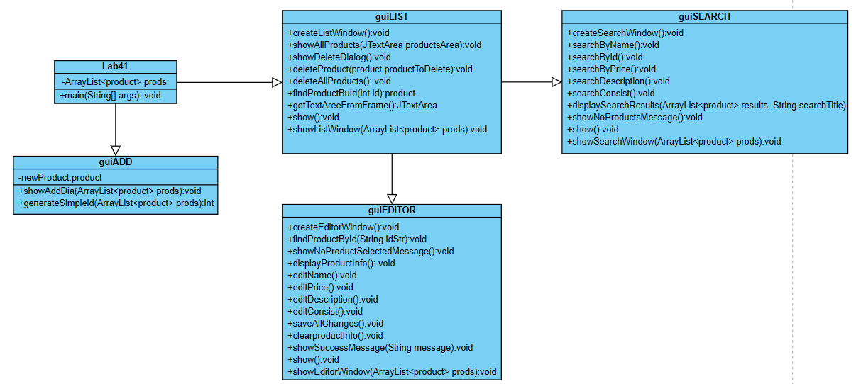
Рис. 1 – Диаграмма классов
Пример работы программы

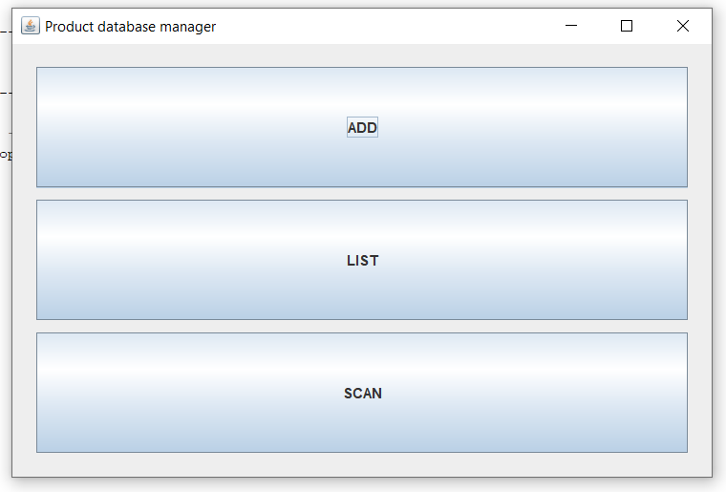
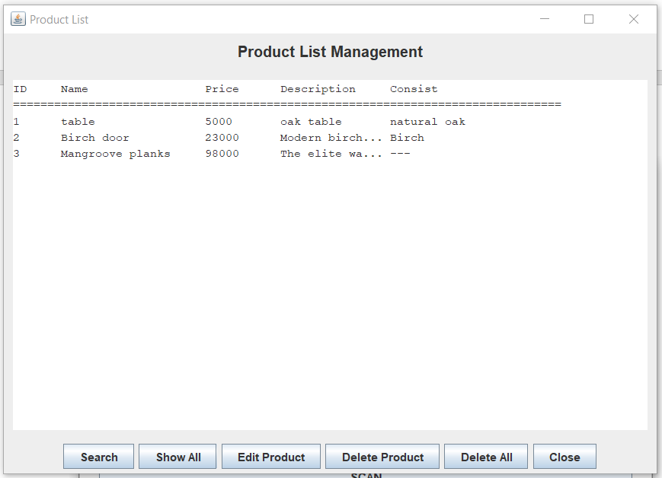
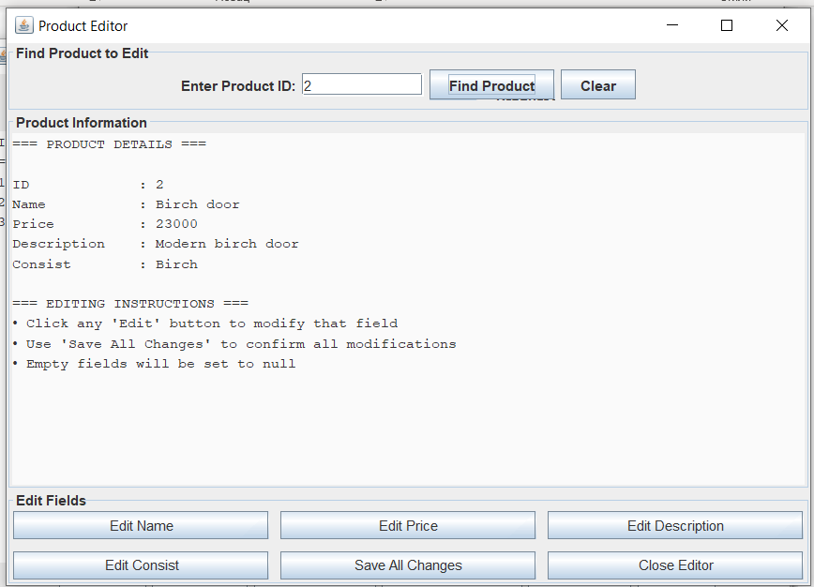
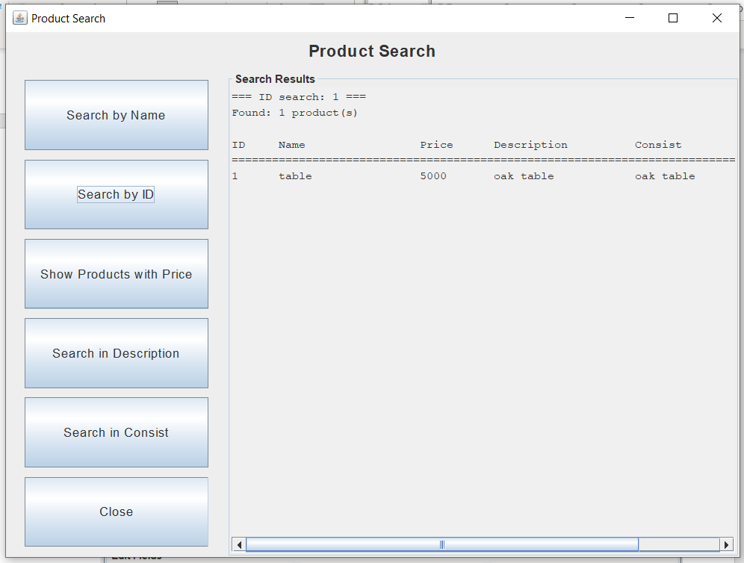
Рисунок 2 – Правильная работа программы

Вывод
Выполнив данную лабораторную работу, был создан графический интерфейс для lab3

