Министерство образования и науки РФ
Санкт-Петербургский политехнический университет Петра Великого
Институт компьютерных наук и кибербезопасности
Высшая школа «Компьютерных технологий и информационных систем»

ОТЧЕТ
по дисциплине «Практикум по программированию»
Лабораторная работа №5

Выполнил:
Cтудент гр. 5130902/40001 Панфёров М.А.

Проверил
Ст. преподаватель А.М. Журавская

Санкт-Петербург
2025 г.

Задание

Создание десктопного приложения. Создание десктопного приложения на Windows Form. Овладение навыком разделение проекта на файлы и его структуризации. Перенос классового проекта на С++ в Windows Form. Портирование консольного приложения в Windows Form. В итоге должен получиться скомпилированный исполняемый файл, например .exe. Работа с базами данных (БД) при создании десктопного приложения.
- Подключить БД к проекту.
- Реализовать возможность сохранение данных из БД в файл по кнопке с использованием OpenFileDialog или аналога.
- Реализовать возможность загрузки данных из файла в БД по кнопке с использованием OpenFileDialog или аналога.
- Данные хранить в таблицах БД.

Код программы/Листинг программы
Код на языке java, реализовано в нескольких файлах. База дынных бола приделана к lab4. Показаны только изменённые и новые элементы кода:
Lab41.java:
package com.mycompany.lab41;
import javax.swing.*;
import java.awt.*;
import java.awt.event.ActionEvent;
import java.awt.event.ActionListener;
import java.util.ArrayList;
public class Lab41 extends JFrame {
private static Lab41 instance;
private ArrayList<product> prods;
private JButton dbButton;
private JLabel statusLabel;
public Lab41() {
instance = this;
prods = new ArrayList<>();
initializeGUI();
autoLoadData();
}
public static Lab41 getInstance() {
return instance;
}
public ArrayList<product> getProducts() {
return prods;
}
public void setProducts(ArrayList<product> products) {
this.prods = products;
updateStatusLabel();
}
private void autoLoadData() {
ArrayList<product> loadedProducts = DBconnector.autoLoadOnStartup();
if (loadedProducts != null && !loadedProducts.isEmpty()) {
prods = loadedProducts;
updateStatusLabel();
SwingUtilities.invokeLater(() -> {
JOptionPane.showMessageDialog(this,
"Database detected!\n" +
"Successfully loaded " + prods.size() + " products from database.\n" +
"Storage: " + DBconnector.getDatabaseInfo(),
"Auto-load Complete",
JOptionPane.INFORMATION_MESSAGE);
});
} else {
prods = new ArrayList<>();
updateStatusLabel();
}
}
private void initializeGUI() {
setTitle("Product Database Manager");
setDefaultCloseOperation(JFrame.EXIT_ON_CLOSE);
setSize(600, 400);
setLocationRelativeTo(null);
setResizable(false);
JPanel mainPanel = new JPanel();
mainPanel.setLayout(new BorderLayout());
mainPanel.setBorder(BorderFactory.createEmptyBorder(10, 10, 10, 10));
JPanel buttonPanel = new JPanel();
buttonPanel.setLayout(new GridLayout(4, 1, 10, 10));
JButton addButton = new JButton("ADD");
JButton listButton = new JButton("LIST");
JButton scanButton = new JButton("SCAN");
dbButton = new JButton("DATABASE");
Font buttonFont = new Font("Arial", Font.PLAIN, 14);
addButton.setFont(buttonFont);
listButton.setFont(buttonFont);
scanButton.setFont(buttonFont);
dbButton.setFont(buttonFont);
addButton.addActionListener(new ActionListener() {
@Override
public void actionPerformed(ActionEvent e) {
if (prods == null) prods = new ArrayList<>();
guiADD.showAddDia(prods);
updateStatusLabel();
}
});
listButton.addActionListener(new ActionListener() {
@Override
public void actionPerformed(ActionEvent e) {
if (prods == null) prods = new ArrayList<>();
guiLIST.showListWindow(prods);
}
});
scanButton.addActionListener(new ActionListener() {
@Override
public void actionPerformed(ActionEvent e) {
JOptionPane.showMessageDialog(Lab41.this,
"Future",
"SCAN",
JOptionPane.INFORMATION_MESSAGE);
}
});
dbButton.addActionListener(new ActionListener() {
@Override
public void actionPerformed(ActionEvent e) {
guiDB.showDatabaseWindow();
}
});
buttonPanel.add(addButton);
buttonPanel.add(listButton);
buttonPanel.add(scanButton);
buttonPanel.add(dbButton);
JPanel statusPanel = new JPanel(new FlowLayout(FlowLayout.LEFT));
statusLabel = new JLabel("Products in memory: 0");
statusPanel.add(statusLabel);
mainPanel.add(buttonPanel, BorderLayout.CENTER);
mainPanel.add(statusPanel, BorderLayout.SOUTH);
add(mainPanel);
updateStatusLabel();
}
private void updateStatusLabel() {
if (statusLabel != null) {
int count = (prods != null) ? prods.size() : 0;
statusLabel.setText("Products in memory: " + count);
}
}
public static void main(String[] args) {
SwingUtilities.invokeLater(new Runnable() {
@Override
public void run() {
try {
new Lab41().setVisible(true);
} catch (Exception e) {
JOptionPane.showMessageDialog(null,
"Error starting application: " + e.getMessage(),
"Startup Error",
JOptionPane.ERROR_MESSAGE);
e.printStackTrace();
}
}
});
}
}
DBconnector.java:
package com.mycompany.lab41;
import java.sql.*;
import java.util.ArrayList;
import java.io.*;
public class DBconnector {
private static boolean driverAvailable = false;
static {
checkDriver();
initializeDatabase();
}
private static void checkDriver() {
try {
Class.forName("org.sqlite.JDBC");
driverAvailable = true;
System.out.println("SQLite driver loaded successfully");
} catch (ClassNotFoundException e) {
driverAvailable = false;
System.out.println("SQLite driver not found, using file storage");
}
}
private static void initializeDatabase() {
if (!driverAvailable) return;
try (Connection conn = getConnection();
Statement stmt = conn.createStatement()) {
String sql = "CREATE TABLE IF NOT EXISTS products (\n" +
" id INTEGER PRIMARY KEY,\n" +
" name TEXT NOT NULL,\n" +
" price INTEGER DEFAULT 0,\n" +
" description TEXT,\n" +
" consist TEXT\n" +
")";
stmt.execute(sql);
System.out.println("Database initialized");
} catch (SQLException e) {
System.err.println("Database error: " + e.getMessage());
}
}
private static Connection getConnection() throws SQLException {
if (!driverAvailable) {
throw new SQLException("Database driver not available");
}
return DriverManager.getConnection("jdbc:sqlite:products.db");
}
public static boolean saveAllProducts(ArrayList<product> products) {
if (products == null || products.isEmpty()) {
System.out.println("Cannot save: product list is empty");
return false;
}
if (!driverAvailable) {
System.out.println("Cannot save: database driver not available");
return saveToFile(products);
}
try (Connection conn = getConnection()) {
conn.setAutoCommit(false);
try (Statement stmt = conn.createStatement()) {
stmt.execute("DELETE FROM products");
}
String sql = "INSERT INTO products(id, name, price, description, consist) VALUES(?,?,?,?,?)";
try (PreparedStatement pstmt = conn.prepareStatement(sql)) {
for (product p : products) {
pstmt.setInt(1, p.articul);
pstmt.setString(2, p.name);
pstmt.setInt(3, p.price);
pstmt.setString(4, p.description);
pstmt.setString(5, p.consist);
pstmt.addBatch();
}
pstmt.executeBatch();
}
conn.commit();
saveToFile(products);
System.out.println("Saved " + products.size() + " products to database");
return true;
} catch (SQLException e) {
System.err.println("Database save error: " + e.getMessage());
return saveToFile(products);
}
}
public static ArrayList<product> loadAllProducts() {
if (!driverAvailable) {
return loadFromFile();
}
ArrayList<product> products = new ArrayList<>();
try (Connection conn = getConnection();
Statement stmt = conn.createStatement();
ResultSet rs = stmt.executeQuery("SELECT * FROM products ORDER BY id")) {
while (rs.next()) {
product p = new product();
p.articul = rs.getInt("id");
p.name = rs.getString("name");
p.price = rs.getInt("price");
p.description = rs.getString("description");
p.consist = rs.getString("consist");
products.add(p);
}
System.out.println("Loaded " + products.size() + " products from database");
} catch (SQLException e) {
System.err.println("Database load error: " + e.getMessage());
products = loadFromFile();
}
return products;
}
public static ArrayList<product> autoLoadOnStartup() {
return loadAllProducts();
}
private static boolean saveToFile(ArrayList<product> products) {
try (ObjectOutputStream oos = new ObjectOutputStream(
new FileOutputStream("products_backup.dat"))) {
oos.writeObject(products);
System.out.println("Saved " + products.size() + " products to file");
return true;
} catch (IOException e) {
System.err.println("File save error: " + e.getMessage());
return false;
}
}
@SuppressWarnings("unchecked")
private static ArrayList<product> loadFromFile() {
File file = new File("products_backup.dat");
if (!file.exists()) {
return new ArrayList<>();
}
try (ObjectInputStream ois = new ObjectInputStream(
new FileInputStream("products_backup.dat"))) {
ArrayList<product> products = (ArrayList<product>) ois.readObject();
System.out.println("Loaded " + products.size() + " products from file");
return products;
} catch (IOException | ClassNotFoundException e) {
System.err.println("File load error: " + e.getMessage());
return new ArrayList<>();
}
}
public static String getDatabaseInfo() {
if (!driverAvailable) {
return "File Storage (products_backup.dat)";
}
return "SQLite Database (products.db)";
}
public static boolean isDatabaseAvailable() {
return driverAvailable;
}
public static int getRecordCount() {
if (!driverAvailable) {
return loadFromFile().size();
}
try (Connection conn = getConnection();
Statement stmt = conn.createStatement();
ResultSet rs = stmt.executeQuery("SELECT COUNT(*) as count FROM products")) {
return rs.next() ? rs.getInt("count") : 0;
} catch (SQLException e) {
System.err.println("Count error: " + e.getMessage());
return 0;
}
}
}

guiDB.java:
package com.mycompany.lab41;
import javax.swing.*;
import java.awt.*;
import java.awt.event.ActionEvent;
import java.awt.event.ActionListener;
import java.io.File;
import java.util.ArrayList;
public class guiDB extends JFrame {
public guiDB() {
createDatabaseWindow();
}
private void createDatabaseWindow() {
setTitle("Database Management");
setDefaultCloseOperation(JFrame.DISPOSE_ON_CLOSE);
setSize(450, 350);
setLocationRelativeTo(null);
setResizable(false);
JPanel mainPanel = new JPanel(new BorderLayout());
mainPanel.setBorder(BorderFactory.createEmptyBorder(20, 20, 20, 20));
JLabel titleLabel = new JLabel("Database manager", JLabel.CENTER);
titleLabel.setFont(new Font("Arial", Font.BOLD, 18));
titleLabel.setBorder(BorderFactory.createEmptyBorder(0, 0, 20, 0));
JPanel infoPanel = new JPanel(new GridLayout(4, 1, 10, 10));
infoPanel.setBorder(BorderFactory.createTitledBorder("Database Status"));
String storageType = DBconnector.isDatabaseAvailable() ?
"SQLite Database" : "File Storage";
JLabel dbTypeLabel = new JLabel("Storage type: " + storageType);
JLabel dbFileLabel = new JLabel("Database file: products.db");
JLabel dbStatusLabel = new JLabel("Records in DB: " + DBconnector.getRecordCount());
Lab41 mainApp = Lab41.getInstance();
int memoryCount = (mainApp != null && mainApp.getProducts() != null) ?
mainApp.getProducts().size() : 0;
JLabel memoryLabel = new JLabel("Products in memory: " + memoryCount);
infoPanel.add(dbTypeLabel);
infoPanel.add(dbFileLabel);
infoPanel.add(dbStatusLabel);
infoPanel.add(memoryLabel);
JPanel buttonPanel = new JPanel(new GridLayout(4, 1, 10, 10));
buttonPanel.setBorder(BorderFactory.createTitledBorder("Operations"));
JButton saveButton = new JButton("Save Current Data to Database");
JButton loadButton = new JButton("Load from Database");
JButton backupButton = new JButton("Create Backup");
JButton deleteButton = new JButton("Delete Database");
Font buttonFont = new Font("Arial", Font.PLAIN, 14);
saveButton.setFont(buttonFont);
loadButton.setFont(buttonFont);
backupButton.setFont(buttonFont);
deleteButton.setFont(buttonFont);
saveButton.addActionListener(new ActionListener() {
@Override
public void actionPerformed(ActionEvent e) {
saveCurrentData();
}
});
loadButton.addActionListener(new ActionListener() {
@Override
public void actionPerformed(ActionEvent e) {
loadFromDatabase();
}
});
backupButton.addActionListener(new ActionListener() {
@Override
public void actionPerformed(ActionEvent e) {
createBackup();
}
});
deleteButton.addActionListener(new ActionListener() {
@Override
public void actionPerformed(ActionEvent e) {
deleteDatabase();
}
});
buttonPanel.add(saveButton);
buttonPanel.add(loadButton);
buttonPanel.add(backupButton);
buttonPanel.add(deleteButton);
JButton closeButton = new JButton("Close");
closeButton.setFont(buttonFont);
closeButton.addActionListener(new ActionListener() {
@Override
public void actionPerformed(ActionEvent e) {
dispose();
}
});
JPanel bottomPanel = new JPanel(new FlowLayout(FlowLayout.RIGHT));
bottomPanel.add(closeButton);
mainPanel.add(titleLabel, BorderLayout.NORTH);
mainPanel.add(infoPanel, BorderLayout.CENTER);
mainPanel.add(buttonPanel, BorderLayout.EAST);
mainPanel.add(bottomPanel, BorderLayout.SOUTH);
add(mainPanel);
}
private void saveCurrentData() {
Lab41 mainApp = Lab41.getInstance();
if (mainApp == null) {
JOptionPane.showMessageDialog(this,
"Main application not found!",
"Error",
JOptionPane.ERROR_MESSAGE);
return;
}
ArrayList<product> currentProducts = mainApp.getProducts();
if (currentProducts == null || currentProducts.isEmpty()) {
JOptionPane.showMessageDialog(this,
"Cannot save: product list is empty!\n" +
"Please add some products first.",
"Empty List",
JOptionPane.WARNING_MESSAGE);
return;
}
int confirm = JOptionPane.showConfirmDialog(this,
"Save " + currentProducts.size() + " products to database?\n" +
"This will overwrite existing data.",
"Confirm Save",
JOptionPane.YES_NO_OPTION,
JOptionPane.QUESTION_MESSAGE);
if (confirm == JOptionPane.YES_OPTION) {
boolean success = DBconnector.saveAllProducts(currentProducts);
if (success) {
JOptionPane.showMessageDialog(this,
"Successfully saved " + currentProducts.size() + " products!",
"Save Complete",
JOptionPane.INFORMATION_MESSAGE);
} else {
JOptionPane.showMessageDialog(this,
"Error saving data!",
"Save Failed",
JOptionPane.ERROR_MESSAGE);
}
}
}
private void loadFromDatabase() {
if (!DBconnector.isDatabaseAvailable()) {
JOptionPane.showMessageDialog(this,
"Database driver not available!\n" +
"Using file storage only.",
"Database Not Available",
JOptionPane.WARNING_MESSAGE);
return;
}
int confirm = JOptionPane.showConfirmDialog(this,
"Load data from database?\n" +
"This will replace current in-memory data.",
"Confirm Load",
JOptionPane.YES_NO_OPTION,
JOptionPane.QUESTION_MESSAGE);
if (confirm == JOptionPane.YES_OPTION) {
ArrayList<product> loadedProducts = DBconnector.loadAllProducts();
if (loadedProducts.isEmpty()) {
JOptionPane.showMessageDialog(this,
"Database is empty!\n" +
"No data loaded.",
"Empty Database",
JOptionPane.INFORMATION_MESSAGE);
return;
}
Lab41 mainApp = Lab41.getInstance();
if (mainApp != null) {
mainApp.setProducts(loadedProducts);
JOptionPane.showMessageDialog(this,
"Successfully loaded " + loadedProducts.size() + " products!",
"Load Complete",
JOptionPane.INFORMATION_MESSAGE);
dispose();
}
}
}
private void createBackup() {
Lab41 mainApp = Lab41.getInstance();
if (mainApp == null || mainApp.getProducts() == null || mainApp.getProducts().isEmpty()) {
JOptionPane.showMessageDialog(this,
"No data to backup!\n" +
"Product list is empty.",
"No Data",
JOptionPane.WARNING_MESSAGE);
return;
}
boolean success = DBconnector.saveAllProducts(mainApp.getProducts());
if (success) {
JOptionPane.showMessageDialog(this,
"Backup created successfully!\n" +
"Data saved to: " + DBconnector.getDatabaseInfo(),
"Backup Complete",
JOptionPane.INFORMATION_MESSAGE);
} else {
JOptionPane.showMessageDialog(this,
"Error creating backup!",
"Backup Failed",
JOptionPane.ERROR_MESSAGE);
}
}
private void deleteDatabase() {
if (!DBconnector.isDatabaseAvailable()) {
JOptionPane.showMessageDialog(this,
"Database not available!",
"No Database",
JOptionPane.WARNING_MESSAGE);
return;
}
int confirm = JOptionPane.showConfirmDialog(this,
"WARNING: This will delete ALL data from database!\n" +
"This action cannot be undone!\n\n" +
"Are you absolutely sure?",
"Confirm Database Deletion",
JOptionPane.YES_NO_OPTION,
JOptionPane.WARNING_MESSAGE);
if (confirm == JOptionPane.YES_OPTION) {
File dbFile = new File("products.db");
if (dbFile.exists() && dbFile.delete()) {
JOptionPane.showMessageDialog(this,
"Database deleted successfully!",
"Deletion Complete",
JOptionPane.INFORMATION_MESSAGE);
} else {
JOptionPane.showMessageDialog(this,
"Error deleting database!",
"Deletion Failed",
JOptionPane.ERROR_MESSAGE);
}
}
}
public static void showDatabaseWindow() {
SwingUtilities.invokeLater(new Runnable() {
@Override
public void run() {
new guiDB().setVisible(true);
}
});
}
}

Ссылка на гитхаб: https://github.com/MatvePan/lab1-java/tree/main/Lab41

Диаграмма классов
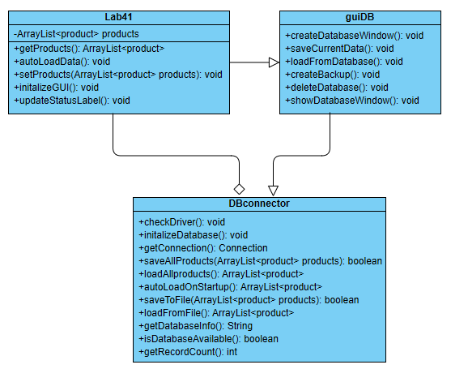
Рис. 1 – Диаграмма классов

Пример работы программы
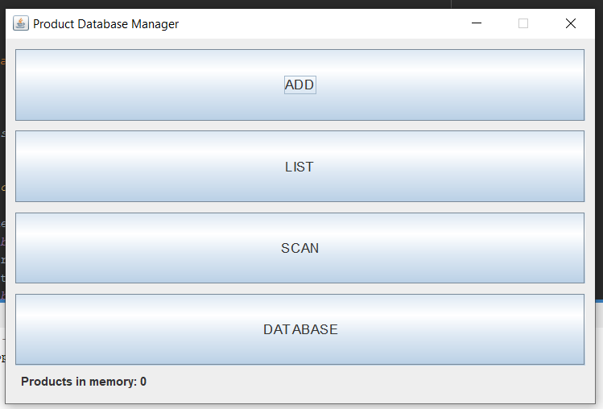
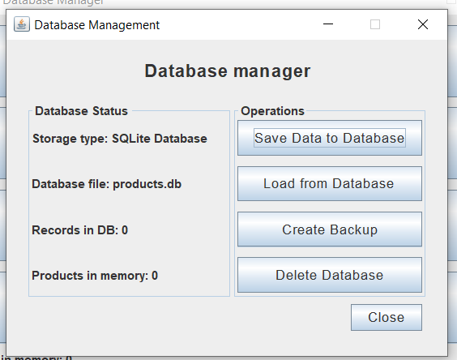
Рисунок 2 и 3 – Правильная работа программы

Вывод
Выполнив данную лабораторную работу, была создана база данных и также программа для взаимодействия с ней.

