MINISTRY OF EDUCATION AND SCIENCE OF UKRAINE

NATIONAL TECHNICAL UNIVERSITY

“KHARKIV POLYTECHNIC INSTITUTE”

DEPARTMENT OF SOFTWARE ENGINEERING AND MANAGEMENT INFORMATION TECHNOLOGIES”

Report of laboratory work № 3

Discipline «Software Engineering»

Executed by: Student of group KN-224a.e.

Antipov M.

Checked by: Associate professor

Melnyk K.V.

Kharkiv

2024

**Theme**: GitHub usage

**Work objective**: Create a repository for the code from previous laboratory work.

**Task**:

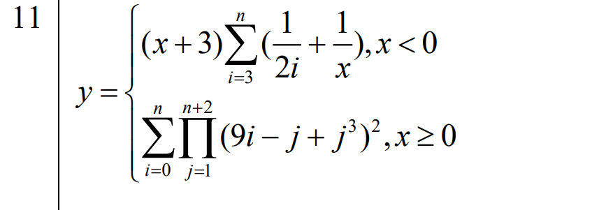

**Progress of work:**

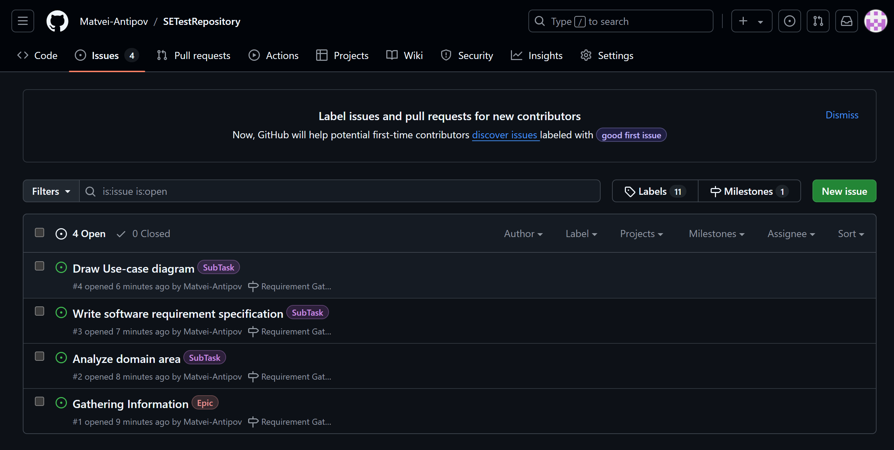

Here we can see issues with lables “Epic” and “SubTask” from “SETestRepository” that contains one milestone that is called “Requirement Gathering” : 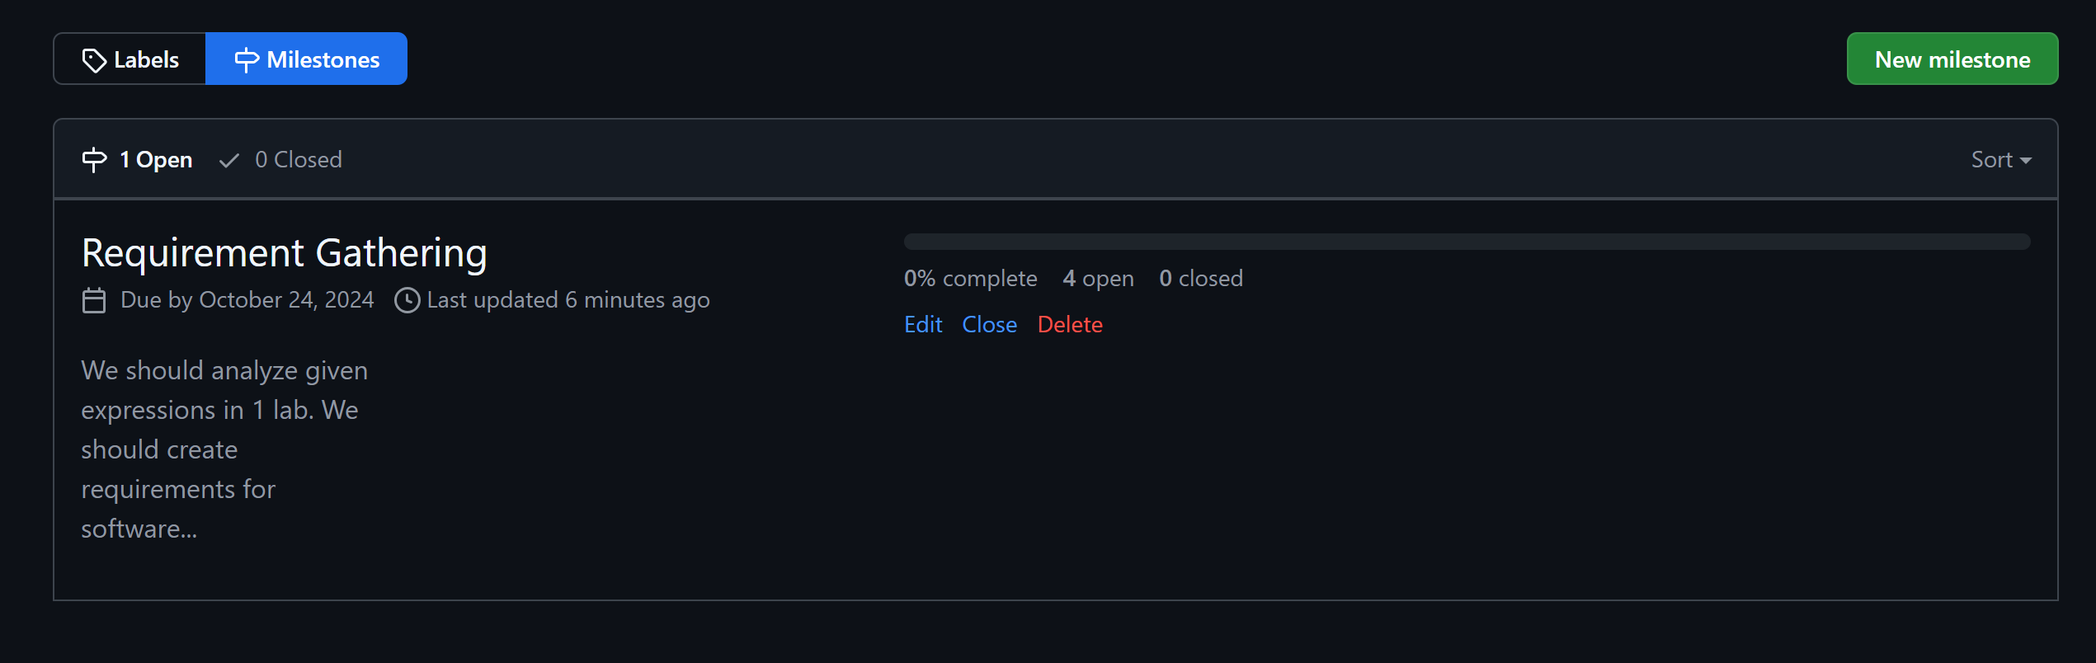

**Theme**: GitHub usage

**Work objective**: Push the source code into main branch

**Progress of work**