Esther Odaibo/ Juan Holmes

Computer Vision Artificial Intelligence ITAI 1378

Professor Patricia McManus

A *neural network*, an artificial intelligence algorithm that mimics the human brain, is not just a theoretical concept. It is the backbone of technologies like image recognition, speech recognition, and natural language processing, making it a crucial part of our digital world (Nielsen, 2019). While a computer operates in binary, a neural network functions through connections between processing elements like neurons, bringing the power of human-like learning to machines (Islam et al., 2019). The major components of a neural network, including neurons, activation functions, layers, weights and biases, optimization algorithms, loss functions, and backpropagation, are the building blocks of these practical applications (EITCA Academy, 2023).

A neuron is the basic unit in the neuronal system (Ma & Tang, 2017). These neurons are interconnected in sharing information and determine the system's strength. As the name suggests, the activation function is where input from the neurons is switched on or set in motion, leading to activation. Activation functions may be described as mathematical equations that determine whether a neuron will be activated. They determine the output from the input received into the neural network (Kolli, 2024). Activation functions apply nonlinearity to the neural network models for an organic feature representation (Banerjee et al., 2019). Standard activation functions include linear, Sigmoid, Tanh, a hyperbolic tangent activation function, and the rectified linear unit (ReLU) activation function.

A neural network comprises multiple layers, including the input, output, hidden, and multiple layers. The adjustable parameters in a neural network are called weights and biases. The weights and biases determine the behavior of a neural network (EITCA Academy, 2023). *Optimization algorithms* are methods used to manipulate the attributes of a neural network, such as weights and biases and the learning rate, to manage and reduce losses (Doshi, 2017). They update the weights and biases of the neural networks based on the error calculated by the loss function (EITCA Academy, 2023). The loss function determines the difference between predicted and actual output.

Backpropagation is one of the most popular neural network algorithms. It helps the neural network learn from mistakes by adjusting internal weights and biases, improving future performance (EITCA Academy, 2023). The initial task performed was to create a neural network with one hidden layer out of a possible option of six hidden layers. The activation function used was Sigmoid. The sigmoid activation function is usually used when predicting the probability of an output (Sharma, 2022). This initial task was for a batch size of 10. The learning rate was 0.03, and the problem type was classification. The task ran through multiple tens of thousands of Epochs, and the training loss was 0.001, followed by a test loss of 0.003. When the learning rate was adjusted to 0.01, there was not a noticeable change in the neural network. The learning rate is a hyperparameter that guides the system on the degree of error adjustment required. When the rate is too minute, it takes longer for the system to decipher and learn, which may result in lagging or a prolonged process. A learning rate that is too large may result in suboptimal weights or unstable training of the process (Brownlee, 2020).

Parameter changes may reflect real-world scenarios in the field of Dosimetry. According to Napolitano, the director of Medical Dosimetry at Mass General Cancer Center in Boston, an auto-contouring Artificial Intelligence program assists medical dosimetrists in delineating human organs at risk (OAR) within an hour as compared to half a day (McCausland, 2024). This is possible through optimal learning rates in training dosimetry models.

This was not just a learning experience about neural networks, but an opportunity for you to delve into this fascinating field. Below is an image of the neural network that we used in our learning process. This is a testament to your active role in understanding and mastering this complex yet intriguing topic.

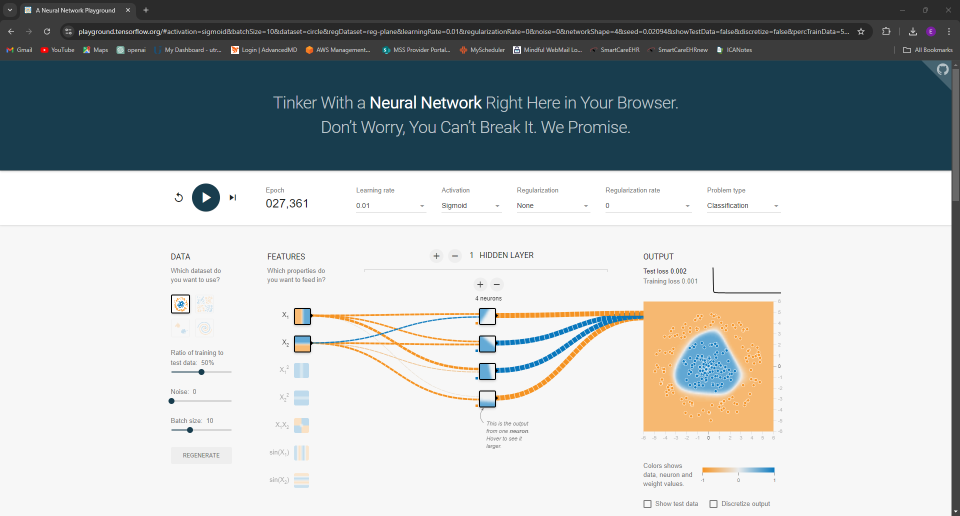

Works Cited

Abdi, Hervé., Valentin, D., & Edelman, B. (2001). *Neural networks*. Sage Publications.

Banerjee, C., Mukherjee, T., Eduardo Pasiliao, Jr., Chaity BanerjeeUniversity of Central Florida, O., Tathagata MukherjeeUniversity of Alabama in Huntsville, H., & Eduardo Pasiliao, Jr. A. F. R. L. (2019, April 18). *An empirical study on generalizations of the ReLU activation function: Proceedings of the 2019 ACM southeast conference*. ACM Conferences. <https://dl.acm.org/doi/abs/10.1145/3299815.3314450>

Brownlee, J. (2020, September 11). *Understand the impact of learning rate on neural network performance*. MachineLearningMastery.com. https://machinelearningmastery.com/understand-the-dynamics-of-learning-rate-on-deep-learning-neural-networks/

Doshi, S. (2020, August 3). *Various optimization algorithms for training neural network*. Medium. https://towardsdatascience.com/optimizers-for-training-neural-network-59450d71caf6

EITCA Academy. (2023, August 8). *What are the key components of a neural network and what is their role?*

Islam, M., Chen, G., & Jin, S. (2019, June 29). *An overview of neural network*. Science Publishing Group. https://www.sciencepublishinggroup.com/article/10.11648/j.ajnna.20190501.12

Kolli, A. (2024, February 20). *The role of activation functions in Neural Networks: A comprehensive guide*. Medium.

Ma, J., & Tang, J. (2017). A review for dynamics in neuron and neuronal network. *Nonlinear Dynamics*, *89*(3), 1569–1578. <https://doi.org/10.1007/s11071-017-3565-3>

McCausland, T. (2024, January). *The use of AI in Dosimetry*. Society for Radiation Oncology Administrators. https://www.sroa.org/blog/the-use-of-ai-in-dosimetry/

Nielsen, M. A. (2019, December 1). Neural networks and deep learning. <http://neuralnetworksanddeeplearning.com/index.html>

Sharma, S. (2022, November 20). *Activation functions in neural networks*. Medium. https://towardsdatascience.com/activation-functions-neural-networks-1cbd9f8d91d6