Cumplimiento ISO/IEC 27002:2022

[55] Dunder Mifflin

22.11.2022

Introducción
Código: 55
Nombre: Dunder Mifflin

Descripción:

Datos administrativos:

• Organización: Dunder Mifflin
• Descripción: Venta de productos de oficina
• Autor: Marcos, Jaime, Juan, Norberto
• Versión: 1.0
• Fecha: 14/11/2022

Dominios de seguridad
[base] Nueva York

[Scranton] Scranton
• padre: [base] Nueva York

[Akron] Akron
• padre: [base] Nueva York

[Nashua] Nashua
• padre: [base] Nueva York

Controles

Niveles de madurez
• L0 - inexistente
• L1 - inicial / ad hoc
• L2 - reproducible, pero intuitivo
• L3 - proceso definido
• L4 - gestionado y medible
• L5 - optimizado

[5] Controles organizativos
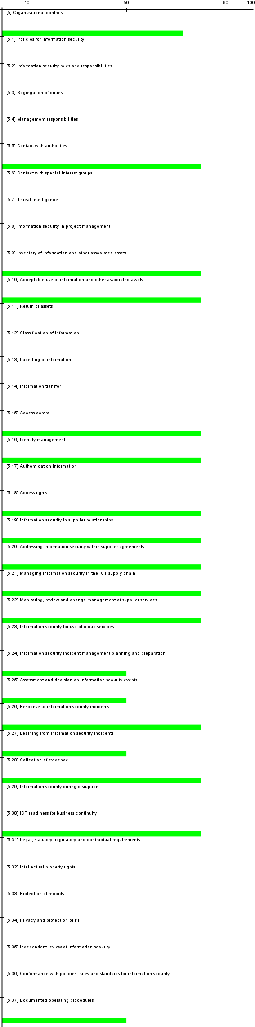
[current] situación actual
[target] situación objetivo
[PILAR] recomendación

dominio: [base] Nueva York

control | aplica | current | target | PILAR
[5] Organizational controls | / sí |  |  | L2-L3
[5.1] Policies for information security | / sí |  |  | n.a.
[5.2] Information security roles and responsibilities | / sí |  |  | n.a.
[5.3] Segregation of duties | / sí |  |  | n.a.
[5.4] Management responsibilities | / sí |  |  | n.a.
[5.5] Contact with authorities | / sí |  |  | L3
[5.6] Contact with special interest groups | / sí |  |  | n.a.
[5.7] Threat intelligence | / sí |  |  | n.a.
[5.8] Information security in project management | / sí |  |  | n.a.
[5.9] Inventory of information and other associated assets | / sí |  |  | L3
[5.10] Acceptable use of information and other associated assets | / sí |  |  | L3
[5.11] Return of assets | / sí |  |  | n.a.
[5.12] Classification of information | / sí |  |  | n.a.
[5.13] Labelling of information | / sí |  |  | n.a.
[5.14] Information transfer | / sí |  |  | n.a.
[5.15] Access control | / sí |  |  | L3
[5.16] Identity management | / sí |  |  | L3
[5.17] Authentication information | / sí |  |  | n.a.
[5.18] Access rights | / sí |  |  | L3
[5.19] Information security in supplier relationships | / sí |  |  | L3
[5.20] Addressing information security within supplier agreements | / sí |  |  | L3
[5.21] Managing information security in the ICT supply chain | / sí |  |  | L3
[5.22] Monitoring, review and change management of supplier services | / sí |  |  | L3
[5.23] Information security for use of cloud services | / sí |  |  | n.a.
[5.24] Information security incident management planning and preparation | / sí |  |  | L2
[5.25] Assessment and decision on information security events | / sí |  |  | L2
[5.26] Response to information security incidents | / sí |  |  | L3
[5.27] Learning from information security incidents | / sí |  |  | L2
[5.28] Collection of evidence | / sí |  |  | L3
[5.29] Information security during disruption | / sí |  |  | n.a.
[5.30] ICT readiness for business continuity | / sí |  |  | L3
[5.31] Legal, statutory, regulatory and contractual requirements | / sí |  |  | n.a.
[5.32] Intellectual property rights | / sí |  |  | n.a.
[5.33] Protection of records | / sí |  |  | n.a.
[5.34] Privacy and protection of PII | / sí |  |  | n.a.
[5.35] Independent review of information security | / sí |  |  | n.a.
[5.36] Conformance with policies, rules and standards for information security | / sí |  |  | n.a.
[5.37] Documented operating procedures | / sí |  |  | L2

dominio: [Scranton] Scranton

control | aplica | current | target | PILAR
[5] Organizational controls | / sí |  |  | L2-L3
[5.1] Policies for information security | / sí |  |  | n.a.
[5.2] Information security roles and responsibilities | / sí |  |  | n.a.
[5.3] Segregation of duties | / sí |  |  | n.a.
[5.4] Management responsibilities | / sí |  |  | n.a.
[5.5] Contact with authorities | / sí |  |  | L2
[5.6] Contact with special interest groups | / sí |  |  | n.a.
[5.7] Threat intelligence | / sí |  |  | n.a.
[5.8] Information security in project management | / sí |  |  | n.a.
[5.9] Inventory of information and other associated assets | / sí |  |  | L3
[5.10] Acceptable use of information and other associated assets | / sí |  |  | L2
[5.11] Return of assets | / sí |  |  | n.a.
[5.12] Classification of information | / sí |  |  | n.a.
[5.13] Labelling of information | / sí |  |  | n.a.
[5.14] Information transfer | / sí |  |  | n.a.
[5.15] Access control | / sí |  |  | L2
[5.16] Identity management | / sí |  |  | L2
[5.17] Authentication information | / sí |  |  | n.a.
[5.18] Access rights | / sí |  |  | n.a.
[5.19] Information security in supplier relationships | / sí |  |  | n.a.
[5.20] Addressing information security within supplier agreements | / sí |  |  | n.a.
[5.21] Managing information security in the ICT supply chain | / sí |  |  | n.a.
[5.22] Monitoring, review and change management of supplier services | / sí |  |  | n.a.
[5.23] Information security for use of cloud services | / sí |  |  | n.a.
[5.24] Information security incident management planning and preparation | / sí |  |  | n.a.
[5.25] Assessment and decision on information security events | / sí |  |  | n.a.
[5.26] Response to information security incidents | / sí |  |  | L3
[5.27] Learning from information security incidents | / sí |  |  | L2
[5.28] Collection of evidence | / sí |  |  | n.a.
[5.29] Information security during disruption | / sí |  |  | n.a.
[5.30] ICT readiness for business continuity | / sí |  |  | L2
[5.31] Legal, statutory, regulatory and contractual requirements | / sí |  |  | n.a.
[5.32] Intellectual property rights | / sí |  |  | n.a.
[5.33] Protection of records | / sí |  |  | n.a.
[5.34] Privacy and protection of PII | / sí |  |  | n.a.
[5.35] Independent review of information security | / sí |  |  | n.a.
[5.36] Conformance with policies, rules and standards for information security | / sí |  |  | n.a.
[5.37] Documented operating procedures | / sí |  |  | n.a.

dominio: [Akron] Akron

control | aplica | current | target | PILAR
[5] Organizational controls | / sí |  |  | L2-L3
[5.1] Policies for information security | / sí |  |  | n.a.
[5.2] Information security roles and responsibilities | / sí |  |  | n.a.
[5.3] Segregation of duties | / sí |  |  | n.a.
[5.4] Management responsibilities | / sí |  |  | n.a.
[5.5] Contact with authorities | / sí |  |  | L2
[5.6] Contact with special interest groups | / sí |  |  | n.a.
[5.7] Threat intelligence | / sí |  |  | n.a.
[5.8] Information security in project management | / sí |  |  | n.a.
[5.9] Inventory of information and other associated assets | / sí |  |  | L3
[5.10] Acceptable use of information and other associated assets | / sí |  |  | L2
[5.11] Return of assets | / sí |  |  | n.a.
[5.12] Classification of information | / sí |  |  | n.a.
[5.13] Labelling of information | / sí |  |  | n.a.
[5.14] Information transfer | / sí |  |  | n.a.
[5.15] Access control | / sí |  |  | L2
[5.16] Identity management | / sí |  |  | L2
[5.17] Authentication information | / sí |  |  | n.a.
[5.18] Access rights | / sí |  |  | n.a.
[5.19] Information security in supplier relationships | / sí |  |  | n.a.
[5.20] Addressing information security within supplier agreements | / sí |  |  | n.a.
[5.21] Managing information security in the ICT supply chain | / sí |  |  | n.a.
[5.22] Monitoring, review and change management of supplier services | / sí |  |  | n.a.
[5.23] Information security for use of cloud services | / sí |  |  | n.a.
[5.24] Information security incident management planning and preparation | / sí |  |  | n.a.
[5.25] Assessment and decision on information security events | / sí |  |  | n.a.
[5.26] Response to information security incidents | / sí |  |  | L3
[5.27] Learning from information security incidents | / sí |  |  | L2
[5.28] Collection of evidence | / sí |  |  | n.a.
[5.29] Information security during disruption | / sí |  |  | n.a.
[5.30] ICT readiness for business continuity | / sí |  |  | L2
[5.31] Legal, statutory, regulatory and contractual requirements | / sí |  |  | n.a.
[5.32] Intellectual property rights | / sí |  |  | n.a.
[5.33] Protection of records | / sí |  |  | n.a.
[5.34] Privacy and protection of PII | / sí |  |  | n.a.
[5.35] Independent review of information security | / sí |  |  | n.a.
[5.36] Conformance with policies, rules and standards for information security | / sí |  |  | n.a.
[5.37] Documented operating procedures | / sí |  |  | n.a.

dominio: [Nashua] Nashua

control | aplica | current | target | PILAR
[5] Organizational controls | / sí |  |  | L2-L3
[5.1] Policies for information security | / sí |  |  | n.a.
[5.2] Information security roles and responsibilities | / sí |  |  | n.a.
[5.3] Segregation of duties | / sí |  |  | n.a.
[5.4] Management responsibilities | / sí |  |  | n.a.
[5.5] Contact with authorities | / sí |  |  | L2
[5.6] Contact with special interest groups | / sí |  |  | n.a.
[5.7] Threat intelligence | / sí |  |  | n.a.
[5.8] Information security in project management | / sí |  |  | n.a.
[5.9] Inventory of information and other associated assets | / sí |  |  | L3
[5.10] Acceptable use of information and other associated assets | / sí |  |  | L2
[5.11] Return of assets | / sí |  |  | n.a.
[5.12] Classification of information | / sí |  |  | n.a.
[5.13] Labelling of information | / sí |  |  | n.a.
[5.14] Information transfer | / sí |  |  | n.a.
[5.15] Access control | / sí |  |  | L2
[5.16] Identity management | / sí |  |  | L2
[5.17] Authentication information | / sí |  |  | n.a.
[5.18] Access rights | / sí |  |  | n.a.
[5.19] Information security in supplier relationships | / sí |  |  | n.a.
[5.20] Addressing information security within supplier agreements | / sí |  |  | n.a.
[5.21] Managing information security in the ICT supply chain | / sí |  |  | n.a.
[5.22] Monitoring, review and change management of supplier services | / sí |  |  | n.a.
[5.23] Information security for use of cloud services | / sí |  |  | n.a.
[5.24] Information security incident management planning and preparation | / sí |  |  | n.a.
[5.25] Assessment and decision on information security events | / sí |  |  | n.a.
[5.26] Response to information security incidents | / sí |  |  | L3
[5.27] Learning from information security incidents | / sí |  |  | L2
[5.28] Collection of evidence | / sí |  |  | n.a.
[5.29] Information security during disruption | / sí |  |  | n.a.
[5.30] ICT readiness for business continuity | / sí |  |  | L2
[5.31] Legal, statutory, regulatory and contractual requirements | / sí |  |  | n.a.
[5.32] Intellectual property rights | / sí |  |  | n.a.
[5.33] Protection of records | / sí |  |  | n.a.
[5.34] Privacy and protection of PII | / sí |  |  | n.a.
[5.35] Independent review of information security | / sí |  |  | n.a.
[5.36] Conformance with policies, rules and standards for information security | / sí |  |  | n.a.
[5.37] Documented operating procedures | / sí |  |  | n.a.

[6] Controles del personal
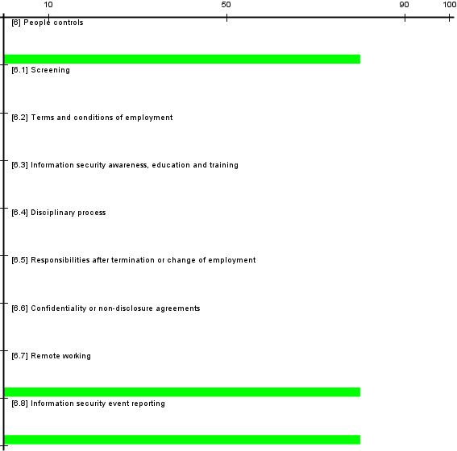
[current] situación actual
[target] situación objetivo
[PILAR] recomendación

dominio: [base] Nueva York

control | aplica | current | target | PILAR
[6] People controls | / sí |  |  | L3
[6.1] Screening | / sí |  |  | n.a.
[6.2] Terms and conditions of employment | / sí |  |  | n.a.
[6.3] Information security awareness, education and training | / sí |  |  | n.a.
[6.4] Disciplinary process | / sí |  |  | n.a.
[6.5] Responsibilities after termination or change of employment | / sí |  |  | n.a.
[6.6] Confidentiality or non-disclosure agreements | / sí |  |  | n.a.
[6.7] Remote working | / sí |  |  | L3
[6.8] Information security event reporting | / sí |  |  | L3

dominio: [Scranton] Scranton

control | aplica | current | target | PILAR
[6] People controls | / sí |  |  | L2-L3
[6.1] Screening | / sí |  |  | n.a.
[6.2] Terms and conditions of employment | / sí |  |  | n.a.
[6.3] Information security awareness, education and training | / sí |  |  | n.a.
[6.4] Disciplinary process | / sí |  |  | n.a.
[6.5] Responsibilities after termination or change of employment | / sí |  |  | n.a.
[6.6] Confidentiality or non-disclosure agreements | / sí |  |  | n.a.
[6.7] Remote working | / sí |  |  | L3
[6.8] Information security event reporting | / sí |  |  | L2

dominio: [Akron] Akron

control | aplica | current | target | PILAR
[6] People controls | / sí |  |  | L2-L3
[6.1] Screening | / sí |  |  | n.a.
[6.2] Terms and conditions of employment | / sí |  |  | n.a.
[6.3] Information security awareness, education and training | / sí |  |  | n.a.
[6.4] Disciplinary process | / sí |  |  | n.a.
[6.5] Responsibilities after termination or change of employment | / sí |  |  | n.a.
[6.6] Confidentiality or non-disclosure agreements | / sí |  |  | n.a.
[6.7] Remote working | / sí |  |  | L3
[6.8] Information security event reporting | / sí |  |  | L2

dominio: [Nashua] Nashua

control | aplica | current | target | PILAR
[6] People controls | / sí |  |  | L2-L3
[6.1] Screening | / sí |  |  | n.a.
[6.2] Terms and conditions of employment | / sí |  |  | n.a.
[6.3] Information security awareness, education and training | / sí |  |  | n.a.
[6.4] Disciplinary process | / sí |  |  | n.a.
[6.5] Responsibilities after termination or change of employment | / sí |  |  | n.a.
[6.6] Confidentiality or non-disclosure agreements | / sí |  |  | n.a.
[6.7] Remote working | / sí |  |  | L3
[6.8] Information security event reporting | / sí |  |  | L2

[7] Controles físicos
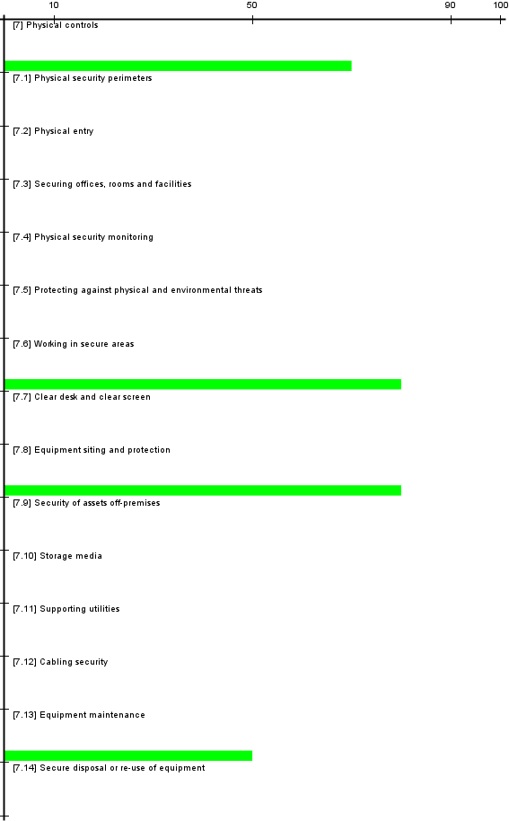
[current] situación actual
[target] situación objetivo
[PILAR] recomendación

dominio: [base] Nueva York

control | aplica | current | target | PILAR
[7] Physical controls | / sí |  |  | L2-L3
[7.1] Physical security perimeters | / sí |  |  | n.a.
[7.2] Physical entry | / sí |  |  | n.a.
[7.3] Securing offices, rooms and facilities | / sí |  |  | n.a.
[7.4] Physical security monitoring | / sí |  |  | n.a.
[7.5] Protecting against physical and environmental threats | / sí |  |  | n.a.
[7.6] Working in secure areas | / sí |  |  | L3
[7.7] Clear desk and clear screen | / sí |  |  | n.a.
[7.8] Equipment siting and protection | / sí |  |  | L3
[7.9] Security of assets off-premises | / sí |  |  | n.a.
[7.10] Storage media | / sí |  |  | n.a.
[7.11] Supporting utilities | / sí |  |  | n.a.
[7.12] Cabling security | / sí |  |  | n.a.
[7.13] Equipment maintenance | / sí |  |  | L2
[7.14] Secure disposal or re-use of equipment | / sí |  |  | n.a.

dominio: [Scranton] Scranton

control | aplica | current | target | PILAR
[7] Physical controls | / sí |  |  | L2-L3
[7.1] Physical security perimeters | / sí |  |  | n.a.
[7.2] Physical entry | / sí |  |  | n.a.
[7.3] Securing offices, rooms and facilities | / sí |  |  | n.a.
[7.4] Physical security monitoring | / sí |  |  | n.a.
[7.5] Protecting against physical and environmental threats | / sí |  |  | n.a.
[7.6] Working in secure areas | / sí |  |  | L2
[7.7] Clear desk and clear screen | / sí |  |  | n.a.
[7.8] Equipment siting and protection | / sí |  |  | L3
[7.9] Security of assets off-premises | / sí |  |  | n.a.
[7.10] Storage media | / sí |  |  | n.a.
[7.11] Supporting utilities | / sí |  |  | n.a.
[7.12] Cabling security | / sí |  |  | n.a.
[7.13] Equipment maintenance | / sí |  |  | L2
[7.14] Secure disposal or re-use of equipment | / sí |  |  | n.a.

dominio: [Akron] Akron

control | aplica | current | target | PILAR
[7] Physical controls | / sí |  |  | L2-L3
[7.1] Physical security perimeters | / sí |  |  | n.a.
[7.2] Physical entry | / sí |  |  | n.a.
[7.3] Securing offices, rooms and facilities | / sí |  |  | n.a.
[7.4] Physical security monitoring | / sí |  |  | n.a.
[7.5] Protecting against physical and environmental threats | / sí |  |  | n.a.
[7.6] Working in secure areas | / sí |  |  | L2
[7.7] Clear desk and clear screen | / sí |  |  | n.a.
[7.8] Equipment siting and protection | / sí |  |  | L3
[7.9] Security of assets off-premises | / sí |  |  | n.a.
[7.10] Storage media | / sí |  |  | n.a.
[7.11] Supporting utilities | / sí |  |  | n.a.
[7.12] Cabling security | / sí |  |  | n.a.
[7.13] Equipment maintenance | / sí |  |  | L2
[7.14] Secure disposal or re-use of equipment | / sí |  |  | n.a.

dominio: [Nashua] Nashua

control | aplica | current | target | PILAR
[7] Physical controls | / sí |  |  | L2-L3
[7.1] Physical security perimeters | / sí |  |  | n.a.
[7.2] Physical entry | / sí |  |  | n.a.
[7.3] Securing offices, rooms and facilities | / sí |  |  | n.a.
[7.4] Physical security monitoring | / sí |  |  | n.a.
[7.5] Protecting against physical and environmental threats | / sí |  |  | n.a.
[7.6] Working in secure areas | / sí |  |  | L2
[7.7] Clear desk and clear screen | / sí |  |  | n.a.
[7.8] Equipment siting and protection | / sí |  |  | L3
[7.9] Security of assets off-premises | / sí |  |  | n.a.
[7.10] Storage media | / sí |  |  | n.a.
[7.11] Supporting utilities | / sí |  |  | n.a.
[7.12] Cabling security | / sí |  |  | n.a.
[7.13] Equipment maintenance | / sí |  |  | L2
[7.14] Secure disposal or re-use of equipment | / sí |  |  | n.a.

[8] Controles tecnológicos
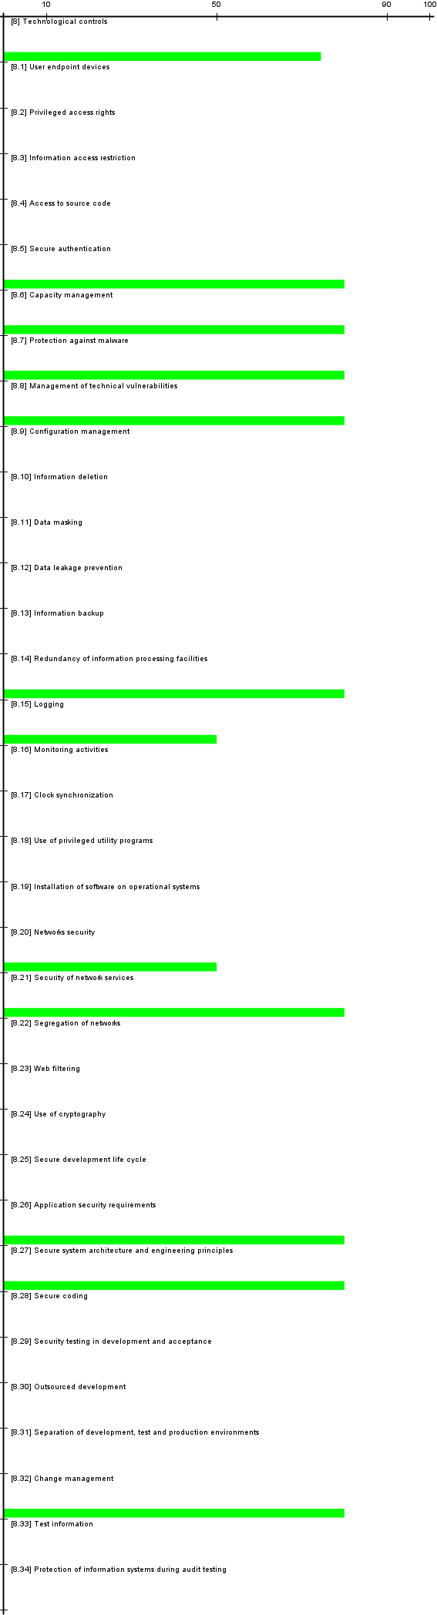
[current] situación actual
[target] situación objetivo
[PILAR] recomendación

dominio: [base] Nueva York

control | aplica | current | target | PILAR
[8] Technological controls | / sí |  |  | L2-L3
[8.1] User endpoint devices | / sí |  |  | n.a.
[8.2] Privileged access rights | / sí |  |  | n.a.
[8.3] Information access restriction | / sí |  |  | n.a.
[8.4] Access to source code | / sí |  |  | n.a.
[8.5] Secure authentication | / sí |  |  | L3
[8.6] Capacity management | / sí |  |  | L3
[8.7] Protection against malware | / sí |  |  | L3
[8.8] Management of technical vulnerabilities | / sí |  |  | L3
[8.9] Configuration management | / sí |  |  | n.a.
[8.10] Information deletion | / sí |  |  | n.a.
[8.11] Data masking | / sí |  |  | n.a.
[8.12] Data leakage prevention | / sí |  |  | n.a.
[8.13] Information backup | / sí |  |  | n.a.
[8.14] Redundancy of information processing facilities | / sí |  |  | L3
[8.15] Logging | / sí |  |  | L2
[8.16] Monitoring activities | / sí |  |  | n.a.
[8.17] Clock synchronization | / sí |  |  | n.a.
[8.18] Use of privileged utility programs | / sí |  |  | n.a.
[8.19] Installation of software on operational systems | / sí |  |  | n.a.
[8.20] Networks security | / sí |  |  | L2
[8.21] Security of network services | / sí |  |  | L3
[8.22] Segregation of networks | / sí |  |  | n.a.
[8.23] Web filtering | / sí |  |  | n.a.
[8.24] Use of cryptography | / sí |  |  | n.a.
[8.25] Secure development life cycle | / sí |  |  | n.a.
[8.26] Application security requirements | / sí |  |  | L3
[8.27] Secure system architecture and engineering principles | / sí |  |  | L3
[8.28] Secure coding | / sí |  |  | n.a.
[8.29] Security testing in development and acceptance | / sí |  |  | n.a.
[8.30] Outsourced development | / sí |  |  | n.a.
[8.31] Separation of development, test and production environments | / sí |  |  | n.a.
[8.32] Change management | / sí |  |  | L3
[8.33] Test information | / sí |  |  | n.a.
[8.34] Protection of information systems during audit testing | / sí |  |  | n.a.

dominio: [Scranton] Scranton

control | aplica | current | target | PILAR
[8] Technological controls | / sí |  |  | L2
[8.1] User endpoint devices | / sí |  |  | n.a.
[8.2] Privileged access rights | / sí |  |  | n.a.
[8.3] Information access restriction | / sí |  |  | n.a.
[8.4] Access to source code | / sí |  |  | n.a.
[8.5] Secure authentication | / sí |  |  | n.a.
[8.6] Capacity management | / sí |  |  | L2
[8.7] Protection against malware | / sí |  |  | n.a.
[8.8] Management of technical vulnerabilities | / sí |  |  | n.a.
[8.9] Configuration management | / sí |  |  | n.a.
[8.10] Information deletion | / sí |  |  | n.a.
[8.11] Data masking | / sí |  |  | n.a.
[8.12] Data leakage prevention | / sí |  |  | n.a.
[8.13] Information backup | / sí |  |  | n.a.
[8.14] Redundancy of information processing facilities | / sí |  |  | L2
[8.15] Logging | / sí |  |  | L2
[8.16] Monitoring activities | / sí |  |  | n.a.
[8.17] Clock synchronization | / sí |  |  | n.a.
[8.18] Use of privileged utility programs | / sí |  |  | n.a.
[8.19] Installation of software on operational systems | / sí |  |  | n.a.
[8.20] Networks security | / sí |  |  | n.a.
[8.21] Security of network services | / sí |  |  | n.a.
[8.22] Segregation of networks | / sí |  |  | n.a.
[8.23] Web filtering | / sí |  |  | n.a.
[8.24] Use of cryptography | / sí |  |  | n.a.
[8.25] Secure development life cycle | / sí |  |  | n.a.
[8.26] Application security requirements | / sí |  |  | n.a.
[8.27] Secure system architecture and engineering principles | / sí |  |  | L2
[8.28] Secure coding | / sí |  |  | n.a.
[8.29] Security testing in development and acceptance | / sí |  |  | n.a.
[8.30] Outsourced development | / sí |  |  | n.a.
[8.31] Separation of development, test and production environments | / sí |  |  | n.a.
[8.32] Change management | / sí |  |  | L2
[8.33] Test information | / sí |  |  | n.a.
[8.34] Protection of information systems during audit testing | / sí |  |  | n.a.

dominio: [Akron] Akron

control | aplica | current | target | PILAR
[8] Technological controls | / sí |  |  | L2
[8.1] User endpoint devices | / sí |  |  | n.a.
[8.2] Privileged access rights | / sí |  |  | n.a.
[8.3] Information access restriction | / sí |  |  | n.a.
[8.4] Access to source code | / sí |  |  | n.a.
[8.5] Secure authentication | / sí |  |  | n.a.
[8.6] Capacity management | / sí |  |  | L2
[8.7] Protection against malware | / sí |  |  | n.a.
[8.8] Management of technical vulnerabilities | / sí |  |  | n.a.
[8.9] Configuration management | / sí |  |  | n.a.
[8.10] Information deletion | / sí |  |  | n.a.
[8.11] Data masking | / sí |  |  | n.a.
[8.12] Data leakage prevention | / sí |  |  | n.a.
[8.13] Information backup | / sí |  |  | n.a.
[8.14] Redundancy of information processing facilities | / sí |  |  | L2
[8.15] Logging | / sí |  |  | L2
[8.16] Monitoring activities | / sí |  |  | n.a.
[8.17] Clock synchronization | / sí |  |  | n.a.
[8.18] Use of privileged utility programs | / sí |  |  | n.a.
[8.19] Installation of software on operational systems | / sí |  |  | n.a.
[8.20] Networks security | / sí |  |  | n.a.
[8.21] Security of network services | / sí |  |  | n.a.
[8.22] Segregation of networks | / sí |  |  | n.a.
[8.23] Web filtering | / sí |  |  | n.a.
[8.24] Use of cryptography | / sí |  |  | n.a.
[8.25] Secure development life cycle | / sí |  |  | n.a.
[8.26] Application security requirements | / sí |  |  | n.a.
[8.27] Secure system architecture and engineering principles | / sí |  |  | L2
[8.28] Secure coding | / sí |  |  | n.a.
[8.29] Security testing in development and acceptance | / sí |  |  | n.a.
[8.30] Outsourced development | / sí |  |  | n.a.
[8.31] Separation of development, test and production environments | / sí |  |  | n.a.
[8.32] Change management | / sí |  |  | L2
[8.33] Test information | / sí |  |  | n.a.
[8.34] Protection of information systems during audit testing | / sí |  |  | n.a.

dominio: [Nashua] Nashua

control | aplica | current | target | PILAR
[8] Technological controls | / sí |  |  | L2
[8.1] User endpoint devices | / sí |  |  | n.a.
[8.2] Privileged access rights | / sí |  |  | n.a.
[8.3] Information access restriction | / sí |  |  | n.a.
[8.4] Access to source code | / sí |  |  | n.a.
[8.5] Secure authentication | / sí |  |  | n.a.
[8.6] Capacity management | / sí |  |  | L2
[8.7] Protection against malware | / sí |  |  | n.a.
[8.8] Management of technical vulnerabilities | / sí |  |  | n.a.
[8.9] Configuration management | / sí |  |  | n.a.
[8.10] Information deletion | / sí |  |  | n.a.
[8.11] Data masking | / sí |  |  | n.a.
[8.12] Data leakage prevention | / sí |  |  | n.a.
[8.13] Information backup | / sí |  |  | n.a.
[8.14] Redundancy of information processing facilities | / sí |  |  | L2
[8.15] Logging | / sí |  |  | L2
[8.16] Monitoring activities | / sí |  |  | n.a.
[8.17] Clock synchronization | / sí |  |  | n.a.
[8.18] Use of privileged utility programs | / sí |  |  | n.a.
[8.19] Installation of software on operational systems | / sí |  |  | n.a.
[8.20] Networks security | / sí |  |  | n.a.
[8.21] Security of network services | / sí |  |  | n.a.
[8.22] Segregation of networks | / sí |  |  | n.a.
[8.23] Web filtering | / sí |  |  | n.a.
[8.24] Use of cryptography | / sí |  |  | n.a.
[8.25] Secure development life cycle | / sí |  |  | n.a.
[8.26] Application security requirements | / sí |  |  | n.a.
[8.27] Secure system architecture and engineering principles | / sí |  |  | L2
[8.28] Secure coding | / sí |  |  | n.a.
[8.29] Security testing in development and acceptance | / sí |  |  | n.a.
[8.30] Outsourced development | / sí |  |  | n.a.
[8.31] Separation of development, test and production environments | / sí |  |  | n.a.
[8.32] Change management | / sí |  |  | L2
[8.33] Test information | / sí |  |  | n.a.
[8.34] Protection of information systems during audit testing | / sí |  |  | n.a.

