* Go to the EC2 Dashboard
* Select snapshots
* Click on create snapshot of volume

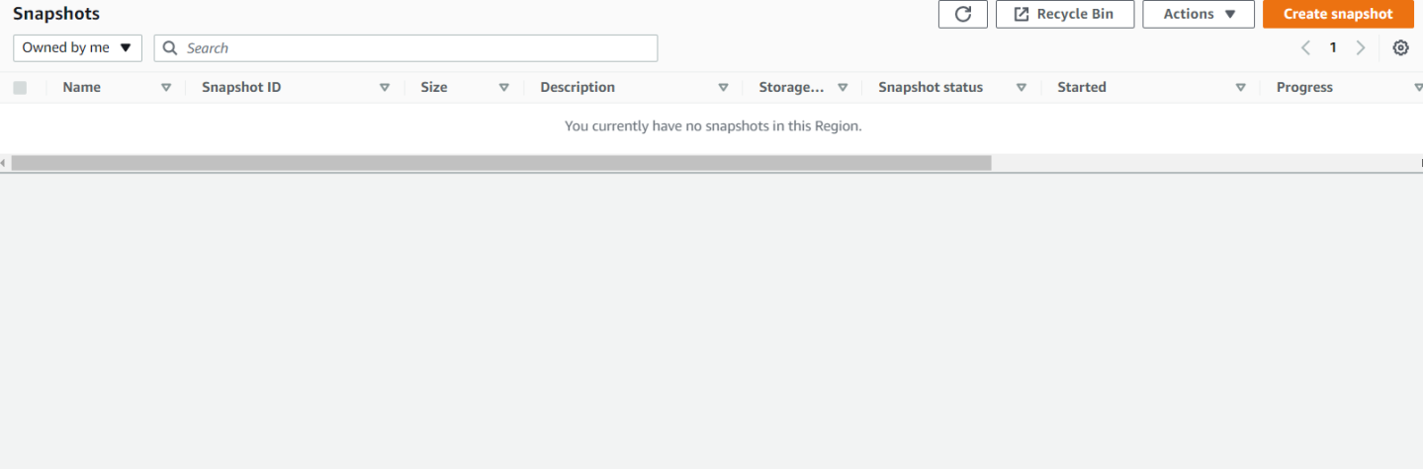

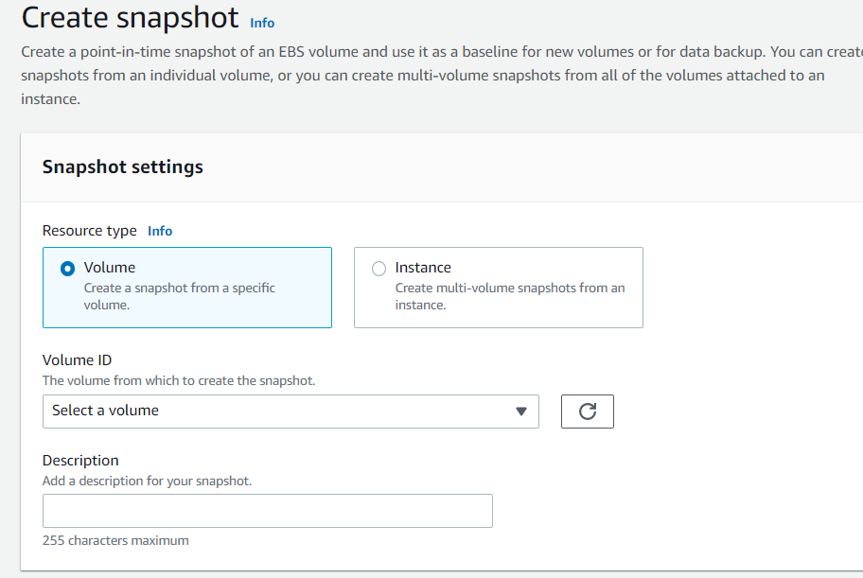

* Give name to the snapshot🡪nodejs_mongodb_snapshot

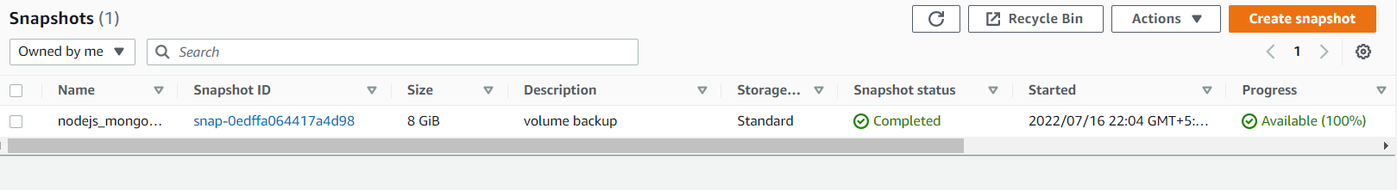

* Select create snapshot
* Create image from snapshot for sharing with other aws account

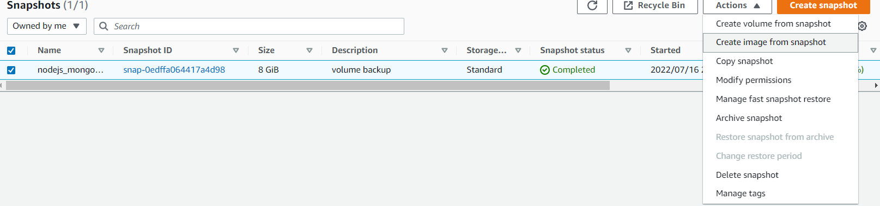

* Click on create image from snapshot
* Give image name rest default

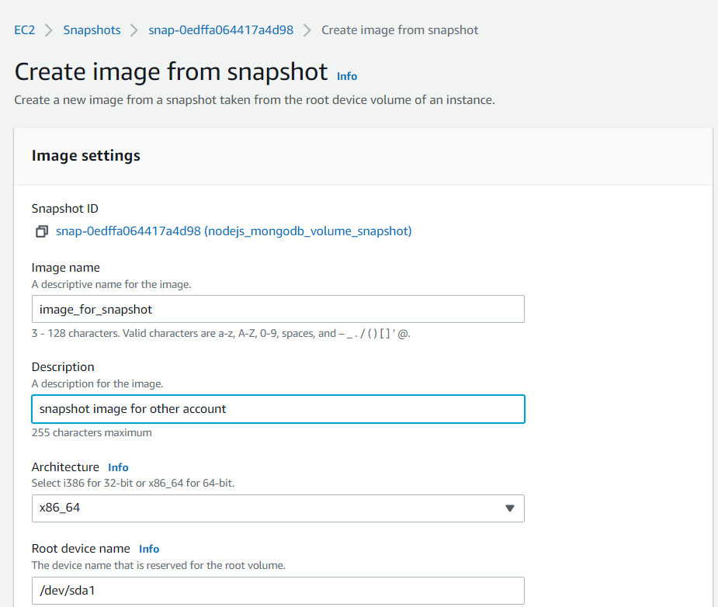

* Select –edit AMI permission

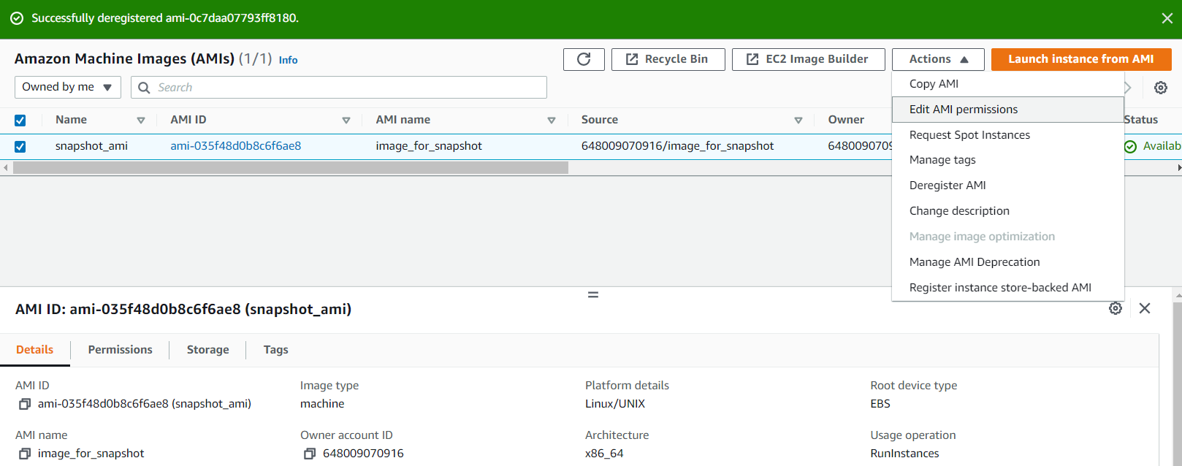

* To share snapshot with specific account
* Select ami availability -🡪private
* Select 🡪add account id from share accounts

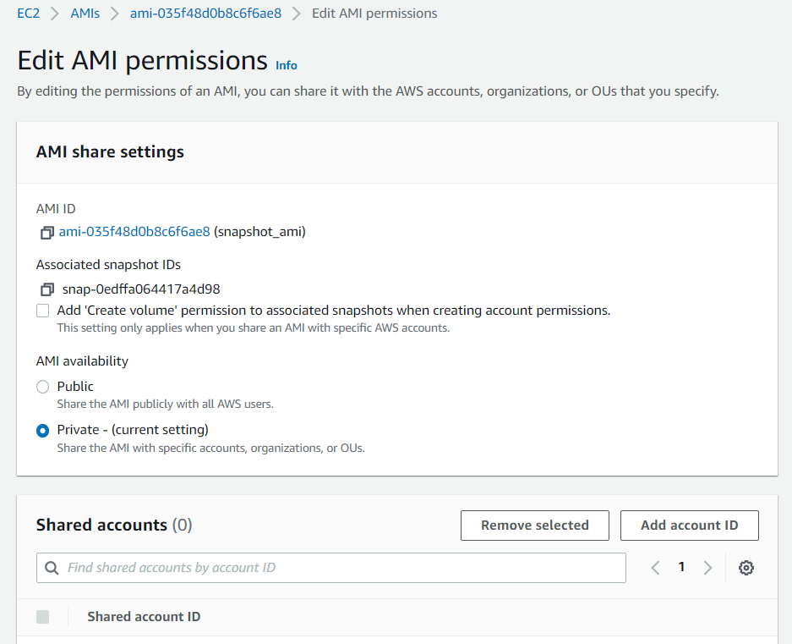

* Insert another aws account ID …as shown in below
* Click share AMI

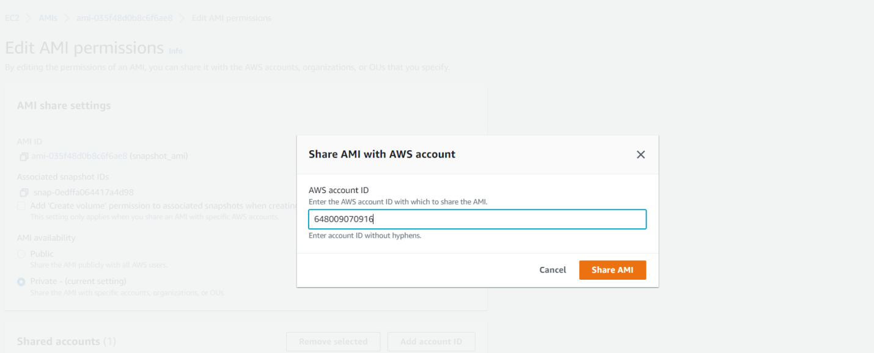

* Save changes
* Now ready to share with other account

