**Reporte de Pruebas**

**Escenario: The user can write and obtain results in the searching**

Paso 1: The user navigate to www.mercadolibre.com.mx  
Resultado: Exitoso

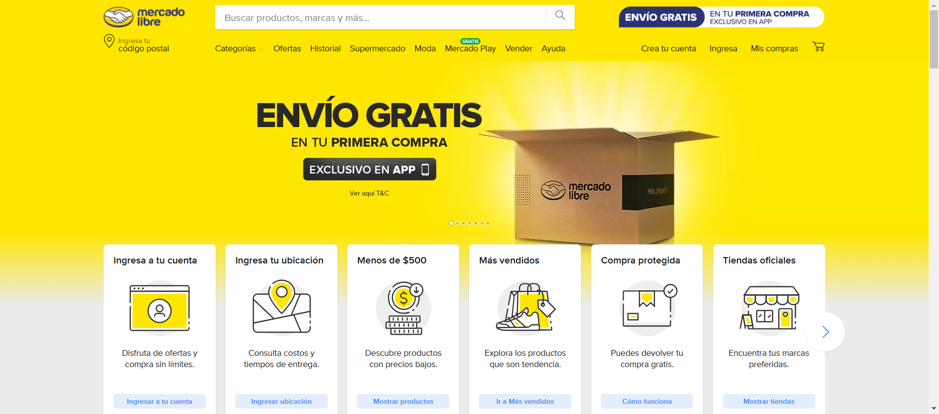

Paso 2: The user write Playstation and search results  
Resultado: Exitoso

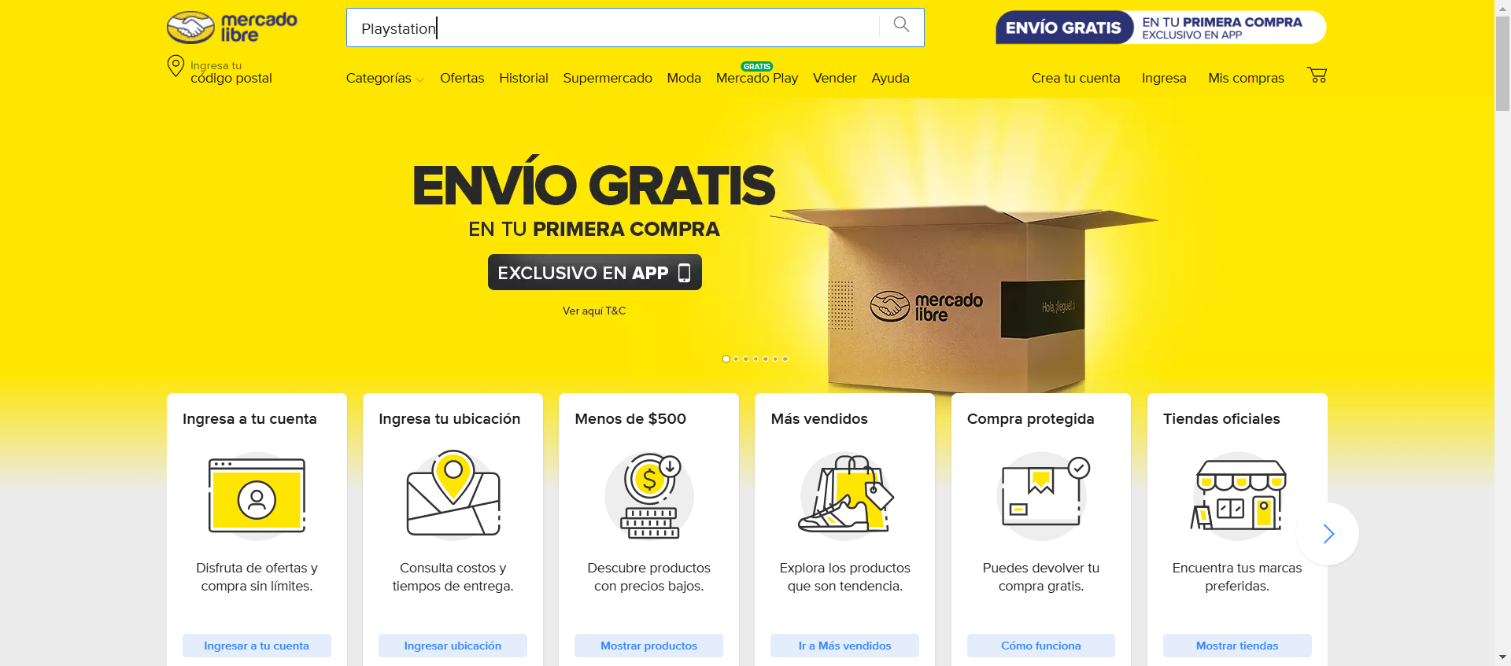

Paso 3: The user obtain a list of results  
Resultado: Exitoso

