**Reporte de pruebas 20250401_131310**

**Escenario: I can realize hoverover at all images of a product**

Paso 1: The user navigate to www.mercadolibre.com.mx  
Resultado: Exitoso



Paso 2: The user write Alexa and search results  
Resultado: Exitoso

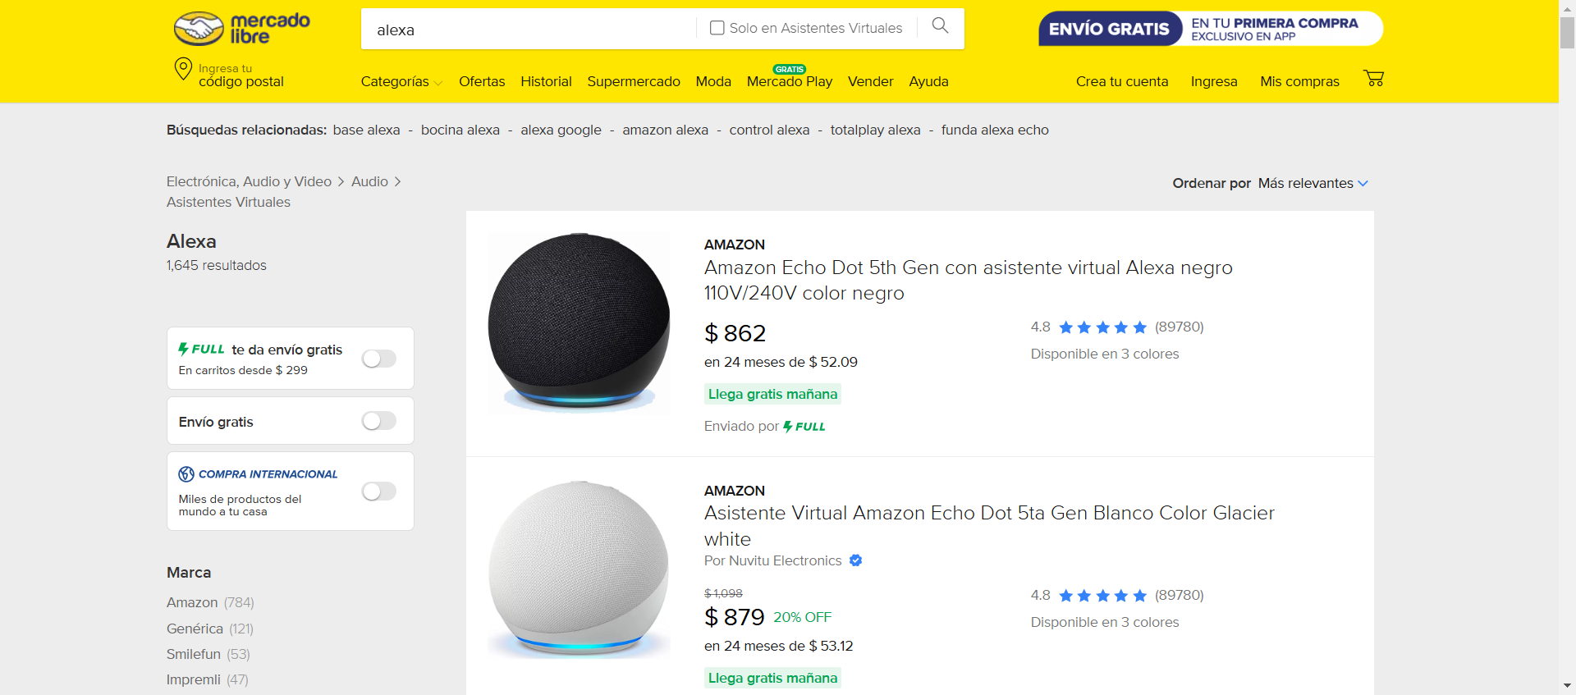

Paso 3: The user select the first result  
Resultado: Exitoso

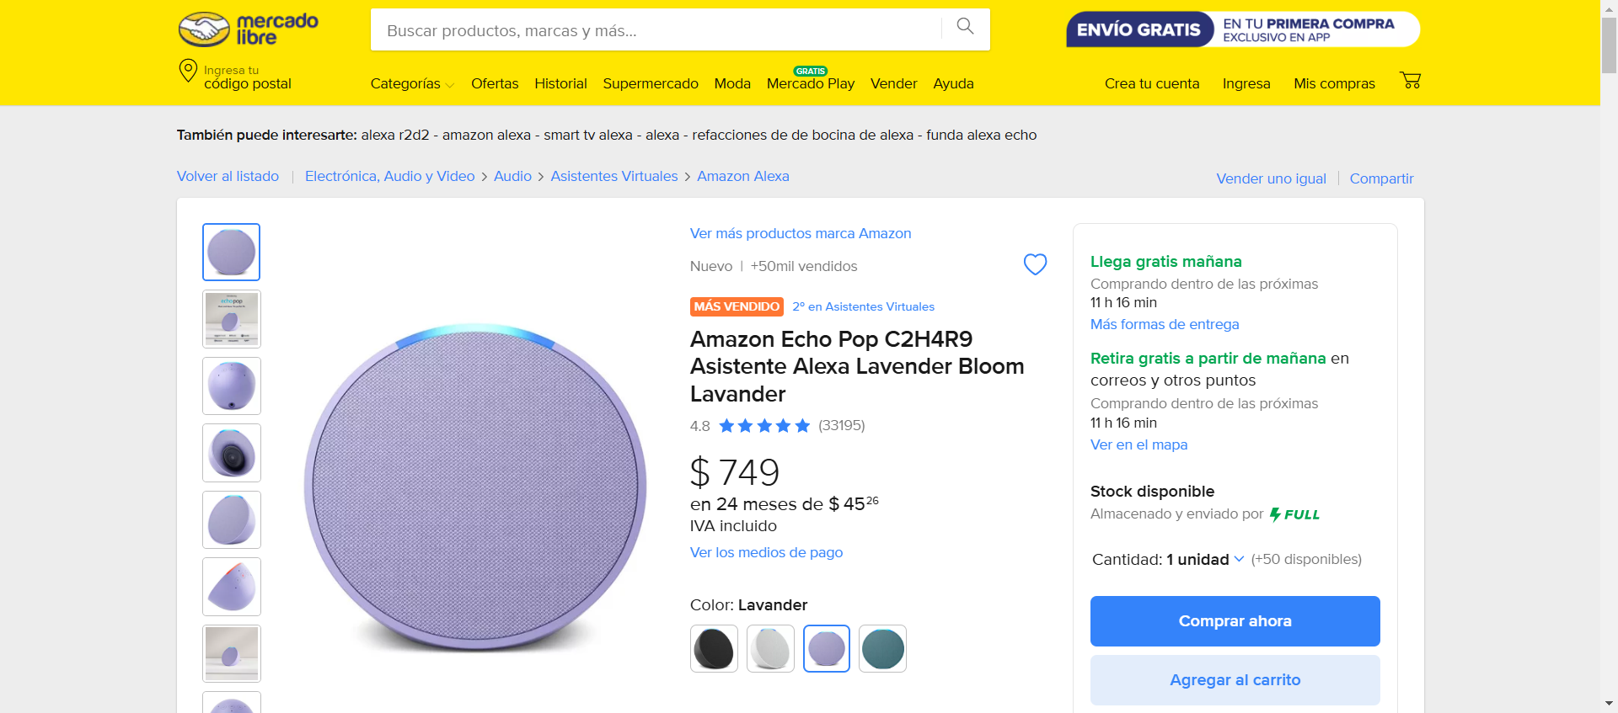

Paso 4: The user made hoverOver in the images  
Resultado: Exitoso

