Rishav Snehil

**ASSIGNMENT 1**

In this assignment we launched an EC2 Instance and created a database, then we created we installed Apache web server with PHP and MariaDB and connected our Apache server to the DB instance.

DATABASE

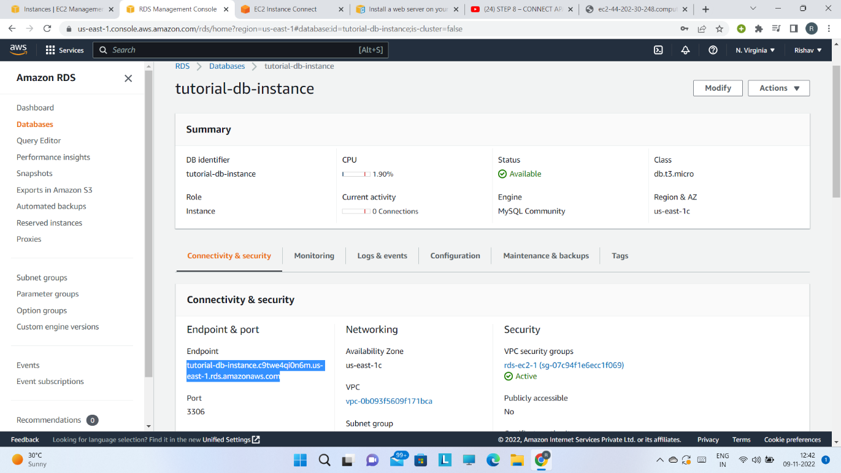

INSTANCE

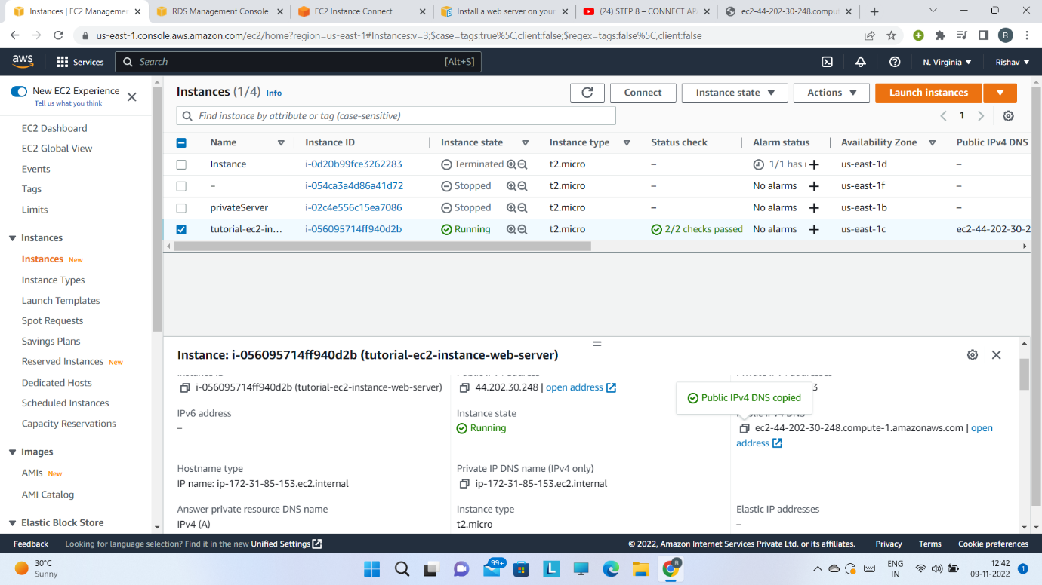

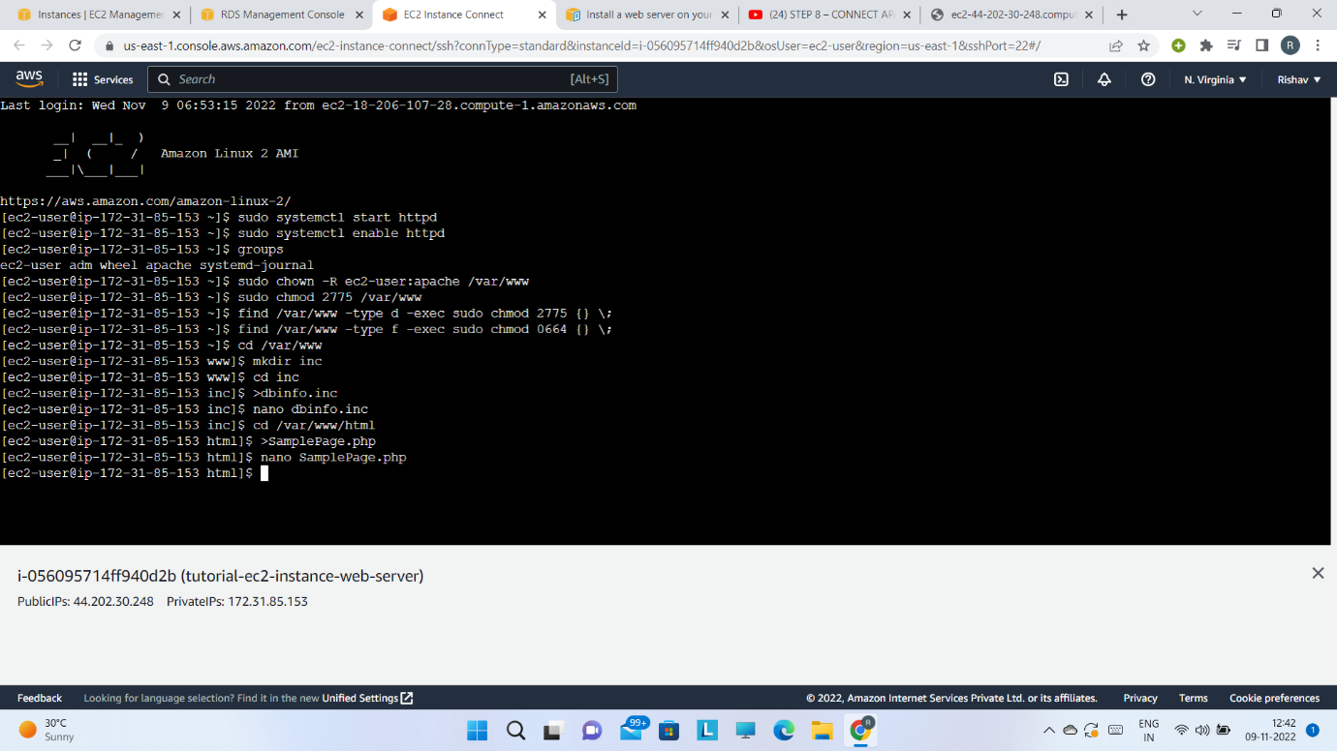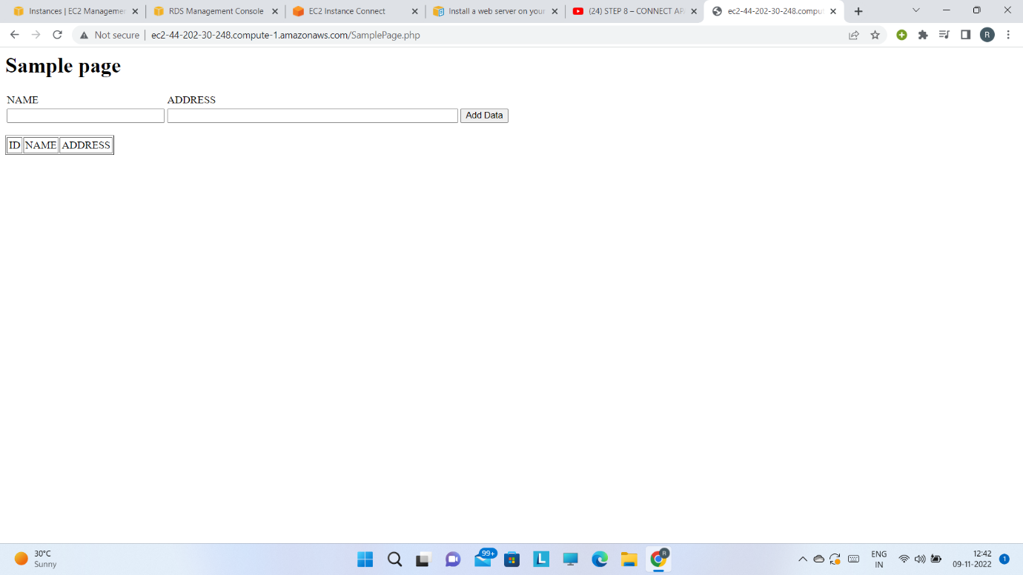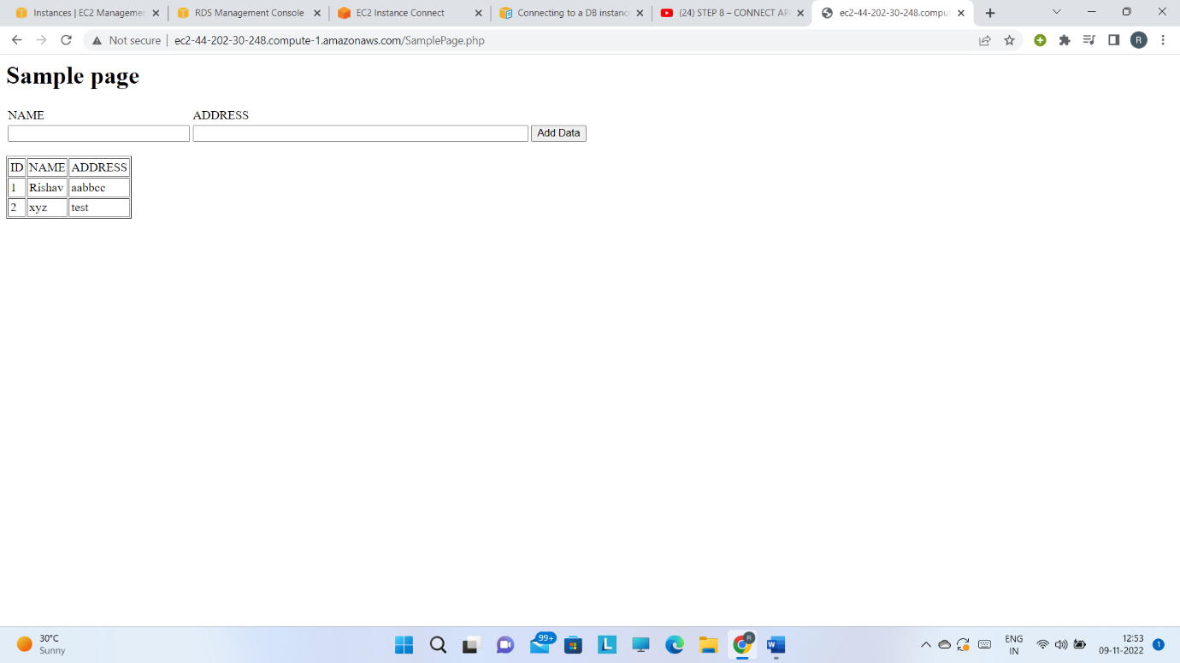

**ASSIGNMENT 2**

In this assignment we created an IAM role and provided AWSServiceRole and S3FullAccess permission. Then we created a s3 bucket with directories containing a csv file and another directory in which the output (csv to parquet) was to be present. Then we glue studio to create a job which would convert the file format.

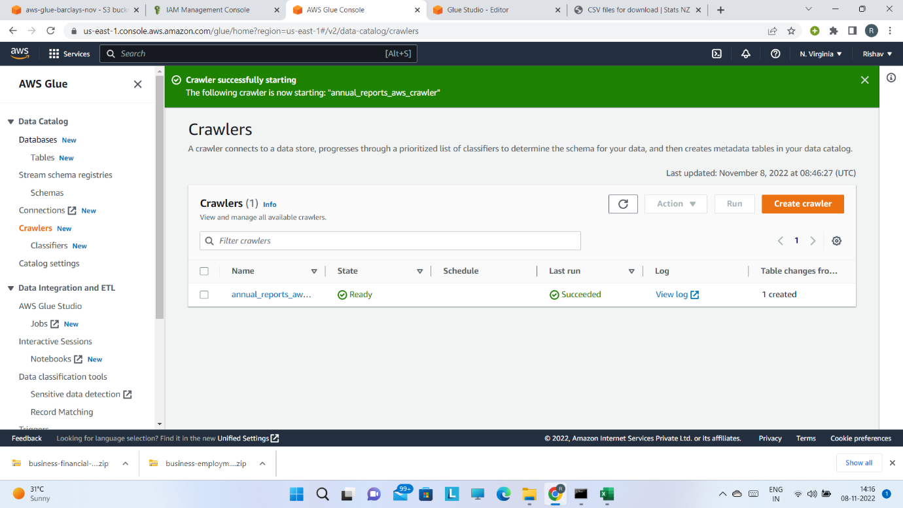

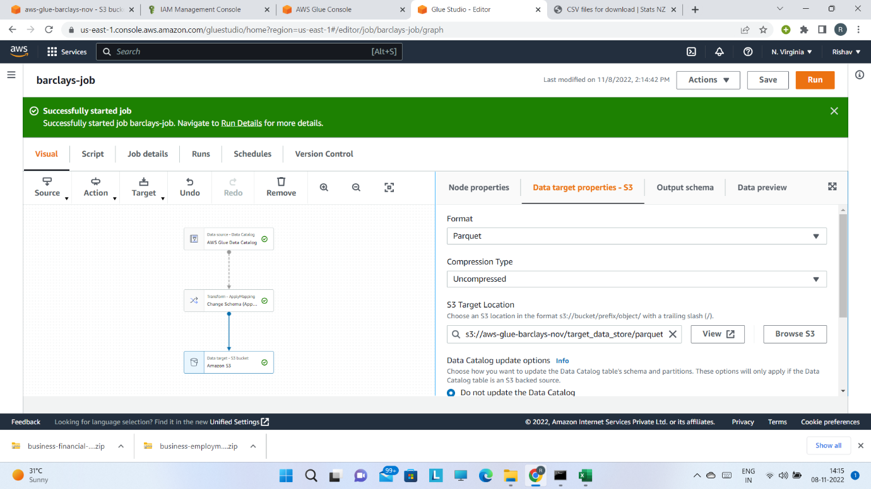

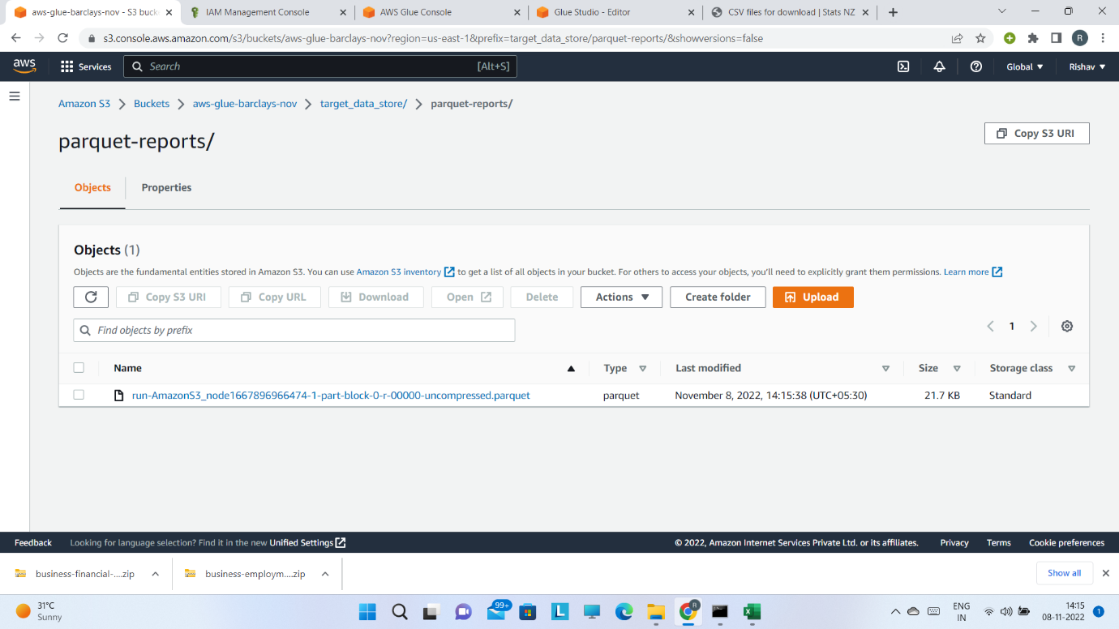

**ASSIGNMENT 3**

In this assignment we created a container image, to do so we first installed docker and created a Dockerfile, then we paste code to run in dockerfile. We run the dockerfile to build the docker image with repository name “hello-world”.

