VIIRF
Versatile IIR Filter

License
MIT License

Copyright (c) 2017 Mario Mauerer

Permission is hereby granted, free of charge, to any person obtaining a copy
of this software and associated documentation files (the "Software"), to deal
in the Software without restriction, including without limitation the rights
to use, copy, modify, merge, publish, distribute, sublicense, and/or sell
copies of the Software, and to permit persons to whom the Software is
furnished to do so, subject to the following conditions:

The above copyright notice and this permission notice shall be included in all
copies or substantial portions of the Software.

THE SOFTWARE IS PROVIDED "AS IS", WITHOUT WARRANTY OF ANY KIND, EXPRESS OR
IMPLIED, INCLUDING BUT NOT LIMITED TO THE WARRANTIES OF MERCHANTABILITY,
FITNESS FOR A PARTICULAR PURPOSE AND NONINFRINGEMENT. IN NO EVENT SHALL THE
AUTHORS OR COPYRIGHT HOLDERS BE LIABLE FOR ANY CLAIM, DAMAGES OR OTHER
LIABILITY, WHETHER IN AN ACTION OF CONTRACT, TORT OR OTHERWISE, ARISING FROM,
OUT OF OR IN CONNECTION WITH THE SOFTWARE OR THE USE OR OTHER DEALINGS IN THE
SOFTWARE.

Introduction
This project comprises the hardware description (VHDL) and configuration tools (Python) of a flexible IIR filter implementation. No vendor-specific language constructs or bus interfaces are used, such that the system description can easily be used in all hardware development environments.
The IIR filter is incorporated by cascaded (series-connected) second-order sections (SOS), or biquads. This enables very high-order filters while maintaining their numerical stability and integrity.
So far, the SOS are implemented using the direct-form I (DF1), which is robust against internal overflows.
The config folder contains scripts (Python and Matlab) that help configuring the desired filter:
- IIR_Config.py
This is a Python script that takes the SOS and gain coefficients of a cascaded SOS filter and performs numerous sanity checks on the coefficients and possible hardware configurations. It also simulates the filter (both floating-point and fixed-point) and plots the step response. It also creates stimuli and reference outputs for the VHDL testbenches (which are stored in the folder FilterStimuliData).
- IIR_SOS_Filt_df1.py
This contains two Python classes that implement two cascaded direct-form I filters (one floating-point, one quantized), which are used by IIR_Config.py to simulate the filter’s response.
- export_sos_python_lists.m
This Matlab function exports SOS and G-matrices generated by Matlab (e.g., fdatool) to a text-file with a syntax that is compatible with Python/IIR_Config.py.

Biquad Coefficients
The SOS/biquad implements the following transfer function:

which, using the direct-form 1 implementation, and adding a separate output gain g, results in this difference equation:

The filter coefficients are named identically throughout this project.
The coefficients are provided to the configuration script (IIR_Config.py) as floating-point values and are quantized according to the Q-notation defined by the VHDL-generics W_COEF and W_FRAC, whereas W_COEF is the total length (bits) of the coefficient, and W_FRAC is the length of the fraction.
For example, a Q-notation of Q1.15 is selected with W_COEF = 16 and W_FRAC = 15.
The quantized coefficients are calculated according to:

The SOS-coefficients are (e.g., in Matlab), provided as a matrix, where each row contains the coefficients of one SOS in this form:

This is also the form utilized by IIR_Config.py. Note that the 4th coefficient is always unity.
Each SOS can have an output gain g or not. The gains are provided by the vector G, where each entry corresponds to the gain of an SOS.
In the hardware implementation, the parameter SOSGAIN_EN controls the generation of the section’s output multiplication hardware. Depending on the coefficient scaling (see usage example below), the section-gains can often all be set to unity and these multiplication steps can be omitted.
Furthermore, the filter implementation also features a final output gain that is applied after all cascaded sections (see hardware description). This gain is also provided by the G-matrix, as the last entry (see usage example below).

Usage Example
In the following, the filter design workflow is illustrated.
- Design a transfer function or IIR filter and obtain the SOS-representation of it. With Python, this can be achieved e.g., by using the scipy package. Matlab’s fdatool is also a very convenient way to design digital filters. The process for fdatool is as such:
  - With fdatool, design the desired filter (select the IIR topology).
  - Edit – Convert Structure – Direct-Form I, SOS
  - Edit – Reorder and Scale Second-Order Sections
Apply desired reordering and scaling methods. For low-noise / high-precision filters, put the scale-slider towards “Highest SNR”. Then (not exclusively) the SOS-gains are all unity, which also reduces resource utilization and latency.
  - File – Export
Export SOS and G to the workspace. We do not need to quantize the coefficients, as we do this ourselves.
  - In Matlab, run the function export_sos_python_lists.m (part of this project) on the exported SOS and G matrices. This creates a text-file with SOS and G as python lists.
- Insert the SOS and G lists into IIR_Config.py
- Configure the remaining parameters of the filter, e.g., if all section gains are unity, SOSGAIN_EN can be set to false and the unity-coefficients can be deleted. Note that the shape of the G-list depends on SOSGAIN_EN and FINALGAIN_EN. See IIR_Config.py.
Choose a filter coefficient quantization. This can be dependent of the type of multipliers available in the target hardware. E.g., Xilinx’s DSP48E1 features a 25x18 multiplier. Hence, it is advantageous if W_SECT_DAT = 25 and W_COEF = 18. Select W_FRAC as high as possible, but such that it still covers the coefficient range (IIR_Config.py will raise errors if the selected value is unfit). Higher data/coefficient widths are of course possible, but then the synthesis tool has to use more multipliers / logic.
- Run IIR_Config.py. If it succeeds, it creates various files, most in a directory (FILENAME_METADATA and DIRNAME_STIMULIDATA).
There might be console outputs indicating that filter data has been saturated. This is OK, and the effects are visible in the step-response. If the response is unsatisfactory, increase NUM_BITS_SECT_DAT_EXT_MANUAL until the response is good (this increases W_SECT_DAT). This is likely the case if SOSGAIN_EN is set to true and the SOS-gains are small. Another approach is to rescale the filter coefficients such that all SOS-gains are unity, and only use the filter’s final gain (if needed). Additionally, an increase of the coefficient width can also improve the filter’s performance/precision.
- If the filter’s performance is satisfactory, configure sos_cascaded_top_tb.vhd according to the contents in the filter metadata-file (e.g., FilterMetaData.txt), that has been created by the Python script.
- Copy the contents of the stimuli-directory (e.g., FilterStimuliData), that has been created by the Python script, to the folder testbench_stimuli. This is where the testbench reads the files from (This step can be omitted by pointing the testbench to the FilterStimuliData-folder).
NOTE: The testbench might need absolute file paths, depending on the utilized system. See/configure the paths in sos_cascaded_top_tb.vhd.
- Run the testbench. This simulates the filter and compares the output to what the python script generated. No errors should be raised during the testbench execution (except if it runs out of stimuli data – see error reports in the simulator console).
- Configure sos_cascaded_top.vhd also according to the metadata-file (e.g., FilterMetaData.txt).
- Synthesize / utilize sos_cascaded_top.vhd as desired.

Hardware Description

Direct-Form 1 Biquad Core
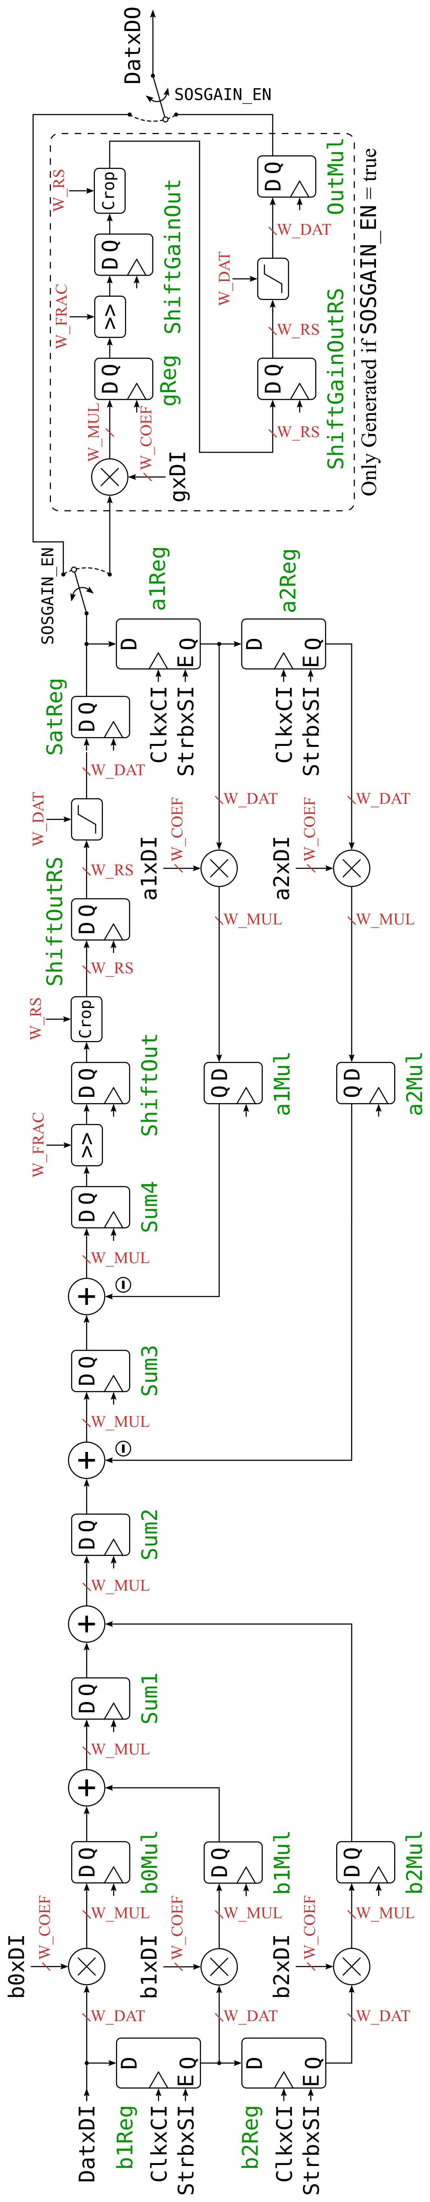
The figure on the left illustrates the hardware implementation of the direct-form 1 biquad (the figure is also available in the doc folder of this project). This implementation is heavily pipelined such that there is as little logic as possible between registers in order to enable a higher maximum clock rate.
This structure requires 5 (or 6, if SOSGAIN_EN is true) multipliers.
This structure is implemented in sos_core_df1.vhd
There is a second implementation of this filter core provided by sos_core_df1_reuse.vhd, which uses a state-machine in order to provide the filter data sequentially to a single multiplier. This can not run at very high clock rates due to the additional logic required to feed the multiplier with the correct data, but it uses only one multiplier.

Top-Level Module: Cascading of the SOS Cores
The following figure illustrates how, in sos_cascaded_top.vhd, the SOS are cascaded and how the final filter output gain is applied.
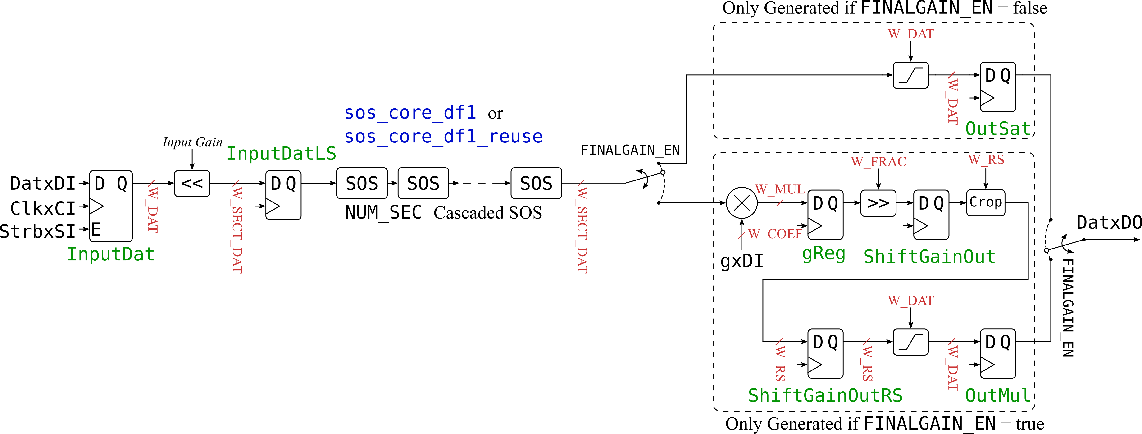

Configuration
The filter’s top-level file is sos_cascaded_top.vhd. It can be configured with the following VHDL generics. These generics are provided by the Python script Config_IIR.py
- NUM_SEC (Integer)
Number of cascaded SOS sections. Maximum value: 255
- W_DAT_INPUT (Integer)
Width of the (signed) filter input data (bits)
- GAIN_INPUT (Integer, must be power of 2)
This gain is applied to the input signal before it is passed through the filter. Usable to increase the filter’s precision (more bits available due to the left-shift operation of this gain).
- W_SECT_DAT (Integer)
Width of the cascaded SOS data-path (bits). Due to the input gain, and potentially due to the output gain and SOS-gains, the SOS require wider data vectors in order not to lose data.
- W_COEF (Integer)
Width of the (quantized) coefficients (bits)
- W_FRAC (Integer)
Fraction width (in bits) of the quantized coefficients. Together with W_COEF, this defines the Q-notation of the filter coefficient quantization.
- SOSGAIN_EN (Bool)
If set to true, each biquad has a gain-stage at its output. If set to false, this additional multiplication-hardware is omitted / not generated.
- FINALGAIN_EN (Bool)
If set to true, there is a gain-stage at the output of the filter (at output of last SOS in the cascade). If set to false, this additional multiplication hardware is omitted / not generated.
- W_DAT_OUTPUT (Integer)
Width of the (signed) filter output data (bits). The output of the filter is saturated to this signed data width, there is no overflow.
- W_DAT_INTF (Integer)
Width of the data/address signals of the generic filter coefficient interface.
- USE_PIPELINE_CORE (Bool)
If set to true, the pipelined implementation of the filter is used (sos_core_df1.vhd; uses more multipliers, but can operate at higher clock rates). If set to false, the multiplier of each SOS is reused (sos_core_df1_reuse.vhd), hence only one multiplier per SOS is required (uses less multipliers, but cannot operate at higher clock rates due to the additional logic required to feed the multiplier with the correct data).

Coefficient Data Interface
The coefficients are provided to the filter via a simple data interface that can easily be adapted to interfaces like Wishbone or Axi. Its signals are:
- SectAddrxDI
Address of the SOS for which the coefficients are provided. Range: 0 to NUM_SEC.
Note: When SectAddrxDI = NUM_SEC and CoeffAddrxDI = 6, the final output gain of the whole filter (FinalGain) is addressed (see also below).
- CoeffAddrxDI
Address of the biquad coefficient. Range: 0-6. Coefficient mapping:
CoeffAddrxDI | SOS Coefficient
0 | b0
1 | b1
2 | b2
3 | a1
4 | a2
5 | g (Section output gain)
6 | FinalGain (SectAddrxDI must be = NUM_SEC to write this coefficient)
- CoeffDatxDI
Coefficient data
- CoeffValidxSI
Coefficients are only written to the filter if this valid-signal is logic high.

Revision History
Initial project setup and commit | Mario Mauerer (MM) | Zürich, 5. June 2017

