**“**Multilingual Chat-Bot**”**

**A**

**PROJECT REPORT**

***Submitted by***

|  |  |  |
| --- | --- | --- |
| **Sr. No.** | **Name** | **Enrollment No.** |
| 1 | Sneh Raval | 200390107024 |
| 2 | Maulik Mangukiya | 200390107007 |
| 3 | Shivam Rathore | 200390107009 |
| 4 | Prerna Parmar | 200390107028 |
| 5 | Pratik Solanki | 200390107045 |

***Guided by***

**Prof. Avani Dedhia**



**CERTIFICATE**

(Online copy downloaded from GTU website)

Table of Contents

**1. Introduction** **5**

1.1 Domain Introduction 5

1.2 Why did we choose this topic? 5

2. LATERAL Thinking **6**

2.1 White Hat 6

2.2 Red Hat 6

2.3 Green Hat 6

2.4 Yellow Hat 7

2.5 Black Hat 7

2.6 Blue Hat 7

3. Literature Review – CASE STUDY **8**

4. SCAMPER Tool & its application **9**

**5. AEIOU CANVAS** **10**

6. Empathy Canvas **11**

**7. Mind Mapping Canvas** **12**

8. Ideation Canvas **13**

9. Product Development Canvas **14**

**10. Learning Need Matrix** **15**

**11. Prototype** **16**

**List of Figures**

**1. Introduction** **5**

1.1 Domain Introduction 5

1.2 Why did we choose this topic? 5

**2. LATERAL Thinking** **6**

2.1 White Hat 6

2.2 Red Hat 6

2.3 Green Hat 6

2.4 Yellow Hat 7

2.5 Black Hat 7

2.6 Blue Hat 7

**3. Literature Review – CASE STUDY** **8**

**4. SCAMPER Tool & its application** **9**

**5. AEIOU CANVAS** **10**

**6. Empathy Canvas** **11**

**7. Mind Mapping Canvas** **12**

**8. Ideation Canvas** **13**

**9. Product Development Canvas** **14**

**10. Learning Need Matrix** **15**

**11. Prototype** **16**

# 

# 1. Introduction

## 1.1 Domain Introduction

Conversational AI is a set of technologies that enable computers to understand, process, and respond to voice or text inputs in natural ways, and is typically used in conjunction with bots or intelligent virtual agents (IVAs). Done well, it helps people interact with complex systems in faster and easier ways, and helps businesses deliver personalized engagements and support at scale.

## 1.2 Why did we choose this topic?

Farming is the backbone of India. Farmers lose their yield because they lack knowledge of new technologies and different parameters that help them increase their yield. Our proposed system performs machine learning analysis on all the valuable parameters required for increasing the farmers yield .We analyze the weather , season, rainfall ,and type of soil of a region and based on historic data train the system to suggest which crops to grow , and which mix crops grown together increase their yield We also answer all these farmers questions using auto-chat bot .This chat bot is NLP trained hence it learns on its own and improvises its answers .This system helps farmers in remote places where no connectivity is present to better understand the crop to be grown based on atmospheric conditions and also answer their basic questions on farming

# 2. LATERAL Thinking

Following the rules written by Edward De Bono, we defined the six thinking Hats mentioned below:

## 2.1 White Hat

Observations under White Hat are like:

* What are the facts?
* What information is available & what is missing?
* How am i going to get the missing places?

The answer we got after thinking are:

* Most of the farmers are uneducated.
* Information is available on internet but they don't know.
* We can make changes to usual system.

## 2.2 Red Hat

Observations under Red Hat are like:

* What do you feel?
* I love this… I like that…
* What is your gut feeling?

The answer we got after thinking are:

* Gut Feeling
* Chatbot will help farmers to get information about farming

## 2.3 Green Hat

Observations under Green Hat are like:

* Get into the creative mode of thinking.
* Look for new ideas and new solutions from other domains
* You can use SCAMPER

The answer we got after thinking are:

* **Combine** = Alexa’s Features
* **Adapt** =.Adapted Voice of Alexa In the Chatbot
* **Modify** = Text to Speech

## 2.4 Yellow Hat

Observations under Yellow Hat are like:

* What are the positive points about your idea?
* How is it effective?
* What are the benefits and advantages?

The answer we got after thinking are:

* Saves time and makes easy access
* It is more efficient and effective
* Wide range of benefits

## 2.5 Black Hat

Observations under Black Hat are like:

* What are the risks/ dangers involved?
* Are there any grave disadvantages?
* Are there any difficulties in the idea?

The answer we got after thinking are:

* Language Barriers
* Low Accuracy Of Chatbot

## 2.6 Blue Hat

Observations under Blue Hat are like:

* This hat controls and organizes
* Sets focus if people go off-topic
* Gives the Summary & sees the big picture - if we have missed anything

The answer we got after thinking are:

* Compare it with database
* Shows the result on screen

# 3. Literature Review – CASE STUDY

* The evolution of User Interfaces has been amazing. From Command Line Interface (CLI) to Graphical User Interface (GUI) to the new era of Voice-enabled User Interface, there is a paradigm shift in how users interact with a system (or vice versa).
* Amazon Alexa is a voice-activated personal assistant that allows users to speak their Amazon Echo, Echo Dot, and other Amazon smart home devices. By default, Alexa comes with some basic capabilities such as playing music, reading the latest news, pulling up the weather etc. However, this is not the only thing that can be done with Amazon Alexa. By building Alexa Skills, businesses can give more abilities and power to Alexa to help, entertain, and inform the users.

# 4. SCAMPER Tool & its application

Scamper is a tool that’s helpful to generate a series of thought sparkers which help to innovate an existing product, service, or situation by looking through different perspectives.

C - Combine - Alexa’s Features

A - Adapt - Adapted Voice of Alexa In the Chatbot

M - Modify/Magnify - Text to Speech

# 5. AEIOU CANVAS

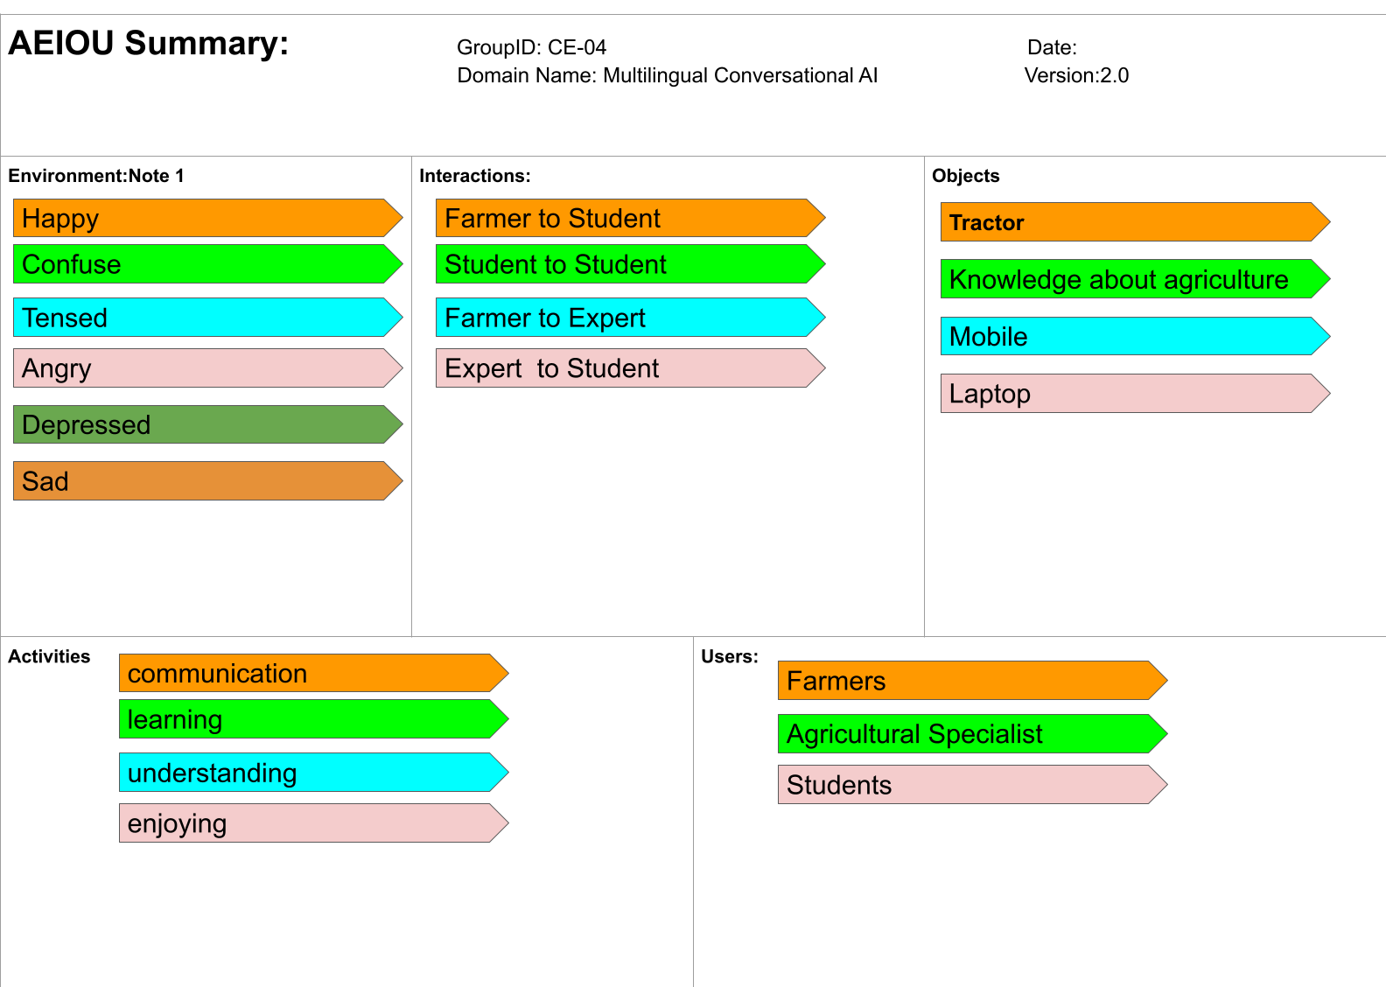All the above observations are recorded in our AEIOU:

**Figure 4: AEIOU Canvas**

# 6. Empathy Canvas

To understand our users, customers and stakeholders better, we conducted interviews to understand their association with the domain and presented it in the form of happy and sad stories in the canvas below:

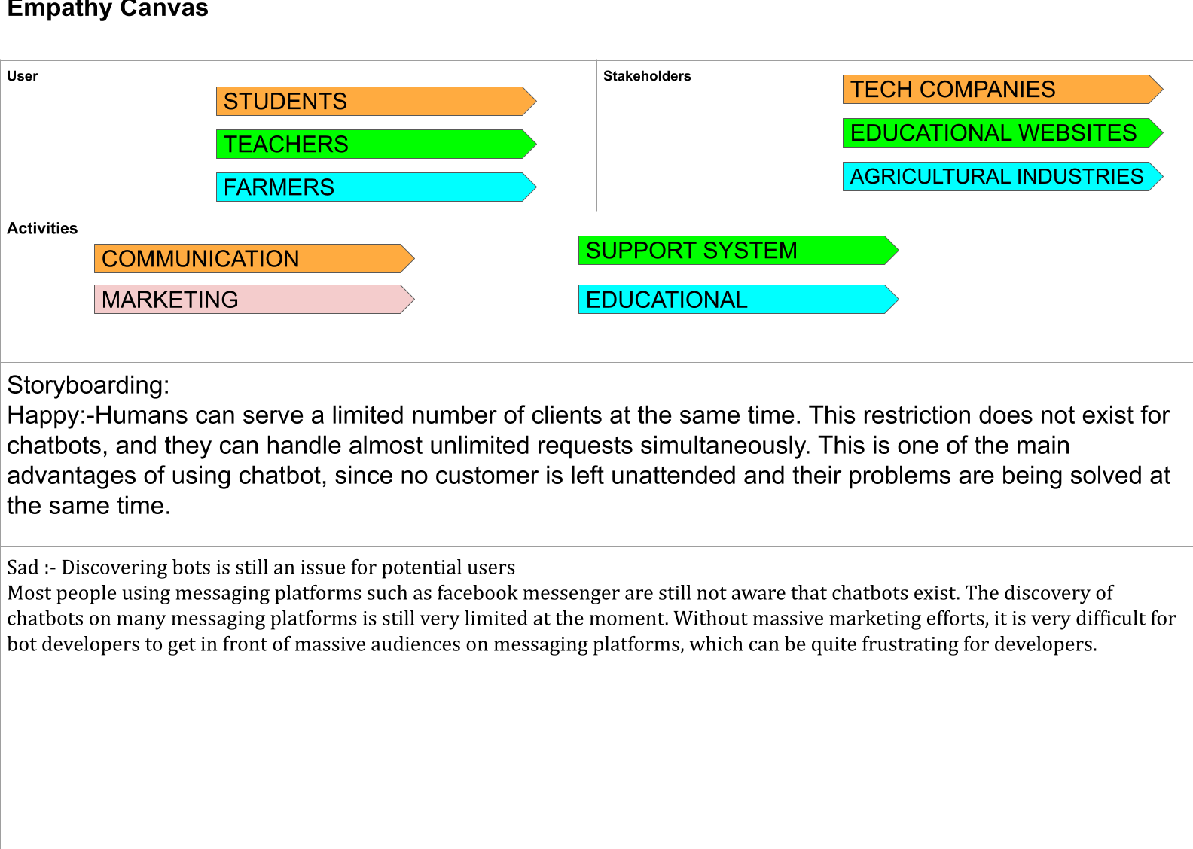

**Figure 5: Empathy Canvas**

# 

# 7. Mind Mapping Canvas

We then bifurcated our main domain into branches for easy understanding and made the mind mapping sheet as follows:

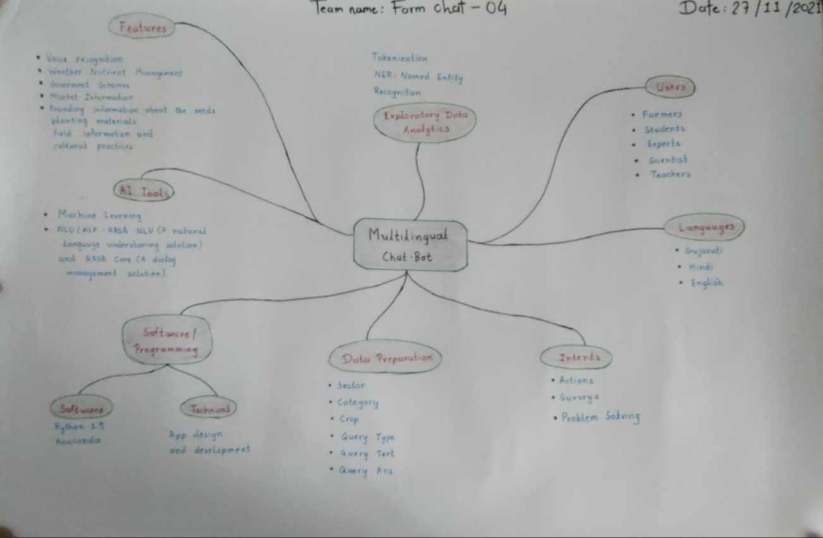

**Figure 6: Mind Mapping Canvas**

# 8. Ideation Canvas

The Ideation sheet that we made is shown as below:

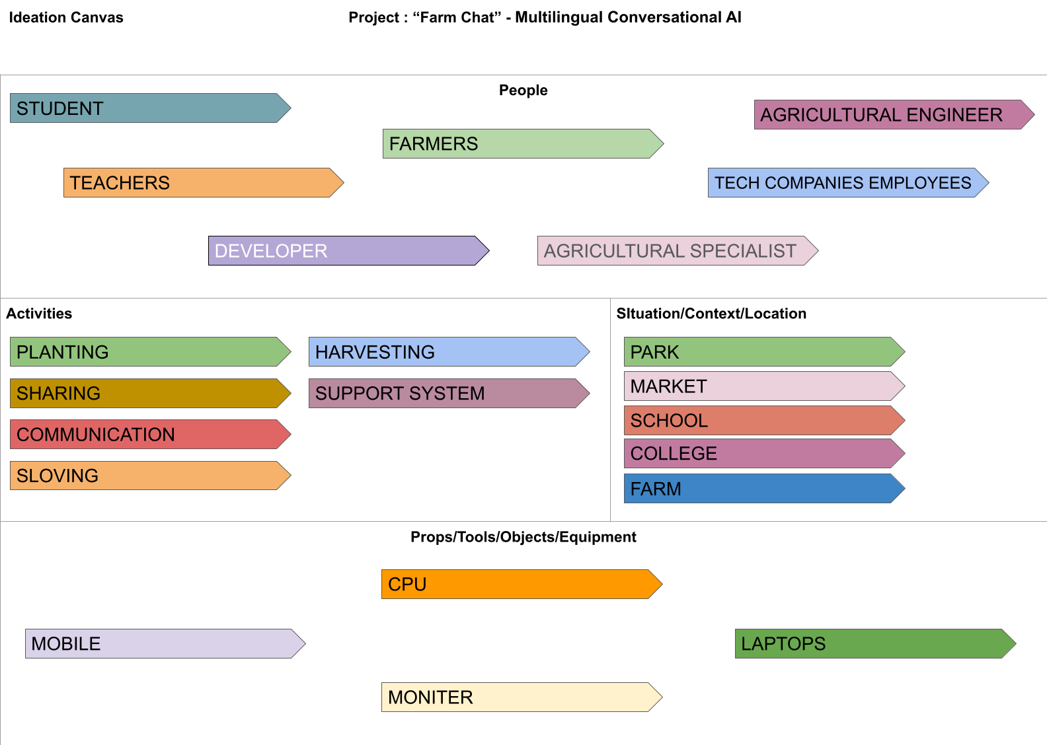

**Figure 7: Ideation Canvas**

# 9. Product Development Canvas

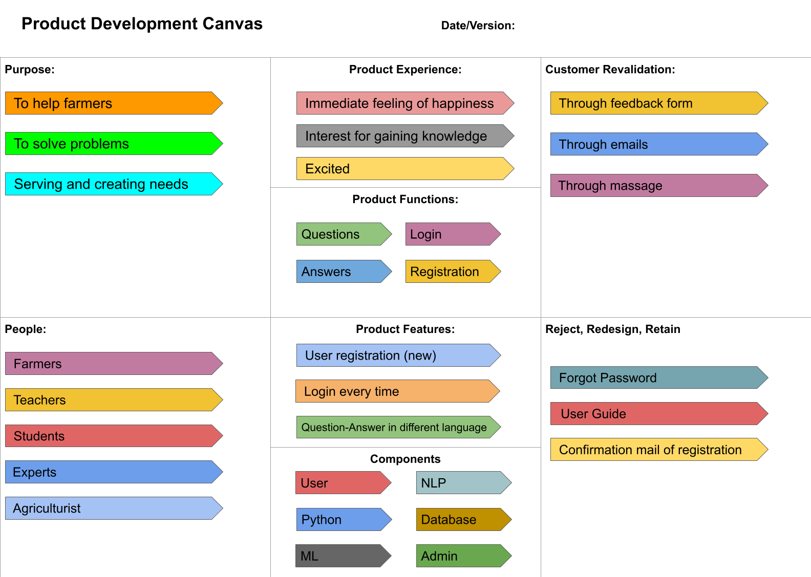

**Figure 8 : Product Development Canvas**

# 

# 

# 

# 10. Learning Need Matrix

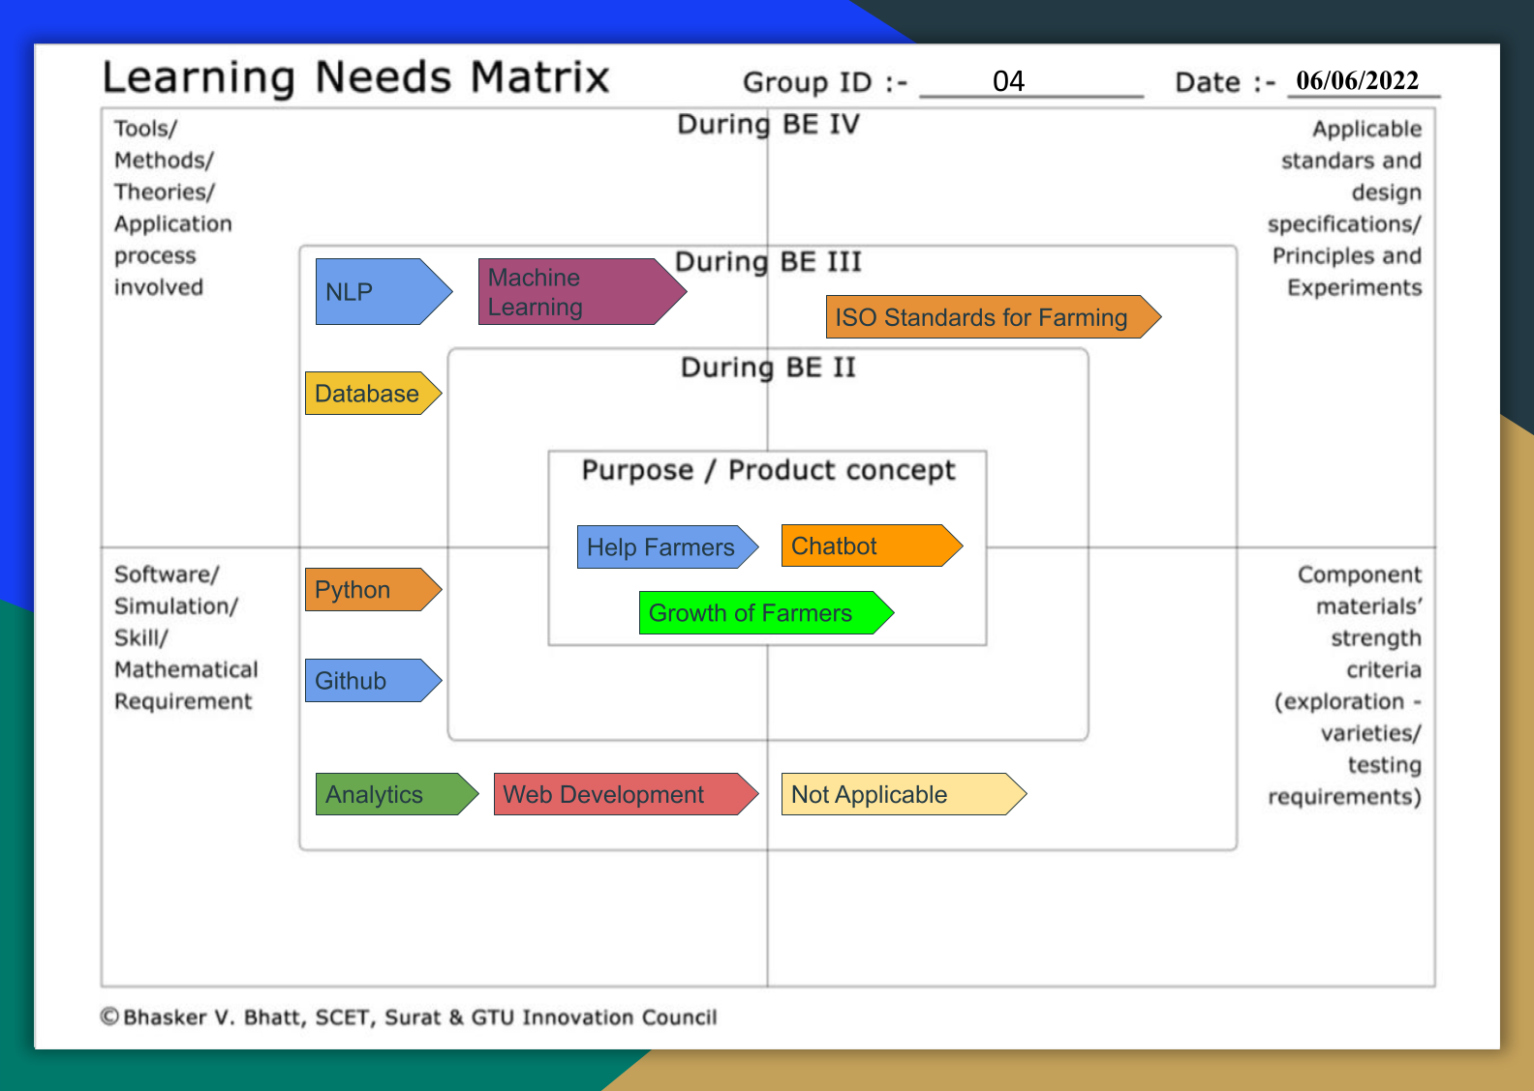

**Figure 9 : Learning Need Matrix**

# 

# 

# 

# 11. Prototype

**Figure 10 : Prototype Page**

