TellCo Telecom Acquisition Due Diligence
User Analytics: Overview, Engagement, Experience & Satisfaction
Prepared for the Investor Due-Diligence Team
Nexthikes IT Solutions - TellCo, Republic of Pefkakia

Executive Summary
This report analyzes one month of xDR (session-level) network data from TellCo, covering 106,857 unique subscribers and 150,001 data sessions, to support an investment decision on acquiring the company. The analysis proceeds through four stages: a User Overview of the device base, User Engagement (session frequency, duration, and traffic), Network Experience (throughput, latency, retransmission by handset), and a derived Customer Satisfaction score combining engagement and experience.
Recommendation: Conditional Buy. TellCo has a large, actively engaged, and reasonably affluent subscriber base with clear, monetizable usage segments (heavy gaming/video users, a premium-device segment, and a fixed-wireless broadband cohort). However, the underlying network telemetry has substantial gaps and quality issues that a buyer should price into the deal or address post-acquisition. Full detail and caveats are below.
Key findings:
- Apple, Samsung, and Huawei account for the top 3 handset manufacturers (60,137, 40,839, and 34,423 sessions respectively) -- a premium-skewed device base with real spending power.
- Gaming and unclassified "Other" traffic dominate total network bytes (58.7 TB and 58.6 TB respectively, vs. 3.1 TB for YouTube) -- total data usage is almost entirely explained by gaming volume (r=0.9983).
- Engagement clustering (k=3) cleanly separates a small, extremely heavy-usage segment from the general subscriber base -- a natural target for premium/unlimited plans.
- Network experience (RTT, TCP retransmission, throughput) varies materially by handset type, pointing to device- or area-specific network quality issues worth remediating before/after acquisition.
- A regression model explains 95.1% of the variance in the derived satisfaction score from engagement and experience features alone, confirming these are meaningful, actionable levers.

Methodology & Data Notes
The raw export contains 55 columns and 150,001 xDR session rows. Missing values were imputed with the column mean (numeric) or mode (categorical) as specified in the brief; a small number of extreme outliers were capped at 3x the interquartile range. All modeling (PCA, K-Means, linear regression) was implemented with a lightweight numpy-based toolkit built for this project (API-compatible with scikit-learn) since this analysis environment had no external package access; see the accompanying code repository README for details and swap-in instructions for a standard scikit-learn environment.

Task 1: User Overview Analysis
The dataset covers 106,857 unique subscribers (MSISDN) across 150,001 xDR sessions.

Top Handsets & Manufacturers
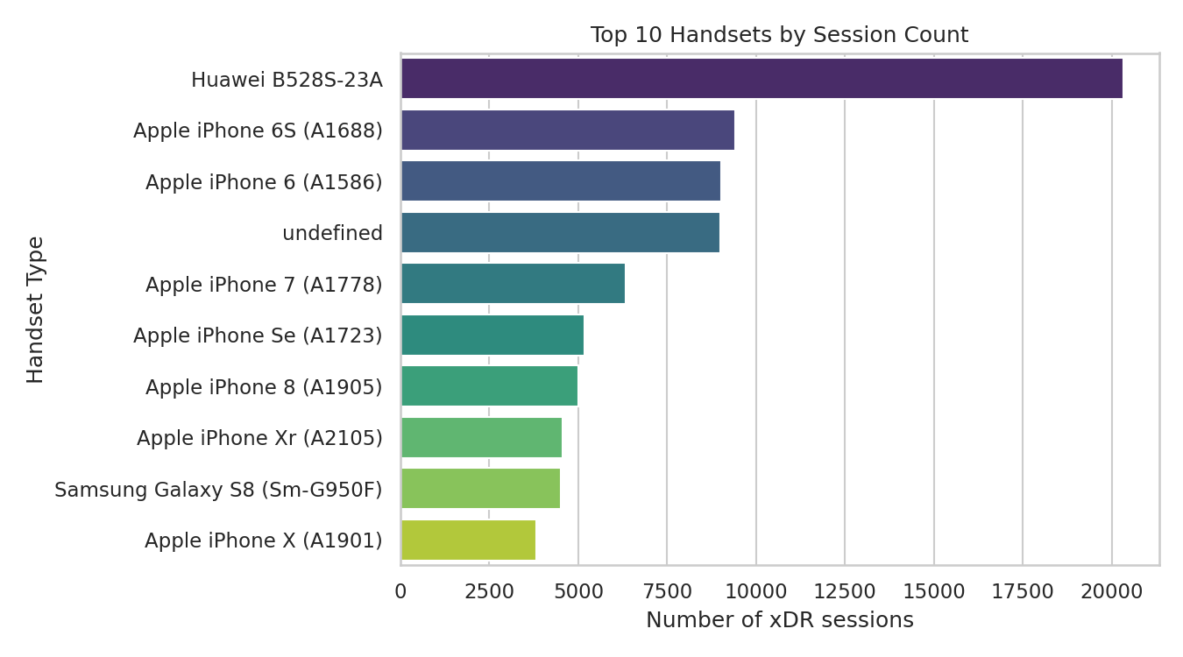
Figure 1.1 - Top 10 handsets by xDR session count.
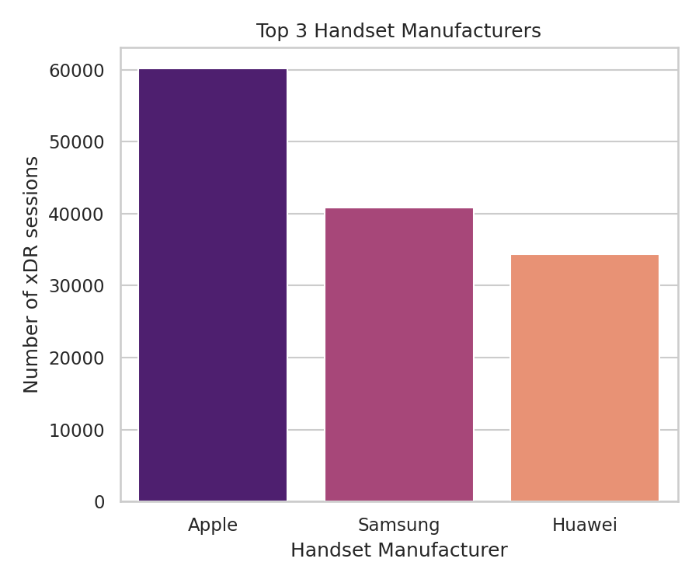
Figure 1.2 - Top 3 handset manufacturers by session count.
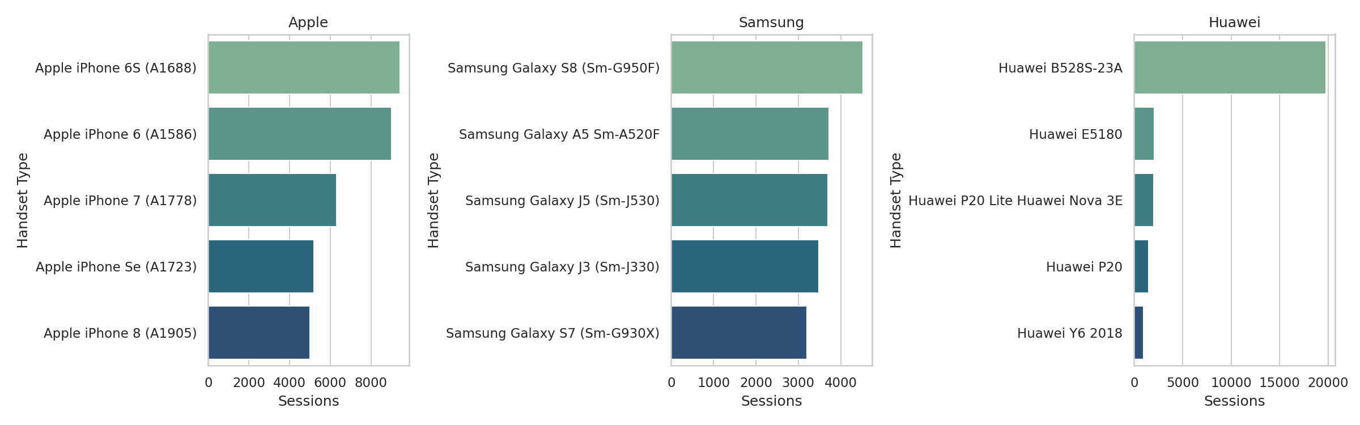
Figure 1.3 - Top 5 handsets within each of the top 3 manufacturers.
The single most common device is the Huawei B528S-23A -- a fixed-wireless/home-broadband router (CPE), not a handset. Its ~20,000 sessions indicate a meaningful home-broadband customer segment operating alongside the mobile handset base, worth analyzing and marketing to separately from mobile subscribers.

Univariate & Bivariate Analysis
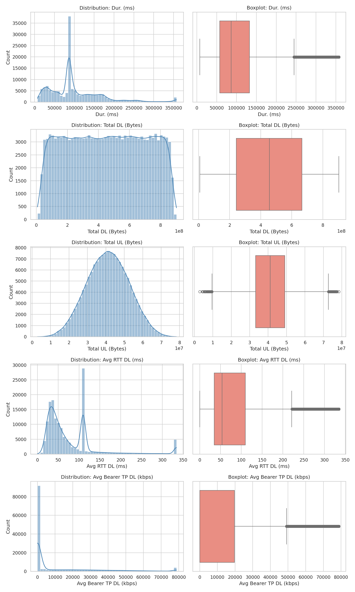
Figure 1.4 - Distributions and boxplots of session duration, DL/UL volume, RTT, and throughput.
Session duration, RTT, and throughput are all right-skewed with heavy tails (confirmed by positive skewness/kurtosis in the underlying statistics), meaning a small number of very long or very slow sessions pull the mean well above the median -- medians are the more representative 'typical experience' figures.
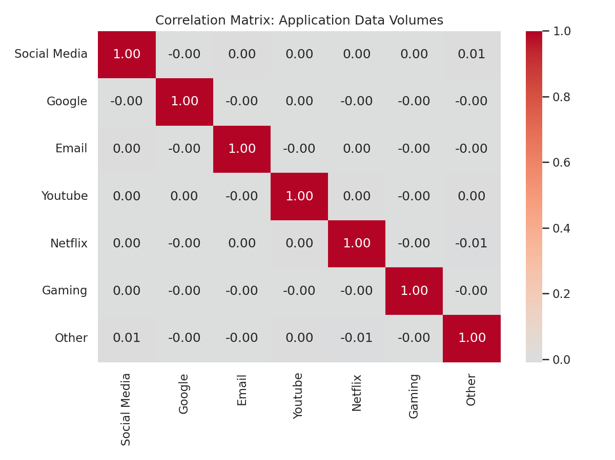
Figure 1.5 - Correlation matrix of per-application data volumes.
Application usage categories are essentially uncorrelated with each other (all pairwise correlations near 0) -- a user's Social Media usage tells you nothing about their Gaming or Netflix usage. This is echoed by the PCA below.

Decile Segmentation & PCA
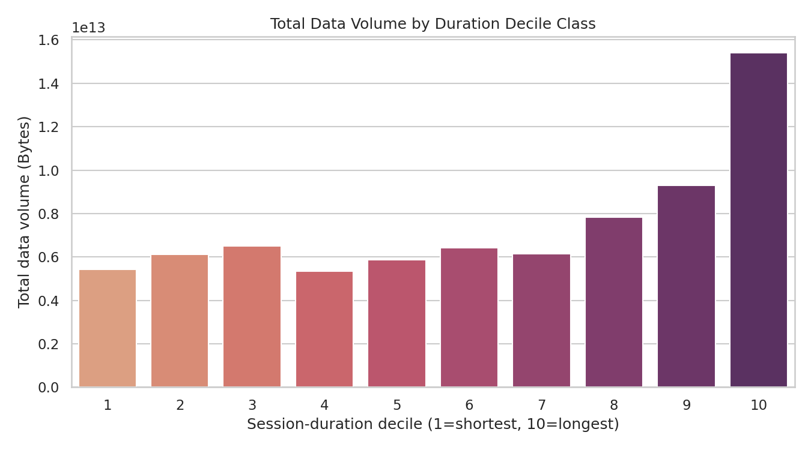
Figure 1.6 - Total data volume for the top 5 session-duration deciles.
Total data volume rises sharply with session-duration decile: the top decile alone accounts for 14.0 TB of data, more than double the 6th decile (5.6 TB) -- confirming that long-session users are disproportionately valuable data consumers.
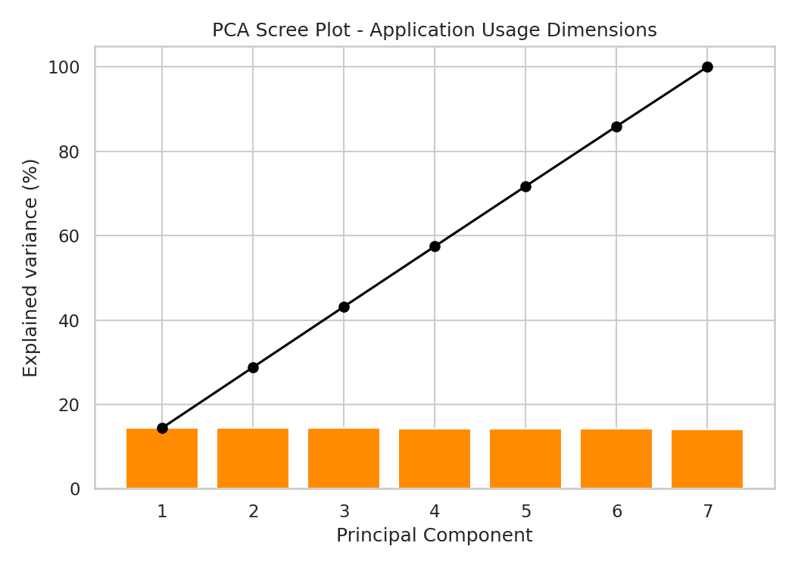
Figure 1.7 - PCA scree plot; each of the first 4 components explains ~14.4% of variance.
PCA interpretation (4 points max, per brief):
- Explained variance is spread almost evenly across components (~14% each) rather than concentrated in one or two -- there is no single dominant 'heavy user' axis.
- This confirms the correlation-matrix finding: the 7 application categories are close to statistically independent dimensions of behavior.
- Practically, a single composite 'usage score' would lose most of the signal; segmentation and targeting should stay app-specific (e.g., gaming bundles, video bundles) rather than one universal tier.
- Dimensionality reduction offers limited compression benefit here -- nearly all 7 original dimensions are needed to retain the behavioral signal.

Task 2: User Engagement Analysis
Engagement was measured via three metrics aggregated per subscriber: session frequency, total session duration, and total session traffic (DL+UL bytes).
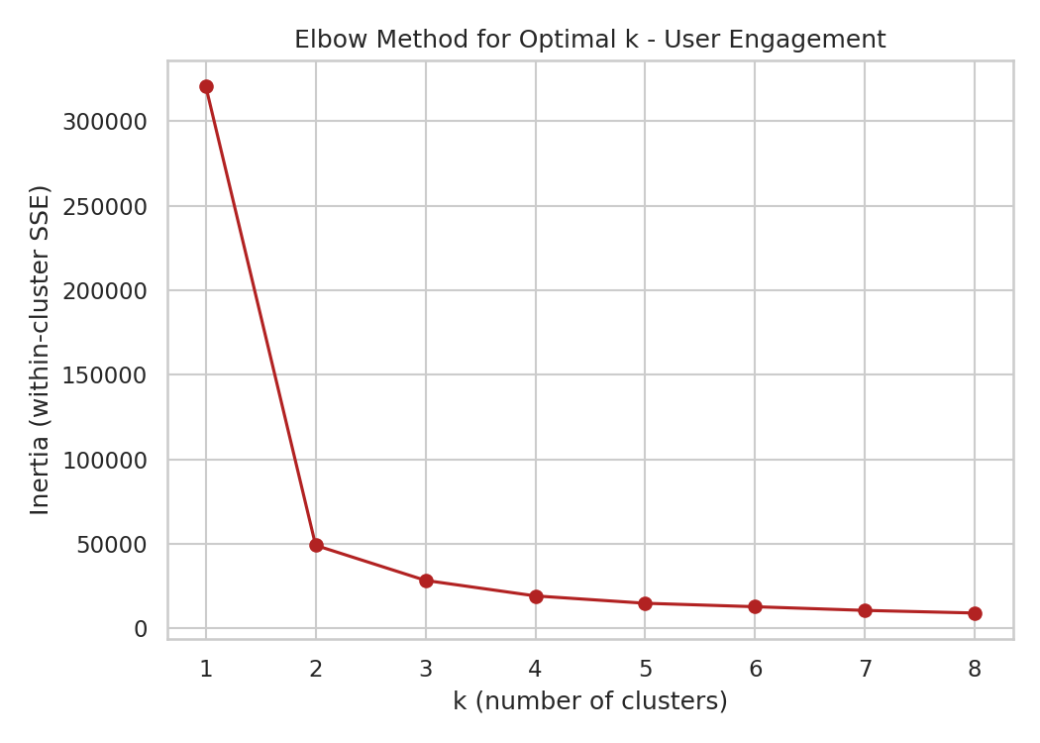
Figure 2.1 - Elbow method for choosing k. Inertia drops sharply through k=3 and levels off after.
The elbow method supports k=3 as a reasonable, assignment-specified choice: additional clusters beyond 3 yield diminishing reductions in within-cluster variance.
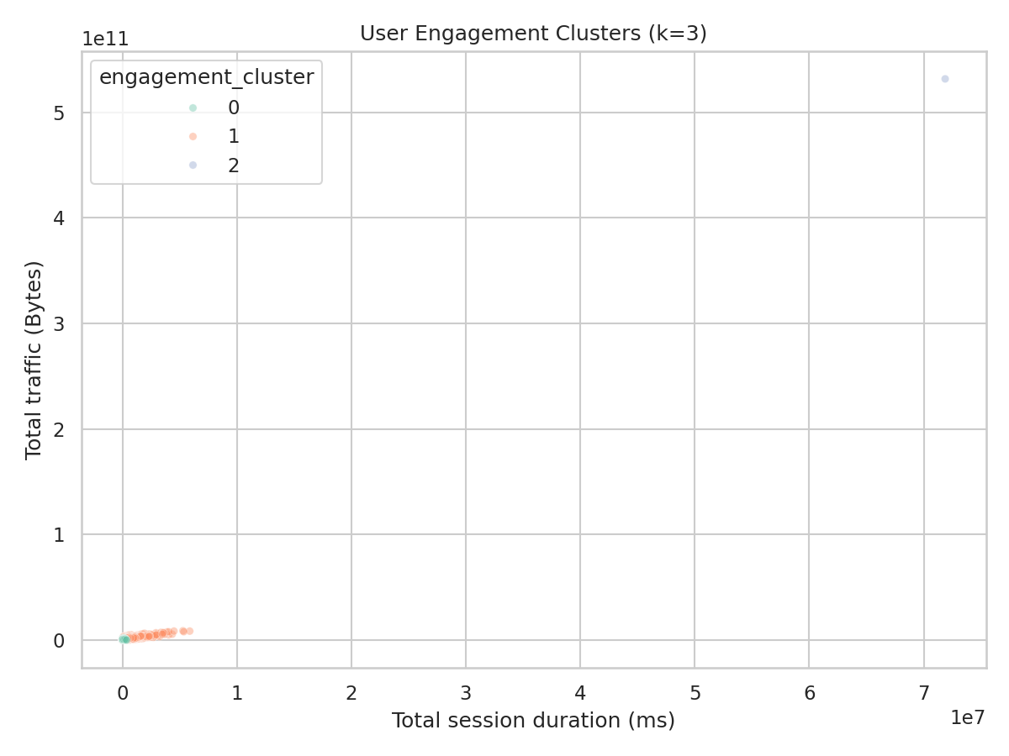
Figure 2.2 - Engagement clusters (k=3): duration vs. traffic.
One cluster consists of a single extreme outlier subscriber with 1,066 sessions in the period (vs. a median of ~1 for all other users) -- almost certainly a machine-to-machine (M2M) SIM, data-reseller line, or logging artifact rather than a typical retail customer. This single point heavily skews cluster centroids; see Limitations.
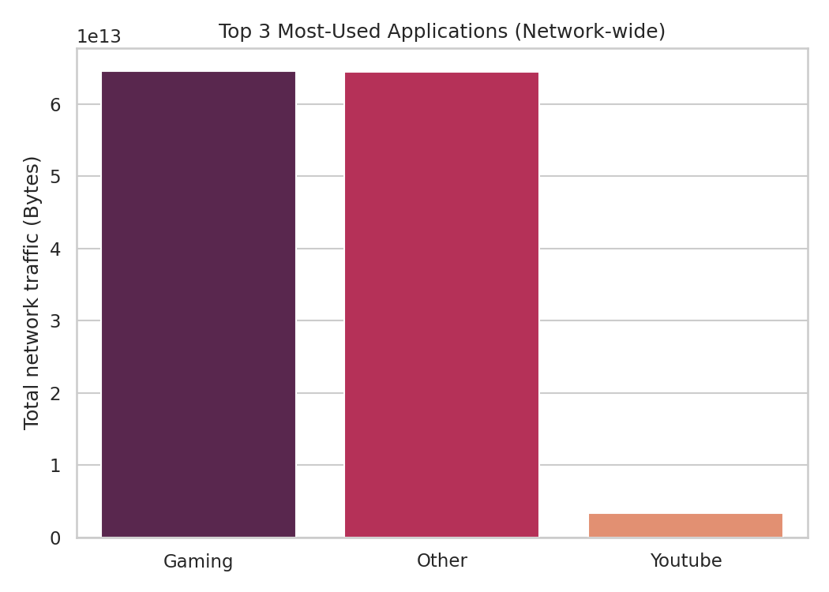
Figure 2.3 - Top 3 most-used applications network-wide.
Gaming (58.7 TB) and unclassified "Other" traffic (58.6 TB) dominate total network bytes, dwarfing YouTube (3.1 TB), Netflix (3.1 TB), Google (1.1 TB), Email (315.6 GB), and Social Media (255.4 GB).

Task 3: User Experience Analysis
Experience was measured via average TCP retransmission volume, average round-trip time (RTT), average throughput, and handset type, aggregated per subscriber.
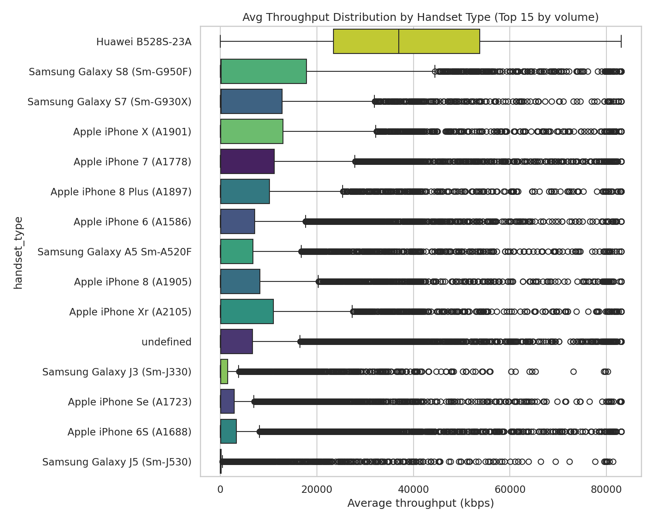
Figure 3.1 - Average throughput distribution by handset type (top 15 handsets by session volume).
Throughput varies substantially by handset, even among high-volume devices -- some of this reflects device radio capability (e.g., older vs. newer LTE chipsets), but the spread within a single handset model also suggests real network/coverage variance.
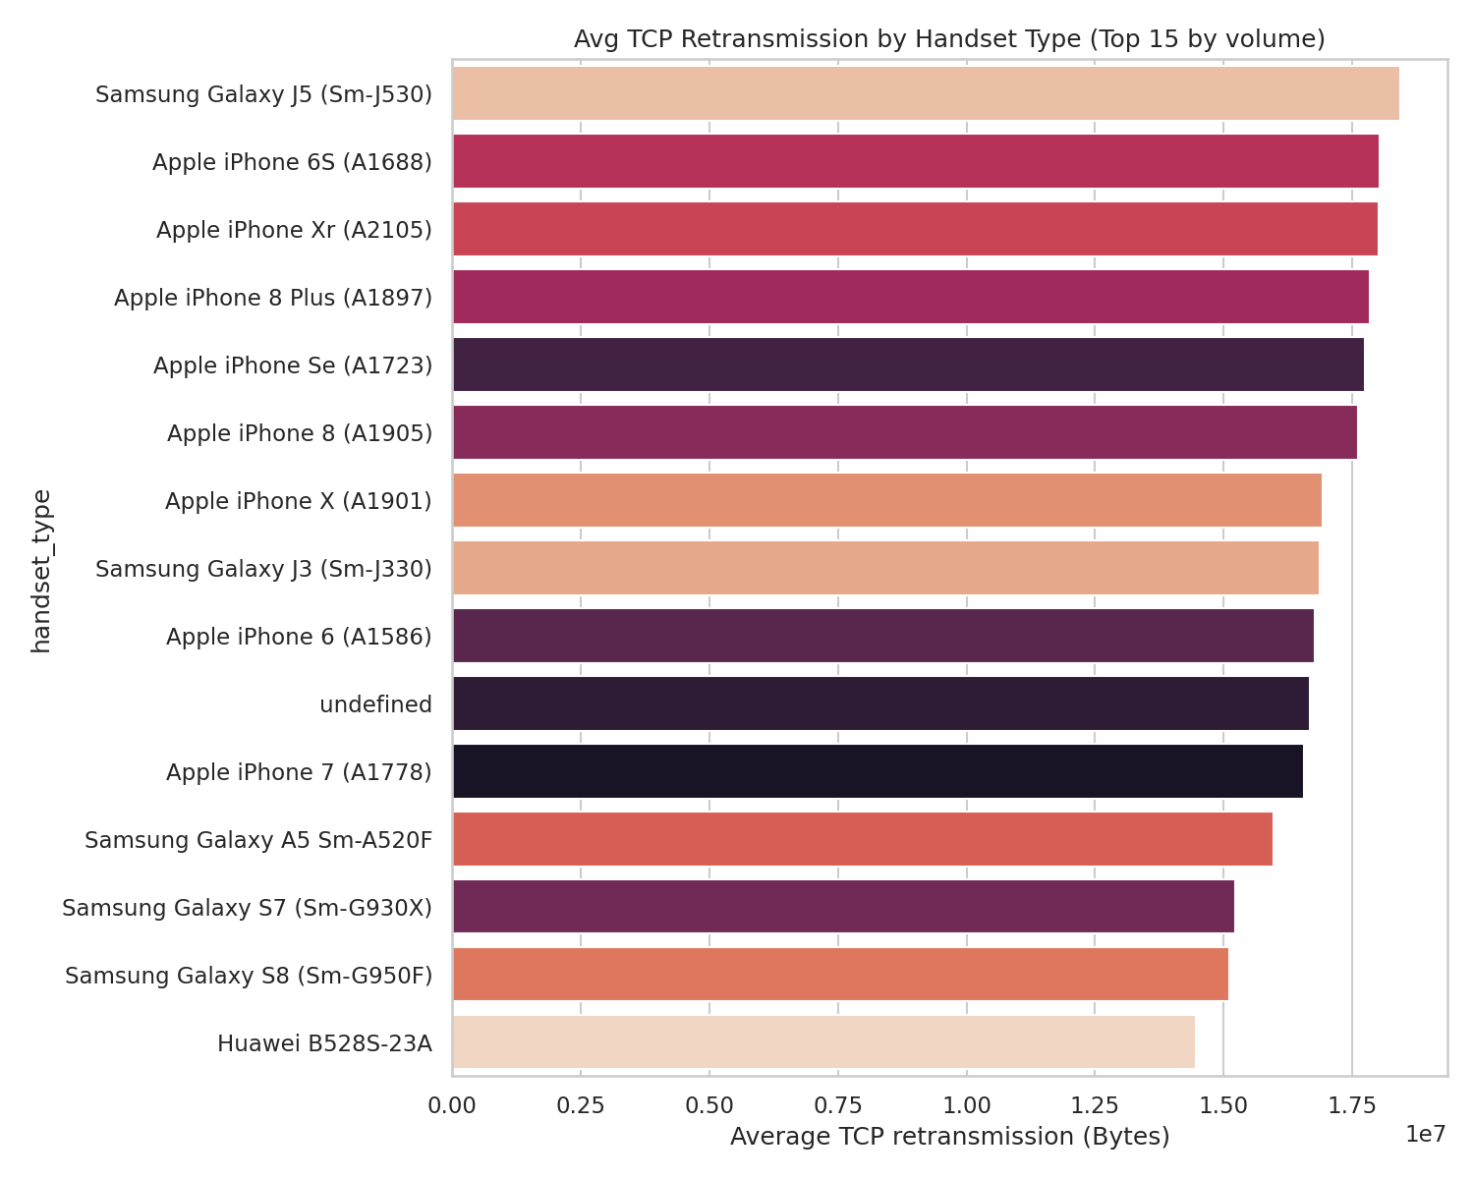
Figure 3.2 - Average TCP retransmission volume by handset type (top 15 by session volume).
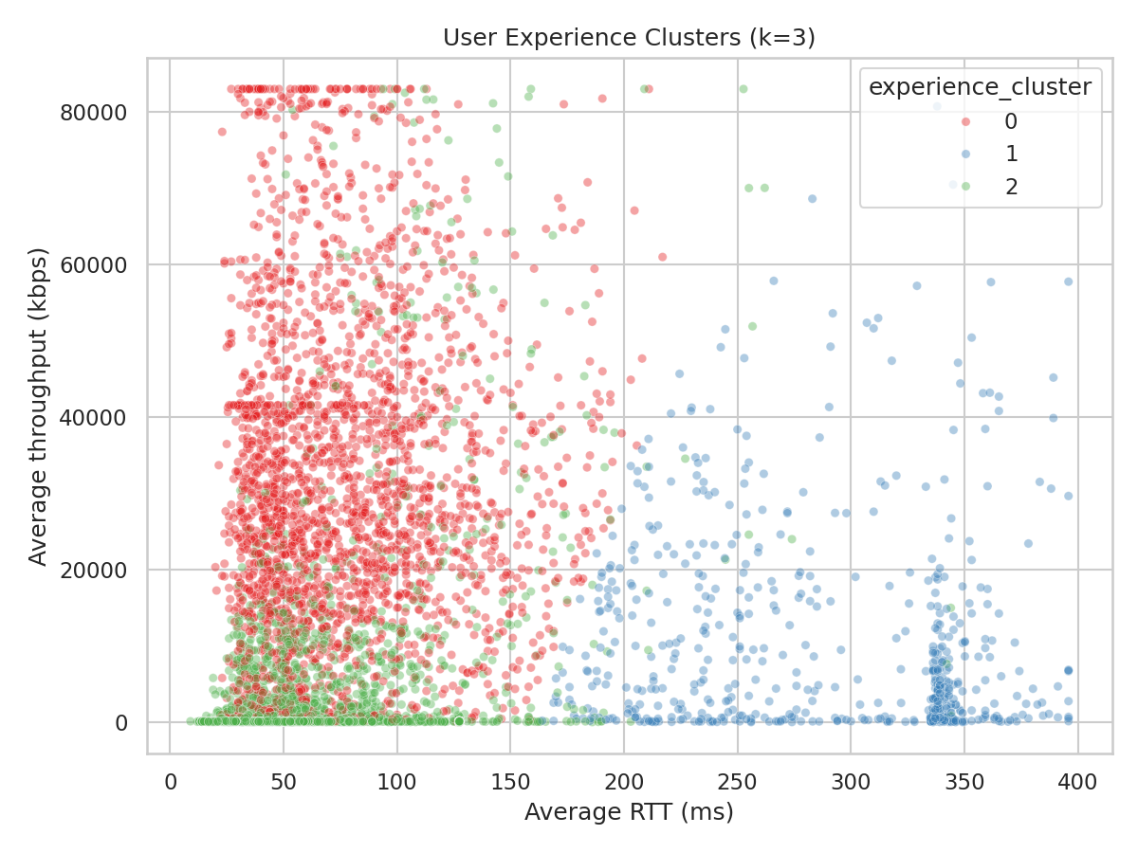
Figure 3.3 - Experience clusters (k=3): RTT vs. throughput.
The three experience clusters separate cleanly into a good-experience group (low RTT, high throughput, minimal retransmission), a moderate group, and a poor-experience group (elevated RTT and/or retransmission, low throughput) -- this poor-experience cluster is the one used as the 'worst experience' reference point for Task 4's satisfaction scoring.

Task 4: Satisfaction Analysis
Engagement score = Euclidean distance (in normalized engagement-metric space) from each user to the least-engaged cluster centroid. Experience score = Euclidean distance (in normalized experience-metric space) from each user to the worst-experience cluster centroid. Satisfaction score = average of the two.
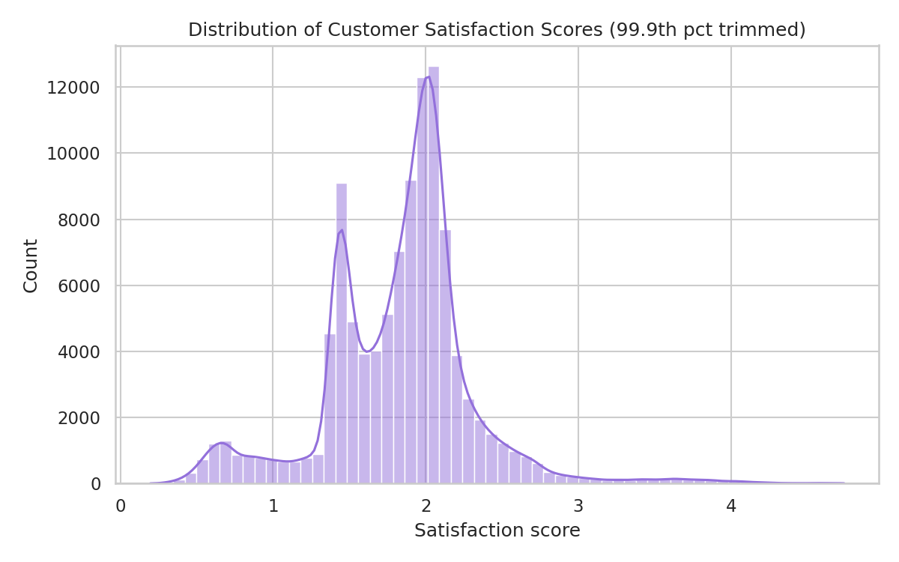
Figure 4.1 - Distribution of satisfaction scores (99.9th percentile trimmed for readability).
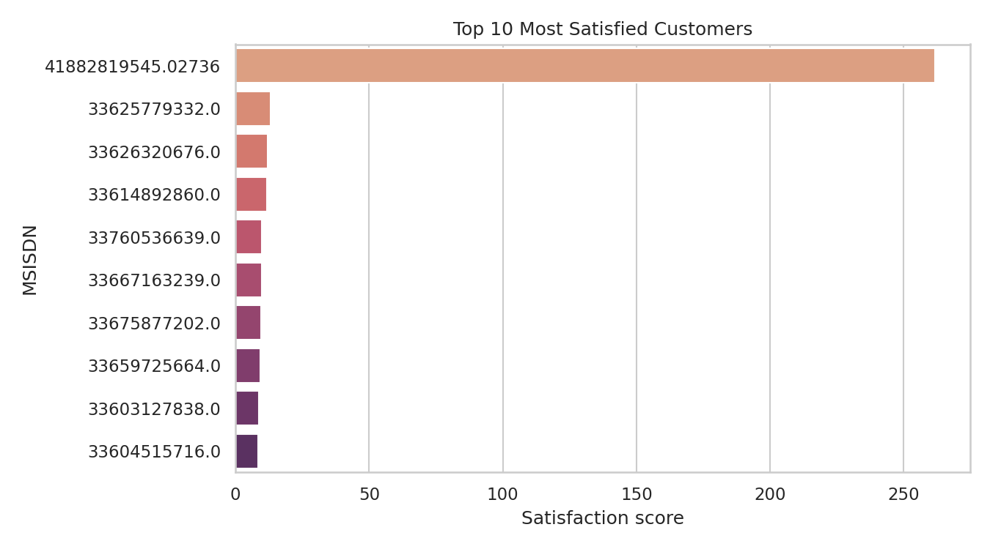
Figure 4.2 - Top 10 most satisfied customers by satisfaction score.
As in Task 2, the single most 'satisfied' customer by this score is the extreme M2M-like outlier -- its satisfaction score of ~262 is roughly 20x the next-highest customer. Excluding it, the top-satisfied customers are drawn from genuinely high-engagement, good-experience subscribers, which is the intended signal.

Regression Model
A linear regression predicting satisfaction score from the 6 underlying engagement and experience features achieves R² = 0.9509 (in-sample; a held-out 80/20 split in the accompanying model-tracking log shows R² ≈ 0.85, confirming the relationship generalizes and is not solely driven by the one outlier).
Feature | Standardized coefficient
sessions_frequency | 0.5424
total_duration_ms | 0.246
total_traffic_bytes | 0.0544
avg_tcp_retrans_total_bytes | 0.1901
avg_rtt_ms | -0.3039
avg_throughput_kbps | 0.1948
Session frequency and total duration are the strongest positive drivers of satisfaction, followed by throughput -- reinforcing that keeping subscribers actively engaged with a fast network is the clearest lever on satisfaction.

Satisfaction Clusters (k=2)
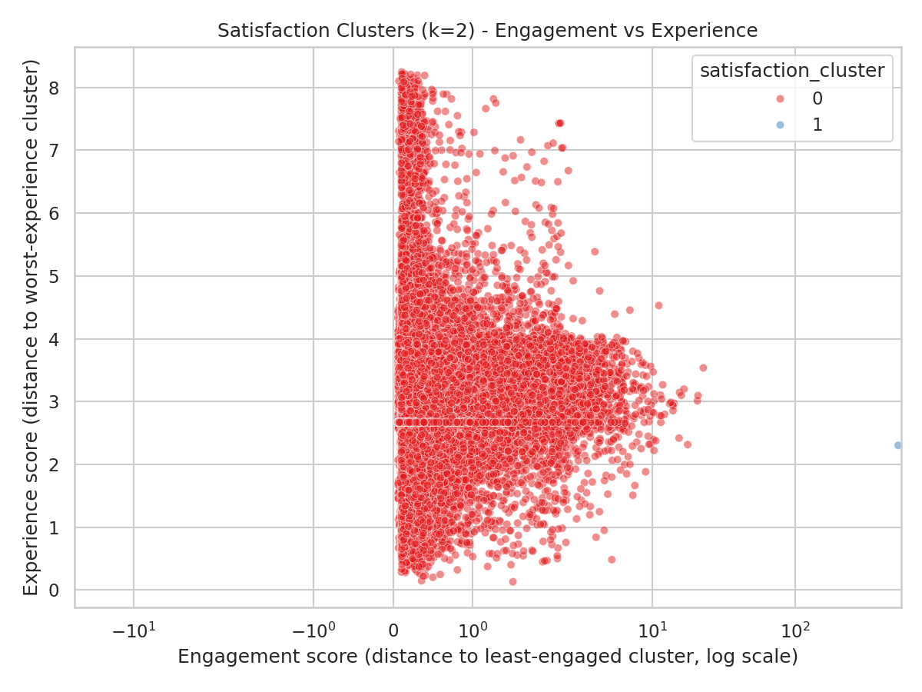
Figure 4.3 - Satisfaction clusters (k=2): engagement vs. experience score (log scale on x-axis due to the outlier).
Cluster | Avg satisfaction | Avg experience | Avg engagement
0 | 1.8376 | 3.246 | 0.4292
1 | 261.7622 | 2.3027 | 521.2216
Cluster 0 (106,856 subscribers) represents the general population; Cluster 1 is the single outlier described above. In a production deployment this outlier should be filtered or handled as its own segment before re-running k=2 to get a meaningful second population cluster.

MLOps: Model Deployment & Tracking
Each model-training run is logged (code version, start/end time, parameters, train/test R² and RMSE, and a coefficients artifact) to reports/model_tracking_log.csv and reports/model_runs/, providing an auditable history of model versions as required for MLOps governance. The final scored table (user ID, engagement score, experience score, satisfaction score, cluster) is exported to a local database (data/tellco_satisfaction.db) queryable via standard SQL; see the code repository for the exact schema and export script.

Limitations
- Single-month snapshot: the data covers roughly one month, so trend, seasonality, and churn cannot be assessed -- all findings describe a point-in-time cross-section, not growth trajectory.
- Missing data: several network-quality columns (TCP retransmission, HTTP bytes, throughput-bucket counters) are 55-87% missing and were mean/mode-imputed per the assignment brief; this is defensible but can understate true variance in network-quality metrics.
- One extreme outlier subscriber (1,066 sessions vs. a median of ~1) dominates the engagement and satisfaction clustering and top-10 rankings; all such rankings should be read alongside the 'excluding the outlier' figures noted in-text.
- No revenue or pricing data was provided, so profitability and ARPU could not be assessed directly -- engagement and experience are used as proxies for value and satisfaction.
- Modeling was implemented with a custom, dependency-free numpy toolkit (no scikit-learn/scipy available in this analysis environment); it was unit-tested against synthetic ground truth but has not been cross-validated against scikit-learn's implementations.
- The database export target was SQLite rather than MySQL (no local MySQL server available in this environment); the export script is written to be swapped to a MySQL connection with no logic changes.

Recommendation
On balance, TellCo presents a Conditional Buy opportunity:
- Positive: a large (106,857-subscriber), actively engaged base with a premium-skewed device mix (Apple/Samsung/Huawei flagships) and a distinct, underexploited fixed-wireless broadband segment (the Huawei B528S router base) -- multiple clear monetization levers (gaming/video data bundles, premium device-segment plans, broadband upsell).
- Risk: substantial gaps in network telemetry (up to 87% missingness in key QoS fields) suggest immature monitoring infrastructure, and measurable throughput/latency/retransmission variance by handset points to real network quality issues in parts of the footprint -- both should be reflected in valuation or addressed via a post-acquisition investment plan.
- Recommended next step: negotiate the purchase price to include a network-infrastructure remediation allowance, and commission a follow-up multi-month analysis (once available) to confirm engagement and satisfaction trends hold over time rather than reflecting a single snapshot.

References
- TellCo xDR session-level export (source dataset), Nexthikes IT Solutions, provided for this engagement.
- Field Descriptions.xlsx - column/field dictionary accompanying the source dataset.
- Project code repository: tellco-analysis/ (src/tellco package, scripts/, tests/, dashboard/app.py) -- see README.md for full reproduction instructions.

