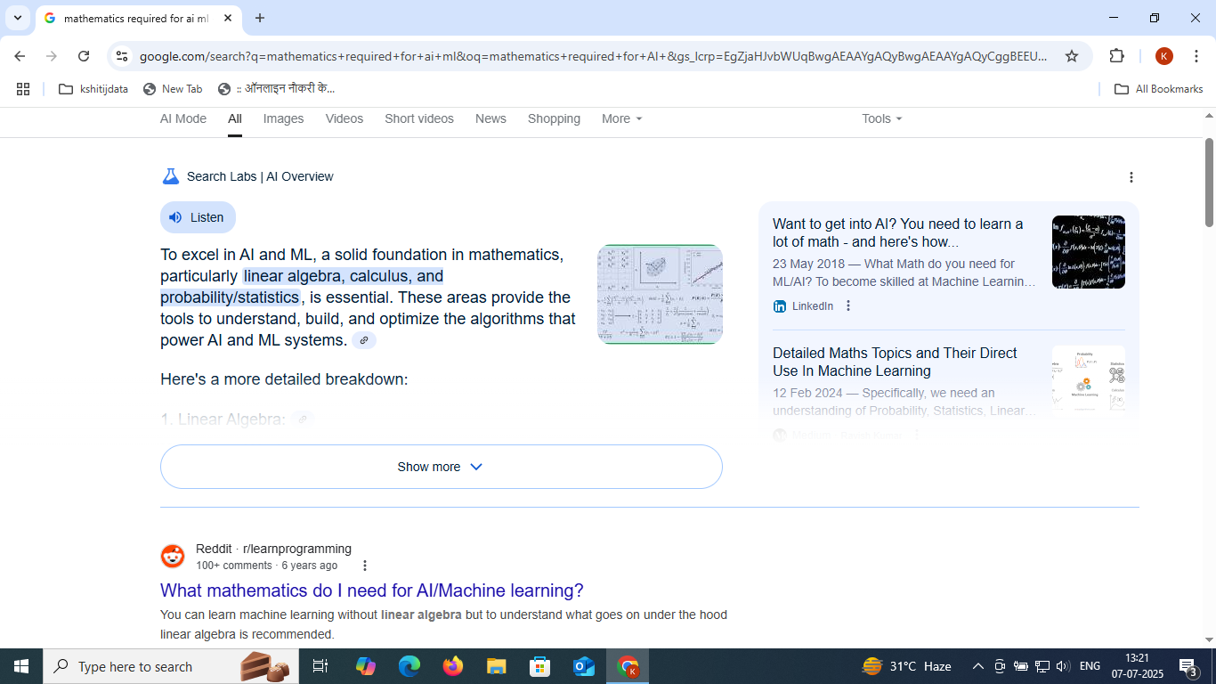

https://www.w3schools.com/ai/ai_mathematics.asp

COURSERA for certification
UDEMY for certification

https://www.youtube.com/watch?v=1VSZtNYMntM
https://www.youtube.com/watch?v=iyxqcS1u5go
simplilearn

