1. What is SDLC?

SDLC (Software Development Life Cycle) is a process used to design, develop, test, and deploy software in a systematic way. It ensures high-quality software is delivered on time and within budget.

2. What is Software Testing?
Software testing is the process of evaluating a software application to check whether it meets specified requirements and is free of defects.

3. What is Agile Methodology?

Agile is a flexible software development approach where requirements and solutions evolve through collaboration between teams. It focuses on iterative development, customer feedback, and quick delivery.

4. What is SRS?
SRS (Software Requirement Specification) is a document that describes the system’s functional and non-functional requirements in detail.

5. What is OOPS?
OOPS (Object-Oriented Programming System) is a programming approach based on objects and classes used to structure software in a modular way.

6. Basic Concepts of OOPS
- Class
- Object
- Encapsulation
- Inheritance
- Polymorphism
- Abstraction

7. What is Object?

An object is an instance of a class that contains data and behavior.

8. What is Class?
A class is a blueprint or template used to create objects.

9. What is Encapsulation?
Encapsulation is wrapping data and methods into a single unit (class) and restricting access using access modifiers.
10. What is Inheritance?
Inheritance allows one class to acquire properties and methods of another class.

11. What is Polymorphism?
Polymorphism means “many forms.” It allows methods to perform different tasks based on input.

12. Draw Usecase on Online book shopping
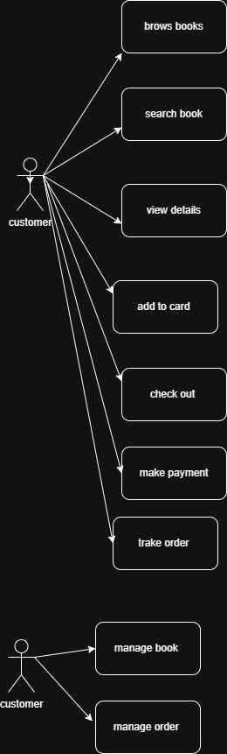
13. Draw Usecase on online bill payment system (paytm)

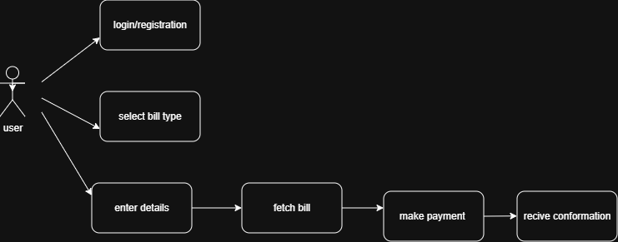

14. Write SDLC phases with basic introduction
1. Requirement Gathering and Analysis
In this phase, the requirements of the customer are collected and analyzed. Developers, analysts, and stakeholders discuss what the software should do and identify system requirements.
Purpose:
- Understand customer needs
- Prepare requirement documents

2. System Design
After requirements are finalized, the system architecture and design are prepared. This includes database design, interface design, and system structure.
Purpose:
- Create blueprint of the software

3. Implementation (Coding)
In this phase, developers write the actual program code according to the design specifications.
Purpose:
- Convert design into working software
4. Testing
The developed software is tested to find and fix errors or bugs. Different testing methods are used to ensure quality and performance.
Purpose:
- Detect defects

5. Deployment
After successful testing, the software is released to users or installed in the production environment.
Purpose:
- Make software available to users

6. Maintenance
Once the software is deployed, regular updates and maintenance are performed to fix issues and improve performance.
Purpose

Fix bugs and errors

15. Explain Phases of the waterfall model
The waterfall is unrealistic for many reasons, especially:
Requirements must be “frozen” to early in the life cycle Requirements are validatedtoolate

Requirements are very well documented, clear and fixed. Product definition is stable
The project is short.
Technology is understood and is not dynamic

Pros.
- Simple and easy to understand and use
- Phases are processed and completed one at a time.
- Process and results are well documented.

Cons.
- No working software is produced until late during the life cycle.
- High amounts of risk and uncertainty.
- Not suitable for projects with a moderate to high risk of changing requirements.

16. Write phases of spiral model

- Planning
- Risk Analysis
- Engineering
- Customer Evaluation

17. • Write agile manifesto principles

* Its in second module

18. Draw usecase on Online shopping product using COD.
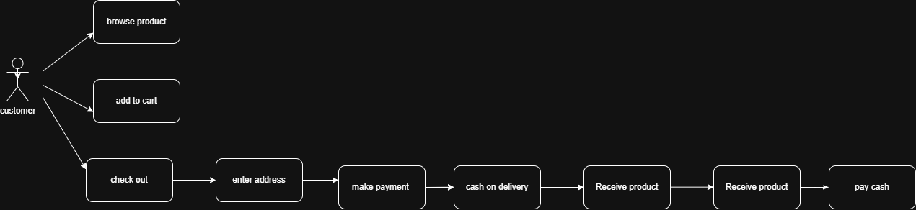

19. Draw usecase on Online shopping product using payment gateway.

