C U R R I C U L U M V I T A E

P e r s o n a l D e t a i l s
Name | : Maulana Irsyad | 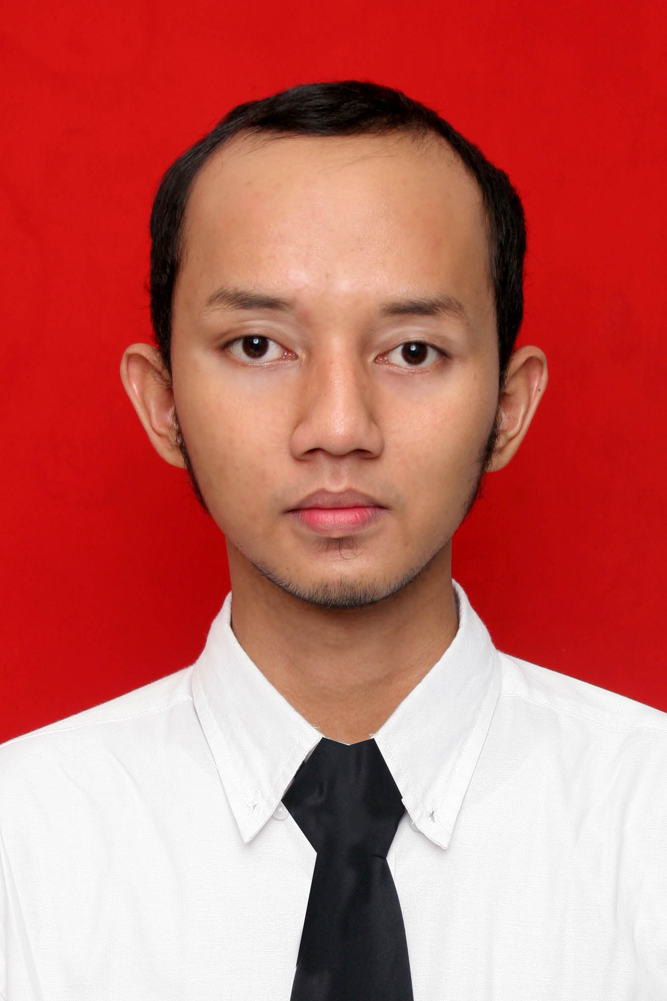
Address | : Jl. Mekar Baru IV no 88 Rt06/06 Cirendeu Ciputat Tangerang 15419 banten, Indonesia
Phone | : (+62)21-7423863 / (+62)8888527881
E-mail | : Maul_oke84@yahoo.com
Place/Date of Birth | : Jakarta / 4 August 1984
Sex | : Male
Marital Status | : Married
Religion | : Moslem
Nationality | : Indonesian

W o r k i n g E x p e r i e n c e s
Specification | Place | Job & Achievement Summary | Year

Professional Job
Programmer | Elnusa Telematika | Managing Web Portal for PERTAMINA and “Interactive Production Data” using EbDesk Expander using ASP.Net (C#) & MS Sql Server 2005 | Nov 2007 – Jun 2008
Software Developer | Venturium System Indonesia | Develop software as vensys products using PHP, .NET, Java, JSP, SQLSERVER & MySQL. Web designer (CSS, javascript, Adobe Photoshop) | Jun 2008 – Aug 2010
System Administrator | PT Pembangunan Jaya Ancol | Managing servers, applications and networks. supervising projects | Aug 2010 – Dec 2011
Programmer | PT Pembangunan Jaya Ancol | Develop applications, supervising projects | Dec 2011 - Now

Freelance
Mobile Developer | www.laurapetreike.com | Develop mobile version of the web | Feb 2012
Supervisor | Semanggi Expo | Pelatihan Massal: Merakit Komputer dan Menginstal Windows XP Starter Edition serta Trial Version Office Standard Edition 2003 Bahasa Indonesia | Feb 2005
Web Developer | Horizon Geoconsulting | Developing Web support for programs made by the company using ASP & MS Access | Mei – June 2005
Web Programmer | www.brener.com/naples | Managing and updating website for www.brener.com/naples using PHP, Javascript | Jul – Oct 2006
Web Programmer | www.rumahsunatan.com | Developing web commerce for www.rumahsunatan.com using ASP & MS Access | Dec 2006 – Jan 2007
Web Developer | Soemadipradja & Taher Law Firm | Developing Web-based Aplication filling system for Warehouse using ASP & MS Sql Server 2000 | Dec 2006 - Feb 2007
Web Programmer | www.nuruzzahroh.org | Developing company web using PHP & MySQL | Jun 2007
Database Administrator | Roda Mas | Creating Database design for company assets management system using MySQL | Oct 2007
Web Programmer | Commodities & Energy Resource | Developing Website www.comenr.com using ASP & Ms Access | Jan 2008 – Mar 2008
S k i l l s and K n o w l e d g e

Software Development :

Visual Basic .NET 2003

Visual Basic .NET 2005

ASP.NET 2003

ASP.NET 2005

MS SQL SERVER 2000

MS SQL SERVER 2005

MS ACCESS

ASP, C#.Net

PHP5

MYSQL

HTML, XHTML, XML, CSS, JavaScript, AJAX

JSP, Java, JCAPS 5.1, JCAPS 6.1

Dreamweaver, frontpage

Adobe Photoshop

DFD, UML

Alfresco
Framework:
- Codeigniter
- jQuery

Operating System:
- Windows server 2003
- Linux Redhat
- Ubuntu
- Suse
Network Applications:
- Apache
- Tomcat
- Mikrotik
- Squid Proxy Server
- Dansguardian

Virtualization :
- VMWare

E d u c a t i o n a l B a c k g r o u n d
Formal Educations
2002 – 2007, STIMIK PERBANAS (Bachelor – Information Technology), Jakarta Indonesia

1999 - 2002, SMU Negeri 34, Jakarta

Informal Educations

2000 – 2002, LB LIA Ciputat (General English)

2006, Binus Center Bintaro (Programmer)
O r g a n i z a t i o n a l E x p e r i e n c e s a n d A c t i v i t i e s i n C o l l e g e
Position | Workplace / Institution | Year
Secretary | Himatika Perbanas | 2006
Member | SPRG (Stimik Perbanas Research Group) | 2002 - 2007
H o b b y a n d I n t e r e s t s
Learning, Coding, Listening Music, Watching Movie, Browsing The Internet

C e r t i f i c a t i o n
2006, ESQ Leadership Training, Jakarta
2006, Agile Software Development Seminar, Jakarta

