SyncUp
Find. Match. Build

Back End Development (22CS021)

Submitted by

Maulshree Jatrana
(2310993874)

Semester: 5



BE-CSE (Artificial Intelligence)

Guided by

Dr. Baljit Singh

CHITKARA UNIVERSITY INSTITUTE OF ENGINEERING & TECHNOLOGY
CHITKARA UNIVERSITY, RAJPURA
MONTH & YEAR
August 2025

Table of Contents

- Introduction 4
  - Objective
  - Technology Stack
- Project Description 4
- System Architecture & Design 5
  - High-Level System Architecture
  - Detailed System Design
  - UML Diagrams
- Database Design 5-6
  - ER Diagram (Simplified)
  - Relationships
- Data Flow Diagrams (DFD) 6
  - Level 0 DFD (Context Level)
  - Level 1 DFD
- Features Implemented 7
- Screenshots 7-9
- Challenges Faced 10
- Pending Tasks 10
- Conclusion 11
- Appendix 11

ACKNOWLEDGEMENT

With immense please I, Ms Maulshree Jatrana presenting “SyncUp: An AI-Driven
Collaboration Platform” project report as part of the curriculum of ‘ BE-CSE (AI) ’.
I would like to express my sincere thanks to Dr. Baljeet Singh, for his valuable guidance and support in completing my project.
I would also like to express my gratitude towards our dean Dr. Sushil Narang for giving me this great opportunity to do a project on an AI-driven collaboration platform. Without their support and suggestions, this project would not have been completed.

Name: Maulshree Jatrana
Roll No: 2310993874

Abstract
SyncUp is a full-stack MERN web application designed to be an intelligent, AI-driven collaboration platform for students. The core problem it addresses is the difficulty students face in finding suitable teammates for projects, hackathons, and entrepreneurial ventures. The platform allows users to create detailed profiles listing their skills, interests, and project goals. It provides a secure authentication system and a dedicated dashboard where users can manage their profile information. The future vision for the project is to implement an AI-based matchmaking engine to suggest ideal teammates and a "Coach Agent" to guide teams through the project lifecycle. This report details the development of the foundational MERN stack application, including the system architecture, database design, and the implementation of core features like user authentication and profile management.

List of Tables
Table No. | Caption | Page No.
1 | Technology Stack | 4
2 | System Components | 5
3 | Implemented Features | 7
4 | Challenges and Solutions | 9

List of Figures
Table No. | Caption | Page No.
1 | Simplified ER Diagram | 6
2 | Level 0 DFD | 6
3 | Level 1 DFD | 7

1. Introduction
1.1 Objective
The primary objective of SyncUp is to create a centralized, intelligent platform that helps students find compatible teammates for technical projects. It aims to solve common team formation issues like mismatched skills, availability, and project goals by using detailed user profiles. The system is built to be a scalable MERN stack application with secure authentication and a foundation for future AI-driven features.
1.2 Technology Stack
The project is developed using the MERN stack and other modern web technologies.
Component | Technology
Frontend | React.js (with Vite), Tailwind CSS, shadcn/ui
Backend | Node.js with Express.js
Database | MongoDB (NoSQL) with Mongoose ODM
Authentication | JSON Web Tokens (JWT)
Deployment | Vercel (Frontend), Render (Backend)
API Testing | Postman

2. Project Description
SyncUp is a web application where students can register and create a profile to showcase their technical abilities and project aspirations. The core functionality implemented so far includes:
- Secure User Authentication: Users can register for a new account and log in securely. The system uses JWTs to manage sessions and protect routes.
- Profile Management: Once logged in, users are directed to a dashboard where they can manage their profile. They can add or remove their skills, personal interests, and specific project goals (e.g., building for a hackathon, creating a startup MVP).
- Foundation for AI Matching: The data collected in the user profile (skills, interests, goals) is structured to be the primary input for the future AI matchmaking engine.

3. System Architecture & Design

3.1 High-Level System Architecture
The application follows a classic three-tier architecture, separating the client, server, and database. This separation of concerns allows for independent development, scaling, and maintenance of each layer. The client (React) communicates with the backend via a RESTful API, and the backend handles all business logic and database interactions.

3.2 Detailed System Design
The system is composed of several key components that interact to provide the application's functionality.
Component | Description
Client (React) | A single-page application built with React and Vite. It handles all UI rendering, client-side routing, and state management. It communicates with the backend API using Axios for all data operations.
API Layer  (Express) | A RESTful API built with Node.js and Express.js. It exposes endpoints for authentication (/api/auth) and profile management (/api/profile).
Authentication | Handled via JWTs. A middleware function protects private routes by verifying the token sent in the request header.
Database  (MongoDB) | A NoSQL database used to store user data. Mongoose is used as an Object Data Modeling (ODM) library to define schemas and interact with the database.

4. Database Design

4.1 ER Diagram (Simplified)
The core of the database is the User collection.
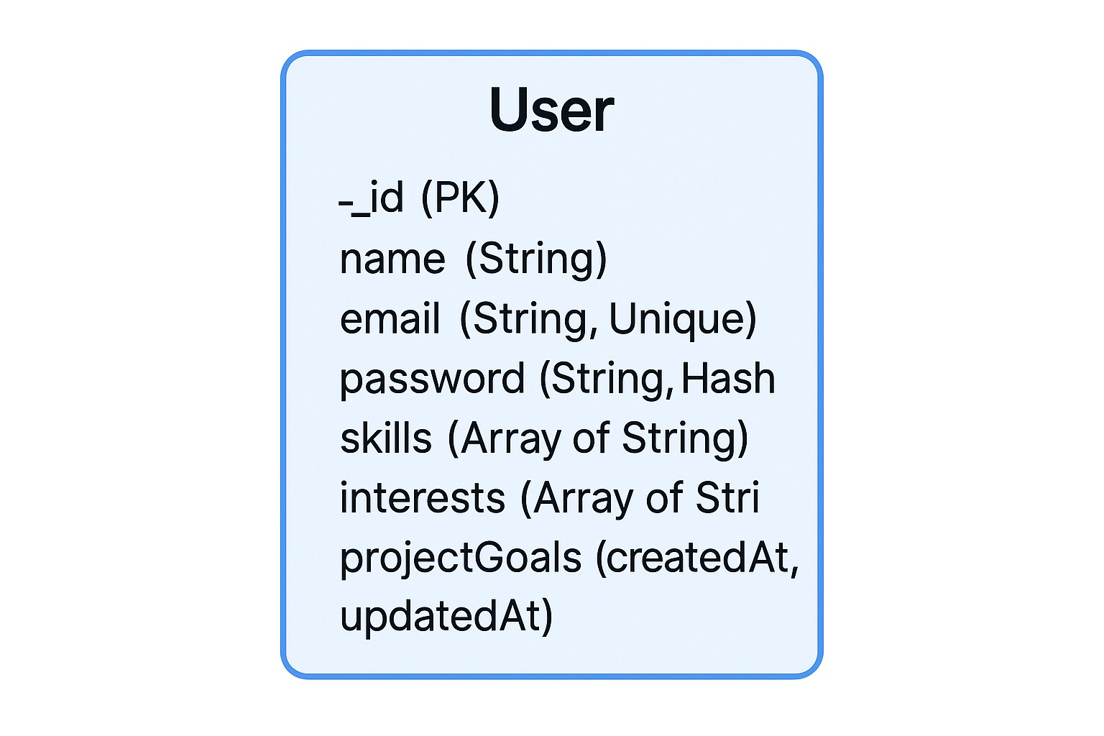

4.2 Relationships
Currently, the database consists of a single “user” model. The planned architecture will introduce a “Project” model, creating a One-to-Many relationship: one “User” can be a part of many “Projects”.

5. Data Flow Diagrams (DFD)

5.1 Level 0 DFD (Context Level)
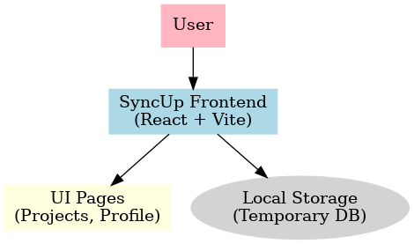

5.2 Level 1 DFD

6. Features Implemented

Feature | Description
User Authentication (JWT-based) | Secure login and registration flow with route protection on both frontend and backend.
Profile Management Dashboard | Users can create and edit profiles with details such as name, skills, interests, and project goals.
Dynamic Skill & Interest Tags | Modern, interactive tag-based UI for adding and removing skills and interests.
Responsive UI/UX | Clean, professional interface built with Tailwind CSS, framer-motion animations, and shadcn/ui components.
Project Management Module (Frontend) | Users can create new projects, view project cards, and manage teams with demo project data.
Local Data Persistence | Projects and tasks temporarily stored using localStorage for seamless testing without backend dependency.

7. Screenshots
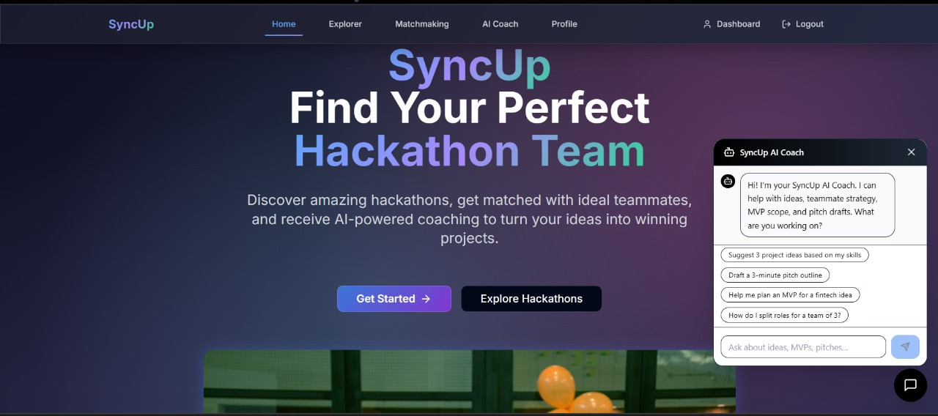Fig 7.1
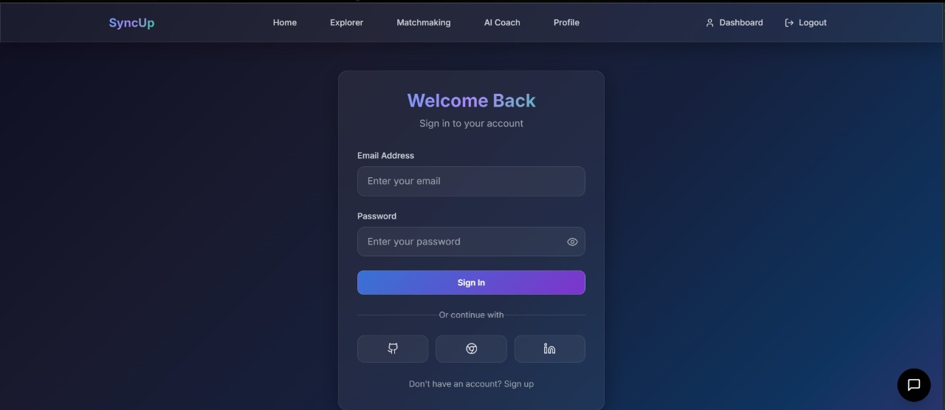

Fig 7.2
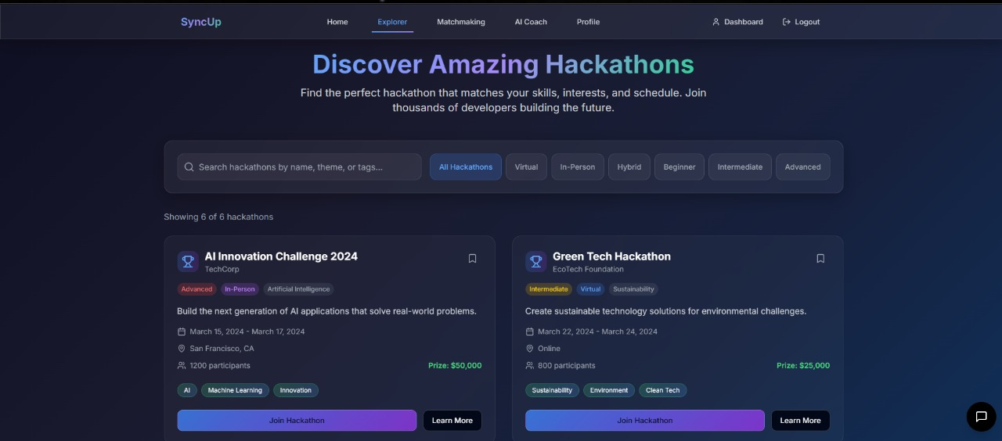

Fig 7.3
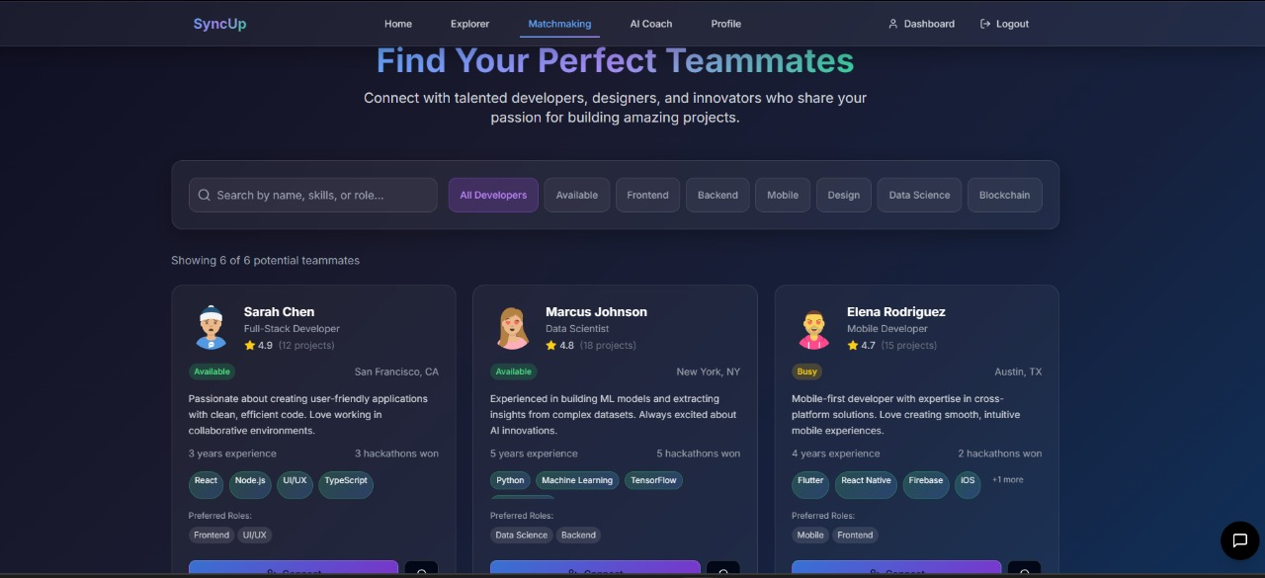
Fig 7.4
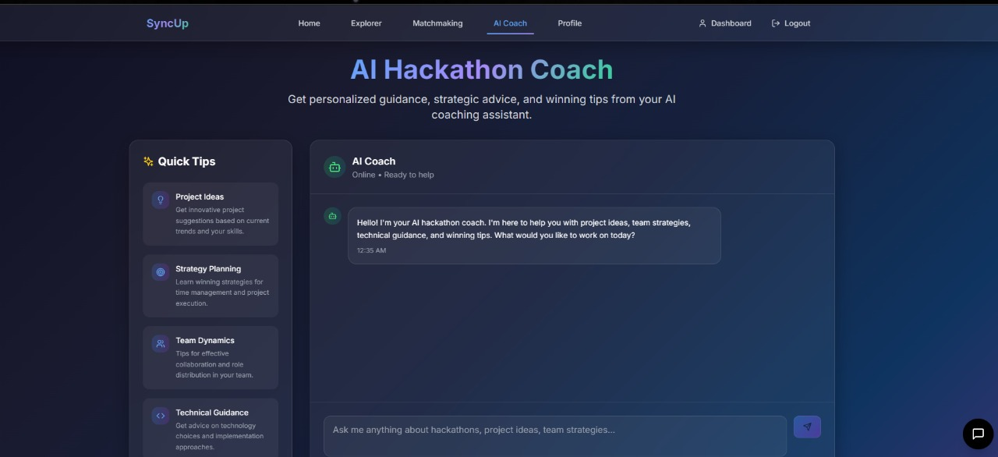Fig 7.5
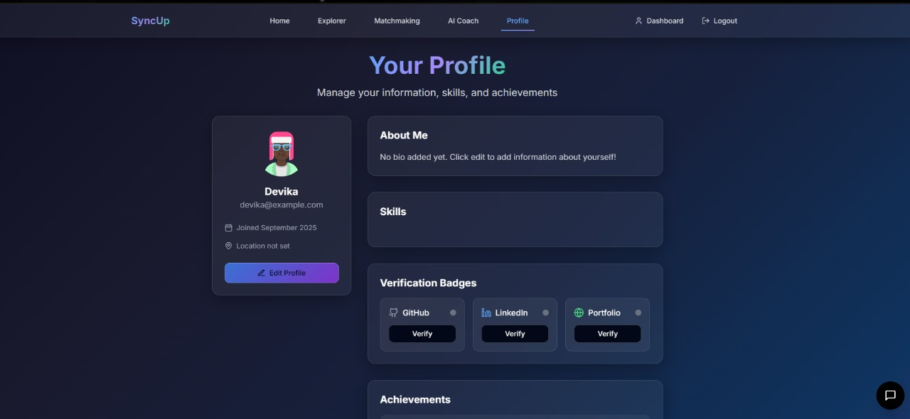Fig 7.6
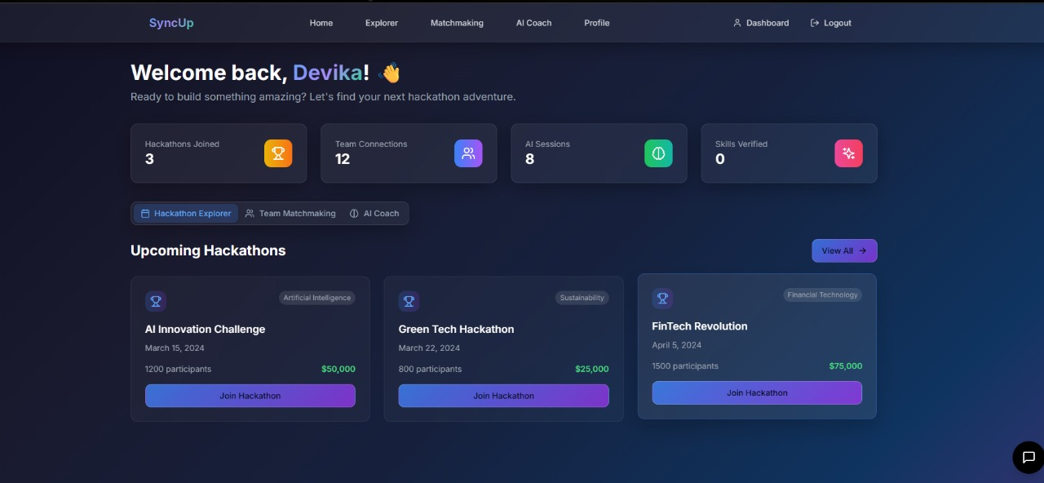Fig 7.7

8. Challenges Faced

Challenge | Solution
Local Storage vs Backend Dependency | Initially designed to rely on MongoDB, but localStorage was implemented for project persistence since backend integration is pending.
Context Provider Issues | Blank pages appeared because the Projects component wasn’t wrapped in ProjectProvider. Debugging React Context initialization fixed this.
Routing & Aliasing Errors | Challenges with integrating shadcn/ui and framer-motion animations; required alias adjustments and additional configuration.
Environment & Deployment Differences | The app behaved differently in local vs Hostinger environments due to build configurations and missing localStorage entries. Debugging environment-specific issues ensured smooth deployment.

9. Pending Tasks (Future Enhancements)
- Connect the frontend with a Node.js/Express + MongoDB backend to enable persistent data storage and retrieval.
- Replace temporary JWT/localStorage-based authentication with a proper backend-verified login and signup flow.
- Implement real-time collaboration in Project Rooms (chat, task updates, notifications) using WebSockets.
- Build out project rooms with real-time features like chat (using Socket.io) and Kanban boards.
- Allow users to upload profile pictures and link GitHub/LinkedIn for skill verification.
- Configure production-ready build and deployment pipeline to ensure consistency across Hostinger and local environments.

10. Conclusion

The SyncUp Hackathon Platform successfully delivers an engaging and interactive frontend for project management, team collaboration, and hackathon participation. Core functionalities such as project listing, profile management, and a visually appealing UI have been implemented, making the platform intuitive and user-friendly.

Although backend integration and advanced collaboration features are still pending, the current implementation lays a strong foundation for future development. With further improvements like real-time updates, authentication, and persistent data storage, the platform has the potential to evolve into a complete end-to-end solution for hackathon management and team synergy.

11. Appendix
● GitHub Repo: https://github.com/DevikaMalik/SyncUp-Find.Match.Build

