**Computational Thinking Using Python – CSE1500**

**Lab sheet - 1.1**

Anaconda Installation Step by Step Process on Windows:

To install Anaconda on Windows, download the installer from the official website, run the executable, and follow the on-screen instructions, choosing your preferred installation options. Key steps include accepting the license, selecting the installation type ("Just Me" or "All Users"), specifying the installation directory, and deciding whether to add Anaconda to your PATH environment variable and register it as your default Python. After installation, you can launch Anaconda Navigator from the Start Menu to manage your packages and environments.

**1. Download Anaconda:**

* + Go to the Anaconda downloads page: [Anaconda.com/downloads](https://www.anaconda.com/download).
  + Select the Windows installer that matches your system's architecture (64-bit or 32-bit).
  + Click "Download" and save the installer file (e.g., Anaconda3-xxxx-Windows-x86_64.exe).

**2. Run the Installer:**

* + Locate the downloaded installer file and double-click it to launch the setup wizard.
  + Click "Next" on the welcome screen.
  + Read the license agreement, and click "I Agree".
  + Choose the installation type: "Just Me" (recommended) or "All Users" (requires administrator privileges).

**3. Choose Installation Location:**

* + Select the destination folder where you want to install Anaconda. It's generally recommended to use a directory path without spaces or Unicode characters.
  + Click "Next".

**4. Advanced Options:**

* + You'll be presented with two advanced options:
  + Add Anaconda to your PATH environment variable: This allows you to run Anaconda commands from the command prompt without specifying the full path. However, it's generally recommended to avoid adding it to the PATH to prevent potential conflicts with other software. Instead, use Anaconda Navigator or Anaconda Prompt from the Start Menu.
  + Register Anaconda as your default Python: This option sets Anaconda as the default Python interpreter for your system. Unless you need to manage multiple Python versions, it's usually safe to leave this option checked.
  + Click "Install".

**5. Installation Progress:**

* + The installer will begin copying files and installing packages. This may take some time, depending on your system and the chosen options.
  + You can click "Show Details" to see the packages being installed.

**6. Complete the Installation:**

* + Once the installation is finished, click "Next".
  + Uncheck the boxes to skip the introductory documentation and tutorials (or leave them checked to explore them).
  + Click "Finish".

**7. Launch Anaconda Navigator:**

* + You can now find Anaconda Navigator in your Start Menu.
  + Open it to manage your Python environments and packages.

Open Jupyter Notebook and run python program:

1. Click start button or windows iocn, type jupyter notebook and select jupyter notebook option.

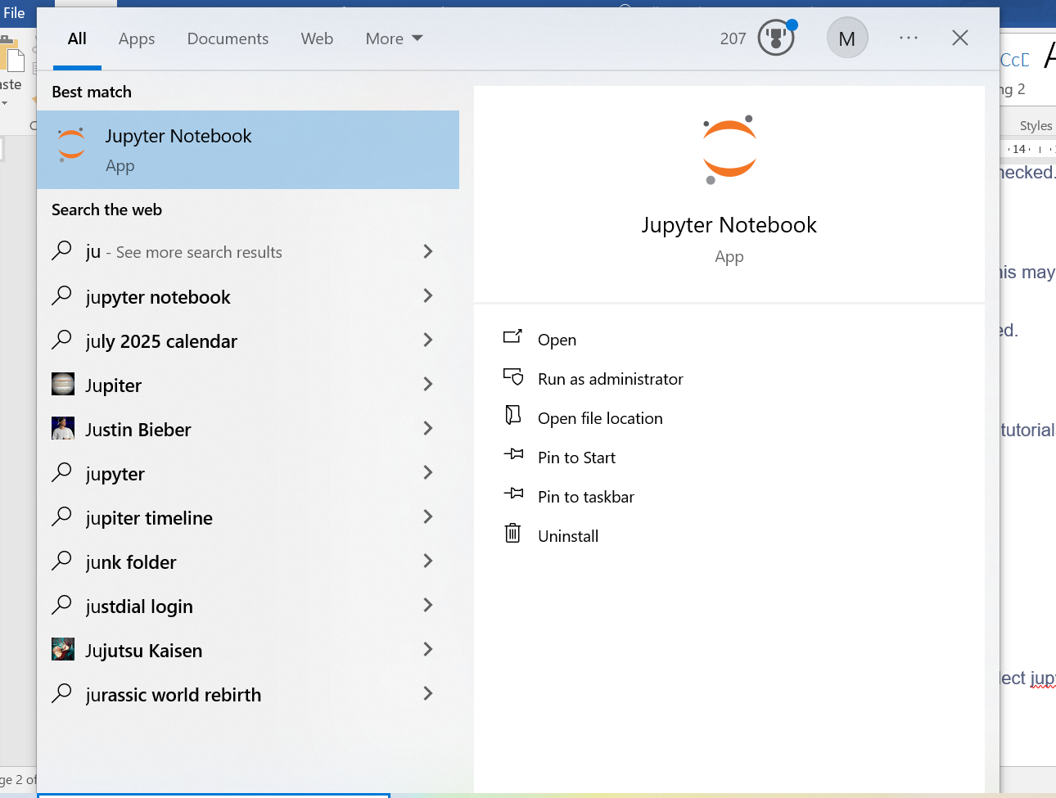

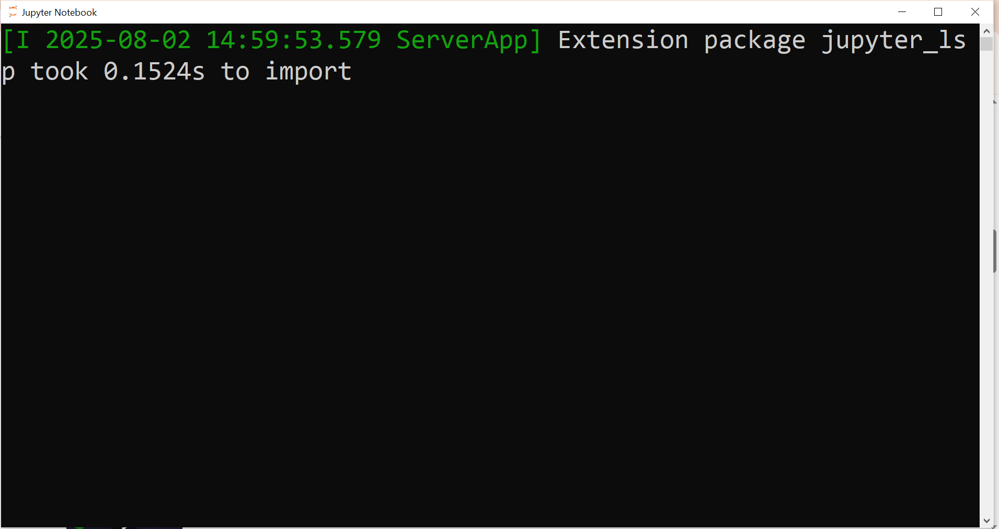

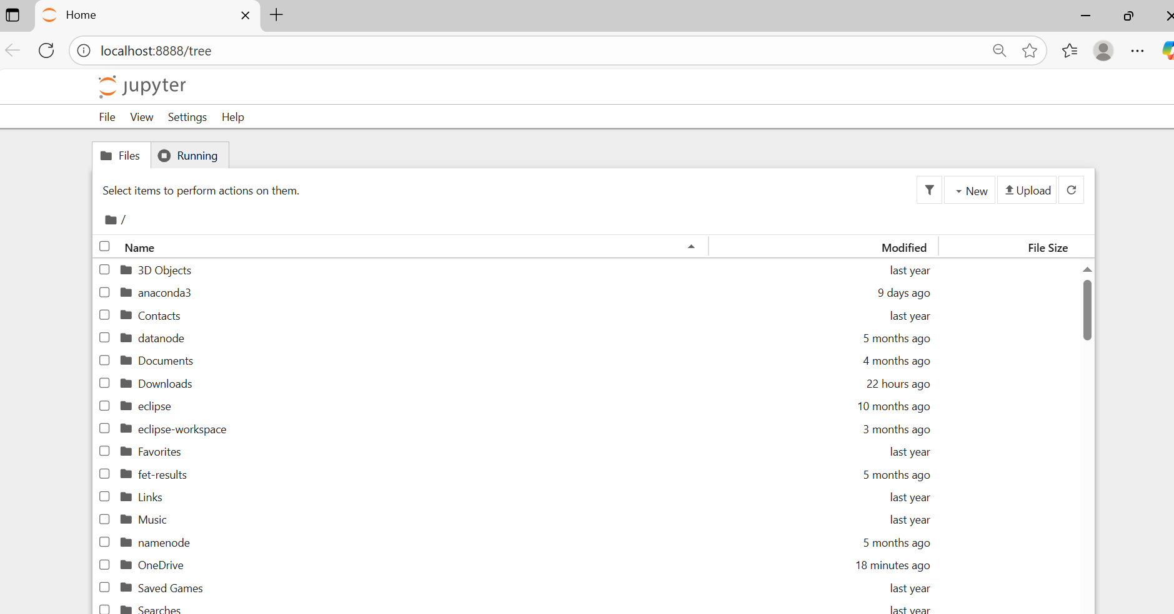

After appear the above browser to select File menu and new option and notebook option.

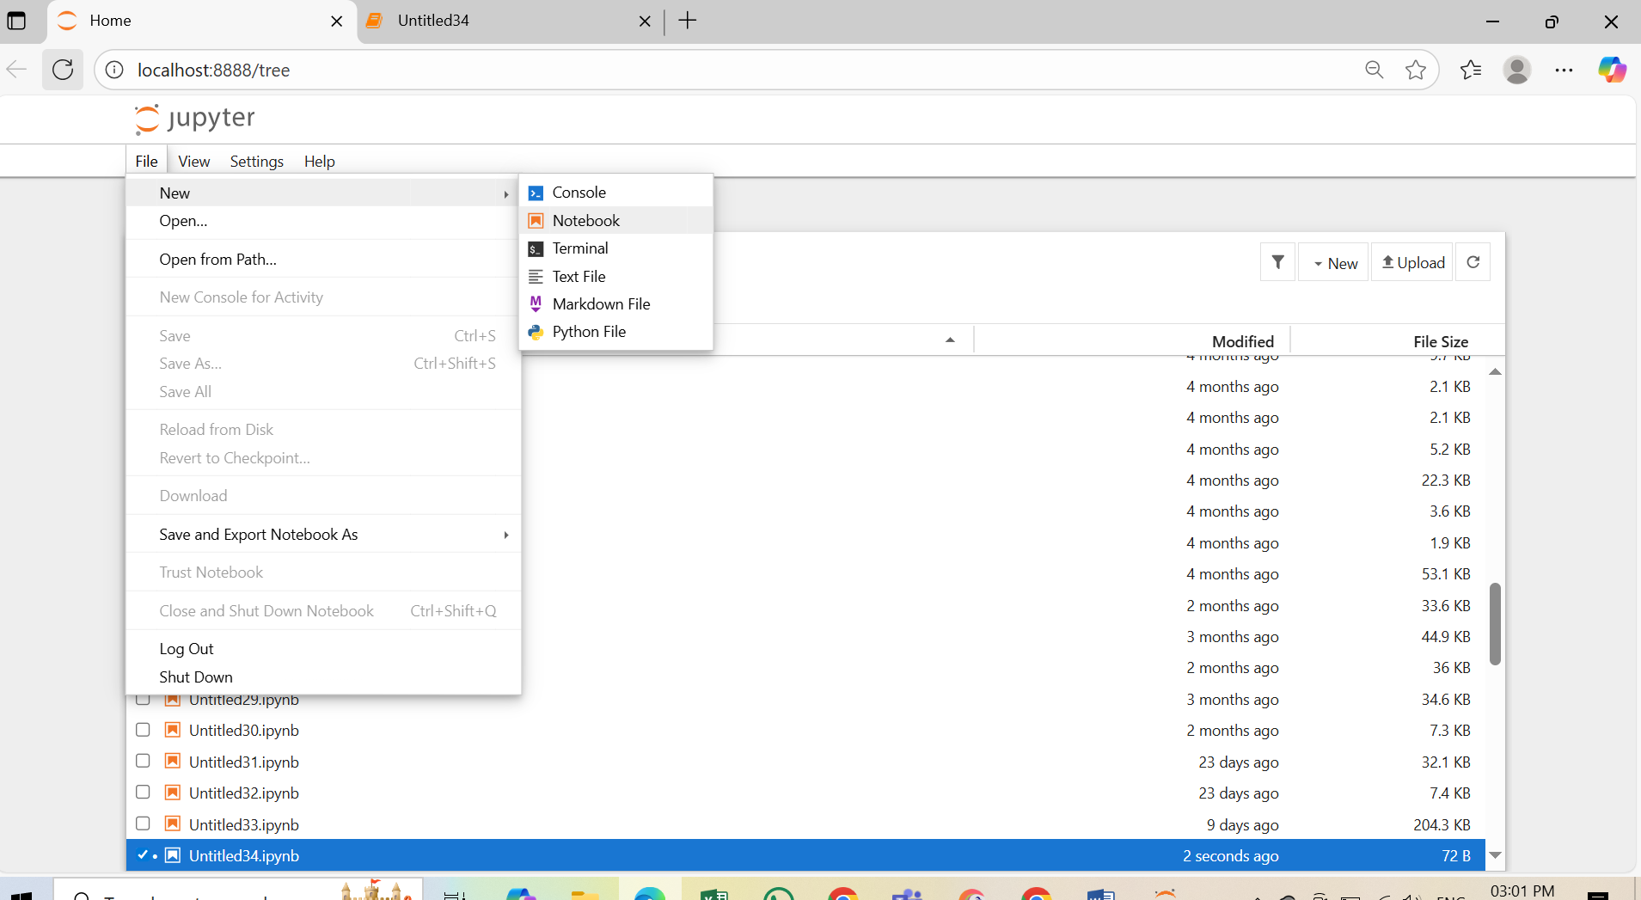

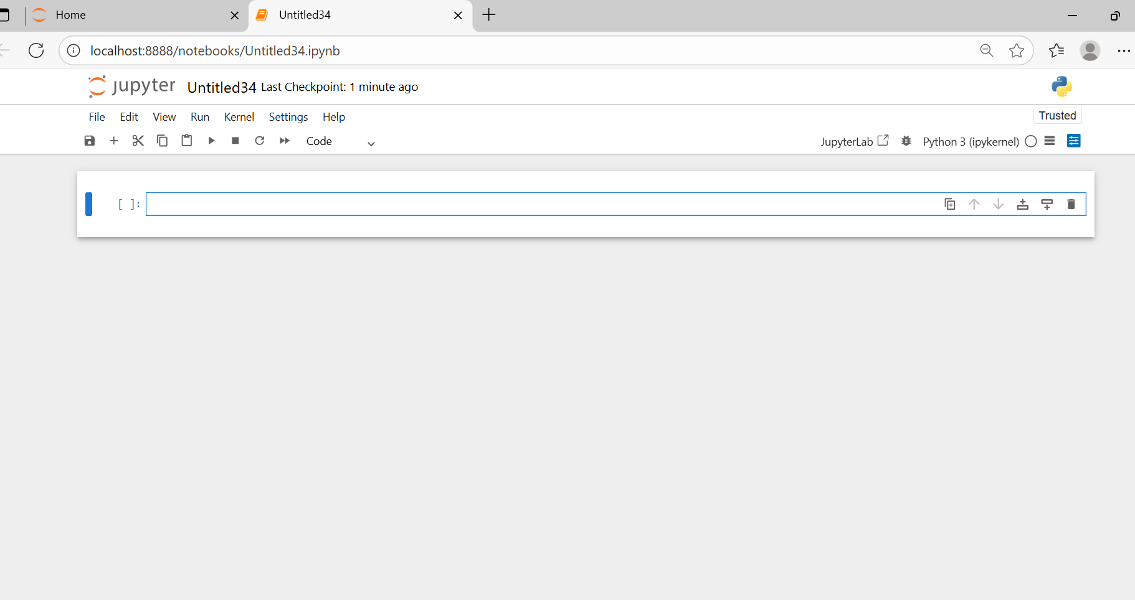

And type python program in current cell.

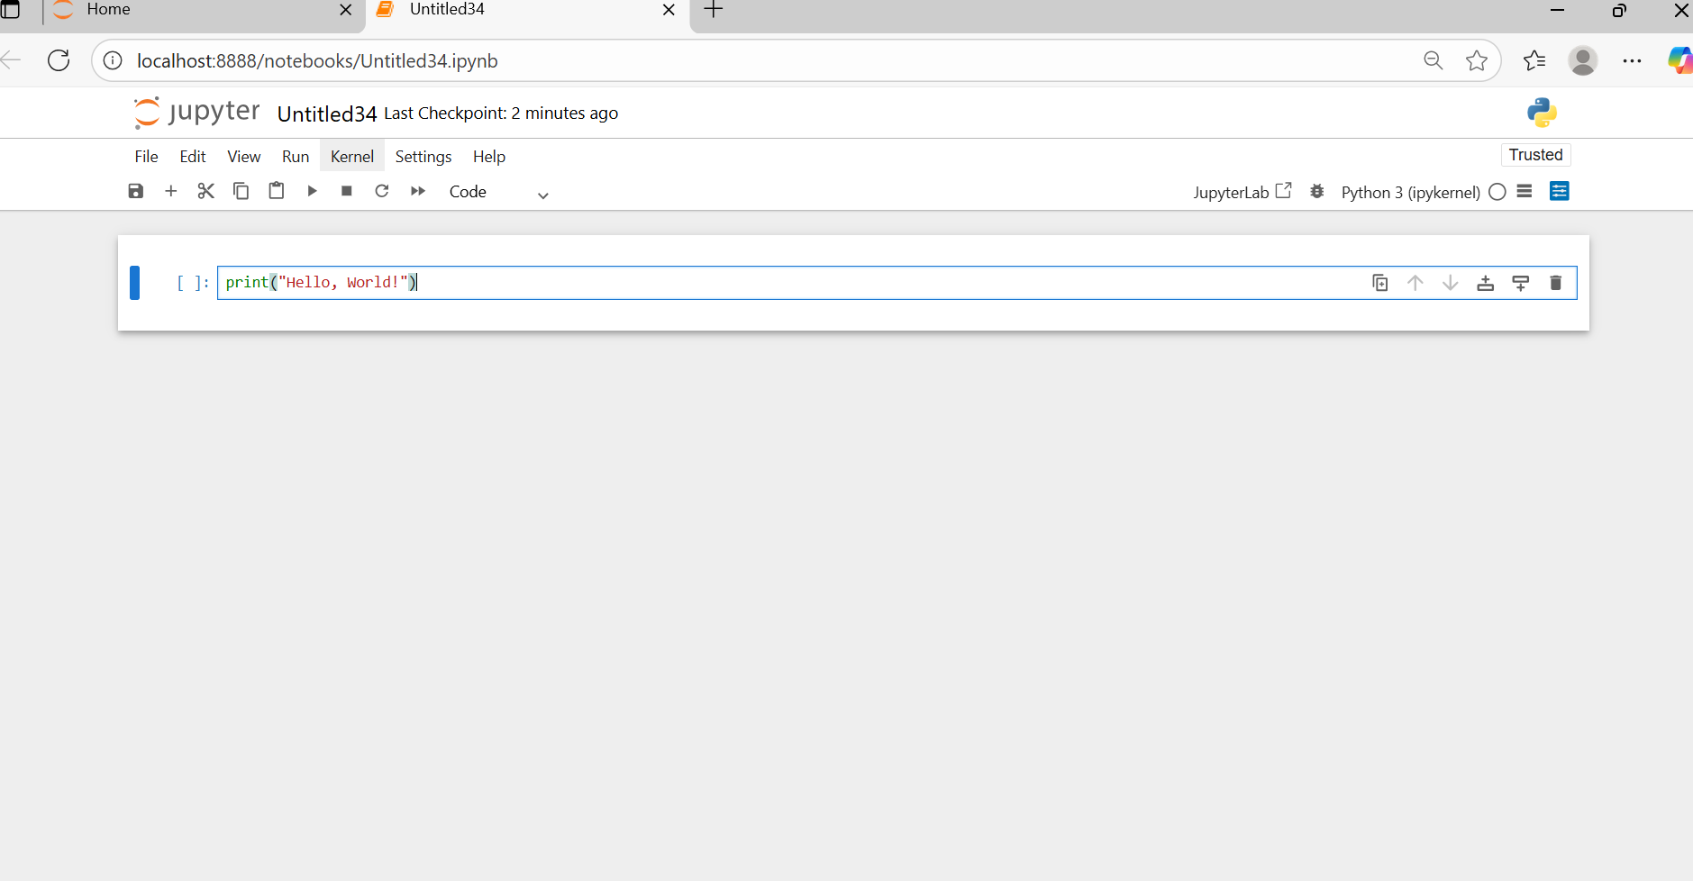

After completed program click run button

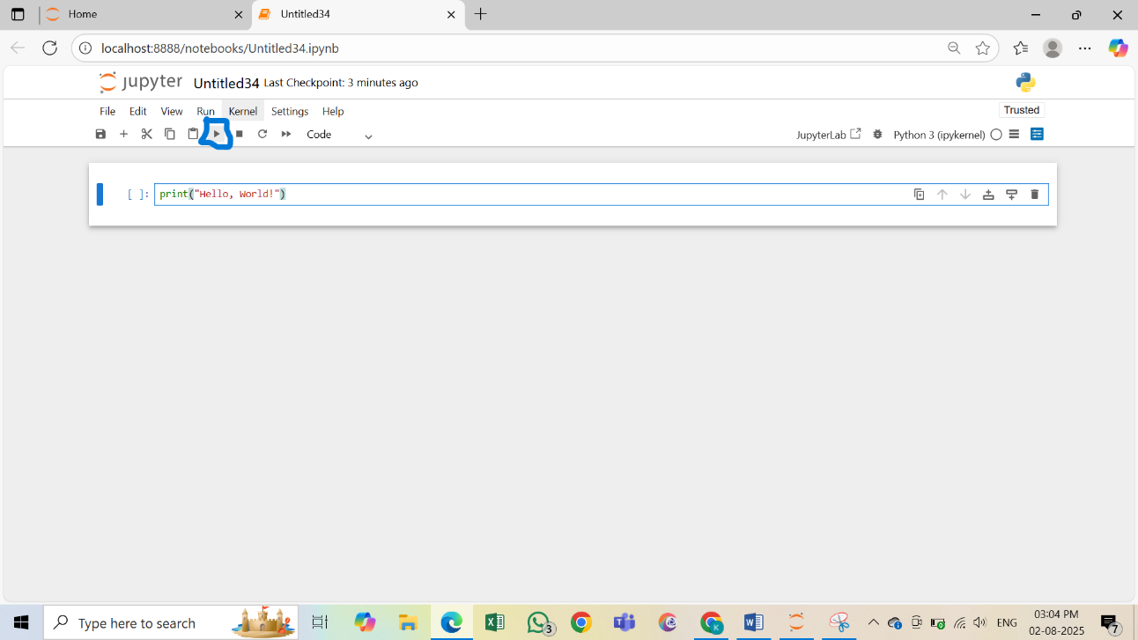

Output:

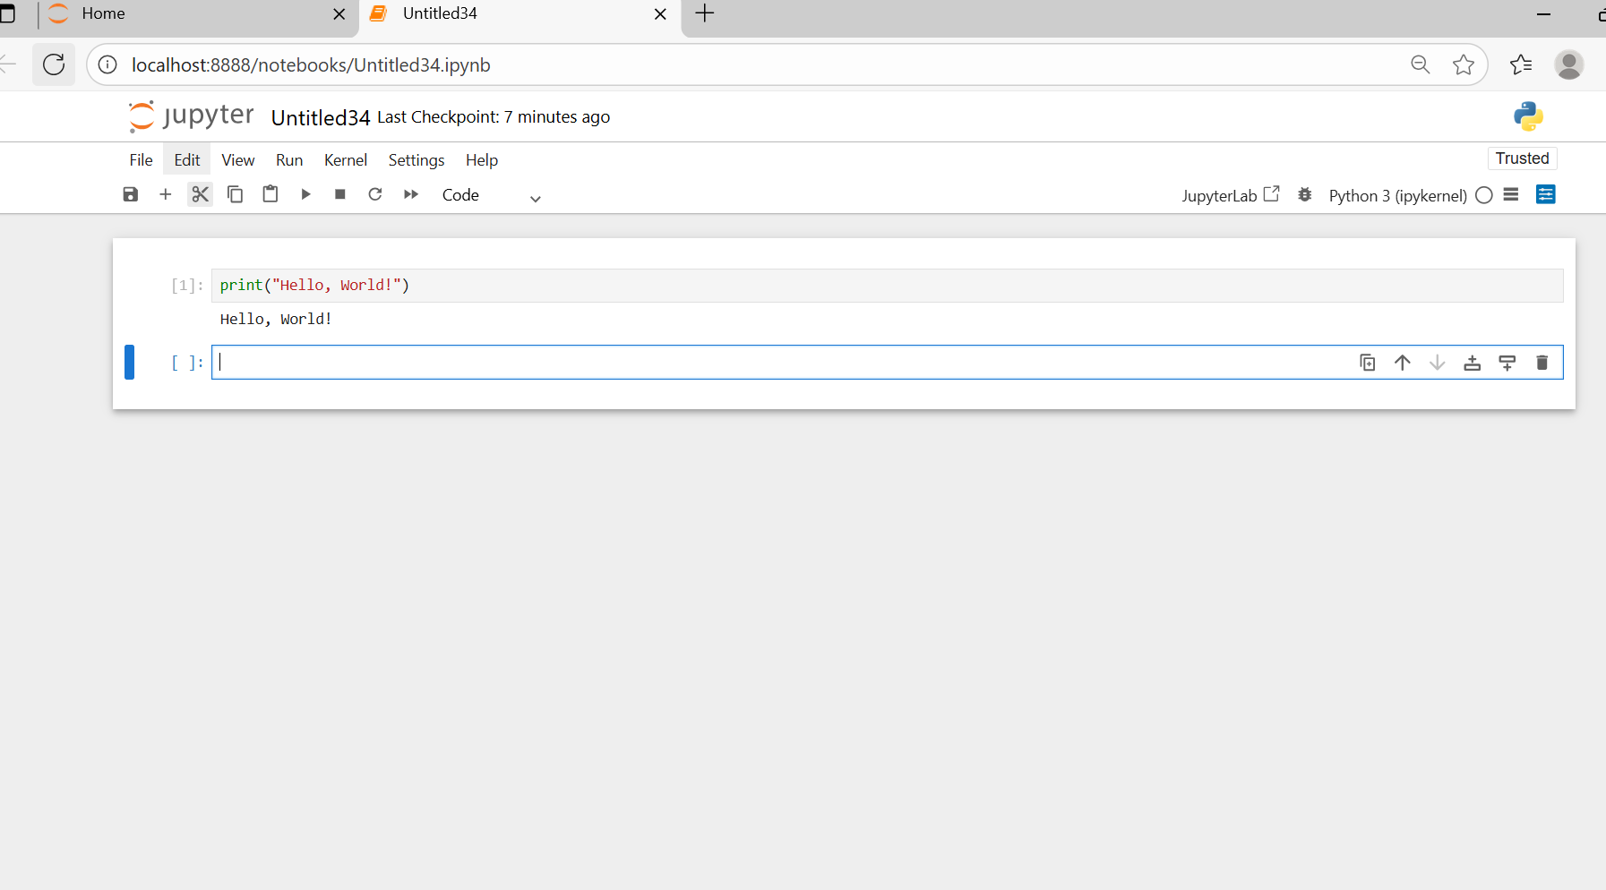

=========================

**Program 1**

# Read student details such as name, roll number, marks in 3 subjects and #calculate total and average. Print student details

name = input("Enter student name: ")

roll_no = input("Enter roll number: ")

# Read marks for 3 subjects

mark1 = float(input("Enter marks in subject 1: "))

mark2 = float(input("Enter marks in subject 2: "))

mark3 = float(input("Enter marks in subject 3: "))

# Calculate total

total = mark1 + mark2 + mark3

# Print details

print("\n Student Details :")

print("Name :", name)

print("Roll No :", roll_no)

print("Marks :", mark1, ",", mark2, ",", mark3)

print("Total Marks:", total)

======================

**Program 2:**

# Read employee details such as name id and salary, calculate tax as 5% of

# salary. Print employee information.

# Read employee details

name = input("Enter employee name: ")

emp_id = input("Enter employee ID: ")

salary = float(input("Enter salary: "))

# Calculate tax (5% of salary)

tax = salary * 0.05

# Print employee information

print("\n--- Employee Information ---")

print("Name :", name)

print("ID :", emp_id)

print("Salary :", salary)

print("Tax (5%) :", tax)

===================

Problem: A loan of ₹20,000 is given at 10% annual interest compounded yearly for 2 years. Calculate the final amount to be paid.

# Read loan details from user

principal = float(input("Enter loan amount: "))

rate = float(input("Enter annual interest rate (%): "))

time = int(input("Enter time in years: "))

# Calculate Compound Interest

amount = principal * (1 + rate/100) ** time

# Print result

print("\n--- Loan Details ---")

print("Loan Amount :", principal)

print("Interest Rate(%) :", rate)

print("Time (years) :", time)

print("Final Amount to be Paid:", amount)

========================

Problem :

A weather station records the temperature as 35°C. Convert it into Fahrenheit for international reports.

Develop python code for the above problem

=============================

Problem Statement:

An electricity board wants to generate monthly bills for customers.

Write a Python program that:

Reads the customer name and meter number.

Reads the previous month’s reading (old reading) and current month’s reading (new reading).

Calculates the number of units consumed as:

units = new_reading - old_reading

Calculates the monthly bill at the rate of ₹5 per unit.

Displays the customer details, units consumed, and the total bill amount.

======================