1. The .container class provides a responsive **fixed width container**
2. The .container-fluid class provides a **full width container**, spanning the entire width of the viewport

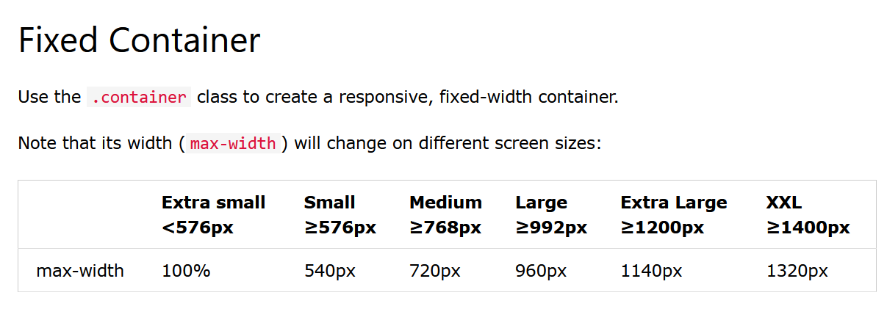

**Container Padding**

By default, containers have left and right padding, with no top or bottom padding. Therefore, we often use **spacing utilities**, such as extra padding and margins to make them look even better. For example, .pt-5 means "add a large **top padding**":

* **container**: Creates a centered, responsive container.
* **p-5**: Adds large padding on all sides.
* **my-5**: Adds large margin on the top and bottom.
* **bg-dark**: Sets a dark background color.

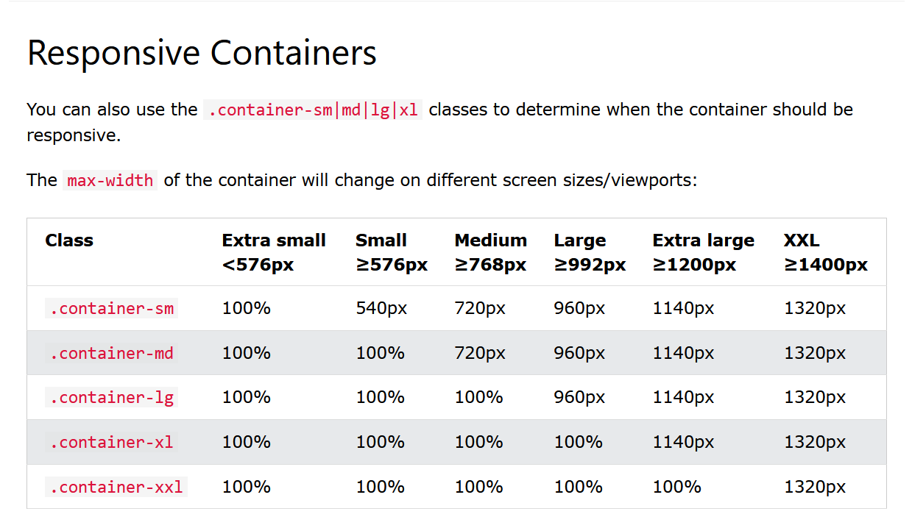

## Bootstrap 5 Grid System

Bootstrap's grid system is built with flexbox and allows up to 12 columns across the page.

**Grid Classes**

The Bootstrap 5 grid system has six classes:

* .col- (extra small devices - screen width less than 576px)
* .col-sm- (small devices - screen width equal to or greater than 576px)
* .col-md- (medium devices - screen width equal to or greater than 768px)
* .col-lg- (large devices - screen width equal to or greater than 992px)
* .col-xl- (xlarge devices - screen width equal to or greater than 1200px)
* .col-xxl- (xxlarge devices - screen width equal to or greater than 1400px)

The classes above can be combined to create more dynamic and flexible layouts.

**Tip:** Each class scales up, so if you want to set the same widths for sm and md, you only need to specify sm.

# Bootstrap 5 Text/Typography

Bootstrap 5 uses a default font-size of 1rem (16px by default), and its line-height is 1.5.

In addition, all <p> elements have margin-top: 0 and margin-bottom: 1rem (16px by default).

