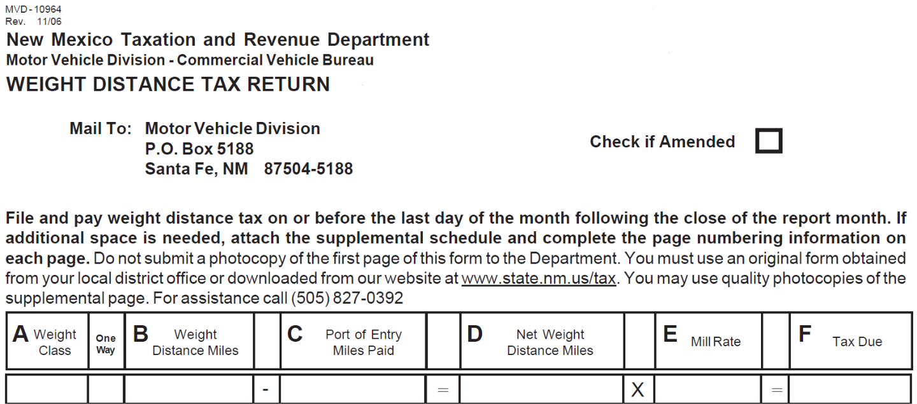

27 1,658 0 1,658 0.04 $72.59

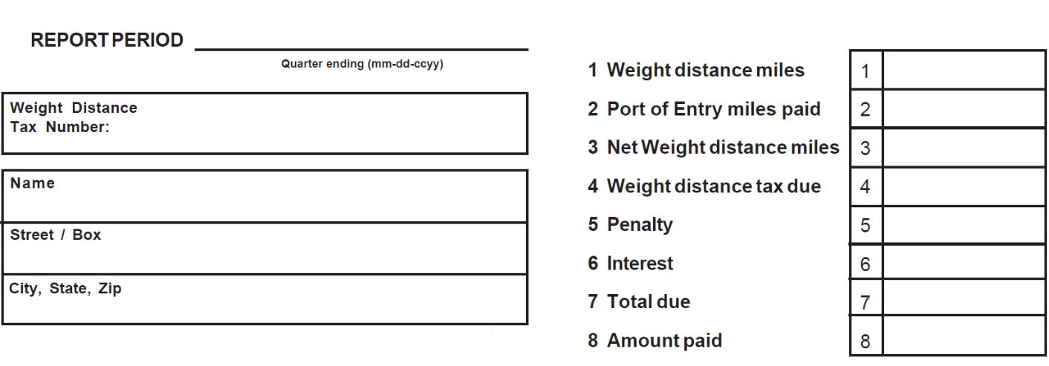

|  |  |  |  |
| --- | --- | --- | --- |
| 30-Jun-2025 |  |  |  |
|  |  | 1,658 |  |
| ************* |  | 0 |  |
|  |  |  |
|  |  | 1,658 |  |
| {{legal_name}} |  | $72.59 |  |
|  |  |  |
|  |  | $0.00 |  |
| {{street}} |  | $0.00 |  |
|  |  |  |
| {{city}} {{state}} {{zip}} |  | $72.59 |  |
|  |  |

Your Weight Distance Tax Return request for the filing period **30-Jun-2025** has been submitted and your confirmation number is **\*\*\*\*\*\*\*\*\*\*\*\*\*\*\*\*\***

|  |  |
| --- | --- |
| Date Submitted: | **30-Jul-2025** |
| Name: | **{{legal_name}}** |
| Account Type: |  |
| Account ID: | **\*\*\*\*\*\*\*\*\*\*** |
| Total Tax Due: | **72.59** |
| Penalty *: | **0.00** |
| Interest *: | **0.00** |

Total Amount Due: **72.59**

* **Penalty and interest are an estimate and could change once the return is processed. The Department will issue a notice of assessment for any additional charges.**

For general questions, please call (505) 841-6352 or (866) 285-2996. For technical assistance, contact us at TRD-Tap-TechnicalHelp@state.nm.us

When contacting the department for assistance with TAP, we will need your:

* Name
* Phone Number
* Email Address
* TAP Logon
* FEIN/SSN
* Tax type we can assist you with
* Detailed description of your issue