BMW Prime Time App Screens.

Start the app by just running the PrimeTimeApplication main method from the IDE like you would with any IDE.

The App takes 3 – 5 seconds to start.

2018-01-21 03:26:54.783 INFO 8742 --- [ main] o.s.j.e.a.AnnotationMBeanExporter : Registering beans for JMX exposure on startup

2018-01-21 03:26:54.812 INFO 8742 --- [ main] s.b.c.e.t.TomcatEmbeddedServletContainer : Tomcat started on port(s): 9191 (http)

2018-01-21 03:26:54.816 INFO 8742 --- [ main] z.co.bmw.primetime.PrimeTimeApplication : Started PrimeTimeApplication in 2.989 seconds (JVM running for 3.413)

2018-01-21 03:26:59.458 INFO 8742 --- [nio-9191-exec-1] o.a.c.c.C.[Tomcat].[localhost].[/] : Initializing Spring FrameworkServlet 'dispatcherServlet'

2018-01-21 03:26:59.459 INFO 8742 --- [nio-9191-exec-1] o.s.web.servlet.DispatcherServlet : FrameworkServlet 'dispatcherServlet': initialization started

2018-01-21 03:26:59.472 INFO 8742 --- [nio-9191-exec-1] o.s.web.servlet.DispatcherServlet : FrameworkServlet 'dispatcherServlet': initialization completed in 13 ms

Once started, go to the below URL;

<http://localhost:9191/>

* On Start of the application:

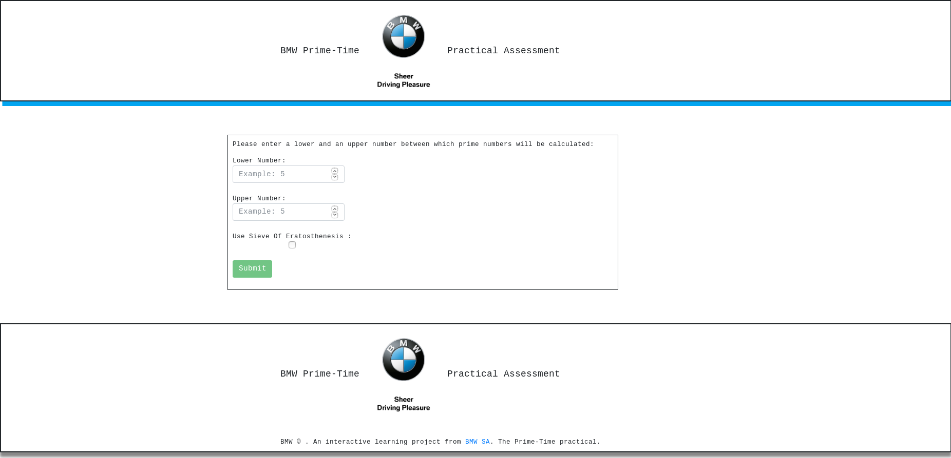

* Parameters: lowerNumber = 60000 ; upperNumber 60100. Results are seen below.

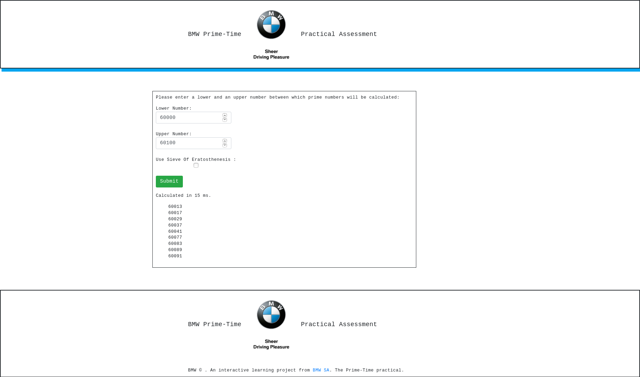

* Parameters: lowerNumber = 60000 ; upperNumber 60100; and Use Sieve Of Eratosthenesis enabled: Results are seen below.

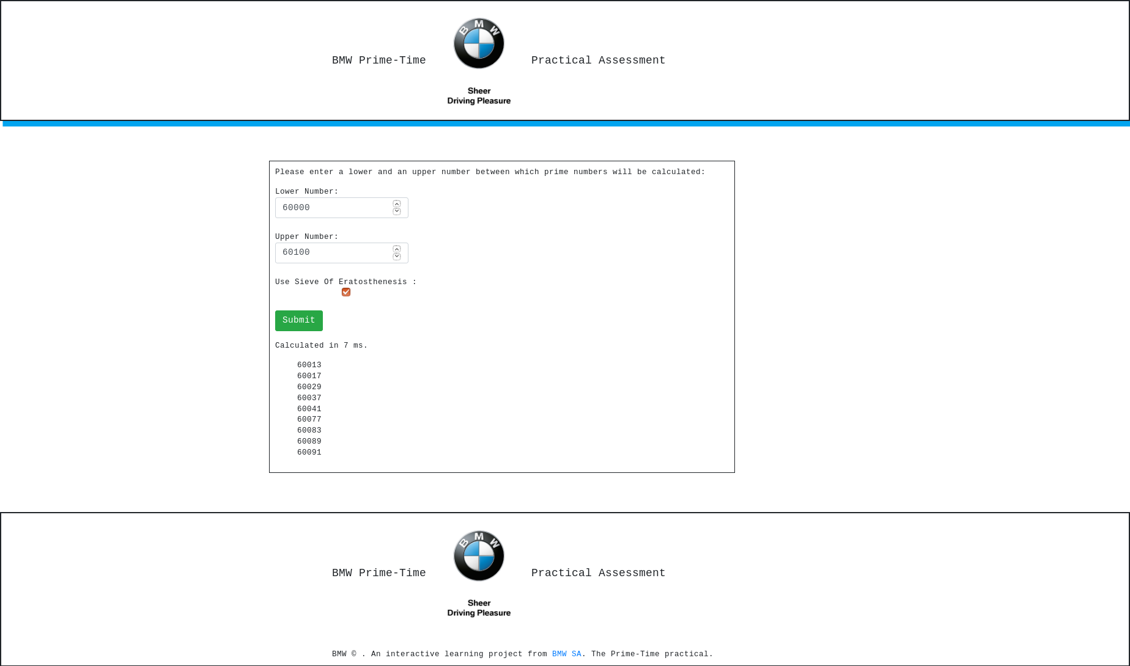

* Application Exception Handling

1. When Lower Number is Greater than Upper Number. Error is shown - Lower Number cannot be great than Upper Number!

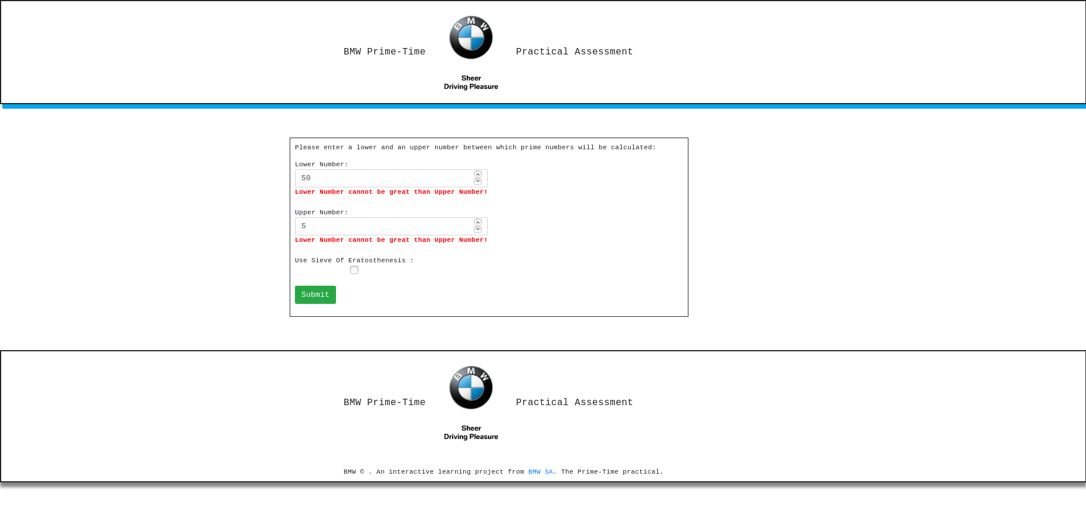

1. When Lower Number is Equal to Upper Number. Error is shown - Lower Number cannot be equal to Upper Number!

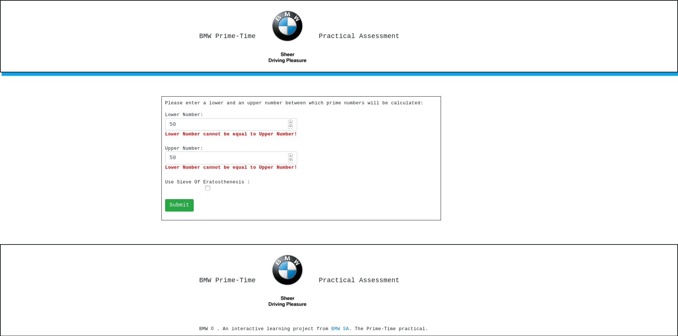

1. When Upper Number is Greater than Lower Number by 1. Error is shown - Difference of Upper Number and Lower Number has be great than 1!

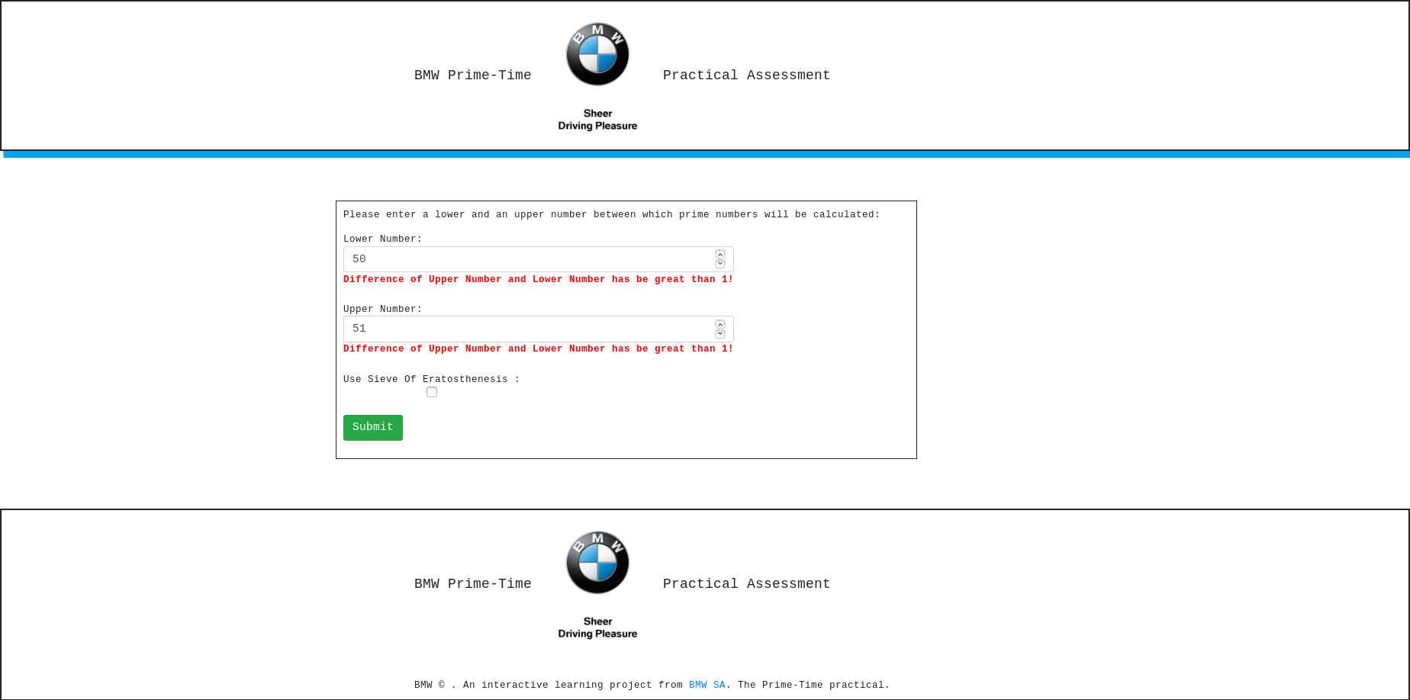

Application Tech Stack:

1. Angular 5
2. Springboot 1.5.9.RELEASE
3. spring-boot-starter-data-jpa
4. spring-boot-starter-data-rest
5. spring-boot-starter-web
6. spring-boot-starter-web-services
7. In-Memory Database : com.h2database:h2
8. Spring Rest
9. Apache Comms
10. Gradle build tool.
11. IntelliJ